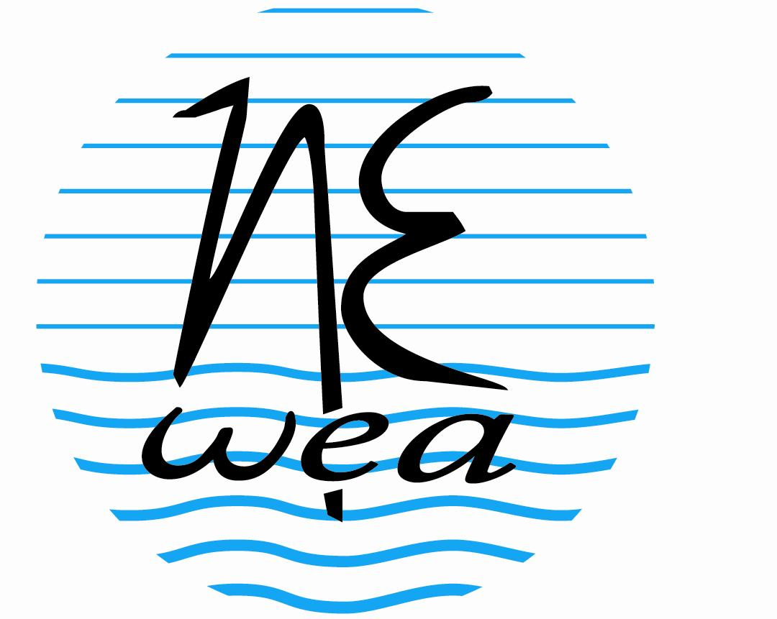
4th Northeast Onsite Wastewater Short Course
&
NOWRA’s 21st Annual
Technical and Education Conference

It's all water - Non-traditional water and wastewater management

April 2-5, 2012
Biltmore Hotel, Providence, RI

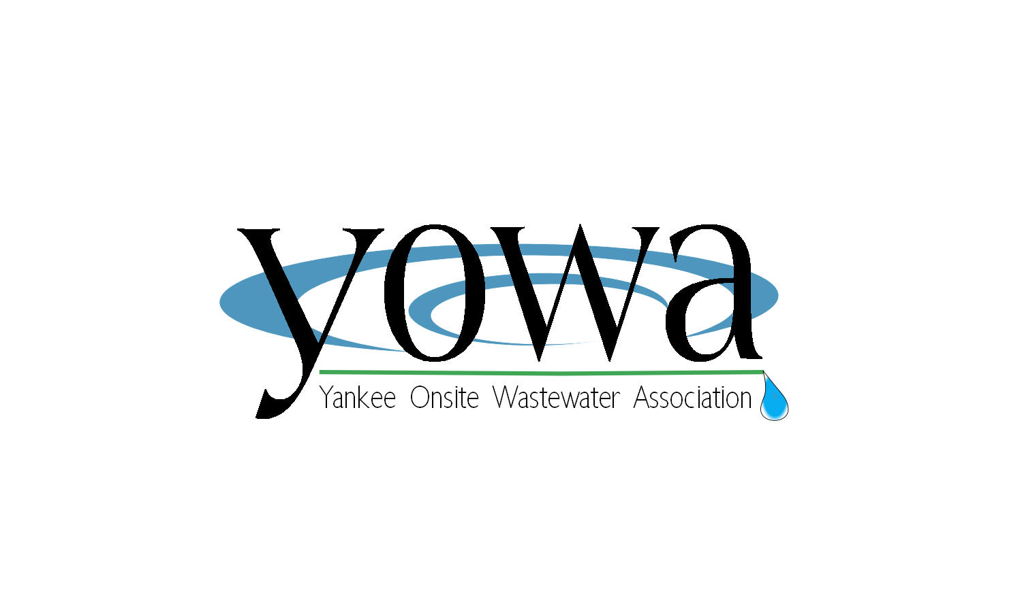
Hosted By:

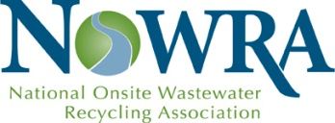

Featuring:
- The NOWRA Onsite Systems A to Z Program
- Advances in management of onsite infrastructure
- Technological innovation
- A Trade Fair featuring a Who’s Who of industry suppliers
- Focus on key challenges facing Northeast states
- Field Trips – 3 states, 3 unique perspectives

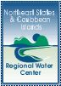
Other Conference co-sponsors
NOWRA and YOWA present
4th Northeast Onsite Wastewater Short Course
and
NOWRA’s 21st Annual Technical & Education Conference

Plan to Attend the Leading Conference for Onsite Industry Professionals!

Mark your calendar for April 2-5, 2012, so that you can join your industry colleagues for the 4th Northeast Onsite Wastewater Short Course, formerly offered by NEIWPCC (New England Interstate Water Pollution Control Commission). The Short Course is being offered by NOWRA – the National Onsite Wastewater Recycling Association – and YOWA – the Yankee Onsite Wastewater Association – as part of NOWRA’s 21st Annual Technical & Education Conference.

Regardless of which segment of the onsite industry is your focus, this conference can help you identify opportunities and ideas which lead to greater success for you and the organization you represent. The conference enjoys a well-deserved reputation for its ability to bring together highly respected leaders and innovative thinkers from across the industry to deliver a first rate education program which provides both technical understanding and practical, hands-on information which you can put into practice.

Three different themes will intersect at this conference:
- Onsite issues and opportunities in New England
- Non-traditional water and wastewater management
- An A to Z overview of onsite wastewater management

New England is home to many innovative wastewater management programs and organizations, and at the same time faces a host of challenges for both policymakers and professionals involved in wastewater management. New England also features many examples of non-traditional water and wastewater management. The education program will focus on challenges and opportunities in traditional and non-traditional management. Many of these challenges are not unique to New England; professionals from the other Northeastern and Mid-Atlantic states will benefit by participating in these sessions.

Beyond the education sessions, these key themes are woven into other aspects of this conference, including the Opening Plenary Session, three exciting Field Trips, and a Trade Fair featuring the industry’s leading suppliers. All that and more awaits you when you join your colleagues in Providence April 2-5 for this can’t miss event!

About NOWRA and YOWA
NOWRA is the only national association which represents all segments of the onsite wastewater industry. Members include Installers, Service Providers, Regulators, Engineers and Designers, Manufacturers and Academia. NOWRA’s mission is to advance and grow the onsite and decentralized wastewater industry by promoting sustainable wastewater management on a watershed basis through education and outreach. YOWA is a regional organization representing New England-based practitioners in the onsite wastewater business. YOWA provides its members education, training and information specific to the needs of professionals based in the area they serve.
Student Scholarships. A limited amount of scholarship money for students wishing to attend this conference has been provided by USDA’s Northeast States and Caribbean Islands Regional Water Center. After registering for the conference, students will be asked to fill out a scholarship form. To be eligible, students must be attending college or grad school full-time in a course of study related to onsite wastewater management or technology.
The amount of scholarship reimbursement will depend on the number of students applying for scholarship funds. NOWRA will reimburse students for registration costs only.

Earn CEU Credits. All those attending the conference will receive CEUs for professional advancement. (Please note that CEUs may not be applicable for licensing requirements in all states.)

Conference Overview

Monday, April 2, 2012 (NOWRA Pre-Conference Activities)

8:00 am – 2:00 pm NOWRA Board meeting
12:00 noon – 5:00 pm Registration open
2:00 pm – 5:00 pm Committee and partner organization meetings

Tuesday, April 3, 2012
7:00 am – 6:00 pm Registration open
7:00 am – 8:00 am Continental breakfast
8:00 am – 11:30 am Opening Plenary Session
11:30 am – 1:00 pm Lunch on your own
1:00 pm – 4:30 pm Concurrent sessions (3 tracks):
Management of Onsite Infrastructure
Technology
NOWRA Onsite A to Z Course
5:00 pm – 7:00 pm Opening Reception in Tabletop Trade Fair
7:00 pm – 9:00 pm Committee and partner organization meetings

Wednesday, April 4, 2012
7:30 am – 8:30 am Continental Breakfast
7:30 am – 5:00 pm Registration open
8:30 am – 10:00 am Concurrent sessions (3 tracks):
Management of Onsite Infrastructure
Technology
NOWRA Onsite A to Z Course
10:00 am – 10:30 am Break in Tabletop Trade Fair
10:30 pm – 12:00 noon Concurrent sessions (3 tracks):
New England and Regional Issues
Technology
NOWRA Onsite A to Z Course
12:00 noon – 1:30 pm Lunch in Tabletop Trade Fair
1:30 pm – 5:00 pm Concurrent sessions (3 tracks):
New England and Regional Issues
Technology
NOWRA Onsite A to Z Course
5:00 pm – 6:00 pm NOWRA Annual Business Meeting and Reception
6:00 pm – 8:00 pm Committee and partner organization meetings

Thursday, April 5, 2012
8:00 am – 5:00 pm Field Trips
            - Southern Massachusetts – MASSTC and Buzzards Bay Coalition
            - Rhode Island Innovative Wastewater and Stormwater Technologies Tour
            - Connecticut – Old Saybrook and Old Lyme

Technical Sessions (Visit www.nowra.org for full descriptions of session content)

Management of Onsite Infrastructure Track
(Afternoon of April 3, morning of April 4)
- Decentralized Drip Irrigation Solves Surface (NPDES) Discharge Problems in Tennessee, Robert G. O'Dette, M.S., P.E.
- Saving Peach Lake: a fast tracked solution that convinced hundreds of Residents, two Municipalities, New York City and New York State Regulators, Sarah E. Cwikla, PE, BCEE, LEED AP
- Onsite wastewater treatment system training and capacity building in the US Caribbean Islands, George Loomis
- Development of Alternative Effluent Limitations for Small Surface Discharging Wastewater Treatment Systems, Barry Toning
- Innovative Individual Onsite Wastewater Management Demonstration Systems Remove Phosphorus in Greenwood Lake NY, Kurt Mailman, P.E
- Gee, why didn't I think of that before? Integrating stormwater and wastewater management at on-lot and neighborhood scales, Amy Macrellis

New England and Regional Issues Track
(Late morning and afternoon of April 4)
- National Community Decentralized Wastewater Demonstration Project at Skaneateles Lake, Eric Murdock, P.E.
- Innovative Wastewater Treatment and Disposal Improvements at the Crotched Mountain Rehabilitation Center (CMRC) Preserve Wooded Surroundings, Thomas G. Page
- Onsite Wastewater Treatment Systems in the Coastal Zone: Coastal Erosion and Sea Level Rise Policy Implications, James Boyd
- Tank Technological Improvements, Dennis F. Hallahan, P.E.
- Code Blue Implementation Engaging the Regulated Community in Developing LID and Stormwater Standards, M. James Riordan, AICP, LEED-AP
- Future, Direction & Opportunities The Onsite Wastewater Industry, John Rowse

Technology Track
(Afternoon of April 3 and all day April 4)
- Why Water Reuse is Necessary in the U.S., Shane P. Keaney
- Passive Cost Effective Nitrogen Removal Technology as Alternative to Sewers to Achieve TMDL requirements, Pio Lombardo, P.E.
- Membrane Bioreactor (MBR) Technology for Decentralized Wastewater Systems, Reza Shams
- Drip-Dispersal as a Viable Large-Scale Effluent Disposal Reuse Technology, David C. Formato, PE
- New Concepts for Rural, Urban and Suburban Water Reuse Using Distributed Systems, Victor A. D'Amato, PE
- Onsite Wastewater Treatment at a Green Building, a School and a Development, David J. Maciolek, M.S., P.E
- Performance Issues of Nitrification & Denitrification at Ontario Schools, E. Craig Jowett, Ph.D., P.Eng.
- Performance Evaluation of EZflow Geosynthetic Aggregate Leaching System, Ben Berteau
- Performance evaluation of new onsite wastewater technologies experiences with recycled media biofilters on actual homes in Virginia, Kevin M. Sherman, P.E., Ph.D., D. WRE
- Nitrogen Removal Using Unsaturated and Saturated Media Biofilters: Pilot Testing and Simulation Results, Dr. Daniel P. Smith, P.E., DEE
- Seepage Pit Evaluation in Minnesota, Sara Heger
- Onsite Wastewater Treatment System Drainfield Malfunction: Causes, Investigation, and Prevention, David Lentz, P.E.

NOWRA Onsite A To Z Course
(Afternoon of April 3 and all day April 4)
- Septic System Treatment Overview, Sara Heger
- Key Wastewater Characteristics, Randy Miles
- Soils and Site Evaluation Overview, Randy Miles
- Septic Tank Overview: Function, Design, Construction, Inspection and Troubleshooting, John Buchanan
- Gravity & Pressure Soil Based Distribution Methods, Tom Fritts
- Pumps and Controls for Decentralized Systems, John Buchanan
- Soil Treatment Principals and System Types, Randy Miles
- Key Aspects in System Install and Inspection, Sara Heger
- Aerobic Treatment Unit Oveview, Tom Fritts
- Media Filter Overview, Sara Heger
- Drip Distribution, John Buchanan
- Operation and Maintenance, Tom Fritts

Poster Sessions

(Note: Posters will be up during the entire conference. Times shown are when author will be present to answer questions.)

Tuesday, April 3, 1:45 pm – 3:00 pm
- Living Building Challenge for Food and Water: Closed-Loop Water & Nutrient Systems, Mark Buehrer, PE

Wednesday, April 4, 2:15 pm – 3:15 pm
The Rhode Island Cesspool Act of 2007: Lessons Learned From Implementing A Cesspool Phase-out Program, Jon Zwarg

NOWRA Onsite A To Z Course

NOWRA’s Onsite A to Z Course provides participants with invaluable instruction regarding onsite wastewater technologies and system application. The overall program is structured to provide professionals with comprehensive information for use in day to day work. Participants will gain essential knowledge about the different systems and their applications in various conditions.

The objectives of this program are for participants to understand the differences between onsite technology and decentralized systems; recognize important siting considerations; and comprehend key factors in the treatment, collection and management of wastewater for decentralized systems.

These sessions may be approved for continuing education credit under your state’s licensing requirements. Check the NOWRA Annual Conference website for updates on states where your participation in this learning track counts toward your continuing education requirement.

Field Trips

Southern Massachusetts – MASSTC and Buzzards Bay Coalition

The Massachusetts Alternative Septic System Test Center (MASSTC) serves not only as a generator of third-party treatment data and information, but has become a premier research and development site for new ideas in onsite treatment. Operated by George Heufelder and staff member Keith Mroczka, it has been at the forefront of developing and conducting testing protocols that establish the efficacy of new technologies. George will walk us through the site describing how it is set up, discussing each technology and the objects of the client, performance, challenges and conclusions. Among the systems he will show the group will be numerous nutrient removal technologies and leach field rejuvenation technologies . Learn more about the test center at http://www.masstc.org.

The Buzzards Bay Coalition is a membership-supported, non-profit dedicated to the restoration, protection and sustainable use and enjoyment of the Bay and its watershed. Rob Hancock of the Coalition will put together a tour of the New Bedford Headquarters where he will discuss the Storm Water reduction principals they have incorporated into their building design. The tour will be followed by a round table discussion on water quality issues and how the Coalition is working with regulators to provide solutions using on site systems. Learn more at http://www.savebuzzardsbay.org.

Rhode Island - Rhode Island Innovative Wastewater and Stormwater Technologies Tour

The New England Onsite Wastewater Training Center @ URI has organized the following field trip, which will be led by George Loomis and David Kalen of NEOWTC, The tour content will be comprised of about 75% advanced wastewater technologies emphasis and the remaining time will focus on integrated stormwater reuse and management. The tour will look at some low impact development (LID) stormwater measures, including green roofs, cistern to restroom flushing systems, bioretention areas, rain gardens, porous paving/parking, and ultra-compact development using a variety of LID features. The group will then travel to Wickford, RI and see firsthand how advanced onsite wastewater treatment technologies are being used to treat wastewater and preserve the character of this densely developed colonial seaport. We’ll look at both commercial sized systems and residential systems during this segment.

Following lunch, the next stop will be the Laboratory of Soil Ecology and Microbiology at the University of Rhode Island. Professor Jose Amador, Soil Microbial Ecologist and lab Director, will talk about former and ongoing research related to factors that control the structure and function of microbial communities and the biochemical transformations processes involved in wastewater renovation in OWTS. The final stop will be the New England Onsite Wastewater Training Center at the University of Rhode Island Peckham Research Farm. The NEOWTC features full-scale systems constructed above ground for hands-on learning.

Connecticut – Old Saybrook and Old Lyme

The tour will begin in Old Saybrook, where participants will review the processes and technologies used to recover failed leach fields at a health care facility and a hotel/condo development and will also look at a technology which monitors grease interceptors and large septic tanks remotely.

Following lunch, the tour will travel to Old Lyme to look at high capacity leach field systems which can reduce leachfield footprints by 20 to 90 percent through the utilization of high surface area technology. The tour will also visit a septage processing facility which supports mandatory pumping requirements in that community. The tour will then travel to Jordan Cove to look at low impact development (LID) for stormwater. Dr. Michael Dietz will provide detail on LID that focuses on sediment retension, nutrient reduction, peak flow retention and techniques for retaining suspended solids over time. This will be followed by a guided tour of natural (green) and structural (gray) stormwater management and reuse features.

Tabletop Trade Fair

Companies wishing to exhibit at the Tabletop Trade Fair should visit www.nowra.org for full registration information, or call Executive Director Eric Casey at 800-966-2942 or wecasey@comcast.net.

Conference Location

The historic Biltmore Providence is located in the heart of downtown Providence, in close walking distance to the city’s top dining and shopping and nightlife attractions. Located adjacent to the Providence River and picturesque WaterPlace Park, The Biltmore offers a variety of amenities. These include a McCormick & Schmick’s Seafood Restaurant and Starbucks on premises; complimentary wireless internet in all guest rooms, meeting rooms and public spaces; and a fully equipped fitness center. Located at 11 Dorrance Street, the hotel is convenient to I-95, and Routes 6 and 10 and is just 10 minutes by taxi from T.J. Green Airport.

For more information on things to do and see in Providence, visit www.goprovidence.com.

Hotel Registration

A block of rooms has been reserved at the Biltmore Hotel (11 Dorrance Street, Providence, RI 02903; Tel 800-294-7709 or 401-421-0700) at a reduced rate of $109 per night (single, double or quad), plus 13% state/city taxes. These rates will be good from April 1 through April 7. To reserve a room, call the hotel and mention that your will be attending NOWRA Annual Technical Conference in order to receive the reduced rate. You must make your hotel reservation by March 3, 2012, in order to take advantage of the reduced rate.

Conference Registration Information

What’s included with your registration:
Full conference registration includes access to all education sessions, the Tabletop Trade Fair, and food functions, including the Opening Reception, Lunch with Exhibitors, breakfasts and breaks, along with access to the conference proceedings, which will be published online.
Student fee includes full conference registration and a student membership in NOWRA. Students must be attending college or grad school full-time in a course of study related to onsite wastewater management or technology.
Guest fee includes access to continental breakfasts, the Tabletop Expo (including the Opening Reception and Lunch), and all refreshment breaks.
Field Trips are a separate, ticketed event. All tours have limited capacity and space is accepted on a first-come, first-served basis. Should a tour not have sufficient interest, NOWRA reserves the right to move a participant to their 2nd choice of tours.

Registration Procedures
Dates & Deadlines: Registrations received without payment will not be processed and will not be considered to have been accepted until payment is received.

Early Registration discounts: Registration & payment received on or before March 2, 2012 are eligible to receive the discount.

No phone-in registrations can be accepted, and any changes to your registration must be made in writing via fax or email.

Your registration must be received by Wednesday, March 28 in order to be processed. After March 28, you should plan to register on-site at the event.

Cancellations: You may cancel your registration at any time for a full refund minus a $50 processing fee until March 28, 2012. No cancellations will be accepted after March 28 and no refunds will be issued after that date.

How to Register:
By Mail: Send completed registration form and payment to NOWRA, 601 Wythe St., Alexandria, VA 22314, Attn: Annual Conference Registration
By Fax: Send completed registration form and payment (credit card only) to 703-535-5263

NOWRA membership
Members of all affiliated state organizations are automatically NOWRA members. In addition, individuals in non-affiliated states may become NOWRA members on a direct basis. For a current list of affiliated state organizations, visit www.nowra.org/stategroups. If your state is not affiliated with NOWRA, and you have not joined NOWRA on a direct basis, you must register at the non-member rate. Included in the non-member rate is a one-year membership in NOWRA. Registrants from New England will get a one-year membership in the Yankee Onsite Wastewater Association. YOWA membership includes NOWRA membership.

Conference Fees
NOWRA/YOWA members/
Partnering orgs. Non-members
Full Conference
Early registration (by March 2, 2012) $299 $399
Late registration (after March 2, 2012) $399 $499
Industry Regulators
Early registration (by March 2, 2012) $199 $299
Late registration (after March 2, 2012) $299 $399
Students $150 $150

Field trips (Thursday, April 5 – separate fee)
Early registration (by March 2, 2012) $75 $100
Late registration (after March 2, 2012) $100 $125
Spouse/Guest $100 $125
(Includes all meal/social functions)

*NOWRA partnering organizations include: National Association of Wastewater Transporters, National Environmental Health Association, National Ground Water Association, Rural Community Partnership, U.S. Environmental Protection Agency, Water Environment Research Federation, National Association of Towns and Townships, Water Environment Federation, State Onsite Regulators Alliance

REGISTRATION FORM
4TH NORTHEAST ONSITE
WASTEWATER SHORT COURSE and
NOWRA’S 21st ANNUAL TECHNICAL &
EDUCATION CONFERENCE
APRIL 2-5, 2012, BILTMORE HOTEL, PROVIDENCE, RI
Mail this form with check (payable to NOWRA) or fax your registration with credit card information. Registrations will only be accepted with payment in full in U.S. dollars. After March 28 we can only accept registrations onsite at the conference. Please duplicate this form for additional registrations. Online registration at www.NOWRA.org will be available shortly.
Please print:
Full Name ______________________________________________________________
Name for badge _______________________ Spouse/guest name______________________
Company/Org. ______________________________________________________________
Street Address ______________________________________________________________
City/State/Zip ______________________________________________________________
Daytime phone _________________ Fax _______________Email _____________________
NOWRA member? ( ) Yes ( ) No Member of partnering organization? ( ) Yes ( ) No
If yes, name___________________________________
Select fees | Early Registration  (Until March 2) | Full Registration  (March 3 or later) | Amount
NOWRA members and partnering orgs
❑ Full members | $299 | $399 | $________
❑ Regulators | $199 | $299 | $________
❑ Students | $150 | $150 | $________
Non-members
❑ Full members | $399 | $499 | $________
❑ Regulators | $299 | $399 | $________
❑ Students | $150 | $150 | $________
Optional Field Trips, April 5 (separate fee, select 1st and 2nd tour choices)
❑ 1st choice RI CT MA | $75 | $100 | $________
❑ 2nd choice RI CT MA
Spouse/Guest (all meal/social events) | $100 | $125 | $________
One day registration, April 3 or 4 | $175 | $225 | $________
Specify date: | 4/3/12 | 4/4/12
 |  | Total | $___________

*NOWRA partnering organizations include: National Assn. of Wastewater Transporters, National Environmental Health Association, National Ground Water Association, Rural Community Partnership, National Small Flows Clearinghouse, U.S. Environmental Protection Agency, Water Environment Research Foundation, National Association of Towns and Townships
Payment Information (NOWRA EIN# 593099430)
❑ My check in the amount of $_______________ is enclosed (Check #_________)
Please charge my Visa Mastercard in the amount of $___________
Number___________________________________ Exp.____/_____ Security Code ____________
Name on card ___________________________________________________________________
Billing Address ___________________________________________________________________
Signature (required) _______________________________________________________________
NOWRA, 601 Wythe St., Alexandria, VA 22314, Fax: 703-535-5263
Website: www.NOWRA2010.org Inquiries? Call: 800-966-2942 Email: info@nowra.org

