CUMBERLAND COUNTY RESOURCES

Maternal and Child Health Program
Free lead testing for children who live in Portland.
Abigail Leavitt, RN
Maternal and Child Health Program
Public Health Division, Health & Human Services
389 Congress Street, Portland, Maine 04101 (207) 874-8869

The Lead-Safe Housing Program
Info on the dangers of lead poisoning in kids. Also provides:
- Community Education
- Testing and Case Management
- Direct Lead Hazard Control
www.portlandmaine.gov/planning/housingleadsafe.asp
www.portlandmaine.gov/hhs/phleadsafety.asp

City of Portland/Cumberland County Lead Hazard Control Program
Forgivable loans for house and apartment owners in Cumberland County. HUD income limits apply.
Ronda Jones, Project Manager
Planning & Development Dept. Housing & Neighborhood Services
389 Congress St., Portland, Maine 04101
rej@portlandmaine.gov
(207) 756-8089 or (207) 874-8949
www.portlandmaine.gov/planning/housingleadsafe.asp
People’s Regional Opportunity Program (PROP)
Grants for removing lead risks in older homes and apartments (income limits apply).
Ellen Fogg, PROP Loan Office
510 Cumberland Avenue, Portland, Maine 04101
(207) 553-5905
www.propeople.org


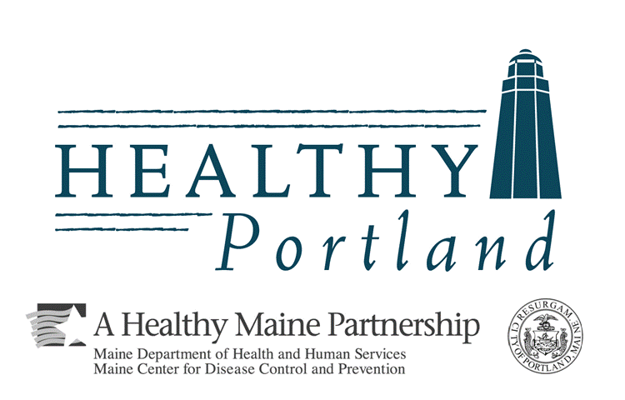
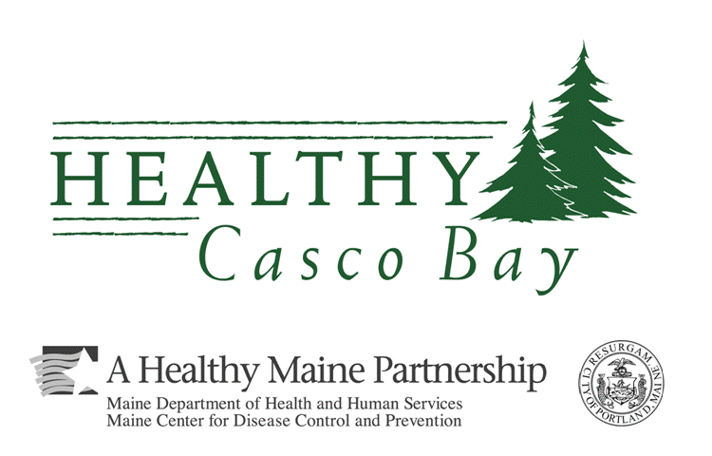

CUMBERLAND COUNTY RESOURCES

Maternal and Child Health Program
Free lead testing for children who live in Portland.
Abigail Leavitt, RN
Maternal and Child Health Program
Public Health Division, Health & Human Services
389 Congress Street, Portland, Maine 04101 (207) 874-8869

The Lead-Safe Housing Program
Info on the dangers of lead poisoning in kids. Also provides:
- Community Education
- Testing and Case Management
- Direct Lead Hazard Control
www.portlandmaine.gov/planning/housingleadsafe.asp
www.portlandmaine.gov/hhs/phleadsafety.asp

City of Portland/Cumberland County Lead Hazard Control Program
Forgivable loans for house and apartment owners in Cumberland County. HUD income limits apply.
Ronda Jones, Project Manager
Planning & Development Dept., Housing & Neighborhood Services
389 Congress St., Portland, Maine 04101
rej@portlandmaine.gov
(207) 756-8089 or (207) 874-8949
www.portlandmaine.gov/planning/housingleadsafe.asp
People’s Regional Opportunity Program (PROP)
Grants for removing lead risks in older homes and apartments (income limits apply).
Ellen Fogg, PROP Loan Office
510 Cumberland Avenue, Portland, Maine 04101
(207) 553-5905
www.propeople.org

CUMBERLAND COUNTY RESOURCES

Maternal and Child Health Program
Free lead testing for children who live in Portland.
Abigail Leavitt, RN
Maternal and Child Health Program
Public Health Division, Health & Human Services
389 Congress Street, Portland, Maine 04101 (207) 874-8869

The Lead-Safe Housing Program
Info on the dangers of lead poisoning in kids. Also provides:
- Community Education
- Testing and Case Management
- Direct Lead Hazard Control
www.portlandmaine.gov/planning/housingleadsafe.asp
www.portlandmaine.gov/hhs/phleadsafety.asp

City of Portland/Cumberland County Lead Hazard Control Program
Forgivable loans for house and apartment owners in Cumberland County. HUD income limits apply.
Ronda Jones, Project Manager
Planning & Development Dept., Housing & Neighborhood Services
389 Congress St., Portland, Maine 04101
rej@portlandmaine.gov
(207) 756-8089 or (207) 874-8949
www.portlandmaine.gov/planning/housingleadsafe.asp
People’s Regional Opportunity Program (PROP)
Grants for removing lead risks in older homes and apartments (income limits apply).
Ellen Fogg, PROP Loan Office
510 Cumberland Avenue, Portland, Maine 04101
(207) 553-5905
www.propeople.org

