FMI Contact:
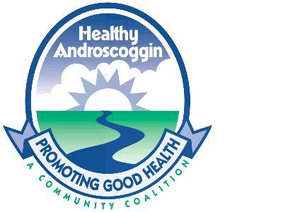
Erin Guay
Healthy Androscoggin
300 Main Street, Lewiston ME 04240
Email: guayer@cmhc.org
Ph (207) 795-5990 ∙ Fax (207) 795-5992
Press Release
October 5, 2009

Training to Satisfy New EPA Lead Rule to Be Held for Contractors and Landlords
Maine Labor Group on Health to discuss new Lead rule and how to make safe repairs on homes containing lead paint

Auburn—Three “Renovation Repair and Painting” (RRP) Courses will be held at Central Maine Community College’s Kirk Hall by the Maine Labor Group on Health. The free all-day course will be held on October 9th and then repeated October 13th and 30th. The course is designed to inform landlords and contractors how to perform maintenance safely on homes with lead-based paint. Pre-registration is required by calling 622-7823 and is on a first come, first served basis. Courses are limited to 20 participants each.

“Lead continues to be a major public health problem for Lewiston and Auburn. Between 2003 and 2007, 119 children under the age of six had elevated levels of lead in their blood. We need to do more to protect our children from lead hazards and this RRP course is one way to ensure that lead-based paint stays away from our most vulnerable community members including children and pregnant women,” says Mark McComas, Deputy Director for the City of Lewiston’s Economic and Community Development Department.

Under the new EPA Lead rule, which goes into effect in April 2010, contractors performing projects that disturb lead-based paint in homes, child care facilities, and schools built before 1978 must be certified by an RRP Course. During the course, contractors will learn specific work practices to prevent lead contamination and other requirements of meeting this EPA Rule.

The Renovation Repair and Painting courses will be offered in October for free by the Maine Department of Environmental Protection through the Lead Poisoning Prevention Fund. This fund, established in 2005, is derived from a 25 cent per gallon fee imposed on manufacturers or wholesalers of paint sold in Maine. The LPPF was established to provide resources to support lead poisoning prevention education, outreach and training programs. Part of the Fund is used to educate Maine landlords and families about the hazards of lead and lead-based paint. Future Renovation Repair and Painting Course fees will be only partially supplemented by the Lead Poisoning Prevention Fund. Future dates and locations for the RRP course have yet to be determined.

The RRP course compliments lead poisoning prevention efforts in Lewiston and Auburn led by the Lead Safe Community Committee and the Healthy Homes Healthy Families partnership which include numerous partners including: city staff, social service providers, and local public health professionals.

For more information about lead-based paint or local lead poisoning prevention efforts, contact Healthy Androscoggin at 795-5990. For more information about the RRP courses please contact Maine Labor Group on Health at 622-7823. Information on the EPA Lead Rule can be found at www.epa.gov/lead.

####

