Pet Me! Pet Me!
Pet Me! Pet Me!

WASH ME!

WASH ME! WASH ME!

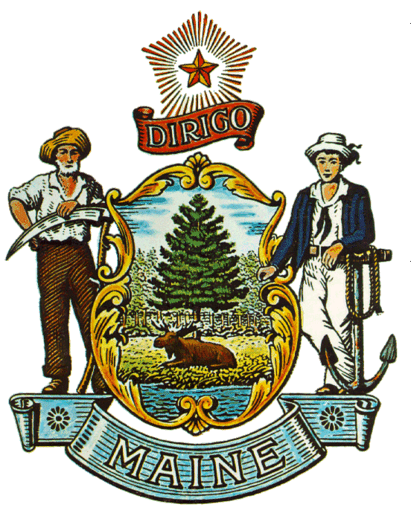Maine Center for Disease Control & Prevention (adopted from Benton Franklin Health District, Environmental Health
Division)

