2008 MAINE STATE PROFILE of
SELECTED PUBLIC HEALTH INDICATORS

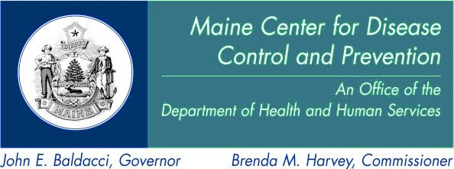

April, 2008

