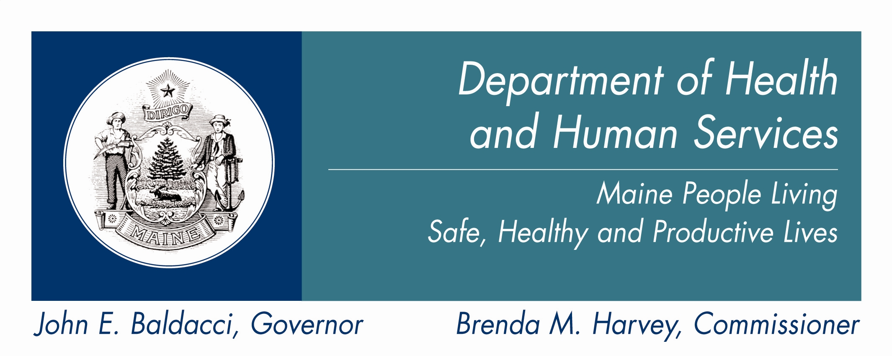

PLAN FOR BRAIN INJURY SERVICES
2008-2009

Brenda Harvey, Commissioner

Jane Gallivan, Director
Office of Adults with Cognitive & Physical Disability Services

Gary Wolcott, Program Manager
Brain Injury Services

January 15, 2008

DHHS PLAN FOR BRAIN INJURY SERVICES: 2008-2009

In early 2007, Brain Injury Services was established within the Office of Adults with Cognitive and Physical Disability Services in DHHS. With the appointment of a manager for Brain Injury Services in February 2007, a 10 month process of fact finding, planning and consolidation was begun. Currently, responsibilities for services and support to persons with disabilities due to brain injuries are spread among many state agencies both in and out of DHHS. Consistent with the Department’s focus, this plan has been developed with the intent of integrating services to achieve the most efficient use of resources while fulfilling its mission of providing high quality services for the health and safety of all Maine citizens.

The Legislature mandated the development of a comprehensive plan for brain injury services in its Resolve Chapter 105, 123rd Maine State Legislature (LD365):

Resolve, To Promote Community Integration for Individuals with Brain Injuries
This resolve requires the Department to complete a comprehensive plan to address the needs of persons with brain injuries. This comprehensive plan must include current and future gaps in services, advances in medical, rehabilitation knowledge and technologies, and models of effective, evidence-based practices and efficient approaches that respond to the wide range of needs of persons with brain injuries and their families. The planning process shall include an evaluation of waiver and other Medicaid programs. The Resolve includes the authorization for the JSCHHS to submit legislation regarding services to persons with brain injuries to the Second Regular Session… Reports are due January 15, 2008, January 15, 2009 and April 15, 2009.

This plan for Brain Injury Services was developed in conjunction with the Acquired Brain Injury Advisory Council (ABIAC). The Council is a representative stakeholder body which reports to the Commissioner. The Council conducted a number of forums during 2007 and two formal public hearings on brain injury priorities and gaps in services. This plan reflects and responds to the findings and recommendations of the ABIAC.

This plan focuses on eight (8) key areas for persons with brain injuries and their families and identified by stakeholders:

1 - Persons with Severe Disabilities Placed in Out-of-State Facilities
2 - Inappropriate Acute Care Placements of Persons with Complex Needs
3 - Specialized Assisted Living Residences
4 - Care Coordination
5 - Outpatient Neurorehabilitation Services
6 - Support for Families
7 - Professional Practice and Education
8 - Military Service Members and Veterans
Additional areas of focus and research are also identified which will be pursued in 2008 and included in the follow-up plan for 2009.

Brain injury in Maine is a significant public health issue touching the lives of more than 7,000 individuals, their families and communities each year.

Outcomes Related to Brain Injuries in Maine
(Estimated Number of Incidents Annually based on Maine CDC (2000-2004) Annual Data)
235 Deaths
1,010
Hospital Discharges
5,330
Outpatient ER Visits
? (data not available)
Other Medical Care
or
No Medical Care
The severity of the brain injury does not necessarily equal the severity of the disability.

LEADING CAUSES of
BRAIN INJURY
- Falls: 28%
- Motor Vehicle
Crashes: 20%
- Other (Assaults, Bicycle Crashes, Sports, Other):52%

Every brain injury is unique and depends upon which area(s) of the brain has been injured.
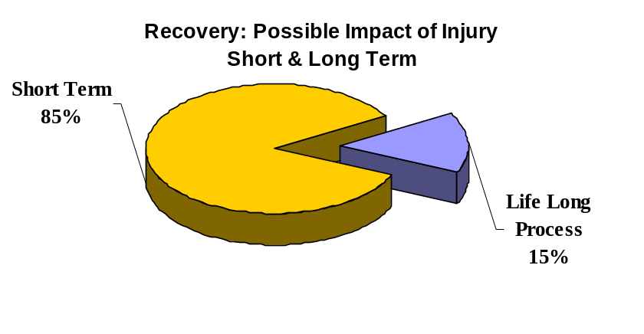

Recovery:
Over Course of a Few Years
- Return to Life before Injury (w/ some adjustment)
- Resume Family Role
- Resume Work/Career
- Resume Leisure Activities
Recovery:
A life Long Process with Long Term Disabilities
Individuals often Experience:
- Loss of Job/Career
- Loss of Family Role
- Loss of Leisure Activities
- Loss of Independence-
Ability to Self-Care,
Manage Finances,
Drive a Car

- U.S. Center for Disease Control estimates that 5,300 individuals were living in Maine with significant disabilities due to brain injuries in 2000.

- Between 300-600 individuals each year in Maine experience brain injuries that lead to significant, life-long disabilities.

Often the most difficult symptoms of a brain injury affect the individual’s self awareness and judgment. These brain injuries usually involve dementia and short-term memory impairments leaving the individual without the capacity to function and live independently. Twenty four hour/seven day-a-week supervision is required to maintain the person’s safety. Ironically, the person’s physical capacities are not often as limited as their cognitive capacities.

Some experts estimate that approximately 6% of those with severe disabilities due to brain injuries develop aggressive, difficult to manage behaviors (Jacobs/McMorrow). This means that between 18 – 36 individuals each year struggle with this additional hurdle to their recovery.

Maine, like most states, faces this growing public health challenge: hundreds of previously productive individuals of all ages suddenly incapacitated with brain injuries requiring intensive supports, their families overwhelmed by the losses associated with their loved one’s brain injury, and a service system not fully prepared to respond to these complex issues.

ANALYSIS OF GAPS IN SERVICES & ACTION STEPS

1 - Persons with Severe Disabilities Placed in Out-of-State Facilities*
(*facilities more than 15 miles from Maine border)
Gaps in Services
 Fourteen (14) adult MaineCare members with brain injuries are in hospitals or nursing facilities in Massachusetts at a total cost of more than $2,000,000 annually due to lack of specialized beds in Maine facilities.
 A review by Schaller Anderson of these fourteen individuals indicates that the level and type of care they are receiving is currently provided in Maine and could be placed in facilities in Maine if openings were available.
 Four (4) of these individuals were placed in Massachusetts facilities this year (2007) due to lack of available beds in Maine.
 Eight (8) of these individuals have resided in Massachusetts facilities for more than two years.
 No active, organized process exists to repatriate these individuals other than an annual review of their medical and financial eligibility for MaineCare.
 Three (3) teenagers with disabilities due to brain injuries who will transition to adult services in the near future are also in out-of-state placements

Action Plan
 Working collaboratively with other Department initiatives (including LD 339/Chapter 61 task force), Brain Injury Services will establish a care coordination process for each of the 14 adults who are out-of-state. This process will include the development of a person centered plan, finding in-state services to meet the member’s needs, identification of resources, and development of an effective transition plan. Transition will occur as resources are available to the Department; with the goal repatriating all of the adult members who wish to return to Maine by December 2009.
 Continue existing collaborative efforts within the Department to identify those members who are at risk of out-of-state placement and locate in-state resources for support and care.
 Establish an integrated oversight process to identify, assess and implement transition services to adolescents who are out-of-state (and soon to move into the adult service system).

2 - Inappropriate Acute Care Placements of Persons with Complex Needs

Gaps in Services
 More than twelve (12) individuals with brain injuries in 2007 were “stuck” in acute hospital beds in Maine awaiting placement for more than 60 days (following their medical treatment).
 A review of these cases indicates the primary issue with discharge was the individual’s complex behavioral support needs which required specialized services. In many cases the acute hospital provided 1:1 supervision of the individual 24 hours per day at an additional cost.
 In a number of these situations the individual was transferred to an acute care bed in a hospital for a medical condition from a long term care facility. Upon the resolution of the medical condition the long term care facility refused to accept the individual back into that facility because of long-standing behavior issues related to the person’s brain injury.
 Costs for an acute care bed in Maine exceed $1200 per day (not including 1:1 care) for which Maine hospitals do not receive reimbursement once the person no longer requires acute care.
 The actual number of these cases may exceed the identified 12 individuals by two or three times due to the lack of a centralized reporting system.
 No coordinated system of surveillance and active care coordination exists to identify the scope of this problem, nor to efficiently identify and transition these individuals with brain injuries to more appropriate, cost-effective services.

Action Plan 2008-2009
 Prioritize individuals with brain injuries in acute care beds awaiting placement in the Department’s efforts to increase access to care during 2008.
 Establish a workgroup representing hospitals, discharge planners, community-based providers, advocates and DHHS to quantify the actual extent of the problem and resulting cost to Maine’s healthcare system with a report out in December 2008. This workgroup will design a pilot Care Coordination project to demonstrate effectiveness and cost efficiency with the goal of implementing the pilot in 2009 if funding can be identified.

Maine’s brain injury residential system is stuck - discharges from Brain Injury Specialized Assisted Living facilities are less then 5% per yr. As a result, few openings are available to meet the need for less intensive services from discharges from acute care hospitals and nursing facilities. This drives out-of state placements!

Out-of-State Rehab. & Long Term Care
(14 Individuals)
Acute Hospitalization & In-Patient Rehab
BI Specialized Skilled Nursing
(50 beds)
BI Specialized Assisted Living 24/7 Support (PNMI) (103 beds)
Acute Hospitalization & In-Patient Treatment
Specialized Skilled Nursing
MH Specialized Assisted Living 24/7 Support (PNMI)
MH Supported Living (PNMI)-Less than 24/7 Support
Comparing Brain Injury Services
and
Mental Health Services*
Living Independently
in the Community
(with Natural Supports)

No
Option

* Note – a similar comparison can be made to services to persons serviced by Developmental Services

3 - Specialized Assisted Living Residences for Persons with Brain Injuries

Gaps in Services
 Opportunity to transition from one of Maine’s current specialized brain injury assisted living facilities to a less restrictive community setting is very limited. Currently, Maine has one hundred three (103) individuals in eight (8) specialized assisted living facilities (PNMI). In 2007 only seven (7) individuals left one of those facilities. The average cost of care in these specialized brain injury residential facilities is $85,000/year.
A CMS funded, Muskie Institute study of eighty one (81) of the one hundred three (103) persons in these programs found that at least 16 and as many as 29 were ready to move to a less restrictive, less supervised, less costly level of care. Schaller Anderson’s review of 23 of the same individuals confirmed the conclusions of the larger Muskie study.
The inability of individuals in specialized assisted living programs to move to a less intensive setting, results in more costly, inappropriate care and blocks access to those in need of movement from institutional placements (acute care, nursing care, and out-of-state).
 No coordinated system of admissions prioritization or discharge exists to identify and transition these individuals with brain injuries to appropriate, cost-effective services.

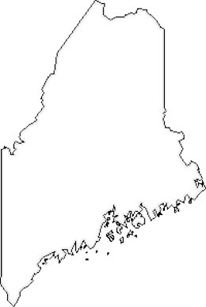
Authorized In-State Providers of Specialized Assisted Living

Provider/ location; Capacity

Lakeview*(Effingham, NH); 51

Goodwill of NNE
Fern Cottage (Leeds); 5
Spiller Park (Gorham); 6
Pride Park (S.Portland); 8
Georgia St. (Portland); 5

CreativeWorks Systems
Butler House (Saco); 7

Essex Street (Bangor); 6

RiverRidge (Kennebunk); 16

*Lakeview, located 15 miles from ME border, is deemed an In-State provider.
Specialized Assisted Living Services to Persons with Brain Injury
(PNMI Residential Care)

Access to specialized brain injury assisted living residential services (PNMI) is highly limited, especially in rural areas of the state. When an individual is placed hundreds of miles from family members and friends, support and active participation in the individual’s recovery is significantly limited and impedes that individual’s recovery.
 The largest specialized brain injury assisted living facility (under contract with MaineCare), Lakeview, is actually just over the border in Effingham, New Hampshire serving fifty one (51) individuals. Lakeview is the only facility of the five (5) providers of these services that has increased in services to MaineCare members, growing from forty three (43) two years ago to fifty one (51). The other four providers are concentrated in York, Cumberland and Androscoggin counties serving a total of fifty two (52) individuals.
 Aroostook and Washington counties have no access to community residential (assisted living) services for persons with brain injuries. For those families near current programs in southern and western Maine the current facilities are accessible. But for many in central, eastern or northern Maine many hours of driving are required to visit and participate in their loved one’s care.
 No prior authorization by DHHS is required to fill an opening in a specialized brain injury assisted living program. Each provider has admissions standards consistent with a MaineCare contract and is left to choose among the individuals on their waiting list. Many providers report that they no longer keep a waiting list due to the very limited number of openings in their programs. No system exists to coordinate these highly limited services on a state-wide basis or prioritize access to care for the most needy.

Action Plan
 In 2008 the Department will explore the design of a pilot project to create 10 units of community-based supportive living to enable persons in a Brain Injury Assisted Living Facility to move to a more appropriate and less costly level of care. This pilot project will be modeled on Mental Health’s scattered-site PNMI structure and will provide a supportive program offering less than 24/7 supervision for the participants who will be served in their own homes. It is estimated that the average cost would not exceed $55,000/person/year. This reflects a potential savings of $30,000 per individual placed in the specialized PNMI system. This new program is dependent upon new funding. If funding for the pilot project can be developed this pilot program will be implemented in 2009.

 Establish in Brian Injury Services (OACPDS) an admissions/discharge clearinghouse for the Specialized Assisted Living Programs: through 1) statewide waiting list; 2) requiring all vacancies/ discharges to be identified; and, 3) prioritized list of potential residents furnished to the provider to support an admissions process based upon mutual agreement of the resident, their family and the provider. The clearinghouse system will be instituted through contract adjustments with the Specialized Brain Injury Providers during 2008.

 In 2006 a commitment was made to families in Aroostook County by the Department to establish a four (4) bed Specialized Brain Injury residence to serve individuals in northern Maine. Funding for this development will need to be identified and an RFP issued to select a provider organization. The goal will be to open this program no later than December 2008, if funding is available. It will be operated by a community-based care provider under the PNMI program at a cost not to exceed the statewide average daily rate for Specialized Brain Injury PNMI programs.

4 - Care Coordination

Elder Services
☑ Case Management
☑ In-Home Supports
☑ Adult Protective Svc
☑Public Guardianship

Mental Health Services
☑ 4-Levels of Case Mgt
☑ Community Crisis Sys
☑ In-Patient Services

Developmental Services (Mental Retardation & Autism)
☑ Case Management
☑ Community Crisis System
☑Adult Protective Services
☑ Public Guardianship

Persons with
Brain Injury

NO CARE COORDINATION SERVICES

MaineCare members with brain injury who qualify in MH, DS or ES receive services- the majority of members with brain injuries are not eligible for Targeted Case Management. This disparity creates significant confusion and sometimes results in shifting the emphasis of a person’s needs in order to gain care coordination. Failure to provide effective care coordination creates an inefficient approach that can result in poor care, increased burden on families, increased burden on acute care hospitals and an increase in institutional care.

Gaps in Services
 Case management services do not exist for the majority of persons with severe disabilities due to brain injuries. Of the three thousand three hundred (3,300) MaineCare members with identified brain injuries (2004 data), forty four (44) are public wards receiving support from Office of Elder Services; one hundred fifty three (153) have a co-occurring diagnosis of mental retardation or autism and receive case management from Developmental Services; and eight hundred sixty five (865) have a co-occurring diagnosis of mental illness and receive case management from the Office of Mental Health. This leaves more than twenty two hundred (2,200) without access to care coordination or case management.
 Lack of access based upon a diagnosis driven from the source of the individual’s impairment is discriminatory and creates barriers to effective care, increased use of medical care, and institutionalization.
 Provision of case management to those persons with brain injuries who qualify under another part of the service system creates significant confusion and emphasis on alternative diagnoses which may lead to less than effective, efficient care.
 For those individuals seeking to move from acute care hospitals or nursing facilities to appropriate community based services, the responsibility for identifying community resources, development of a discharge and transition plan currently lies with the institution’s discharge planner and family members (if available). No formal, centralized information/referral and care coordination resource exists.

Action Plan
 Design a pilot project to demonstrate time-limited, care coordination for 60 MaineCare members with disabilities due to a brain injury who are in immediate need of appropriate services. The goal of this pilot project would be to demonstrate the efficiency/ effectiveness a care coordination system that would not exceed a cost of $1600/ service recipient. Priorities for this project include: 1) individuals in out-of-state institutions seeking a return to Maine; 2) individuals in acute care hospitals without clear, appropriate discharge options; 3) individuals seeking a less-restrictive level of care: and, 4) families seeking to bring a loved one with a brain injury home or to maintain that person in their home. Impact and cost effectiveness measures will be established and monitored through out the project. Complete this pilot project by December 2009. This project can only be developed if funding resources can be obtained.

5 - Outpatient Neurorehabilitation Services

Gaps in Services
 Outpatient neurorehabilitation clinics serve more than 700 MaineCare members annually. Five provider organizations operate these programs from eight locations throughout the State. In 2003 significant changes were made in MaineCare reimbursement rules resulting in the withdrawal of one provider from offering these services and the reduction of services by all of the others. All of these programs maintain CARF accreditation.
 Concerns have been received in the last 8 months from MaineCare members, their families, referring agencies and the public regarding the narrowing of the services provided by the neurorehabilitation clinics.
 Lack of specialized substance abuse and psychiatric services within the transdisciplinary teams in these programs appears to have led to more fragmented, less coordinated care for individuals with co-occuring conditions.
 Restructuring reimbursement based upon length of time since the individual’s brain injury appears to have led to limited access to allied health professionals (OT, PT, SPL, etc) for some service recipients and increased use of group treatment that may be inconsistent with individual’s needs and person- centered plan.
 Ambiguity in current rules may have led some providers to limit the use of neuropsychologist services in the day-to-day operation of the clinics.
 MaineCare rules (11/01/04) required a Utilization Review system to be developed for services provided in these clinics. The current system UR system is limited to providers furnishing the clinical oversight and the Department documenting the reported information.

Action Plan
 Establish a stakeholder work group of providers, medical and allied health professionals with brain injury expertise, individuals with brain injuries and their families to re-evaluate the rules governing the Neurorehabilitation programs. This reevaluation will incorporate current, evidenced-based, and best practice standards in brain injury recovery and rehabilitation, as well as approaches to increase the efficiency of services. This group will make recommendations to the Commissioner before July 2008.
 Improvements to the utilization review system will be developed with the cooperation of OACPDS-Brain Injury Services, Office of Elder Services, and Office of MaineCare Services and become operational by July 2008.

6 - Family Support

Gaps in Services
 Support for families following the brain injury of a family member is limited and fragmented. When a family member receives a brain injury, the entire family is disrupted emotionally and economically. With increasingly limited health care benefits, shorter hospital stays and the high cost of in-home care, family members are often required to leave their jobs to care for a loved one at home. This combination of factors leaves families in significant need of support, guidance, and targeted services to weather this extremely difficult experience.
 Lack of support for families was the most frequently identified issue in the recent public hearings conducted by the Acquired Brain Injury Advisory Council.

Action Plan
 Brain Injury Services will seek grant funds to improve family information and resource services in Maine by submitting at least one grant application in 2008.
 Development of the care coordination pilot project (see above) will include participation of representative family members to insure that the pilot responds to family needs.

7 - Professional Practice and Education

Gaps in Services
 Brain injuries have created a relatively new disability group. Prior to the 1970’s very few individuals survived their injuries. With the establishment of the EMS system and significant advances in acute medical technology, the survival rate was well over 90% by the early 1990’s. However, the knowledge and care for improved recovery and rehabilitation however, has lagged behind the emergency/acute medical care system. Advances in understanding brain-behavior relationships through new neuro-imaging technologies and long-term studies of the effectiveness of cognitive rehabilitation are only now emerging. Many current working professionals received their graduate training prior to this shift in survival rates and these rapid advances in brain knowledge. As a result, understanding of the consequences of brain injury and its many different forms of recovery and rehabilitation is lacking throughout the medical, educational, and social services systems in Maine.
 Lack of knowledge and inconsistent approaches to rehabilitation and care were frequently cited issues in the recent public hearings conducted by the Acquired Brain Injury Advisory Council (ABIAC).
 Misidentification/misdiagnosis of brain injuries were identified in the 2005 ABIAC Needs Assessment as a significant issue.

Action Plan
 Brain Injury Services provides support to the Acquired Brain Injury Advisory Council (ABIAC) and will work with the Council to further define the issues, scope and systems change initiatives required to address this substantial challenge. The ABIAC operates with three standing committees: Prevention, Adult Services, and Children’s Services. Focus on this issue in all the committees is underway. A summary of the Council’s efforts in this area will be made by December 2008.
 Brain Injury Services will facilitate eight (8) days of training through the Department’s Staff Education and Training unit (SETU) focusing on issues associated with brain injuries that occur in children and adults.

8 - Military Service Members and Veterans

Gaps in Services
 Concern for returning service members from the Iraq and Afghanistan conflicts continues to be high. The news media and medical writers frequently refer to brain injury as the “signature wound” of these wars. Much progress has been made both in Maine and at a national level in responding to service members who receive a brain injury. Significant cooperative efforts are currently underway to meet the anticipated need for rehabilitation and long term support for those individuals. What remains unclear is the effectiveness of current and proposed approaches to identifying and supporting those service members with mild traumatic brain injuries. The consequences of these injuries can be far reaching, yet go unidentified or ignored. The current screening and education project being conducted by Dartmouth Medical School for the Maine National Guard and funded by a grant from the Maine Health Access Foundation appears to be an effective response to this problem. However, it only reaches service members from our National Guard, the Maine service members from the regular armed forces and reserve units are not included in this project due to lack of regular military units based in Maine.

Action Plan 2008-2009
 Brain Injury Services will continue to coordinate with and support the efforts of the Maine National Guard, Office of Veteran’s Services, Veterans Administration and the Dartmouth Medical School Project in their efforts to support service members and veterans with brain injuries.

Additional Areas of Focus and Ongoing Research to Define Needs and Service Options 2008-2009

Evaluation of Medicaid Waivers for Funding Services to Persons with Brain Injuries
Ongoing efforts continue to evaluate options under the Federal Deficit Reduction Act for use of Medicaid waivers to support these services. New changes to Medicaid rules by the CMS have made this evaluation process much more complex. Additional time and data is needed to access the viability of these options and a report will be completed by December 2008.

Fact Finding & Data Collection Efforts
Brain Injury Services will conduct ongoing efforts to explore the impact of the following issues which involve Maine citizens with brain injuries and their families:
Emergency and Acute Medical System
Education System (early childhood through college)
Substance Abuse Co-Occurring Disorders
Domestic Violence
Homelessness
These efforts will be approached with a collaborative, integrated focus - working with other offices within the Department, State Government and with stakeholders groups.

