STANDARD OPERATING PROCEDURE

FOR HYDRAULIC AQUIFER TEST

USING A PNEUMATIC SLUG TEST APPARATUS

Maine Department of Environmental Protection

Division of Technical Services

Standard Operating Procedure: DTS#001
Revision: 0
Date: 11 Feb 2008
Written by: Rob Hoey &
Sean Dougherty
Reviewed by: Rob Peale

- PURPOSE

The purpose of this document is to describe the Maine Department of Environmental Protection, Bureau of Remediation and Waste Management, Division of Technical Services (MEDEP/TS) standard operating procedure (SOP) for conducting hydraulic tests with a pneumatic slug test apparatus.

- INTRODUCTION

MEDEP/TS is responsible for providing technical assistance pursuant to the investigation and remediation of petroleum, solid waste, and hazardous substance sites throughout Maine. As part of this technical assistance MEDEP/TS performs field testing to determine hydraulic properties of aquifers and aquitards. This Standard Operating Procedure (SOP) is designed to be a guideline for MEDEP/TS staff in the use of a pneumatic slug test apparatus for the determination of transmissivity (T) or hydraulic conductivity (K). This procedure is based on Butler(2002) and the field experience of MEDEP personnel.

The initiation of a slug test is often accomplished by the addition of a known volume of water to the test well or the submergence/withdrawal of a solid slug into/from the water column. The introduction or removal of the slug displaces the water level in the well. A record of the water level return to the static condition provides the data with which transmissivity or hydraulic conductivity may be calculated. In moderate to high transmissivity zones the use of an electronic pressure transducer is preferred for recording the head data as the water level recovers from the slug induced stress. The transducer is capable of recording a large number of data points in the relatively short recovery time of a high transmissivity zone. Water and solid slugs have the unfortunate characteristic of introducing a substantial amount of noise in the early recovery time data recorded on the transducer. In the case of very high transmissivity formations where the recovery time is in a matter of seconds, this noise can wipe out most of the recovery data. The time it takes to introduce the water or solid slug can take a substantial fraction of the water level recovery time. The use of a pneumatic slug avoids the disturbance of the transducer which generates the noise. It also generates a more “instantaneous” water level displacement than does a water or solid slug.

- RESPONSIBILITIES

All MEDEP/TS staff must follow this procedure when using the pneumatic slug test apparatus. Because this apparatus is often employed with the inflatable packers and uses high pressure gas, all staff using this device are required to have the Technical Services equipment coordinator or a qualified user assist them in the field until adequate familiarity with the apparatus, its use, and applicable safety protocols (Appendix A) is achieved.
The respective managers and supervisors for MEDEP/TS are responsible for ensuring that their staff receive adequate training, are familiar with, and adhere to these procedures.

- EQUIPMENT

The following is a list of components that make up the pneumatic slug test apparatus and ancillary equipment.

Well Head Manifold
Low Pressure Regulator Manifold
Pressure Transducer
Tubing: 250 psi gas lines
Adapters; 2” well pipe to 1-1/4” mpt, 1-1/4”fpt to ¾” well pipe, 2x2” rubber coupling
Laptop with Telog software
Nitrogen tank
Tank regulator
Tool Kit

The Well Head Manifold is constructed of Sch. 40 PVC fittings and is designed to attach to ¾”, 1”, and 2” nominal well pipe as well as the inflatable packer center tube. There are several adapters to fit the manifold to various pipe sizes. The manifold consists of a wye fitting with a 2” threaded well pipe adapter. The wye is fitted with a cable compression fitting to seal the transducer cable, a Swagelok® quick connect gas fitting for admitting the gas slug, and a 2” ball valve for venting the gas. See Figure 1.

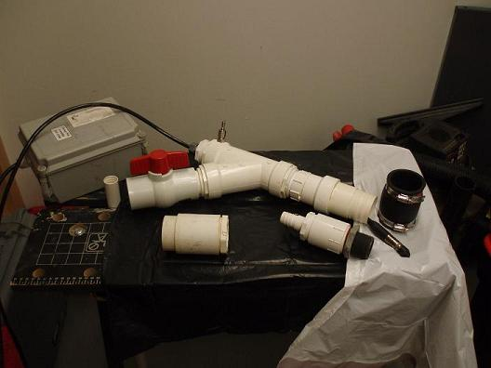

Figure 1. Well Head Manifold with transducer installed and several well pipe adapters. The Telog® data logger is the gray box on the left.

The Low Pressure Regulator Manifold has three components; a 1000 psi to 10 psi pressure reducing regulator, a plug valve, and a 10 psi pressure gauge. This device lowers the pressure from the high pressure gas tank regulator to a pressure that is manageable for the purpose of the test. It also enables the technician to finely adjust the pressure admitted to the well and thereby control the amount of water level drawdown. See Figure 2.

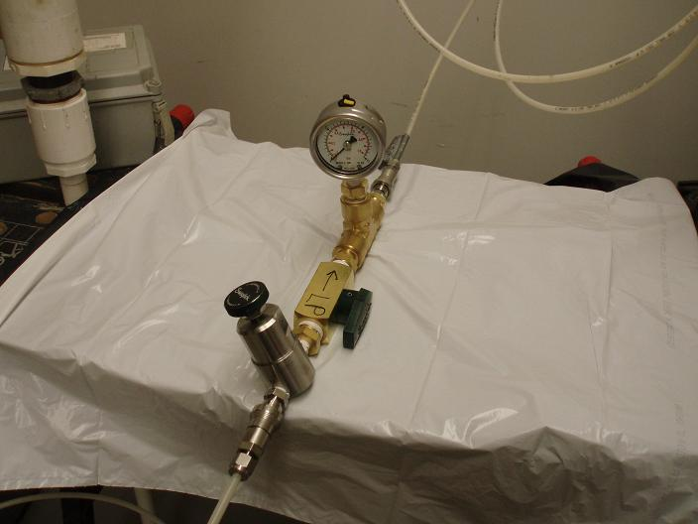

Figure 2. Low Pressure Regulator Manifold consisting of three components from bottom of picture; low pressure gas regulator, plug valve, and pressure gauge.

The Pressure Transducer is used to measure water levels in the well during the course of the slug test. It is connected by a cable to a Telog® data logger which records the water level at a predetermined frequency, usually one reading per second. The transducer is rated at 10 psi and has a range of 7 meters (23 feet).

The tubing is ¼ inch OD nylon rated at a working pressure of 250 psi. There are two lengths of tubing completed with Swagelok® fittings to facilitate assembly of the apparatus. One length connects the Tank Regulator to the Low Pressure Regulator Manifold. The other connects the Low Pressure Regulator Manifold to the Well Head Manifold.

The laptop computer with Telog® software is used to read the data from the transducer data logger.

The nitrogen tank provides the gas for the pneumatic slug. The gas is delivered through the tank regulator which reduces the tank pressure to less than 1000 psi.

- GUIDELINES/PROCEDURES FOR USE OF THE PNEUMATIC SLUG
TEST APPARATUS

5.1 Equipment Set-Up

CAUTION: Before assembling and operating the apparatus review the safety protocols in Appendix A.

After setting up and securing the nitrogen tank purge the tank valve by cracking open the tank valve and immediately closing it. This very short discharge of gas will blow out any debris which may have accumulated in the downstream side of the valve. This debris, if not removed, could prevent a seal between the tank regulator and the tank valve or could become lodged in the regulator preventing its proper functioning.

Attach the tank regulator to the tank valve and tighten with an adjustable wrench. See Figure 3. The fitting only needs to be tight enough to prevent gas leakage. Over tightening can damage the fitting. Ensure that the pressure control screw (T-handle on front of regulator) is turned counter-clockwise until there is no resistance on the screw. This is the closed position for the regulator. Test for gas leakage by opening tank valve slowly. There should be no sound of escaping gas. The pressure gauge (HP) on the regulator closest to the tank should indicate the tank pressure. The other pressure gauge (LP) indicates the output pressure of the regulator and should read 0 psi at this time.

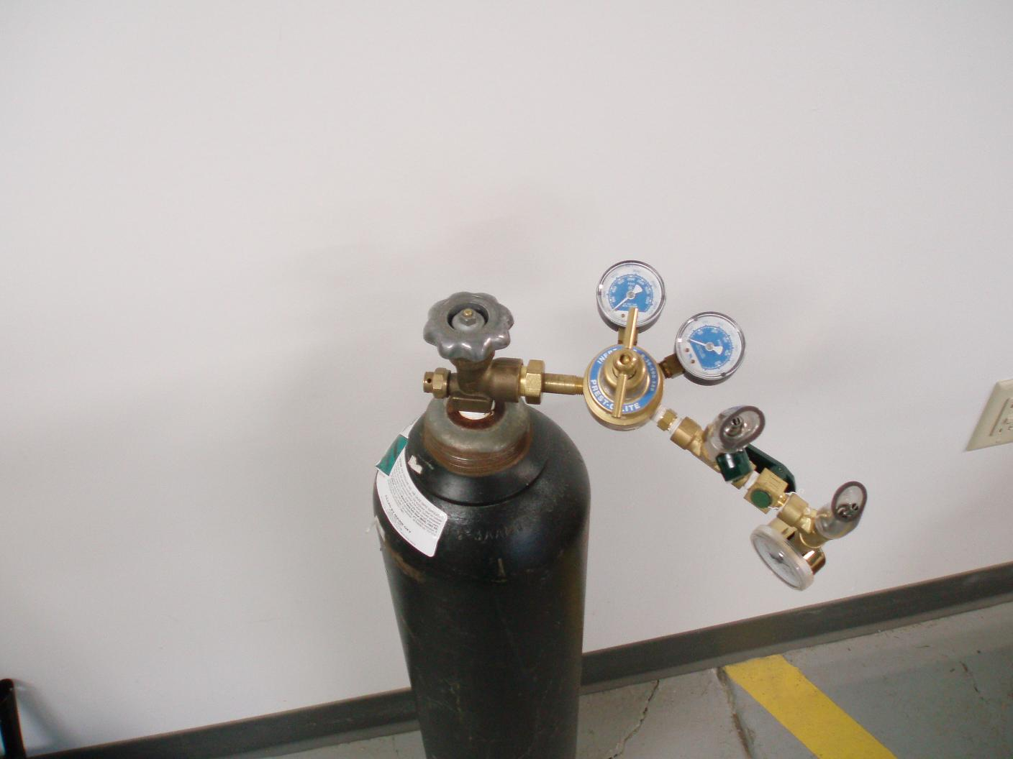
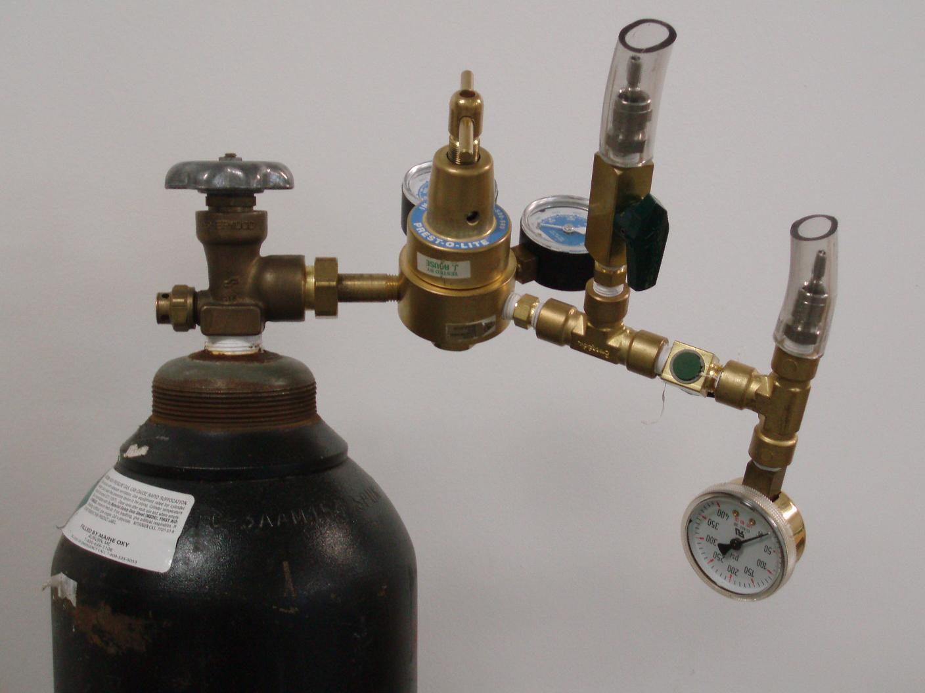

Figure 3. Two views of the Nitrogen tank with tank regulator installed. Upper view shows two gauges on the regulator. The one closest to the tank (HP gauge) indicates tank pressure. The other (LP gauge) indicates the pressure on the output of the regulator. The third gauge seen in the both photos at the lower right also indicates regulator output pressure but with a more precise scale than the LP gauge. In the lower photo is a view of two quick-connect fittings (with protective sleeves) that connect the regulator to the pneumatic slug test apparatus (left) and the inflatable packers (right).

Assemble Well Head Manifold with the adapter appropriate to the well being tested and attach to well head. When using the inflatable packers, the well pipe riser that extends to the surface from the top packer should be assembled with O-rings or Teflon tape to improve the seal between pipe sections.

Measure the water depth below the top of the Well Head Manifold by passing the water level probe through the threaded opening for the transducer cable. This depth plus the estimated depth of drawdown for the test is the minimum depth for the transducer.

Install the transducer and the cable compression fitting in the top of the Well Head Manifold. Be sure the compression collar is loose before tightening the cable compression fitting to avoid twisting the transducer cable. Lower the transducer into the water keeping in mind the minimum depth below the top of the manifold and the maximum depth below the water surface, which is 7 meters (23 feet) for a 10 psi transducer. Verify the transducer depth with the laptop connected to the data logger. Refer to Appendix B. After the transducer is set at the appropriate depth, tighten the compression collar around the transducer cable by hand.

Connect the Low Pressure Regulator Manifold to the tank regulator (Figure 3) and the Well Head Manifold (Figure 4) with the dedicated gas tubing.

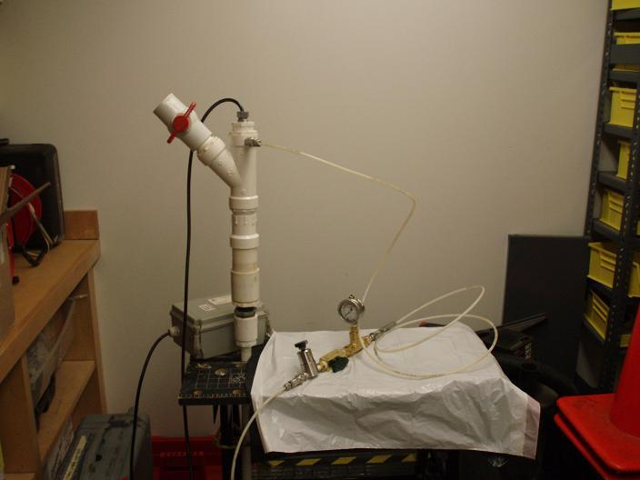

Figure 4. Pneumatic Slug Test Apparatus showing Well Head Manifold (left), Low Pressure Regulator Manifold (right), and Telog® data logger (behind Well Head Manifold).

  - Slug Test Procedure

With the pressure control screw on the tank regulator in the closed position, open the tank valve and verify tank pressure. Close the control valve on the Low Pressure Regulator. See Figure 5. On the tank regulator manifold, open the plug valve leading to the pneumatic slug test apparatus. Ensure the other plug valve on the tank regulator manifold is closed. These valves are open when the handle is aligned with the valve body and closed when perpendicular to it.

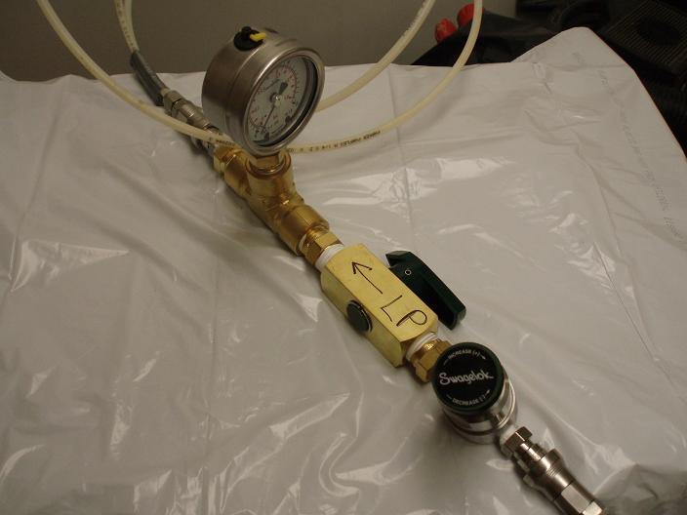

Figure 5. Low Pressure Regulator control, marked Swagelok®, is closed when turned fully counter-clockwise. Regulator has a maximum input pressure of 1000 psi and maximum output of 10 psi. Plug valve is open.

Open the tank regulator control valve by turning the T-handle screw slowly clockwise while observing the regulator LP gauge. The maximum pressure allowed on this gauge is 1000 psi as this is the maximum pressure allowed on the high pressure side of the low pressure regulator. As an added measure of safety in this application do not exceed 500 psi. When using the slug test apparatus with the inflatable packers do not exceed the maximum pressure used to inflate the packers.

To deliver the gas slug to the well and initiate the slug test perform the following steps:

- Ensure that the vent valve on the Well Head
Manifold is closed; valve handle perpendicular to
valve body. See Figure 4.

- Open the plug valve on the Low Pressure Regulator
Manifold. See Figure 5.

- Slowly open the Low Pressure Regulator control
(turn clockwise) while monitoring the pressure gauge on the Low Pressure Regulator Manifold. The increase in pressure corresponds to the drawdown in water level at the rate of 1 psi to 0.7 meters (2.3 feet). When the desired drawdown is reached close the plug valve and monitor the pressure gauge and the transducer head reading on the laptop to verify that the pressure and head remain constant and there are no leaks in the system. The pressure transducer reading should equilibrate to the pre-slug reading.

- Open the vent valve in one quick motion to release the gas slug and initiate the test. You will observe an initial sharp drop in the transducer readings. As the water level recovers the head on the transducer will increase. Monitor the head readings on the laptop (Appendix B) until the water level returns to the pre-test static level.

- After each test has been completed recover the test data from the Telog recorder and save to the laptop (see Appendix B). Telog recorders have a cycling memory system. Once the recorder memory is full the Telog unit will begin to write over the oldest values stored. If this data has not been retrieved and saved, it will be lost.

In formations with moderate to high hydraulic conductivity, these tests can be run in a matter of minutes. If time permits it is worthwhile to run several tests on each well or test interval. If multiple tests are conducted use different water level displacements by varying the pressure of the gas slug.

5.3 Data Reduction

The raw data from the data logger will have a pattern similar to that in Figure 6.

Figure 6. Hypothetical Pneumatic Slug Test exhibits the pattern of transducer head data during the various phases of the test.

A number of well known techniques are available for estimating hydraulic conductivity or transmissivity from the water level data recorded in the data logger. The analyst is referred to Kruseman and de Ridder(1990) and Butler(1998). These analytical methods may be added to the field laptop to facilitate real time estimates of K and T.

- DECONTAMINATION PROCEDURE

The only component in the slug test apparatus that comes in contact with the water in the well is the transducer and that portion on the cable that extends below the water. For decontamination purposes all of the cable in the well may be considered potentially contaminated. The standard decontamination procedures specified in MEDEP/DR SOP DR#017: Decontamination Procedures Protocol will be sufficient for monitoring wells, only. For drinking water wells the procedures in Appendix C must be followed.

- QUALITY ASSURANCE/QUALITY CONTROL

QA/QC is maintained by following the procedures in this SOP and those referenced. A formal QAPP developed in accordance with MEDEP/DR SOP DR#016: Requirements for the Development of a Site Specific Quality Assurance Project Plan should be considered in the context of the specific site investigation requirements.

  - Deviations from SOPs

All deviations from the procedures outlined in this or referenced SOPs must be documented in the field notes.

- DOCUMENTATION

Documentation is a vital aspect of any data collection event. Documentation should be completed with the idea that someone not present during the actual event may need to repeat the event exactly as it was conducted originally. To facilitate data collection specific to pneumatic slug testing, a log sheet is provided in Appendix D.

- HEALTH AND SAFETY

As part of the overall work plan at a hazardous substance site, a site specific health and safety plan (HASP) must be developed and adhered to by all personnel working at the site. Refer to MEDEP/DR SOP DR#014: Development of a Sampling and Analysis Plan, Attachment A.

All personnel must understand that if these tests cannot be performed safely, the test should not be conducted. If a test cannot be performed due to safety considerations it should be documented in the geologist’s field book.

All personnel should be aware of the potential dangers associated with this particular test method. These dangers include, but are not limited to, handling heavy objects and the use of high pressure gas containers. All necessary precautionary measures should be understood and practiced when performing this test method. Refer to Appendix A.

REFERENCES

Butler, J.J., et al. 2002. Hydraulic Tests with Direct-Push Equipment. GROUND WATER 40, no. 1: 25-36

Kruseman, G.P. and N.A. de Ridder. 1990. Analysis and Evaluation of Pumping Test Data. International Institute for Land Reclamation and Improvement.

Butler, J.J. 1998. The Design, Performance, and Analysis of Slug Tests. Lewis Publishers/CRC Press LLC.

Appendix A

Safety Precautions for the Use of
High Pressure Gas Equipment

High pressure gas (nitrogen), stored in compressed gas bottles, present unique safety hazards. It is vital that all personnel using compressed gas equipment understand and adhere to the following safety precautions.

- During movement and vehicular transportation of high pressure gas cylinders protect the valve from damage. A cylinder valve cover is provided and must be used whenever the tank is moved. DO NOT DROP THE CYLINDER. Ensure that the cylinder is secured against movement when loaded in a vehicle. At the site set up the gas cylinder where it can be tied to secure object. If possible shade the cylinder.

- When purging high pressure gas ensure that personnel are clear of the direction in which the gas is venting to avoid projectile or gas injection injury.

- When opening the tank valve after the tank regulator has been installed, ensure that the pressure control is closed (T-handle turned counter-clockwise until no resistance), stay clear of high pressure gauge, and crack open valve no more than a quarter turn. A defect in the gauge could cause the face of the gauge to burst resulting in a potential projectile or gas injection injury.

- Before disconnecting any gas line ensure that the pressure has been vented from the line. Gas venting may be accomplished by a variety of methods depending on the equipment configuration.

Appendix B

Instructions for the Operation of
Telogers for Windows Software

The software program Telogers for Windows is used to communicate with the Telog pressure transducer unit used in performing slug tests. The best way to do this is with a laptop connected directly to the Telog unit while the test is being executed.

Telogers for Windows: Obtaining ‘real time’ readings

- Open Telogers for Windows by either clicking the desktop icon or selecting the program through the Start menu.

- Telogers for Windows will open two windows. One is a Help window and the other is the program menu bar. You may close the Help window. You should now see the Telogers for Windows menu bar.

- Make sure that the Telog unit is connected to the computer with the proper Telog cable(s).

- Select Communicate from the menu bar. In the drop down menu select “With Local Recorder”. In the pop-up window select “Display Latest Readings” and Click the Start button.

- The Local Communications window will open and after a few seconds a value should be displayed with the associated units. If the Telog unit has been programmed correctly these units will be in feet of water above the transducer. This value will be updated as often as the attached Telog unit has been set to take readings.

- If Telogers for Windows is unable to communicate with the Telog unit an error message, “Unable to establish communications. Check your cables.”, will be displayed. Click the Ok button, check the cable connections and begin again at step #4. If Telogers is still unable to communicate with the Telog unit, the unit may have a dead battery or may not be functioning properly.

Recovering Test Data from the Telog Unit

- Assuming that the Telogers for Windows program is already running, select Communicate from the menu bar and select “With Local Recorder”. In the pop-up window select “Collect Data” and click Start.

- Telogers for Windows will display connection information in the Telogers for Windows menu bar. This information should include the serial number of the Telog unit. Once data transfer is complete the message displayed will be, “Ready. Current database path:…”. The data has now been added to the Telogers database on that computer. Go through this procedure after each test to ensure that data is not overwritten by the Telog unit and lost.

Viewing test data and saving to Excel

- The first icon in the menu bar is the database icon (yellow, white and red icon with Db). Click this icon to open the Database window.

- This window has two tabs, the “Data Set Properties” tab and the “Select Data to Analyze” tab. In the “Select Data to Analyze” tab scroll through the list of recorder serial numbers in the list on the left until you see the number of the Telog unit that you are working with. Click the recorder number to highlight it and click the “>” button to move it to the Selected list.

- Now select the “Data Set Properties” tab. You will see two calendars. Set the “Select Start Date” side to the date and time of the beginning of your test. Set the “Select Stop Date” side to the date and time of the end of your test, or click the “Set to most recent date available” box. Click the Ok button.

- A window will open displaying a time series plot of the data on the left and the raw values on the right.

- To export this data to an Excel file select File from the menu bar and select “Save data set as” from the dropdown menu. Give the file a name and a location and click the save button. The data set will be saved as a comma delimited (.CSV) file and can be opened directly in Excel.
Appendix C

Standard Operating Procedure for the Decontamination
of Telog® Pressure Loggers

Telog® pressure loggers consist of a data recorder and a pressure transducer connected by a length of cable. The pressure loggers are used to record pressure changes, which can be directly converted to water level changes, in a well over a period of time. Given that these recorders are often used in drinking water wells, they must be thoroughly decontaminated between usage to minimize the risk of well cross-contamination.

Decontamination of the Telog® pressure loggers should be performed in the DEP decontamination room.

To begin, the cable and pressure transducer should be thoroughly rinsed with tap water to remove any gross contamination, being careful not to get the recorder box/cylinder excessively wet. Using a damp paper towel, wipe off the outside of the recorder box/cylinder. Wash the cable and the pressure transducer in a tap water and Liqui-nox® detergent solution, scrubbing to remove any remaining gross contamination. Make sure to remove all bits of duct tape or electrical tape and the adhesive from the cable. Rinse with tap water and wipe the cable and transducer off with a clean, dry paper towel.

Wearing plastic gloves and safety glasses, add about an ounce of chlorine bleach to a five gallon bucket of tap water. Coil the cable and pressure transducer inside the bucket, submerging as much of the cable in the bleach solution as possible, without risking immersion of the recorder box/cylinder. Don’t get any of the solution on your clothing because it will bleach it. Allow the cable and transducer to soak in the bleach solution for several hours to ensure that it is biologically sterile. Remove the cable from the bleach solution and rinse. Dry the cable and transducer with paper towels and place in a clean, white garbage bag. Draw the ties tightly closed and tie off. Label the outside of the bag with the Telog® serial number (located on the outside of the recorder box/cylinder) and the transducer rating (e.g., No.21530, 10 psi). Store in the designated cabinet located in the equipment room.

Appendix D

Pneumatic Slug Test Data Log

