DEP FACT SHEET
Contact Information Peter Moulton or David McCaskill @
207-287-2651

Double-Walled Home Heating Oil Tanks

Replacing your old oil tank? Building a new house and going to heat with oil? You should be aware of a new law that may affect you.

As of July 1, 2009 all new and replacement home heating oil tanks within the wellhead protection zone of community drinking water wells must be double-walled or have secondary containment. Think this does not affect you? Read on. Community drinking water wells can be closer than you think.

What is the wellhead protection zone of a community drinking water well?
The wellhead protection zone of a community drinking water well is the greater of the:
• area within 1,000 feet of the well; or
• source water protection area of the well mapped by the Department of Health and Human Services as described under Title 30-A, section 2001, subsection 20-A.

The wellhead protection zone is the area around a well where pollution is most likely to reach drinking water. Protecting this area helps keep drinking water safe.

Community water systems serve at least 25 people living in the buildings served by the water system, (or has at least 15 “service connections” or “hook-ups”) at least 60 days a year. Community water systems include municipal water departments and districts, as well as mobile home parks, condominium associations and nursing homes that have their own water supply. There are more than 400 community water systems in Maine.

How do I find out if my building is within the wellhead protection zone of a community drinking water well?
Call your local water district and the Maine Drinking Water Program at 287-2070. Let them know what town you are in, where you are located, and the reason for your call. Once any nearby wellhead protection zones are identified, you will be able to contact the community water systems, discuss the exact locations of the wellhead protection zone, and determine whether or not you are in the wellhead protection zone.

What kinds of oil tanks protect my drinking water?

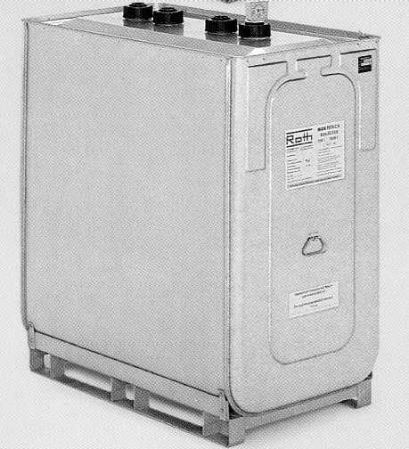 | Double-walled tank  - Polyethylene inner tank with a galvanized, sheet metal outer jacket  - Outer jacket is designed to hold contents if the inner tank leaks  - Space between the inner tank and outer jacket is monitored by a gauge
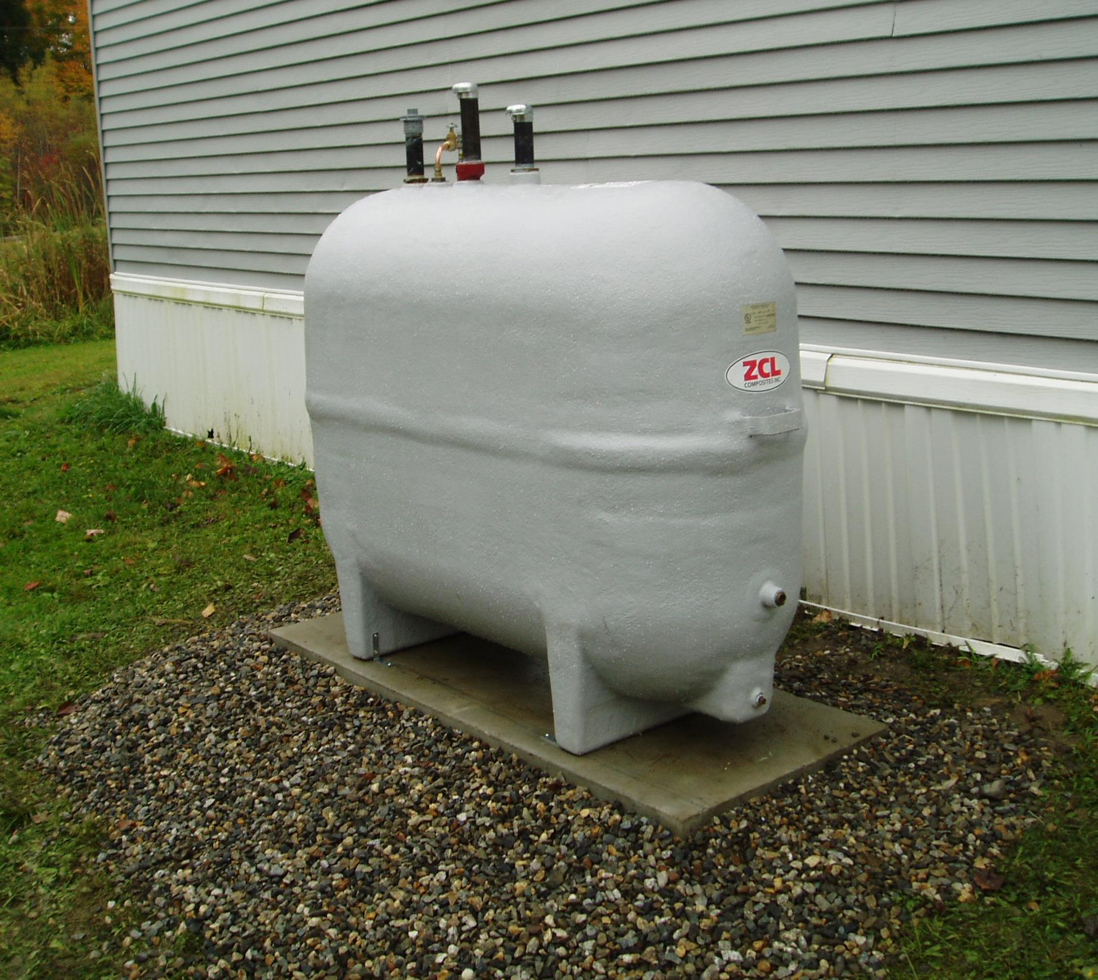 | Double-walled fiberglass reinforced tank  - Better for outside use  - “Sight glass” to monitor the space between the inside tank and outside tank
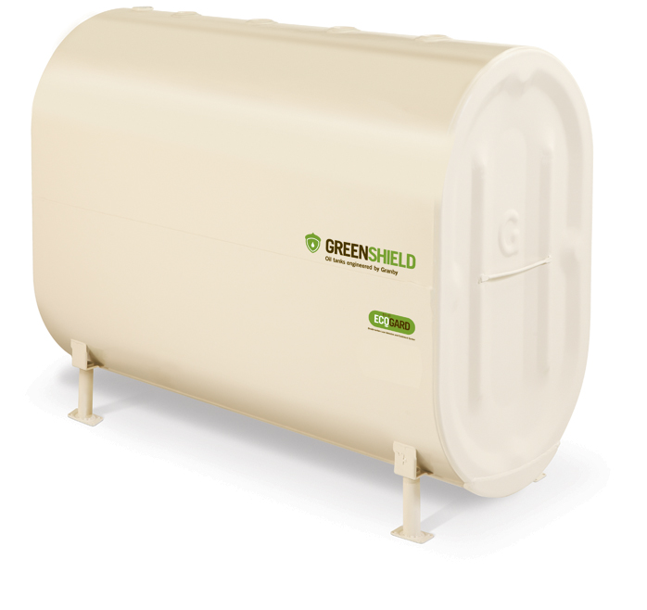 | Steel double bottom tanks  - Look like traditional 275 gallon home heating oil tank  - Has two layers of steel separated by a small space along the portion of the tank between the legs  - Space between the double steel bottoms is monitored with a float device mechanism for visual inspection.
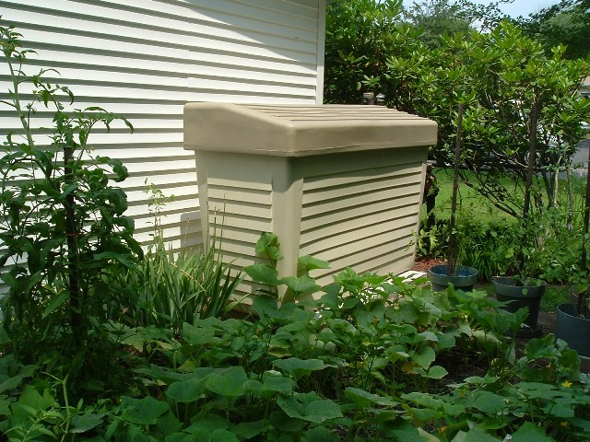 | Secondary containment  - Large polyethylene container that encloses a standard steel single wall 275 or 330 gallon home heating oil tank  - Catches leaks and protects the tank from the weather  - Underwriters Laboratories (UL) standard 2258

Contact your local oil delivery company or your local licensed heating technician for more information.

What else do I need to know?

Do oil tanks have to be “listed?”
Yes. Any double-walled tank or secondary containment installed in the wellhead protection zone of a community drinking water well must be “listed” (tested) by a nationally recognized, independent testing laboratory, such as Underwriters Laboratories (UL).

Can anybody install these tanks?
No. Home heating oil tanks installed in the wellhead protection zone of a community drinking water well must be the installed by a journeyman or master oil burner technician licensed by the Oil and Solid Fuel Board or - if the tank is an outside tank serving manufactured housing - by a mobile home mechanic licensed by the Oil and Solid Fuel Board.

Why are double-walled and secondary containment home heating oil tanks necessary?
The Maine Department of Environmental Protection (DEP) responds, on average, to more than 1 spill a day from home heating oil tanks, and that is just at single family residences! Such spills contaminate homeowner and neighboring wells, pollute the air in your home, and often cause considerable damage to the house.

Corrosion is the single largest cause of leaks from home heating oil tanks. Double-walled tanks and secondary containment vessels will help to minimize the number of spills from oil tanks by preventing corrosion and capturing oil released from the inner tank should a leak occur..

To help prevent these spills and to protect public drinking water supplies, Maine’s legislature enacted 38 MRSA § 1391 et seq. “An Act to Prevent Contamination of Drinking Water Supplies”. This law was approved by the Governor on April 7, 2008.

Who do I call for more information?
For answers to general questions, contact Peter Moulton or David McCaskill at the Department’s Bureau of Remediation and Waste Management at (207) 287-2651.
To help determine whether or not an oil technician is licensed by the State of Maine Oil and Solid Fuel Board look at the website http://pfr.informe.org/almsonline/almsquery/welcome.aspx
For help in locating public drinking water supplies look at the website http://www.maine.gov/dep/gis/datamaps/index.htm#dwp. Note that you will have to register with the State of Maine Drinking Water Program before you can view the maps. For assistance using these web based maps, call Beth Pratte at the Maine Drinking Water Program (207-287-2070) or Christian Halsted at Maine DEP (207-287-8754).

