
Description of Chapter 579: Classification Attainment Evaluation Using Biological Criteria for Fresh Surface Waters
March 1, 2026

MAINE DEPARTMENT OF ENVIRONMENTAL PROTECTION
17 State House Station | Augusta, Maine 04333-0017
www.maine.gov/dep

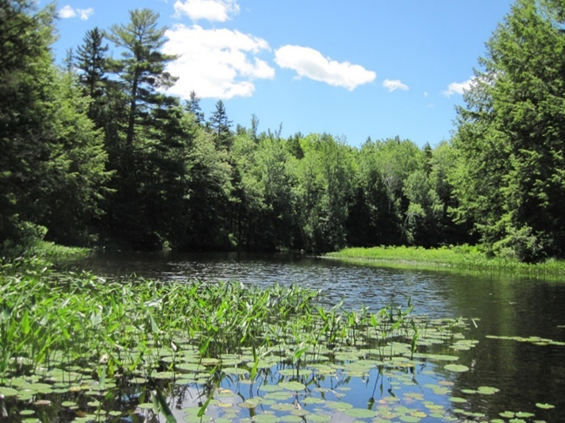
Hopkins Stream, Mt. Vernon, Maine



Maine Department of Environmental Protection
17 State House Station
Augusta, ME 04333-0017
http://www.maine.gov/dep/index.shtml
207-287-7688 or 1-800-452-1942 toll free

Authors and Grant Managers
Jeanne DiFranco and Beth Connors

Biological Criteria Team
Tom Danielson, Leon Tsomides, Susan Davies,
David Courtemanch, Cynthia Loftin, Francis Drummond,
Susanne Meidel, Doug Suitor, Adam Pepi, Wendy Garland,
Matt Hight, Meagan Sims and Brian Kavanah

Funding Acknowledgement
Substantial funding for data collection, sample processing, taxonomic analysis, and staff support related to development of biological criteria came from U.S. Environmental Protection Agency (USEPA) grants under Clean Water Act Section 104(b)(3) (Wetland Program Development Grants) and Section 106 Monitoring Initiative funds.

Table of Contents

Table of Contents 3

1. Introduction 5

1.1. Background and Purpose of the Proposed Rule 5

1.2. Federal Framework and Maine’s Water Quality Standards 6

1.3. Advantages of Biological Monitoring 6

1.4. Biological Response Indicators 7

1.5. Water Quality Standards and Tiered Aquatic Life Criteria 9

1.6. Maine’s Tiered Criteria and EPA’s Biological Condition Gradient Framework 10

2. Sampling Methods 12

2.1. Targeted habitat sampling approach 12

2.2 Sampling benthic macroinvertebrates in eroded, mineral-bottom streams and rivers 13

2.3. Sampling benthic macroinvertebrates in soft-bottom streams, marshes and shallow lakes and ponds 13

2.4. Sampling epilithic algae in eroded, mineral-bottom stream reaches 14

2.5. Sampling epiphytic algae in soft-bottom streams, marshes and shallow lakes and ponds 14

2.6. Accompanying data 15

2.7. Sampling across a disturbance gradient 16

3. Data Analysis 16

3.1. Reference Site Selection and Ordination 16

3.1.1. Reference site criteria 16

3.1.2. Reference Site Ordination 17

3.2. Calculating Taxa Optima, Tolerance Values and Maine Tolerance Indices 21

3.2. Evaluating Biological Attributes as Candidate Metrics 25

4. Predictive Model Development 26

4.1. Discriminant Analysis 26

4.2. A Priori Classification of Biological Samples 26

4.3. Model Building 28

5. Class Attainment Determinations 34

5.1. Data requirements 35

5.2. Model interpretation 35

5.3. Use of professional judgment 39

5.3.1. Sampling procedures and minimum provisions conform but other confounding factors exist 39

5.3.2. Minimum provisions for model are not met 39

5.3.3 Standard sampling procedures are not feasible or appropriate 40

6. Potential for listing new impaired waters and potential impacts to permits and licenses 40

Literature Cited 43

Appendix 1. LDM Metric Response Plots Updated with All Available Data. 47

Appendix 2. Maine Tolerance Values for Macroinvertebrates in Soft-Bottom Habitats 51

Appendix 3. Maine Tolerance Values for Epilithic Algae in Mineral-Bottom Streams 56

Appendix 4. Maine Tolerance Values for Ephiphytic Algae in Soft-Bottom Habitats 67

Appendix 5. Pearson Correlation Matrices for Linear Discriminant Model Metrics 74

Appendix 6. Statistical transformations and coefficients for final linear discriminant model metrics 75

Appendix 7. Sample Aquatic Life Report for Macroinvertebrates in Soft-Bottom Habitats 78

Appendix 8. Sample Aquatic Life Report for Epilithic Algae in Eroded Mineral-Bottom Streams 67

Appendix 9. Sample Aquatic Life Report for Epiphytic Algae in Soft-Bottom Habitats 78

1. Introduction

1.1. Background and Purpose of the Proposed Rule

The Maine Department of Environmental Protection (Department) adopted Chapter 579 (Classification Attainment Evaluation Using Biological Criteria for Rivers and Streams) in 2003. The existing rule defines biological criteria to quantify narrative aquatic life standards provided in Maine’s Water Classification Program statute (38 M.R.S. §§464-470(H)) for eroded, mineral-bottom streams and rivers based on the benthic macroinvertebrate community. The 2003 rule includes numeric criteria and statistical models to determine if biological criteria for Class AA, A, B and C waters are met, and includes related definitions, assessment methods and implementation provisions. No changes to existing criteria are proposed or planned at this time. The history, technical methods, data analysis, management applications and case studies related to existing numeric biological criteria for eroded, mineral-bottom streams and rivers are described in detail in Biological Water Quality Standards to Achieve Biological Condition Goals in Maine Rivers and Streams: Science and Policy (Davies, et al., 2016), which serves as a companion document to the technical summary of the proposed additional biological criteria described below.

The proposed new criteria are described in Chapter 579 Classification Attainment Evaluation Using Biological Criteria for Fresh Surface Waters. The revised rule will incorporate existing criteria and models for eroded, mineral-bottom streams and rivers, along with the addition of numeric criteria and statistical models for the following waterbody and biological community types that are the focus of this technical document:

- Benthic macroinvertebrate communities in soft-bottom streams, marshes and shallow lakes and ponds,

- Epilithic algal communities (algae growing on hard surfaces such as rocks and logs) in eroded, mineral-bottom streams and rivers,

- Epiphytic algal communities (algae growing on aquatic plant stems) in soft-bottom streams, marshes and shallow lakes and ponds.

The proposed additional biological criteria will enable Department staff to assess a greater diversity of waterbodies, document their level of ecological health, and determine if state water quality standards are attained. Assessing more than one type of biological community (i.e., macroinvertebrates and algae) will also enhance our ability to identify different environmental stressors (toxic substances, nutrient enrichment, altered habitat, etc.) that may be causing harm to aquatic organisms. Understanding the causes and sources of biological impairment helps target management strategies to protect and improve water quality for the future.

1.2. Federal Framework and Maine’s Water Quality Standards

The Federal Water Pollution Control Act, 33 U.S.C. § 1251 et seq. or Clean Water Act (CWA) includes the objective to “restore and maintain the chemical, physical, and biological integrity of the Nation’s waters”. Under the CWA, states are required to develop monitoring and assessment programs and adopt water quality standards for waters of the United States that fall within their boundaries, and to report to the U.S. Environmental Protection Agency (EPA) every two years on the condition of their waters in relation to state water quality standards. Monitoring and assessment results for Maine are reported biannually in the Integrated Water Quality Monitoring and Assessment Report or "Integrated Report".

State water quality standards are described in Maine’s Water Classification Program statute (38 M.R.S. §464), which mirrors the objective of the CWA:

“The Legislature declares that it is the State's objective to restore and maintain the chemical, physical and biological integrity of the State's waters and to preserve certain pristine state waters.”

The Maine Department of Environmental Protection’s Biological Monitoring Program (BMP) focuses on monitoring and assessment to evaluate the biological integrity of the state’s waters. The following is a commonly accepted definition of biological integrity:

“The ability of an aquatic ecosystem to support and maintain a balanced, adaptive community of organisms having a species composition, diversity, and functional organization comparable to that of natural habitats within a region.” (Karr and Dudley, 1981).

1.3. Advantages of Biological Monitoring

Aquatic ecosystems encompass numerous physical, chemical and biological components with complex interactions occurring among the different parts. Physical and chemical measures such as temperature, dissolved oxygen, pH, conductivity and contaminant concentrations help predict if water quality is suitable for fish, invertebrates and other aquatic life, and may aid in identifying and locating sources of pollution. These measures only tell part of the story of ecosystem health however, since they do not directly measure biological responses to stressors such as urban runoff, toxic spills, nutrient enrichment, excessive sedimentation, habitat damage, invasive species and altered flow regimes. In addition, physical and chemical measurements often represent only a snapshot in time. For example, dissolved oxygen levels, pH, and other water chemistry may vary significantly within a 24-hour period, weekly, or seasonally depending on the time of day, weather and precipitation events, frequency of discharges, and water flow patterns.

Biological monitoring directly measures the condition of aquatic life by evaluating one or more taxonomic assemblages (macroinvertebrates, algae, plants, fish, etc.) to detect potential adverse changes in community structure and function compared with conditions expected in natural, healthy waterbodies. Aquatic organisms integrate the cumulative influences of all chemical, physical and biological stressors during the portion of their life cycle spent in the water, which may be multiple years. The numbers and types of organisms found in a waterbody therefore reflect the conditions under which they have been living for an extended period of time. Community structure changes in measurable and predictable ways, including reduced taxa richness and diversity, loss of pollution-sensitive taxa, and over-abundance of tolerant organisms, due to stressors caused by human activities. Biological assessments combined with supporting chemical and physical data greatly improve our ability to detect ecological impairment, identify and diagnose stressors, and determine the best management actions to protect and restore biological integrity (Courtemanch, 1995; Courtemanch et al., 1989; Karr, 1991; Karr and Chu, 1999; USEPA, 2002; USEPA, 2011).

Biological monitoring data have been used successfully by the department for many years to inform a variety of regulatory and management activities (Long Creek Watershed Management District, 2024; MDEP, 2023-2024; Danielson et al., 2016):

- Ambient water quality monitoring and trend analysis;
- Identifying pollution sources to target and improve management responses;
- Identifying high quality waters for additional protection (MDEP, 2024);
- Permit and license reviews for waste discharges, stormwater, dams and hydropower projects, and proposed wetland and stream alterations;
- Developing and refining watershed management plans (FB Environmental Associates, 2025);
- Evaluating the success of wetland compensatory mitigation projects (DiFranco et al., 2013; MDEP, 2023) and other restoration work (EPA approved TMDLs) such as:
  - installation of non-point source pollution control measures
  - salmon habitat improvement projects (MDEP Salmon Habitat Monitoring Program)
  - dam removals
  - toxic spill and historic contamination remediation efforts
  - stream channel and floodplain restoration projects.

1.4. Biological Response Indicators

The BMP evaluates the health of rivers, streams and freshwater wetlands based on the types and numbers of benthic macroinvertebrates and algae residing in these waters.

Benthic macroinvertebrates are aquatic insects and other animals without a backbone, such as snails, clams and worms, that can be seen without magnification and live on the bottom of virtually all waterbodies. Although some spend their entire lives in the water, many mature into terrestrial insects that are familiar to most people, for example mayflies and dragonflies. Macroinvertebrates are an important component of aquatic ecosystems, and serve as food for fish, waterfowl and other animals. They have a wide range of tolerance to human stressors, are relatively long-lived and tend to remain in the same vicinity of a waterbody during their aquatic life stages. These characteristics make them excellent indicators of environmental condition, and many state and tribal environmental agencies include macroinvertebrates in their bioassessment programs.

Algae are a diverse group of organisms that obtain energy from sunlight through the process of photosynthesis. Algae can be found in either macroscopic forms that are visible to the naked eye, or in microscopic forms that live free-floating in the water column and on rocks, wood, and aquatic plants. Algae are important in energy and nutrient cycling and provide food for other aquatic life. There are many different types of algae, and they exhibit predictable responses to a wide range of stressors including excess nutrients, organic pollution, road salt and other toxics, changes in pH and sedimentation. Since algae tend to grow and disperse quickly, they often serve as early indicators of changes in ecosystem health. Diatoms are a group of algae that have a glass-like cell wall made of silica which enables them to persist over time, so they may even be sampled during dry conditions for certain studies and have been used by scientists to determine historic conditions in lakes and wetlands.

Why sample both macroinvertebrates and algae?

There are many benefits of sampling more than one biological assemblage. Different groups of organisms vary in their sensitivity and responses to specific environmental stressors, and sampling both macroinvertebrates and algae improves our ability to detect problems in the health of biological communities and accurately diagnose causes and sources of impairment. For example, algal communities often respond more quickly to increasing nutrient concentrations than macroinvertebrates. Sampling two or more taxa assemblages also provides complementary data to verify the biological condition of a waterbody in cases where results of one of the groups are ambiguous. Macroinvertebrates, for instance, sometimes naturally occur in very low numbers in high quality streams with low organic matter and nutrient concentrations, making it difficult to interpret monitoring results. In this situation, evaluating the condition of the algal community can help support the decision-making process to determine if the waterbody is in good condition and meets water quality criteria for aquatic life.

1.5. Water Quality Standards and Tiered Aquatic Life Criteria

Maine’s Water Classification Program statute describes state water quality standards, which include three parts.

- “Designated Uses” or management goals that vary depending on the water body type and local conditions such as land use characteristics and licensed discharges present. Examples of designated uses include drinking water, fishing, agriculture, recreation in and on the water, industrial uses, hydroelectric power generation, navigation, and habitat for fish and other aquatic life.

- Standards and criteria that protect designated uses. These include chemical, physical and biological criteria that may be numeric (e.g., quantitative thresholds for bacteria and dissolved oxygen) or narrative (e.g., the habitat of certain high-quality rivers and streams “must be characterized as free-flowing and natural”).

- Maine’s Antidegradation Policy (38 M.R.S. §464.4.F.4), which protects existing uses and high-quality waters, including Outstanding National Resource Waters such as waterbodies occurring within state and national parks and public reserve lands.

Figure 1. Statutory water quality class assignments for riverine fresh surface waters (2022 data)

All waters of the State are assigned a water quality class and associated standards and criteria by the Maine legislature that reflect the management goals for those waters (Figure 1). Classes for riverine fresh surface waters include AA, A, B and C, with Class AA and A having the highest standards for water quality protection. Although standards for Class B and C allow some changes in water quality to enable designated uses of those waters, standards for all classes must meet minimum standards defined in the CWA. The following is a summary of narrative tiered habitat and aquatic life criteria for fresh surface waters not classified as great ponds (38 M.R.S. §465, Standards for classification of fresh surface waters):
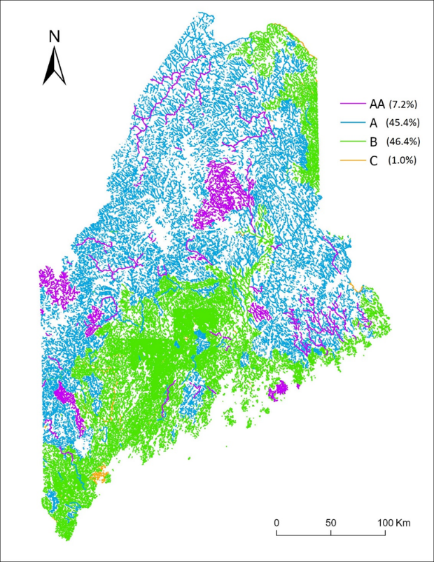

Class AA Habitat for aquatic life must be characterized as free flowing (no dams allowed) and natural. Aquatic life must be as naturally occurs.

Class A Habitat for aquatic life must be characterized as natural. Aquatic life must be as naturally occurs.

Class B Habitat for aquatic life must be characterized as unimpaired. Must support all indigenous aquatic species without detrimental changes in the resident biological community.

Class C Must be suitable as habitat for fish and other aquatic life. Some changes to aquatic life are allowed but must support all indigenous fish species and maintain the structure and function of the resident biological community.

What are the advantages of tiered criteria?

Maine’s tiered criteria approach has many advantages over single pass/fail thresholds used in some other states. Tiered criteria enable the Department to identify and protect the highest quality aquatic resources, detect incremental changes in the health of biological communities (improving or declining), set realistic, attainable management goals, and trigger early corrective actions if conditions begin to worsen. Moreover, the state’s antidegradation policy enables waterbodies that consistently meet criteria for a higher water quality class to be upgraded by the Maine legislature so that improvements are maintained over time (see 38 M.R.S. § 464(4)(F)(4)). Since the enactment of the CWA over 50 years ago, water quality and ecological integrity of aquatic resources in Maine have steadily improved, and statutory class assignments and associated management goals have reflected those positive changes (Courtemanch et al., 2023; Schaffner et al., 2019). Maine’s water classification history and a spatial analysis of changes over time are summarized in a story map titled Maine: 50 Years of Water Quality Restoration and Protection.

1.6. Maine’s Tiered Criteria and EPA’s Biological Condition Gradient Framework

In the past, BMP staff relied on “best professional judgement” to interpret biological monitoring results and determine if narrative aquatic life criteria were met. The adoption of numeric biological criteria for mineral-bottom streams and rivers in 2003 allowed for a standard, transparent process to interpret narrative criteria and provide other programs with clear and consistent information about waterbody condition, impacts to aquatic life and causes of impairment.

The additional numeric criteria and statistical models proposed for inclusion in Chapter 579 rules were developed following a similar process and importantly, were calibrated to align with waterbody condition characteristics described in Maine’s statutory narrative biological criteria. Each model was developed specifically for the type of waterbody and taxonomic group sampled. BMP staff carefully examined the attributes of minimally-disturbed reference communities for macroinvertebrates and algae from different habitats to gain an understanding of what is typically natural for each habitat. Biological monitoring data were also collected to encompass a gradient of human disturbance, from high quality reference sites to highly disturbed sites, to document expected community changes in response to increasing levels of anthropogenic stress. Water quality class attainment results may therefore be compared among different biological assemblages (macroinvertebrates and algae) and waterbody types (soft-bottom vs. mineral-bottom streams, etc.). For example, a model result of Class A for either a high gradient mineral-bottom stream or a slow moving soft-bottom stream indicates that aquatic life conforms with the characteristics of a community which is considered “as naturally occurs” based on the expected community in reference sites for each waterbody type.

In addition to narrative criteria, the BMP used EPA’s Biological Condition Gradient (BCG) framework to inform development of numeric biological criteria. The BCG is a descriptive model developed by EPA to interpret changes in aquatic ecosystem health across a range of human disturbance. The BCG describes how 10 ecological attributes change in response to increasing levels of environmental stressors. It encompasses taxonomic composition and tolerance, non-native taxa, organism condition, ecosystem functions, scale dependent factors, spatial/temporal extent of impacts and ecosystem connectance. The BCG is divided into six condition tiers, ranging from “natural” (undisturbed) to severely altered conditions (Davies and Jackson, 2006; USEPA, 2016).

The BCG framework can be applied on a regional or national basis independent of the types of monitoring and assessment methods used by various states and tribes as it provides a common scale for describing biological condition. The model is also useful to clearly and simply communicate information about the condition of aquatic resources and restoration potential. Figure 2 below depicts the six BCG tiers in relation to Maine’s tiered aquatic life use criteria.

Figure 2. Biological condition gradient descriptions and crosswalk with Maine tiered aquatic life classes

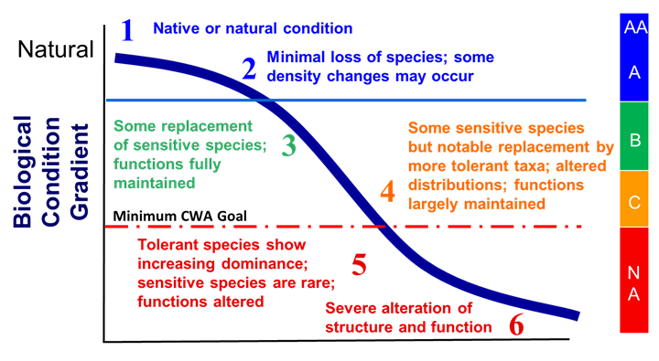

2. Sampling Methods

2.1. Targeted Habitat Sampling Approach

The BMP uses a targeted habitat sampling approach including standard required methods appropriate for different water body types and biological assemblages. Within established protocols for target habitat type, specific sampling sites are selected based on characteristics that are representative of the stream reach or lentic waterbody to be sampled, including substrate composition, water depth, vegetation present, etc. Typically, three replicate samples are collected to account for spatial variability and improve sampling precision (Karr and Chu, 1997). Sampling methods are designed to maximize standardization of data collection to provide consistent, scientifically and legally defensible assessments of biological condition in relation to tiered aquatic life criteria. Biological condition results for all methods are expressed in terms of water quality class attainment (AA/A, B, C or non-attainment (NA) of criteria for any class) and are therefore comparable across water body types and taxonomic assemblages. All sampling methods are detailed in Standard Operating Procedures (SOPs) that are part of the program’s Quality Assurance Project Plan (QAPP) approved by EPA (MDEP, 2019). The standard sampling methods that are required for the data used in the Department’s linear discriminant models (LDMs) are summarized in Table 1, described briefly below, and are available on the Biological Monitoring Program web pages. https://www.maine.gov/dep/water/monitoring/biomonitoring/material.html

Table 1. Standard sampling methods required for use of biological monitoring data in Department linear discriminant models (LDMs).
Waterbody Type | Biological Assemblage | Target Habitat | Sampling Method
Eroded, mineral-bottom streams and rivers | Aquatic macroinvertebrates | Riffles, runs, pools | Artificial substrate samplers consisting of rock bags, baskets or cones (Davies and Tsomides, 2014)
Soft-bottom streams, marshes and shallow lakes and ponds | Aquatic macroinvertebrates | Shallow areas having aquatic vegetation beds | Standardized D-net sweeps (DiFranco, 2019)
Eroded, mineral-bottom streams and rivers | Epilithic algae | Stream reaches having a rocky bottom or containing submerged large woody debris | Rock or log scrapings (Danielson, 2019a)
Soft-bottom streams, marshes and shallow lakes and ponds | Epiphytic algae | Shallow areas having aquatic vegetation beds | Plant stem rubbings (Danielson, 2019a)

2.2 Sampling Benthic Macroinvertebrates in Eroded, Mineral-bottom Streams and Rivers

Aquatic macroinvertebrates within eroded mineral-bottom streams have been sampled in Maine according to a standard methodology since 1987. Artificial substrate samplers (rock bags, baskets or cones) are used to collect organisms from riffles, runs, or pools. Samplers are deployed on the stream bottom and left for 28 days, +/- 4 days, to allow organisms to colonize. Upon retrieval, rocks and other material collected from the samplers (detritus, leaves, sand, etc.) are placed into a 600 μm screen sieve bucket. Rocks and the samplers are rinsed into the bucket and inspected, and all organisms found are removed by hand. Organisms and all other material collected are placed into jars and preserved with ethyl alcohol. The macroinvertebrates are sorted from extraneous material in the laboratory and sent to external professional taxonomists for identification. Macroinvertebrates are identified to genus or lower by qualified taxonomists, or the lowest possible taxonomic level if it is not possible to identify to genus.

2.3. Sampling Benthic Macroinvertebrates in Soft-bottom Streams, Marshes and Shallow Lakes and Ponds

Aquatic macroinvertebrates within soft-bottom streams, marshes and shallow lakes and ponds have been sampled in Maine according to a standard methodology since 2002. The standardized D-net sweep method targets benthic macroinvertebrates in shallow areas having aquatic vegetation. A 500 - 600 μm D-frame net is swept through the water column for a distance of one meter. The net is gently bumped against the bottom substrate three times (at the beginning, the middle, and the end of the one-meter sweep) to dislodge and collect organisms from the sediment. Organisms and other material (detritus, leaves, etc.) are sieved through a 600 μm screen, collected into jars and preserved with ethyl alcohol. The macroinvertebrates are sorted from extraneous material in the laboratory and sent to external professional taxonomists for identification. Macroinvertebrates are identified to genus or lower by qualified taxonomists, or the lowest possible taxonomic level if it is not possible to identify to genus.

2.4. Sampling Epilithic Algae in Eroded, Mineral-bottom Stream Reaches

Epilithic algae in rivers and streams have been sampled in Maine according to a standard methodology since 1999. The rock or log scraping method targets epilithic algae found in stream reaches having a rocky bottom or containing submerged large woody debris within eroded, mineral-bottom streams and rivers. At each site, three transects are established and six rocks (cobble or small boulder) or pieces of submerged large woody debris are collected per transect for a total of 18 per site. Algae are removed with a stiff-bristled brush from a 2.54- cm-diameter circle on the top of each rock/log. The algae removed from the 18 rocks/logs are composited into a single sample representing the stream reach, preserved and stored in an opaque bottle. The sample is sent to an external taxonomist to be identified and enumerated. Diatoms and soft algae are identified to the lowest practical taxonomic level. Most diatoms are identified to the species level, and most soft algae are identified to species or genus level.

2.5. Sampling Epiphytic Algae in Soft-bottom Streams, Marshes and Shallow Lakes and Ponds

Epiphytic algae within soft-bottom streams, marshes and shallow lakes and ponds have been sampled in Maine according to a standard methodology since 2002. The plant stem rubbing method targets epiphytic algae found in shallow areas having aquatic vegetation beds. Submerged plant stems are clipped and placed into a whirlpak bag, discarding parts that were above the water. The algae is removed by adding water and massaging each stem inside the whirlpak bag. Each stem is rinsed off into the bag and set aside for measuring to obtain dimensions needed to calculate the surface area. The contents of the bag are measured in a graduated beaker and brought to a known volume with tap water. The sample is transferred to an opaque bottle and preserved. The sample is sent to an external taxonomist to be identified and enumerated. Diatoms and soft algae are identified to the lowest practical taxonomic level. Most diatoms are identified to species, and most soft algae are identified to species or genus.

2.6. Accompanying Data

In addition to sampling the macroinvertebrate and/or algal community at each monitoring station (site), the following information is also collected. Specific items collected depend on the habitat being sampled.
- Potential stressors and the station’s location relative to those stressors, land use, upstream terrain, canopy cover, terrain, dominant vegetation, and the physical characteristics of the stream substrate.
- An evaluation of the human disturbances in the wetland and the immediate watershed using DEP’s Wetland Human Disturbance Assessment (WHDA, Connors and DiFranco, 2019).
- Instantaneous dissolved oxygen, specific conductance, temperature, pH, and flow velocity (eroded, mineral-bottom stream sites only) are measured at each site visit using field meters (Connors, 2019a; Danielson, 2019b).
- Stream width (bankfull and wetted, eroded, mineral-bottom stream sites only) and depth are measured using meter sticks, meter tapes, or range finders.
- Representative digital photographs are taken of the waterbody to obtain a visual record of sampling sites.
- Longitude and latitude of the sampling site are recorded using a GPS unit.
- Water samples are collected for chemical analysis of all or a subset of the following, as deemed appropriate and as resources allow: total Kjeldahl nitrogen (TKN), nitrate plus nitrite-N (NO₃+NO₂-N), total phosphorus (TP), ortho-phosphate-P (OPO4-P), ammonia-N (NH₃-N), dissolved organic carbon (DOC), total suspended solids (TSS), total dissolved solids (TDS), chlorophyll a, chloride, alkalinity (as CaCO₃) and true color (Connors, 2019b).

2.7. Sampling Across a Disturbance Gradient

Samples used to develop each predictive model came from sites that encompass the full gradient of human disturbance including reference (“minimally-disturbed”) sites (Stoddard et al., 2006) and severely degraded waters. Sites also represented conditions found across Maine. Sampling locations spanned Level-III ecoregions (Omernik, 1987; Griffith et al., 2009) in the Acadian Plains and Hills, Northeastern Highlands, and Northeastern Coastal Zone (Figure 3). The Acadian Plains and Hills cover the eastern 53% of the state, the Northeastern Highlands cover the western 43% of the state, and the Northeastern Coastal Zone covers the southern 4% of Maine. The disturbance gradient was defined using abiotic parameters (see 3.1.1, Reference Site Criteria below).
Figure 3. U.S. EPA Level III Ecoregions in Maine (Omernik, 1987)
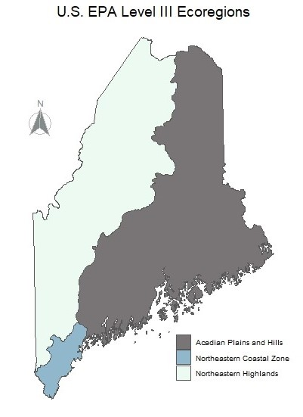

3. Data Analysis

3.1. Reference Site Selection and Ordination

3.1.1. Reference Site Criteria
Reference sites for all analyses were selected based on a “minimally-disturbed” condition standard (Stoddard, et al., 2006, Reynoldson et al.,1997). For macroinvertebrates and epiphytic algae collected from soft-bottom streams and marshes, the following reference site criteria were used:

- Upstream watershed land use 95% or greater natural, consisting of either forest or wetland based on spatial analysis;
- DEP Wetland Human Disturbance Assessment (WHDA) score less than or equal to 10 (highest possible score is 125) with no sub-category of disturbance greater than a score of 5;
- Specific conductance measured in-situ less than 100 uS/cm (most values were less than 50 uS/cm);
- Reference sites were also screened for pollution sources or atypical habitat characteristics that might warrant exclusion from the reference set.

For epilithic algae collected from eroded, mineral-bottom streams, the following criteria were used to select reference sites:
- Upstream watershed land use 95% or greater natural, consisting of either forest or wetland;
- No upstream dams;
- No significant discharges such as wastewater treatment plants or isolated sources of pollution present.

3.1.2. Reference Site Ordination
Macroinvertebrates samples from soft-bottom streams and marshes
Ordination of macroinvertebrate data from 51 reference sites was performed to identify any natural patterns in species composition among ecoregions and waterbody types sampled (lacustrine or riverine). BMP staff used non-metric multidimensional scaling (NMDS) and multi-response permutation (MRPP) in PC-ORD 5.0. to analyze macroinvertebrate relative abundance data. An arcsine square root transformation was used to down-weight the influence of ubiquitous taxa, especially amphipods in the genus Hyallela, that occur in high numbers in some samples and may obscure patterns in the data. Ubiquitous taxa were not excluded because they are an important component of community structure and their relative abundance varies depending on other ecological attributes present at a given site.
Figure 4. Reference site ordination. NMDS results for macroinvertebrates in soft-bottom habitats by waterbody type (lacustrine or riverine) indicate no apparent patterns in community composition.
Taxa occurring in less than 5% of reference sites were considered rare and excluded. Three axes were examined, however Axis 1 and 2 showed the majority of the variability. Results indicated no significant patterns in macroinvertebrate community composition due either to or waterbody type (Figure 4) or ecoregions. Based on these analyses, staff concluded that separate statistical models and biocriteria are not necessary for different geographic areas of the state, or for wetlands associated with lakes and ponds vs. rivers and streams. Further evidence to support this decision is discussed in Davies et al., 2016 in which analyses of macroinvertebrate communities in mineral-bottom streams demonstrated that a stratified modeling approach was not needed based on either geographic location or stream order. Figures 5 and 6 show class attainment response plots of final model metrics by waterbody type and ecoregions.
Figure 5. LDM metric response for macroinvertebrates in soft-bottom habitats (comparison by waterbody type). N = 201 for original data set analyzed. Updated metric response plots based on all currently available data are shown in Appendix 1.

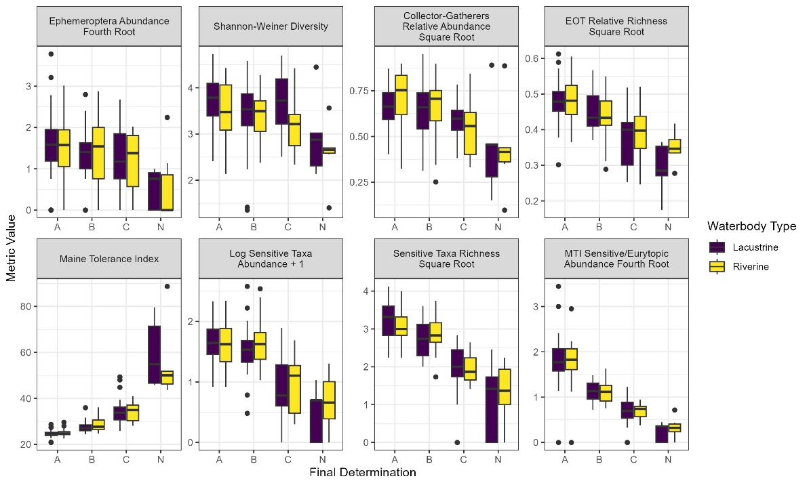
Figure 6. LDM metric responses for macroinvertebrates in soft-bottom habitats (comparison by ecoregions). N = 201 for original data set analyzed. Updated metric response plots based on all currently available data are shown in Appendix 1.
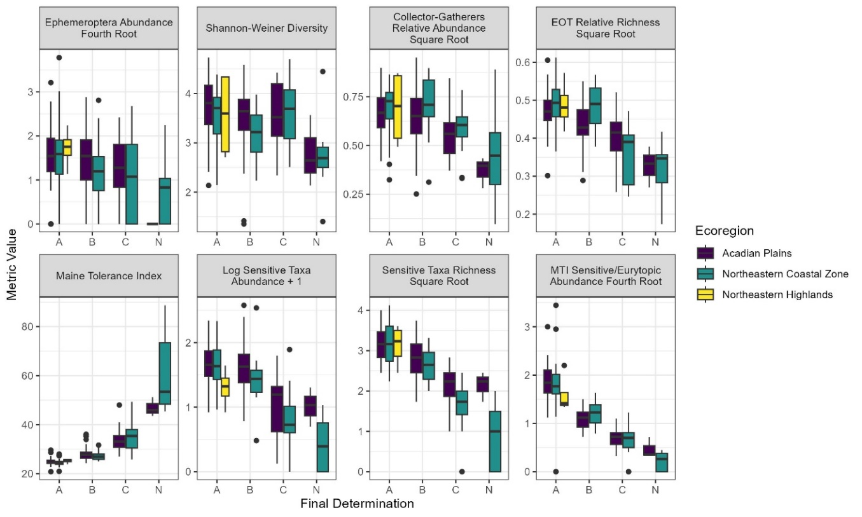

Epilithic algae samples from eroded mineral-bottom streams and rivers
Potential ecoregion effects on species composition were analyzed based on 42 reference sites using PC-ORD 5.0. A square root transformation of relative abundance data was applied to reduce the influence of ubiquitous taxa including Achnanthidium minutissimum and Gomphonema parvulum. Taxa occurring in less than 5% of reference sites were considered rare and excluded. No sites sampled in the Northeastern Coastal Zone ecoregion (southern 4% of the state) met reference criteria due to widespread development and agriculture. Major patterns in species were identified using NMDS plots, and potential significant differences in species composition due to ecoregion were examined using multi-response permutation procedures (MRPP). Results indicated that patterns in species composition were not strongly related to ecoregions. Although differences in species composition between the Northeastern Highlands and Acadian Plains and Hills were statistically significant, the size effect was very small. BMP staff concluded that the ecological importance of these differences is questionable and therefore developed a single statewide bioassessment model (Danielson et al., 2011; Danielson et al., 2012). Metric response plots by ecoregion are shown in Figure 7.

Figure 7. LDM metric responses for epilithic algae in mineral-bottom streams and rivers (comparison by ecoregions). N = 230 for original data set analyzed. Updated metric response plots based on all currently available data are shown in Appendix 1.

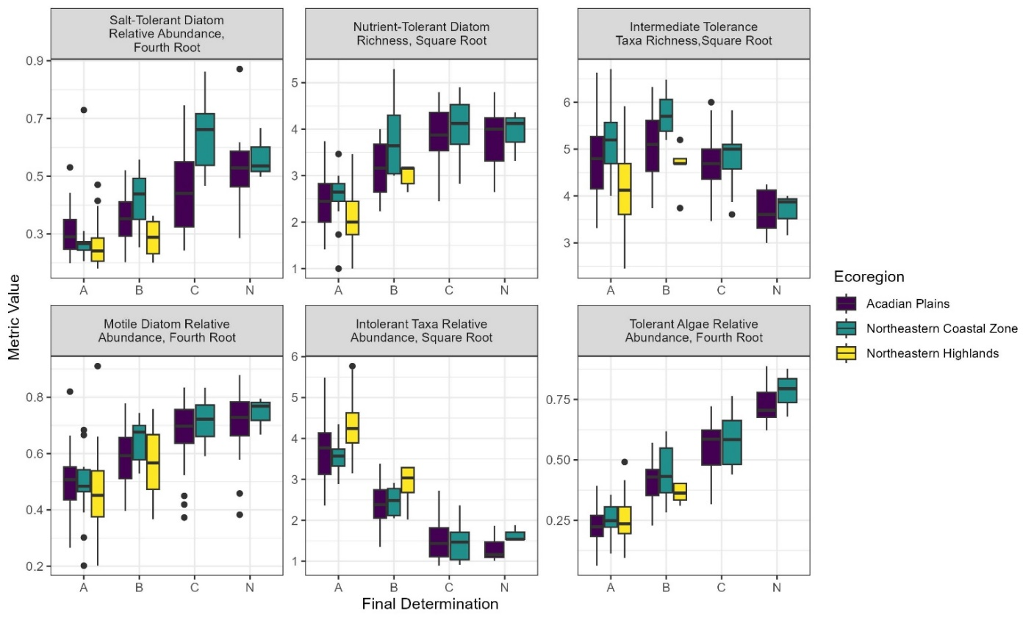

Epiphytic algae samples from soft-bottom streams and marshes
Similar to macroinvertebrates, relative abundance data for epiphytic algae samples from 47 reference sites were analyzed using NMDS and MRPP to determine if there were patterns in community composition based on either ecoregion or water body type (lacustrine or riverine). Data were transformed to down-weight the influence of ubiquitous taxa including Achnanthidium minutissimum. Taxa occurring in less than 5% of reference sites were considered rare and excluded. Results indicate that there were no significant differences in epiphytic algae communities among ecoregions or waterbody types included in the data set. Figures 8 and 9 show model metric response plots by waterbody type and ecoregions.
Figure 8. LDM metric responses for epiphytic algae in soft-bottom habitats (comparison by waterbody type). N = 300 for original data set analyzed. Updated metric response plots based on all currently available data are shown in Appendix 1.

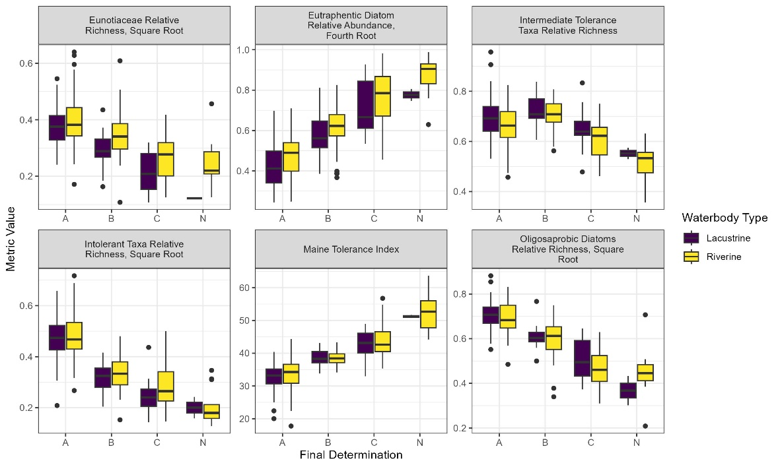

Figure 9. LDM metric responses for epiphytic algae in soft-bottom habitats (comparison by ecoregions). N = 300 for original data set analyzed. Updated metric response plots based on all currently available data are shown in Appendix 1.
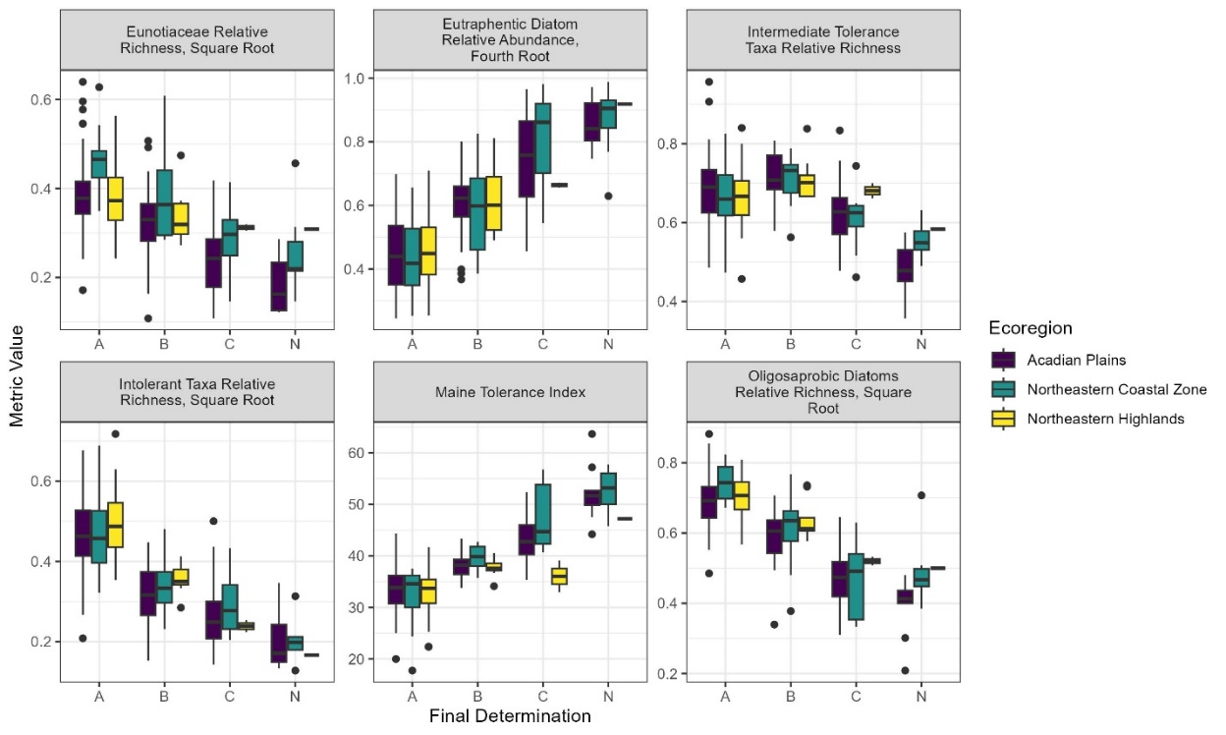

3.2. Calculating Taxa Optima, Tolerance Values and Maine Tolerance Indices (Danielson et al., 2011)

Additional NMDS ordinations of biological data and environmental variables indicating human disturbance were performed to examine relationships with biological community composition. Sites encompassing a full disturbance gradient were included in this analysis, ranging from completely forested watersheds to highly urbanized areas. Environmental variables included physical/chemical, land use and land cover measures. Maine land use/land cover categories were aggregated to develop a generalized stressor gradient based on percent watershed development/percent natural watershed. Percent watershed development combines all land use/land cover categories that are not forest or wetland. “Percent natural” includes only areas of forest or wetland. For the two models for soft-bottom habitats, we also incorporated Wetland Human Disturbance Assessment scores as a generalized stressor gradient measure. This assessment tool includes spatial analysis and field observations for 4 major stressor categories (hydrologic modifications, vegetative modifications, evidence of chemical pollutants and watershed characterization/potential NPS impacts).
A subset of environmental variables representing major stressors affecting Maine waters and that were strongly correlated with NMDS axis 1 for each assemblage were selected for further analysis (Table 2). Environmental variables and biological data were used to calculate weighted-average taxa optima for each assemblage using C2 statistical software (version 1.5.0, 2007) based on the following formula:
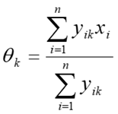
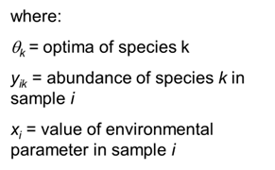

Optima values indicate preferred environmental conditions for individual taxa and predict whether a species is typically found in high quality or degraded waters (Figures 10 and 11). Specific conductance and total phosphorus data were log transformed prior to calculating optima values. Macroinvertebrate and diatom optima were calculated using square root percent abundance data to downweight the influence of ubiquitous, dominant taxa. Optima for soft algae were calculated separately using log10 abundance data to avoid distortion by large densities of cyanobacteria.
Major patterns in the resulting taxa optima values for environmental variables were identified using principal components analysis (PCA) in PC ORD version 5.0. Maine tolerance values were calculated using taxa scores for PCA Axis 1, which represented most of the variation in the data for all assemblages analyzed. Taxa tolerance values were multiplied by 10 and scaled from 1 (most sensitive) to 100 (most tolerant). Taxa optima and tolerance values were calculated separately for each of the three biological assemblages (Appendices 2-4).

Table 2. Environmental stressor variables included in analyses for taxa optima and Maine Tolerance Values
Biological Assemblage | Environmental Variables
Aquatic macroinvertebrates in soft-bottom streams and marshes | Specific conductance, total phosphorus, watershed percent impervious cover, total developed area (i.e., not forest or wetland) within a 1000-meter buffer, DEP WHDA score
Epilithic algae in mineral-bottom streams | Total phosphorus, total nitrogen, specific conductance, watershed percent development (i.e., not forest or wetland), watershed percent impervious cover
Epiphytic algae in soft-bottom streams and marshes | Specific conductance, total phosphorus, watershed percent impervious cover, total developed area (i.e., not forest or wetland) within a 1000-meter buffer, DEP WHDA score

Figure 10. Generalized depiction of individual taxa optima (“preferred conditions”) in relation to a total phosphorus gradient.
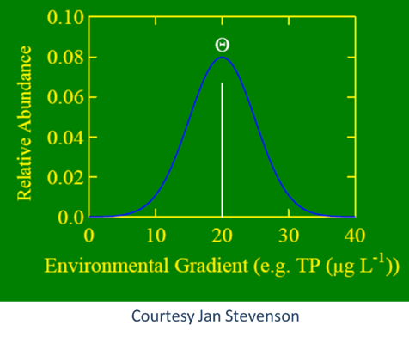

Figure 11. Taxa optima for three diatom species collected from Maine streams in relation to watershed development.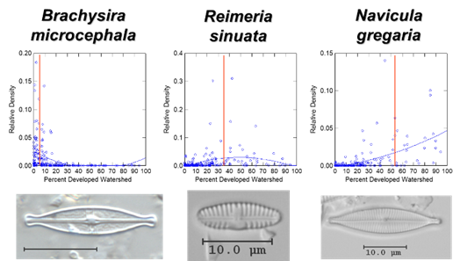
Thomas J. Danielson, PhD
BMP biologists examined plots of square root relative abundance data in CONOCO (CanoDraw version 4.1.4, 2002) to determine individual taxa responses to environmental disturbance variables. Using this information along with cumulative distribution curves (quantile plots and dot density diagrams), biologists assigned threshold values for three taxa tolerance categories: 1) sensitive, 2) intermediate and 3) tolerant taxa (for epilithic algae in hard-bottom streams) or eurytopic taxa (for macroinvertebrates and epiphytic algae in soft-bottom habitats). Eurytopic taxa can adapt to a wide range of environmental conditions and often occur in high quality sites, but may become dominant in degraded sites that are not able to support more sensitive organisms. Community level weighted-average indices were also calculated for each site sampled. Maine Tolerance Index (MTI) scores are calculated similarly to the Hilsenhoff Biotic Index commonly used in stream bioassessments (Hilsenhoff, 1987), but using Maine data:

$$\text{MTI}=\sum{\frac{n_{i}a_{i}}{N}}$$

Where: MTI = Maine Tolerance Index
n_{i} = number of individuals in the i^{th} taxon
a_{i} = tolerance value assigned to that taxon
N = total number of individuals in sample with tolerance values

3.3. Evaluating Biological Attributes as Candidate Metrics

Biological community attributes were compiled for macroinvertebrates and algae used as metrics in other monitoring programs and from the literature to evaluate their potential use in Maine to reliably predict biological responses across a human disturbance gradient. Candidate metrics were also developed based on Maine Tolerance Values (Appendices 2-4) including the richness, relative richness, relative abundance, and relative biovolume (for algae) of sensitive, intermediate and tolerant or eurytopic taxa. In addition, novel algal community attributes were evaluated combining certain family and genus level taxonomic groups expected to occur in disturbed watersheds (Bacillariaceae, Catenulaceae, Rhoicospheniaceae, and Surirellaceae;
BCRS) and minimally-disturbed watersheds (Brachysira, Eunotia, Tabellaria, and Anomoeoneis; BETA) (Danielson et al., 2011).

Scatter plots of candidate metrics were examined in relation to stressor variables to identify responses along various disturbance gradients (i.e., increasing, decreasing, or unimodal responses). For soft-bottom habitats, disturbance variables included total watershed and buffer alteration, percent impervious surface, specific conductance, and WHDA score (SYSTAT 11.0, 2005). The WHDA was ultimately used as the disturbance gradient (x-axis) to determine scatter plot thresholds since it had the highest correlation with species composition of all variables included in the NMDS analysis. For epilithic algae in mineral-bottom streams, biological attributes were plotted against % watershed development in R (version 2.6.2, 2008).

In addition, triplots of candidate metrics were created based on Maine Tolerance Values for sensitive, intermediate, and tolerant or eurytopic taxa to determine relationships and patterns in the data with respect to reference conditions in SYSTAT 11.0 (examples in Figure 12). Spearman rank correlations were calculated to determine the strength of relationships between candidate metrics and disturbance variables in SYSTAT and R. To identify significant differences in biological attribute values between reference and non-reference sites, Mann-Whitney U tests were used in SYSTAT 11.0. (Danielson et al., 2011). Based on this analysis, we identified candidate metrics for each assemblage that showed strong, predictable responses across the disturbance gradient.

Figure 12. Example triplots for metrics calculated from Maine Tolerance Values
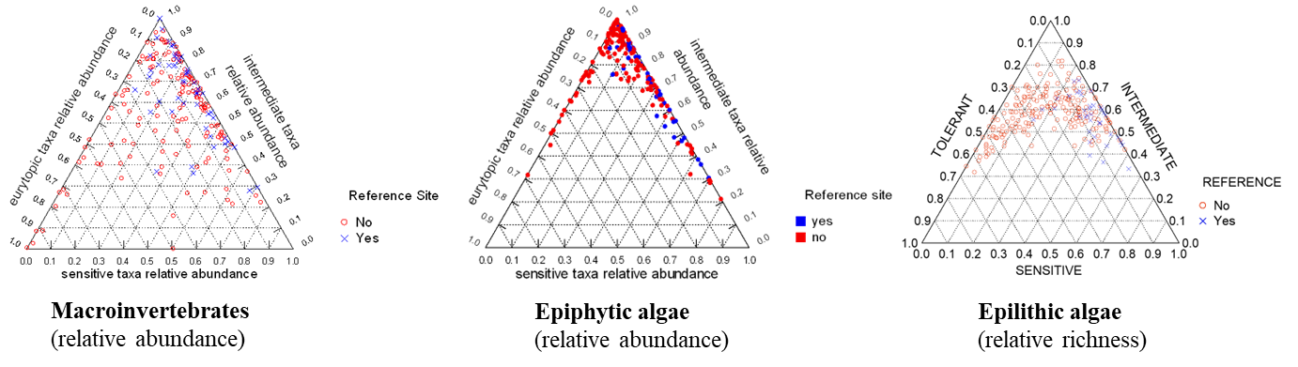

4. Predictive Model Development

4.1. Discriminant Analysis

Discriminant analysis is a statistical method that classifies samples into two or more pre-defined groups based on patterns in the data. This method is particularly useful for analyzing complex datasets such as those found in biological research. By incorporating multiple variables such as the number of mayflies present, the proportion of pollution-tolerant taxa, and other ecological indicators, discriminant analysis can effectively group samples according to the distinct characteristics of their biological communities. This approach aids in understanding and interpreting the relationships between different environmental factors and the composition of biological communities.

Discriminant analysis is a well-established, robust method which can incorporate expert judgment to classify samples, but also objectively identifies and weights the best combinations of variables for predicting group membership. Results integrate multiple community attributes and are expressed as probabilities (0 to 1) of a sample belonging to one or more classes and therefore provide additional information about the level of confidence beyond traditional fixed threshold approaches (Davies et al., 2016; Danielson et al., 2012).

The BMP uses linear discriminant models (LDMs) to predict whether waterbodies meet aquatic life criteria for their assigned class based on biological monitoring data for aquatic macroinvertebrates and algae. The models were developed to find the best combinations of biological variables (metrics) that consistently discriminate among water quality classes AA/A, B, C and “non-attainment” (NA) sites that do not meet criteria for any class. Since Class AA and A waters have the same aquatic life expectations, they are treated as a single group in the models.

The BMP selected discriminant analysis as the method for determining aquatic life classification attainment for numeric biocriteria after carefully evaluating other options. Approaches to predictive classification considered during early development of stream macroinvertebrate assessments included classification trees, logit and multinomial linear models, neural networks, fuzzy clustering, partial least squares regression, and classical discriminant function analysis (Davies et al., 2016). Key requirements for the method selected were the ability to assign a priori water quality classes of biological samples in the model-building process which directly relate to characteristics described in statutory tiered narrative aquatic life criteria, and a probabilistic estimate of class membership that could be used in a regulatory context. Based on these requirements and results of early exploratory data analysis (Davies et al., 2016, Table 4), it was determined that a linear discriminant model was best suited for the state’s needs.

4.2. A Priori Classification of Biological Samples

In order to pre-define groups used to build the LDMs, a team of BMP biologists assigned Maine water quality classes and BCG tiers to biological samples for each model, including 201 samples for macroinvertebrates in soft-bottom habitats, 230 samples for epilithic algae in mineral-bottom streams, and 203 samples for epiphytic algae in soft-bottom habitats. Each team member made initial water quality class assignments (AA/A, B, C or NA) and BCG tier assignments (1 through 6) individually, based on the degree to which samples conformed to statutory narrative aquatic life criteria and narrative descriptions of BCG tiers, and documented the rationale for their decisions. This process was conducted “blind” without knowledge of the site locations, using only biological information to ensure an objective evaluation of the data. Team members were provided with community composition data (taxa lists with numbers of organisms), Maine tolerance values, biological metrics and indices calculated for each site, and information describing expected responses of metrics to anthropogenic stressors.

Following individual team members’ classification assignments, the full team met to discuss sites where one or more people disagreed and used a consensus process based on a modified Delphi technique for group decision-making to reconcile differences and determine final aquatic life class assignments (Bakus et al., 1982; Danielson et al., 2012; Davies and Jackson, 2006; Davies et al., 2016; USEPA, 2016). Final BCG tier assignments were made by averaging individual biologists’ assignments for each sample and were used to help inform biologist consensus class determinations.

In developing the original stream macroinvertebrate LDMs adopted in 2003, the BMP considered algorithmic-based approaches to define a priori water quality classes and tested several methods using objective searches with combinations of macroinvertebrate community metrics. These were ultimately found to be unsatisfactory because results depended on the algorithm used and did not reflect differences in water quality (Davies et al., 2016, Appendix 2).

Peer review by outside experts

For epilithic algae, algal experts from the Academy of Natural Sciences at Drexell University evaluated a subset of 40 samples and assigned water quality classes and BCG tiers to replicate the process. The stream algal metrics and LDM model were developed with collaboration and guidance by University of Maine faculty serving on the PhD committee of a DEP biologist, in addition to US Geological Survey, Maine Cooperative Fish and Wildlife Research Unit staff and Michigan State University faculty. Monitoring and assessment methods, BCG models, biological metrics and LDMs for macroinvertebrates and algae in soft-bottom habitats received extensive peer-review throughout the development process including BMP biologists’ participation in EPA’s national Biological Assessment of Wetlands Workgroup (BAWWG) and the New England Biological Assessment of Wetlands Workgroup (NEBAWG). These groups included experts from multiple federal and state government agencies and academic institutions and involved regular state updates and research presentations, hands-on data review workshops, collaborative projects among state agencies, publication of materials related to biological monitoring, assessment and criteria development, and technical assistance to state monitoring programs. EPA also facilitated a Cooperative Agreement with the BMP and Michigan State University to develop and test diatom indictors in Maine (Wang et al., 2006). Peer review and participation in a priori classification of biological samples by outside experts for macroinvertebrates in mineral-bottom streams are discussed in detail in Davies et al.,2016.

4.3. Model Building

The goal for building the LDMs was to replicate biologists’ professional judgement to predict aquatic life class attainment for new samples (Press, 1980). The models consist of linear discriminant functions using quantitative ecological attributes to determine the strength of the association of a test community to Class AA/A, B, C or NA. The coefficients or weights (also known as “association values”) are calculated using a linear optimization algorithm to minimize the distance, in univariate space, between sites within a class, and to maximize the distance between sites among different classes (Davies et al., 2016).
The linear discriminant function has the formula:

Z = C + W₁X₁ + W₂X₂ + ...W_{n}X_{n}

Where: Z = discriminant score

C = constant

W_{i} = the coefficients or weights

X_{i} = the predictor variable values

Preliminary LDMs were created using approximately 80% of the samples for each biological assemblage as a training set and 20% of samples were reserved as a validation set to test the ability of the models to predict class attainment using new data. Candidate model variables were transformed as needed to meet the distributional assumptions of linear discriminant analysis. Initial models were constructed using an automatic backward stepwise selection process in SYSTAT (version 13) to evaluate biological variables for inclusion in the LDMs.

Preliminary models were used successfully for a number of years to inform water quality attainment decisions based on narrative aquatic life criteria. Over time, the models were revised to refine their predictive capabilities using an R code that calculates all possible combinations of variables. Model predictions of training and validation samples were compared to biologist classifications to calculate % correct predictions, and jackknife analyses were conducted to estimate model precision by randomly selecting subsets of the training data for further testing (Figures 13-15). The best candidate models were evaluated using the following criteria:

  - Low classification error rate based on biologist classifications;
  - Balance of misclassifications among groups (AA/A, B, C and NA);
  - Ecologically-meaningful model variables;
  - Balance of different variable types (abundance, richness, indices, etc.);
  - Minimize redundant or highly correlated variables (| r | > 0.70). Note that some variables exceeding this criterion were retained to ensure a balance of variable types

Figure 13. Model predictions compared with biologist classifications for macroinvertebrate samples collected in soft-bottom habitats.
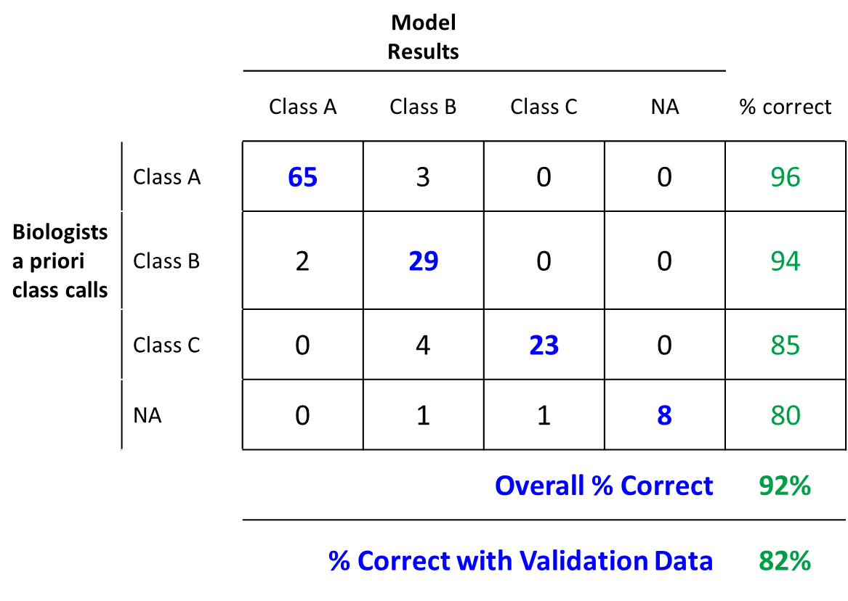

Figure 14. Model predictions compared with biologist classifications for epilithic algae samples collected in mineral-bottom streams and rivers.

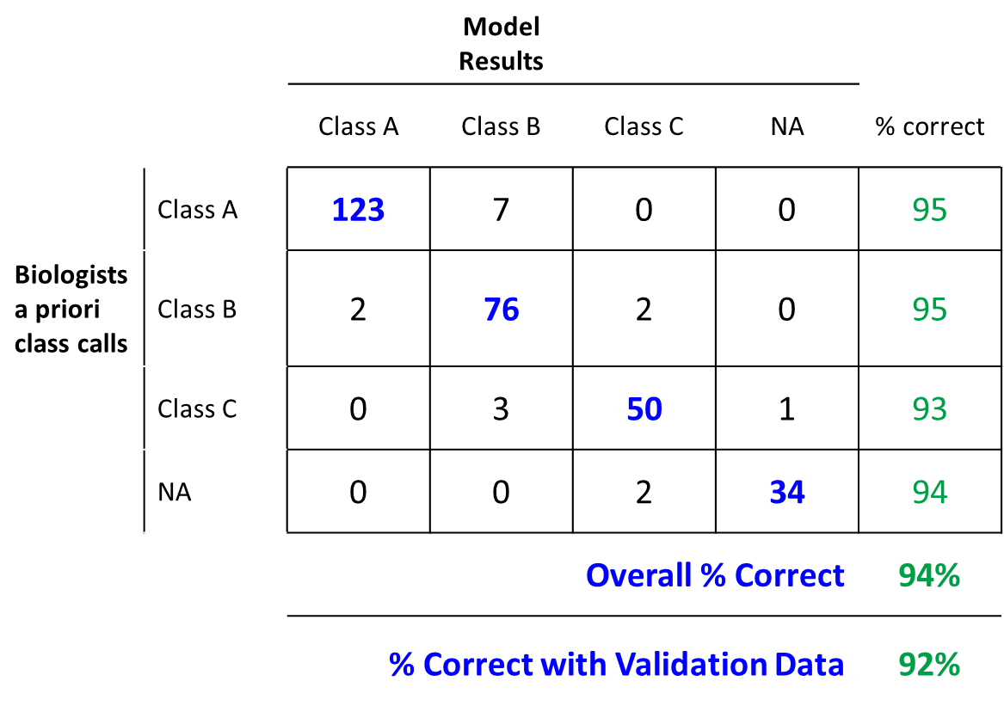

Figure 15. Model predictions compared with biologist classifications for epiphytic algae samples collected in soft-bottom habitats.

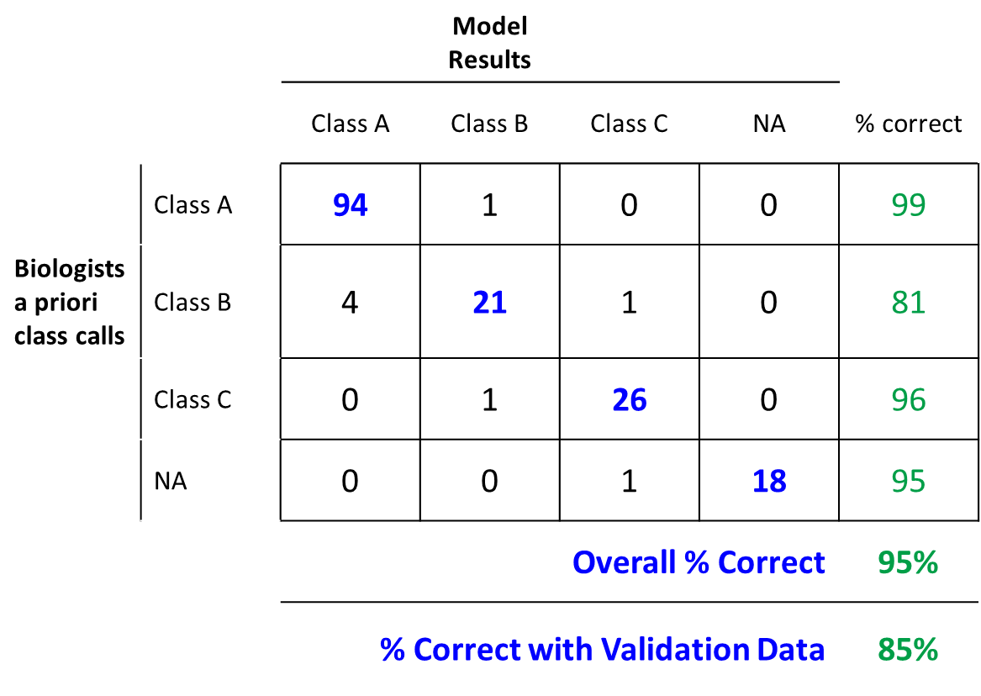

Final model metrics are depicted in Tables 3-5 and Peason correlation matrices appear in Appendix 5. Class attainment response for individual metrics appear in Figures 16-18. Table 6 summarizes the chronology of LDM and numeric biological criteria development. Statistical transformations and coefficients for all final model metrics are shown in Appendix 6.

Table 3. Final LDM metrics for macroinvertebrate samples collected in soft-bottom habitats.

Metric  (Macroinvertebrates in soft-bottom habitats) | Description
Shannon Weiner Diversity Index | Community index based on relative abundance and evenness of species (Shannon, 1948)
Relative abundance of organisms in the collector-gatherer functional feeding group (FFG) | Primarily feed on fine particulate organic matter (FFGs described in Merritt et al., 2019)
Relative richness of mayflies, dragonflies/damselflies and caddisflies | Generally more sensitive taxa groups
Abundance of mayflies | Prefer clean, well-oxygenated water
Maine Tolerance Index | Weighted average community index based on Maine Tolerance Values
Richness of sensitive taxa | Based on Maine Tolerance Values
Abundance of sensitive taxa | Based on Maine Tolerance Values
Ratio of sensitive to eurytopic taxa abundance | Based on Maine Tolerance Values

Table 4. Final LDM metrics for epilithic algae samples collected in mineral-bottom streams and rivers.

Metric  (Epilithic algae from mineral-bottom streams) | Description
Relative richness of sensitive taxa | Based on Maine Tolerance Values
Richness of intermediate taxa | Based on Maine Tolerance Values
Relative abundance of tolerant taxa | Based on Maine Tolerance Values
Relative abundance of salt-tolerant diatoms | Tolerate higher salinity levels (van Dam et al., 1994)
Richness of eutrophentic diatoms | Prefer nutrient rich water (van Dam et al., 1994)
Relative abundance of motile diatoms | Able to move in silt or thick algal mats (Wang et al., 2005)

Table 5. Final LDM metrics for epiphytic algae samples collected in soft-bottom habitats.

Metric  (Epiphytic algae in soft-bottom habitats) | Description
Relative richness of diatoms in Eunotiaceae family | Prefer oligotrophic (low nutrient) to mesotrophic (moderate nutrient), somewhat acidic conditions
Relative abundance of eutrophentic diatoms | Prefer eutrophic (high nutrient) conditions (van Dam et al., 1994)
Relative richness of oligosaprobic diatoms | Prefer low organic enrichment conditions (van Dam et al., 1994)
Relative richness of intermediate taxa | Based on Maine Tolerance Values
Relative richness of sensitive taxa | Based on Maine Tolerance Values
Maine Tolerance Index (MTI) | Weighted average community index based on Maine Tolerance Values

Figure 16. LDM metric response by attained water quality class for macroinvertebrates in soft-bottom habitats. N = 201 for original data set analyzed. Updated metric response plots based on all currently available data are shown in Appendix 1.

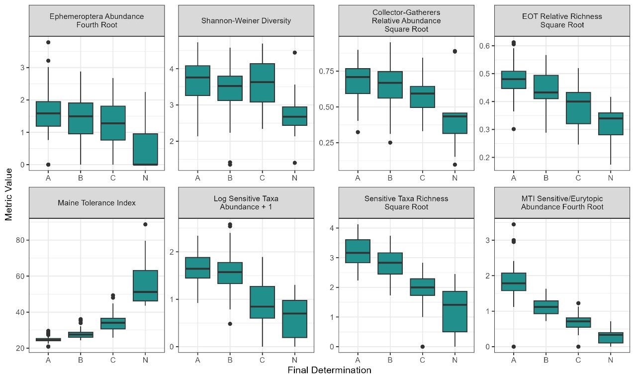

Figure 17. LDM metric response by attained water quality class for epilithic algae in mineral-bottom streams and rivers. N = 230 for original data set analyzed. Updated metric response plots based on all currently available data are shown in Appendix 1.

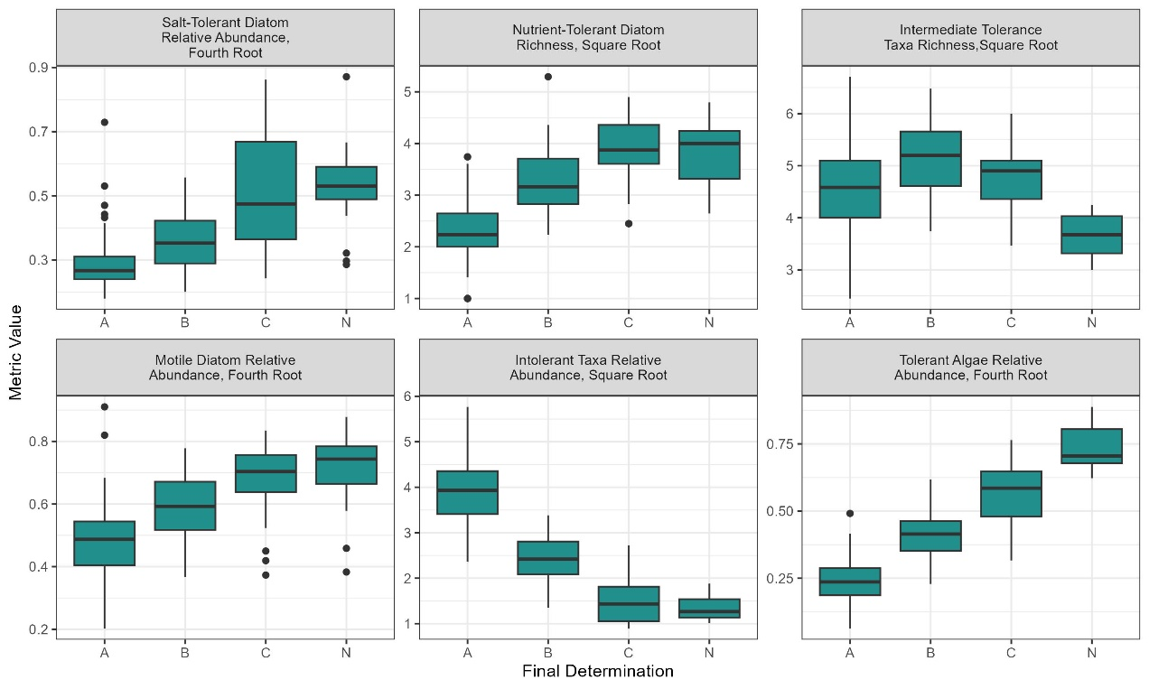

Figure 18. LDM metric response by attained water quality class for epiphytic algae in soft-bottom habitats. N = 300 for original data set analyzed. Updated metric response plots based on all currently available data are shown in Appendix 1.

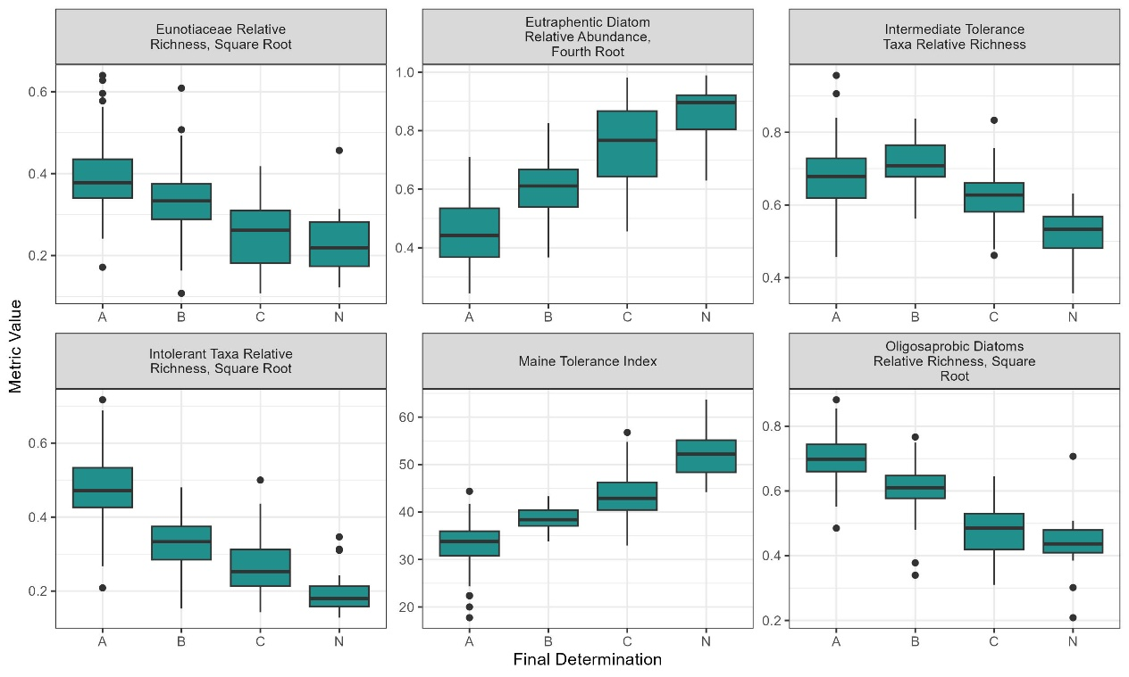

Table 6. Chronology of Numeric Biocriteria Development.

Years | Major Activities
2003 | Numeric biocriteria for macroinvertebrates in eroded, mineral-bottom streams adopted in rules (see Davies et al., 2016 for full chronology).
1999–2006 | Tested and standardized field sampling methods for macroinvertebrates and epiphytic algae in soft-bottom habitats, and epilithic algae in mineral-bottom streams. Collected baseline data at sites across a full gradient of human disturbance.
2006 | Published peer-reviewed journal article describing pilot project to develop and test diatom indicators for Maine wetlands (Wang et al., 2006).
2001–2007 | Conducted exploratory data analysis for all assemblages. Migrated biological, physical and chemical data to Department Oracle water quality database. Migrated spatial data to GIS platform.
2008-2011 | Developed and tested stream epilithic algal Phase I linear discriminant model (LDM) using 230 sample dataset and programed into Department Oracle database.
2009-2012 | Developed and tested Phase I LDM for macroinvertebrates in soft-bottom habitats using 201 sample dataset and programed into Department Oracle database.
2010–present | Used epilithic algal and macroinvertebrate (soft-bottom habitats) LDMs to inform attainment determinations for narrative aquatic life criteria and report results under federal CWA Section 305(b) and 303(d) requirements in the Maine Integrated Water Quality Monitoring and Assessment Report.
2011-2012 | Drafted and published two peer-reviewed journal articles describing stream algal metrics and model development (Danielson et al., 2011; Danielson et al.,2012).
2013-2016 | Developed and tested Phase I LDM for epiphytic algae in soft-bottom habitats using 203 sample dataset.
2015-2016 | Corrected Department Oracle database programming to address errors in macroinvertebrate Phase I LDM calculations.
2016-2018 | Revised epilithic algal Phase I LDM using R script to create Phase II LDM. Programed final Phase II model into Department Oracle database.
2016-2018 | Revised macroinvertebrate Phase I LDM using R script to create Phase II LDM, and programed changes into Department Oracle database.
2017-2018 | Programed epiphytic algal Phase I LDM into Department Oracle database.
2017-present | Used epiphytic algal LDM to inform attainment determinations for narrative aquatic life criteria.
2020-2023 | Revised epilithic algal Phase II LDM using R script to create Phase III LDM. Programed final Phase III model into Department Oracle database.

5. Class Attainment Determinations
Methods described in Chapter 579 rules are used to make decisions about aquatic life criteria attainment to determine whether waterbodies meet criteria for their assigned statutory class. Class attainment results are reported in the Department’s biennial water quality assessment report as required under section 305(b) of Federal Clean Water Act. Waters that are confirmed not to attain their statutory class are added to the state’s list of impaired waters as required under section 303(d) of the Federal Clean Water Act. If a given waterbody consistently attains criteria for a higher class, it may be subject to statutory antidegradation provisions and/or considered for a water quality classification upgrade. The process to upgrade the classification of a waterbody includes a review of all available data (chemical, physical and biological) and evaluation of potential stressors in the watershed that may adversely affect water quality. Class attainment determinations are also used to assess pre-impact baseline conditions, conduct site-specific impact evaluations, and document reference conditions and long-term ecological trends.

Decisions to list a waterbody as impaired are based on protocols described in Maine’s Consolidated Assessment and Listing Methodology (CALM) found in Chapter 4 of the Integrated Report. The CALM generally requires two or more consecutive non-attaining sampling outcomes from different years taking into account conditions including but not limited to unusually high or low flow, point source and non-point source discharges, watershed land use, historic contamination and normal interannual variability. A waterbody’s attained class is determined by Department biologists using the process described below.

5.1. Data Requirements

All samples of benthic macroinvertebrates or algae that are collected for the purpose of classification attainment evaluation using the LDMs by either DEP staff or outside contractors must be collected, processed and identified in conformance with applicable Department SOPs appropriate for the habitat and biological assemblage to be sampled. For all sample types, the first step in evaluating class attainment is to determine if data meet minimum requirements and are appropriate to run through the applicable LDM. The following summarizes minimum data provisions described more fully in the rule:

Macroinvertebrate Samples
- Must be identified to the genus level of taxonomy, where possible;
- Total mean abundance must be at least 50 individuals (average for all replicate samples at a site);
- Total generic richness for all replicate samples at a site must be at least 15 (calculated by counting the number of different genera following the counting rules specified in Chapter 579).

Algal Samples
- Must be identified to the lowest practicable taxonomic level (genus or species where possible);
- Must have a total richness of at least 15 (calculated by adding the number of distinct families, genera, species, and subspecies).

Samples not attaining these criteria may be evaluated by Department biologists using best professional judgement procedures provided in the rule and summarized below in Section 5.3. Best professional judgement evaluations may result in aquatic life class determinations, non-attainment (NA) findings or determinations of “Indeterminate” (I) with a recommendation to re-sample.

5.2. Model Interpretation

For all three proposed new LDMs, determination of attainment results is based on a single four-way model. If the model probability value from 0-1 for any class (A, B, C) or non-attainment category (NA) is equal to or greater than 0.6, the sample attains the corresponding class or is determined to be in non-attainment of criteria for any class. If no probability value is equal to or greater than 0.6 and one or more values are greater than 0.4 and less than 0.6, then best professional judgment may be used to determine sample class or NA status.

For macroinvertebrate samples collected from eroded, mineral-bottom streams and rivers using the rock bag/basket/cone method, determination of attainment results is based on one four-way model and three two-way models, which are described in detail in the Chapter 579 rules and Davies et al., 2016. The models are calculated sequentially, beginning with a 4-way model to determine the probabilities of a sample community attaining each class (AA/A, B, C or NA), followed by calculations for 2-way LDMs to determine if a sample is Class C or better, Class B or better, and finally Class A. The probabilities generated in each model are used in calculations for the next subsequent model.

Figures 19 and 20 illustrate the decision process for determining class attainment based on the model results. Sample aquatic life reports with model results are provided in Appendices 5-7.

Figure 19. Process for determining class attainment using probability values (macroinvertebrate samples collected from mineral-bottom streams and rivers).

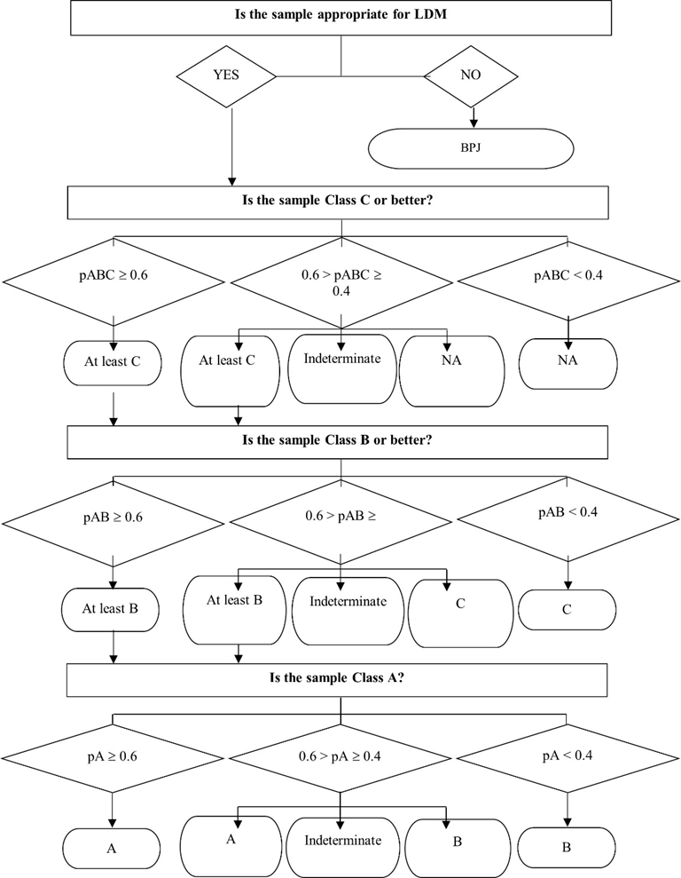

Figure 20. Process for determining class attainment using probability values (macroinvertebrate and epiphytic algae samples collected from soft-bottom habitats and epilithic algae samples collected from mineral-bottom streams and rivers).

5.3. Use of Professional Judgment

Department biologists may use professional judgement to determine class attainment where there is documented evidence of conditions that could result in uncharacteristic findings, when the model probability for a given class is between 0.4 and < 0.6, and in cases where minimum provisions for use of the model are not met. The Department may also require that additional monitoring be conducted prior to issuing a class attainment decision.

5.3.1. Sampling Procedures and Minimum Provisions Conform but Other Confounding Factors Exist

Factors that may allow adjustments to the model outcome include atypical habitat, tidal effects, cataclysmic events (flooding, landslides, etc.), oligotrophic conditions, unusual taxa assemblages, disturbed samplers, subsample vs. whole sample analysis and documented human error in sampling or sample processing. The following adjustments may be made to correct for these conditions.
- Raise the finding. Department biologists may raise the predicted model class or non-attainment result to the next higher class.
- Lower the finding. On the basis of documented, substantive evidence that the narrative aquatic life criteria for the assigned class are not met, the Department may lower the class determination.
- Indeterminate result. Where the Department cannot make a finding as described above, additional monitoring may be required before a determination of class attainment can be made.
- Model association values between 0.4 and 0.6. If one or more model association value is equal to or greater than 0.4 and less than 0.6, the sample is Indeterminate and professional judgement is used to decide whether the sample meets the indeterminate class, an adjacent class, or is in nonattainment of criteria for any class.

5.3.2. Minimum Provisions for Model are not Met

For samples that do not conform to minimum provisions for taxa richness or mean abundance described in Section 5.1 above, professional judgement may be used as follows.
- Determination of nonattainment. Samples not attaining minimum provisions where there is no evidence of confounding factors that could result in uncharacteristic findings are determined to be in non-attainment of aquatic life criteria for any class.

- Determination of class attainment. Where there is evidence of factors that could result in minimum provisions not being met, the Department may use professional judgment to make a finding of attainment of the aquatic life criteria for any class.

- Indeterminate finding. The Department may find that there is insufficient evidence to make a determination of class attainment or nonattainment of aquatic life criteria for any class, therefore the result remains Indeterminate and additional sampling of the test community will be required.

5.3.3 Standard Sampling Procedures are not Feasible or Appropriate
For biological communities and habitats that do not conform to criteria provided in applicable Department SOPs, the Department may assess class attainment or aquatic life impact in accordance with the following procedures:
- Approved sampling plan. A quantitative sampling and data analysis plan must be developed in accordance with methods established in the scientific literature of aquatic ecology, and the Department must approve the plan;
- Determination of sampling methods. Sampling methods are determined on a site-specific basis, depending on the habitat conditions of the sampling site and must be approved by the Department. Standard sampling methods which are required for data to be used in the LDMs are summarized in Table 1 (above) and described in detail in Department SOPs (available on request). Where standard methods are not ecologically appropriate or technically feasible, other methods may be used as approved by the Department but resulting data may not be used in the LDMs. Results of non-standard sampling methods are evaluated by Department biologists using professional judgement to determine if they conform with statutory narrative aquatic life criteria;
- Classification attainment decisions. Department biologists may make class attainment decisions based on the degree to which a sample conforms to statutory narrative aquatic life criteria for its assigned class. The decision is based on established principles of aquatic ecology and must be fully documented;
- Site-specific impact decisions. Department biologists may make site-specific impact decisions based on established methods of analysis of comparative data between a test community and an approved reference community;
- Determination of detrimental impact. Department biologists may make a determination of detrimental impact to aquatic life without an approved reference community if the community fails to demonstrate the ecological attributes defined in statutory narrative criteria for its assigned class. Such determinations are based on established principles of aquatic ecology and must be fully documented.

6. Potential for listing new impaired waters and potential impacts to permits and licenses
Maine’s “Integrated Report” (IR) summarizes water quality data collected by DEP and other state, federal and tribal government agencies, and volunteer organizations. Under Sections 305(b) and 303(d) of the Clean Water Act, states are required to submit an IR to EPA every two years, which includes a list of impaired waters (i.e. waterbodies not meeting all water quality standards and criteria for their assigned class).

The potential for listing new impaired waters in the IR due to adoption of additional numeric biological criteria in Chapter 579 was estimated by examining the most recent 5-year period for which taxonomic data are available (2017-2021). The current process of listing impaired waters is described in the Draft 2024 Integrated Water Quality Monitoring and Assessment Report in the Consolidated Assessment and Listing Methodology (CALM) section.
Based on this evaluation, 28 waters would be listed as impaired based on the proposed numeric criteria. Of these, only four would be new listings since the 24 have already been listed using narrative criteria.

When determining a waterbody’s class attainment, the three additional models proposed for Chapter 579 have been used to inform the Department’s interpretation of narrative biological criteria since each model was finalized (see Table 6 above). These class attainment decisions are considered under the existing permit and license review process. The addition of these three models to Chapter 579 is not expected to cause any significant changes to permitting and licensing processes. Adding these assemblages will codify the Department’s long-standing practice to consider all available biological data when considering new or increased discharge licenses.

The Department reviewed all facilities in proximity of the waters in Table 7. A very small number were found and none will be affected by the proposed changes to Chapter 579.

Table 7. Waters with impairment of the aquatic life use (ALU) based on proposed numeric criteria.
Waterbody | Town | Statutory Class | Biological Assemblage Impaired | Already listed based on Narrative Criteria?
NO NAME BROOK – WETLAND STATIONS W-101 and W-102 | LEWISTON | B | Wetland MI | yes
ROBINSON DAM POND WETLANDS BLAINE - WETLAND STATION W-198 | BLAINE | B | Wetland MI | yes
CAPISIC POND WETLANDS - WETLAND STATIONS W-023 and W-224 | PORTLAND | C | Wetland MI and Wetland EPI | yes
BIRCH BROOK - STATION 1019 | PRESQUE ISLE | B | Stream Algae | yes
CAPISIC BROOK - STATION 1039 and STATION 257 | PORTLAND | C | Stream Algae | yes
COLONEY BROOK - STATION 733 | FORT FAIRFIELD | B | Stream Algae | yes
COWETT BROOK - STATION 1021 | PRESQUE ISLE | B | Stream Algae | yes
CRAIG BROOK - STATION 1006 | LITTLETON | B | Stream Algae | yes
GRAY BROOK - STATION 1023 | FORT FAIRFIELD | B | Stream Algae | yes
GULLY BROOK - STATION 695 | AUBURN | B | Stream Algae | yes
HACKER BROOK - STATION 1024 | FORT FAIRFIELD | B | Stream Algae | yes
HALFMOON STREAM - STATION 697 | THORNDIKE | A | Stream Algae | yes
KENNEDY BROOK - STATION 646 | PRESQUE ISLE | B | Stream Algae | yes
NASON'S BROOK - STATION 638 | PORTLAND | C | Stream Algae | yes
NORTH FORK MCLEAN BROOK - STATION 922 | ST AGATHA | B | Stream Algae | yes
OLIVER BROOK - STATION 1005 | HODGDON | B | Stream Algae | yes
PISCATAQUA RIVER - STATION 759 and STATION 787 | FALMOUTH | B | Stream Algae | no
RIGGS BROOK - STATION 599 | AUGUSTA | B | Stream Algae | yes
ROCKY BROOK - STATION 375 | MARS HILL | B | Stream Algae | yes
SHEEPSCOT RIVER - STATION 74 | WHITEFIELD | AA | Stream Algae | no
SMITH BROOK - STATION 1007 | HOULTON | B | Stream Algae | yes
TANNERY BROOK - STATION 562 | GORHAM | B | Stream Algae | no
UNNAMED BROOK (MADAWASKA) - STATION 1030 | MADAWASKA | B | Stream Algae | no
UNNAMED BROOK (PRESQUE ISLE) - STATION 1027 | PRESQUE ISLE | B | Stream Algae | yes
UNNAMED STREAM (LEWISTON) - STATION 857 | LEWISTON | B | Stream Algae | yes
WEST BRANCH SHEEPSCOT RIVER - STATION 268 and STATION 550 | CHINA | AA | Stream Algae | yes
WHITNEY BROOK - STATION 601 | AUGUSTA | B | Stream Algae | yes
WILLIAMS BROOK - STATION 1031 | PRESQUE ISLE | B | Stream Algae | yes

Literature Cited
Bakus, G. J., W. G. Stillwell, S. M. Latter, and M. C. Wallerstein. 1982. Decision making: with applications for environmental management. Environmental Management 6:493–504.

Connors, B. 2019a. Protocols for Using Dissolved Oxygen and Specific Conductance/pH Meters in Rivers, Streams, and Freshwater Wetlands. DEPLW0636A-2014 (updated 2019). Maine Department of Environmental Protection, Augusta, Maine.

Connors, B. 2019b. Protocols for Collecting Water Grab Samples in Rivers, Streams, and Freshwater Wetlands. DEPLW0637A-2014 (updated 2019). Maine Department of Environmental Protection, Augusta, Maine.

Connors, B. and J. DiFranco. 2019. Protocols for Completing the Biological Monitoring Wetland Human Disturbance Assessment. DEP-LW1259 (updated May 2019). Maine Department of Environmental Protection, Augusta, Maine.

Courtemanch, D.L. 1995. Merging the science of biological monitoring with water resource management policy: Criteria development. Biological Assessment and Criteria: Tools for Water Resource Planning and Decision Making, ed. W.S. Davis and T.P. Simon. CRC Press, Boca Raton, FL. pp 315–326.

Courtemanch, D.L., S.P. Davies, and E.B. Laverty. 1989. Incorporation of biological information in water quality planning. Environmental Management 13:35–41.

Courtemanch, David L., Susan P. Davies, Eileen S. Johnson, Rebecca Schaffner, and Douglas Suitor. 2023. Before and After the Clean Water Act: How Science, Law, and Public Aspirations Drove Seven Decades of Progress in Maine Water Quality. Maine Policy Review 32.1 https://digitalcommons.library.umaine.edu/mpr/vol32/iss1/4.

Danielson, T.J. 2019a. Protocols for sampling algae in wadeable streams, rivers, and freshwater wetlands. DEPLW0634B-2014 (updated 2019). Maine Department of Environmental Protection, Augusta, Maine.

Danielson, T.J. 2019.b Protocols for Measuring Water Velocity in Wadeable Streams and Rivers. DEPLW0635A-2014 (updated 2019). Maine Department of Environmental Protection, Augusta, Maine.

Danielson, T.J., C.S. Loftin, L. Tsomides, J.L. DiFranco, and B. Connors. 2011. Algal bioassessment metrics for wadeable streams and rivers of Maine, USA. Journal of the North American Benthological Society 30:1033–1048.

Danielson, T.J., C.S. Loftin, L. Tsomides, J.L. DiFranco, B. Connors, D.L. Courtemanch, F. Drummond, and S.P. Davies. 2012. An algal model for predicting attainment of tiered biological criteria of Maine’s streams and rivers. Freshwater Science 31(2): 318–340.

Danielson, T.J., L. Tsomides, D. Suitor, J.L. DiFranco, and B. Connors. 2016. Effects of Urbanization on Aquatic Life of Maine Streams. Maine Department of Environmental Protection, Augusta, Maine.

Davies, S.P. and S.K. Jackson. 2006. The Biological Condition Gradient: A Descriptive Model for Interpreting change In Aquatic Ecosystems. Ecological Applications 16(4) pp. 1251-1266.

Davies, S. P., and L. Tsomides. 2014. Methods for biological sampling of Maine’s rivers and streams. DEPLW0387-C2014 (updated April 2014). Maine Department of Environmental Protection, Augusta, Maine.

Davies, S.P., F. Drummond, D.L. Courtemanch, L. Tsomides, and T.J. Danielson. 2016. Biological water quality standards to achieve biological condition goals in Maine rivers and streams: Science and policy. Maine Agricultural and Forest Experiment Station Technical Bulletin 208.

DiFranco, J.L., B. Connors, T.J. Danielson, and L. Tsomides. 2013. Evaluating Alternative Wetland Compensatory Mitigation Assessment Techniques. 104b3 Wetland Program Development Grant Final Report. DEPLW-1258. Maine Department of Environmental Protection, Augusta, Maine.

DiFranco, J.L. 2019. Protocols for sampling aquatic macroinvertebrates in freshwater wetlands. DEPLW0640A-2014 (updated May 2019). Maine Department of Environmental Protection, Augusta, Maine.

FB Environmental Associates. 2025. Capisic Brooks Watershed Management Plan Update. April 2025.

Griffith, G.E., J.M. Omernik, S.A. Bryce, J. Royte, W.D. Hoar, J. W. Homer, D. Keirstead, K.J. Metzler, and G. Hellyer. 2009. Ecoregions of New England (color poster with map, descriptive text, summary tables, and photographs; map scale 1:1,325,000). US Geological Survey, Reston, Virginia.

Hilsenhoff, W.L. 1987. An improved biotic index of organic stream pollution. The Great Lakes Entomologist 20(1):31–39.

Karr, J.R. 1991. Biological integrity: a long-neglected aspect of water resource management. Ecological Applications 1:66–84.

Karr, J.R. and D.R. Dudley. 1981. Ecological Perspectives on Water Quality Goals, Environmental Management, Vol. 5, No. 1, pp. 55-68. DOI:10.1007/BF01866609.

Karr, J.R. and E. W. Chu. 1997. Biological Monitoring and Assessment: Using Multimetric Indexes Effectively. EPA 235-R97-001. University of Washington, Seattle.

Karr, J.R., and E.W. Chu. 1999. Restoring life in running waters: better biological monitoring. Island Press, Washington, DC.

Long Creek Watershed Management District. 2024. Long Creek General Permit Annual Report for Calendar Year 2024. Long Creek Watershed Management District, Windham, Maine

MDEP. 2023. Evaluating Alternative Wetland Compensatory Mitigation Assessment Techniques. Report to the EPA Region 1 – FFY 19/20 Wetland Program Development Grant #3 Final Report. Maine Department of Environmental Protection, Augusta, Maine.

MDEP. 2019. Quality assurance project plan for biological monitoring of Maine’s rivers, streams and freshwater wetlands. DEPLW0638C-2014 (updated June 2019). Maine Department of Environmental Protection, Augusta, Maine.

MDEP. 2023-2024. Surface Water Ambient Toxics Monitoring Program Report 2023-2024. Report to the Joint Standing Committee on Environment and Natural Resources 132nd Legislature, First Session. Maine Department of Environmental Protection, Augusta, Maine. Microsoft Word - 2023-2024 SWAT Report FINAL.docx

MDEP. 2024. 2024 Triennial Review of Water Quality Standards Department Proposals for Upgrades of Water Quality Classifications. Maine Department of Environmental Protection, Augusta, Maine.

Merritt, R.W., K.W. Cummins, and M.B. Berg. 2019. An Introduction to the Aquatic Insects of North America. Fifth edition. Kendall Hunt Publishing Company.

Omernik, J.M. 1987. Ecoregions of the conterminous United States. Annals of the Association of American Geographers 77:118–125.

Press, S.J. 1980. Multivariate group judgments. Multivariate Analysis V, ed. P.R. Krishnaiah. North-Holland Publishing Co., Amsterdam. pp 581–592.

Reynoldson, T.B., R.H. Norris, V.H. Resh, K.E. Day, and D.M. Rosenberg. 1997. The reference condition: a comparison of multimetric and multivariate approaches to assess water-quality impairment using benthic macroinvertebrates. Journal of the North American Benthological Society 16(4):833-852.

Schaffner, R., E.S. Johnson, D. Suitor, D.L. Courtemanch and S.P. Davies. 2019. Mapping Fifty Years of Changes in Maine’s Water Quality Classifications, Papers in Applied Geography, DOI: 10.1080/23754931.2018.1517274

Shannon, C.E. 1948. A Mathematical Theory of Communication. The Bell System Technical Journal, 27, 379-423.

Stoddard, J.L., D.P. Larsen, C.P. Hawkins, R.K. Johnson, and R.H. Norris. 2006. Setting expectations for the ecological condition streams: The concept of reference condition. Ecological Applications 16:1267–1276.

USEPA. 2002. Methods for Evaluating Wetland Condition: Introduction to Wetland Biological Assessment. Office of Water, U.S. Environmental Protection Agency, Washington, DC. EPA-822-R-02-014.

USEPA. 2011. A Primer on Using Biological Assessments to Support Water Quality Management. U.S. Environmental Protection Agency, Office of Science and Technology, Office of Water, Washington, DC. EPA 810-R-11-01.

USEPA. 2016. A Practitioner’s Guide to the Biological Condition Gradient: A Framework to Describe Incremental Change in Aquatic Ecosystems. U.S. Environmental Protection Agency, Washington, DC. EPA-842-R-16-001.

van Dam, H., A. Mertens, and J. Sinkeldam. 1994. A coded checklist and ecological indicator values of freshwater diatoms from the Netherlands. Netherlands Journal of Aquatic Ecology 28:117–133.

Wang, Y.K., R.J. Stevenson, and L. Metzmeier. 2005. Development and evaluation of a diatom-based Index of Biotic Integrity for the Interior Plateau Ecoregion, USA. Journal of the North American Benthological Society 24:990–1008.

Wang, Y.K., R.J. Stevenson, P.R. Sweets, and J. DiFranco. 2006. Developing and testing diatom indicators for wetlands in the Casco Bay watershed, Maine, USA. Hydrobiologia 561:191–206.

Appendix 1. LDM Metric Response Plots Updated with All Available Data.

LDM metric responses for macroinvertebrates in soft-bottom habitats (comparison by waterbody type). Includes all currently available data (N = 512).
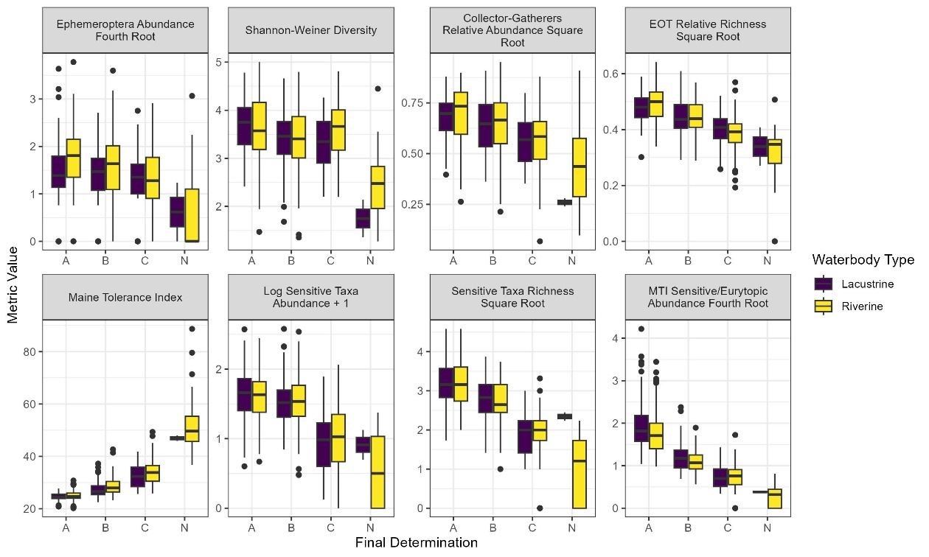
LDM metric responses for macroinvertebrates in soft-bottom habitats (comparison by ecoregions). Includes all currently available data (N = 512).
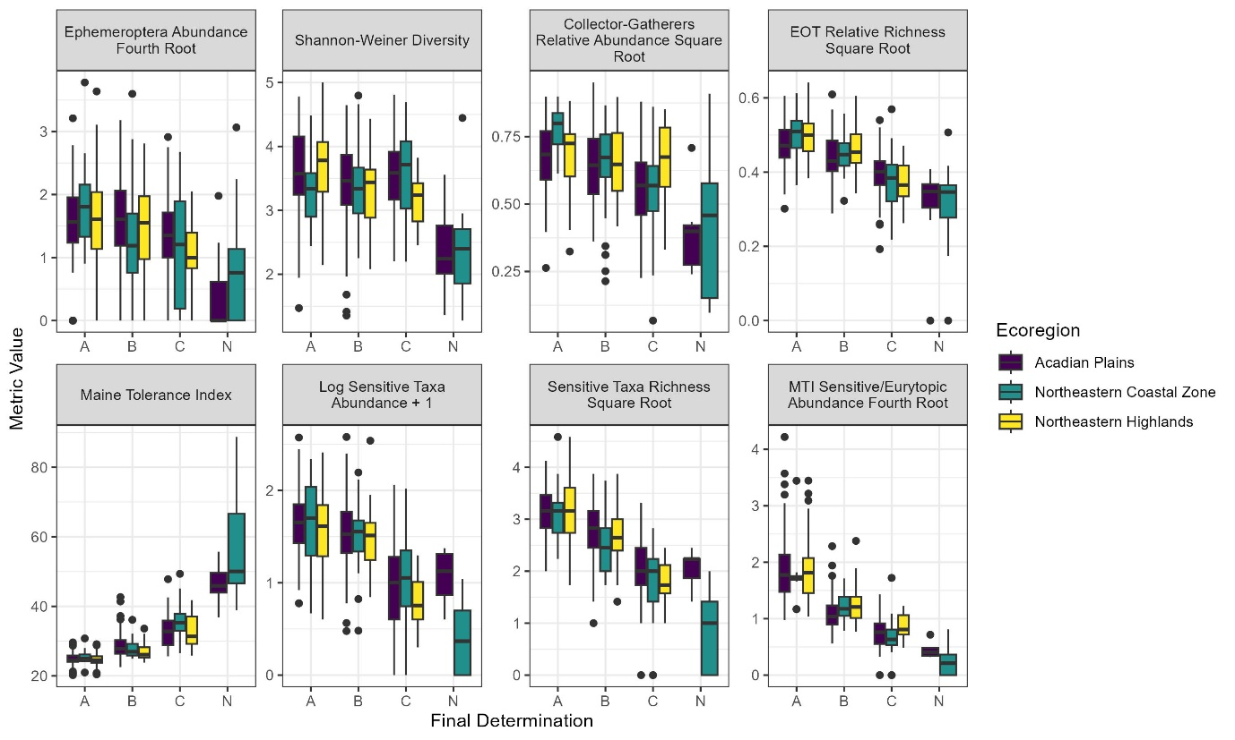

Appendix 1 (continued). LDM Metric Response Plots Updated with All Available Data.

LDM metric response by attained water quality class for macroinvertebrates in soft-bottom habitats. Includes all currently available data (N = 512).
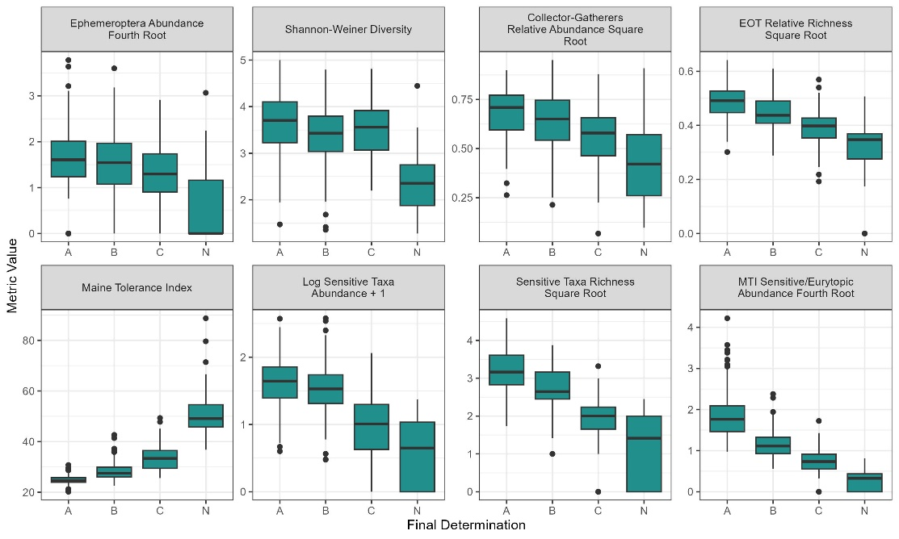
LDM metric responses for epilithic algae in mineral-bottom streams and rivers (comparison by ecoregions). Includes all currently available data (N = 914).
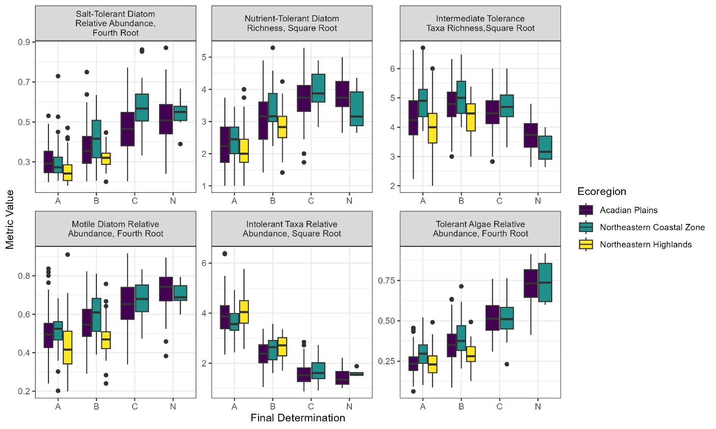

Appendix 1 (continued). LDM Metric Response Plots Updated with All Available Data.

LDM metric response by attained water quality class for epilithic algae in mineral-bottom streams and rivers. Includes all currently available data (N = 914).
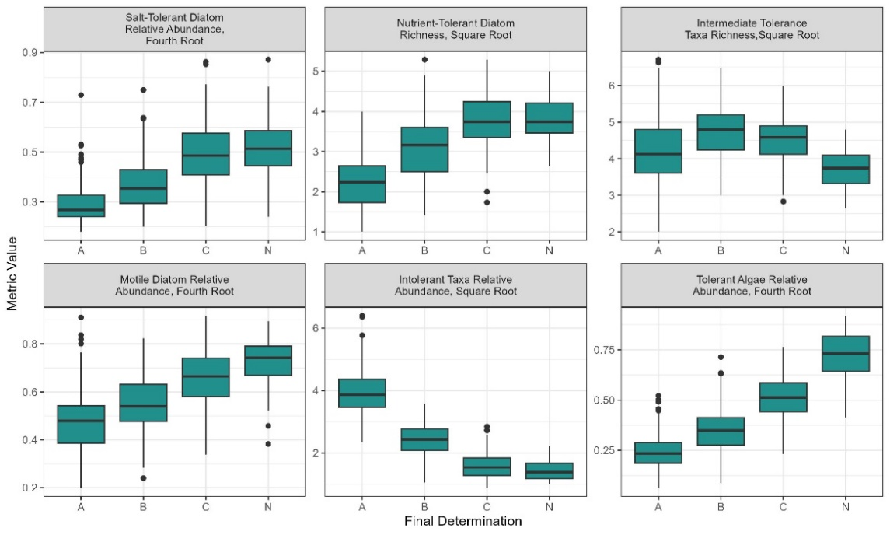
LDM metric responses for epiphytic algae in soft-bottom habitats (comparison by waterbody type). Includes all currently available data (N = 428).
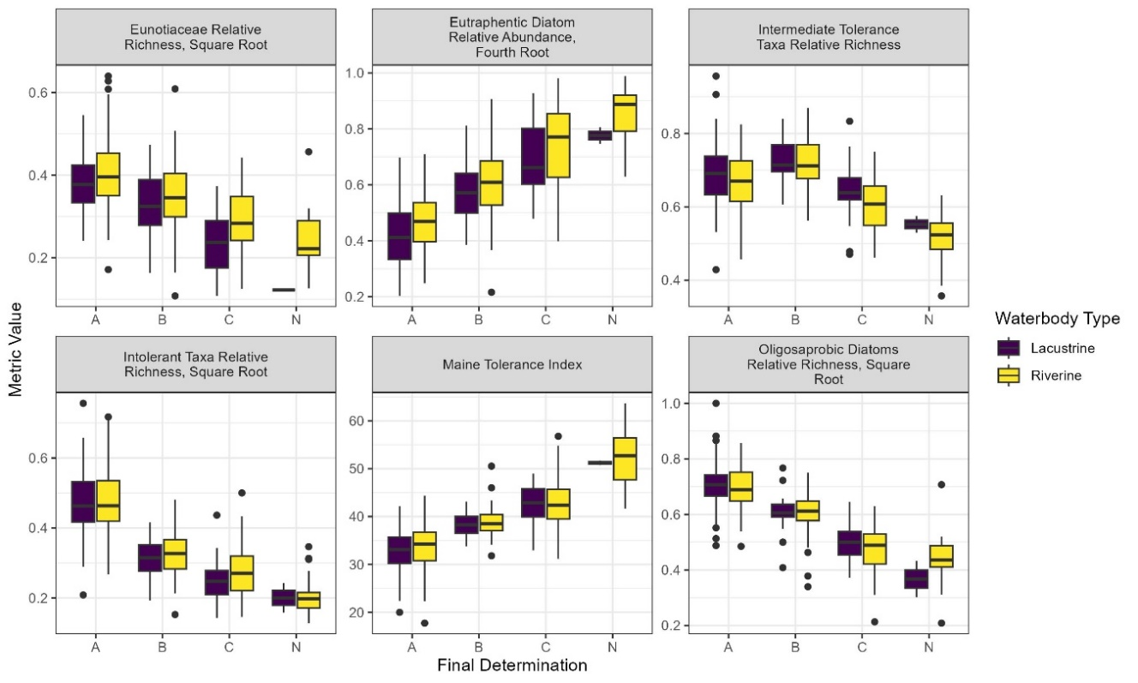

Appendix 1 (continued). LDM Metric Response Plots Updated with All Available Data.
LDM metric responses for epiphytic algae in soft-bottom habitats (comparison by ecoregions). Includes all currently available data (N = 428).
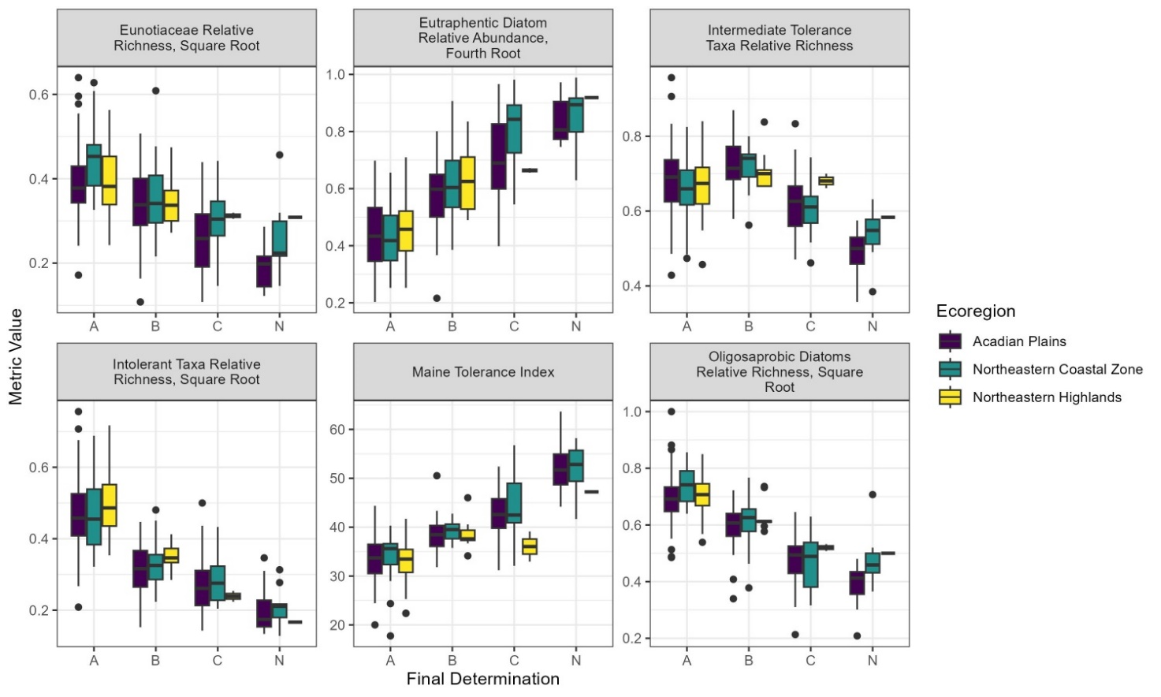
LDM metric response by attained water quality class for epiphytic algae in soft-bottom habitats. Includes all currently available data (N = 428).
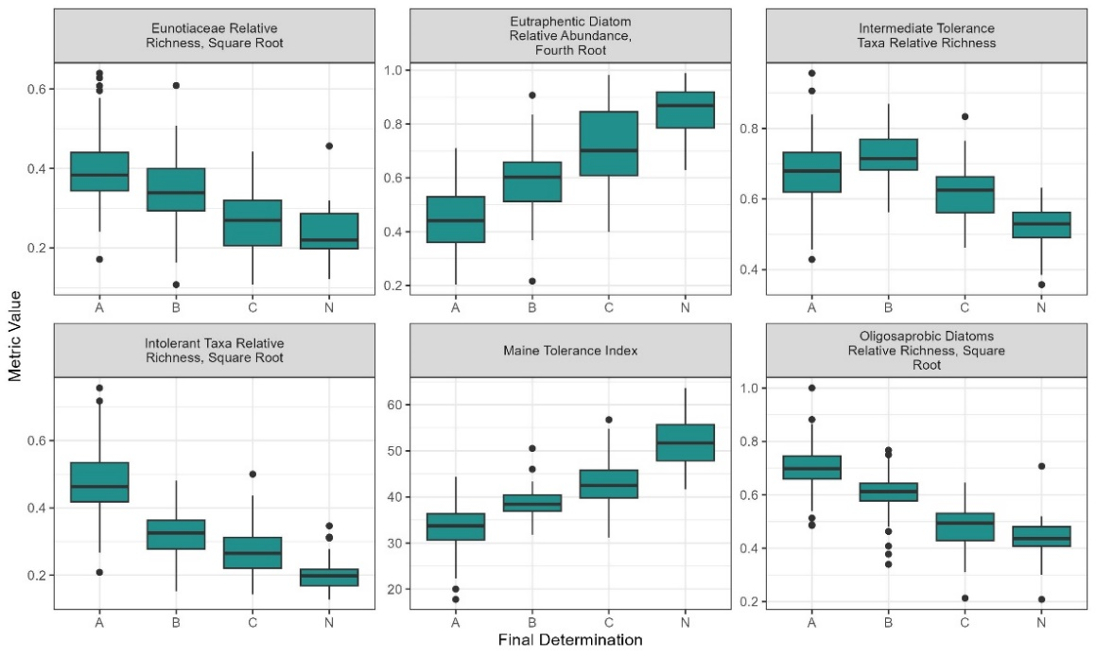

Appendix 2. Maine Tolerance Values for Macroinvertebrates in Soft-Bottom Habitats
Sensitive: 1-22 | Intermediate: 22.1-42.9 | Eurytopic: 43-100
Maine Taxon Code | Taxon | Group | MTV
LW-09020608035 | Agrypnia | Caddisfly | 1.0
LW-09021011108 | Xenochironomus | Fly: Midge | 1.5
LW-08020202018 | Aulodrilus | Tubificid Worm | 3.8
LW-09030110003 | Neolimnochares | Mite | 3.9
LW-08020202012 | Slavina | Worm | 4.2
LW-09020801002 | Sisyra | Sisyrid | 5.8
LW-09021011022 | Zavrelimyia | Fly: Midge | 6.4
LW-09021011083 | Cryptotendipes | Fly: Midge | 7.1
LW-09020901004 | Petrophila | Moth | 7.9
LW-09020301004 | Boyeria | Dragonfly/Damselfly | 8.0
LW-09021011107 | Tribelos | Fly: Midge | 9.3
LW-09021113064 | Dubiraphia | Beetle | 10.4
LW-09030110002 | Limnochares | Mite | 10.5
LW-09020603008 | Neureclipsis | Caddisfly | 10.5
LW-09021011052 | Parakiefferiella | Fly: Midge | 10.9
LW-09021011095 | Nilothauma | Fly: Midge | 11.0
LW-09020309053 | Nehalennia | Dragonfly/Damselfly | 11.3
LW-09021011096 | Pagastiella | Fly: Midge | 11.8
LW-09021104033 | Gyrinus | Beetle | 11.9
LW-09021008031 | Culex | Fly: Mosquito | 12.1
LW-08020202015 | Vejdovskyella | Worm | 13.7
LW-09021011049 | Nanocladius | Fly: Midge | 14.1
LW-09020309052 | Ischnura | Dragonfly/Damselfly | 14.6
LW-09030113001 | Hydrodroma | Mite | 14.8
LW-09020608036 | Banksiola | Caddisfly | 14.9
LW-09020306035 | Libellula | Dragonfly/Damselfly | 15.0
LW-09020603010 | Polycentropus | Caddisfly | 15.4
LW-09020603012 | Plectrocnemia | Caddisfly | 15.4
LW-09021011009 | Larsia | Fly: Midge | 15.6
LW-09020701003 | Nigronia | Dobsonfly | 15.7
LW-09020618078 | Oecetis | Caddisfly | 16.3
LW-09020405021 | Siphlonurus | Mayfly | 17.0
LW-09010202004 | Crangonyx | Amphipod | 17.2
LW-09021011092 | Lauterborniella | Fly: Midge | 17.4

Appendix 2 (continued). Maine Tolerance Values for Macroinvertebrates in Soft-Bottom Habitats
Sensitive: 1-22 |  | Intermediate: 22.1-42.9 | Eurytopic: 43-100
Maine Taxon Code |  | Taxon | Group | MTV
 | LW-09021103014 | Hygrotus | Beetle | 17.6
 | LW-09021010038 | Alluaudomyia | Fly: Biting Midge | 18.0
 | LW-08020202014 | Stylaria | Worm | 18.0
 | LW-09021011008 | Labrundinia | Fly: Midge | 18.1
 | LW-09020618075 | Mystacides | Caddisfly | 18.2
 | LW-09020309050 | Coenagrion | Dragonfly/Damselfly | 18.5
 | LW-10010104013 | Amnicola | Snail | 18.7
 | LW-09020401004 | Cloeon | Mayfly | 19.1
 | LW-09020618077 | Triaenodes | Caddisfly | 19.3
 | LW-09021011006 | Guttipelopia | Fly: Midge | 19.4
 | LW-09020402007 | Arthroplea | Mayfly | 19.5
 | LW-09021011130 | Omisus | Fly: Midge | 20.7
 | LW-09021014052 | Chrysops | Fly: Horse And Deer | 20.7
 | LW-09021011100 | Paratendipes | Fly: Midge | 20.8
 | LW-09021107057 | Scirtes | Beetle | 20.9
 | LW-09020401010 | Procloeon | Mayfly | 21.0
 | LW-09021011133 | Zavreliella | Fly: Midge | 21.8
 | LW-09021011050 | Orthocladius | Fly: Midge | 22.0
 | LW-09020607028 | Oxyethira | Caddisfly | 22.0
 | LW-09021011056 | Psectrocladius | Fly: Midge | 22.0
 | LW-09020412040 | Caenis | Mayfly | 22.1
 | LW-09021011068 | Cladotanytarsus | Fly: Midge | 22.2
 | LW-09021011094 | Microtendipes | Fly: Midge | 22.3
 | LW-09030117001 | Eylais | Mite | 23.0
 | LW-09020410036 | Eurylophella | Mayfly | 23.2
 | LW-09021104032 | Dineutus | Beetle | 23.2
 | LW-09021011001 | Ablabesmyia | Fly: Midge | 23.6
 | LW-09030111001 | Arrenurus | Mite | 23.8
 | LW-09020618072 | Ceraclea | Caddisfly | 23.9
 | LW-09021011102 | Polypedilum | Fly: Midge | 24.2
 | LW-09010203006 | Hyalella | Amphipod | 24.5
 | LW-09020610055 | Limnephilus | Caddisfly | 24.6
 | LW-09021011062 | Thienemanniella | Fly: Midge | 24.7
 | LW-09020306034 | Leucorrhinia | Dragonfly/Damselfly | 24.7
 | LW-09020504013 | Pelocoris | True Bug | 24.7
 | LW-09030108001 | Unionicola | Mite | 24.8
 | LW-10020201003 | Sphaerium | Clam | 24.8

 | Appendix 2 (continued). Maine Tolerance Values for Macroinvertebrates in Soft-Bottom Habitats
Sensitive: 1-22 |  | Intermediate: 22.1-42.9 | Eurytopic: 43-100
Maine Taxon Code |  | Taxon | Group | MTV
 | LW-10020201001 | Musculium | Clam | 24.8
 | LW-09021007025 | Chaoborus | Fly: Phantom Midge | 25.0
 | LW-09021011015 | Procladius | Fly: Midge | 25.1
 | LW-09021114071 | Donacia | Beetle | 25.1
 | LW-09021006024 | Dixella | Fly: Dixid Midge | 25.4
 | LW-09021011076 | Tanytarsus | Fly: Midge | 25.7
 | LW-09030114002 | Hydryphantes | Mite | 25.8
 | LW-09020309051 | Enallagma | Dragonfly/Damselfly | 26.2
 | LW-09021011047 | Limnophyes | Fly: Midge | 26.5
 | LW-10010204035 | Ferrissia | Snail | 26.7
 | LW-09021010043 | Bezzia/palpomyia | Fly: Biting Midge | 26.9
 | LW-09030106001 | Piona | Mite | 27.2
 | LW-09021103030 | Graphoderus | Beetle | 27.4
 | LW-09021011080 | Chironomus | Fly: Midge | 27.4
 | LW-09021011081 | Cladopelma | Fly: Midge | 27.9
 | LW-09020301001 | Aeshna | Dragonfly/Damselfly | 27.9
 | LW-09021011097 | Parachironomus | Fly: Midge | 28.6
 | LW-09021010041 | Probezzia | Fly: Biting Midge | 28.6
 | LW-09021011085 | Dicrotendipes | Fly: Midge | 28.8
 | LW-09021011013 | Paramerina | Fly: Midge | 29.3
 | LW-09020401001 | Baetis | Mayfly | 29.9
 | LW-09021011002 | Clinotanypus | Fly: Midge | 30.3
 | LW-09021010036 | Dasyhelea | Fly: Biting Midge | 30.6
 | LW-09021113070 | Stenelmis | Beetle | 30.7
 | LW-09030103001 | Hydrachna | Mite | 30.8
 | LW-09021011082 | Cryptochironomus | Fly: Midge | 31.3
 | LW-09021103023 | Coptotomus | Beetle | 32.0
 | LW-09020308045 | Lestes | Dragonfly/Damselfly | 32.6
 | LW-10010101001 | Valvata | Snail | 33.4
 | LW-10010203034 | Promenetus | Snail | 33.4
 | LW-09021011018 | Tanypus | Fly: Midge | 33.5
 | LW-10010202027 | Physella | Snail | 34.0
 | LW-09020701001 | Chauliodes | Dobsonfly | 34.4
 | LW-09021103016 | Agabus | Beetle | 34.5
 | LW-08020101002 | Lumbriculus | Worm | 35.0
 | LW-09020512016 | Neoplea | True Bug | 35.5
 | LW-09021011074 | Stempellinella | Fly: Midge | 35.7

 | Appendix 2 (continued). Maine Tolerance Values for Macroinvertebrates in Soft-Bottom Habitats
Sensitive: 1-22 |  | Intermediate: 22.1-42.9 | Eurytopic: 43-100
Maine Taxon Code |  | Taxon | Group | MTV
 | LW-08030203002 | Erpobdella | Leech | 36.4
 | LW-09030112001 | Limnesia | Mite | 37.0
 | LW-09020306041 | Sympetrum | Dragonfly/Damselfly | 37.0
 | LW-09030110001 | Rhyncholimnochares | Mite | 37.1
 | LW-09020306037 | Pachydiplax | Dragonfly/Damselfly | 37.1
 | LW-10010203029 | Gyraulus | Snail | 37.2
 | LW-08020202007 | Dero | Worm | 37.9
 | LW-09021011036 | Corynoneura | Fly: Midge | 40.1
 | LW-09010201003 | Gammarus | Amphipod | 40.3
 | LW-09020401002 | Callibaetis | Mayfly | 40.5
 | LW-09021103018 | Ilybius | Beetle | 40.7
 | LW-09020305026 | Neurocordulia | Dragonfly/Damselfly | 41.3
 | LW-09020502009 | Belostoma | True Bug | 41.7
 | LW-09021010037 | Culicoides | Fly: Biting Midge | 42.1
 | LW-09021008033 | Mansonia | Fly: Mosquito | 42.2
 | LW-09020503012 | Ranatra | True Bug | 42.3
 | LW-10010201025 | Stagnicola | Snail | 42.8
 | LW-10010203030 | Helisoma | Snail | 42.8
 | LW-09021103013 | Hydroporus | Beetle | 42.9
 | LW-09021103021 | Matus | Beetle | 42.9
 | LW-09021008028 | Anopheles | Fly: Mosquito | 43.0
 | LW-09021011037 | Cricotopus | Fly: Midge | 43.0
 | LW-09021011088 | Glyptotendipes | Fly: Midge | 43.0
 | LW-08030101005 | Helobdella | Leech | 43.0
 | LW-08020202009 | Nais | Worm | 43.0
 | LW-09021011071 | Paratanytarsus | Fly: Midge | 43.0
 | LW-09021011011 | Natarsia | Fly: Midge | 43.6
 | LW-09020603011 | Phylocentropus | Caddisfly | 43.8
 | LW-09021011101 | Phaenopsectra | Fly: Midge | 44.2
 | LW-09021011078 | Pseudochironomus | Fly: Midge | 47.7
 | LW-09021113063 | Ancyronyx | Beetle | 49.2
 | LW-09021011087 | Endochironomus | Fly: Midge | 50.2
 | LW-09010101001 | Caecidotea | Isopod | 51.9
 | LW-09020401009 | Labiobaetis | Mayfly | 52.8
 | LW-09021001002 | Tipula | Fly: Crane | 53.8
 | LW-08030101004 | Glossiphonia | Leech | 55.3
 | LW-10010201021 | Fossaria | Snail | 56.1

Appendix 2 (continued). Maine Tolerance Values for Macroinvertebrates in Soft-Bottom Habitats
Sensitive: 1-22 |  | Intermediate: 22.1-42.9 |  | Eurytopic: 43-100
Maine Taxon Code |  | Taxon |  | Group |  | MTV
LW-09021101002 | Peltodytes |  | Beetle |  | 56.2
LW-09021103028 | Hydaticus |  | Beetle |  | 56.9
LW-09021011131 | Monopelopia |  | Fly: Midge |  | 60.4
LW-09020509024 | Mesovelia |  | True Bug |  | 60.6
LW-09021011072 | Rheotanytarsus |  | Fly: Midge |  | 61.6
LW-09021105038 | Tropisternus |  | Beetle |  | 61.8
LW-09021103032 | Deronectes |  | Beetle |  | 63.4
LW-09021103006 | Laccophilus |  | Beetle |  | 63.7
LW-09021101001 | Haliplus |  | Beetle |  | 67.1
LW-09021010046 | Ceratopogon |  | Fly: Biting Midge |  | 71.5
LW-09021011032 | Acricotopus |  | Fly: Midge |  | 75.0
LW-09021011086 | Einfeldia |  | Fly: Midge |  | 76.1
LW-10010201022 | Lymnaea |  | Snail |  | 83.3
LW-08020202022 | Limnodrilus |  | Tubificid Worm |  | 83.9
LW-08020202008 | Haemonais |  | Worm |  | 86.1
LW-09021105040 | Berosus |  | Beetle |  | 87.9
LW-10010102003 | Cipangopaludina |  | Snail |  | 88.2
LW-09021105037 | Hydrophilus |  | Beetle |  | 94.0
LW-09021013051 | Odontomyia |  | Fly: Aquatic Soldier |  | 94.2
LW-09021011016 | Psectrotanypus |  | Fly: Midge |  | 95.6
LW-09021011070 | Micropsectra |  | Fly: Midge |  | 98.1

Appendix 3. Maine Tolerance Values for Epilithic Algae in Mineral-Bottom Streams
Sensitive: 1-32.19 | Intermediate: 32.20-59.99 | Tolerant: 60-100
Maine Taxon Code | Taxon | Group | MTV
LW-22010206003037 | Eunotia muscicola var. tridentula | Pennate Diatom | 1.00
LW-22010201003002 | Diatoma mesodon | Pennate Diatom | 9.68
LW-22010211023004 | Navicula angusta | Pennate Diatom | 11.77
LW-22010206003044 | Eunotia pectinalis | Pennate Diatom | 12.94
LW-22010103002003 | Cyclotella bodanica var. lemanica | Centric Diatom | 14.31
LW-22010210002 | Gomphonema | Pennate Diatom | 15.05
LW-22010210002076 | Gomphonema sp. 14 SAVANNAH EAM | Pennate Diatom | 15.05
LW-22010210002077 | Gomphonema sp. 15 SAVANNAH EAM | Pennate Diatom | 15.05
LW-22010210002078 | Gomphonema sp. 17 NAWQA EAM | Pennate Diatom | 15.05
LW-22010210002079 | Gomphonema sp. 18 NAWQA EAM | Pennate Diatom | 15.05
LW-22010210002080 | Gomphonema sp. 2 ANS NEW JERSEY KCP | Pennate Diatom | 15.05
LW-22010210002081 | Gomphonema sp. 26 NAWQA EAM | Pennate Diatom | 15.05
LW-22010210002082 | Gomphonema sp. 29 NAWQA KM | Pennate Diatom | 15.05
LW-22010210002083 | Gomphonema sp. 31 NAWQA EAM | Pennate Diatom | 15.05
LW-22010210002084 | Gomphonema sp. 32 NAWQA EAM | Pennate Diatom | 15.05
LW-22010210002085 | Gomphonema sp. 34 NAWQA EAM | Pennate Diatom | 15.05
LW-22010210002086 | Gomphonema sp. 36 NAWQA EAM | Pennate Diatom | 15.05
LW-22010210002075 | Gomphonema sp. 1 ME EAM | Pennate Diatom | 15.05
LW-22010210002054 | Gomphonema MESLAP1 | Pennate Diatom | 15.05
LW-22010210002055 | Gomphonema MESLAP2 | Pennate Diatom | 15.05
LW-22010210002056 | Gomphonema MESLAP3 | Pennate Diatom | 15.05
LW-22010210002057 | Gomphonema MESLAP4 | Pennate Diatom | 15.05
LW-22010206003051 | Eunotia rhomboidea | Pennate Diatom | 15.75
LW-22010211005003 | Brachysira brebissonii | Pennate Diatom | 16.29
LW-22010206003022 | Eunotia flexuosa | Pennate Diatom | 16.65
LW-22010211005002 | Brachysira microcephala | Pennate Diatom | 18.00
LW-22010201017006 | Ulnaria oxyrhyncus | Pennate Diatom | 18.33
LW-22010202001001 | Tabellaria fenestrata | Pennate Diatom | 18.76
LW-22010202001003 | Tabellaria flocculosa var. linearis | Pennate Diatom | 18.76
LW-22010202001005 | Tabellaria ventricosa | Pennate Diatom | 18.76
LW-22010202001006 | Tabellaria flocculosa (strain III) | Pennate Diatom | 18.76
LW-22010202001007 | Tabellaria flocculosa (strain IV) | Pennate Diatom | 18.76
LW-22010202001008 | Tabellaria flocculosa (strain IIIp) | Pennate Diatom | 18.76
LW-22010202001002 | Tabellaria flocculosa | Pennate Diatom | 18.76
LW-22010206003003 | Eunotia arcus var. bidens | Pennate Diatom | 18.93
LW-26011202004 | Zygnema | Filamentous Green | 18.98
LW-22010211027041 | Pinnularia subcapitata | Pennate Diatom | 19.46
Appendix 3 (continued). Maine Tolerance Values for Epilithic Algae in Mineral-Bottom Streams
Sensitive: 1-32.19 | Intermediate: 32.20-59.99 | Tolerant: 60-100
Maine Taxon Code | Taxon | Group | MTV
LW-26010201004002 | Tetraedron minimum | Unicellular Green | 19.54
LW-22010206003040 | Eunotia paludosa | Pennate Diatom | 19.92
LW-22010211014003 | Frustulia krammeri | Pennate Diatom | 20.30
LW-22010206003016 | Eunotia exigua | Pennate Diatom | 21.71
LW-22010210002021 | Gomphonema gracile | Pennate Diatom | 21.86
LW-22010206003038 | Eunotia naegelii | Pennate Diatom | 22.28
LW-22010201005004 | Fragilariforma virescens | Pennate Diatom | 23.01
LW-22010207001069 | Cymbella subturgidula | Pennate Diatom | 23.61
LW-22010207001010 | Cymbella cistula | Pennate Diatom | 23.65
LW-22010207002021 | Encyonema neogracile | Pennate Diatom | 24.01
LW-22010206003046 | Eunotia pectinalis var. undulata | Pennate Diatom | 24.34
LW-22010204007012 | Psammothidium marginulatum | Pennate Diatom | 24.64
LW-22010201017005 | Ulnaria delicatissima | Pennate Diatom | 24.65
LW-22010211014002 | Frustulia crassinervia | Pennate Diatom | 24.75
LW-22010206003028 | Eunotia incisa | Pennate Diatom | 24.80
LW-26010701001 | Bulbochaete | Filamentous Green | 25.09
LW-26011101012001 | Staurastrum alternans | Desmid | 25.66
LW-26011101004004 | Cosmarium angulosum | Desmid | 25.97
LW-22010211009007 | Craticula submolesta | Pennate Diatom | 26.63
LW-22010210002001 | Gomphonema acuminatum | Pennate Diatom | 26.66
LW-26011202001 | Mougeotia | Filamentous Green | 26.91
LW-26011202001003 | Mougeotia 15-25Âµm | Filamentous Green | 26.91
LW-26011202001004 | Mougeotia 30-40Âµm | Filamentous Green | 26.91
LW-26011202001005 | Mougeotia sp. 1 d3-10um KMM Maine | Filamentous Green | 26.91
LW-26011202001006 | Mougeotia sp. 2 d10-12,5um KMM Maine | Filamentous Green | 26.91
LW-26011202001002 | Mougeotia 10-12Âµm | Filamentous Green | 26.91
LW-26011202001001 | Mougeotia 5-7Âµm | Filamentous Green | 26.91
LW-26011202001007 | Mougeotia sp. 5 d15-20um KMM Maine | Filamentous Green | 26.91
LW-26011202001008 | Mougeotia sp. 4 d25um KMM Maine | Filamentous Green | 26.91
LW-26011202001009 | Mougeotia sp. 3 d30um KMM Maine | Filamentous Green | 26.91
LW-22010203001024 | Achnanthes nollii | Pennate Diatom | 26.93
LW-22010107002002 | Lindavia michiganiana | Centric Diatom | 27.50
LW-21010101001002 | Batrachospermum vagum | Red Algae | 27.56
LW-21010101001 | Batrachospermum | Red Algae | 27.56
LW-21010101001001 | Batrachospermum spermatangia | Red Algae | 27.56
LW-22010206003027 | Eunotia implicata | Pennate Diatom | 28.33
LW-22010103005001 | Discostella pseudostelligera | Centric Diatom | 28.59

Appendix 3 (continued). Maine Tolerance Values for Epilithic Algae in Mineral-Bottom Streams
Sensitive: 1-32.19 | Intermediate: 32.20-59.99 | Tolerant: 60-100
Maine Taxon Code | Taxon | Group | MTV
LW-22010206003062 | Eunotia subarcuatoides | Pennate Diatom | 28.62
LW-26010901003 | Ulothrix | Filamentous Green | 28.94
LW-26010901003003 | Ulothrix zonata | Filamentous Green | 28.94
LW-26010901003002 | Ulothrix tenerrima | Filamentous Green | 28.94
LW-26010901003001 | Ulothrix aequalis | Filamentous Green | 28.94
LW-26010901003004 | Ulothrix tenuissima | Filamentous Green | 28.94
LW-26010901003006 | Ulothrix spp. 2 MESJAH | Filamentous Green | 28.94
LW-26010901003005 | Ulothrix sp. 1 MESLAP | Filamentous Green | 28.94
LW-22010211001004 | Adlafia suchlandtii | Pennate Diatom | 29.09
LW-20010203001003 | Calothrix fusca | Filamentous Cyanobacteria | 29.11
LW-20010203001 | Calothrix | Filamentous Cyanobacteria | 29.11
LW-20010203001004 | Calothrix sp. 22Âµm | Filamentous Cyanobacteria | 29.11
LW-20010203001001 | Calothrix braunii | Filamentous Cyanobacteria | 29.11
LW-20010203001002 | Calothrix cf breviaticulata | Filamentous Cyanobacteria | 29.11
LW-22010204002003 | Eucocconeis laevis | Pennate Diatom | 29.52
LW-20010102001005 | Chroococcus minor | Cyanobacteria | 30.09
LW-22010204007007 | Psammothidium grischunum fo. daonensis | Pennate Diatom | 30.16
LW-22010201004009 | FragilariaÂ gracilis | Pennate Diatom | 30.58
LW-22010204007003 | Psammothidium bioretii | Pennate Diatom | 31.23
LW-22010210002017 | Gomphonema clevei | Pennate Diatom | 31.28
LW-22010210003001 | Delicata delicatula | Pennate Diatom | 31.33
LW-26011102001024 | Closterium parvulum | Desmid | 31.66
LW-22010201017001 | Ulnaria acus | Pennate Diatom | 31.66
LW-22010201004029 | Fragilaria tenera | Pennate Diatom | 31.94
LW-22010204008001 | Rossithidium linearis | Pennate Diatom | 32.00
LW-22010211005006 | Brachysira vitrea | Pennate Diatom | 32.00
LW-22010210002041 | Gomphonema rhombicum | Pennate Diatom | 32.06
LW-22010201004036 | Fragilaria sepes | Pennate Diatom | 32.08
LW-22010201009001 | Pseudostaurosira brevistriata | Pennate Diatom | 32.24
LW-22010204007004 | Psammothidium chlidanos | Pennate Diatom | 32.48
LW-22010201004006 | Fragilaria capucina | Pennate Diatom | 32.90
LW-22010201017007 | Ulnaria ulna | Pennate Diatom | 34.21
LW-22010210002004 | Gomphonema affine | Pennate Diatom | 34.28
LW-22010201013008 | Synedra rumpens | Pennate Diatom | 34.30
LW-20010104001001 | Aphanocapsa elachista | Cyanobacteria | 34.38
LW-22010101001002 | Aulacoseira ambigua | Centric Diatom | 34.52

Appendix 3 (continued). Maine Tolerance Values for Epilithic Algae in Mineral-Bottom Streams
Sensitive: 1-32.19 | Intermediate: 32.20-59.99 | Tolerant: 60-100
Maine Taxon Code | Taxon | Group | MTV
LW-20010303002001 | Planktothrix prolifica | Filamentous Cyanobacteria | 34.79
LW-22010207003003 | Encyonopsis microcephala | Pennate Diatom | 34.81
LW-26010203004001 | Stauridium tetras | Colonial Green | 35.16
LW-26011102001022 | Closterium moniliferum | Desmid | 35.86
LW-22010211023096 | Navicula radiosafallax | Pennate Diatom | 36.33
LW-22010207001001 | Cymbella affinis | Pennate Diatom | 36.44
LW-22010210002046 | Gomphonema truncatum | Pennate Diatom | 36.49
LW-22010210002007 | Gomphonema angustum | Pennate Diatom | 37.10
LW-26010102004 | Gongrosira | Filamentous Green | 37.29
LW-22010211023078 | Navicula notha | Pennate Diatom | 37.39
LW-22010211007001 | Cavinula cocconeiformis | Pennate Diatom | 37.50
LW-22010206003005 | Eunotia bilunaris | Pennate Diatom | 37.57
LW-26010701002 | Oedogonium | Filamentous Green | 37.60
LW-26010701002006 | Oedogonium 15-20 Âµm | Filamentous Green | 37.60
LW-26010701002001 | Oedogonium undulatum | Filamentous Green | 37.60
LW-26010701002007 | Oedogonium spp. (20-25um) | Filamentous Green | 37.60
LW-26010701002005 | Oedogonium 10-12Âµm | Filamentous Green | 37.60
LW-26010701002004 | Oedogonium 5-7Âµm | Filamentous Green | 37.60
LW-26010701002002 | Oedogonium cf. nodulosum | Filamentous Green | 37.60
LW-26010701002009 | Oedogonium 1um | Filamentous Green | 37.60
LW-26010701002003 | Oedogonium spp. (3.5um) | Filamentous Green | 37.60
LW-26010701002008 | Oedogonium 50Âµm | Filamentous Green | 37.60
LW-22010207003001 | Encyonopsis cesatii | Pennate Diatom | 38.01
LW-22010211001001 | Adlafia bryophila | Pennate Diatom | 38.22
LW-20010304004 | Leptolyngbya | Filamentous Cyanobacteria | 38.27
LW-22010210002028 | Gomphonema micropus | Pennate Diatom | 38.99
LW-20010101003 | Geitleribactron | Filamentous Cyanobacteria | 39.35
LW-26010201005001 | Gloeocystis planctonica | Colonial Green | 39.59
LW-26010201005 | Gloeocystis | Colonial Green | 39.59
LW-26010201005009 | Gloeocystis sp. 1 MESLAP | Colonial Green | 39.59
LW-26010201005002 | Gloeocystis spp. (5.5um) | Colonial Green | 39.59
LW-26010201005005 | Gloeocystis spp. 2 MESJAH | Colonial Green | 39.59
LW-26010201005003 | Gloeocystis spp. (10um) | Colonial Green | 39.59
LW-26010201005008 | Gloeocystis sp. 2 MESLAP | Colonial Green | 39.59
LW-26010201005007 | Gloeocystis sp. 3 MESLAP | Colonial Green | 39.59
LW-26010201005004 | Gloeocystis spp. 1 MESJAH | Colonial Green | 39.59
LW-26010201005006 | Gloeocystis spp. 3 MESJAH | Colonial Green | 39.59

Appendix 3 (continued). Maine Tolerance Values for Epilithic Algae in Mineral-Bottom Streams
Sensitive: 1-32.19 | Intermediate: 32.20-59.99 | Tolerant: 60-100
Maine Taxon Code | Taxon | Group | MTV
LW-26010206004023 | Scenedesmus ecornis | Colonial Green | 39.88
LW-22010211030002 | Stauroneis anceps | Pennate Diatom | 40.11
LW-22010203002007 | Platessa stewartii | Pennate Diatom | 40.61
LW-22010210002037 | Gomphonema pseudotenellum | Pennate Diatom | 40.80
LW-22010204001009 | Achnanthidium minutissimum | Pennate Diatom | 41.16
LW-22010201011004 | Staurosira construens var. venter | Pennate Diatom | 41.30
LW-22010211023095 | Navicula radiosa | Pennate Diatom | 41.83
LW-22010211008003 | Chamaepinnularia mediocris | Pennate Diatom | 41.87
LW-22010211023054 | Navicula hintzii | Pennate Diatom | 42.08
LW-22010210002034 | Gomphonema parvulum | Pennate Diatom | 42.17
LW-22010210002050 | Gomphonema cf. parvulum MESLAP1 | Pennate Diatom | 42.17
LW-22010210002051 | Gomphonema cf. parvulum MESLAP2 | Pennate Diatom | 42.17
LW-22010210002052 | Gomphonema cf. parvulum MESLAP3 | Pennate Diatom | 42.17
LW-22010210002053 | Gomphonema cf. parvulum MESLAP4 | Pennate Diatom | 42.17
LW-22010204007014 | Psammothidium subatomoides | Pennate Diatom | 42.42
LW-22010206003033 | Eunotia minor | Pennate Diatom | 42.43
LW-26011202003 | Spirogyra | Filamentous Green | 42.56
LW-26011202003002 | Spirogyra 15-20Âµm | Filamentous Green | 42.56
LW-26011202003009 | Spirogyra >100Âµm | Filamentous Green | 42.56
LW-26011202003006 | Spirogyra 50Âµm | Filamentous Green | 42.56
LW-26011202003008 | Spirogyra spp. (55um) | Filamentous Green | 42.56
LW-26011202003003 | Spirogyra spp. (20-25um) | Filamentous Green | 42.56
LW-26011202003007 | Spirogyra sp. 3 d53 KMM Maine | Filamentous Green | 42.56
LW-26011202003005 | Spirogyra 30-40Âµm | Filamentous Green | 42.56
LW-26011202003001 | Spirogyra 10-15Âµm | Filamentous Green | 42.56
LW-26011202003004 | Spirogyra sp. 2 d25-35 KMM Maine | Filamentous Green | 42.56
LW-20010303001019 | Phormidium ambiguum | Filamentous Cyanobacteria | 42.62
LW-20010303001008 | Phormidium minnesotense | Filamentous Cyanobacteria | 42.62
LW-20010303001010 | Phormidium retzii | Filamentous Cyanobacteria | 42.62
LW-20010303001 | Phormidium | Filamentous Cyanobacteria | 42.62
LW-20010303001018 | Phormidium autumnale | Filamentous Cyanobacteria | 42.62
LW-20010304011003 | Geitlerinema acutissimum | Filamentous Cyanobacteria | 42.62
LW-20010303001002 | Phormidium aerugineo-caeruleum | Filamentous Cyanobacteria | 42.62
LW-20010303001012 | Phormidium amoenum | Filamentous Cyanobacteria | 42.62
LW-20010303001003 | Phormidium amphibium | Filamentous Cyanobacteria | 42.62
LW-20010303001004 | Phormidium chalybeum | Filamentous Cyanobacteria | 42.62
LW-20010303001005 | Phormidium formosum | Filamentous Cyanobacteria | 42.62

Appendix 3 (continued). Maine Tolerance Values for Epilithic Algae in Mineral-Bottom Streams
Sensitive: 1-32.19 | Intermediate: 32.20-59.99 | Tolerant: 60-100
Maine Taxon Code | Taxon | Group | MTV
LW-20010303001006 | Phormidium granulatum | Filamentous Cyanobacteria | 42.62
LW-20010303001009 | Phormidium nigrum | Filamentous Cyanobacteria | 42.62
LW-20010303001011 | Phormidium tergestinium | Filamentous Cyanobacteria | 42.62
LW-20010303001020 | Phormidium cf. formosum | Filamentous Cyanobacteria | 42.62
LW-20010303001007 | Phormidium limnetic | Filamentous Cyanobacteria | 42.62
LW-20010303001017 | Phormidium sp. 3 d7um KMM Maine | Filamentous Cyanobacteria | 42.62
LW-20010303001014 | Phormidium spp. 1 MESJAH | Filamentous Cyanobacteria | 42.62
LW-20010303001013 | Phormidium taylori | Filamentous Cyanobacteria | 42.62
LW-20010303001015 | Phormidium sp. 1 KMM Maine | Filamentous Cyanobacteria | 42.62
LW-20010303001016 | Phormidium sp. 2 d5um tapering KMM Maine | Filamentous Cyanobacteria | 42.62
LW-26010102002001 | Stigeoclonium lubricum | Filamentous Green | 42.63
LW-26010102002 | Stigeoclonium | Filamentous Green | 42.63
LW-26010102002002 | Stigeoclonium nanum | Filamentous Green | 42.63
LW-26010102002004 | Stigeoclonium polymorphum | Filamentous Green | 42.63
LW-26010102002003 | Stigeoclonium pachydermum | Filamentous Green | 42.63
LW-20010304002002 | Homoeothrix janthina (basal coccoid cells) | Filamentous Cyanobacteria | 43.04
LW-20010304002001 | Homoeothrix janthina | Filamentous Cyanobacteria | 43.04
LW-20010106001001 | Aphanothece clathrata | Cyanobacteria | 43.10
LW-22010101001001 | Aulacoseira alpigena | Centric Diatom | 43.36
LW-22010204001003 | Achnanthidium deflexum | Pennate Diatom | 43.50
LW-22010210002016 | Gomphonema clavatum | Pennate Diatom | 43.55
LW-22010210002073 | Gomphonema pumilum var. rigidum | Pennate Diatom | 43.57
LW-22010210002038 | Gomphonema pumilum | Pennate Diatom | 43.57
LW-22010201007002 | Meridion circulare var. constrictum | Pennate Diatom | 43.73
LW-22010211002001 | Amphipleura pellucida | Pennate Diatom | 43.83
LW-26010206004005 | Scenedesmus acuminatus | Colonial Green | 44.01
LW-22010201012004 | Staurosirella pinnata | Pennate Diatom | 44.18
LW-22010201004030 | Fragilaria vaucheriae | Pennate Diatom | 44.20
LW-22010211014001 | Frustulia amphipleuroides | Pennate Diatom | 44.46
LW-22010211015002 | Geissleria decussis | Pennate Diatom | 44.52
LW-22010211023034 | Navicula cryptotenella | Pennate Diatom | 44.59
LW-22010210002044 | Gomphonema subclavatum | Pennate Diatom | 44.70
LW-22010201009011 | Pseudostaurosira elliptica | Pennate Diatom | 44.94
LW-22010211023066 | Navicula leptostriata | Pennate Diatom | 45.28
LW-22010211049002 | HumidophilaÂ schmassmannii | Pennate Diatom | 45.36
LW-26010206004032 | Scenedesmus spinosus | Colonial Green | 45.72
LW-26010205002002 | Ankistrodesmus falcatus | Colonial Green | 45.73

Appendix 3 (continued). Maine Tolerance Values for Epilithic Algae in Mineral-Bottom Streams
Sensitive: 1-32.19 | Intermediate: 32.20-59.99 | Tolerant: 60-100
Maine Taxon Code | Taxon | Group | MTV
LW-26010206004029 | Scenedesmus quadricauda | Colonial Green | 46.40
LW-22010201007001 | Meridion circulare | Pennate Diatom | 46.45
LW-22010214004069 | Nitzschia recta | Pennate Diatom | 46.63
LW-22010201003004 | Diatoma tenuis | Pennate Diatom | 46.79
LW-22010201011001 | Staurosira construens | Pennate Diatom | 46.82
LW-22010211029005 | Sellaphora pupula | Pennate Diatom | 46.84
LW-22010214004034 | Nitzschia gracilis | Pennate Diatom | 46.90
LW-22010207002007 | Encyonema silesiacum | Pennate Diatom | 46.95
LW-22010211027032 | Pinnularia obscura | Pennate Diatom | 47.05
LW-26010205002006 | Ankistrodesmus sp. 1 ANS FWA Adirondack | Colonial Green | 47.47
LW-26010205002 | Ankistrodesmus | Colonial Green | 47.47
LW-21010102001 | Audouinella | Red Algae | 47.47
LW-21010000001 | Unknown Rhodophyte Florideophycidae (Chantransia) | Red Algae | 47.47
LW-20010104005007 | Merismopedia tenuissima | Cyanobacteria | 47.59
LW-22010201010001 | Stauroforma exiguiformis | Pennate Diatom | 48.04
LW-22010211030006 | Stauroneis kriegeri | Pennate Diatom | 48.35
LW-20010302001009 | Lyngbya sp. 2 ANS FWA | Filamentous Cyanobacteria | 48.50
LW-20010302001010 | Lyngbya sp. 3 ANS FWA | Filamentous Cyanobacteria | 48.50
LW-20010302001001 | Lyngbya aestuarii | Filamentous Cyanobacteria | 48.50
LW-20010302001 | Lyngbya | Filamentous Cyanobacteria | 48.50
LW-20010302001002 | Lyngbya major | Filamentous Cyanobacteria | 48.50
LW-20010302001004 | Lyngbya cf. martensiana MESLAP | Filamentous Cyanobacteria | 48.50
LW-20010302001003 | Lyngbya cf. limnetica MESLAP | Filamentous Cyanobacteria | 48.50
LW-20010302001006 | Lyngbya spp. 2 MESJAH | Filamentous Cyanobacteria | 48.50
LW-20010302001008 | Lyngbya sp. 2 d25um KMM Maine | Filamentous Cyanobacteria | 48.50
LW-20010302001007 | Lyngbya spp. 3 MESJAH | Filamentous Cyanobacteria | 48.50
LW-20010302001005 | Lyngbya spp. 1 MESJAH | Filamentous Cyanobacteria | 48.50
LW-22010211029019 | Sellaphora stroemii | Pennate Diatom | 48.65
LW-22010201009003 | Pseudostaurosira parasitica | Pennate Diatom | 49.60
LW-22010201002001 | Ctenophora pulchella | Pennate Diatom | 49.74
LW-22010203002001 | Platessa conspicua | Pennate Diatom | 49.76
LW-22010204001011 | Achnanthidium rivulare | Pennate Diatom | 49.90
LW-22010207002003 | Encyonema minutum | Pennate Diatom | 50.19
LW-22010201004007 | Fragilaria vaucheriae var. capitellata | Pennate Diatom | 50.33
LW-22010214004032 | Nitzschia frustulum | Pennate Diatom | 50.40
LW-22010211015001 | Geissleria acceptata | Pennate Diatom | 50.83
LW-22010204001004 | Achnanthidium exiguum | Pennate Diatom | 51.12
Appendix 3 (continued). Maine Tolerance Values for Epilithic Algae in Mineral-Bottom Streams
Sensitive: 1-32.19 | Intermediate: 32.20-59.99 | Tolerant: 60-100
Maine Taxon Code | Taxon | Group | MTV
LW-22010211029008 | Sellaphora seminulum | Pennate Diatom | 51.46
LW-22010205001006 | Cocconeis placentula var. lineata | Pennate Diatom | 51.52
LW-22010210002070 | Gomphonema olivaceoides var. hutchinsoniana | Pennate Diatom | 51.56
LW-22010207005008 | Cymbopleura naviculiformis | Pennate Diatom | 51.58
LW-22010214004003 | Nitzschia acidoclinata | Pennate Diatom | 51.64
LW-22010211014008 | Frustulia vulgaris | Pennate Diatom | 51.66
LW-22010201003003 | Diatoma moniliformis | Pennate Diatom | 52.82
LW-20010202001004 | Anabaena oscillarioides | Filamentous Cyanobacteria | 53.11
LW-20010202001 | Anabaena | Filamentous Cyanobacteria | 53.11
LW-20010202001009 | Anabaena subcylindrica | Filamentous Cyanobacteria | 53.11
LW-20010202001001 | Anabaena affinis | Filamentous Cyanobacteria | 53.11
LW-20010202001003 | Anabaena limnetica | Filamentous Cyanobacteria | 53.11
LW-20010202001015 | Anabaena sp. 1 MSU NAWQA KMM 1998 | Filamentous Cyanobacteria | 53.11
LW-20010202001002 | Anabaena inaequalis | Filamentous Cyanobacteria | 53.11
LW-20010202001006 | Anabaena macrospora | Filamentous Cyanobacteria | 53.11
LW-20010202001012 | Anabaena sp.1 KMM Maine | Filamentous Cyanobacteria | 53.11
LW-20010202001011 | Anabaena cf. scheremetievi KMM Maine | Filamentous Cyanobacteria | 53.11
LW-20010202001005 | Anabaena planctonica | Filamentous Cyanobacteria | 53.11
LW-20010202001013 | Anabaena sp. 2 MESLAP | Filamentous Cyanobacteria | 53.11
LW-20010202001007 | Anabaena spiroides | Filamentous Cyanobacteria | 53.11
LW-20010202001008 | Anabaena spiroides var. crassa | Filamentous Cyanobacteria | 53.11
LW-20010202001010 | Anabaena wisconsiense | Filamentous Cyanobacteria | 53.11
LW-20010202001014 | Anabaena sp. 3 MESJAH | Filamentous Cyanobacteria | 53.11
LW-22010204007015 | Psammothidium ventralis | Pennate Diatom | 53.34
LW-22010214004054 | Nitzschia palea var. debilis | Pennate Diatom | 53.37
LW-20010108003 | Xenococcus | Cyanobacteria | 53.40
LW-22010209001003 | Amphora copulata | Pennate Diatom | 53.47
LW-22010204003004 | Karayevia suchlandtii | Pennate Diatom | 53.53
LW-22010210002019 | Gomphonema drutelingense | Pennate Diatom | 53.99
LW-22010214004046 | Nitzschia linearis | Pennate Diatom | 54.17
LW-22010204003002 | Karayevia clevei | Pennate Diatom | 54.31
LW-26011001001 | Chlamydomonas | Unicellular Green | 54.46
LW-26011001001003 | Chlamydomonas gracilis | Unicellular Green | 54.46
LW-26011001001002 | Chlamydomonas gloeophila | Unicellular Green | 54.46
LW-26011001001001 | Chlamydomonas angulosa | Unicellular Green | 54.46
LW-26011001001004 | Chlamydomonas sp. 807um | Unicellular Green | 54.46
LW-22010210002029 | Gomphonema minutum | Pennate Diatom | 54.56

Appendix 3 (continued). Maine Tolerance Values for Epilithic Algae in Mineral-Bottom Streams
Sensitive: 1-32.19 | Intermediate: 32.20-59.99 | Tolerant: 60-100
Maine Taxon Code | Taxon | Group | MTV
LW-22010211023099 | Navicula reichardtiana | Pennate Diatom | 55.66
LW-22010211023033 | Navicula cryptocephala | Pennate Diatom | 56.30
LW-22010204006013 | Planothidium rostratum | Pennate Diatom | 56.59
LW-22010214004061 | Nitzschia perminuta | Pennate Diatom | 56.67
LW-22010211040001 | Eolimna minima | Pennate Diatom | 56.98
LW-22010204001031 | Achnanthidium subhudsonis var. kraeuselii | Pennate Diatom | 57.01
LW-22010207001048 | Cymbella tumida | Pennate Diatom | 57.83
LW-22010210002006 | Gomphonema angustatum | Pennate Diatom | 57.99
LW-22010205001005 | Cocconeis placentula var. euglypta | Pennate Diatom | 58.16
LW-22010211023138 | Navicula viridulacalcis | Pennate Diatom | 58.90
LW-22010204003003 | Karayevia laterostrata | Pennate Diatom | 58.98
LW-26010204001004 | Microspora pachyderma | Filamentous Green | 59.00
LW-26010204001001 | Microspora amoena | Filamentous Green | 59.00
LW-26010204001 | Microspora | Filamentous Green | 59.00
LW-26010204001002 | Microspora amoena var. crassior | Filamentous Green | 59.00
LW-26010204001007 | Microspora amoena var. gracilis | Filamentous Green | 59.00
LW-26010204001003 | Microspora floccosa | Filamentous Green | 59.00
LW-26010204001011 | Microspora spp. 4 MESJAH | Filamentous Green | 59.00
LW-26010204001008 | Microspora spp. 1 MESJAH | Filamentous Green | 59.00
LW-26010204001010 | Microspora spp. 3 MESJAH | Filamentous Green | 59.00
LW-26010204001009 | Microspora spp. 2 MESJAH | Filamentous Green | 59.00
LW-22010214004012 | Nitzschia archibaldii | Pennate Diatom | 60.05
LW-22010214004053 | Nitzschia palea | Pennate Diatom | 60.34
LW-22010214004022 | Nitzschia dissipata | Pennate Diatom | 60.87
LW-22010207004001 | Reimeria sinuata | Pennate Diatom | 60.92
LW-22010214004056 | Nitzschia paleacea | Pennate Diatom | 61.33
LW-22010213004001 | Surirella amphioxys | Pennate Diatom | 61.47
LW-22010211023101 | Navicula rhynchocephala | Pennate Diatom | 62.11
LW-22010204003009 | Karayevia oblongella | Pennate Diatom | 62.17
LW-22010211019001 | Luticola mutica | Pennate Diatom | 62.17
LW-22010214004044 | Nitzschia lacuum | Pennate Diatom | 64.03
LW-22010211023071 | Navicula menisculus | Pennate Diatom | 64.26
LW-22010211008002 | Chamaepinnularia bremensis | Pennate Diatom | 64.44
LW-22010204001001 | Achnanthidium affine | Pennate Diatom | 64.71
LW-22010214004023 | Nitzschia dissipata var. media | Pennate Diatom | 64.73
LW-22010211006002 | Caloneis bacillum | Pennate Diatom | 64.95
LW-22010204006014 | Planothidium frequentissimum | Pennate Diatom | 65.05

Appendix 3 (continued). Maine Tolerance Values for Epilithic Algae in Mineral-Bottom Streams
Sensitive: 1-32.19 | Intermediate: 32.20-59.99 | Tolerant: 60-100
Maine Taxon Code | Taxon | Group | MTV
LW-22010211021003 | Mayamaea permitis | Pennate Diatom | 65.27
LW-22010214004083 | Nitzschia supralitorea | Pennate Diatom | 65.38
LW-22010213004002 | Surirella angusta | Pennate Diatom | 65.40
LW-22010211023005 | Navicula antonii | Pennate Diatom | 65.42
LW-22010214004045 | Nitzschia liebethruthii | Pennate Diatom | 65.76
LW-22010211023035 | Navicula cryptotenelloides | Pennate Diatom | 66.01
LW-22010211023103 | Navicula rostellata | Pennate Diatom | 66.11
LW-22010211023043 | Navicula erifuga | Pennate Diatom | 66.46
LW-22010211017001 | Hippodonta capitata | Pennate Diatom | 66.82
LW-22010211027046 | Pinnularia viridis | Pennate Diatom | 66.84
LW-22010101002001 | Melosira varians | Centric Diatom | 66.95
LW-22010211009006 | Craticula molestiformis | Pennate Diatom | 67.22
LW-22010211023109 | Navicula escambia | Pennate Diatom | 67.29
LW-22010211021001 | Mayamaea agrestis | Pennate Diatom | 67.77
LW-22010211023013 | Navicula capitatoradiata | Pennate Diatom | 68.50
LW-22010211023129 | Navicula tripunctata | Pennate Diatom | 69.44
LW-22010211023137 | Navicula viridula | Pennate Diatom | 70.67
LW-22010210002030 | Gomphonema olivaceoides | Pennate Diatom | 70.80
LW-22010214004065 | Nitzschia pumila | Pennate Diatom | 71.18
LW-22010210002025 | Gomphonema kobayasii | Pennate Diatom | 71.24
LW-22010205001002 | Cocconeis pediculus | Pennate Diatom | 72.28
LW-22010204006010 | Planothidium lanceolatum | Pennate Diatom | 72.50
LW-22010204006020 | Planothidium lanceolatum var. omissum | Pennate Diatom | 72.50
LW-22010103002006 | Cyclotella meneghiniana | Centric Diatom | 72.58
LW-22010214004017 | Nitzschia capitellata | Pennate Diatom | 75.66
LW-22010211023126 | Navicula tenelloides | Pennate Diatom | 75.83
LW-22010207002006 | Encyonema reichardtii | Pennate Diatom | 76.13
LW-22010209001010 | Amphora pediculus | Pennate Diatom | 76.18
LW-22010211023062 | Navicula lanceolata | Pennate Diatom | 77.53
LW-22010211023130 | Navicula trivialis | Pennate Diatom | 78.55
LW-22010211023049 | Navicula gregaria | Pennate Diatom | 79.60
LW-22010213004011 | Surirella minuta | Pennate Diatom | 79.72
LW-22010211023135 | Navicula veneta | Pennate Diatom | 79.74
LW-22010214004006 | Nitzschia amphibia | Pennate Diatom | 79.84
LW-26010401001007 | Cladophora glomerata | Filamentous Green | 80.00
LW-26010401001 | Cladophora | Filamentous Green | 80.00
LW-26010401001006 | Cladophora spp. (30um) | Filamentous Green | 80.00

Appendix 3 (continued). Maine Tolerance Values for Epilithic Algae in Mineral-Bottom Streams
Sensitive: 1-32.19 | Intermediate: 32.20-59.99 | Tolerant: 60-100
Maine Taxon Code | Taxon | Group | MTV
LW-26010401001005 | Cladophora spp. (60um) | Filamentous Green | 80.00
LW-26010401001004 | Cladophora spp. (25um) | Filamentous Green | 80.00
LW-26010401001003 | Cladophora spp. (35um) | Filamentous Green | 80.00
LW-22010207002005 | Encyonema prostratum | Pennate Diatom | 80.90
LW-22010214004087 | Nitzschia tubicola | Pennate Diatom | 81.23
LW-22010214004031 | Nitzschia fonticola | Pennate Diatom | 82.24
LW-22010212001001 | Rhoicosphenia abbreviata | Pennate Diatom | 83.40
LW-22010214004041 | Nitzschia inconspicua | Pennate Diatom | 83.70
LW-22010201003005 | Diatoma vulgaris | Pennate Diatom | 88.74
LW-22010213004005 | Surirella brebissonii | Pennate Diatom | 100.00

 | Appendix 4. Maine Tolerance Values for Ephiphytic Algae in Soft-Bottom Habitats
 | Sensitive: 1-34.9 | Intermediate: 35.0-51.9 | Eurytopic: 52-100
 | Maine Taxon Code | Taxon | Group | MTV
 | LW-22010206001001 | Actinella punctata | Pennate Diatom | 1.0
 | LW-22010213003003 | Stenopterobia delicatissima | Pennate Diatom | 7.5
 | LW-22010201005004 | Fragilariforma virescens | Pennate Diatom | 7.8
 | LW-22010206003056 | Eunotia serra | Pennate Diatom | 10.7
 | LW-22010206003040 | Eunotia paludosa | Pennate Diatom | 11.2
 | LW-22010206003024 | Eunotia glacialis | Pennate Diatom | 11.4
 | LW-22010211007005 | Cavinula pseudoscutiformis | Pennate Diatom | 11.7
 | LW-22010211014006 | Frustulia saxonica | Pennate Diatom | 12.4
 | LW-22010206003048 | Eunotia pirla | Pennate Diatom | 14.6
 | LW-22010101001005 | Aulacoseira distans | Centric Diatom | 14.8
 | LW-26011101006013 | Euastrum pulchellum | Desmid | 15.0
 | LW-22010101001014 | Aulacoseira subarctica | Centric Diatom | 15.3
 | LW-22010213003002 | Stenopterobia curvula | Pennate Diatom | 15.4
 | LW-26011101002001 | Bambusina brebissonii | Desmid | 16.0
 | LW-22010206003029 | Eunotia intermedia | Pennate Diatom | 16.3
 | LW-22010211014003 | Frustulia krammeri | Pennate Diatom | 16.6
 | LW-22010211014002 | Frustulia crassinervia | Pennate Diatom | 17.1
 | LW-26011101006002 | Euastrum bidentatum | Desmid | 17.4
 | LW-22010206003055 | Eunotia septentrionalis | Pennate Diatom | 17.4
 | LW-22010211005003 | Brachysira brebissonii | Pennate Diatom | 17.6
 | LW-22010211027005 | Pinnularia biceps | Pennate Diatom | 17.7
 | LW-22010207002021 | Encyonema neogracile | Pennate Diatom | 18.2
 | LW-22010206003039 | Eunotia nymanniana | Pennate Diatom | 18.3
 | LW-22010211023066 | Navicula leptostriata | Pennate Diatom | 18.3
 | LW-26011101004033 | Cosmarium punctulatum | Desmid | 19.3
 | LW-22010101001002 | Aulacoseira ambigua | Centric Diatom | 19.3
 | LW-22010211008003 | Chamaepinnularia mediocris | Pennate Diatom | 19.3
 | LW-22010211027018 | Pinnularia gibba var. linearis | Pennate Diatom | 19.4
 | LW-22010103005001 | Discostella pseudostelligera | Centric Diatom | 19.6
 | LW-22010202001005 | Tabellaria ventricosa | Pennate Diatom | 19.7
 | LW-22010206003051 | Eunotia rhomboidea | Pennate Diatom | 19.8
 | LW-22010206003007 | Eunotia mucophila | Pennate Diatom | 20.0
 | LW-22010211029024 | Sellaphora pseudoventralis | Pennate Diatom | 21.2
 | LW-22010202001004 | Tabellaria quadriseptata | Pennate Diatom | 21.9
 | LW-26011101010006 | Pleurotaenium ehrenbergii | Desmid | 21.9
 | LW-20010304011002 | Geitlerinema splendidum | Filamentous Cyanobacteria | 22.1
 | LW-22010211027021 | Pinnularia interrupta | Pennate Diatom | 22.2
Appendix 4 (continued). Maine Tolerance Values for Ephiphytic Algae in Soft-Bottom Habitats
Sensitive: 1-34.9 |  | Intermediate: 35.0-51.9 | Eurytopic: 52-100
Maine Taxon Code |  | Taxon | Group | MTV
 | LW-22010211027017 | Pinnularia gibba | Pennate Diatom | 22.2
 | LW-22010206003058 | Eunotia tetraodon | Pennate Diatom | 22.2
 | LW-22010204002003 | Eucocconeis laevis | Pennate Diatom | 22.7
 | LW-22010206003016 | Eunotia exigua | Pennate Diatom | 22.7
 | LW-22010211018001 | Kobayasiella subtilissima | Pennate Diatom | 23.0
 | LW-26011101004003 | Cosmarium amoenum | Desmid | 23.0
 | LW-22010204001003 | Achnanthidium deflexum | Pennate Diatom | 23.2
 | LW-22010202001002 | Tabellaria flocculosa | Pennate Diatom | 24.7
 | LW-22010204007012 | Psammothidium marginulatum | Pennate Diatom | 24.8
 | LW-22010101001001 | Aulacoseira alpigena | Centric Diatom | 24.8
 | LW-20010402001 | Hapalosiphon | Filamentous Cyanobacteria | 25.2
 | LW-20010104005007 | Merismopedia tenuissima | Cyanobacteria | 25.4
 | LW-22010211027065 | Pinnularia brauniana | Pennate Diatom | 25.7
 | LW-22010211027046 | Pinnularia viridis | Pennate Diatom | 25.8
 | LW-22010210002004 | Gomphonema affine | Pennate Diatom | 25.8
 | LW-22020101001003 | Dinobryon tabellariae | Chrysophyte | 26.2
 | LW-22010206003023 | Eunotia formica | Pennate Diatom | 26.5
 | LW-26010201003001 | Sphaerocystis schroederii | Unicellular Green | 26.5
 | LW-26011101004049 | Cosmarium undulatum var. minutum | Desmid | 26.7
 | LW-22010206003022 | Eunotia flexuosa | Pennate Diatom | 27.2
 | LW-22010211005006 | Brachysira vitrea | Pennate Diatom | 27.3
 | LW-22010204007003 | Psammothidium bioretii | Pennate Diatom | 27.3
 | LW-22010204007014 | Psammothidium subatomoides | Pennate Diatom | 27.6
 | LW-22010206003062 | Eunotia subarcuatoides | Pennate Diatom | 27.6
 | LW-22010202001003 | Tabellaria flocculosa var. linearis | Pennate Diatom | 27.8
 | LW-22010206003028 | Eunotia incisa | Pennate Diatom | 28.0
 | LW-22010207003001 | Encyonopsis cesatii | Pennate Diatom | 28.3
 | LW-22010211023078 | Navicula notha | Pennate Diatom | 28.4
 | LW-22010206003044 | Eunotia pectinalis | Pennate Diatom | 28.4
 | LW-22010206003049 | Eunotia praerupta | Pennate Diatom | 28.5
 | LW-22010206003038 | Eunotia naegelii | Pennate Diatom | 28.5
 | LW-22010103002003 | Cyclotella bodanica var. lemanica | Centric Diatom | 28.6
 | LW-22010201010001 | Stauroforma exiguiformis | Pennate Diatom | 28.7
 | LW-22010211024004 | Neidium ampliatum | Pennate Diatom | 29.0
 | LW-26011101004017 | Cosmarium garrolense | Desmid | 29.1
 | LW-22010202001001 | Tabellaria fenestrata | Pennate Diatom | 29.1
 | LW-22010211030002 | Stauroneis anceps | Pennate Diatom | 29.2
 | LW-22010207005008 | Cymbopleura naviculiformis | Pennate Diatom | 29.2
Appendix 4 (continued). Maine Tolerance Values for Ephiphytic Algae in Soft-Bottom Habitats
Sensitive: 1-34.9 |  | Intermediate: 35.0-51.9 | Eurytopic: 52-100
Maine Taxon Code |  | Taxon | Group | MTV
 | LW-26011101011002 | Spondylosium planum | Desmid | 29.3
 | LW-22010211005002 | Brachysira microcephala | Pennate Diatom | 29.4
 | LW-26011202001002 | Mougeotia 10-12Âµm | Filamentous Green | 29.5
 | LW-22010206003080 | Eunotia sp. 1 ME EAM | Pennate Diatom | 30.5
 | LW-22010211027014 | Pinnularia divergens | Pennate Diatom | 30.5
 | LW-26011101004038 | Cosmarium reniforme | Desmid | 30.6
 | LW-26011101008002 | Hyalotheca mucosa | Desmid | 30.7
 | LW-22010214006002 | Tryblionella gracilis | Pennate Diatom | 30.7
 | LW-22010207003003 | Encyonopsis microcephala | Pennate Diatom | 30.7
 | LW-22010211002001 | Amphipleura pellucida | Pennate Diatom | 31.0
 | LW-22010206003046 | Eunotia pectinalis var. undulata | Pennate Diatom | 31.0
 | LW-22010103005002 | Discostella stelligera | Centric Diatom | 31.3
 | LW-22010210002028 | Gomphonema micropus | Pennate Diatom | 31.3
 | LW-22010211027041 | Pinnularia subcapitata | Pennate Diatom | 31.5
 | LW-22010207002013 | Encyonema lunatum | Pennate Diatom | 31.9
 | LW-22010210002094 | Gomphonema variostriatum | Pennate Diatom | 32.0
 | LW-22010211029003 | Sellaphora laevissima | Pennate Diatom | 32.1
 | LW-22010204008001 | Rossithidium linearis | Pennate Diatom | 32.1
 | LW-20010106001001 | Aphanothece clathrata | Cyanobacteria | 32.2
 | LW-22010203001018 | Achnanthes lineariformis | Pennate Diatom | 32.3
 | LW-22010201011004 | Staurosira construens var. venter | Pennate Diatom | 32.4
 | LW-26011101004004 | Cosmarium angulosum | Desmid | 32.4
 | LW-20010303001008 | Phormidium minnesotense | Filamentous Cyanobacteria | 32.8
 | LW-22010211027031 | Pinnularia nodosa | Pennate Diatom | 32.9
 | LW-26011101008001 | Hyalotheca dissiliens | Desmid | 33.2
 | LW-22010202001006 | Tabellaria flocculosa (strain III) | Pennate Diatom | 33.7
 | LW-22040102001005 | Ophiocytium parvulum | Yellow Green Algae | 33.7
 | LW-26011102001022 | Closterium moniliferum | Desmid | 33.8
 | LW-26010206004023 | Scenedesmus ecornis | Colonial Green | 34.2
 | LW-22010214004023 | Nitzschia dissipata var. media | Pennate Diatom | 34.4
 | LW-26011101004052 | Cosmarium sp.1 MDEP FWA | Desmid | 34.4
 | LW-22010202001007 | Tabellaria flocculosa (strain IV) | Pennate Diatom | 34.6
 | LW-22010201009011 | Pseudostaurosira elliptica | Pennate Diatom | 34.8
 | LW-22010201009001 | Pseudostaurosira brevistriata | Pennate Diatom | 34.9
 | LW-22010201013008 | Synedra rumpens | Pennate Diatom | 34.9
 | LW-22040102001003 | Ophiocytium cochleare | Yellow Green Algae | 35.1
 | LW-22010101001008 | Aulacoseira italica | Centric Diatom | 35.1
 | LW-26011101004037 | Cosmarium regnellii var. minimum | Desmid | 35.2
Appendix 4 (continued). Maine Tolerance Values for Ephiphytic Algae in Soft-Bottom Habitats
Sensitive: 1-34.9 |  | Intermediate: 35.0-51.9 | Eurytopic: 52-100
Maine Taxon Code |  | Taxon | Group | MTV
 | LW-22010211030007 | Stauroneis phoenicenteron | Pennate Diatom | 35.4
 | LW-22010206003027 | Eunotia implicata | Pennate Diatom | 35.7
 | LW-22010210002007 | Gomphonema angustum | Pennate Diatom | 35.8
 | LW-22010214004078 | Nitzschia subacicularis | Pennate Diatom | 35.9
 | LW-22010204001004 | Achnanthidium exiguum | Pennate Diatom | 35.9
 | LW-20010102001004 | Chroococcus minimus | Cyanobacteria | 35.9
 | LW-22010206003005 | Eunotia bilunaris | Pennate Diatom | 36.1
 | LW-22010206003060 | Eunotia soleirolii | Pennate Diatom | 36.7
 | LW-22010210002053 | Gomphonema cf. parvulum MESLAP4 | Pennate Diatom | 36.7
 | LW-22010211027029 | Pinnularia microstauron | Pennate Diatom | 36.7
 | LW-26010205002002 | Ankistrodesmus falcatus | Colonial Green | 36.8
 | LW-20010104001001 | Aphanocapsa elachista | Cyanobacteria | 37.0
 | LW-22010201001001 | Asterionella formosa | Pennate Diatom | 37.1
 | LW-26011202001 | Mougeotia | Filamentous Green | 37.5
 | LW-22010214004034 | Nitzschia gracilis | Pennate Diatom | 37.6
 | LW-22020101001002 | Dinobryon sertularia | Chrysophyte | 37.7
 | LW-26010102002001 | Stigeoclonium lubricum | Filamentous Green | 37.7
 | LW-22010214004061 | Nitzschia perminuta | Pennate Diatom | 37.8
 | LW-22010206003033 | Eunotia minor | Pennate Diatom | 38.0
 | LW-26010203004001 | Stauridium tetras | Colonial Green | 38.0
 | LW-22010201017002 | Ulnaria biceps | Pennate Diatom | 38.2
 | LW-26010701002 | Oedogonium | Filamentous Green | 38.2
 | LW-22010214004012 | Nitzschia archibaldii | Pennate Diatom | 38.3
 | LW-22010206003002 | Eunotia arcus | Pennate Diatom | 38.6
 | LW-22010210002021 | Gomphonema gracile | Pennate Diatom | 38.6
 | LW-22010201004036 | Fragilaria sepes | Pennate Diatom | 38.7
 | LW-22010201004009 | FragilariaÂ gracilis | Pennate Diatom | 39.1
 | LW-26011102001033 | Closterium venus | Desmid | 39.2
 | LW-22010201013028 | Synedra sp. 8 NAWQA MORALES | Pennate Diatom | 39.3
 | LW-26011202003 | Spirogyra | Filamentous Green | 39.6
 | LW-22010201011002 | Staurosira construens var. binodis | Pennate Diatom | 40.3
 | LW-26010206004032 | Scenedesmus spinosus | Colonial Green | 40.4
 | LW-22010201007001 | Meridion circulare | Pennate Diatom | 40.8
 | LW-20010304002001 | Homoeothrix janthina | Filamentous Cyanobacteria | 41.1
 | LW-22010210002001 | Gomphonema acuminatum | Pennate Diatom | 41.4
 | LW-20010102001005 | Chroococcus minor | Cyanobacteria | 41.4
 | LW-22010201004029 | Fragilaria tenera | Pennate Diatom | 41.5
 | LW-26010201005 | Gloeocystis | Colonial Green | 41.6
Appendix 4 (continued). Maine Tolerance Values for Ephiphytic Algae in Soft-Bottom Habitats
Sensitive: 1-34.9 |  | Intermediate: 35.0-51.9 | Eurytopic: 52-100
Maine Taxon Code |  | Taxon | Group | MTV
 | LW-22010214004032 | Nitzschia frustulum | Pennate Diatom | 41.7
 | LW-26010101001002 | Aphanochaete repens | Filamentous Green | 41.8
 | LW-22040301001001 | Tribonema affine | Yellow Green Algae | 42.2
 | LW-22010211023123 | Navicula subrotundata | Pennate Diatom | 42.4
 | LW-20010202001 | Anabaena | Filamentous Cyanobacteria | 42.8
 | LW-22010204006013 | Planothidium rostratum | Pennate Diatom | 43.1
 | LW-26011001001 | Chlamydomonas | Unicellular Green | 43.4
 | LW-22010214004003 | Nitzschia acidoclinata | Pennate Diatom | 43.4
 | LW-22010214004050 | Nitzschia nana | Pennate Diatom | 43.5
 | LW-22010208002001 | Rhopalodia gibba | Pennate Diatom | 43.7
 | LW-22010201007002 | Meridion circulare var. constrictum | Pennate Diatom | 43.8
 | LW-22010201011001 | Staurosira construens | Pennate Diatom | 44.0
 | LW-22010211019001 | Luticola mutica | Pennate Diatom | 44.3
 | LW-22010201017007 | Ulnaria ulna | Pennate Diatom | 44.5
 | LW-22010207001012 | Cymbella cymbiformis | Pennate Diatom | 44.7
 | LW-26010201004002 | Tetraedron minimum | Unicellular Green | 44.7
 | LW-26010206004009 | Scenedesmus acutus | Colonial Green | 44.8
 | LW-26011101004018 | Cosmarium granatum | Desmid | 45.1
 | LW-26010204001005 | Microspora tumidula | Filamentous Green | 45.5
 | LW-22010101001006 | Aulacoseira granulata | Centric Diatom | 45.6
 | LW-22010207002007 | Encyonema silesiacum | Pennate Diatom | 45.6
 | LW-22010214004065 | Nitzschia pumila | Pennate Diatom | 45.9
 | LW-22010207003005 | Encyonopsis subminuta | Pennate Diatom | 46.4
 | LW-22010201017010 | Ulnaria delicatissima var. angustissima | Pennate Diatom | 46.5
 | LW-22010204008003 | Rossithidium pusillum | Pennate Diatom | 47.7
 | LW-22010204001011 | Achnanthidium rivulare | Pennate Diatom | 48.0
 | LW-26011101010004 | Pleurotaenium trabecula | Desmid | 48.4
 | LW-22010201012004 | Staurosirella pinnata | Pennate Diatom | 48.5
 | LW-22010214004040 | Nitzschia incognita | Pennate Diatom | 48.5
 | LW-26010206004005 | Scenedesmus acuminatus | Colonial Green | 48.7
 | LW-22010211029008 | Sellaphora seminulum | Pennate Diatom | 48.7
 | LW-22010207001010 | Cymbella cistula | Pennate Diatom | 48.8
 | LW-22010214004056 | Nitzschia paleacea | Pennate Diatom | 49.0
 | LW-22010211023095 | Navicula radiosa | Pennate Diatom | 49.0
 | LW-22010211006002 | Caloneis bacillum | Pennate Diatom | 49.5
 | LW-22010204001009 | Achnanthidium minutissimum | Pennate Diatom | 49.5
 | LW-22010210002038 | Gomphonema pumilum | Pennate Diatom | 50.5
 | LW-22010210002069 | Gomphonema minusculum | Pennate Diatom | 50.7
Appendix 4 (continued). Maine Tolerance Values for Ephiphytic Algae in Soft-Bottom Habitats
Sensitive: 1-34.9 |  | Intermediate: 35.0-51.9 | Eurytopic: 52-100
Maine Taxon Code |  | Taxon | Group | MTV
 | LW-22010107002002 | Lindavia michiganiana | Centric Diatom | 51.0
 | LW-22010201004030 | Fragilaria vaucheriae | Pennate Diatom | 51.3
 | LW-22010211029005 | Sellaphora pupula | Pennate Diatom | 51.3
 | LW-22010201004015 | Fragilaria crotonensis | Pennate Diatom | 51.4
 | LW-22010214004098 | Nitzschia subtilis | Pennate Diatom | 51.4
 | LW-22010201017005 | Ulnaria delicatissima | Pennate Diatom | 52.2
 | LW-22010211023034 | Navicula cryptotenella | Pennate Diatom | 52.4
 | LW-22010209001003 | Amphora copulata | Pennate Diatom | 52.4
 | LW-22010214004053 | Nitzschia palea | Pennate Diatom | 52.5
 | LW-22010211040001 | Eolimna minima | Pennate Diatom | 53.2
 | LW-22010210002025 | Gomphonema kobayasii | Pennate Diatom | 53.4
 | LW-22010205001006 | Cocconeis placentula var. lineata | Pennate Diatom | 53.6
 | LW-22010214004069 | Nitzschia recta | Pennate Diatom | 54.0
 | LW-22010207002003 | Encyonema minutum | Pennate Diatom | 54.1
 | LW-22010210002046 | Gomphonema truncatum | Pennate Diatom | 54.3
 | LW-22010211023101 | Navicula rhynchocephala | Pennate Diatom | 54.4
 | LW-22010211030006 | Stauroneis kriegeri | Pennate Diatom | 54.6
 | LW-27010101004004 | Trachelomonas volvocina | Euglenoid | 54.7
 | LW-22010210002034 | Gomphonema parvulum | Pennate Diatom | 55.7
 | LW-22010211023138 | Navicula viridulacalcis | Pennate Diatom | 56.1
 | LW-22010213004002 | Surirella angusta | Pennate Diatom | 56.3
 | LW-22010201017001 | Ulnaria acus | Pennate Diatom | 57.4
 | LW-22010210002006 | Gomphonema angustatum | Pennate Diatom | 57.8
 | LW-22010214004022 | Nitzschia dissipata | Pennate Diatom | 57.9
 | LW-26010206004029 | Scenedesmus quadricauda | Colonial Green | 58.0
 | LW-22010201004006 | Fragilaria capucina | Pennate Diatom | 58.2
 | LW-22010201003004 | Diatoma tenuis | Pennate Diatom | 58.5
 | LW-22010214004045 | Nitzschia liebethruthii | Pennate Diatom | 58.8
 | LW-22010211023103 | Navicula rostellata | Pennate Diatom | 61.2
 | LW-22010210002016 | Gomphonema clavatum | Pennate Diatom | 62.1
 | LW-22010214004031 | Nitzschia fonticola | Pennate Diatom | 62.2
 | LW-22010201009006 | Pseudostaurosira trainorii | Pennate Diatom | 63.2
 | LW-22010204006010 | Planothidium lanceolatum | Pennate Diatom | 64.0
 | LW-22010101002001 | Melosira varians | Centric Diatom | 64.2
 | LW-27010101001 | Euglena | Euglenoid | 64.3
 | LW-22010210002044 | Gomphonema subclavatum | Pennate Diatom | 64.4
 | LW-22010214004006 | Nitzschia amphibia | Pennate Diatom | 65.5
 | LW-22010211023033 | Navicula cryptocephala | Pennate Diatom | 66.2
Appendix 4 (continued). Maine Tolerance Values for Ephiphytic Algae in Soft-Bottom Habitats
Sensitive: 1-34.9 |  | Intermediate: 35.0-51.9 | Eurytopic: 52-100
Maine Taxon Code |  | Taxon | Group | MTV
 | LW-22010214004046 | Nitzschia linearis | Pennate Diatom | 66.6
 | LW-22010210002022 | Gomphonema hebridense | Pennate Diatom | 67.0
 | LW-22010205001004 | Cocconeis placentula | Pennate Diatom | 67.9
 | LW-22010210002029 | Gomphonema minutum | Pennate Diatom | 68.0
 | LW-22010214004042 | Nitzschia intermedia | Pennate Diatom | 68.9
 | LW-22010210002068 | Gomphonema lagenula | Pennate Diatom | 69.1
 | LW-22010205001005 | Cocconeis placentula var. euglypta | Pennate Diatom | 69.2
 | LW-22010210002033 | Gomphonema parvulius | Pennate Diatom | 69.5
 | LW-22010210002092 | Gomphonema italicum | Pennate Diatom | 69.7
 | LW-22010211017001 | Hippodonta capitata | Pennate Diatom | 70.0
 | LW-22010201004010 | Fragilaria mesolepta | Pennate Diatom | 72.0
 | LW-22010210002036 | Gomphonema pseudoaugur | Pennate Diatom | 72.5
 | LW-22010201003003 | Diatoma moniliformis | Pennate Diatom | 75.4
 | LW-22010214004054 | Nitzschia palea var. debilis | Pennate Diatom | 75.5
 | LW-22010207001048 | Cymbella tumida | Pennate Diatom | 76.6
 | LW-22010211023130 | Navicula trivialis | Pennate Diatom | 76.8
 | LW-22010204006014 | Planothidium frequentissimum | Pennate Diatom | 77.1
 | LW-22010214004002 | Nitzschia acicularis | Pennate Diatom | 77.4
 | LW-22010201002001 | Ctenophora pulchella | Pennate Diatom | 83.2
 | LW-22010211023135 | Navicula veneta | Pennate Diatom | 84.2
 | LW-22010103002006 | Cyclotella meneghiniana | Centric Diatom | 85.6
 | LW-22010211023013 | Navicula capitatoradiata | Pennate Diatom | 86.0
 | LW-22010204005001 | Lemnicola hungarica | Pennate Diatom | 96.6
 | LW-22010211023049 | Navicula gregaria | Pennate Diatom | 100

Appendix 5. Pearson Correlation Matrices for Linear Discriminant Model Metrics

Appendix 6. Statistical transformations and coefficients for final linear discriminant model metrics

Model details for macroinvertebrate in eroded, mineral-bottom streams are found in Davies et al., 2016. Metric transformations and model coefficients for the additional models to be added to Chapter 579 appear below. Transformations and coefficients for all models are also included in Chapter 579 rules.

Model coefficients for macroinvertebrate samples collected from soft-bottom streams, marshes and shallow lakes and ponds using the standardized D-net method

Variable | Transfor-mation | Model Coefficients
Macroinvertebrates  (soft-bottom habitats) |  | AA/A | B | C | NA
Macroinvertebrates  (soft-bottom habitats) | Constant: | -161.543 | -136.581 | -129.993 | -140.016
Shannon-Wiener Generic Diversity Index | -- | 24.57971 | 23.06538 | 23.67237 | 18.93293
Relative abundance of collector-gatherer taxa | square root | 56.1496 | 54.63462 | 55.63192 | 43.26608
Relative Generic Richness of Ephemeroptera, Odonata, and Trichoptera | square root | 189.5138 | 176.7903 | 167.3398 | 146.2942
Ephemeroptera mean abundance | 4th root | -4.21759 | -4.43895 | -4.82144 | -5.67683
Maine Tolerance Index | -- | 1.898626 | 1.822415 | 1.906884 | 2.712681
Generic Richness of Sensitive Taxa | square root | 8.412304 | 6.008252 | 4.501556 | 6.084531
Mean Abundance of Sensitive Taxa | Log₁₀+1 | -6.63102 | -4.34576 | -5.60927 | -5.50135
Ratio of Sensitive to Eurytopic Taxa Abundance | 4th root | 24.88097 | 19.74993 | 17.32717 | 17.53744

Appendix 6 (continued). Statistical transformations and coefficients for final model metrics

Model coefficients for epilithic algae samples collected from eroded, mineral-bottom streams using the rock scrapings method

Variable | Transfor-mation | Model Coefficients
Epilithic algae  (mineral-bottom streams) |  | Class AA/A | Class B | Class C | NA
Epilithic algae  (mineral-bottom streams) | Constant: | -47.7498 | -37.6661 | -30.7909 | -34.3411
Relative richness of sensitive algae | Arcsine square root | 12.74281 | 8.890575 | 4.554797 | 2.92692
Richness of intermediate algae | Square root | 12.2867 | 10.33789 | 6.01114 | 1.817007
Relative abundance of tolerant algae | 4th root | 7.899358 | 13.11909 | 21.87007 | 33.4012
Relative abundance of salt-tolerant diatoms | 4th root | -6.50943 | -4.47783 | 1.486956 | -1.22376
Richness of eutrophentic diatoms | Square root | -1.94064 | -0.35065 | 1.370636 | 3.591617
Relative abundance of motile diatoms | 4th root | -10.6338 | -1.27934 | 13.62663 | 25.10755

Appendix 6 (continued). Statistical transformations and coefficients for final model metrics

Model coefficients for epiphytic algae samples collected from soft-bottom streams, marshes and shallow lakes and ponds using the plant clippings method

Variable | Transfor-mation | Model Coefficients
Epiphytic algae  (soft-bottom habitats) |  | Class AA/A | Class B | Class C | NA
Epiphytic algae  (soft-bottom habitats) | Constant: | -258.1647495 | -257.1190828 | -224.7542754 | -222.7828704
Relative Richness of diatoms in the Eunotiaceae Family | square root | -13.63093995 | -6.791484023 | -11.4493779 | -16.27325923
Relative Abundance of Eutrophentic Diatoms | 4th root | 85.84867886 | 89.64715806 | 89.40347772 | 89.38860194
Relative Richness of Oligosaprobic Diatoms | square root | 176.3177542 | 171.8750904 | 161.1565337 | 184.8001292
Relative Richness of Intermediate Taxa | -- | 259.5701353 | 253.2858536 | 223.3879692 | 162.8025981
Relative Richness of Sensitive Taxa | square root | 199.273381 | 178.2932481 | 152.6551021 | 111.117886
Maine Tolerance Index | -- | 2.657234576 | 2.907996234 | 2.974285651 | 3.625543226

Appendix 7. Sample Aquatic Life Report for Macroinvertebrates in Soft-Bottom Habitats

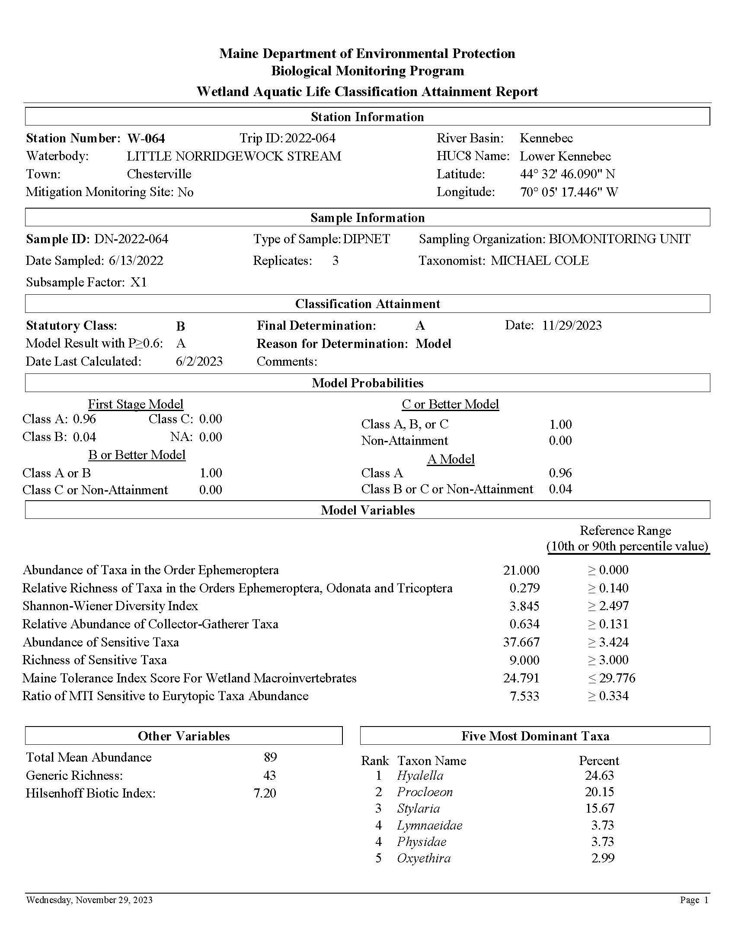

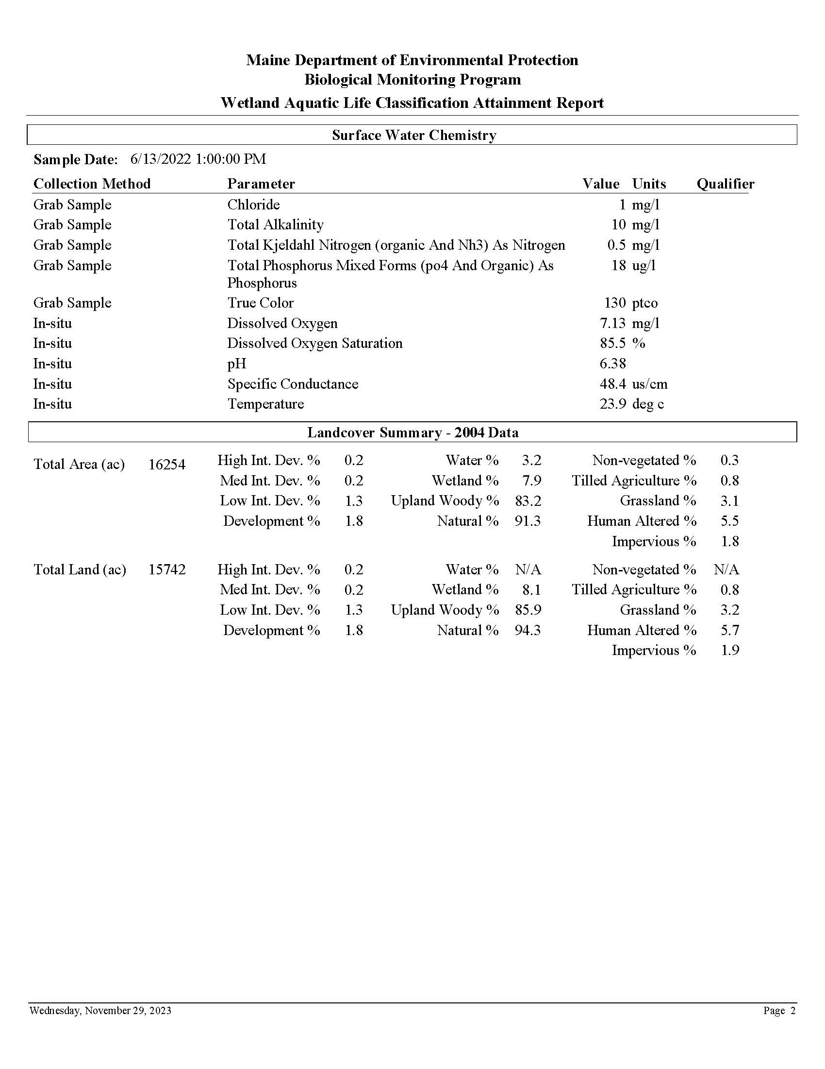

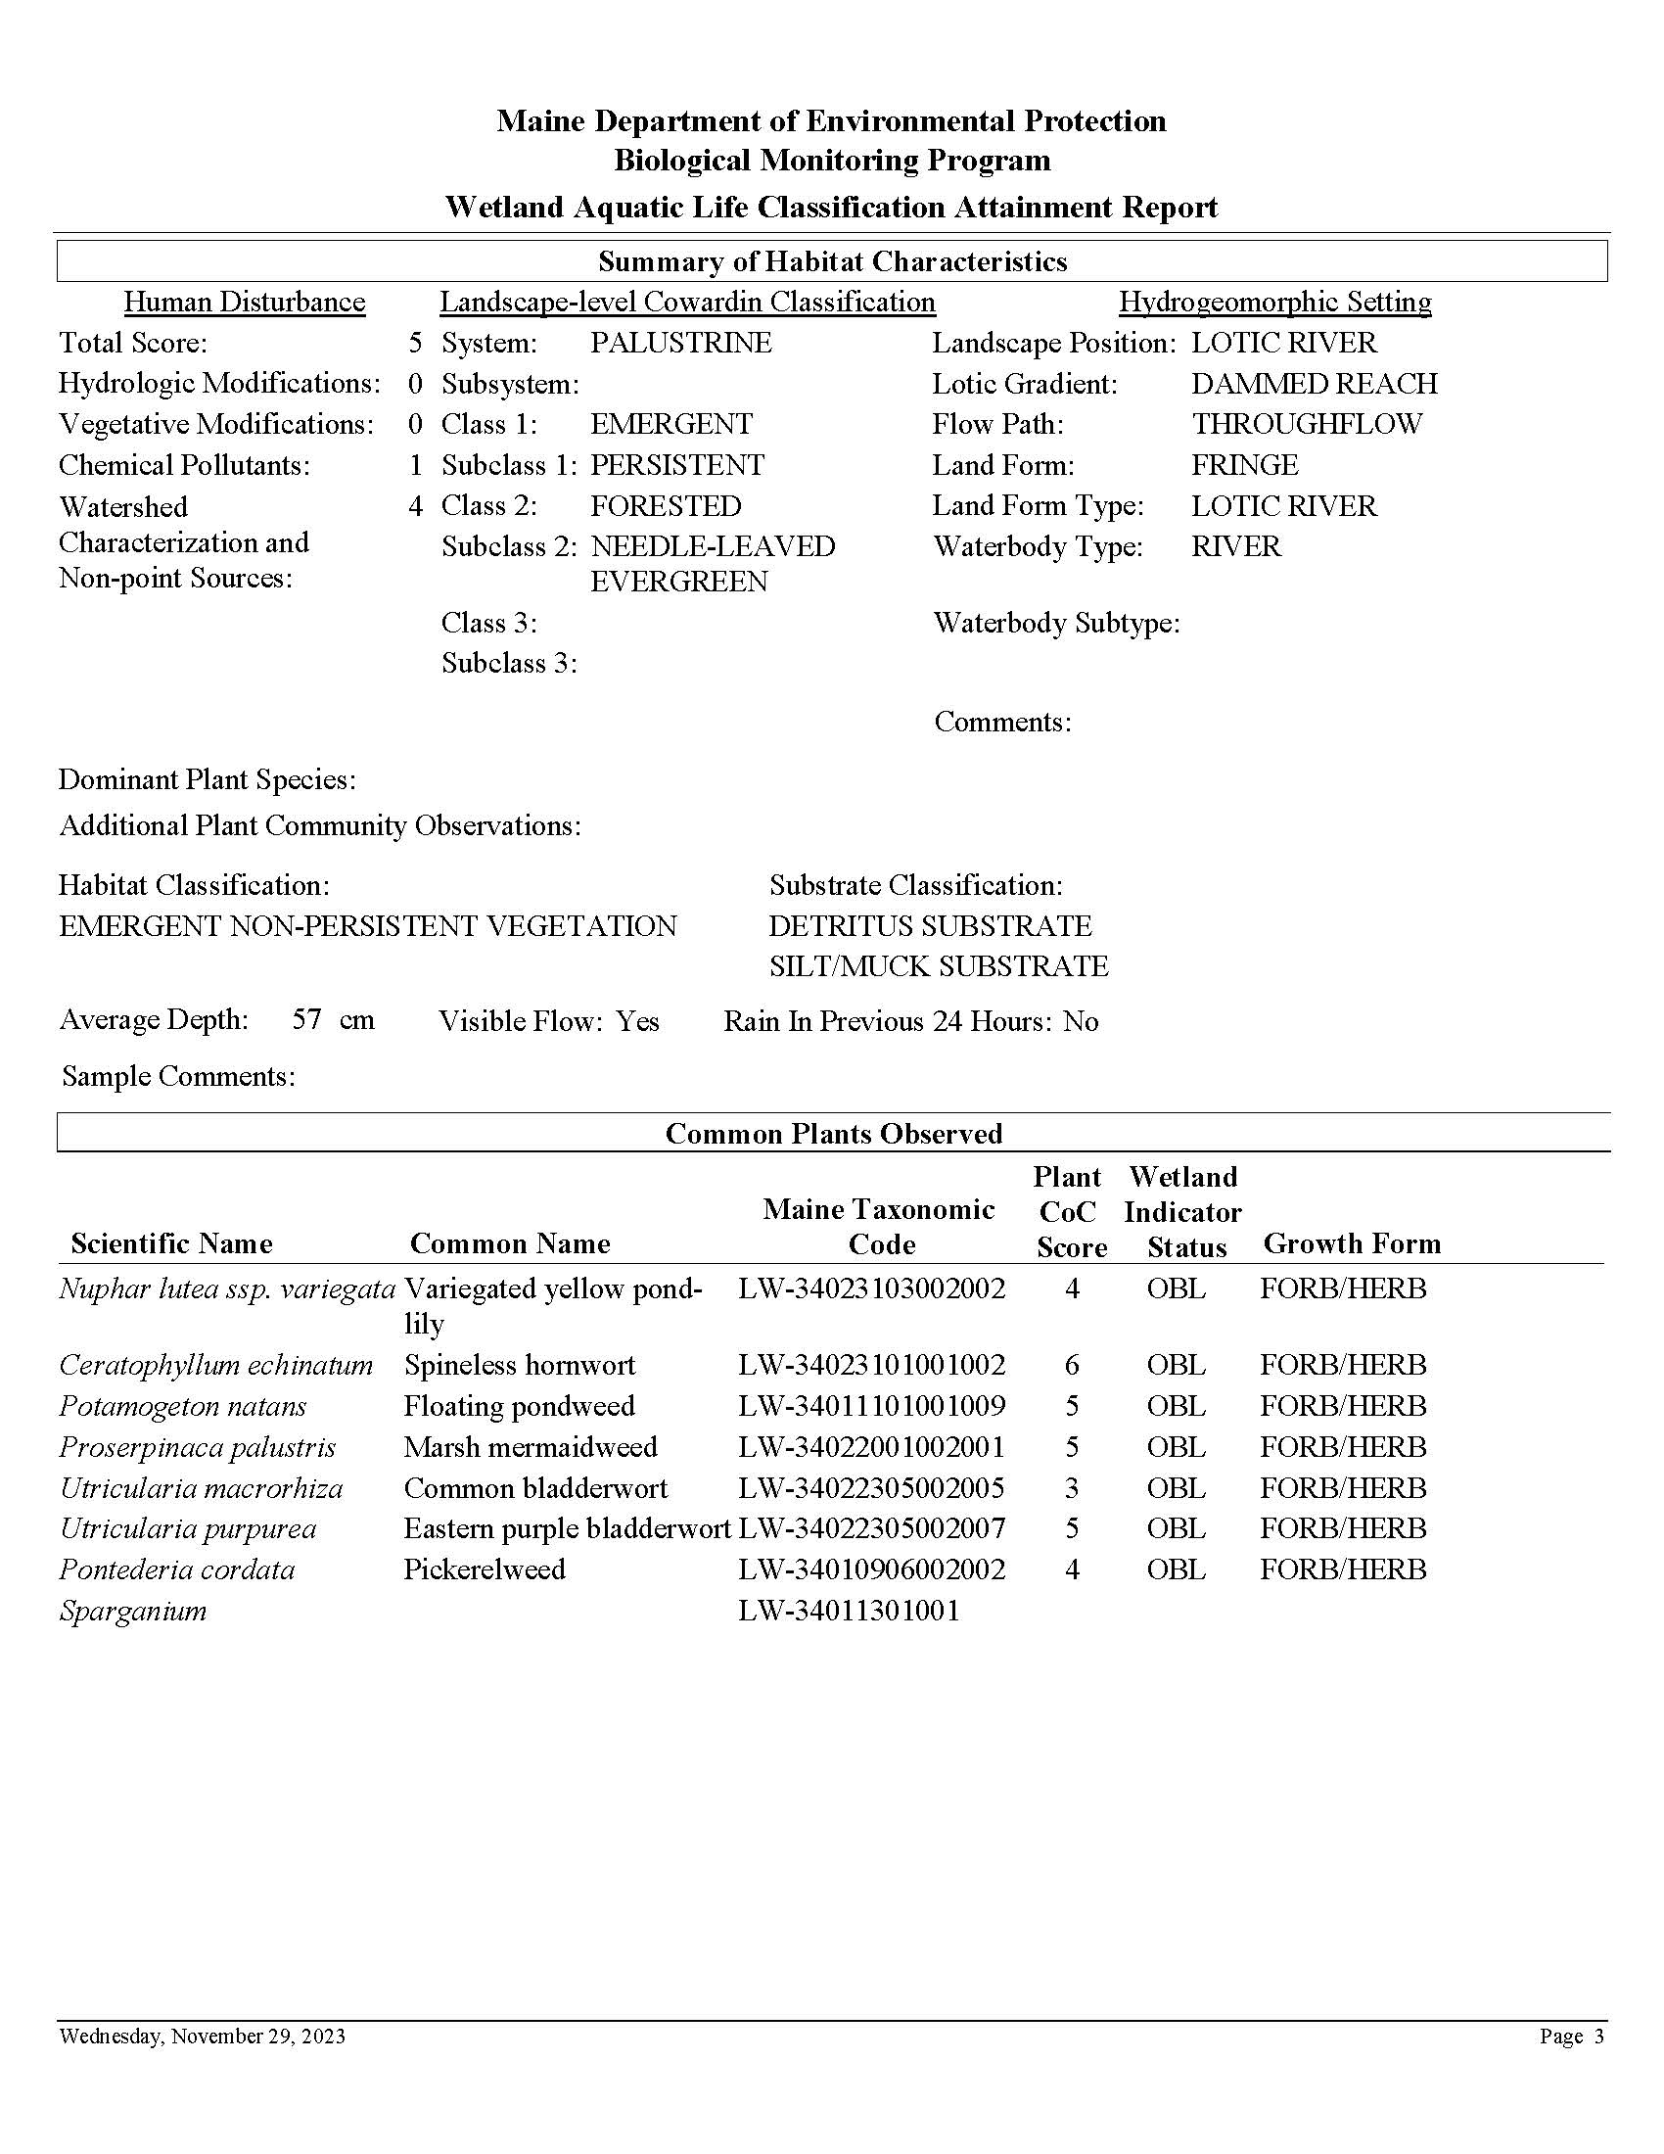

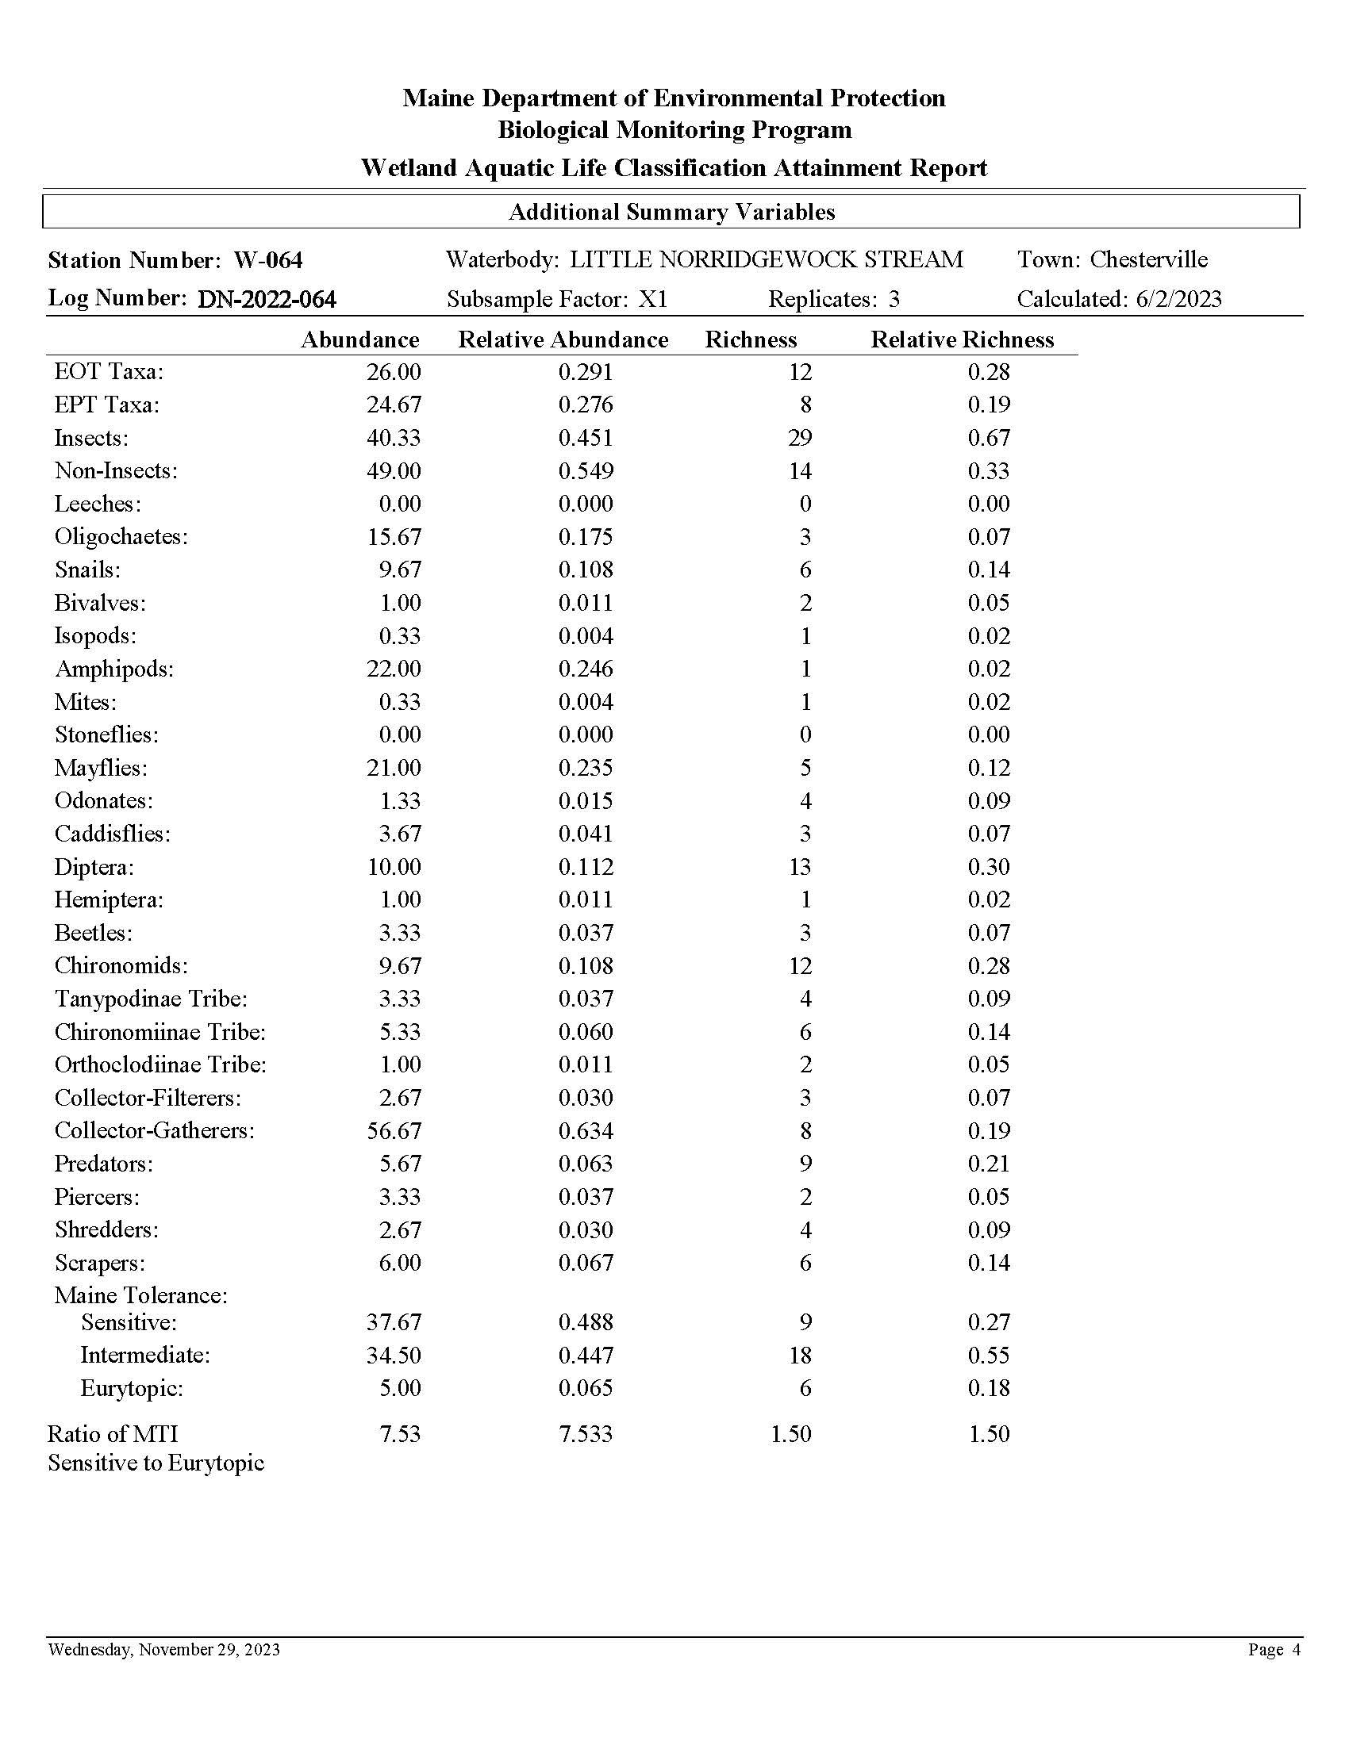

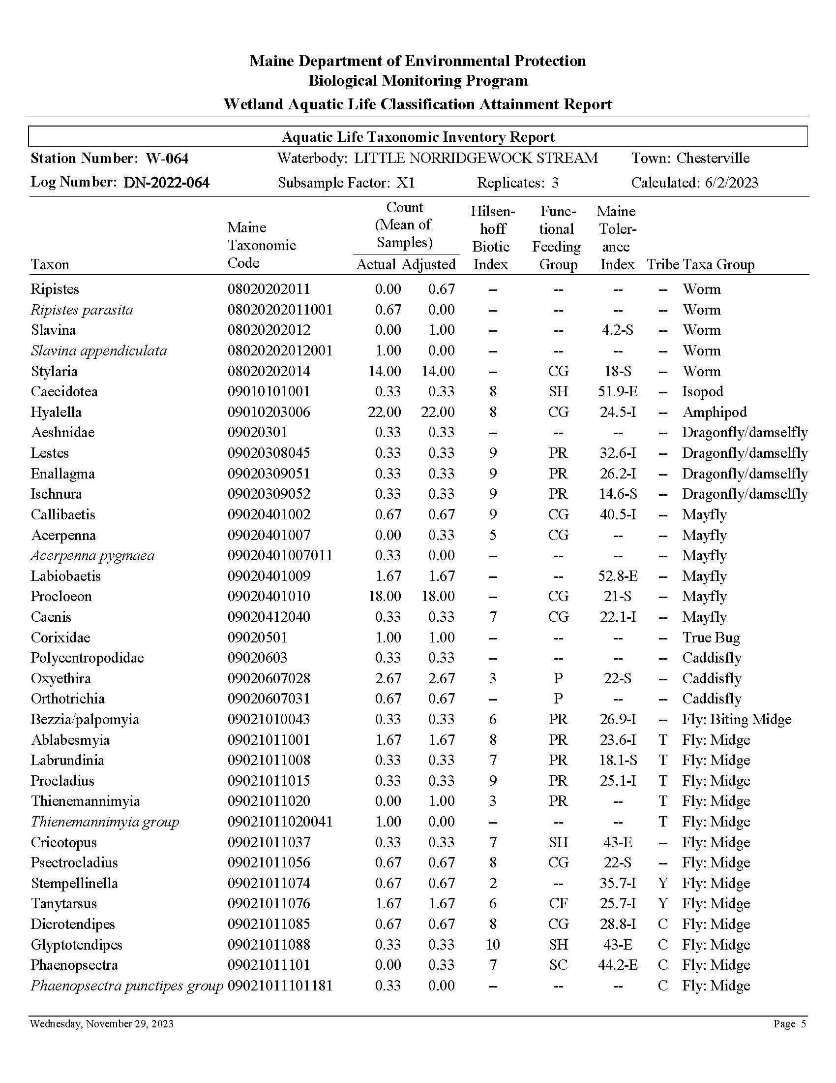

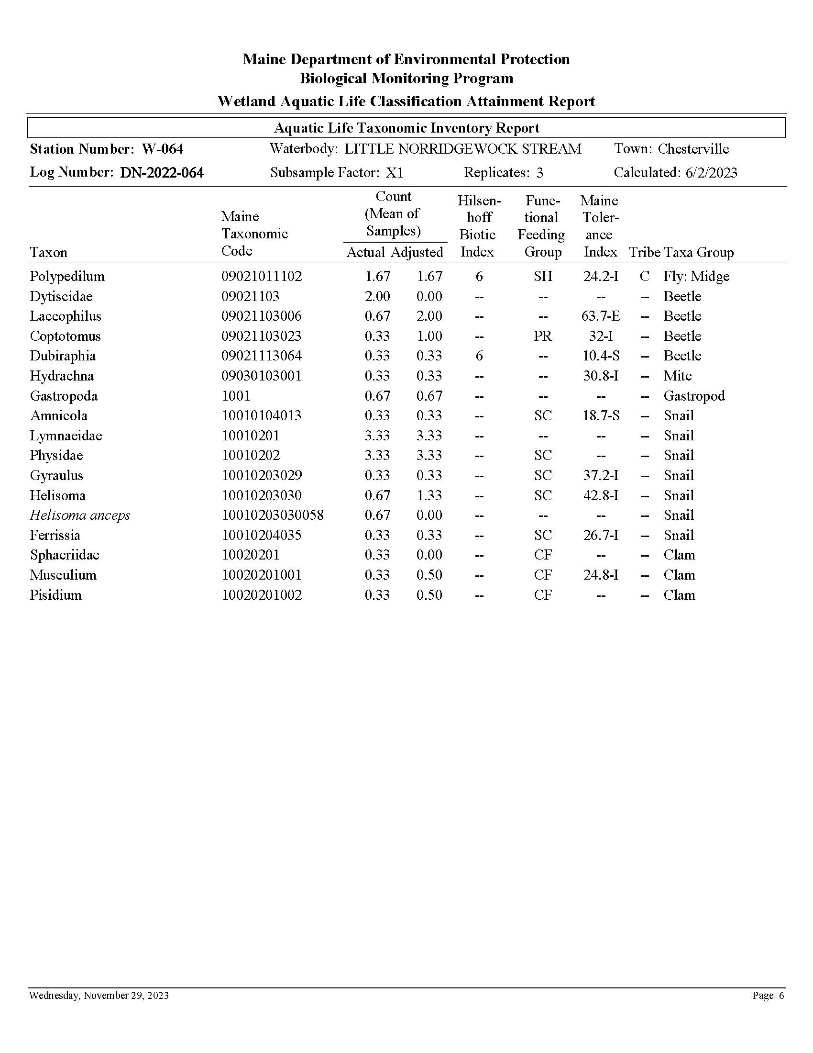

Appendix 8. Sample Aquatic Life Report for Epilithic Algae in Eroded Mineral-Bottom Streams

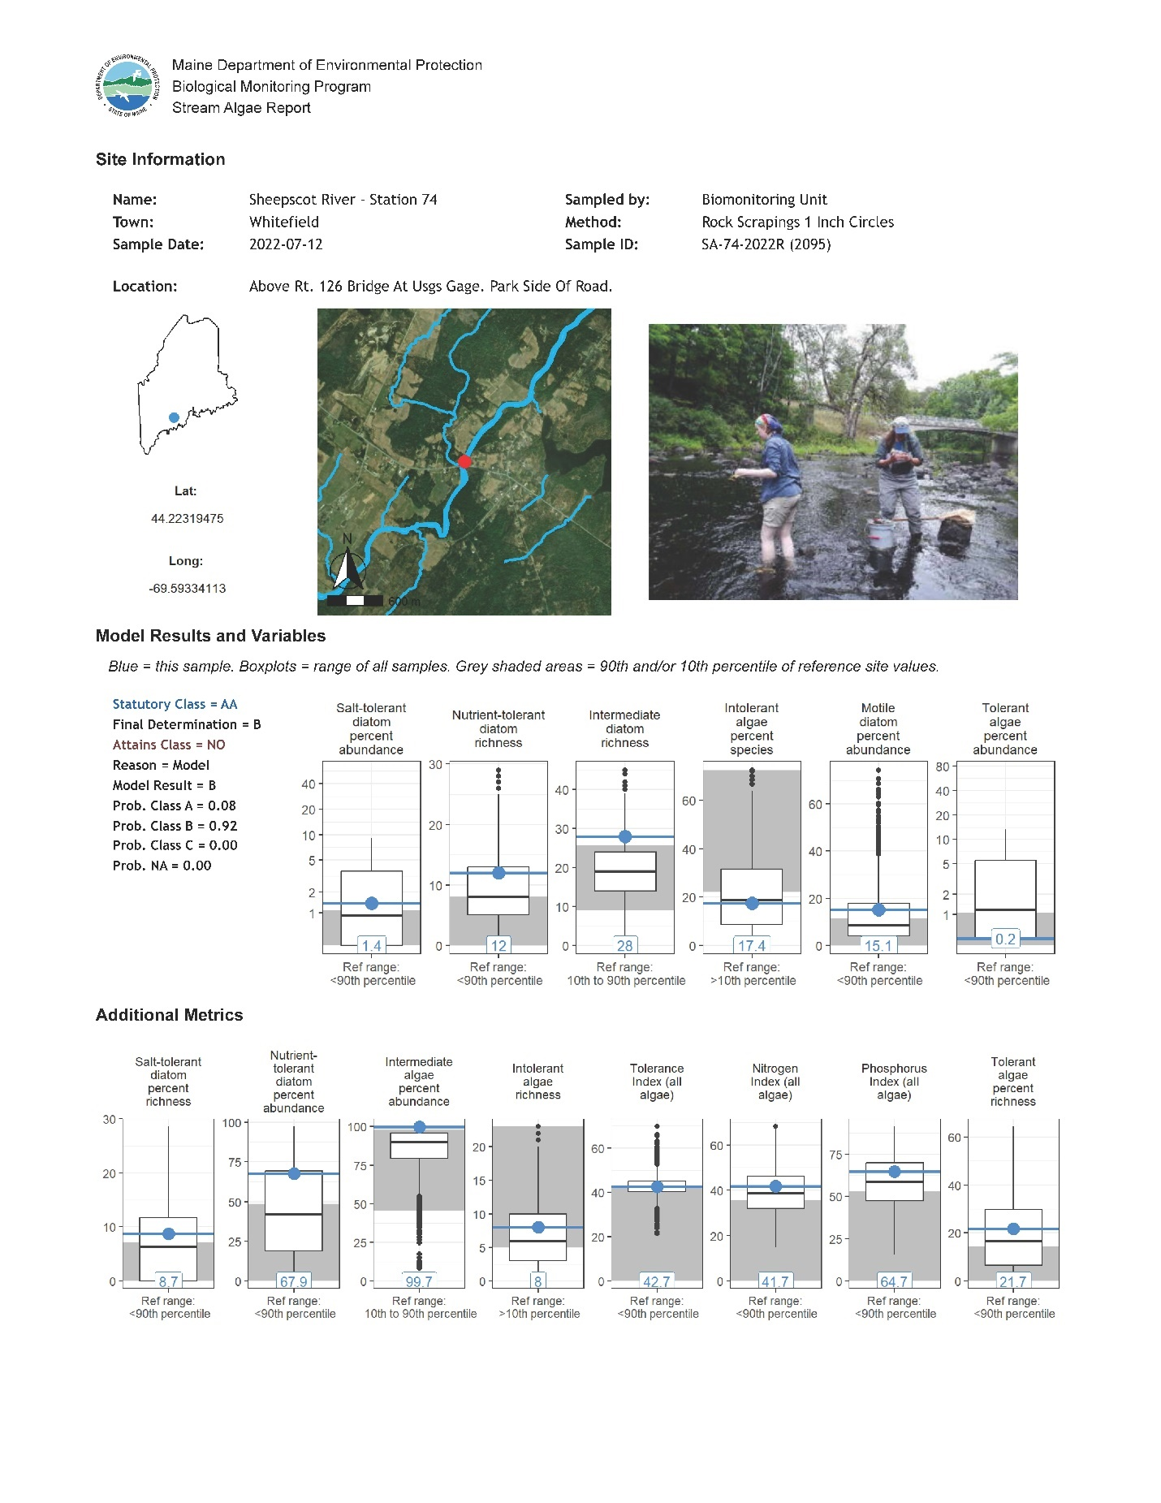

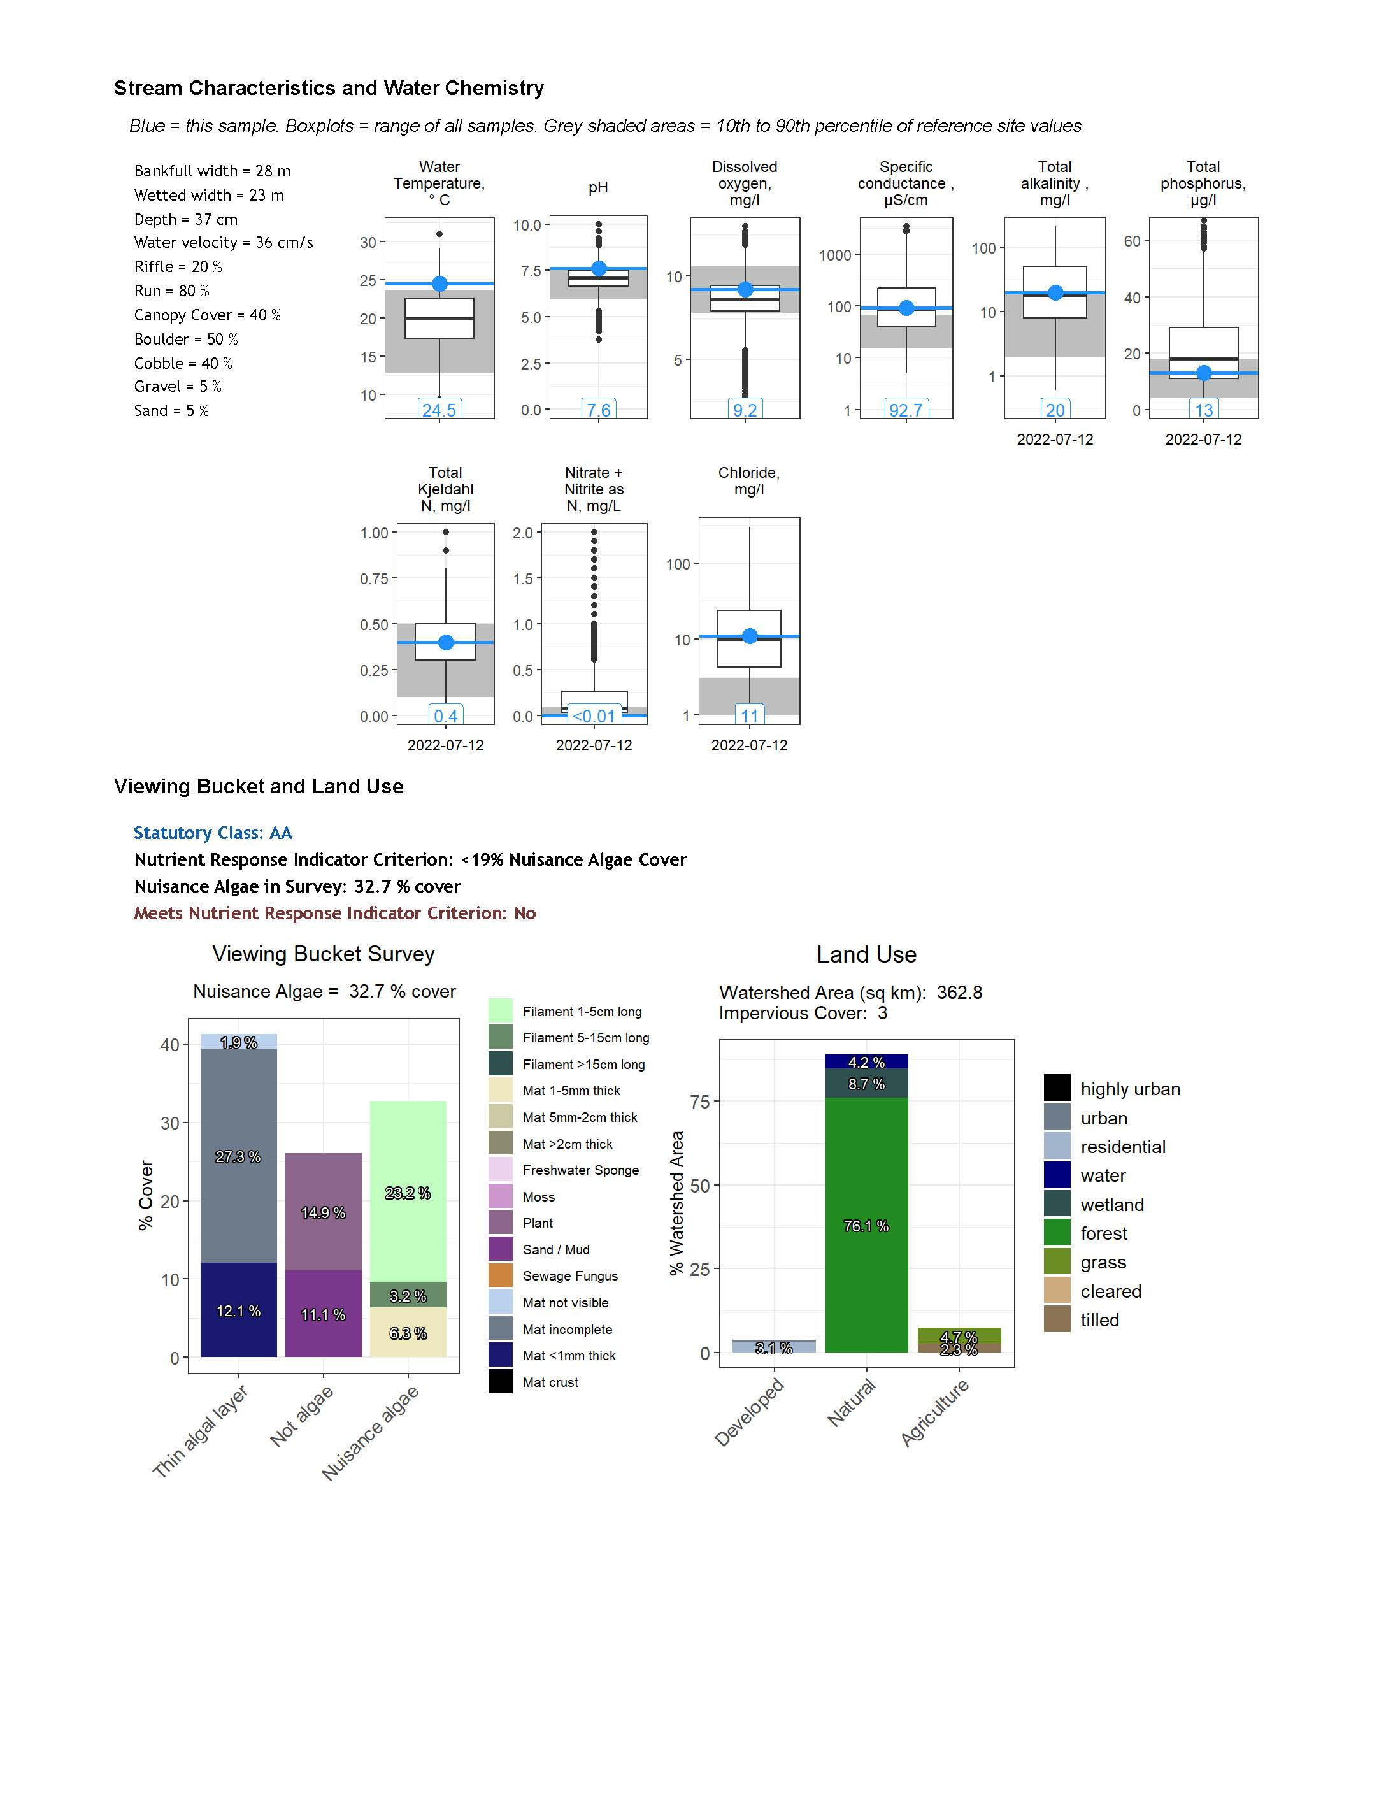

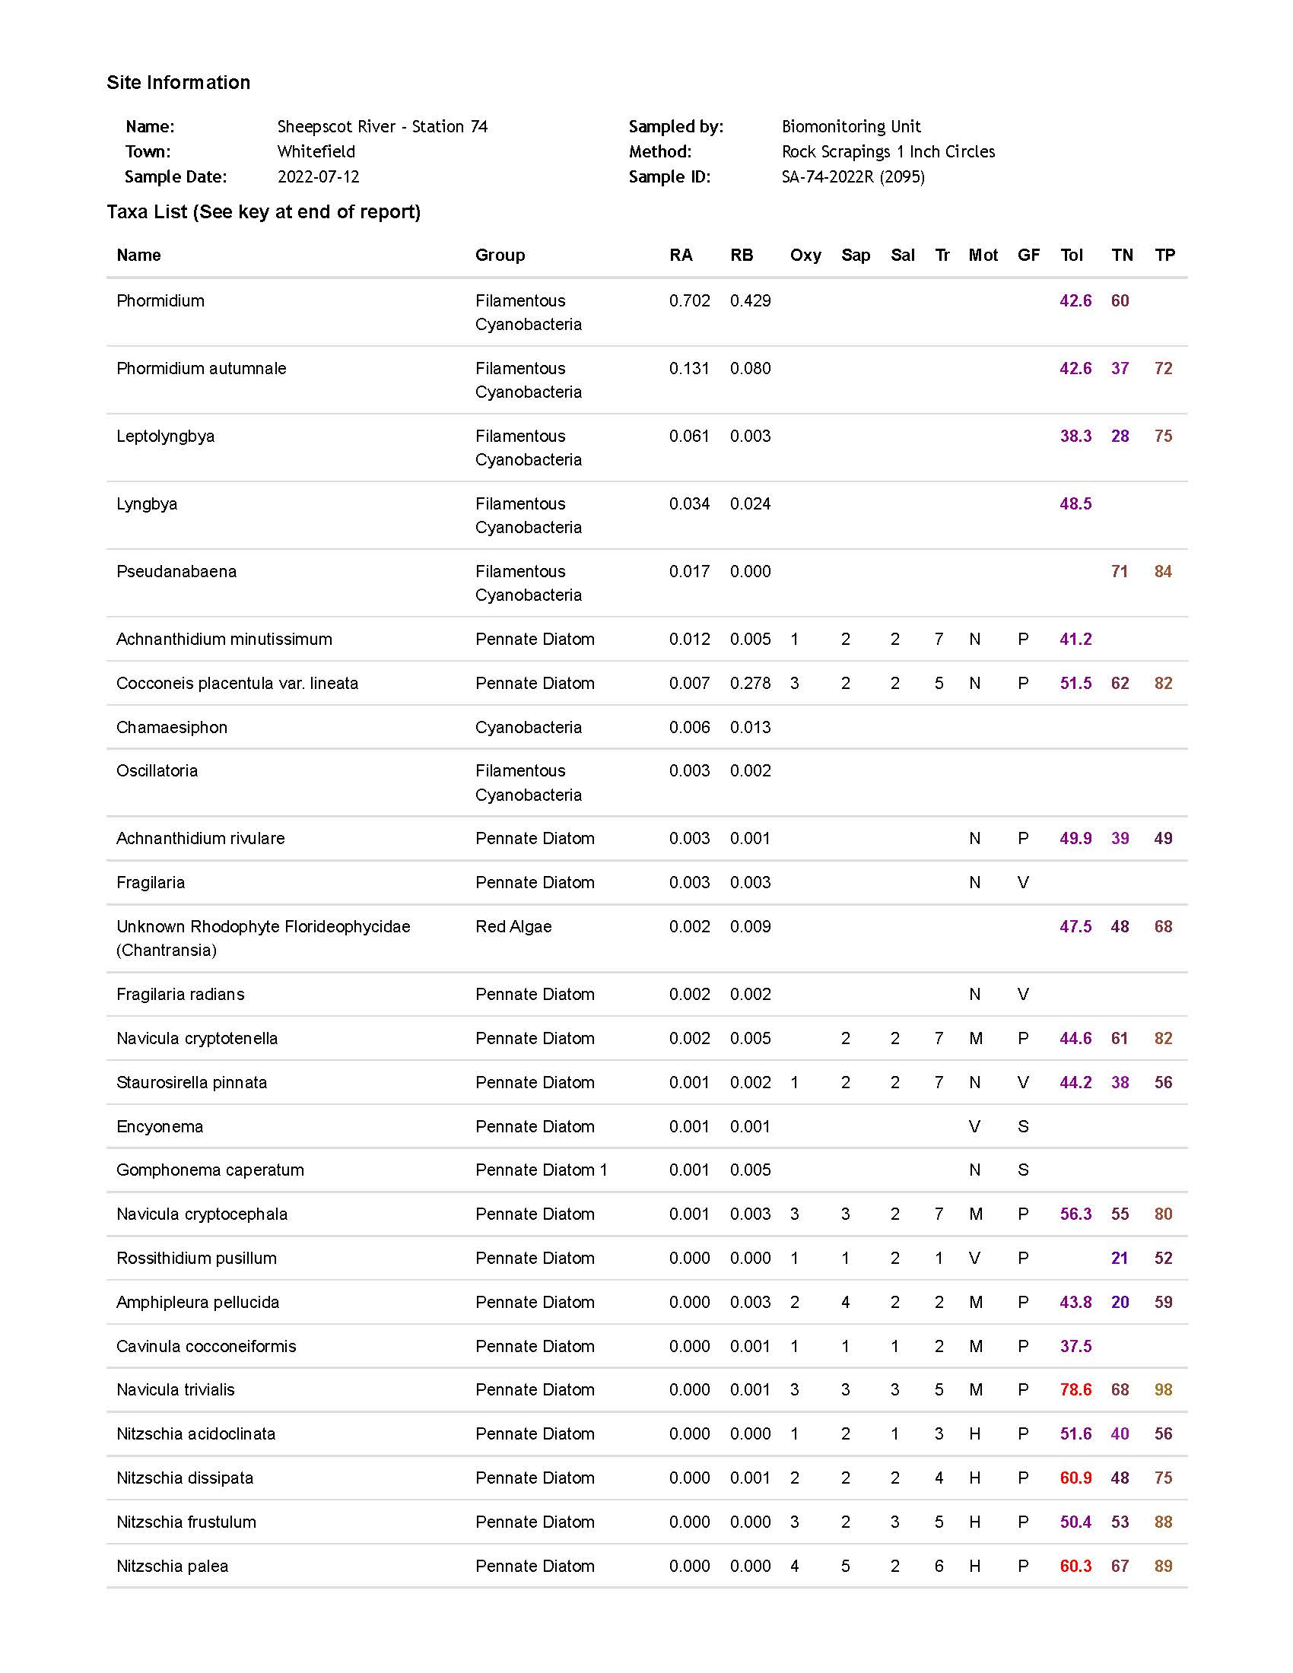

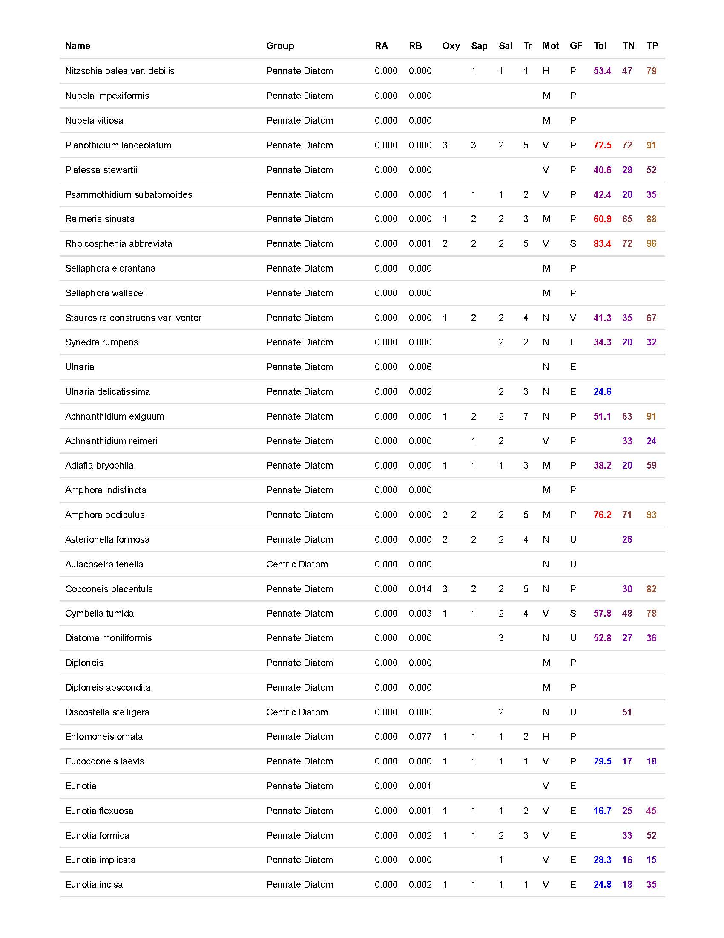

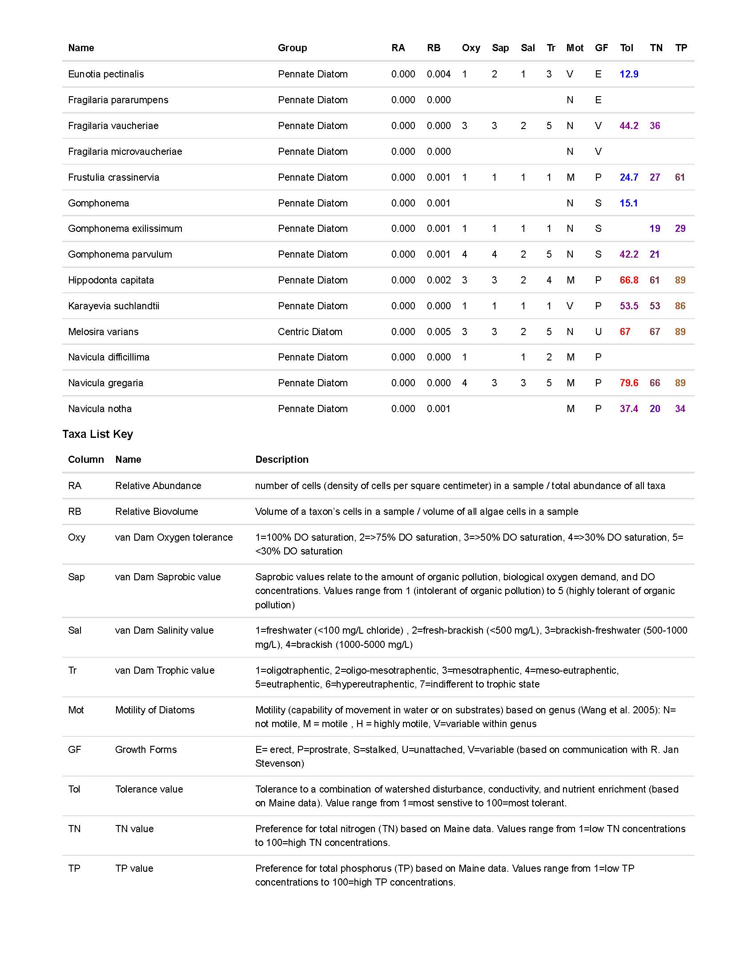

Appendix 9. Sample Aquatic Life Report for Epiphytic Algae in Soft-Bottom Habitats

