DRAFT PRELIMINARY ASSESSMENT REPORT
FOR
Site Name/Address

CERCLIS NO. XXXXXXXXXX

PRELIMINARY ASSESSMENT
Region I 8(a) Superfund Technical Assessment and Response Team

Prepared for:

U.S. Environmental Protection Agency
Region I
Office of Site Remediation and Restoration
Boston, MA 02109-3912

Submitted by:

MEDEP or Consultant Name

December 2021

Reviewed and Approved:

EPA NAME, EPA SAM  Site Manager |  | Date
DEP NAME, ME DEP  Project Manager |  | Date

Table of Contents

1.0 INTRODUCTION 1
2.0 SITE DESCRIPTION 1
3.0 OPERATIONAL AND REGULATORY HISTORY AND WASTE CHARACTERISTICS 3
4.0 GROUNDWATER MIGRATION PATHWAY 6
6.0 SURFACE WATER MIGRATION PATHWAY 7
7.0 SOIL EXPOSURE PATHWAY 11
8.0 AIR MIGRATION PATHWAY 11
9.0 SUMMARY & CONCLUSIONS 13
REFERENCES 14

LIST OF ATTACHMENTS

Attachment ID No. Title

LIST OF FIGURES

Figure No. Title Page

LIST OF TABLES

Table No. Title Page

1.0 INTRODUCTION
The AGENCY requested that CONTRACTOR perform a Preliminary Assessment (PA) of the SITE NAME property, located in SITE TOWN, STATE. Tasks were conducted in accordance with the PA scope of work TITLE OF SOW. A Pre-Screen (PS) report for the SITE NAME was prepared by CONTRACTOR on DATE. On the basis of the information provided in the PS report, the SITE NAME PA was initiated.

Background information used in the generation of this report was obtained through file searches conducted at EPA, STATE REGULATOR, telephone interviews with town officials, conversations with persons knowledgeable of the SITE NAME, and conversations with other Federal, State, and local agencies.

This report follows the guidelines developed under the Comprehensive Environmental Response, Compensation, and Liability Act of 1980 (CERCLA), as amended, commonly referred to as Superfund. However, these documents do not necessarily fulfill the requirements of other EPA Region I regulations such as those under the Resource Conservation and Recovery Act (RCRA) or other Federal, State, or local regulations. PAs are intended to provide a preliminary screening of sites to facilitate EPA Region I’s assignment of site priorities. They are limited efforts and are not intended to supersede more detailed investigations.

2.0 SITE DESCRIPTION

Figure 1 Site Locus

3.0 OPERATIONAL AND REGULATORY HISTORY AND WASTE CHARACTERISTICS

Figure 2 Site Plan

Table 1 summarizes structures or areas on the SITE NAME that are documented or potential sources of contamination, the containment factors associated with each source, and the relative location of each source.

Table 1

Source Evaluation for SITE NAME

Source Area | Containment Factors | Spatial Location

Table 2 summarizes the types of potentially hazardous substances which have been disposed, used, or stored on the SITE NAME.

Table 2

Hazardous Waste Quantity for SITE NAME

Source Area | Substance(s) | Quantity or  Volume/Area | Years of  Use/Storage | Years of  Disposal

Only source areas which contain CERCLA eligible pollutants or contaminants have been listed.

4.0 GROUNDWATER MIGRATION PATHWAY

Table 3 summarizes the public groundwater supply sources within 4-radial miles of the SITE NAME.

Table 3

Public Groundwater Supply Sources Within 4-Radial Miles of SITE NAME (former)

Distance/  Direction from Site | Source  Name | Location  of Sourceª | Estimated  Population Served |  | Source  Type^{b}

ª Indicates Town in which well is located.
^{b} Overburden, Bedrock, or Unknown.

Table 4 summarizes the estimated drinking water population served by groundwater sources within a 4-mile radius of the SITE NAME.

Table 4

Estimated Drinking Water Populations Served by Groundwater Sources
Within 4-Radial Miles of SITE NAME

Radial Distance from  SITE NAME  (miles) | Estimated Population  Served by  Private Wells |  | Estimated Population Served by Public Wells |  | Total Estimated Population Served by Groundwater Sources Within the Ring
≥ 0.00 to 0.25
> 0.25 to 0.50
> 0.50 to 1.00
> 1.00 to 2.00
> 2.00 to 3.00
> 3.00 to 4.00
TOTAL

6.0 SURFACE WATER MIGRATION PATHWAY

Figure 3. 15-mile Surface Water Pathway Figure

Table 5 summarizes the surface water body characteristics located along the 15-mile downstream pathway.

Table 5

Surface Water Bodies Along the 15-Mile Downstream Pathway
from SITE NAME

Surface  Water Body | Descriptorª | Length of Reach  (miles) |  | Flow Characteristics (cfs)^{b} |  | Length of Wetland  Frontage  (miles)

ª Small to moderate stream 10-100 cfs. Moderate to large stream >100-1,000 cfs.
^{b} Cubic feet per second.

The sensitive environments along the 15-mile downstream pathway are listed in Table 6.

Table 6

Sensitive Environments Along the 15-Mile Downstream Pathway
from SITE NAME

Sensitive  Environment  Name | Sensitive  Environment  Type | Surface  Water Body | Downstream  Distance from PPE (miles) |  | Flow Rate  at Environment  (cfs)ª

ª Cubic feet per second
PPE = Probable Point of Entry

7.0 SOIL EXPOSURE PATHWAY

8.0 AIR MIGRATION PATHWAY

Table 11 summarizes the estimated population within 4-radial miles of the SITE NAME.

Table 11

Estimated Population Within 4-Radial Miles of
SITE NAME

Radial Distance from SITE NAME (miles) | Estimated Population
On Site
> 0.00 to 0.25
> 0.25 to 0.50
> 0.50 to 1.00
> 1.00 to 2.00
> 2.00 to 3.00
> 3.00 to 4.00
TOTAL

Table 12 summarizes the sensitive environments located within 4-radial miles of the TSY property.

Table 12

Sensitive Environments Located Within 4-Radial Miles
of the SITE NAME

Radial Distance from SITE NAME (former) | Sensitive Environment
On a source
> 0.00 to 0.25
> 0.25 to 0.50
> 0.50 to 1.00
> 1.00 to 2.00
> 2.00 to 3.00
> 3.00 to 4.00

9.0 SUMMARY & CONCLUSIONS

SITE NAME

REFERENCES
[1] Author. Year. Title or reference. Date.

[2] Author. Year. Title or reference. Date.

ATTACHMENT A

SITE NAME

PHOTOGRAPH LOG

On-Site Reconnaissance Photograph Log: Site Name
Site City, State
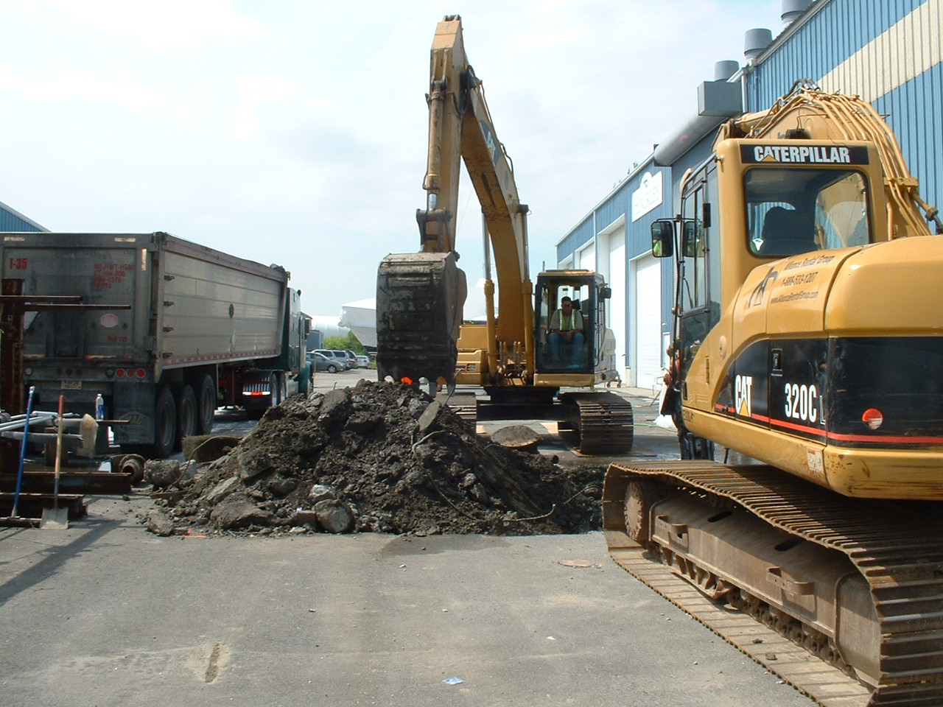  Descriptive Text Entered Here | Descriptive Text Entered Here
Descriptive Text Entered Here | Descriptive Text Entered Here

