**MANE-VU&VA 2007 and 2020 Mobile Status Report and Emissions Analysis**

**MARAMA**

**April 3, 2020**

Regional mobile emissions for the MARAMA air quality modeling inventory is estimated for 2007 and predicted for 2020 using the MOVES model in the Look-up Table mode. This involved a number of steps. First, MOVES inventory runs were completed to obtain both evaporative refueling emissions and activity inputs for SMOKE-MOVES. Then MOVES Look-up Table runs were performed using the same meteorology that was used in CMAQ modeling. Then SMOKE-MOVES runs were performed to combine activity data, meteorology and site-specific inputs to estimate grided mobie emissions. Finally postprocessing summarized the SMOKE-MOVES reports at county and SCC levels typically used by states in their SIP inventories. The various modeling runs were performed initially by a team of regional groups and states that included MARAMA, NESCAUM, Pennsylvania, New York and Virginia. However, in some cases, errors were found in the initial runs. . The errors were corrected by re-running SMOKE-MOVES. These are noted in Table 1. Please note that MOVES modeling in Look-up Table mode has been conducted only once (i.e., it has never been re-run).

**Table 1. – Overview of modeling runs**



1. Initial inputs were revised and rerun.

After a long process, we have estimates for both 2007 and 2020. This document is intended to be a project status report. The project is not complete and will require additional work before the results should be used in air quality modeling. In the report we present and evaluate the emissions results on a state-by-state basis.

Post-processed SMOKE-MOVES data in SCC format was up-loaded by Jin-Sheng Lin to the MARAMA ftp and downloaded by MARAMA on 3/12/2012. The 2007 and 2020 MOVES text files were combined into a single Excel document and uploaded into Access. MARAMAI then joined month, county, and SCC and summed all the pollutants by state. The pollutants of interest were: NOx, PM2.5, SO2, and VOC.

In addition to reporting total annual emissions by state, this analysis uses the approach of normalizing emissions on population. This approach allows emissions from large states, such as New York and Pennsylvania to be compared with smaller states, such as Rhode Island or Vermont. The readers should be aware that the comparison is not perfect as state differences, such as the amount of cross-state through traffic, and differences in urbanization, are still confounding. To develop the normalizing charts MARAMA obtained the 2010 population data for each state from the census. Annual state emissions in both 2007 and 2020 were then divided by state population and plotted together.

**TEMP2 versus TEMPG**

The OTC MOVES modelers have been working with GA and UNC on merging MOVES-based emissions from two RPOs into one regional inventory for air quality modeling.  To be consistent with SEMAP, some changes must be made to the OTC modeling.

Specifically, the temperature parameter used in our SMOKE-MOVES runs, TEMPG (ground level temperature), needs to be switched to TEMP2 (2-m temperature).  Normally, the switch would require re-running both MOVES (in lookup table mode) and SMOKE-MOVES.  To save time and resources, a simplified approach has been taken which involves re-running only SMOKE-MOVES with TEMP2 as the temperature parameter in interpolating emission rates from already-developed TEMG-based lookup tables.  Using this “semi” TEMP2 approach, VA has conducted a preliminary 2007 SMOKE-MOVES re-run for MANEVU+VA.  That modeling inventory, although not a “real” TEMP2, will be used to merge with SEMAP inventory and we propose using these adjusted results in regional modeling.

As a result of this adjustment, mobile source emissions used in modeling are expected to be different (around a few percentages) from the values quoted in this status report.  When comparing the results using TEMPG to TEMP2, some emissions increase (e.g., CO winter time, PM winter time) while others decrease (e.g., CO summer time, VOC throughout the year).  When comparing the full TEMP2 run to the semi_TEMP2 run, overall the differences seem to be minor. The largest differences are for NOx at about 1.1%, but.  The “semi” TEMP2 inventory should be regarded as our “final” SIP quality run because ultimately it is the one used in CMAQ modeling.

**Missing SCCs in the 2020 output**

When summarizing emissions, MARAMA noted that there were SCCs missing in the 2020 output for Maryland and New Jersey. Activity data for these SCCs were included in the 2007 inputs not the 2020 inputs. Maryland and New Jersey reran MOVES in the inventory mode to generate activity data for 2020. Virginia reran SMOKE-MOVES for these states.

**Mobile 2007 & 2020 NOX emissions**

Figure 1 shows the estimated regional NOx emissions for 2007 and 2020. Figure 2 shows the same data normalized on 2010 population. As can be seen in Figure 1, in general, we expect NOx emissions to drop between 40 and 70% between 2007 and 2020. On a per capita basis, NOx emissions in 2007 range from 30 to 55 lb/person year. In 2020 emissions drop to between 6 and 8 lb/person year. The 2020 results for four state need further scrutiny. These are the District of Columbia, Delaware, New Hampshire and Rhode Island. In these states emissions are predicted to only drop slightly by 2020.

**Mobile 2007 & 2020 emissions trends for other pollutants**

A similar analysis was done for PM2.5, SO2 and VOC. State by state results are shown in the charts in Figures 3-8. The results are summarized in Table 2.

**Table 2. – Summary of Mobile Emission Change from 2007 to 2020**



As can be seen in the Figures 3 – 8, 2020 emissions for some states require further review as their trend is out of line with other states and with what is expected. Of the five states with issues, it is probably more important to review the emissions for the District of Columbia and Delaware because of their proximity to nonattainment areas. MARAMA and Virginia have provided Delaware with the input files used for their evaluation. Other states, including DC have not yet been contacted about this issue.

Even within states where other pollutant reductions are fairly regular, SO2 emissions changes between 2007 and 2010 are more variable from state to state than other pollutant emissions ranging from a decrease of 64% in Pennsylvania to an increase in 9% in Virginia. While interesting, it is probably not worth deep scrutiny as the mobile source sector is an extremely minor source of SO2.

**Mobile 2017 emissions estimates**

The MARAMA modeling emissions inventory was intended to include estimates for 2007, 2017 and 2020 for all sectors. Because of the difficulties of using the MOVES model, to date only 2007 and 2020 emissions have been prepared. MARAMA has issued an RFP to obtain contractor bids for the task of estimating 2017 emissions. We have received quotes ranging from $18,670 to $58,000 to perform the runs. The selection committee will meet next week to select the best proposal. However, there is currently no money budgeted for the work.

**Figure 1. Regional NOX emissions for 2007 and 2020**

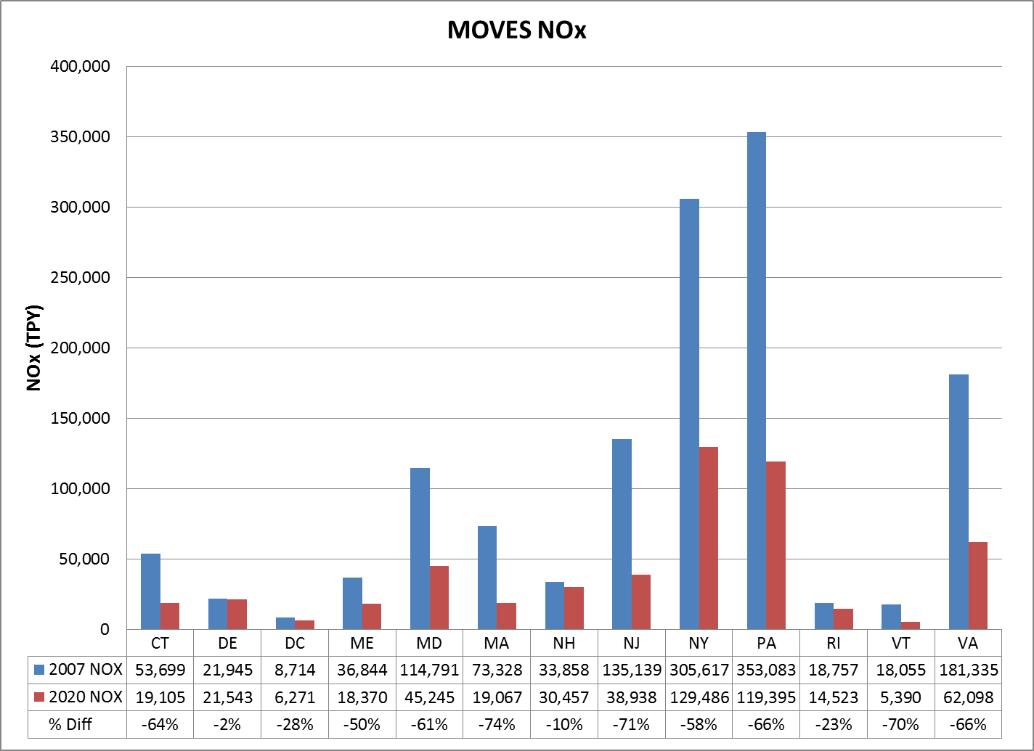

**Figure 2. Population normalized NOX emissions for 2007 and 2020**

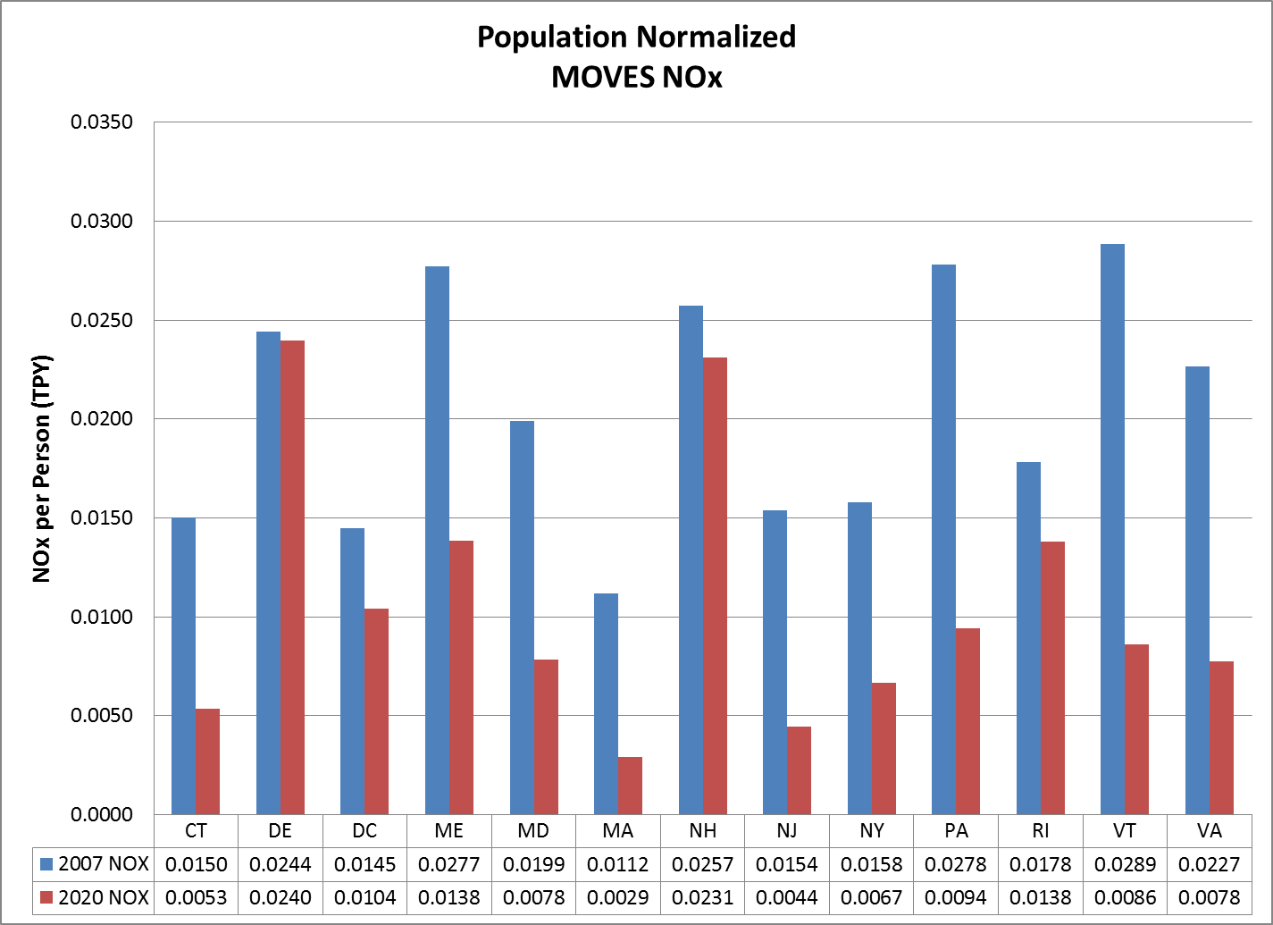

**Figure 3. Regional PM2.5 emissions for 2007 and 2020**

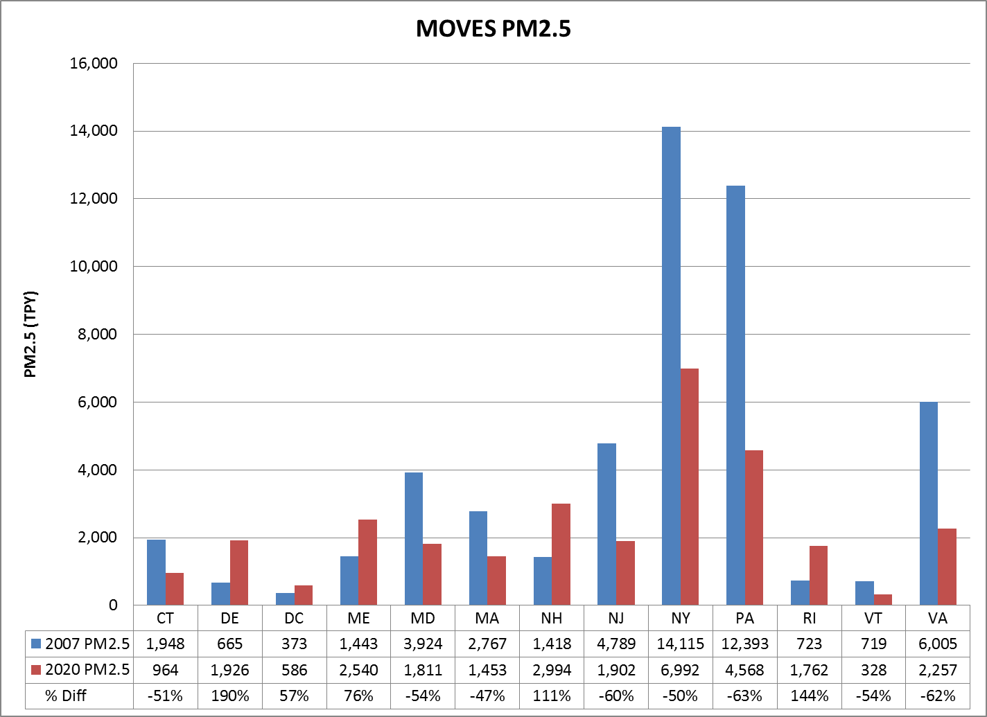

**Figure 4. Population normalized PM2.5 emissions for 2007 and 2020**

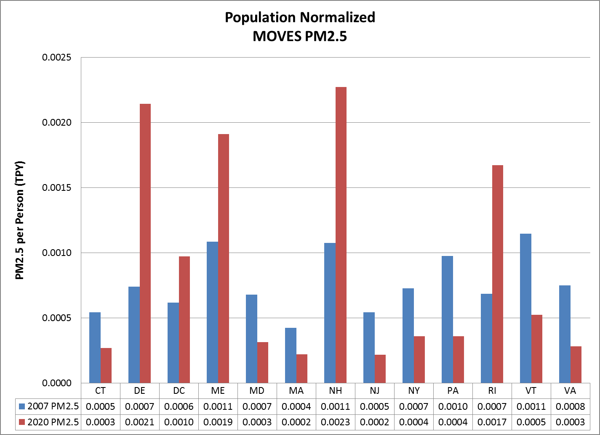

**Figure 5. Regional SO2 emissions for 2007 and 2020**

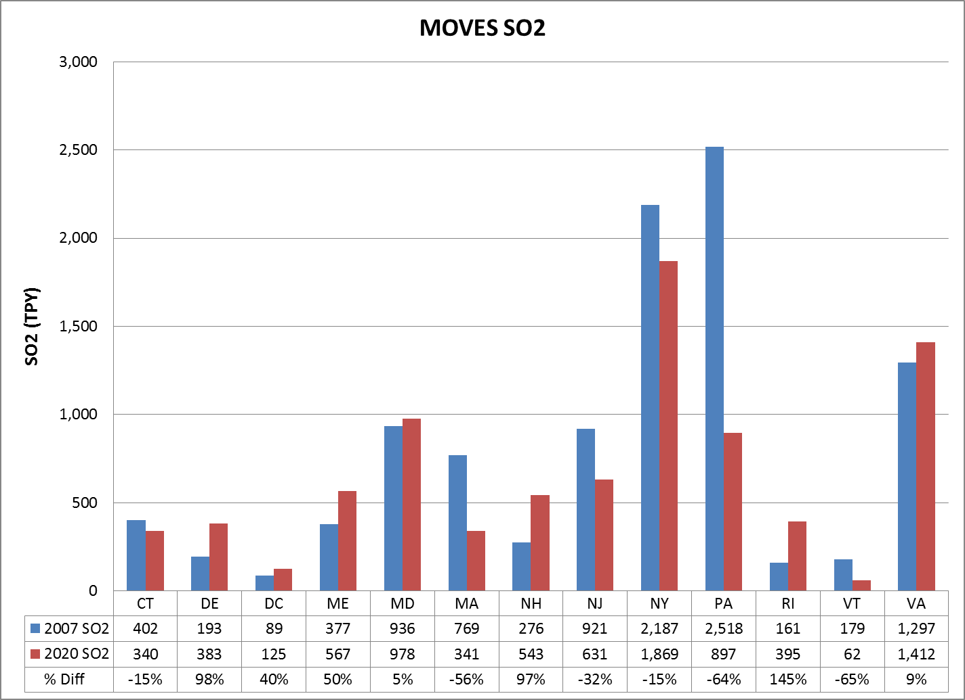

**Figure 6. Population normalized SO2 emissions for 2007 and 2020**

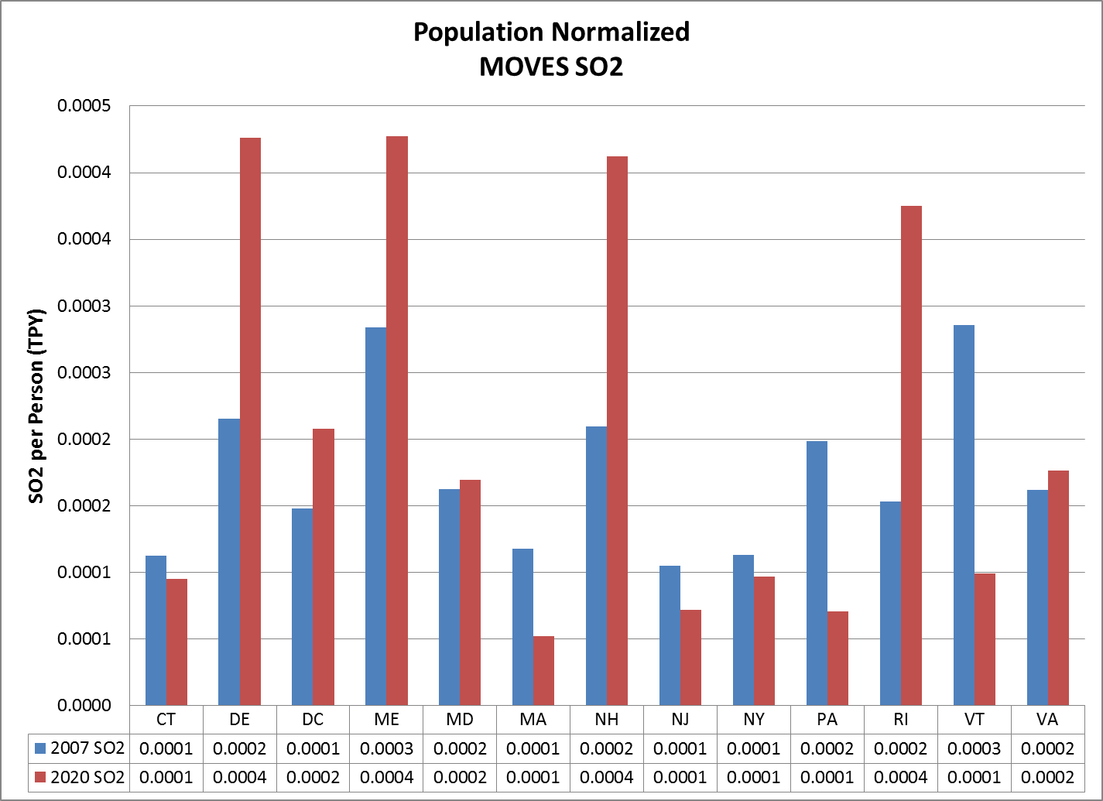

**Figure 7. Regional VOC emissions for 2007 and 2020**

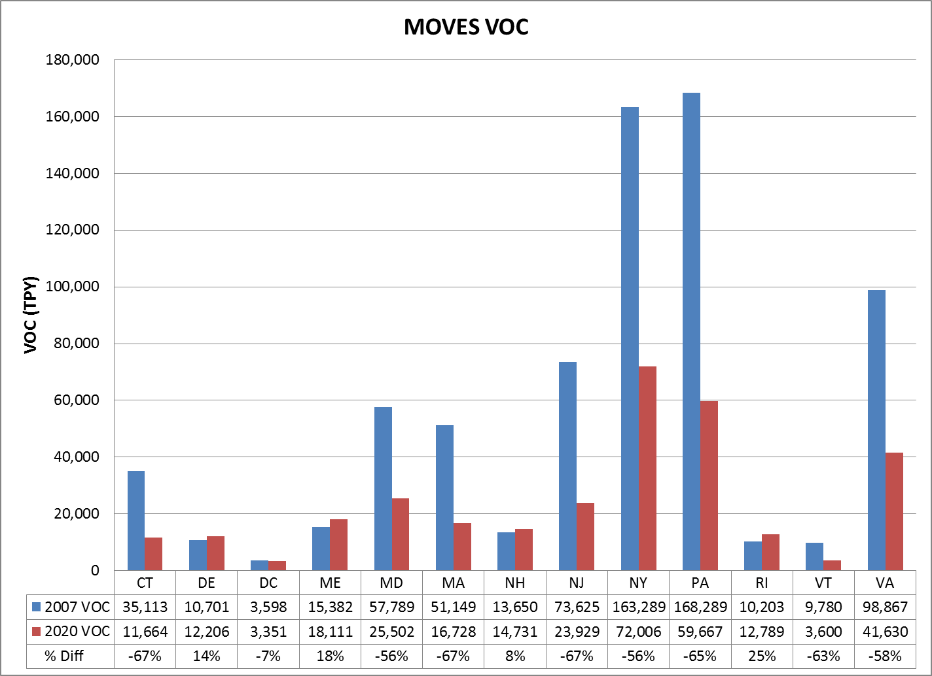

**Figure 8. Population normalized VOC emissions for 2007 and 2020**

