Exhibit A
Green Lake Project
P-7189
Description of Project and Proposed Mode of Operation

Revision: September 12, 2022
Amended: April 20, 2024

Table of Contents
1.0 Project Location 1-1
2.0 Description of Project 2-1
2.1 Project Facilities 2-1
2.1.1 Reservoir and Storage 2-1
2.1.2 Dam 2-1
2.1.3 Penstock 2-6
2.1.4 Powerhouse 2-7
2.1.5 Tailwater 2-9
2.1.6 Turbine/Generator 2-11
2.1.7 Project Impoundment 2-11
2.1.8 Fishway Facilities 2-12
2.1.9 Appurtenant Facilities and Equipment 2-13
2.1.10 Proposed Facilities 2-14
2.1.11 Provisions for Future Units 2-14
2.2 Project Operation 2-15
2.2.1 Current Project Operation 2-15
2.2.2 ”Proposed Project Operation 2-17
2.2.3 Proposed Environmental Measures 2-17
2.3 Average Annual Generation 2-18
2.4 Estimated Average Head 2-18
2.5 Hydraulic Capacity of the Project 2-19
2.6 Estimated Cost of the Project 2-19
3.0 Purpose of the Project 3-1
4.0 Estimated Cost of Relicensing 4-1
5.0 Value of Project Power 5-1
6.0 Estimated Change in Project Generation 6-1
7.0 Undepreciated Net investment (Book Value) of the Project 7-1
7.1 Green Lake Project Current Net Investment 7-1
7.2 Annual Operation and Maintenance Costs 7-1
8.0 Estimated Annual Cost of the Project 8-1
9.0 Project Safety Program 9-1
10.0 References 10-1
11.0 Appendices 11-1
11.1 Appendix A – Single-Line Diagram 11-2

List of Tables
Table 2-1 Green Lake Hydroelectric Project Summary Table 2-14
Table 2-2 Monthly and Yearly Generation (kWh) for the Green Lake Project 2-18

List of Figures
Figure 1–1 Green Lake Project Location Map 1-2
Figure 1–2 Project Drainage Area 1-3
Figure 2–1 Project Impoundment 2-12

List of Photos
Photo 2-1 Green Lake Dam from the Northwest 2-3
Photo 2-2 Green Lake Dam from the Southeast 2-3
Photo 2-3 Spillway and Flume 2-4
Photo 2-4 Green Lake Dam Gates and Fish Screens 2-5
Photo 2-5 Underground Penstock 2-6
Photo 2-6 Wood Stave Penstock 2-6
Photo 2-7 Powerhouse from Driveway 2-7
Photo 2-8 Powerhouse North Side 2-8
Photo 2-9 Main generator and turbine 2-8
Photo 2-10 Control Panel and Second Unit 2-8
Photo 2-11 Transformer 2-9
Photo 2-12 Reeds Brook Below Powerhouse, Tailwater on Left 2-10
Photo 2-13 Tailwater Concrete Pipes 2-10

Project Location
The Green Lake Water Power Project is located on Green Lake and Reeds Brook, six miles north of the center of the City of Ellsworth in Hancock County, Maine. The project dam is on land owned by Green Lake Water Power on the shore of Green Lake. The remainder of the project structures are on Federal Land, within the boundary of the Green Lake National Fish Hatchery, which is managed by the U.S. Fish & Wildlife Service.
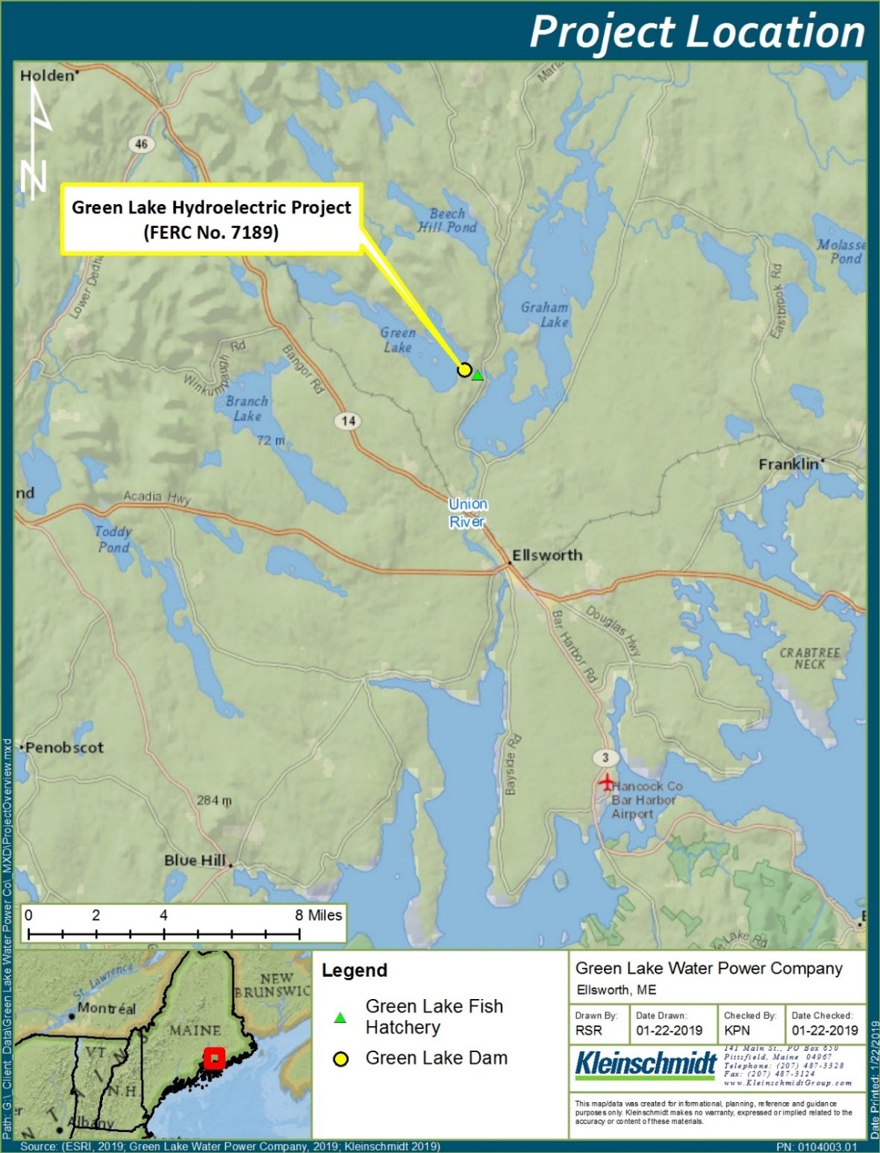
Figure 1–1 Green Lake Project Location Map
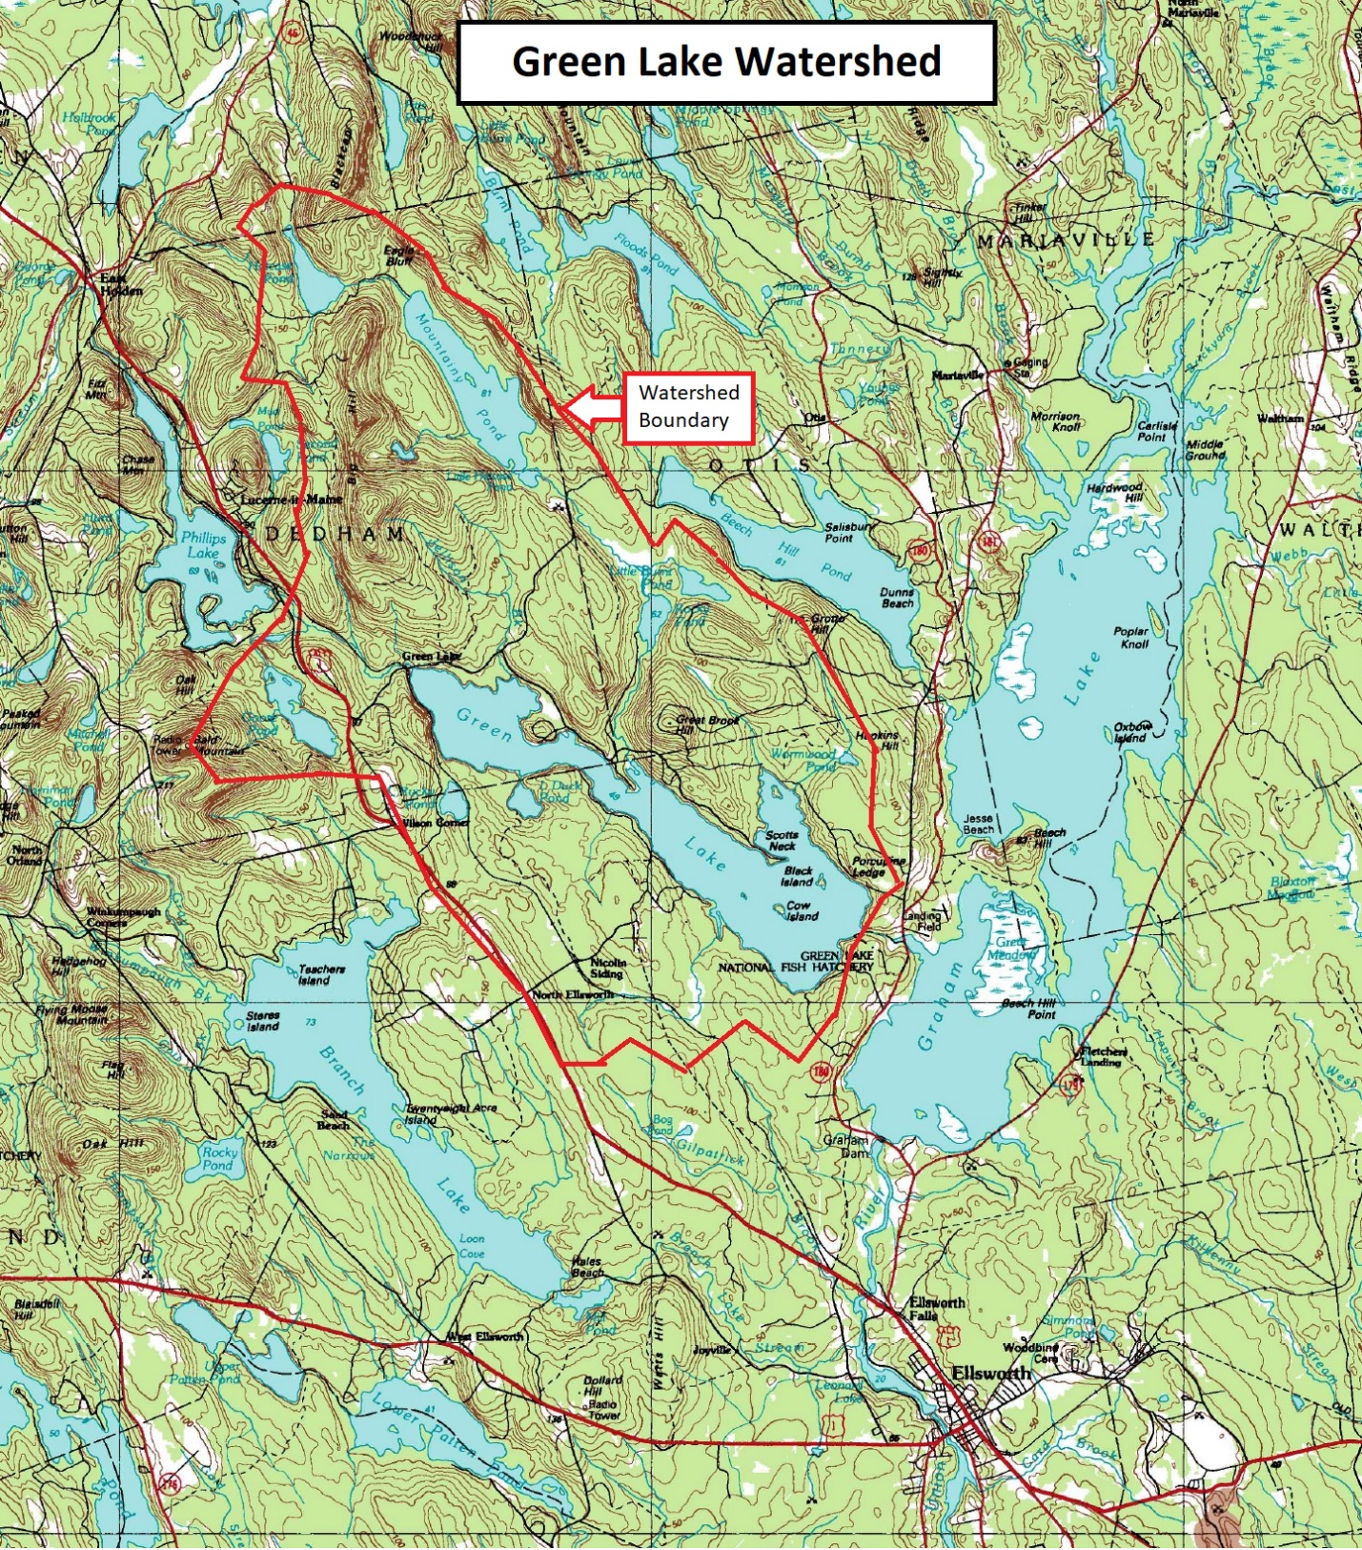
Source: GLWP and USGS Map 44068-E1-TM-100, “Bangor, Maine”, 1994 Revision
Figure 1–2 Project Drainage Area

Description of Project

Project Facilities

Reservoir and Storage
Green Lake has an area of approximately 3312 acres. During much of the year, the Project can maintain the water level within a range of 157.5 to 160.7 feet NGVD29, yielding a maximum usable storage of about 10,136 acre-feet. Net volume from gate sill elevation to full pond (154.0 to 160.7 feet NGVD29) is approximately 17,731 acre feet.
The Project manages the lake level on Green Lake using the main turbine and the manually operated gates at the dam. The level is managed to maintain recreation values, allow a dependable water supply for the Green Lake National Fish Hatchery (GLNFH or Hatchery), and to protect arctic charr spawning habitat. Water is drawn from Green Lake by GLNFH by means of two submerged pipes (non-project) to supply the Hatchery. Up to 30 cfs may be used on a priority basis by the Hatchery.
During the summer, recreational uses of the lake are given priority. The project is allowed to maintain the lake level from 159.7 to 160.7 NGVD29 from 01-June through Labor Day weekend, yielding a maximum storage of about 3312 acre-feet. In practice, to allow for anticipated dry weather during the late summer, along with the possibility of occasional heavy rain, less than half of this storage amount can be used for turbine operation.

Dam
Green Lake Water Power Company (GLWP) owns the Green Lake Dam and a small amount of surrounding land (0.4 acres) as part of the Project. The dam was built in the early 1900’s by the Bangor Hydro-Electric Company for water storage purposes. It was originally a dry stone and timber structure. In the 1960’s a concrete gate structure was added, and sheet steel was added to the upstream face of the dam and on the deck to replace deteriorating hemlock planks.
GLWP acquired the dam in 1984. As part of the initial Project license a 12’ by 17’ intake structure was added to the dam, on the southwest side of the dam, adjacent to the concrete gate structure. The intake is protected by 8’ wide by 12’ trashracks, which have one-inch clear spacing to prevent large debris from passing into the penstock. The structure contains a headgate with a 4.5’ by 4.5’ opening and manually operated gate lift.
In the late 1980’s the section of the dam between the intake structure and the southwest shore was improved to include a concrete spillway and a flume to safely channel the spillway flow into Reeds Brook. The GLNFH valve house is located approximately 50 feet downstream of the dam on the southwest side of Reeds Brook. The new spillway and flume protect the GLNFH valve house and road from the possibility of inundation by high spillway flow during extreme weather events. The GLNFH draws water from the lake via two concrete lined ductile iron pipes (non-project) beneath the southwest section of the dam.
The dam is a dry rock, concrete, timber, and sheet steel dam that is a maximum of 7.5 feet high, has a maximum top width of 7 feet, and is 272.7 feet long. The dam is oriented in the northeast-southwest direction. A concrete gravity dam section approximately 83 feet long makes up the southwest end of the dam. Within this section is a 79.8 foot spillway channel with a crest elevation of 160.7 feet NGVD29 datum, with fish screens which extend two feet above the crest.
Adjacent to the spillway is the intake structure, described above. Moving northeast along the dam, adjacent to the intake structure is the concrete gate structure. The gate structure is 20.2 feet in length and contains two manually operated gates which measure 6.4’ wide by 7.25’ high and 6.3’ wide by 7.25’ high. The gate sill elevation is 154.0 feet NGVD29 datum, which corresponds to the 0.5 foot mark on the staff gauge located next to the gate structure. A concrete walkway and an 18.2’ long by 13.7’ high steel frame with a 6-ton (or similar) chain hoist for the gates and a 2-ton (or similar) chain hoist for the fish screens are located over the gate section. The deck is at an elevation of 162.5 feet NGVD29 and has a handrail on the downstream side (away from the gates).
The northeast end of the dam is a dry stone, timber, sheet steel, and concrete structure, totaling 157 feet in length. This section of the dam contains two auxiliary spillways: a 35.5-foot section adjacent to the gate structure built to elevation 161.5 feet NGVD29 datum, and a 121.5-foot section which slopes from elevation 163 feet to 164 feet. The shorter, 35.5-foot section of auxiliary spillway has a concrete walkway with guardrail.
From Route 180, a one-half mile long road maintained by the GLNFH provides access to the Hatchery facilities, Hatchery water filtration building, pipeline valve pit, and the dam. The Hatchery water pipelines are underground and generally follow the centerline of the road.

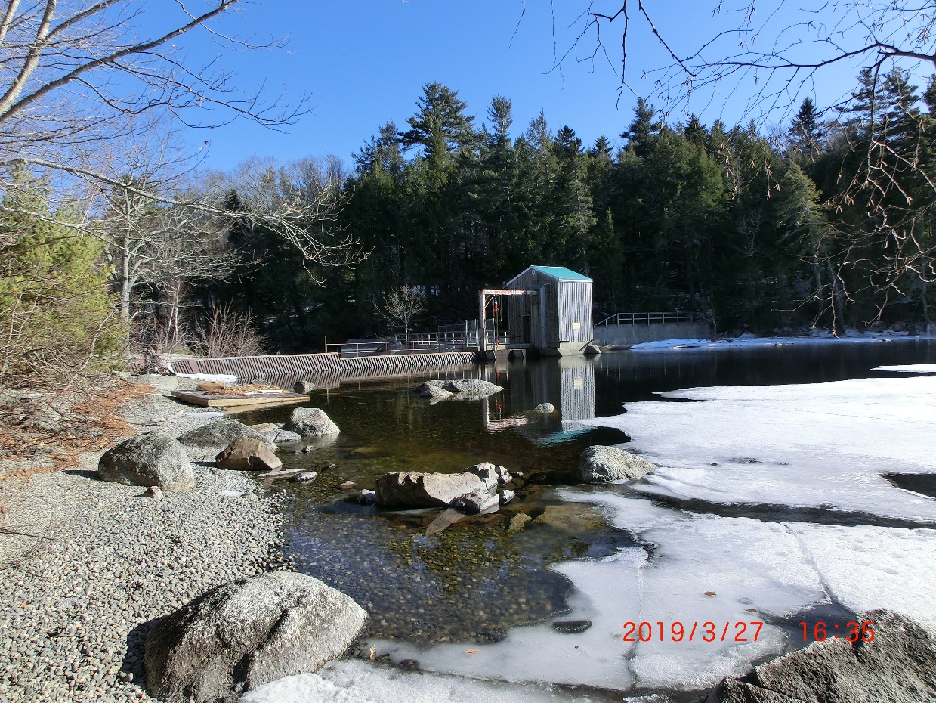
Photo 2-1 Green Lake Dam from the North

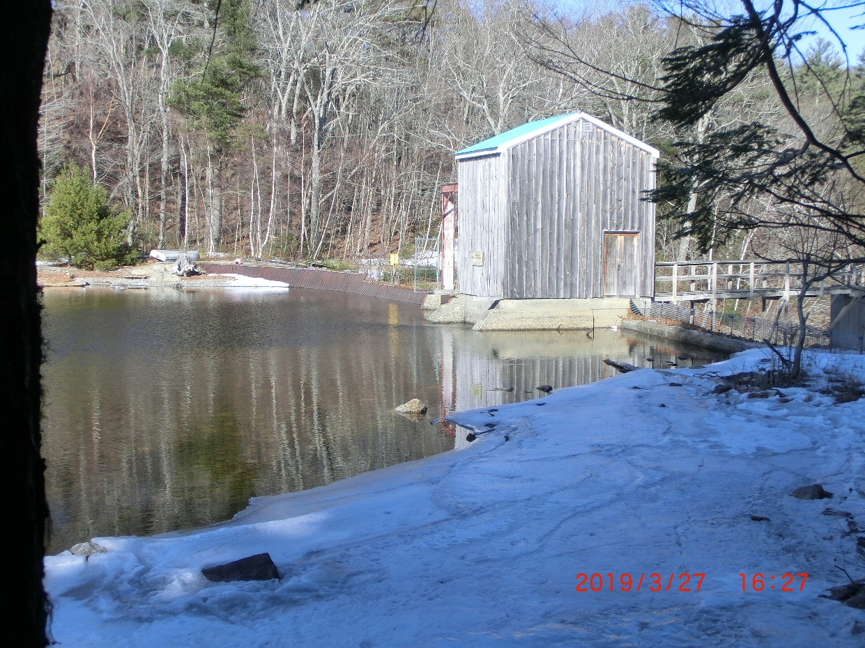
Photo 2-2 Green Lake Dam from the Southwest
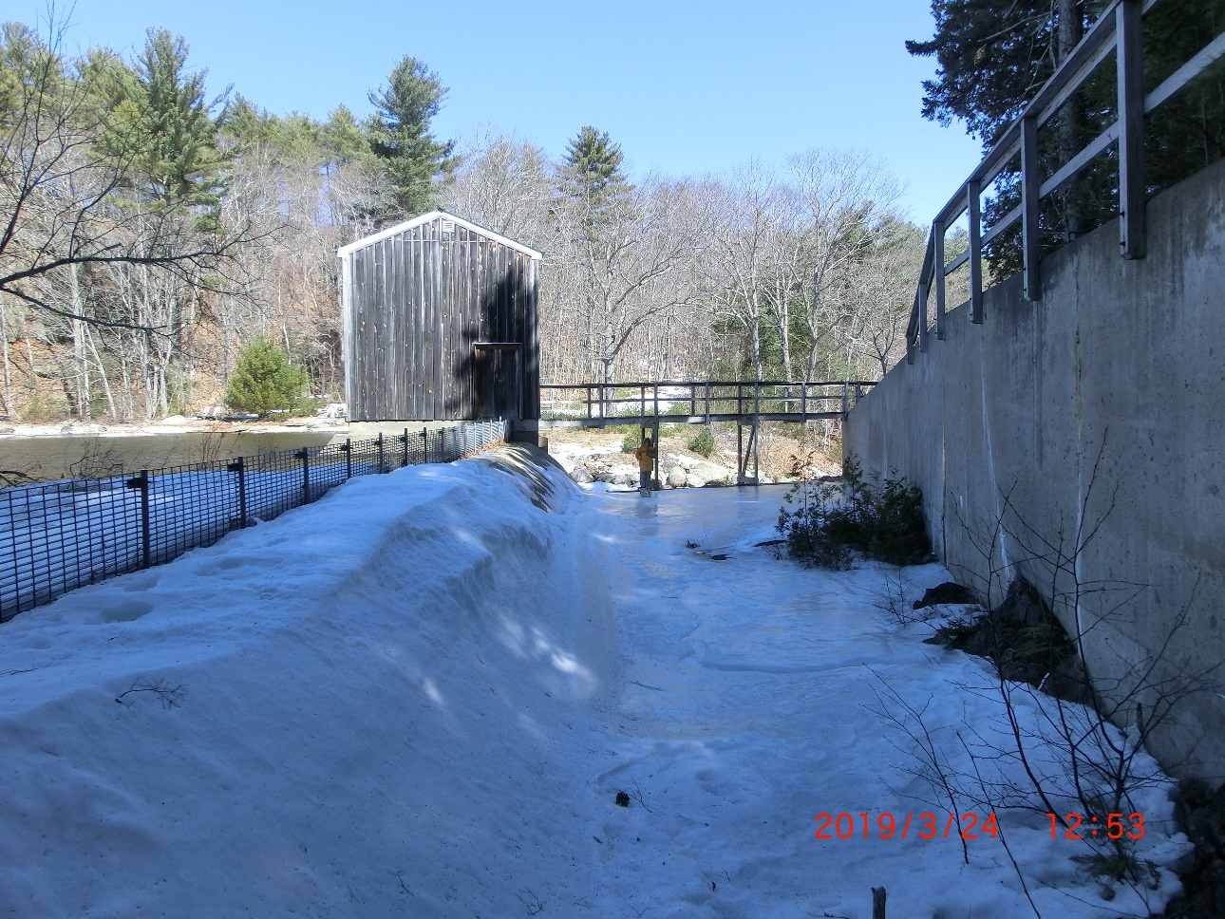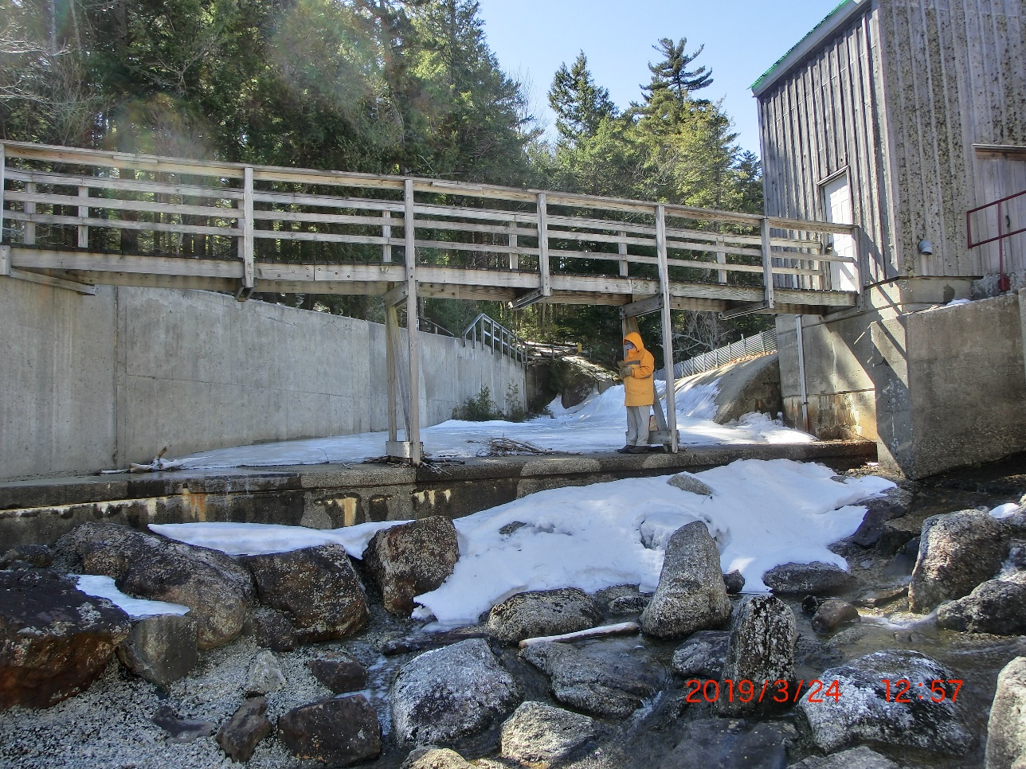
Photo 2-3 Spillway and Flume
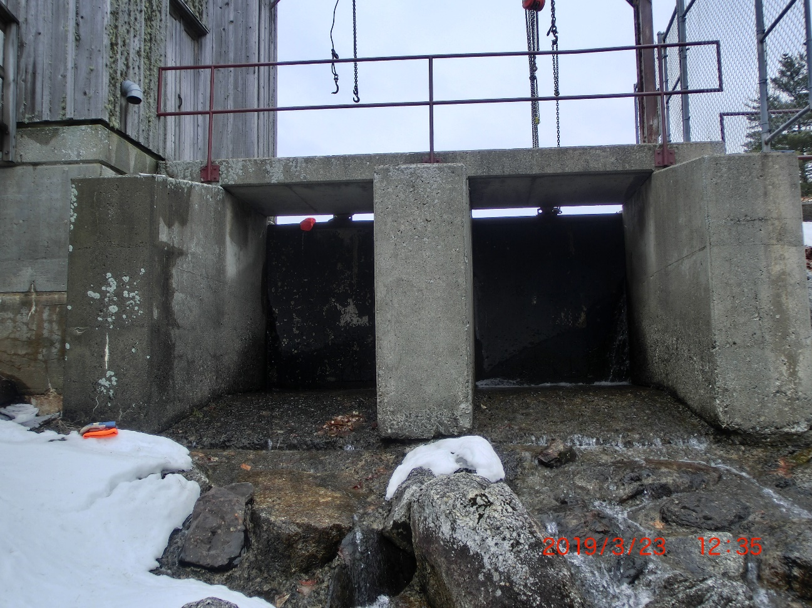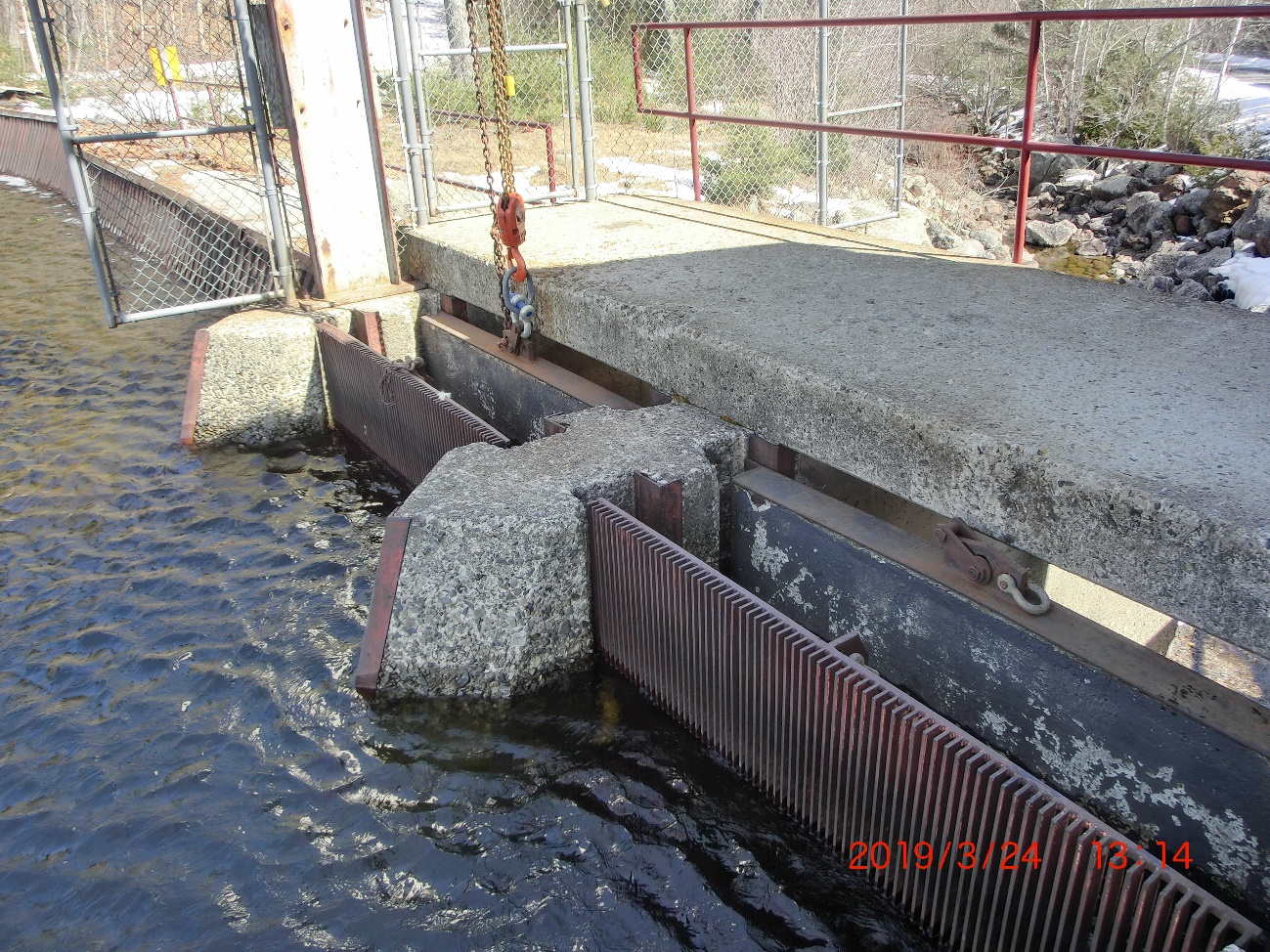
Photo 2-4 Green Lake Dam Gates and Fish Screens

Penstock
The 1,744-foot-long penstock is located along the shoulder of the hatchery road. Immediately below the intake structure, approximately 70 feet of 54-inch square (inside dimension) concrete penstock are located partially or completely beneath grade. The next section of penstock is 54-inch diameter reinforced concrete pipe that is 410 feet long. Included is an 8-ft long by 21-ft wide transition block and valve pit which create a transition to a 48-inch diameter round reinforced concrete penstock. The transition block also contains a 24-inch penstock tap and valves to supply water to the Hatchery. The 48” round concrete penstock section is 264 feet long. A minimum of one foot of fill has been placed over this portion of penstock. An 8-foot square concrete transition block is at the end of the 48-inch concrete penstock. From the transition block, 1000 feet of 48-inch diameter wood stave penstock connect to the powerhouse. The wood stave penstock is supported approximately 10 inches above grade by timber cradles at 8-foot intervals. Penstock capacity at the powerhouse is approximately 115 cfs.
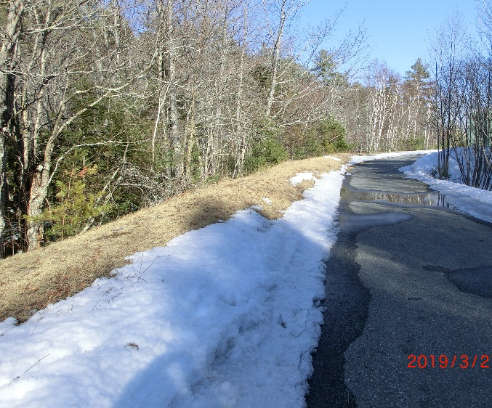
Photo 2-5 Underground Penstock

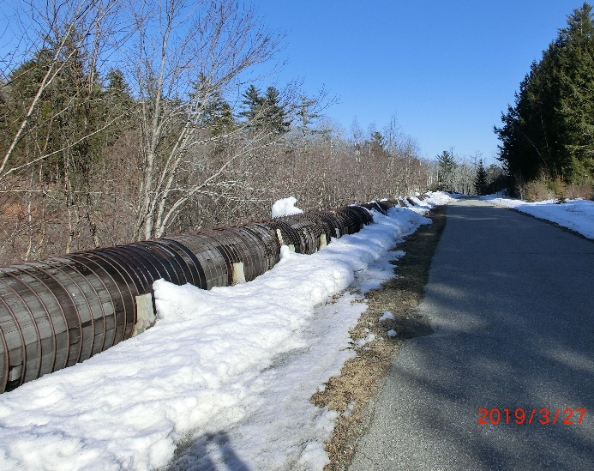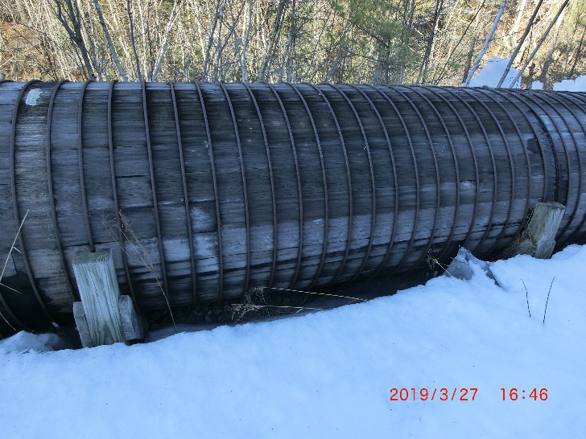
Photo 2-6 Wood Stave Penstock

Powerhouse
The powerhouse is a reinforced concrete substructure, 27’ by 35’ in plan, and houses the turbines, generators, switchgear equipment, operator’s quarters, and garage. The operator’s quarters and garage are housed in a wood frame structure that rests on the concrete ceiling slab of the generator room. The concrete slab contains hatches that allow the turbines and generators to be lifted into the garage. The ceiling area of the garage contains a monorail with a 6-ton capacity chain hoist for lifting the units. This hoist is capable of lifting the heaviest individual component of the main turbine unit.
The powerhouse is located approximately 1,744 feet downstream of the dam, on the south side of Reeds Brook, adjacent to the GLNFH. The powerhouse is a three-story structure built into the existing slope. The site is graded so that only the operator’s quarters (upper story) are visible from the south (Hatchery) side. A concrete pad outside the powerhouse supports the transformer.

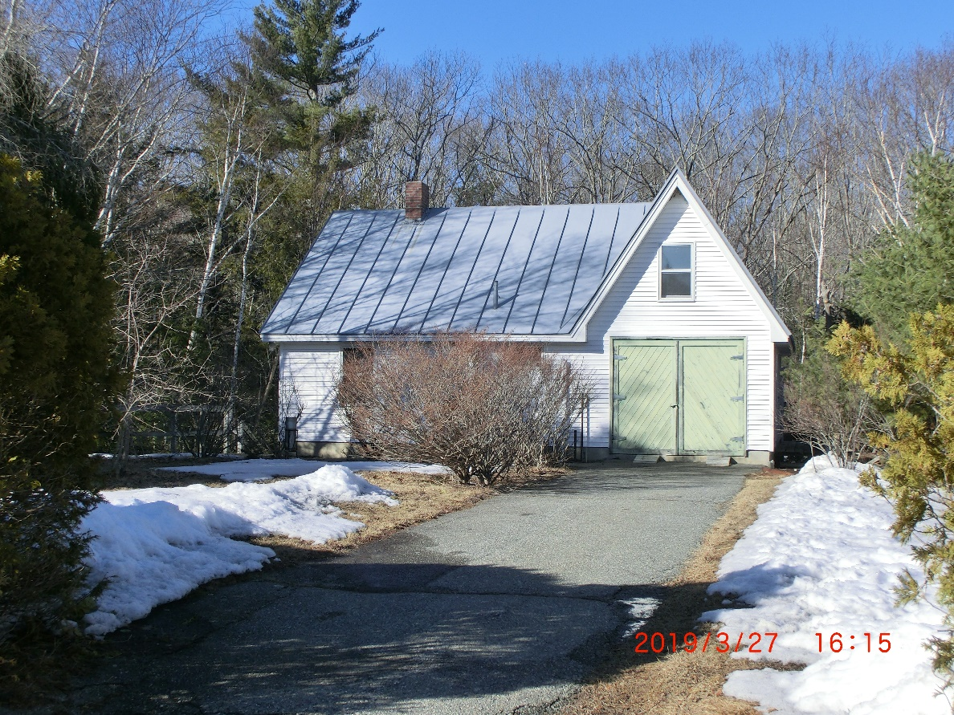
Photo 2-7 Powerhouse from Driveway
A paved driveway, 10 feet wide and approximately 75 feet long, provides access to the powerhouse. This driveway connects with the existing Hatchery road at the east end of the Hatchery parking lot.
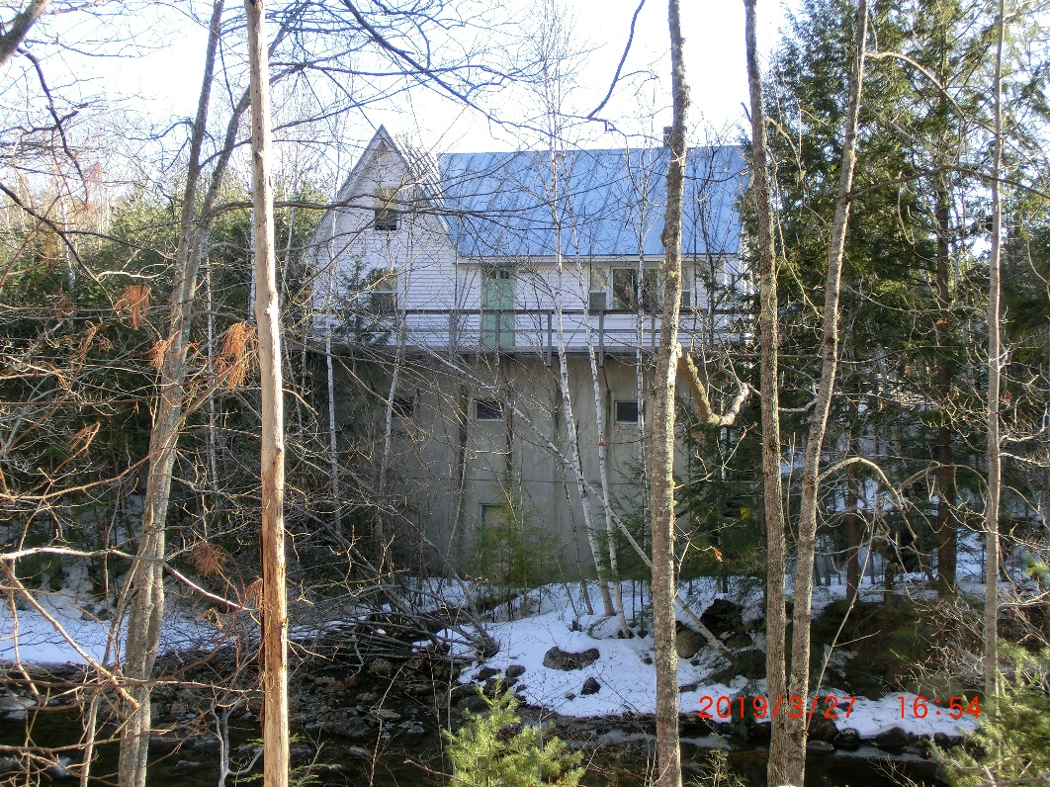
Photo 2-8 Powerhouse North Side
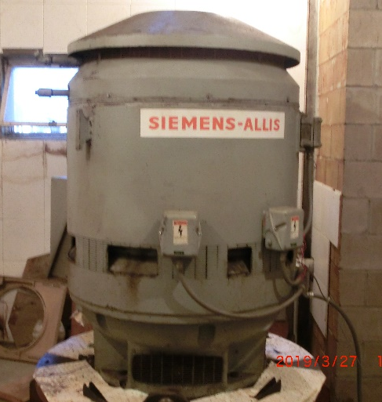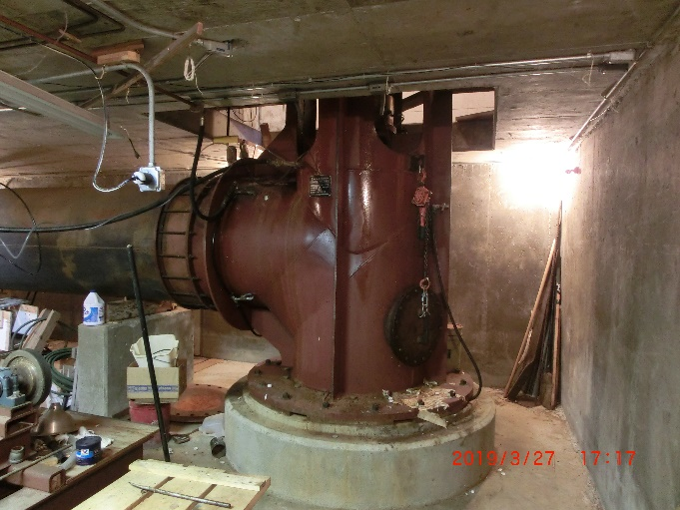
Photo 2-9 Main generator and turbine
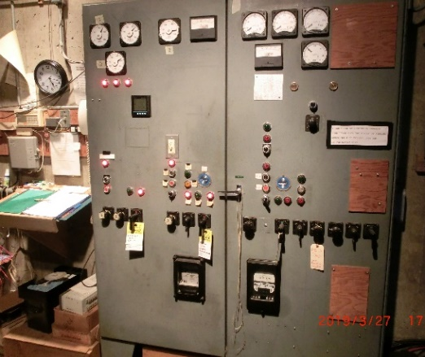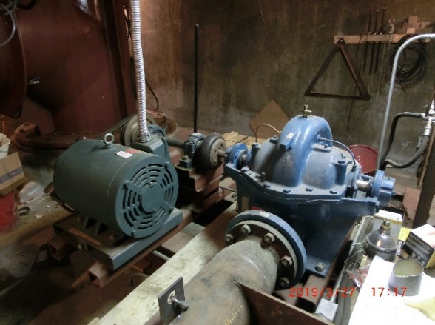
Photo 2-10 Control Panel and Second Unit

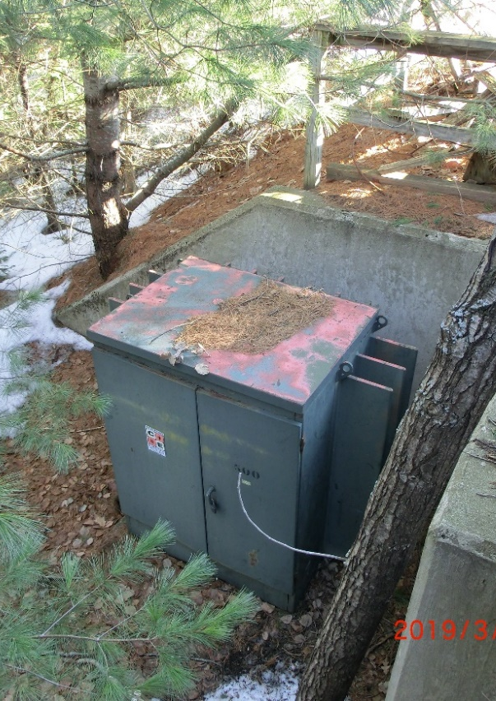
Photo 2-11 Transformer

Tailwater
Two five-foot diameter concrete pipes, extending 35.38’ and 42.25’ from the powerhouse to Reeds Brook, serve as the discharge pipes. The pipes are located below grade, and riprap has been placed around the mouth of the pipes to stabilize the stream bed and bank. An area extending a maximum of approximately 70 feet by 55 feet from the mouth of the discharge pipes has been dredged to improve hydraulic flow. Normal tailwater elevation varies between El. 99’ and El. 103’ NGVD29 datum, depending on the level of Graham Lake.
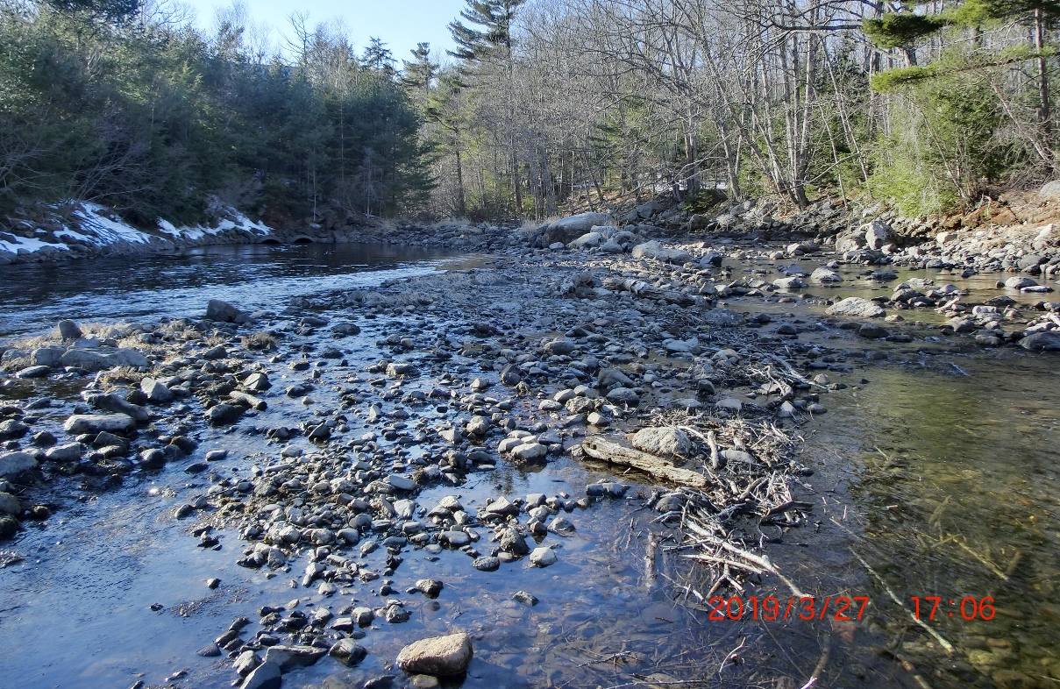
Photo 2-12 Reeds Brook Below Powerhouse, Tailwater on Left

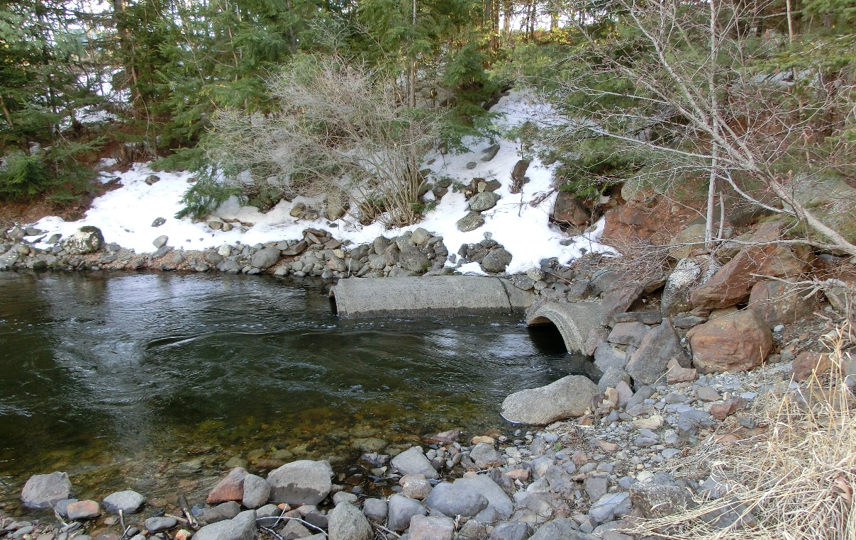
Photo 2-13 Tailwater Concrete Pipes

Turbine/Generator
The Project contains two turbine-generator units. One with a rated capacity of 400 kW and the second with a rated capacity of 25 kW. Together they have a hydraulic capacity of about 97 cfs. The project head of generation is approximately 50 feet.
The 400 kW Allis-Chalmers tube turbine has a 28-inch runner (with five blades) which is centered on an elevation of 101.9 ft NGVD29 datum. This tube turbine does not have different runner inlet and discharge diameters. The turbine runs at a speed of 726 RPM when generating at normal capacity, with a generator efficiency of 95.3%. The turbine does not have a variable gate.
The 25-kW centrifugal pump-as-turbine has an eleven-inch runner. It has a six-inch inlet and an eight-inch outlet.

Project Impoundment
The Green Lake impoundment has an area of 3312 acres. During much of the year (mid-October through the following May), the Project can maintain the water level within a range of 157.5 to 160.7 feet NGVD29 datum, yielding a maximum usable storage of about 10,136 acre-feet. Volume from gate sill elevation to full pond (154.0 to 160.7 feet NGVD29 datum) is about 17,731 acre-feet.

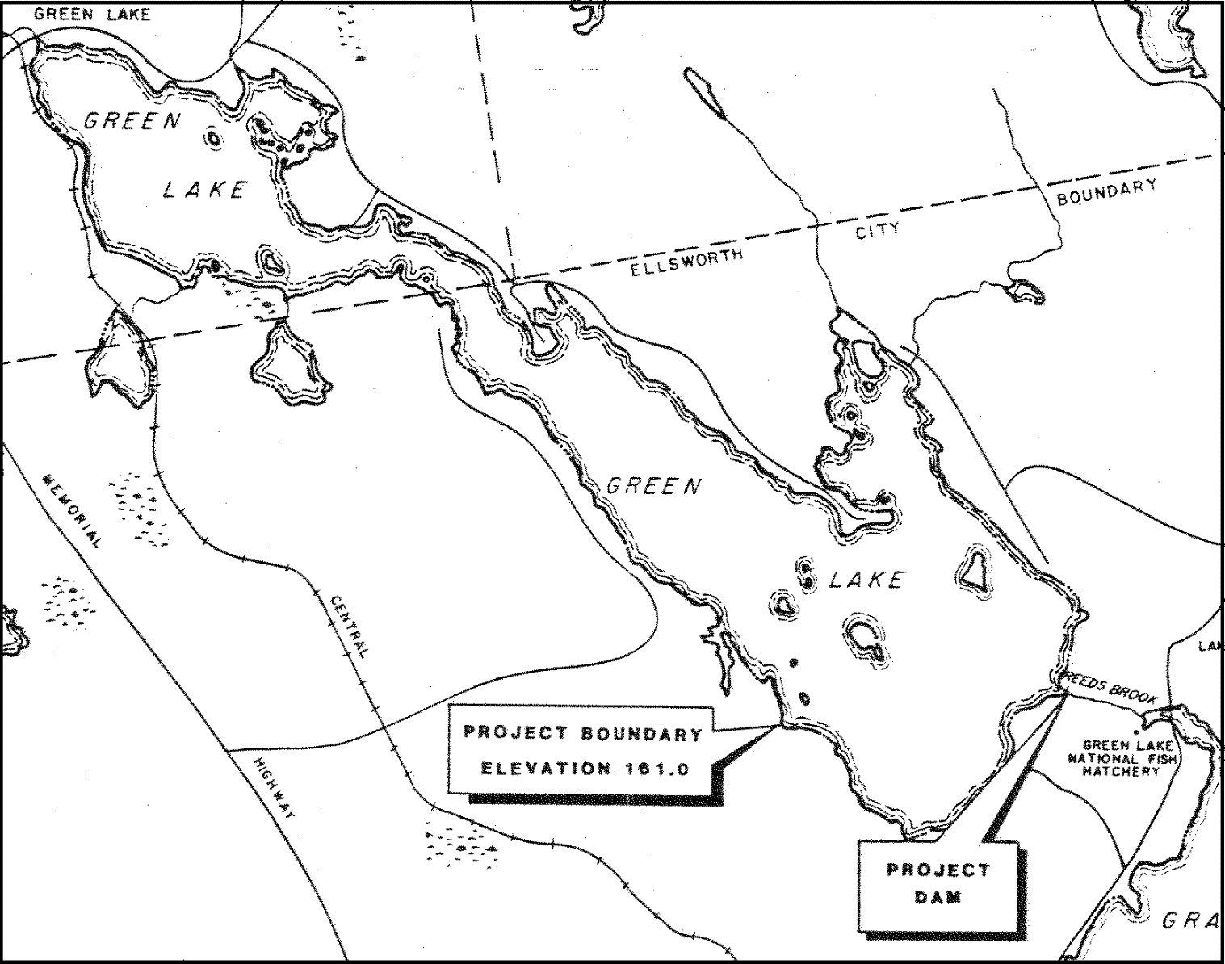
(GLWP 1983 – Original Project License Application)
Figure 2–1 Project Impoundment

Fishway Facilities
Fish passage in the upstream direction is not recommended for the Project because of the possibility of alewife being introduced into Green Lake and contaminating water withdrawn for the Green Lake National Fish Hatchery (GLNFH) with alewife-borne diseases, because of potential effects on resident fish, and because of potential mechanical problems at the GLNFH filtration plant from large numbers of out-migrating alewives. To prevent fish from migrating upstream over the dam into Green Lake, the Project proposed, with concurrence from Interior and MDIFW, to maintain the pre-existing fish screens at the crest of the project dam. The Project also proposed, at the request of Interior and MDIFW, to install screens at the project intake with a maximum mesh size of 2 inches to prevent adult salmonids from moving out of Green Lake.
Article 28 of the existing license requires Licensee to install screens at the project intake to minimize mortality due to entrainment and to prevent out-migration of adult salmonids from Green Lake. (FERC, 1984)

Appurtenant Facilities and Equipment
Green Lake Project – FERC No. 7189
Description | Number or Fact
General Information
FERC Number | P-7189
License Issued | 5-Apr-84
License Substantially Amended | 25-May-84
License Expiration Date | 31-Mar-24
Licensed Capacity | 500 kW
Project Location | On Green Lake and Reeds Brook in the  City of Ellsworth, Hancock County, Maine.
Reservoir and Dam
Surface Area of Reservoir | 3312 acres
Normal Pond Elevation | 160.7 feet NGVD29 datum
Usable Storage of Reservoir | 10,136 acre feet
Drainage Area | 46 square miles
Dam Construction Date | Early 1900’s
Elevation Top of Dam | 164 feet NGVD29 datum
Height | 7.5 feet
Length of Dam | 272.7 feet
Lift Gate 1  Lift Gate 2 | 6.4 feet wide by 7.25 feet high  6.3 feet wide by 7.25 feet high
Log Sluice | None
Spillway | 1) 79.8’ long at 160.7 feet NGVD29
 | 2) 35.5’ long at 161.5 feet NGVD29
 | 3) 121.5’ at 163.0 to 164.0 feet NGVD29
Flashboards | None
Trashracks | 8’ wide x 12’ long, 1” clear spacing
Top of Trashrack elevation | 162.5 feet NGVD29
Powerhouse
Length (Superstructure) | 35 feet
Width (Superstructure) | 27 feet
Turbines/Generators
Number of units | 2, 400 kW and 25 kW nameplate capacities
Main Unit | Allis Chalmers tube turbine
Estimated Minimum Hydraulic Capacity | 90 cfs
Estimated Maximum Hydraulic Capacity | 90 cfs
2nd Unit | Centrifugal pump
Estimated Minimum Hydraulic Capacity | 7 cfs
Estimated Maximum Hydraulic Capacity | 7 cfs
Estimated Average Head | 50 feet
Average Annual Generation | 1,657,759 kWh
Fishway Passage
Upstream Passage | None
Downstream Passage | None
Transmission Lines and Transformer
Transmission Line Type | Underground 12.47 kV
Transmission Line Length | 650 ft
Transformer | 500 kVA, Primary 12.47 kV,  Secondary 480 V, 3 phase
Table 2-1 Green Lake Hydroelectric Project Summary Table

The Project is equipped with a 500-kVA, 480V/12.47kV transformer and a 650-foot-long, 12.47 kV transmission line.

Proposed Facilities
Most of the existing facilities are expected to remain the same, but one environmental measure is proposed. An environmental change is covered in Section 2.2.3 below.

Provisions for Future Units
There are no plans for additions or modifications for future units.

Project Operation

Current Project Operation
The Green Lake Dam is managed for power generation at the Project. In addition, water management of Green Lake is designed to maintain recreation values, allow water supply for the Green Lake National Fish Hatchery (GLNFH), protect Arctic charr spawning habitat, and maintain sufficient flow in Reeds Brook. The Green Lake dam gates are manually operated. Water is drawn from Green Lake by the GLNFH by means of two submerged pipes (non-project) to supply the Hatchery. Up to 30 cfs from Green Lake may be used on a priority basis by the Hatchery.
Brookfield Renewable Energy Group owns and operates a water control dam at the outlet of Graham Lake, downstream of Green Lake, and a hydroelectric generating facility (FERC No. 2727) approximately four miles downstream of Graham Lake in the City of Ellsworth. The Project does not operate as part of the Brookfield projects nor benefit financially or otherwise from these projects. The Project does coordinate with Brookfield’s River Control (as well as Ellsworth officials and other emergency personnel as appropriate) during heavy flood flows to make sure water released from the Green Lake Dam will not cause problems for Brookfield or the City of Ellsworth.
The Licensee adheres to an operating schedule which ensures maintenance of recreational values, allows water supply for the hatchery, and protects Arctic charr spawning habitat. The lake is drawn down during the fall and winter from the spillway elevation of 160.7 ft NGVD29 datum to a minimum of 157.5 ft NGVD29 datum (7.2 to 4.0 feet on the staff gauge). The fall drawdown begins after Labor Day weekend and is completed by October 15 of each year. The lake is then allowed to partially refill during the fall and early winter. Depending on the extent that the pond is refilled, the pond is drawn down prior to spring runoff to protect against flooding. Winter drawdown varies annually, depending on the amount of runoff anticipated from snowpack. Throughout the winter the lake level is not drawn down below the level on October 15 of the previous year.
The maximum fall/winter/spring drawdown level of 3.2 feet from full pond is in place to guarantee that Arctic charr eggs are not dewatered. It was originally believed that it was necessary to complete the fall drawdown before Arctic charr spawn in the lake, but that has been discovered to not be necessary, as covered in Section 2.2.2 below.
The lake is restored to between elevations 159.7 ft and 160.7 ft NGVD29 datum (6.2’ and 7.2’ on the staff gauge) by June 1. The lake is maintained between elevation 159.7 ft and 160.7 ft NGVD29 datum for the period of June 1 through Labor Day of each year. This provides for the recreational use of the lake and shorefront areas and provides sufficient water pressure for the Hatchery’s to draw water from Green Lake into their filtration building using their own pipes.
Turbine operation is controlled manually. Because of the fixed operating point of the larger turbine, it is either operated at full discharge capacity of 90 cfs or is off. The smaller turbine with a fixed, but much smaller, flow (estimated at 7 cfs) can operate continuously as lake level and inflow allow. The Licensee maintains an instantaneous minimum flow of 1 cfs in Reeds Brook. (FERC, 1984) Under most conditions, the leakage past the dam is more than the required 1 cfs.
The Project runs as an impoundment but its operation is closer to fixed point “run of river” than it is to peaking during much of the year, especially during the summer. This is because the project typically has “too much” water (in which case the main unit runs) or the project has too little water (in which case the main unit is off). During the summer the level is maintained to a range of plus or minus 0.5 feet. The Project units are on or off. GLWP’s current plans are not to do peaking generation as it has not been an effective means of operating recently.
The fall drawdown procedure varies from year to year depending on the weather. During a “typical fall” the main unit is started Labor Day or the day after and run non-stop until the lake drops to about 157.7 ft NGVD29 datum, which is 0.2 feet above the 157.5 ft NGVD29 datum drawdown target. As 15-Oct approaches the lake level and precipitation dictate when the turbine is started to complete the drawdown. Usually, four to five weeks (of an average six-week drawdown period) are required to drop the lake to 157.5 ft NGVD29 datum. Some years less than two weeks of generating have been required for the drawdown, some years opening the waste gates at the dam has been required to approach the drawdown target. When the second turbine is fully operational and tested for unsupervised operation, it may be used as part of the drawdown if extra water is present. At the end of the drawdown period, after 15-Oct, the main turbine is shut down to allow the lake level to rise. This provides a buffer in case the early winter is unusually dry.
Refills during the winter and spring are highly weather dependent. Some winters consistent snow melts during the winter result in no snowpack. Other winters have significant snowpack.
Winters with heavy runoff (no or little snowpack) result in the lake being held at a higher level to increase the likelihood of being in the summer range starting in June. Winters with a heavy snowpack result in the lake being held at a lower level during the winter, and as low as possible in the spring, in anticipation of heavy spring runoff.

Proposed Project Operation
GLWP is proposing to continue operating the Green Lake Project as described in the section 2.2.1 Current Project Operation with changes to the fall drawdown period. MDIFW has informed GLWP that Arctic charr spawn below a depth of 6 ft in Green Lake, using historic spawning locations from before the first Green Lake Dam was built. One of the reasons they know this is that they have been unable to catch Arctic charr in their trap nets.
The dam raises the level of Green Lake about 7.5 ft at full pond. The maximum allowed normal drawdown is 3.2 ft from the full pond level. Even with 3 ft of ice on the lake, the maximum drawdown would not dewater the historic Arctic charr spawning beds. The current fall drawdown restrictions are not needed to protect Arctic charr in Green Lake.
GLWP is not proposing changing the summer or winter period dates, or the lake levels allowed during these periods. GLWP is proposing removing the requirements that the fall drawdown is completed by October 15 each year, and that throughout the winter and spring the water level is not drawn down below the level on October 15 of the previous year.
Removing the fall drawdown end date will allow the fall drawdown to be delayed based on weather conditions. This will enable recreational use of Green Lake later into the fall and allow the Project to perform more routine maintenance in the fall (rather than the summer), benefitting the Hatchery. Removing the winter/spring drawdown limitation based on the previous fall drawdown level will allow the use of the full drawdown range to minimize the dangers of ice damage and spring flooding around the lake.

Proposed Environmental Measures
Modification of the trashracks is proposed to add one bar such that neither poor trashrack section placement nor shifting can cause a clearspace gap greater than 1 inch. The estimated material and labor cost for this measure is $5000. No significant additional maintenance/operation costs are expected from this change.

GLWP proposes that the summer and winter lake level periods and levels be maintained in the new license (with the removal of some of the existing drawdown restrictions, as discussed in Section 2.2.2 above.) The maximum lake level drawdown during the winter period of 3.2 feet below full pond has been chosen to protect Arctic charr in Green Lake.

Average Annual Generation
Project generation for five years (2016-2020) averaged 1,657,759 kWh; the monthly and yearly kWh totals are as follows:
Year / | 2016 | 2017 | 2018 | 2019 | 2020 | 5 year Average
Month
January | 234,143 | 242,144 | 162,336 | 249,261 | 250,317 | 227,640
February | 229,542 | 225,473 | 223,480 | 225,368 | 237,069 | 228,186
March | 237,943 | 245,249 | 251,781 | 253,134 | 252,575 | 248,136
April | 209,792 | 235,391 | 233,438 | 236,917 | 233,414 | 229,790
May | 138,506 | 234,544 | 86,780 | 224,302 | 241,822 | 185,191
June | - | 121,224 | 10,180 | 209,847 | 36,135 | 75,477
July | - | - | 63,865 | 146,387 | - | 42,050
August | - | - | 29 | 59,492 | - | 11,904
September | 100,895 | 93,163 | 117,389 | 231,749 | 101,013 | 128,842
October | - | - | 56,032 | 117,392 | 42,437 | 43,172
November | 869 | - | 131,149 | 136,614 | 9,194 | 55,565
December | 100,310 | 70,888 | 250,133 | 246,842 | 240,848 | 181,804
Total | 1,251,999 | 1,468,076 | 1,586,592 | 2,337,305 | 1,644,824 | 1,657,759
Table 2-2 Monthly and Yearly Generation (kWh) for the Green Lake Project

Estimated Average Head
The estimated average operating head for the Project is 50 feet.

Hydraulic Capacity of the Project
The total maximum hydraulic capacity of the Green Lake Project generating units is 97 cfs, at an operating head of approximately 50 feet. The units are both fixed point units with the main turbine using 90cfs and the 2nd unit using 7cfs when running.

Estimated Cost of the Project
An environmental measure, covered in Section 2.2.3 above, is estimated to cost $5000. No additional annual Project maintenance nor operation expenses are anticipated from this measure. Relicensing costs are covered in section 4.0 and annual operation and maintenance costs are covered in section 8.0 below.

Purpose of the Project
The Green Lake Project is operated for the production of renewable hydroelectric power. The power generated by this Project is sold to Versant Power, formerly Emera Maine. Versant Power provides reliable high voltage electric power to approximately 159,000 people within the state of Maine.

Estimated Cost of Relicensing
GLWP estimates that the cost of relicensing the Green Lake Hydroelectric Project is approximately $200,000. This includes both internal administrative costs and external expenses (e.g., consultant costs) over the course of the Integrated Licensing Process (ILP).

Value of Project Power
The power generated by the Green Lake Hydroelectric Project has been producing an average of about $72,000 per year.
Electric rates are currently in a state of flux, and within the last few years GLWP has seen both the lowest and highest rates experienced by the project.
GLWP has been accepted into Maine’s Net Energy Billing (NEB) program starting 01-Sep-2024. While future electricity rates are always somewhat unpredictable, the nature of the NEB rate structure provides a rate that is almost certain to be more stable and substantially higher on average than what GLWP has been getting in the recent past.

Estimated Change in Project Generation
GLWP does not anticipate any significant changes in project generation.

Undepreciated Net investment (Book Value) of the Project

Green Lake Project Current Net Investment

Buildings and other depreciable assets $1,374,441
Accumulated depreciation $ 969,570
Undepreciated Net Investment $ 404,871

Annual Operation and Maintenance Costs
The annual operation and maintenance costs of running the Green Lake Hydroelectric Project facility are $49,592. This includes approximately $34,691 for the annual administrative expenses.

Estimated Annual Cost of the Project
The total annual cost to operate the project, including administrative costs, insurance, operations and maintenance, general and other expenses is as follows:
• Administrative costs $35,000
– includes insurance, pay, property taxes, administrative and general costs.
• Operations and maintenance $15,000
Much of the payroll and general costs (included in Administrative costs) are for operations and maintenance activities.
The project incurs infrequent, and somewhat unpredictable, maintenance and repair costs. For example, this past winter (2021-2022) the main generator required a rebuild, at a cost of about $44,000. While this represents a cost of about $1200 per year considering the age of the generator, the overall condition discovered upon disassembly of the generator indicates that it was capable of running much longer without experiencing a “normal wear-and-tear” type failure. The freak failure of an internal, metal clad heater caused the failure of a generator coil. A different type of heater was installed during the rebuild to preclude this particular failure from happening again. To reflect a rough estimate for such repairs, $3000 per year has been included in the maintenance figures above.
The numbers do not include replacement of the penstock (estimated at 600-1200K$) and investigation and service or replacement of the station septic leaching field (no cost known until the investigation of leaching field condition is complete).
Where possible, any expenditures which are not needed if a new license is not granted to the Project are being deferred until after the new license is granted.

Project Safety Program
The project has a ‘low hazard’ classification and is exempt from the requirement to submit an Emergency Action Plan. An analysis of risks was done when this was determined and it was determined that because the dam is a rock crib dam, any failure would be gradual and the Route 180 bridge downstream would not be jeopardized.
The Dam Safety Surveillance and Monitoring Program and Report (DSSMP) defines the appropriate monitoring for the project works. The DSSMP for the Project was filed with the FERC on December 28, 2018.
In addition, Section 10(c) of the Federal Power Act (FPA) authorizes FERC to establish regulations requiring licensees to operate and properly maintain their Projects for the protection of life, health, and property. FERC Part 12 regulations include such safety measures as signage and exclusion devices.
The project is inspected by FERC every 3 years for safety.

References
FERC 1984 – Federal Energy Regulatory Commission (FERC). 1984 Order Issuing License (Minor) for Green Lake Hydroelectric Project (FERC No. 7189). 27 FERC ¶62,023. Issued April 5, 1984.
GLWP 1983 – Green Lake Water Power Project (GLWP). 1983. Application for a License for a Minor Water Power Project – FERC No. 4894.
USGS Map 44068-E1-TM-100, “Bangor, Maine”, 1994 Revision

Appendices

Appendix A – Single-Line Diagram

Appendix A

Single Line Diagram

The current Single Line Diagram was filed on July 27, 2022 and is not being refiled with this document.

May 25, 1984 Order Amending License P-7189 is included as a file in this submission
Accession # 20220131-5099_MDIFW comments on DLA 1-29-2022 – in the Record as 2022-01-29_MDIFW comments on DLA – further clarified by MDIFW in email (included as a file in this submission) to GLWP on April 10, 2024 and on a phone call with Greg Burr of MDIFW

