July 2, 2024

DEP Hydropower Staff

Augusta, Maine 04333-0017

Regarding:



Dear DEP Hydropower Staff:

I am a retired scientist and member of the Downeast Chapter of Trout Unlimited, the Downeast Salmon Association, and the Union Salmon Association. I want to comment on the current draft of the Clean Water Certification that has been issued for Brookfield with respect to the Rumford Falls Hydroelectric Project.

I feel that the current draft gives all the cookies to Brookfield, providing them with a *status quo* permit that does not adequately address public and legal concerns with this project. The main problems are that the Androscoggin River remains dewatered in the falls area as water is diverted to the turbines and there is no good option for fish passage except through the turbines. This draft permit allows parts of Rumford Falls, the Upper and Middle Dam Bypasses, both sections of Class C river to not attain any legal requirements. Except for elevated discharges for 3 days in the summer for whitewater boaters, there is no provision to provide minimum flows to support public uses, fisheries, or aquatic communities. So, in my mind, the river in these locations fails to attain even Class C criteria and is legally “non-attaining” due to present development and dam operations.

As mentioned in the draft, hydropower facilities are expected to meet at least Class C criteria, namely:

Chapter 3: PROTECTION AND IMPROVEMENT OF WATERS

Subchapter 1: ENVIRONMENTAL PROTECTION BOARD

Article 4-A: WATER CLASSIFICATION PROGRAM

§465. Standards for classification of fresh surface waters

…

4. Class C waters. Class C shall be the 4th highest classification.

1. Class C waters must be of such quality that they are suitable for the designated uses of drinking water supply after treatment; fishing; agriculture; recreation in and on the water; industrial process and cooling water supply; hydroelectric power generation, except as prohibited under Title 12, Section 403; navigation; and as a habitat for fish and other aquatic life.
2. The dissolved oxygen content of Class C … (must meet DO criteria) … (and E. coli criteria) …
3. Discharges to Class C waters may cause some changes to aquatic life, except that the receiving waters must be of sufficient quality to support all species of fish indigenous to the receiving waters and maintain the structure and function of the resident biological community.

Notice that the criteria are about the water (not the fish or aquatic communities per se) and that the water must be suitable for designated uses. Fishing, recreation, and so on, are possible only if there is adequate water. Brookfield says that the reach has an extreme slope and lack of habitat, and so would not be expected to support fish or much of an invertebrate community. So, actually the slope is variable, there are low slope as well as high slope areas, pools, and even cascades that could support some plants and animals. Anyway, there is no minimum number of fish or animals required by law. I would argue that the best standard is that the organisms that were there before the falls were dewatered should be supported now. This would include fish passing downstream, maybe some resident fish, plants (like *Podostemum* and *Fluviatilis*) and macroalgae (*Hydrurus, Lemmanea, Toumeya*) and invertebrates. Macrophytes provide low current velocities forming a bottom layer microhabitat that shelters invertebrates. If there is water and physical habitat, there will be an aquatic community.

DIFW is correct in their comment that there will be little in the bypass reaches by way of fish. But I would argue that no one actually has to fish there, much of the value of the community is in the biomass and unique flora and faunas of cascades. This adds to the biodiversity of the Androscoggin watershed which enhances ecological and climate resilience. A watered cascade also has scenic value. Threadfoot (*Podostemum ceratophyllum*) is rare, is on the Endangered and Threatened list in Maine (12 MRSA §544-B, sub-§3-A), and is considered a “foundation plant” because it provides habitat in Rheophyte communities. If you support foundation species, you will have an entire community. In contrast, a bare river bottom has no scenic or biological values.

The dam builders created this biological desert. Brookfield does not get to claim that there is nothing here to save when the dams are the source of the problem. DEP does have minimum flow requirements, namely:

**Chapter 587: IN-STREAM FLOWS AND LAKE AND POND WATER LEVELS**

…  
**5. Flow requirements for Class A, B, and C waters**

**…**

1. **Flow requirements** **for Class B and C waters.** Flow requirements established by the standard allowable alteration in Class B and C waters may not be less than the seasonal aquatic base flow as defined, except when natural conditions alone cause those flows to be less. The Commissioner may establish,pursuant to sections 7 or 8 of this chapter, site-specific water flows that are protective of all water quality standards, including all designated uses and characteristics of those waters.

(But, Hydropower projects are exempt and min flows are set in the licensing process).

DEP’s own Hydropower rules generally require a 75% of wetted perimeter of the cross-section area compared to bankfull. In a river the size of the Androscoggin, this would be a lot of water. The Upper Dam Bypass gets only 1 cfs which falls far short of the standard. Brookfield’s own models show increasing habitat with an optimum flow-habitat ratio at 265 cfs. So, let’s create some habitat.

One of the critical functions of streams is connectivity, the ability of organisms to migrate upstream and downstream. Many species and probably all fish species use the ability to move to occupy different habitats for different life phases and purposes (i.e., spawning vs feeding). Dams critically impair this ability. Upstream migration in a cascade is probably not possible except for American eel, but we know eels are in the area, both upstream and downstream of the dams. So, provide for that. And downstream migration is also important. Sometimes with dams this downstream movement is only provided for by the turbine discharges, and we know that large number of fish to not survive the turbine blades. In the Union River where I live, I find eels are chopped up into 8-inch pieces. Nothing larger than 8 inches can make it through the turbines (which would include all adult American eels). Fish that are smaller than 8 inches have to time the passage exactly right or suffer a blade strike. Furthermore, blade strikes are not the most important mortality factor (see photo below). Turbines Intakes for the Rumford Falls turbines should have trash racks with 1 inch spacing. Floating curtains should divert fish toward the bypass, and the bypass should have adequate flows. So, even if there are few resident fish, the ability of fish to pass through the cascade (connectivity) is important to the integrity of the river ecosystem.

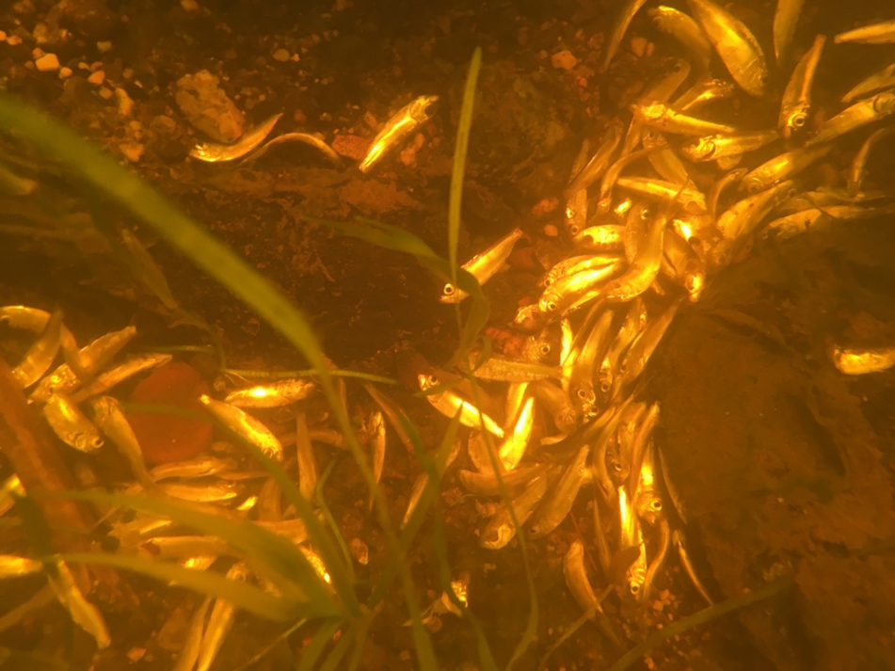

*Figure 1. Photo of fish kill below Leonard’s Lake Dam in Ellsworth. The dead fish are young-of-the-year alewife. Notice that the fish are mostly whole and have mostly not been killed by blade strikes, but rather by barotrauma. The sudden changes in pressure in front of, and behind the turbine blades often pops eyes out of sockets and ruptures the swim bladder. This photo was taken by a snorkel diver. There was very little evidence above the water of what was happening below the waterline.*

Upstream of the Rumford Falls Hydropower facility, the Gorham NH facility has minimum flow requirements of 400 cfs during trout spawning season, and 200 cfs otherwise. I would argue that 200 cfs is a sort of minimum flow for a large river to make it look like a river. In the draft CWC, DEP staff calculated that 200 cfs would be necessary to support Class C waters at the Middle Dam Bypass. So, why wasn’t that required? Maine’s interpretation of the Clean Water Act should be like that of New Hampshire. Bypass reaches in NH have minimum flows and the same should apply here.

Right now, the DEP draft CWC gives all the water to Brookfield. The Androscoggin River belongs to all of us. I think that a licensing process that is working would distribute the water so that the public, the river, and wildlife also get something. Thank you for your consideration.

Sincerely,

Mark Whiting, PhD

145 Gary Moore Rd, Ellsworth

mark.c.whiting@gmx.com