FINAL DRAFT

White Paper

August 28, 2024

Carp in the lower Kennebec River

The concerns of invasion

By Matthew Scott, Aquatic Biologist; Emeritus

AFS, Fisheries Scientist #617

Belgrade, Maine 04917

**Introduction**

In 1834 the Maine Legislature granted a petition to the Kennebec Dam Company to construct a dam in Augusta; Dawson 1989. The dam was completed in 1837 with no provision of a fishway thus terminating all fish movement above the dam, blocking all migratory fish movement. European carp were introduced in 1877 decades after dam construction.

European Carp are a potentially destructive nonindigenous species that in Maine were presently confined to the lower Kennebec River. The purpose of this paper is to discuss the risks of inadvertently allowing this population to expand its range, and to recommend actions to limit or prevent this from occurring. In 1999 when I saw the excavator tearing a hole on the western side of the Edwards Dam, I said to my boss, we have just opened “Pandora's Box”. Meaning that all the fish and aquatic life assemblages below Augusta will have access to waters accessible between Augusta and Waterville. My concerns then and now follow.

**Early Introductions of Carp**

European settlers saw this fish a source of food. The US Bureau of Fisheries, in 1877, decided that carp should be introduced and cultivated for the benefit of all people. Based on State of Maine Fish Commissioner reports, Maine received the first stocking of carp in 1880. According to DeRoche 1967, in his Androscoggin River report, “Maine unknowingly complicated anadromous fish restoration by introducing European carp.” Foye et al 1969, in his Kennebec River report, also stated facts about carp and his electrofishing reports below Sands Island, South Gardiner.

**Biology and Impacts**

The carp as a species is a very interesting fish. It is in fact the largest member of the minnow family of fishes; *Cyprinidae*. The fish is easily identified, based on size and its single spine in the long soft rayed dorsal fin and a single spine in the anal fin. A sucker-type mouth, with two barbels, and very large scales. Females of this species are very prolific. Large females can produce over 1,000,000 eggs. Thus, indicating a very high fecundity rate. In the food world carp eggs along with sturgeon eggs are relished as caviar. Their fecundity, as mentioned above, is very high, about 100,000 eggs per pound of female body weight.

Their ecology is dictated by the need for shallow warmwater environments with lots of sediment and aquatic vegetation. They often swim or move quickly in streams and rivers seeking suitable habitat for food sources, spawning and development. They are rarely found in stratified lakes and ponds as they seek shallow weedy water. As shallow water, bottom feeders they suck up bottom sediments and eject it to feed on suspended food particles. Thus, creating a constant, very muddy, and roiled habitat. The habit of feeding and keeping the water roiled prevents sunlight penetration for native aquatic plant growth and disturbs native bottom fauna. This was very noticeable when I was collecting carp below the Sands in South Gardiner and in sections of the eastern River, in Dresden, back in the 1960’s.

The food items that carp prefer are midge larvae, other aquatic insects, snails, and some aquatic plant rhizomes, and roots. They are reported to be very omnivorous and impact mostly warmwater fish habitat of bass, perch, and pickerel. Fish eggs are a typical food of carp when available. Young carp are speculated to feed on migratory fish eggs, e.g., shad, alewives, or sturgeon. Carp consumption of sturgeon eggs has been recorded during their spawning runs on the Columbia River, Fuller et al; 1999.

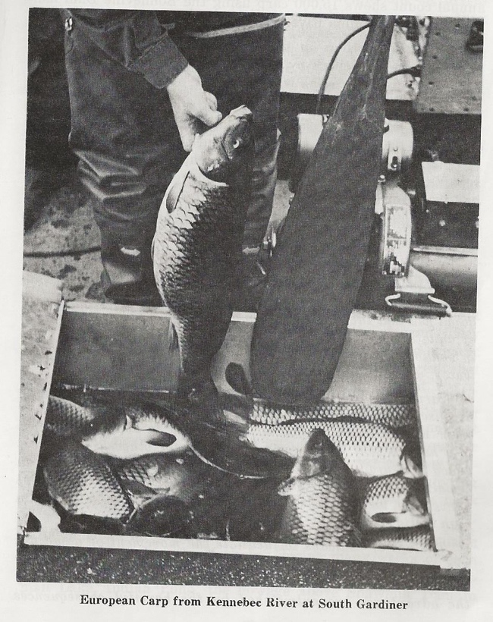**Distribution and Movements**

These fish are excellent swimmers, negotiating fishways with ease and can leap like salmon to heights of five to six feet. Until recent times they were confined to intertidal sections of the lower Kennebec and Eastern rivers, plus, smaller intertidal rivers of Merrymeeting Bay. Everhart, 1958 reported a 7 ½lb., carp was taken from the Abagadasset River and stated, “*Care must be taken not to spread this pest into any other waters of Maine*.” Carp have remained confined to their present habitat by dams and/or impoundments, plus high salinity ocean waters. This has prevented carp movement beyond Merrymeeting Bay. While working as Bob Foye’s assistant in the mid-1960s, I personally saw and netted many carp below the Sands Island in South Gardiner and the Eastern River with a large electrofishing boat. We captured about 100 pounds of adult fish during our sampling projects. See attached photos.

The Edwards Dam historically prevented carp migration into upper sections of the Kennebec River. Ocean salinity is a barrier that keeps carp confined and prevent their movement to other coastal watersheds beyond the Bay. DeRoche, 1967 expressed his concerns as, “*Every precaution must be taken to prevent the spread of carp to inland waters*”. Foye 1965, wrote a popular article in the Maine Fish and Wildlife Magazine. He talked about the numerous carp stockings in Maine and that fish cultivation, handling and sheer low numbers were all key factors for the fish not surviving these early stocking attempts. The lower Kennebec is the only exception. Foye concluded the factors limiting carp distribution were “*A most fortunate event for Maine’s inland fisheries*.” It was, but change has occurred.

In 1990, Fuller et al., American Fisheries Society publication #27 report on Nonindigenous Fishes that “*Carp are found to be ubiquitous in all off the lower 48 States; except for Maine*.” The Maine population is isolated thus far in three tidal sections as stated above in this paper. Fuller further commented on Carp as vigorous swimmers and excellent vertical jumpers like salmon leaping up to five or six feet. They are very capable of negotiating fishways or quick water. “In the past 50 years, the statistical average at the Columbia River, Bonneville Dam fishway records of 15,000 carp annually” from Fuller et al; 1999.

Maine has been very fortunate that the existing carp population has thus far been confined to the freshwater estuaries where salinity values are low in sections of Merrymeeting Bay, Eastern River and others. The apparent inability of carp to tolerate sea water prohibits the fish to be established in other coastal waters is a significant barrier, as mentioned earlier in this report.

Until recent times high dams have prevented carp from becoming established further upstream in our inland waters. However, removal of the Edwards Dam in Augusta has allowed the movement of this species into upriver habitat of the Kennebec. Seiders; personal communication, 2023, points out the fact that during screening for invasives at the Lockwood fish lift, small carp have been found in the river below Lockwood as well as white catfish. Annual electrofishing surveys in the Kennebec and Sebasticook rivers at various locations, have collected adult carp beginning in 2001, shortly after Edwards Dam was removed (Yoder, et al., 2006). Attached photos.

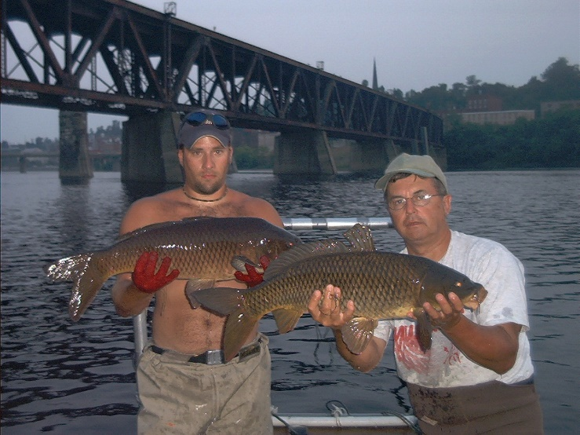 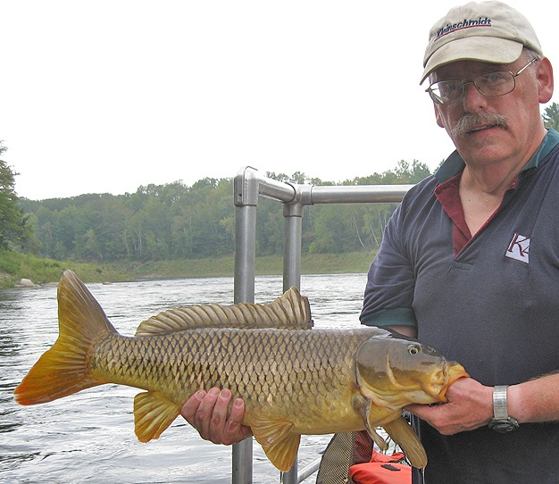

**Adult carp, Kennebec River near Augusta, 2002 (left) and Sebasticook River, 2011 right.**

The Benton Falls fish lift on the Sebasticook River is problematic, with enormous potential for human errors failing to detect carp plus northern pike and white catfish or other invasive fishes of concern. The low gradient, warm Sebasticook River and its network of tributary lakes above Benton Falls such as Unity Pond, Great Moose Pond, Plymouth Pond, Sebasticook Lake etc. are at risk as potentially fertile carp habitat. The first fishway established by DMR at Webber Pond was done after the Edwards Dam removal and has allowed carp to become established. This needs to be corroborated.

Carp has a long-life cycle and will take 20 years perhaps to establish a reproducing population. Togus Pond could be next as a new fishway has been established and operating. Lower Togus is excellent carp habitat. China Lake is the next possibility due to the existence of new fishways and dam removals on Outlet Stream. None of the fishways are being monitored or sampled for invasives, my opinion.

Recognizing the destructive behavior of carp and its aggressive colonizing of habitat is a significant fishery management issue. The Maine Department of Inland Fisheries and Wildlife (IF&W) has a new Invasive Biologist; a great addition to the staff. A very good sign that IF&W has expanded their serious concerns about invasive fish species.

**Summary and Conclusions**

With strong advocacy for dam removal for fish passage from Waterville to Skowhegan, there should be a greater concern of potential carp movement into our inland waters, and a plan is needed to prevent the spread of this species. We have at least three NGOs and one state agency all with missions to restore and encourage dam removal for fish passage facilities of former native species; Atlantic salmon, shad, river herring and American eels. I happen to be supportive and have membership in most. However, we must be very cautious and protective regarding all and effective ways to control the advancement of European carp into inland waters.

Conflicts of interest come with change. Some may agree we already have enough to worry about so why bother. Well, that is true. But not considering the possibility or being precautionary will not make European carp go away. Thinking is free and this is a very good topic to ponder. Is it a current problem? Some say, “No it is not even a concern!” I say yes, as it is only a matter of time for change to occur. For example, removal of the Edwards Dam and the fishway at Webber Pond provided the first upstream access for alewives’ entrance and the next open door for carp into Three Mile Pond. They are probably in Webber, and with time, will establish a new population. The next concern is Lower Togus Pond below Augusta. There is a new fishway for open movement of alewives and carp. Togus has excellent carp habitat. My next concern is China Lake with much added change on Outlet Stream of new fish passage for alewives into the lake. Carp can now enter the lake and become established into suitable habitat that exists in the north end of China Lake; when and if they find it. These fishways are not being monitored for invasive fish thus all species move freely into the system. Cobbossecontee may become another future example as Pleasant Pond is prime habitat for Carp.

We must take precautionary measures to control the distribution, access, and establishment of this invasive. These fish passage facilities and related water bodies should have invasive species management protocols, and be monitored, my opinion. All possible steps to prevent carp from entering China Lake, Webber Pond and Togus habitat are in order. It is not a question of when carp will become established because the fact is they may already be there but not yet as mature adults.

**Epilogue**

Although we should not panic, I think we should take the threat seriously and educate ourselves about the issue. There is no reason not to learn the signs of infestation, the carp life cycle, and how it impacts freshwater species. Control methods are in order such as fishway monitoring. The fact remains that the carp plays nasty with warmwater habitat, even to waterfowl. We should learn, at least mentally, and be prepared for its arrival. If we sweep it under the carpet, if we “wait and see,” because it is not here today, or is it? We may simply delay tomorrow. Then we avoid reality. But if I am wrong and the carp turns out to be just another intruder, then I will celebrate. Sometimes it is best to be wrong. Metaphorically speaking; Aristotle said it well; “*friendship is a broad source of connectedness to others and absolutely essential to living a meaningful life*.” The point I am making is not what I ever expected from life but rather what life expects from me…

REFERENCES

Everhart, W. H. 1976. Fishes Of Maine. Maine Department of Inland Fisheries and Wildlife, Augusta, Maine

Fuller, P. L., G. Nico, and J. D. Williams.1999. Nonindigenous Fishes Introduced into Inland Waters of the United State. American Fisheries Society, Special Publication #27; Bethesda, Maryland

DeRoche, S.E. 1967. Fishery Management in the Androscoggin River, Fisheries Bulletin No. 7, Maine Department of Inland Fisheries and Wildlife, Augusta, Maine

Foye, R.E. 1965. Menace In Merrymeeting. Maine Fish and Game Magazine, Spring Issue. Maine Department of Inland Fisheries and Wildlife

Foye, R. E., C. F. Ritzi, R. P. AuClair. 1969 Fishery Management in the Kennebec River. Fishery Research Bulletin No. 8. Maine Department of Iland fisheries and Wildlife; Augusta, Maine

Seiders, D. J. 2023, Personal; Communication, Email August 11, 2023, Carp in the Kennebec River system. Regional Fishery office. Sidney, Maine.

Yoder, C.O., B. H. Kulik, J. M. Audet, and J. D. Bagley. 2006. The Spatial and Relative Abundance Characteristics of the Fish Assemblages in Three Maine Rivers. Center for Applied Bioassessment & Biocriteria, Midwest Biodiversity Institute, Columbus, OH 43221-0561. 269 pp.

Kulik, B. H. 2024, Personal Communication, Retired Fishery Scientist and former employee of Kleinschmidt Associates’ Pittsfield, Maine.

Dawson, M. 1989; Edwards Dam Relicensing, Augusta, Maine; A Kennebec River Council Report, 27 pages. A University of Maine Cooperative Extension Public Policy Education Program.

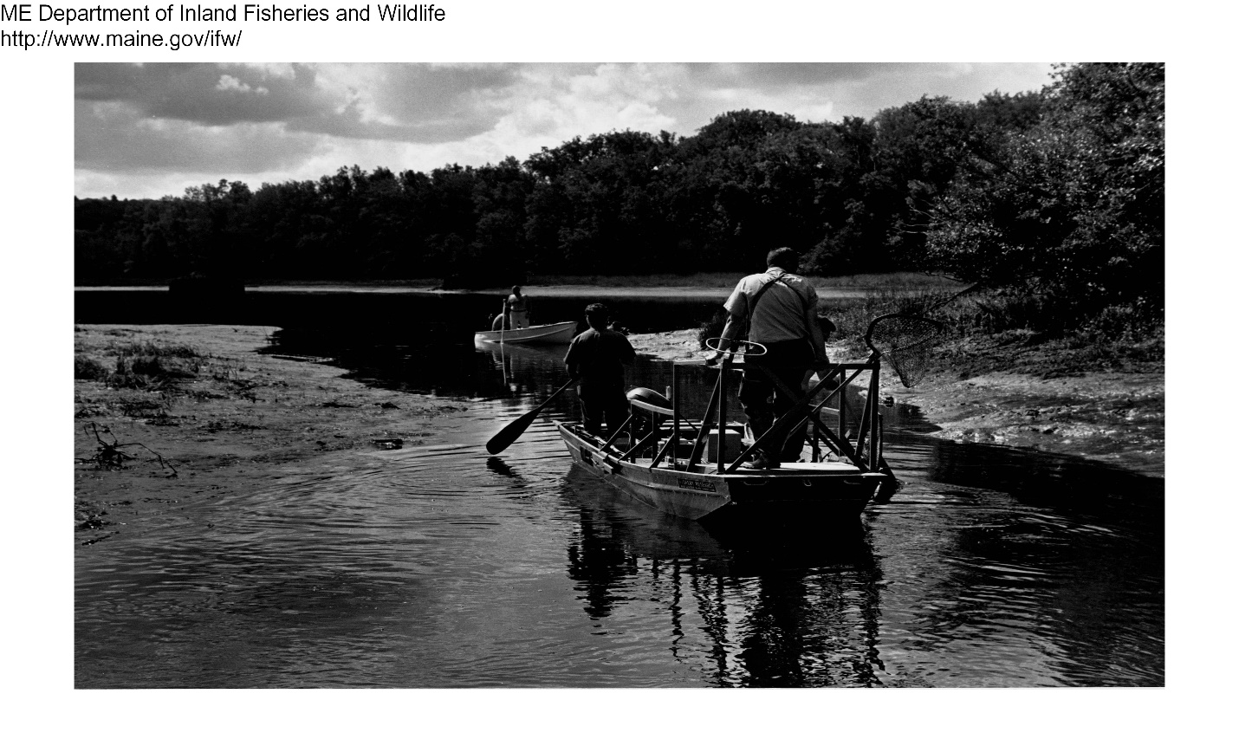Electrofishing boat; Foye, Scott & Flagg ~1964

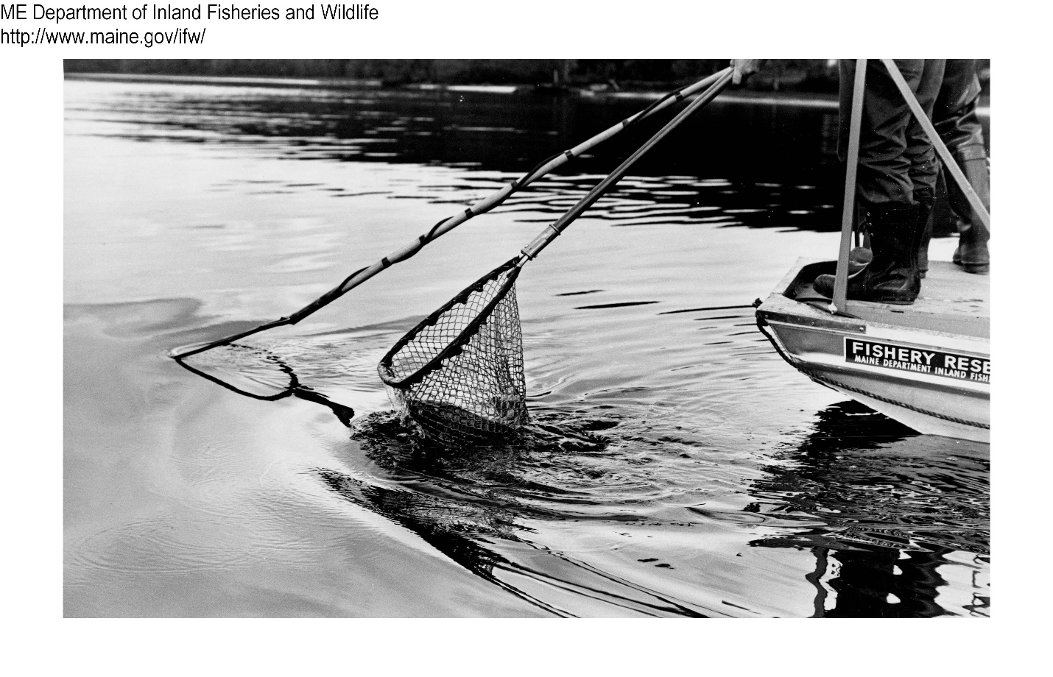

Carp captured in net ~1964

**Acknowledgements**

I thank Barry Mower for review and comments on my first draft and Brandon Kulick for numerous comments and suggestions with photos from Chris Yoders publication for the final draft. Yoders publication is cited in this document.