**Environment and Outdoors**

**Conservation group urges better fish passage for Brunswick dam**

**Maine Public | By Peter McGuire**

Published January 6, 2025 at 4:02 PM EST

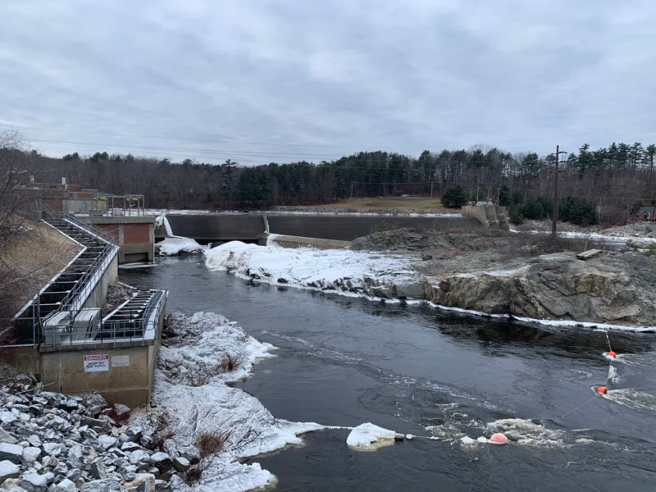

*via BDN*

The Brunswick-Topsham dam on Dec. 23, 2024.

Conservation groups see an opportunity to restore migratory fish on the Androscoggin River as a hydropower dam in Brunswick goes through federal relicensing.

Brookfield Renewable wants to keep the dam operating after its license expires in 2029. But critics say its current fish passage is ineffective and are pressing the company to consider all alternatives to improve passage.

Free the Andro, a recently established coalition of local and national conservation groups argue the 40-year-old dam blocks Atlantic Salmon, shad and other fish from traveling the river to spawn.

In 2023, for example, just 91 shad made it up the existing fish ladder, even though sonar readings showed up to 10,000 of the fish were locked in a holding pattern below the dam, said organizer Chip Spies, a Brunswick resident.

"The best solution frankly is removal of the dam," Spies said. "But there’s other alternatives and that is what is being considered right now. There could be ways to improve the fishway, to improve attraction to the current fishway up and downstream, there could be alternative fishways that are designed," he added.

The Federal Energy Regulatory Commission recently approved a revised study plan submitted by Brookfield White Pine Hydro that included a probe of fish passage alternatives. The company does not intend to decommission the dam, according to its proposal.

Brookfield White Pine, in a statement, said the relicensing would take years and is intended to balance public, economic, energy and natural resource interests.

The Brunswick dam can produce 19 megawatts of electricity, enough to power about 13,500 homes, the company added.

"We are working on studies as part of the relicensing of the Project that will review measures to modify or replace the existing fish passage," a Brookfield spokesperson said.

The Maine Department of Marine Resources also wants better fish passage at the dam.

Sean Ledwin, director of the department's Bureau of Sea-Run Fisheries and Habitat said it intends to recommend a number of measures to significantly improve fish passage. The department has invested significant resources to restoring the upstream watershed, including the Sabattus River, that require improvements at the dam to succeed, Ledwin added.

"The current fishway has numerous issues that prevent the restoration of sea-run fish and currently limit meaningful recreational and commercial fisheries above the project," he said in a statement.

Spies, from Free the Andro, said relicensing presents the only realistic opportunity to require improved fish passage at the dam. The Free the Androscoggin coalition was formed by Maine Rivers, American Rivers and the Merrymeeting Bay chapter of Trout Unlimited.

"It’s a once in a lifetime opportunity, and multiple generations are going to either benefit or not benefit from the decisions made in the next five years around this relicensing," Spies said.