April 2, 2019

Frank Dunlap
Black Bear Hydro Partners, LLC
c/o Brookfield Renewable Energy Group
150 Main Street
Lewiston, Maine 04240

RE: DEP APPLICATION #L-13256-33-L-N, ELLSWORTH PROJECT

Dear Mr. Dunlap:

Black Bear Hydro Partner LLC’s Water Quality Certification application was received by the Department of Environmental Protection on March 21, 2019 and found to be acceptable for processing on April 2, 2019. Acceptance of the application does not preclude the Department from requesting additional information during processing. Your application has been given the above reference number.

The project will now be examined to determine whether a license can be issued. The statutory deadline for the Department to reach a final decision on your application is March 20, 2020; however, we will do our best to process the application and issue a decision as soon as possible. No construction related to the proposed activities currently under review may be started prior to receiving a final decision from the Department.

Please feel free to contact me at (207) 446-2642 or via email at Kathy.Howatt@maine.gov if you have any questions regarding this project.

Sincerely,
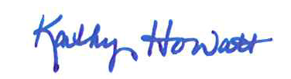
Kathy Davis Howatt, Hydropower Coordinator
Bureau of Land Resources

cc: Kelly Maloney, email
File

