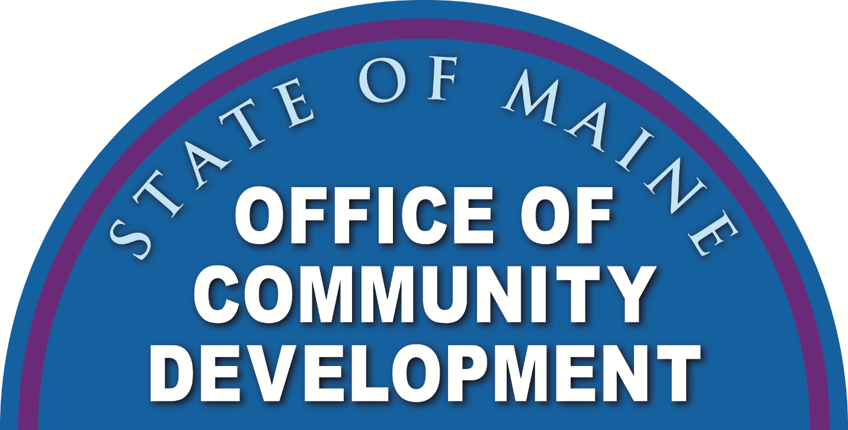

State of Maine

Community Development Block Grant Program

CDBG CV19 PROGRAM STATEMENT

July 1, 2020

Office of Community Development

**111 Sewall Street, 3rd Floor**

**59 State House Station**

**Augusta, Maine 04333-0059**

**Phone: (207) 624-7484**

**Fax: (207) 287-8070**

**TTY: 1-800-437-1220**

**www.meocd.org**

**CDBG CV19 PROGRAM STATEMENT**

**Contents**

**SUMMARY 3**

**SECTION 1. PROGRAM OVERVIEW ….. 3**

**A. CDBG OBJECTIVES 3**

**B. METHOD OF DISTRIBUTION: 4**

**C. STATE ADMINISTRATION: 4**

**D. CDBG CV19 PROGRAM BUDGET. 5**

**SECTION 2. COMMUNITY DEVELOPMENT PROGRAMS**

**A.** **HOUSING EXPENSE ASSISTANCE PROGRAM 6**

**B.** **FOOD SECURITY PROGRAM 7**

**SECTION 3. ECONOMIC DEVELOPMENT PROGRAMS**

**A. MICRO-ENTERPRISE ASSISTANCE GRANT PROGRAM 8**

**SECTION 4. TECHNICAL ASSISTANCE 9**

**SECTION 5. REDISTRIBUTION OF GRANT FUNDS 9**

**SECTION 6. AMENDMENTS TO THE PROGRAM STATEMENT 9**

**SECTION 7. SPECIAL PROJECTS 10**

**The Office of Community Development reserves the right to disburse the funds in a manner deemed to be in the best interest of, and that offer definable benefits to, the State of Maine and the Community Development Block Grant Program. The Director of the Office of Community Development (OCD) may waive any requirement of the program provided such waiver would not be out of compliance with CDBG Program regulations.**

# 

# SUMMARY

This Program Statement describes the method by which Maine’s Community Development Block Grant (CDBG) CV19 Program funds will be distributed. This allocation was authorized by the Coronavirus Aid, Relief, and Economic Security Act (CARES Act), Public Law 116-136, which was signed on March 27, 2020, to respond to the growing effects of this historic public health crisis. The Maine CDBG program is administered pursuant to 5 M.R.S.A 13073.

# SECTION 1. PROGRAM OVERVIEW

## A. CDBG OBJECTIVES

All CDBG funded activities must meet one of three National Objectives of the program. These objectives are:

* Benefit to low and moderate income persons;
* Prevention and/or elimination of slum and blight conditions; and
* Meeting community development needs having a particular urgency.

**The activities that are to be funded with CDBG CV19 by the Maine CDBG Program are consistent with the definition of activities to address urgent needs in 24 CFR Part 570.483 (d).**

**Activities designed to meet community development needs having a particular urgency**. In the absence of substantial evidence to the contrary, an activity will be considered to address this objective if the unit of general local government certifies, and the state determines, that the activity is designed to alleviate existing conditions which pose a serious and immediate threat to the health or welfare of the community which are of recent origin or which recently became urgent, that the unit of general local government is unable to finance the activity on its own, and that other sources of funding are not available. A condition will generally be considered to be of recent origin if it developed or became urgent within 18 months preceding the certification by the unit of general local government.

**CDBG CV19 may not duplicate funds received through other federal, state, or local programs.**

## B. METHOD OF DISTRIBUTION:

The CDBG CV19 Program Statement provides a description of the criteria that OCD will use to allocate CDBG CV19 funds. Programs are grouped under the categories listed below.

**1. Community Development**

a. Housing Expense Assistance Program

b. Food Security Program

**2. Economic Development**

a. Micro-Enterprise Program

**3. Special Projects**

## C. STATE ADMINISTRATION:

**1. General Administration Allocation:** Pursuant to Section 106(d) (3) (A) of the Housing and Community Development Act of 1974, as amended (the Act), the DECD will utilize $100,000 plus 2% of its allocation from the Department of Housing and Urban Development (HUD) to administer Maine’s CDBG CV19 Program in accordance with Federal and State requirements.

**2. Technical Assistance Administration Allocation:** Pursuant to Section 106(d) (5) of the Act, DECD will utilize up to 1% of its allotment from HUD to provide technical assistance in accordance with Federal and State requirements.

**3. Exclusion of Entitlement Communities and Counties:** Persons and businesses residing in the entitlement communities of Auburn, Bangor, Biddeford, Lewiston, Portland and all of Cumberland County with the exception of Brunswick and Frye Island, are not eligible to receive State CDBG-CV19 program funds.

**4. HUD Waivers:** This Method of Distribution is anticipating HUD granting a waiver of the requirement that all CDBG-CV19 funds be distributed to Units of General Local Government. If the waiver is not granted the State of Maine will adhere to that requirement.

D. CDBG CV19 PROGRAM BUDGET

**COVID Relief Funding CDBG Budget**  $**7,022,416**

State Administration $240,448

Technical Assistance Administration $70,224

**Community Development**

Housing Expense Assistance Program $2,200,000

Food Security Program $2,200,000

**Economic Development**

Micro-Enterprise Assistance Program $ 2,000,000

**Special Projects** $ 511,744

# SECTION 2. COMMUNITY DEVELOPMENT PROGRAMS

## CV19 – HOUSING EXPENSE ASSISTANCE PROGRAM

The CV19 Housing Expense Assistance Program (HEAP-C) provides funding to address emergency housing needs for low-and moderate-income persons as a direct result of the COVID19 pandemic.

**1. Program Delivery and Project Benefit:** Program funds will be distributed through a partnership with MaineHousing who will distribute funding to each of the participating Maine Community Action Agencies (or other approved entity) to provide Housing Assistance Services in the region. Participation in the delivery system is subject to the approval of the Director of the OCD. The Community Action Agencies will verify applicant eligibility and the amount of assistance.

**2. Eligible Activities:** Eligible activities under the CV19 Funding include housing payments of up to a total of $1,200 per month. This amount can include utility payments such as electricity, heating fuel, and sewer/water costs. **Emergency housing payments may not duplicate funds received through other federal, state, or local programs**.

These expenditures are eligible per 24 CFR 570.207 (a) (4) under the following conditions:

**a.** The payments do not exceed three consecutive months; and

**b.** The payments are made directly to the provider of such services on behalf of a low to moderate income individual or family.

## CV19 – URGENT NEED FOOD SECURITY PROGRAM

The CDBG CV19 Urgent Need Food Security Program addresses community needs of food insecurity by providing funding for operating expenses, program supplies, and distribution activities of the **Good Shepard Food Bank** which will benefit low/moderate income (LMI) persons.

**1. Eligible Activities:** Eligible activities include but are not limited to, operating and program expenses, and distribution for the purpose of providing nutritious food to more than 450 partner agencies across the state, including food pantries, meal sites, schools, and senior programs.

**2. Project Benefit:** The project will provide benefits to a non-profit entity, where 51% or greater of the persons receiving benefit from the activities are determined to be LMI. CDBG-CV19 funding will serve LMI Clientele who access food through GSFB’s network of partners in non-entitlement areas across the State of Maine. This population includes, but is not limited to, populations that HUD presumes to be low to moderate income, including elderly persons, homeless persons, illiterate adults, severely disabled adults, persons living with AIDS, and migrant farm workers.

**3. The activity represents a quantifiable increase in the level of an existing service:**

Good Shepherd Food Bank, Maine’s largest hunger-relief organization, announced that an estimated $6.3M in additional resources will be needed over a six-month period to help Mainers struggling with hunger as a result of the COVID-19 crisis. This represents a 150 percent increase to the baseline six-month operating costs.

This announcement comes on the heels of a release earlier this month from Feeding America that estimated that its entire nationwide network of 200 food banks could experience a total of $1.4 billion in increased expenses over six months.

Rising unemployment and poverty due to quarantine and stay-at-home orders are impacting people already at risk of hunger and could result in up to an additional 67,000 Mainers experiencing food insecurity, an increase of 39 percent, based on projections using Feeding America’s Map the Meal Gap data.

**About Good Shepherd Food Bank:**  
As the largest hunger-relief organization in Maine, Good Shepherd Food Bank provides for Mainers facing hunger by distributing nutritious food to more than 450 partner agencies across the state, including food pantries, meal sites, schools, and senior programs. Together with its network, the Food Bank leads a statewide effort to combat the root causes of hunger by engaging in advocacy, nutrition education, and strategic partnerships.

**SECTION 3. ECONOMIC DEVELOPMENT PROGRAM**

## A. CV19 - MICRO-ENTERPRISE ASSISTANCE GRANT PROGRAM

The Micro-Enterprise Assistance Grant (MEA) Program provides grant funds to micro-enterprise businesses in non-entitlement areas through a partnership with Maine’s Small Business Development Centers and their partners. **Micro-Enterprise businesses that can demonstrate loss of revenue directly due to the COVID-19 pandemic are eligible to apply. However, micro-enterprise assistance funds may not duplicate funds received through other federal, state, or local programs.**

**1. Eligible Activities:** Eligible activities include grants to for-profit businesses that can be used for working capital to cover loss of revenue due to COVID-19. Maine’s Small Business Development Centers will identify and pre-qualify those businesses who are eligible for the program. Potential participants will need to document previous years’ (2019) monthly revenues as well as current, (2020) monthly revenues in order to demonstrate actual loss of revenue due to closure, show cancellations, or limited ability to operate normally due to the COVID 19 pandemic.

**Cannabis related businesses are not eligible.**

**2. Maximum Amount of Micro-Enterprise Assistance to an individual Business:** $5,000

**3. Project Benefit / Demonstration of National Objective:**

**Micro-Enterprise Grant:** Existing businesses that have five or fewer employees, **one of whom owns the enterprise, and whose household income is Low/Moderate as defined by HUD will meet the project benefit**. Applicants will need to submit a copy of their 2019 Personal Income Tax filing with their application. Non-owner employees’ incomes are not considered in meeting project benefit.

**4. Selection Process:**

All Micro-Enterprise businesses wishing to submit a MEA application must meet with their local Small Business Development Center office to determine eligibility and verification of loss. SBDC staff will review and approve complete applications to be considered for funding.

**SECTION 4. TECHNICAL ASSISTANCE**

The Office of Community Development will use Technical Assistance funds to: produce program materials and provide technical assistance and outreach to recipients.

# SECTION 5. REDISTRIBUTION OF GRANT FUNDS

This section describes the methods by which undistributed funds, disencumbered funds, additional funds received from HUD, and program income will be redistributed.

**1. Unallocated State Grants to Local Entities:** Unallocated grant funds resulting from lack of adequate program demand and any additional funds allocated by HUD may be added to any open CDBG CV19 contract and can be used to make additional awards under any eligible CDBG program activity.

**2. Basis for Redistribution:** The decision to redistribute funds will be made after staff evaluation of the following: the total funds available, new requests for funding, requests for additional funding from current CDBG CV19 grantees. The OCD may redistribute available funds to any project deemed to be in the best interest of, and that offer CDBG definable benefits to the State of Maine that are a direct result of the COVID 19 pandemic.

# SECTION 6. AMENDMENTS TO THE PROGRAM STATEMENT

The State may amend the CDBG CV19 Program Statement from time to time in accordance with the same procedures required for the preparation and submission of the program statement. The Department of Housing and Urban Development’s citizen participation requirements will guide the amendment process.

Flexibilities within the Corona Virus Relief, and Economic Security Act (CARES Act) (Public Law (116-136) provides that grantees may amend citizen participation plans to establish expedited procedures to draft, propose, or amend consolidated plans. Expedited procedures must include notice and reasonable opportunity to comment of no less than 5 days. The 5-day period can run concurrently for comments on the action plan amendment and amended citizen participation plans.

In-person public hearings are not required. Grantees may meet public hearing requirements with virtual public hearings if:

1) national/local health authorities recommend social distancing and limiting public

gatherings for public health reasons; and

2) virtual hearings provide reasonable notification and access for citizens in accordance with the grantee’s certifications, timely responses from local officials to all citizen questions and issues.

## SECTION 7. SPECIAL PROJECTS PROGRAM

The CV19 Special Projects Program provides CDBG CV19 funds to projects for alternative grant activities and partnerships that meet community or economic development needs and CDBG National Objectives in the State of Maine.  Approval for the use of SP funds is through the Director, Office of Community Development.

#### THIS MATERIAL IS AVAILABLE IN ALTERNATIVE FORMAT

#### UPON REQUEST

**BY CONTACTING:**

**OFFICE OF COMMUNITY DEVELOPMENT**

**111 SEWALL STREET, 3RD FLOOR**

**59 STATE HOUSE STATION**

**AUGUSTA, MAINE 04333-0059**

**TELEPHONE (207) 624-7484**

**TTY: 1-800-437-1220**

**ALSO AVAILABLE ON THE OFFICE OF COMMUNITY DEVELOPMENT WEB SITE:**

[**www.meocd.org**](http://www.meocd.org)

**The Maine CDBG Program is Funded by:**

HUD Logo

