State of Maine Community Development Block Grant Program


Community Enterprise Grant Program


https://www.maine.gov/decd/community-development
59 State House Station
2026 Application
Package

Office of Community Development
111 Sewall Street 59 State House Station Augusta, ME 04333-0059
Phone: (207) 624-7484
TTY: 1-800-437-1220

Application by Invitation Only

Community Enterprise Grant Program
Table of Contents
Application Timetable and Requirements | Page | 3
Step-by-Step Guide for Successful Application Submission | Page | 4
Application Checklist & Packaging Requirements | Page | 5
Application Overview | Page | 6
Application Instructions and Scoring Criteria | Page | 8
Budget Summary | Page | 11
Cover Sheet | Page | 12
Activity Designation Sheet | Page | 15
Sample Application Title VI Public Hearing Notice | Page | 16

Community Enterprise Program

APPLICATION TIMETABLE & REQUIREMENTS
Please take note that eligible applicants for CE funding are limited to those communities receiving prior written OCD approval of their Letter of Intent to Apply. Applicants submitting a CE application without OCD approval of their Letter of Intent will have the application returned unscored.

All applications must be received electronically by 4:00 P.M., Friday, April 10, 2026.

Late submissions will not be accepted. Faxed copies will not be accepted.
Applications must be received as one complete PDF format application submitted via email to:
ocd.application@maine.gov

FOR FURTHER INFORMATION: (207) 624-7484
SUBMISSION REQUIREMENTS
See Page 5 for packaging instructions.
Include only those attachments requested by OCD
ONE ORIGINAL – Scanned and emailed in PDF format, packaged in this exact order:
Signed Cover Sheet with Certifications, Project Information Sheet, Application Responses, Matching Funds Table with attached Letters of Commitment, Budget Summary, and Public Hearing Record and Mandatory Attachments as directed.
MARGIN AND TYPE SIZE for all Applications must contain margins consistent with those in this Application document and be typed using a minimum size 12 Arial font on 8 1/2 x 11-inch paper.

MAXIMUM LENGTH OF APPLICATIONS is limited to four (4) pages to provide the responses required in Section II (D), not counting required attachments.

NON-CONFORMING APPLICATIONS WILL NOT BE SCORED

This Application Package is available electronically at:

https://www.maine.gov/decd/community-development

Community Enterprise Grant Program
A STEP-BY-STEP GUIDE FOR SUCCESSFUL APPLICATION SUBMISSION
- Read the entire Application Package carefully! Be sure to follow instructions on Page 3 as to due date, font size, and paper size, margins, emailing requirements, and maximum length allowed for your required responses. For additional information on all CDBG programs consult the 2026 CDBG Program Statement available on the OCD web site.

- Choose the proper Community Enterprise activity(s) group listed on Page 15 that matches your proposed project.

- Complete the Application Cover Sheet on Pages 13-14. The Cover Sheet contains places for signatures and lists specific state and federal regulations that applicants certify they will follow if awarded CDBG funds. Make sure all required signatures are obtained. At a minimum, each applicant will need the signature of their Chief Executive Officer (CEO). In addition, signatures are required from each CEO for multi-jurisdictional Applications.

- Complete the Activity Designation Sheet on Page 15. This sheet will list project activities; CE amounts requested and identify if the project is multi-jurisdictional.
- Use a maximum of four (4) pages for your Required Responses to the Impact, Development of Strategy and Citizen Participation criteria contained on Pages 8-10 in Section 2 (D) of this application package. Make sure you address each applicable subcategory! (Some point totals are for OCD review purposes only) You must submit an attachment documenting cost estimates and projected project timeline. This does not count towards the 4 pages.

- Complete the Budget Summary on Page 11. Directions for completion are included with the form.

- Attach documentation of local public hearing to the Application. The hearing notice must follow the requirements set forth on Page 6. Please remember all public hearing notices must comply with the Title VI requirements set forth in the sample notice contained on page 16 of this application package. Any applicant submitting a non-compliant public hearing notice will have five points deducted from their final application score.
- Package your application exactly in the order specified on Page 3.
- Use the Application Checklist & Packaging Requirements on Page 5 as a tool to make sure your application will be complete and ready for OCD review.

- Remember! The Application due date is 4:00 PM, Friday, April 10, 2026.

Community Enterprise Grant Program

APPLICATION CHECKLIST & PACKAGING REQUIREMENTS
Use this to make sure your application contains all required submissions and is packaged in the proper order!
A complete application consists of the following items packaged in this exact order.
  - Cover Sheet with original signature
  - Activity Designation Sheet
  - Required Responses to the Impact, Development Strategy and Citizen Participation sections. (Maximum of four (4) pages)
  - Budget Summary
  - Public hearing record including the published public hearing notice, attested hearing minutes and attendance list – Notice must comply with sample notice contained on page 16 of this application package; and
  - Mandatory documentation of cost estimates and projected project timeline.
Incomplete packages or applications for projects not demonstrating a firm financial commitment as required in the application materials will be removed from the scoring process during the threshold review.

SECTION I. COMMUNITY ENTERPRISE GRANT APPLICATION OVERVIEW

Introduction
The Community Enterprise Grant Program (CE) provides grant funds for business façade improvements and/or streetscapes in downtown and village areas. Assistance to businesses may be in the form of grants or loans at the discretion of the community. Multi-jurisdictional applications from two or more communities must designate a lead community.

Letter of Intent as CE Application Eligibility Requirement
Eligible applicants for CE funding are limited to those communities receiving prior written OCD approval of their Letter of Intent to Apply. Applicants submitting a CE application without OCD approval of their Letter of Intent will have the application rejected.

Public Hearing Requirements
Each applicant is required to hold a duly authorized public hearing during the Application process with a minimum of 10 days prior notice. The hearing must be advertised in local newspapers and posted according to local requirements. The published notice must meet the Title VI requirements set forth in the sample notice contained on Page 16 of this application package. Any applicant submitting a non-compliant public hearing notice will have five points deducted from their final application score. Applicants must attach a copy of the published hearing notice, attested copy of the minutes and attendance list to the Application.

Documentation of CDBG National Objective:
Each CE project activity must meet a National Objective of the CDBG program as set forth on Page 26 & 27 of the 2026 Program Statement, Section 3 (a).

Eligible CE Activities:
Applicants may apply to undertake one or more of the following activities: façade grants to for-profit or non-profit businesses for exterior improvements, including signage, painting, siding, awnings, lighting, display windows and other approved exterior improvements (interior improvements are not allowed) or streetscapes including pocket parks, benches, street lighting, tree plantings, signage, traffic calming improvements, sidewalks and other approved improvements; eligible planning activities necessary to complete the Project Development Phase. Sewer, water, storm drainage, parking, roads or streets and other infrastructure improvements are not eligible. All streetscape improvements must take place on publicly owned property.
- Maximum CE Grant Amount: $100,000
- Maximum Amount of CE Assistance to Individual Business: $25,000

Matching Funds Requirements
Communities applying for CE funds must demonstrate they will provide a direct cash match of at least 25% of the total CDBG grant award. A minimum of 25% may come from any public and/or private source. This must be reflected in the Matching Funds Table contained within this Application Package. Firm letters of commitment for all cash matching funds must be attached to the table.

Applicant Prohibitions
Units of local government may not apply for more than one CE program per grant year. All CE applicants must meet the past performance criteria contained in the 2026 Program Statement on page 8, Section 1 (H) (2) (f). Eligible units of general local government as defined above may apply

for CDBG assistance on behalf of the five Maine Indian Tribes. Maine Indian Tribes are not themselves eligible applicants.
(i) Downtown Revitalization Program Prohibition - Communities applying for a CE grant may not apply for, receive, or benefit from a Downtown Revitalization Program (DR) grant in the same program year.

Multi-Jurisdictional Applications
A multi-jurisdictional application is one submitted from two or more communities joining together to create a single CE program to meet shared problems in the respective communities.

Application Process
The selection process for the CE Program consists of two phases - an Application Phase and a Project Development Phase.
  - Competitive Application
The application must provide a narrative description of the Impact, Development Strategy, and Citizen Participation relating to downtown revitalization activities proposed in the application.
The applicant must complete the application form and may only attach additional information if specifically requested. Please remember to answer briefly and as completely as possible within the allotted space. The focus of the review is to assess the readiness, feasibility, LMI impact, health, and safety issues, and need for funding from the basic facts of the situation and proposed solution. Reviewing and scoring applications will begin following the application deadline of April 9, 2026. Each application will be rated on its own merit and in relation to all other applications.
Successful communities will be invited into the project development phase.

  - Project Development
An invitation into the Project Development Phase reserves funds for the project. Program funding is contingent upon the Office of Community Development’s (OCD) receipt of funds from HUD and successful completion of Project Development criteria. All aspects of the Project Development Phase must be completed prior to the execution of a contract with OCD and include:

    - environmental review
    - cost analysis and justification
    - non CDBG project funds commitments
- management plan development; and
- specific state and federal requirements.

The emphasis during the Project Development Phase is on development of the best project to meet the community's CE needs. A Development Program Manager will be assigned to work with each community to assist in the finalization of their project. Applicants have six months to complete the project development phase process or notice of award may be rescinded.
  - Project Implementation
Following contract execution, the community will be awarded CE funds and will begin to implement their project. The Development Program Manager will remain involved with the community throughout project implementation providing technical assistance and to monitor for compliance with federal and state regulations.

SECTION II - COMMUNITY ENTERPRISE GRANT PROGRAM APPLICATION INSTRUCTIONS AND SCORING CRITERIA

Introduction
Communities must provide a narrative description of the Impact, Development Strategy and Citizen Participation relating to the community enterprise activity proposed in the application. Scoring criteria for Impact, Development Strategy and Citizen Participation are described below.
There is no minimum score required for an application to be considered for funding. The maximum length of an application, excluding the Cover Sheet and Activity Designation Sheet, Public Hearing Documentation, and mandatory attachment documenting cost estimates and projected project timeline is four (4) pages on 8 1/2 x 11-inch paper with a print size no smaller than that in this application package. Please refer to Page 5 of this application package for required packaging instructions. All Nonconforming applications will be rejected.

Cover Sheet
On Page 12 in this Application Package is the Community Enterprise Grant Program Cover Sheet. The Cover Sheet consists of three sections:

  - Applicant Identification
Community’s name, address, Chief Executive Officer (CEO), contact person, and phone numbers. The Cover Sheet must be completed, signed, and attached to the front of the application. The Chief Executive Officer of the applicant or the County Commissioner on behalf of unorganized territories must sign the Cover Sheet.
In multi-jurisdictional applications, one unit of local government must be identified as the lead applicant. Signature of the Chief Executive Officer of each other participating unit of general local government signifies approval for the lead applicant to apply on its behalf.
  - State Certifications
List of State Certifications that applicants agree to follow if they are awarded Community Enterprise Program funds.
  - Federal Certifications
List of Federal Certifications that communities agree to follow if they are awarded Community Enterprise Program funds.

Activity Designation Sheet
An Activity Designation Sheet is included on Page 15 of this Application Package and lists eligible activity categories and whether the project is multi-jurisdictional. The applicant is to indicate the categories in which funding is proposed and CE amounts requested.

Review Team Analysis
Review Point Totals will consist of the sum of the four scoring areas below and be determined by the total of each sub-scoring area. A maximum of 100 points is obtainable.
  - Impact (40 points) describes the community problems or needs the applicant wishes to address with CE assistance. The following rating criteria will be used:
State the problems then present the scope and magnitude of the identified problems. – 6 points
Explain how these problems negatively impact the local economy and the viability of existing downtown or village area. – 8 points

Clearly define how the problems negatively affect LMI persons and/or contribute to slum/blight conditions. – 10 points
Describe the obstacles to overcoming the identified problems – 6 points
Explain why CE funds are necessary for the project; describe efforts to secure other grant or loan funds, tell why they are not available locally to assist businesses or local government with their development and site improvement needs. – 10 points

  - Development Strategy (40 points) presents solutions to the problems identified in the Impact section. The following rating criteria will be used:
List the specific activities to be undertaken in the project; for streetscapes include location, size, and design features. – 5 points
Identify the specific use of CE funds and the specific tasks or activities to be funded with each other source of funds. – 5 points
Provide Identification and description of potential business grant/loan applicants and their needs; or provide details of how areas in need of streetscape improvements were identified and prioritized. – 5 points
Explain how the CE project will stimulate business in the downtown or village area and assist in
improving the area’s long-term viability. – 6 points
Describe how the CE funded activities will have a positive impact on LMI persons and/or on alleviation of the slum/blight conditions. – 6 points
Provide a project timeline; list activities or actions completed to date. – 4 points
Describe the capacity and experience of the administrator to conduct a facade program or
streetscape improvement effort; and how CE funds will be expended in a timely manner. – 5 points
Budget Summary Review – 4 points

(You must submit an attachment documenting cost estimates and projected project timeline.)

  - Citizen Participation (20 points) describes how citizens, businesses, community groups and project beneficiaries participated in identifying the problems and solutions included in this application. (Note: you must also submit a public hearing record consisting of the Title VI compliant published public hearing notice, hearing minutes, and attendance list with the original and all six copies of the application.) The following rating criteria will be used:
Effective use of any media (newspapers, radio, TV, etc) to further public awareness and participation
– 4 points
Relevance of listed meeting/hearing activities/comments (not counting required public hearing) and the overall citizen participation process in application and project development – 4 points
Involvement of downtown and local businesses, Chambers of Commerce, development groups or other business-related organizations in identification of problems and development of application and project – 4 points
Involvement of potential LMI project beneficiaries in development of application and project and how the required public hearing relates to the application development and citizen participation process
– 4 points
Describe how other local resources (cash and in-kind) are directly related to the project and the establishment of a cash value equivalent for all in-kind commitments – 4 points

- Opportunity Zone Bonus – 3 bonus points will be assigned to each applicant community certified as an Opportunity Zone location at time of application.

- Final Application Score
Applications will be awarded funding based on the consensus of the review team. There is no minimum Final Application Score required for an application to be considered for funding.

Community Development Block Grant Community Enterprise Grant Program
Budget Summary (Include Cash & In-Kind)

 | Column 1  CDBG | Column 2  Local | Column 3  State | Column 4  Utility | Column 5  Non-CDBG  Federal | Column 6  Other | Column 7  Cost Category Total
Legal Expenses
Appraisals
Relocation
Demolition
Site Work
Architectural
Engineering
Administration
Construction
Materials
Streetscapes
Façade Grants
Inspection
Other (List)
1.
2.
3.
TOTAL COSTS

Directions for Completing Budget Summary
  - For each applicable cost (cash and in-kind) in the Cost Category column, list the projected dollar amount for all applicable funding sources in columns 1-6.
  - List the total dollar amount for each cost category in column 7, Cost Category Total
  - Enter the total of all Cost Category amounts in column 7 in the TOTAL COSTS box directly under column 7.
  - Submit a copy of this Summary with the application.

STATE OF MAINE
COMMUNITY DEVELOPMENT BLOCK GRANT COVER SHEET AND CERTIFICATIONS

Community Enterprise Grant Program
- Applicant Identification

Applicant:
Address:
Town/City/County:
Zip Code:
Chief Executive Officer:
Phone Number:
E-Mail:
Contact Person:
Phone Number:
E-Mail:
Census Tract(s) Where Proposed CE Activities will occur:
Applicant UEI (Unique Entity Identifier) :

(To find or request a Unique Entity Identifier please visit www.sam.gov.)

- CERTIFICATION BY AUTHORIZED OFFICIAL OF MUNICIPALITY AND SUB-GRANTEE (if
applicable):
  - State Certifications
    - To the best of my knowledge and belief, the information in this Application is true and correct:
    - the governing body of the applicant has duly endorsed the document:
    - the proposed project has been reviewed, and it complies with the Community's comprehensive plan and/or applicable state and local land use requirements:
    - will work with the Office of Community Development to develop a detailed project if it receives a conditional award; and
    - will comply with all applicable State laws and regulations.
  - Federal Certifications
    - will take actions to affirmatively further fair housing and implement CDBG activities in compliance with Title VI of the Civil Rights Act of l964 and Title VIII of the Civil Rights Act of 1968:
    - will not attempt to recover capital costs for the construction of public improvements, assisted in whole or in part with CDBG funds, by charging special assessments or fees against properties owned and occupied by persons of low and moderate income, including any fee, charge or assessment made as a condition of obtaining access to such public improvements, unless:
      - CDBG funds are used to pay the proportion of such fee or assessment that relates to the capital costs of such public improvements that are financed from revenue sources other than CDBG funds; or
      - for purposes of assessing any amount against properties owned and occupied by persons of low and moderate income who are not persons of very low income, and the applicant certifies that it lacks sufficient CDBG funds to comply with the requirements of clause (i) above.
    - prior to expenditure of CDBG funds, it will establish a local community development plan that identifies the Community's housing and community development needs, including the needs of low and moderate income, and the activities to be undertaken to meet them:
    - will provide in a timely manner for citizen participation, public hearings, and access to information with respect to the Maine CDBG Program and the proposed local CDBG project/program. Indicate in public notices and at public hearings that the State program is competitive, the maximum grant amount that can be requested, and the general type of activities contained in the proposed local program. Also announce in public notices the availability of the local program plan/application, describe the Community's previous CDBG performance (if any), and how the Community will collect, consider, and maintain all oral and written comments received on the proposal:
    - will adopt and follow a residential anti-displacement and relocation assistance plan which complies with Section 104 (d) of the Housing and Community Development Act of 1974, as amended, that at a minimum provides for the replacement of all low/moderate income dwelling units that are demolished or converted to a non-LMI housing use as a direct result of CDBG assistance, and a relocation assistance component:
    - is not listed on U. S. Department of Labor’s Debarred and Suspended Contractor’s List and will not employ
contractors
or subcontractors on this list:
    - will comply with the requirements of Section 319 of Public Law 101-121 regarding government-wide restrictions on lobbying; and
    - with the exception of administrative or personnel costs, it will verify that no person who is an employee, agent, consultant, officer, or elected official or appointed official of state or local government or of any designated public agencies, or sub-recipients which are receiving CDBG funding may obtain a financial interest or benefit, have an interest in or benefit from the activity, or have an interest in any contract, subcontract or agreement with respect to CDBG activities, per 24 CFR Part 570.611.
    - Jobs created/retained must be in the community applying for the EDP award, new jobs to that community and not associated with any other branches of the assisted business located in another community.
    - Transfer positions cannot be counted toward the job creation/retention requirements.
    - All projects must document that at a minimum, 51% of all jobs created or retained as a result of the funded activity must be taken/held by persons of low and moderate income as defined by HUD.
    - The Federal Equal Credit Opportunity Act prohibits creditors from discriminating against credit applications on the basis of race, color, religion, national origin, sex, marital status, age (provided that the applicant has the capacity to enter into a binding contract); and because all or parts of the applicant’s income is derived from any public assistance program; or because the applicant has, in good faith, exercised any rights under the Consumer Credit Protect Act. The federal agency that administers compliance with this law concerning this creditor is the Federal Trade Commission. If a person believes that he or she was denied assistance in violation of this law, they should contact the Federal Trade Commission, Washington DC 20580.
M. The applicant acknowledges that no federal public benefit may be provided to an ineligible alien who entered the United States illegally or is otherwise unlawfully present in the United States.
Signature of Chief Executive Officer Name of Community Date: mm/dd/year

Signature of Each Participating Applicant in a Multi-Jurisdictional Application

Signature of Chief Executive Officer | Name of Community | Date: mm/dd/year
Signature of Chief Executive Officer | Name of Community | Date: mm/dd/year
Signature of Chief Executive Officer | Name of Community | Date: mm/dd/year
Signature of Chief Executive Officer | Name of Community | Date: mm/dd/year
Signature of Chief Executive Officer | Name of Community | Date: mm/dd/year

Community Development Block Grant Community Enterprise Grant Program
Activity Designation Sheet
- Activity Declaration

  - List the activities you will be doing in your proposed project:

- CE Grant Funds Requested
- Business Façade Grants & Streetscapes

- Streetscapes

Amount Requested:

Amount Requested:

Total CE Requested:

- Multi-Jurisdictional Declaration

  - Is this a multi-jurisdictional project? Yes No

  - If yes, which local government has been designated as the lead applicant?

  - If yes, list all participating or benefiting local governments.

NOTE: Remember all participating or benefiting local governments must sign the Cover Sheet Certification Form.

Public Hearing Notice to Comply with Title VI Requirements
Public Hearing Notice
The City/Town of

The City/Town of will hold a Public Hearing on (date) , at (time) , at the (location) to discuss an application being submitted to the State of Maine CDBG program for a Community Enterprise Grant. The purpose of the grant application is to state purpose). Public comments will be solicited at this Hearing and will be submitted as part of the application. All persons wishing to make comments or ask questions about the grant application are invited to attend this Public Hearing. Comments may be submitted in writing to: (name of contact, address) at any time prior to the Public Hearing. TDD/TTY users may call (list local TTY number or 711) . If you are physically unable to access any of the City’s/Town’s programs or services, please call (list local contact and phone number), so that accommodations can be made.
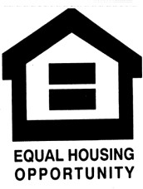

Any applicant submitting a non-compliant public hearing notice will have five points deducted from their final application score.

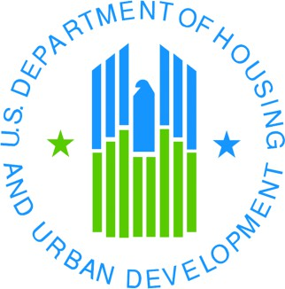
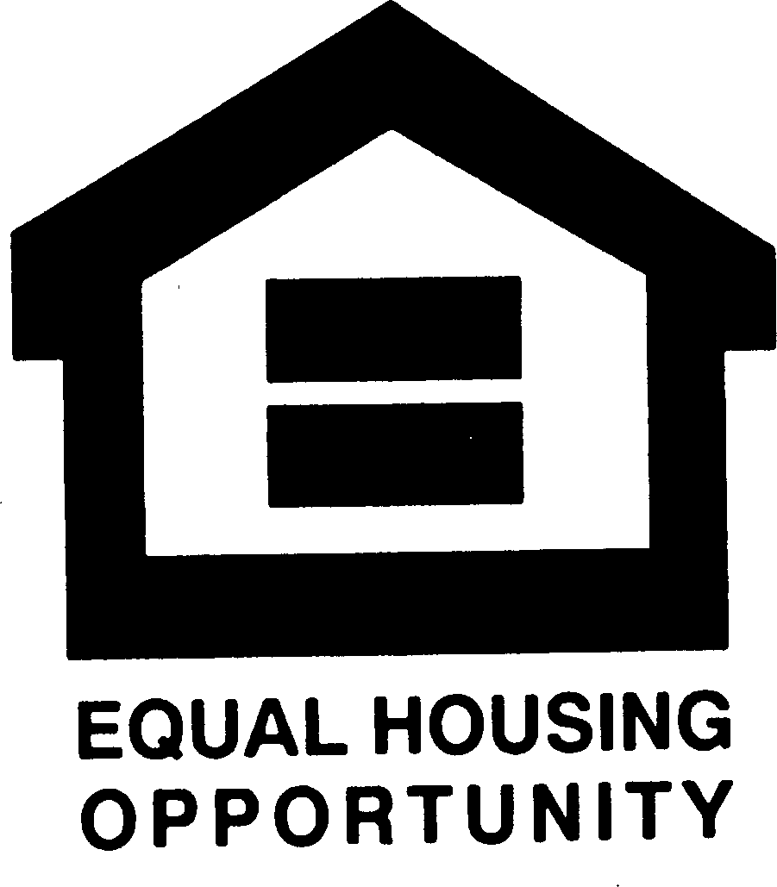
THIS MATERIAL IS AVAILABLE IN ALTERNATIVE FORMAT UPON REQUEST
BY CONTACTING:
OFFICE OF COMMUNITY DEVELOPMENT 111 SEWALL STREET, 3RD FLOOR
59 STATE HOUSE STATION AUGUSTA, MAINE 04333-0059
TELEPHONE (207) 624-7484
TTY: 1-800-437-1220
ALSO AVAILABLE ON THE OFFICE OF COMMUNITY DEVELOPMENT WEB SITE:

www.meocd.org

The Maine State CDBG Program is Funded by:

