State of Maine
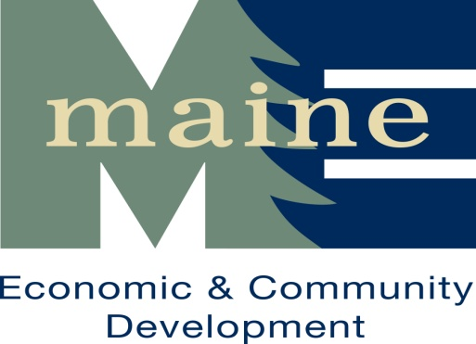
Community Development Block Grant Program
2023 Public Service Grant Program
Letter of Intent to Apply
Due at DECD on or before March 24, 2023, 4:00 p.m.

Letters of Intent may be submitted via email to: ocd.loi@maine.gov
Please enter “PS LOI” in the subject line.

All communities wishing to apply for a 2023 Public Service Grant must use this Letter of Intent to document compliance with requirements established by Title I of the Housing and Community Development Act of 1974, as amended and the State of Maine CDBG program. Applicants who submit a completed and approved Letter of Intent will be notified by OCD that they are eligible to submit a full application. Eligibility to submit a full application does not imply final project approval or funding. Funds will not be available until after July 1, 2023.

A. APPLICANT ELIGIBILITY

1. Legal Applicant:
Applicant: |  | Phone:
Address: |  | Fax:
City, ZIP: |  | E-Mail:
Chief Official:
Census Tracts #(s) Where Proposed Activities Will Occur:
Applicant UEI (please visit www.sam.gov) #:
2. Applying on Behalf of Sub-Grantee (if applicable): (e.g.: Non-Profit, etc.)
Sub-Grantee: |  | Phone:
Address: |  | Fax:
City, ZIP: |  | E-Mail:
Agency Rep: |  | Title

B. PROJECT INFORMATION
Provide a concise description of the proposed project below. The scope of work should be very specific in identifying how the CDBG money will be used, how the proposed PS activities represent a new or expanded service and how the service will continue after CDBG assistance.

C. COST ESTIMATES & PROJECT FUNDING
Provide the estimated project cost, amount of CDBG funds to be requested and sources, amounts and dates secured for all anticipated cash matching funds. Clearly state the source of the cost estimates.

Total Estimated Project Cost: | $ | CDBG Request: | $

Funding Source | Amount | Date Secured
TOTAL: | $

D. NATIONAL OBJECTIVE
Check the appropriate box below and attach all required documentation listed in the appropriate box.

BENEFITTING LOW-TO-MODERATE INCOME PERSONS (LMI)
Community-Wide LMI National Objective (for Public Safety Equipment only)
Attach Census Figures indicating 51% or more of the community is LMI along with a completed Beneficiary Profile OR recent survey materials meeting the requirements set forth in OCD Policy Letter Number 19 and Income Survey Methodology Handbook.)
Predominant Use by LMI National Objective
Attach documentation that the public service activities to be provided by CDBG funds will benefit LMI persons, where at least 51% of participants are LMI.
Limited Clientele LMI National Objective
Attach written documentation that the proposed CDBG activity will serve a HUD recognized Limited Clientele group as set forth by the United States Department of Housing and Urban Development in 24 CFR Part 570 and the State of Maine CDBG Program. Limited Clientele Groups are: Abused Children, Battered Spouses, Elderly Persons, Severely Disabled Adults, Homeless Persons, Illiterate Adults, Migrant Farm Workers or Persons Living With AIDS.

Applicant Certifications

a. To the best of my knowledge and belief, the information in this Letter of Intent and all attached documentation is true and correct.

b. This pre-application complies with all applicable State and federal laws and regulations; and

c. Approval of this Letter of Intent by OCD to submit a final application does not imply final project approval or funding.

Signature of Chief Executive Officer Name of Community Date: mm/dd/year

