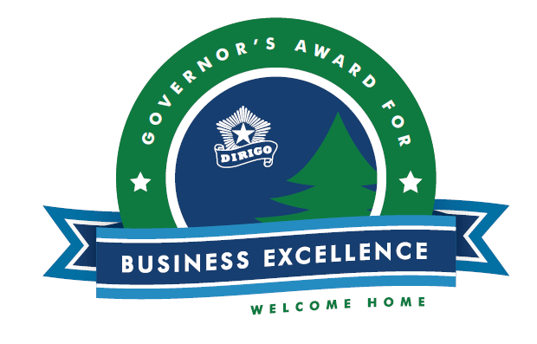

GOVERNOR’S AWARD FOR BUSINESS EXCELLENCE 2026

APPLICATION PROCESS OVERVIEW

The complete instructions for the Governor’s Award for Business Excellence application can be found in the Nomination Form. A complete application includes the following components:

- A cover sheet that includes:
  - the company/organization name
  - the company/organization address
  - the GABE Award Category which is most applicable. This year’s award categories are: Climate Leader; Heritage Industry; Innovation; and Rural Revitalization.

- A one to two-page narrative, additional context available in Nomination Form. This narrative should include:
  - Description of the company/organization, the products and/or services provided, and years of operation.
  - Commitment to Employees: please include the number of employees and average hourly wage, excluding management. Please describe how your company/org prioritizes its employees by going above and beyond with compensation packages, benefits, flexible work schedule, retirement plans, paid vacation, professional development, and other programs designed to help attract and retain talented employees.
  - Commitment to Community: please include details on how the company/org serves the community it operates in, with details on volunteerism, philanthropy, workforce development/school partnerships, and other programs intended to help the local community.
  - Commitment to Customers: describe how your company is committed to customer/constituent/member satisfaction and/or service excellence: please include details on why your company produces “best in class” products of the highest value; or how your organization is committed to its mission; please include metrics and success stories to support your claims.

- The signature of the nominee (the signature form is within Nomination Form).

- At least three (3) letters of reference.

- MRS Interagency Authorization Form – this is important because we check the status of each company that applies to make sure they are in good standing with various State agencies – for example, Maine Revenue Services.

Applications for the GABE awards can be submitted through a new online portal on the DECD website.
Applications can be submitted through 11:59 PM ET Friday, September 18, 2026.

