Steps to Change Security Settings in Internet Explorer

1. Go to Tools, then Internet Options

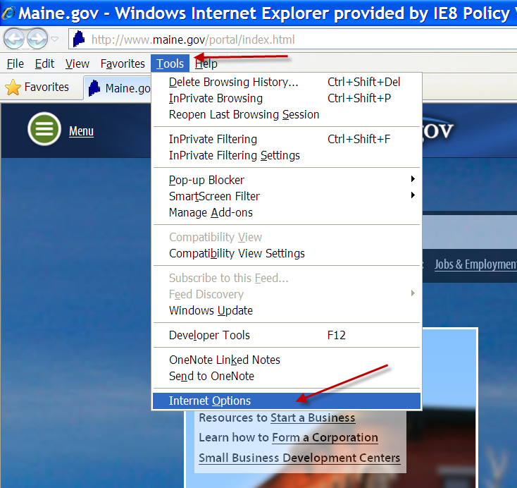

2. Go to the Advanced tab and scroll down to the Security section
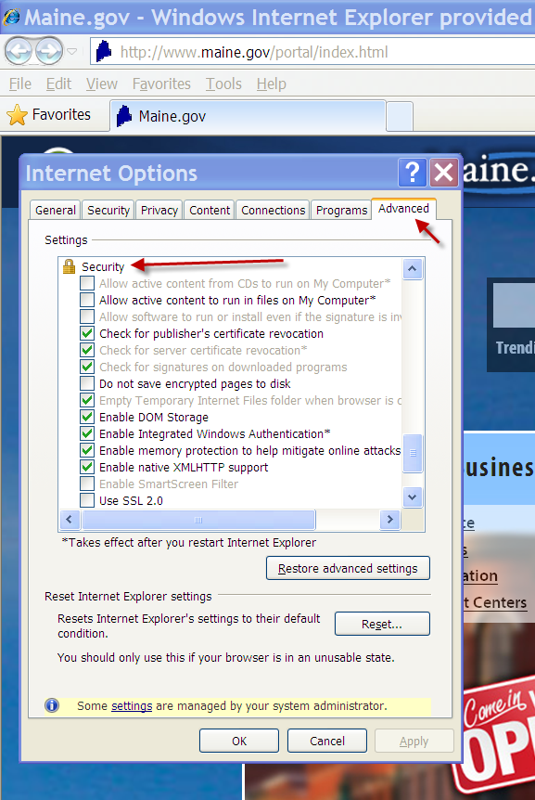

3. If TLS 1.0 is not checked, you will not be able to open VSS and will see the second screenshot below displayed.
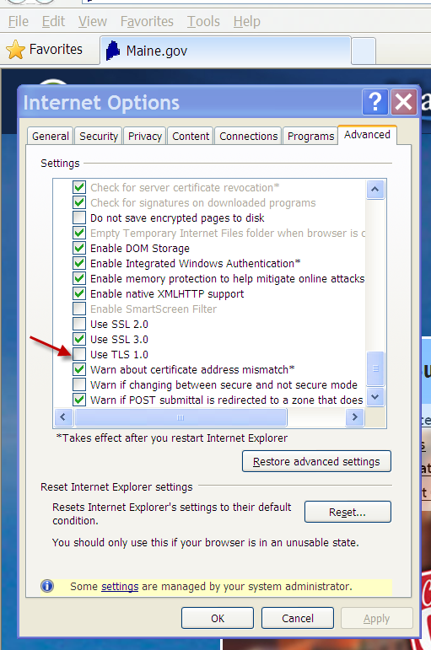

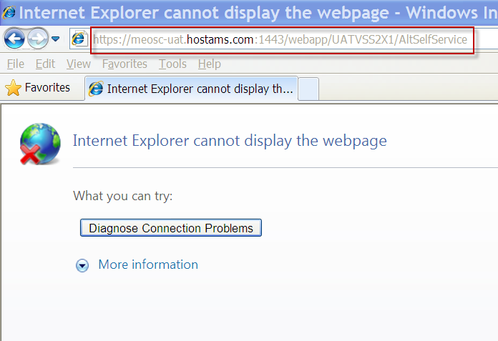

4. Check TLS 1.0, click Apply and Ok.
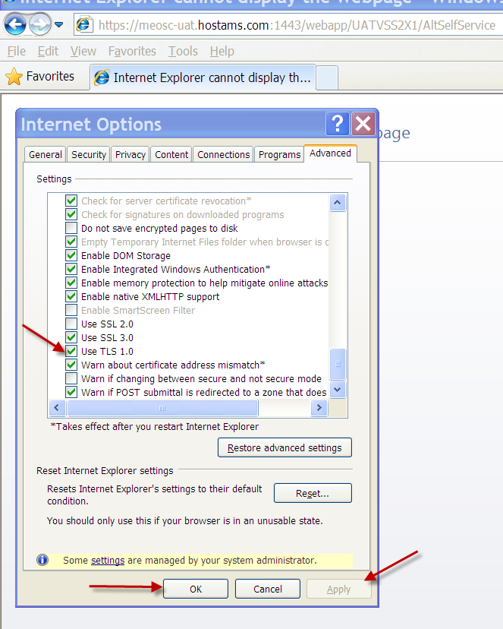

5. Open VSS
