STATE OF MAINE
Department of Administrative and Financial Services

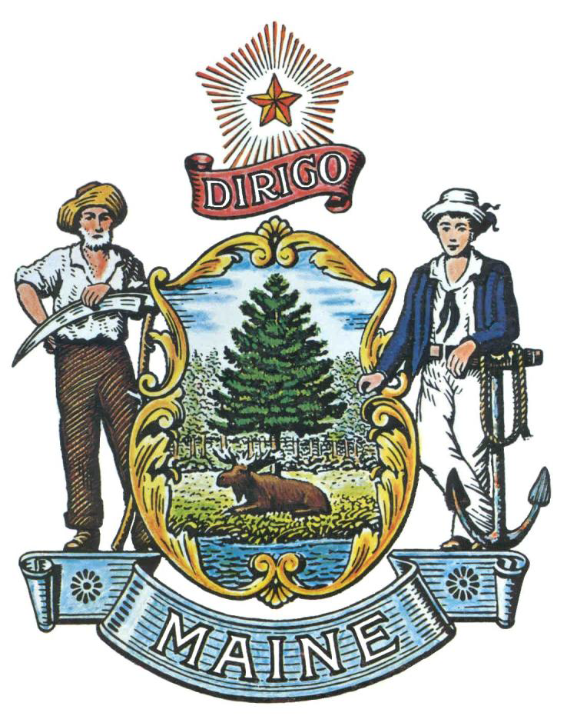

REQUEST FOR APPLICATIONS

Pre-Qualified Vendor List for
Mobile Food Truck Services

Contact Information | All communication, including questions and proposal submission must be made using the email address below. Contact Information: Proposals@maine.gov
Open Enrollment | Applications will be accepted at any time. Applications must be submitted electronically to the email address provided above. Please include “Mobile Food Truck Services” in the subject line of the email.

State of Maine - Department of Administrative and Financial Services
REQUEST FOR APPLICATIONS
Pre-Qualified Vendor List for
Mobile Food Truck Services

Summary

The Department of Administrative and Financial Services (DAFS) is seeking applications from licensed Mobile Food Truck vendors who will offer a variety of reasonably priced, high quality meals, snacks, specialty coffee, and other non-alcoholic beverages for various facilities located statewide. Vendors must possess a Mobile Eating Place License from the State of Maine Department of Health and Human Services, Maine Center for Disease Control and Prevention, Division of Environmental Health, Health Inspection Program and meet the certification requirements to operate a Mobile Eating Place. MRS, Title 22 § 2492.

Pre-Qualified Vendor List Term

Applications will be accepted on a rolling basis. All applications will be reviewed for completion and vendors will be notified of acceptance or non-acceptance within thirty (30) days of receipt of application. Vendors will need to submit updated information by the end of January each year, after acceptance to the Pre-Qualified Vendor List (PQVL), in order to continue to participate in the PQVL mini-bid process as described below (C.).

Vendors will be eligible to participate on the PQVL upon review of a successfully completed application. A successfully completed application will include:

- Completed and signed Cover Page and Debarment, Performance and Non-Collusion Certification Forms (Appendices C & D)
- Current and valid State of Maine Mobile Eating Place License
- Up-to-date insurance certification
- No health or safety violations in the preceding twelve (12) months that are deemed detrimental by the Department for award consideration

C. Mini-Bid Process

The Department will notify all vendors on the PQVL when specific services are needed. Each vendor will be given a description of the particular services needed and asked to respond within a specific timeframe.

The Department will select one or multiple vendors utilizing a “mini-bid” process for specific services based on the following:

- Availability for the specific services;
- Willingness to provide the specific services; and
- Any additional information specified to meet the need of the specific service.

The Department reserves the right to select vendors from the PQVL without using the mini-bid process for emergencies, if the need arises.

- General Requirements

A list of general provisions applicable to the PQVL can be found on Appendix A.

A list of general requirements applicable to Mobile Food Truck Vendors and service provisions can be found on Appendix B.

- Application for PQVL

All applicants must provide the following:

  - Signed application cover page and areas willing to provide services (see Appendix C);
  - Debarment, Performance and Non-Collusion Certification Form (see Appendix D - Failure to provide this certification will result in the disqualification of the application);
  - State of Maine issued license and any additional operating permits;
  - Certification of insurance (see Appendix B, #12);
  - Standard menu, including pricing;
  - Picture of all sides of the mobile food vehicle; and
  - Documentation of health and safety violations for previous twelve (12) months, if applicable.
- Removal from Pre-Qualified Vendors List

The Department may remove a vendor from the PQVL at any time, upon giving 10 days’ written notice to the Vendor, if the Department determines it is in the best interest of the State to remove the Vendor. Examples for cause for removal:

  - The Vendor failed or refused to perform agreed upon services,
  - The performance was unsatisfactory including, but not limited to, the quality and timeliness of services provided, or
  - The Vendor no longer has the ability to perform the services.

APPENDIX A - GENERAL PQVL PROVISIONS

State of Maine
Department of Administrative and Financial Services
REQUEST FOR APPLICATIONS
Pre-Qualified Vendor List for
Mobile Food Truck Services

- The State of Maine is not required to issue an award or to pay expenses incurred by a Respondent in the preparation of their response. This includes attendance at personal interviews or other meetings and software or system demonstrations, where applicable.
- All applications and resulting procurements will be considered public records available for public inspection pursuant to the State of Maine Freedom of Access Act (FOAA) (1 M.R.S. §§ 401 et seq.): http://www.mainelegislature.org/legis/statutes/1/title1sec401.html
- The Department, at its sole discretion, reserves the right to recognize and waive minor informalities and irregularities found in submitted applications.
- All applicable laws, whether or not herein contained, shall be included by this reference. It is the responsibility of all applicants to determine the applicability and requirements of any such laws and to abide by them.
- The State of Maine Division of Procurement Services reserves the right to authorize other Departments to use the Pre-Qualified Vendor Lists resulting from this RFP, if it is deemed to be beneficial for the State to do so.
- Appeal rights shall not apply to Vendors submitting an application to be listed on the resulting PQVL.
- Any person aggrieved by an award decision resulting from a mini-bid subsequent to this list may appeal the decision in the manner prescribed in 5 MRSA § 1825-E and 18-554 Code of Maine Rules, Chapter 120 (found here: http://www.maine.gov/purchases/policies/120.shtml).
- In providing services resulting from this PQVL, the Vendor shall act as an independent contractor and not as an agent of the State of Maine.
- No personnel currently employed by the Department or any other State agency participated, either directly or indirectly, in any activities relating to the preparation of the application.
- No attempt has been made, or will be made, by the applicant to induce any other person or firm to submit or not to submit an application.

APPENDIX B - GENERAL SERVICES PROVISIONS

State of Maine
Department of Administrative and Financial Services
REQUEST FOR APPLICATIONS
Pre-Qualified Vendor List for
Mobile Food Truck Services

- Only food and/or non-alcoholic beverages will be permitted to be sold.
- The Vendor must be self - contained when operating. The Department will not be responsible to provide access to water, electricity, or sewer.
- The Vendor will provide the required trash and/or recycling receptacles, which shall be in contact with the vehicle and shall not impede the free movement of automobiles or pedestrians.
- The Vendor will not utilize polystyrene while on any State property. MRS, Title 38 § 1652.
- The Vendor shall maintain an approved fire extinguisher and first aid kit in the truck at all times.
- The Vendor shall ensure that grease and abrasives will not be disposed of on any State property.
- The Vendor shall utilize designating smoking areas on all State property.
- All expenses associated with the Vendor’s business and operations are the sole responsibility of the Provider.
- The Department will not be responsible for any lost, stolen, or damaged property of the Vendor.
- The Vendor must be in compliance with the State of Maine motor vehicle laws and maintain a Maine State driver’s license.
- The Vendor shall be responsible for the collection, reporting, and payment of all Maine sales tax related to the products sold.
- At the Vendor’s own expense, the following must be secured and maintained while providing services on behalf of the State of Maine:
  - Automobile liability insurance for the vehicle(s) with combined single limits of not less than $400,000 per occurrence.
  - General liability insurance as a concession business with limits of not less than $400,000 per occurrence.
  - Products liability and completed operations insurance as a concession business with limits of not less than $400,000 per occurrence.
- The Vendor shall deliver excellent customer service while conducting itself in an acceptable manner.
- The Vendor shall conduct its operations in a sanitary and orderly manner as to not aggravate, disturb, or be offensive. This shall include music, advertising, and any other audio or visual aspect operations.
- The Vendor shall display, in a place readily visible to customers or other persons, applicable licenses or certifications.

APPENDIX C - COVER PAGE

State of Maine
Department of Administrative and Financial Services
REQUEST FOR APPLICATIONS
Pre-Qualified Vendor List for
Mobile Food Truck Services

Organization Name:
Address:
Tel: |  |  | E-mail:
Street Address:
City/State/Zip:

To the best of my knowledge, all information provided in this application is complete and accurate at the time of submission and agree to all General PQVL and Services Provisions (Appendices A&B)

Name (Print): | Title:
Authorized Signature: | Date:

Location Availability: Please identify any county in which your organization is interested in provided services:

 | Androscoggin |  | Aroostook
 | Cumberland |  | Franklin
 | Hancock |  | Kennebec
 | Kennebec |  | Knox
 | Lincoln |  | Oxford
 | Penobscot |  | Piscataquis
 | Sagadahoc |  | Somerset
 | Waldo |  | Washington
 | York

Attach the following:
☐ Signed Appendix D – Debarment, Performance, and Non-Collusion Certification Form.
☐ State of Maine issued license and any additional operating permits
☐ Certifications of insurance
☐ Standard menu including pricing
☐ Photos of all sides of the mobile food vehicle
☐ Documentation of health and safety violations for previous twelve (12) months, if applicable
APPENDIX D - DEBARMENT, PERFORMANCE and NON-COLLUSION CERTIFICATION

State of Maine
Department of Administrative and Financial Services
REQUEST FOR APPLICATIONS
Pre-Qualified Vendor List for
Mobile Food Truck Services

Organization Name:

By signing this document, I certify to the best of my knowledge and belief that the aforementioned organization, its principals and any subcontractors named in this application:
- Are not presently debarred, suspended, proposed for debarment, and declared ineligible or voluntarily excluded from bidding or working on contracts issued by any governmental agency.
- Have not, within three years of submitting this application, been convicted of or had a civil judgment rendered against them for:
  - Fraud or a criminal offense in connection with obtaining, attempting to obtain, or performing a federal, state or local government transaction or contract.
  - Violating Federal or State antitrust statutes or committing embezzlement, theft, forgery, bribery, falsification or destruction of records, making false statements, or receiving stolen property;
  - Are not presently indicted for or otherwise criminally or civilly charged by a governmental entity (Federal, State or Local) with commission of any of the offenses enumerated in paragraph (b) of this certification; and
  - Have not, within a three (3) year period preceding this application, had one or more federal, state or local government transactions terminated for cause or default.
- Have not entered into a prior understanding, agreement, or connection with any corporation, firm, or person submitting a response for the same materials, supplies, equipment, or services and this application is in all respects fair and without collusion or fraud. The above-mentioned entities understand and agree that collusive bidding is a violation of state and federal law and can result in fines, prison sentences, and civil damage awards.
Failure to provide this certification will result in the disqualification of the Applicant.

Name (Print): | Title:
Authorized Signature: | Date:

