Request for Qualifications
Information for Architects and Engineers

The Department of Administrative and Financial Services/Bureau of General Services wishes to procure architectural/engineering services for Envelope Stabilization and Hazardous Materials Abatement at the Stone Building located at 67 Independence Drive in Augusta, Maine.

The purpose of the proposed project is to mitigate the damage to the historic facility by understanding the current status of the building envelope and structure, developing an ordered, prioritized remediation, stabilization, and maintenance plan, and systematically implementing that plan.

The facility is a contributing building listed on the National Register of Historic Places and is comprised of a six of interconnected structures, built between 1840 and 1958, totaling approximately 260,000 square feet in floor area. See sketch below.
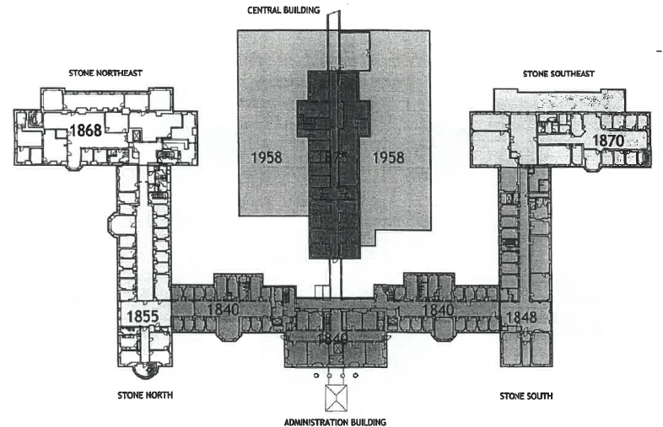

The scope of services includes the following:
- Documentation of a comprehensive assessment of the entire building envelope;
- Structural engineering related to envelope breaches and general building safety;
- All engineering required to actuate mechanical, electrical, security and other systems to create a stable interior environment so that the facility can be “mothballed”;
- Remediation design for lead paint, asbestos, bat and pigeon guano, and other hazardous materials, as needed;
- Oversight and reporting of the remediation and stabilization plan;
- Budgeting for each component of the plan;
- Scheduling for the phased implementation of the plan; and
- Other services as required.

Interested firms should submit one paper copy and one electronic copy of a Letter of Interest with a Statement of Qualifications which includes the firm's response to each of the following criteria.
- qualifications to undertake this project;
- documented experience with budgets, estimating, and project cost control;
- list of projects that demonstrate the firm's capabilities;
- list of recently completed work of similar type and size projects, with client contact information for each project;
- organization of team and profiles of key personnel who would be involved in the project;
- statement of current workload and ability to absorb the project; and
- list of business references other than those listed above, including contact information.

The paper copy of the Letter of Interest and Statement of Qualifications should be sent to Jill Instasi, Bureau of General Services, 111 Sewall Street, 77 State House Station, Augusta ME 04333-0077 so as to be received not later than 1:00 PM on 23 July 2021. The electronic copy of the Letter of Interest and Statement of Qualifications should be sent as an attachment to an email addressed to BGS.Architect@Maine.gov so as to meet the deadline noted above.

Firms responding will be screened and interviewed on the basis of qualifications only. Project fees and specific design solutions for this project will not be discussed at the interview. Specific program information will not be available before the screening of qualification packages. The selection committee will rank all firms and negotiate fees with the highest ranked firm.
Architect-Engineer Procurement Process

The standard procurement process of Architect and Engineer design services for public improvements is a Qualification Based Selection (QBS) process per statute (Title 5, §1742 subsection 6), described briefly here.

- The advertisement of this Request for Qualifications is the initial step in the process after the Agency assures that the project itself is approved and funded. A clear scope of services statement is an essential component of the advertisement.

- Interested firms respond to the Request for Qualifications (RFQ) as described below, submitting the Letter of Interest and Statement of Qualifications to the Selection Committee.

- The Selection Committee screens all submissions and invites the most qualified firms to interview for the project, typically three to five firms.

- The Selection Committee interviews the firms. Second interviews may be scheduled. References are checked.

- The Selection Committee ranks all of the interviewed firms. The Committee negotiates an agreement with the highest ranked firm based on the scope of professional services identified in the RFQ and interview.

- A BREM Architect/Engineer Agreement is drafted.

- The agreement must be approved by BREM before work commences.

