POLICY MANUAL
9/11/03
BURTON M. CROSS BUILDING
111 Sewall Street

By The Banker Management Group

1. THE BURTON CROSS BUILDING 1
2. COMMON AREAS 1
◻ Receptionist 1
◻ Conference Rooms 1
◻ Computer Training Room on 1st Floor 2
◻ Showers on 1st Floor 3
◻ Basement Storage 3
◻ Supply Rooms 3
3. Safety 4
◻ Emergency Response Manuals 4
◻ Emergency 9-911 4
◻ Fire Drills 4
◻ Nurse 4
4. Parking 5
5. Security 5
◻ Employees 5
◻ Visitors 6
6. Food and Beverages 6
◻ Cafeteria 6
◻ Food in Work Areas 7
7. Decorating 8
◻ Artwork 8
◻ Plants 8
◻ Pets 8
8. Cleaning and Recycling 9
9. Climate Control 11
10. Deliveries 11
11. Smoking Policy 11
12. Open Office Courtesy 14
13. Furniture/Signage 14
◻ Furniture 14
◻ Space and Furniture Changes 14
◻ Signage 15
◻ Systems furniture 15
◻ Shelving & filing cabinets 15
◻ Freestanding furniture 15
14. Tunnel Access 15
15. Lighting 16
16. Electrical Plugs 16
17. Building Modifications 16

- THE BURTON CROSS BUILDING

The new name for the renovated State Office Building (SOB) is the Burton M. Cross Building. It is named after former Governor Burton M. Cross who was governor of Maine from 1952-1955. Governor Cross was a native of Augusta, born here in 1902 and passed away in Augusta in 1998. He was a member of the House of Representatives from 1941-1945 and a member of the Maine State senate 7th district from 1945-1952.

- COMMON AREAS

- Receptionist

There are multiple agencies on the 3rd and 4th floors. The receptionist from each of these floors will be provided by the Department of Administrative & Financial Services.

- Conference Rooms

- The furniture in the conference rooms are pre-arranged. If your meeting requires a different arrangement you should contact Property Management in Room 110, 24 hours prior to the meeting, if possible.

- Property Management will provide an evacuation plan for these areas.

- Each shared conference room will be equipped with a phone that has local access and will require a code or calling card for long distance access. Conference rooms will be equipped with tables, chairs, a covered white board with a pull down screen, and a credenza.

- Use of available Legislative rooms on the 2nd floor will be coordinated with the Legislature. Call 287-1692.

- Conference rooms will be shared throughout the building. They will be centrally managed and reserved by the 3rd floor receptionist. All employees will have access to view the schedule of the conference rooms. To make reservations call 624-7600.

- AudioVisual equipment will be provided. There are four carts each on the 3rd, 4th, 5th and 6th floors and one on the 1st and 7th floors. These carts are equipped with a television and VCR. They can be wheeled from conference room to conference room within a floor but should remain on the floor to which they are designated.

The shared conference rooms are:

Floor Room # Capacity Phone #

1st 107 28 287-4122

3rd
300 18 287-4125
302 12 287-4124
333 14 287-4129
336 12 287-4130

4th
400 18 287-4135
401 12 287-4137
402 12 287-4134
432 12 287-4138
434 14 287-4173
436 12 287-4178

5th 500 18 624-6704
501 12 624-6619

6th 600 24 287-4237

7th 700 12 287-4297

- Computer Training Room on 1st Floor

The training room will be managed by the State Training & Development Office which is part of the Bureau of Human Resources. Procedures will be added at a later date.

- Showers on 1st Floor

- There are two shower rooms: one exclusively for men and the other exclusively for women.

- The rooms will be locked. The key can be checked out at Building Control Center, Room # 127. Employees will leave their badge while they have the key and will get their badge back when they return the key.

- Open face lockers will be provided for storage of clothes while showering or exercising.

- No valuables should be left unattended in the shower room.

- Showers are available for State employees and Legislators exclusively.

- Basement Storage

- The door into the storage area is equipped with a card reader. Only people that are on the access list will be able to access this area. This card reader grants access into the corridor where the storage cages are located. Once inside each agency will have their own key to their storage cage controlled by the agency.

- No employee will have their office space in the basement.

- Storage areas are to be limited access and should not be used primarily for storage that requires access more than an average of once a day.

- Supply Rooms

There are two supply rooms on the 3rd through the 5th floors and one on the 6th floor. The supply rooms will be equipped with a locking supply cabinet and one open shelving unit for each agency sharing the room. The supply rooms on the 3rd and 4th floors are shared as follows:

3rd floor
East side West side
DAFS Finance & Personnel DECD
DAFS Commissioner Treasurer
DAFS Budget
DAFS Risk Management

4th floor
East side West side

DAFS Bureau of General Services Secretary of State
DAFS Purchases
DAFS Accounts & Control

DAFS Bureau of Human Resources

3. Safety

- Emergency Response Manuals

Emergency Response Manuals shall be made available as soon as possible. There is a version being edited and a sample should be available November 2000.

- Emergency 9-911

In the event of an emergency you should call 9-911. This connects you directly to the local 911 dispatch center. Be prepared to say that you are in the 111 Sewall Street, Augusta and tell them the floor you are on and a description of the problem. The dispatcher will send help and the dispatcher will notify the Building Control Center.

- Fire Drills

The Augusta Fire Department will do a pre-inspection of the facility prior to any fire drill. This will include all three shifts. Fire drills will be coordinated with the Augusta Fire Department. People will be notified in advance in order to get accustomed to the horns, strobe lights and the exits from the building. People should be at least 100 feet away from the building after they exit the building. Everyone will be assigned a designated reporting area in order to account for all staff. Elevators will not be used during a fire drill.

- Nurse

There is a Registered Nurse on the first floor, room number 119.

4. Parking

The draft master plan for the Capitol complex calls for an addition to the parking garage in order to close a deficit of 300-400 spaces around the complex. The plan also calls for public spaces adjacent to the buildings. Until more parking spaces can be constructed we intend to manage the spaces we have as best we can to accommodate employees and to make the complex more customer friendly.

The deficit in parking spaces occurs only during legislative sessions. At other times, there is generally sufficient parking. Because most employees will be moving in after April 1, 2001, parking during the upcoming legislative session should be adequate, if tight. We will be working with the legislature to develop a plan for the session beginning in January, 2002, as well as interim plans to get us through the construction period in 2001 during which the Education Building will be demolished, the tunnel will be completed and the north wing of the State House renovated.

Employees should be aware that until new parking can be constructed any parking plan must involve the use of shuttles. Draft plans will be circulated for comment.

5. Security

- Employees

- Badges should be displayed at all times by employees.

- Stairways will require a badge to access. Your badge will allow you access to the floor you work on only. Employees that work on 3rd or 4th floors will be provided access to both floors since there is so much interaction. All stairwells are open to enter from the hall without badge access, however, the 1st and 2nd are the only floors that you can leave the stairwell from without a badge. There will be a sign on the 2nd floor landing stating that there is no access from floors above 2nd that they are for employees only.

- The building is open to all employees from 6:00 AM to 6:00 PM Monday-Friday. Employees must use their access badge to enter the building before 7:45 AM when it is opened to the public.

- If additional access is required the Bureau Director must request in writing access hours per employee. The Building Control Center will program access to the building per the written request.

- Access badge instructions on use and access will be provided.

- Visitors

Visitors will go the receptionist on the floor they are visiting and ask the receptionist to call the employee. The receptionist will sign the visitor in and assign them a badge that must be worn at all times. The visitor will leave a form of ID such as a driver’s license that will be returned when they return their visitor’s badge. The badge is identification only and is not an access badge. The employee will come to the reception station and escort the visitor to the workspace. All visitors are required to be escorted while within the work areas. Visitors must sign out with the receptionist when they leave and return the badge assigned to them.

- The building is open to the public from 7:45 AM to 5:00 PM Monday-Friday

- The floor receptionist on each floor must have visitors and contractors sign-in. The floor receptionist will assign visitors and contractor badges. These are ID badges only and will not provide door access. The contractors that sign-in with the receptionist will be people specifically called for that floor alone, for instance, a copier repair person. The visitor or contractor is required to return the badge before they leave.

- All other contractors are required to sign in with Building Control and they will be assigned Contractor badges. These are ID only and must be turned in when the person leaves.

6. Food and Beverages

- Cafeteria

- The name of the cafeteria is The Cross Café.
- The cafeteria hours are 6:30 A.M. to 3:30 P.M.
- The cafeteria will cater meetings in the building.

- Vending Machines

- Vending Machines are located on the 1st floor.

- Break Rooms

- There are 2 break rooms on each floor, which will be shared by agencies on the floor.

- Each break room will be equipped with the following equipment: cabinets, a refrigerator, a microwave, a table and chairs. The water supply for the building had been fitted with a purification system to provide purified drinking water to occupants.

- A coffee machine is provided in each break room by the cafeteria vendor. The machine will operate with a packet of coffee. The packet is inserted into the machine and hot water passes through it to make fresh coffee for each cup. The coffee comes in a variety of flavors. Property Management suggests that a lid be put on the coffee to avoid spills.

- Other appliances are prohibited to eliminate an overloading of the circuits, which can pose a fire hazard and can cause indoor air quality issues. Custodial staff will dispose of any appliances found in the break rooms.

- An exception to no appliances in the break room is for special occasions such as agency parties; in that case the appliance (e.g., a crock pot) can be brought in for the day but must be removed at the end of the day.

- The employees using the refrigerators will clean the refrigerators out every Friday. It is suggested that items be labeled with a name and the date it is placed in the refrigerator. Please be considerate of other staff that are using the refrigerators by limiting the quantity of food you store to ensure adequate room for everyone. Custodial staff will dispose of all perishable items on Friday if left in the refrigerator.

- Food in Work Areas

- There will not be any microwaves, coffeepots or other appliances in the work areas or individual workstations.

- Employees can eat in their workstation and are responsible for cleaning up after themselves.

7. Decorating

- Artwork

- Nothing will be attached to fixed building walls except by Property Management personnel. In order to have an item hung you must contact that office and they will hang items using appropriate fasteners.

- Please do not hang anything on common area walls.

- Agencies can decorate their common area for holidays. Decorations can be put up two weeks prior to the holiday and must be removed within two business days following the holiday. Please no live trees or wreaths.

- No tape on walls. The custodial staff will remove anything hung with tape.

- Bulletin boards will be located in the break room for postings.

- Workstations – nothing should show over the workstation walls. E.g., no placement of items on the edge of panels or on top of shelving units.

- Plants

- The building will not have any live plants. Air quality studies demonstrate that live plants can cause mold, air quality issues and confined building can cause allergies, mold, air quality and insect infestation.

- Delivered plants and flowers should be taken home at the end of the day.

- Silk plants are acceptable providing they are within the workstation and conform to other sections of this manual regarding decorating.

- Pets

- The only animals permitted in the building are those used to assist people with disabilities

- No other animals or pets will be permitted in the building.

8. Cleaning and Recycling

- The majority of Custodial Services in the Burton M. Cross State Office Building will be provided during unoccupied hours. Custodial staff will work from 10:00 PM to 6:30 AM Sunday through Thursday. Day shift coverage will be provided from 5:00 AM to 5:30 PM Monday through Friday.

- Cleaning tasks and frequencies will be in accordance with the following schedule:

Daily Tasks

- Empty wastebaskets, collect trash, and remove to disposal area.

- Dry mop/Damp mop or machine-wash all non-carpeted floors.

- Sweep/Damp mop all stairwells.

- Maintain all entry floor mats and runners.

- Complete hygienic cleaning of rest rooms and showers.

- Restock rest room and shower supplies.

- Vacuum all traffic lanes.

- Vacuum Conference and Hearing rooms.

- Clean drinking fountains.

- Wash door glass; interior windows, and glass walls.

- Spot clean walls, partitions, and woodwork as needed.

- Replace defective light bulbs/tubes.

- Reset furniture in Conference/Hearing Rooms.

- Keep Janitorial closets clean and free of odors.

- Spot clean carpet spills

Weekly Tasks

- Vacuum all carpet not on the Daily schedule.

- Low and mid-level dusting (up to 6 feet).

- Machine buff tiled floor areas.

Monthly Tasks

- High Level dusting (above 6 feet).

- Wash desks and table tops (if cleared).

- Vacuum air intake and exhaust grills.

Quarterly Tasks

- Shampoo Carpeting

Semi-Annual Tasks

- Strip, seal, and refinish tile floor areas.

- Wash inside of exterior windows.

Annual Tasks

- Wash file cabinets and bookcases.

- Vacuum systems furniture panels.

- Wash outside of exterior windows.

9. Climate Control

The building has been renovated and central climate control installed which includes heating, humidification and air conditioning. In order to effectively manage the temperatures in the building the following guidelines must to be followed.

- Fans and heaters are not permitted.

- Thermostats are to be managed by Building Control Center.

10. Deliveries

- Loading dock: A courtesy phone will be located at the loading platform with a phone directory of receptionist by floor. It is the responsibility of each agency to notify their floor receptionist if they are expecting a delivery. The receiving department is responsible to meet the carrier and allow access. The Building Control Center cannot accept deliveries.

11. Smoking Policy

CORRECTION – Monday, January 22, 2001

AMENDMENT TO WORK RULE ON SMOKING IN AND AROUND THE BURTON M. CROSS BUILDING, NASH SCHOOL, CULTURAL BUILDING AND THE PARKING GARAGE.

- Work Rule on Smoking in and around the Burton M. Cross Building, Nash School, Cultural Building, and the Parking Garage in Augusta

The work rule on smoking in and around the Burton M. Cross Building, Nash School, Cultural Building, and the Parking Garage is hereby amended as follows:

As indicated by the red line on the attached map, NO SMOKING is permitted within the perimeter bounded by Capitol Street to Sewall Street, then south on Sewall to the north edge of the parking lot, along the edge of the parking lot to Jackson Street, along Jackson Street to the Street on the south side of the Burton M. Cross Building, along the edge of the parking lot, across the south side of the Cultural Building, running north along the edge of the parking lot below the Cultural Building across the street and then running along the State House side of the parking lot/road to Capitol Street EXCEPT FOR THE PICNIC TABLES WITHIN THE PERIMETER DESIGNATED ON THE MAP BY BLUE DOTS, AT WHICH SMOKING IS PERMITTED.

NO SMOKING IS PERMITTED IN AND AROUND THE PARKING GARAGE

- Enforcement

Enforcement of this rule shall be by counseling first, followed by progressive discipline, consistent with the terms of applicable collective bargaining agreements.

- Effective Date

This rule is effective Monday, February 5, 2001

***PLEASE POST***
NO LATER THAN

Monday, January 22, 2001

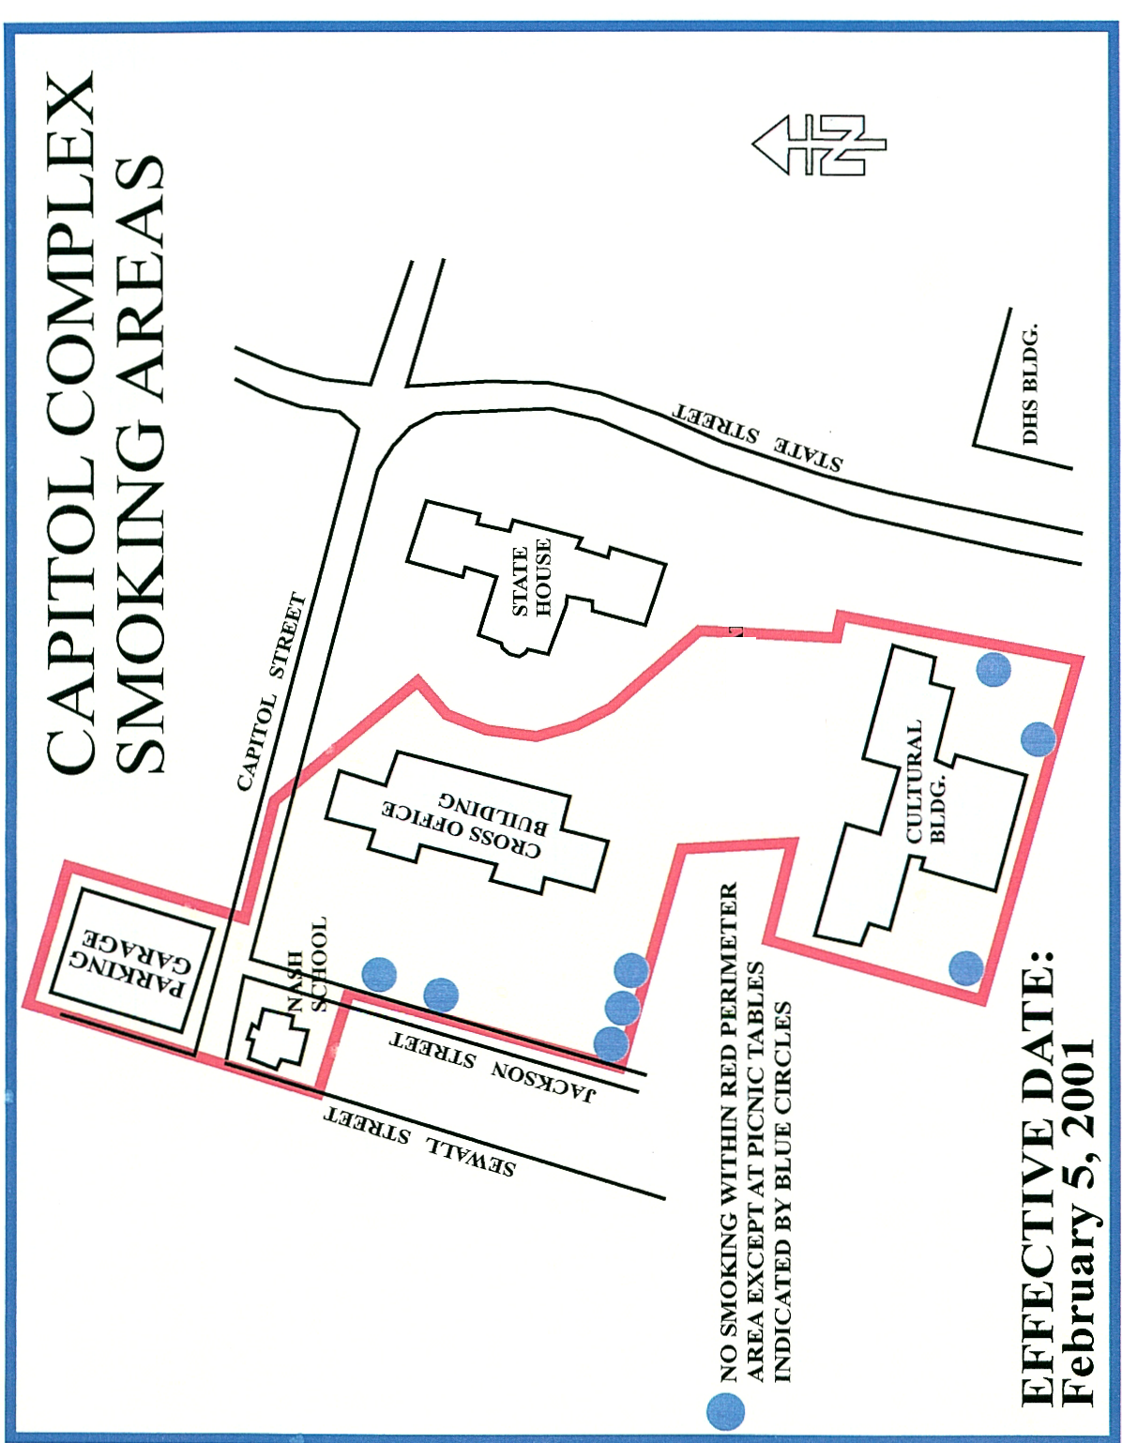
12. Open Office Courtesy

- In an open office environment it is especially important to respect the privacy of others. A few simple acts can make life more comfortable for everyone.

- Do not wander through other departments without a purpose.

- Keep your voice low and try to keep conversations with others away from people’s workstations.

- Hold meetings in designated meeting rooms.

- People may have varying degrees of sensitivity to external elements in the air. Please be conscientious and considerate of your workmates when using cleaners, perfumes, air fresheners and similar products.

- Lock-up your confidential documents at night and take valuables with you.

13. Furniture/Signage

- Furniture

In order to maintain the aesthetic integrity of the building standards have been set for the furniture that will be used in the building. A furniture coordinator will be named at a later date that will manage all requests.

- Space and Furniture Changes

- The systems furniture, common area furniture including lobbies conference rooms and filing cabinets except in the basement and hard walled offices are the property of The Bureau of General Services and belong to the building. If after the move an agency requests a change or addition it will be done through a process that assures compatible furniture is purchased. Changes will be paid for by the agency after the initial move in however they will become part of the building and will remain with the building if the agency should leave. Hanging tools for systems furniture are the exception to this rule and are purchased and owned by the agency.

- Signage

Building signs will be ordered through Joe Ostwald at the Bureau of General Services at 624-7353.

System furniture signs will be ordered through the furniture coordinator.

- Systems furniture

- Hanging tools are provided with each workstation. Additional tools can be purchased by the agency and will remain the property of that agency.

- Reconfigurations, design and new purchase, will done at the expense of the requesting agency and will stay with the building if the agency leaves.

- Reconfigurations, changes, additions and ergonomic adjustments will be requested by contacting a designated furniture coordinator. This contact will be provided at a later update.

- Shelving & filing cabinets

- Standards have been set for filing and shelving within the building and should be adhered to after the move.

- Freestanding furniture

- If furniture is within a workstation it cannot be taller than the panels

- No freestanding furniture will be placed in the common areas.

14. Tunnel Access

- The tunnel should be complete spring of 2001.

15. Lighting

- Task lights should be turned off by the employee at the end of the workday.

- Common area lighting on the 3rd through 7th floors are on motion sensors. After hours the main lights will go off if there is no activity in the area. Activity will put them back on. The tasks lights in each workstation are not effected and most hard walled rooms such as conference rooms are on switches.

16. Electrical Plugs

- There is a single plug that is off white in color with red lettering, different than all other plugs, which are gray. This plug is specifically designed to plug your computer into.

- There are six additional plugs in the workstation

17. Building Modifications

Upon receipt of ownership, it shall be the responsibility of agency and department heads, to foster an agreement with the Bureau of General Services by means of a form BGS21, directed to Property Management Department at 287-3151, SHS # 76.

Examples that would require such a form 21 are as follows: Installation of, or renovation to walls. Installation of additional receptacles. Note: Building inspection forms shall be available at Property Management. Prior to receipt of ownership, walk-throughs shall be conducted. Upon receipt, quarterly inspections are recommended by the offices of the Superintendent as a commitment to quality.

- Review and approval by the Bureau of General Services is required.

