Project Management
Procedures Manual

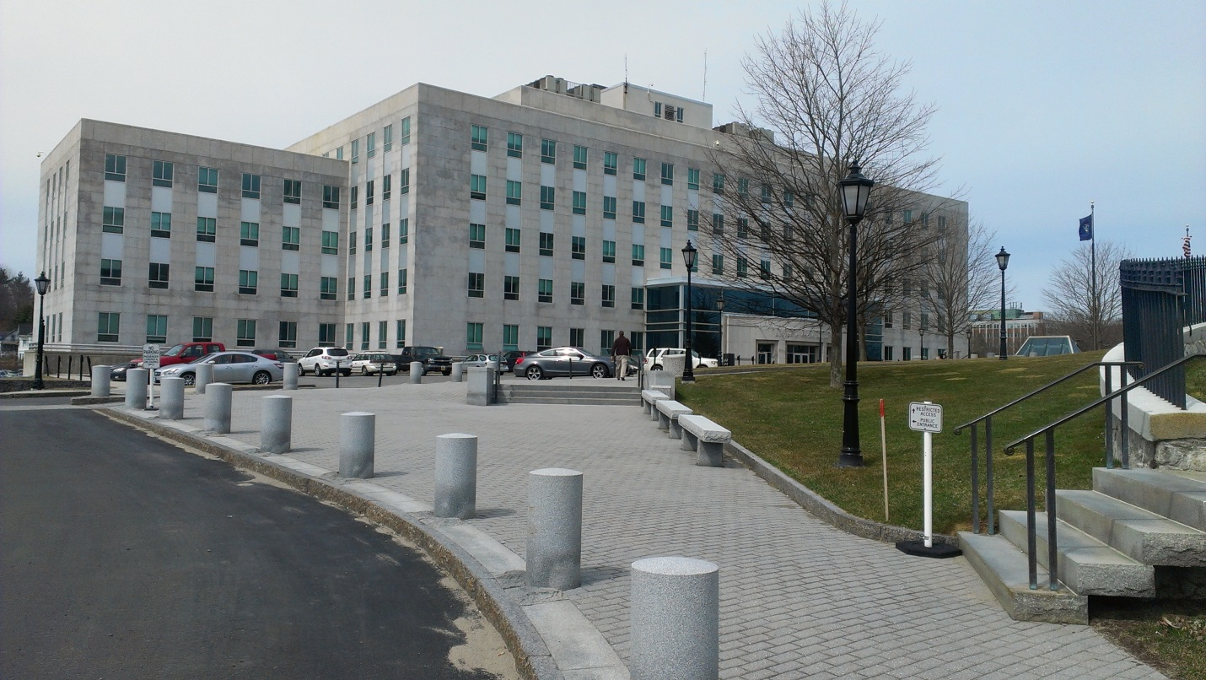
Burton M. Cross Building

The Division of Planning, Design & Construction of the Bureau of General Services (BGS) oversees the project management activities shown in this Procedures Manual, describing the routines and best practices which are called for by statute and rule, and BGS policy. The Division of Planning, Design & Construction and the Director of the Bureau of General Services make decisions on approval of documents based on compliance with the procedures contained in this document. These procedures are subject to review and revision.

Table of Contents
Definitions 3
Organizing a Project 5
Planning Documents 6
Design Services Procurement 7
Negotiating the Architect-Engineer Agreement 11
Changes to the Architect-Engineer Scope of Services 11
Related Services Procurement 11
Construction Services Procurement 12
Pre-construction Conference 14
Changes to the Construction Contract Scope of Work 15
Frequently Asked Questions 17

Definitions

Bureau of General Services (BGS) is the approval authority for the procurement of design and construction services, including the procedures followed in carrying out a project and the forms used in those procedures.

Consensus scoring is a method used by the Selection Committee when they agree as a group to a single score on each criterion for each candidate. See the Design Services Procurement section.

Consultant is the Architect or Engineer firm or individual or other professional consultant acting as the Professional-of-Record for the project.

Contractor is the construction company implementing the design of the Consultant.

IFB (Invitation for Bids) is the method of competitive procurement used for construction services. The basis for selection is the lowest bid submitted.

Other (on the Change Order form) is an optional, project-specific, Owner-defined signatory such as the Maine Department of Education or an Owner’s Representative. Use this signature authority line only if deemed necessary.

Owner is the contracting authority of the project, defined in statute as any department, officer, board, commission or agency of the State of Maine, including the Executive Branch agencies (excluding the Department of Transportation), the Judicial Branch, School Administrative Units, the Maine Community College System, and the Maine Maritime Academy.

Public Improvement is the term used for capital projects consisting of work that is distinct from maintenance and operations projects. See the language of the statute in the Frequently Asked Questions at the end of this document.

Reason Code (on the Change Order form) is the designation which identifies the reason and the single most prominent responsible party for a particular Change Order item. See table below.

Reason Code | Description | Examples
EO | Error or omission of Consultant | Item required by code but not shown in plans or specifications  Requirement noted in Owner’s program but not shown in plans or specifications  Mistaken engineering or wrong specification
UC | Unforeseen job site condition | Unsuitable soils not noted in soils report  Hazardous Materials not previously identified  Underground utility line conflict not shown on plans
OC | Owner-generated change | Owner directed scope of work change  Owner directed change in type or quality of materials  Owner directed upgrades to original design
RC | Regulatory authority-generated change | Work not previously required by third party authority  Code Enforcement Officer requires additional work such as signage for accessibility  Fire Marshal requires change in rated wall assembly
CC | Contractor-generated change | Work necessitated by contractor action or error  Contractor improperly installed items which inhibits ideal placement of other fixtures or equipment  Contractor failed to protect property or work in place resulting in replacement or repair

RFP (Request for Proposals) is the method of procurement used for Related Services Procurement and certain Alternative Project Delivery Method construction services. The basis for selection is the highest score of various criteria including cost.

RFQ (Request for Qualifications) is the method of procurement used for Consultant services. The basis for selection is the best qualified firm for a given project. Fees are negotiated with the highest ranked firm in a phase of procurement following ranking and preceding award.

Organizing a Project

BGS provides various aides for managing a public improvement project, including consultation as needed. A good place to start is the brief BGS Project Process Checklist showing the typical steps and considerations of a project. The Checklist is summarized below. This Project Procedures Manual highlights and details some of the more important procedures, such as Design Services Procurement and Construction Services Procurement.

- Planning Phase
- Planning your project, and notification of BGS
- Pre-procurement preparations
- Architect-Engineer procurement process

- Design Phase
- Permits and approvals
- Appropriate project documents
- Wage rate determination
- Bid bond or bid security
- Performance bond and payment bond
- Soliciting bids
- Receiving bids
- Construction contract award

- Construction Phase
- Proper contract form
- Pre-construction conference
- General contractor requisitions
- Construction contract change forms
- Final inspection of the project
- Project close-out documents
- Warranty period review of work

Planning Documents

There are three standard forms which are helpful in planning a public improvement project, in addition to the BGS Project Process Checklist. The three forms address the project scope, schedule and cost. Ideally, they are developed and updated periodically during the implementation of the project as a tool in managing the work.

- The Project Requirements
  - A narrative of the programmatic needs of the project. Include information such as business functions, parking spaces, square foot areas and other spatial information, employee and customer counts, et cetera. These requirements aid the A/E team in carrying out the work.

- The Project Schedule
  - A chronological outline of the projected dates for all important events of the project, including procurements, Owner review and approval dates, moving, commissioning, furnishing, et cetera.

- The Project Budget
  - A summary of the major categories of projected costs divided into three parts- Administrative, Fees and Services, and Construction. The Owner is responsible for approval of all expenditures on the entire project. The costs for designers are contained in the Fees and Services part. Detailed cost accounting and management is carried out with other documents which are reflected in this summary document.

These planning documents should be supplemented by whatever drawings, reports, and other information can be utilized to describe the project.


Harlow Building

Design Services Procurement

There are two methods of procurement for architectural and engineering services for the standard Design-Bid-Build project delivery method. Both are based on professional competency and qualifications. Small projects may use single source selection as detailed below. The other method is a Request for Qualifications (RFQ) process with interviews, also shown below.

- Single source selection
Maine statute allows a single source procurement of architects and engineers for certain projects. If all fees for the entire project total not more than $50,000, procurement may be by the Professional Services Prequalification List (the List). In this approach the prime Consultant must have a majority of the fee amount relative to any subconsultants. Only those professionals who qualify and are placed on the List may be chosen by state agency Owners to negotiate an agreement for those projects.

The use of the List is not required for up-to-$50,000 contracts, however, it may result in an abbreviated procurement time line, compared to the RFQ process. The following step-by-step procedure shall be carried out for proper use of the List.

- Assessment. Owner reviews available Consultants on Professional Services Prequalification List to determine firms with the appropriate specialty qualifications, experience, and location for the subject project.

- Selection. Owner selects and contacts one Consultant from the List.
  - Owner contacts the Consultant and informs that they were selected based on their presence on the List.
  - Consultant confirms that all relevant information contained in their prequalification application has not changed.
  - Owner provides a written project scope, project schedule, and project budget to the Consultant.
  - Owner requests a detailed written proposal from the Consultant.

- Proposal. Consultant provides a detailed written proposal to Owner.
  - If the Consultant does not reply affirmatively, or if Owner cannot successfully negotiate terms of the agreement, return to Step 1 to continue the procurement with a different Consultant.
  - The proposal should include: a scope of services; a work schedule; the fee amount and any allowance for reimbursable expenses, if applicable.
  - Owner and Consultant negotiate the final terms of the agreement.

- Agreement. Owner drafts a standard BGS Architect-Engineer Agreement based on negotiation with the Consultant. BGS may assist by confirming that agreement is feasible.
  - Owner and Consultant sign Architect-Engineer Agreement.
  - Owner sends complete, signed Architect-Engineer Agreement to BGS for approval.

- Approval. After Agreement is approved by BGS, the Consultant carries out the work of the Agreement with the Owner.
  - Owner administers the Agreement including approval of invoices.
  - Owner drafts Supplemental Agreements as needed, understanding that the initial Agreement plus Supplemental Agreements shall not exceed $50,000 in fee.

- Request for Qualifications
Owners may elect to publish a project-specific Request for Qualifications (RFQ) and interview a number of firms for architect and engineer procurement. BGS has sample ads, forms, evaluation sheets, letters, et cetera used in carrying out this process.

Requirements of BGS policy:
- The selection committee shall have a chairperson responsible for documenting the scoring, deliberations, and ranking of firms at each stage of the procurement process.
- The selection committee shall consist of not less than three and not more than six members.
- Not more than half of the committee shall be members of the Owner agency; the balance of the committee shall be from other State agencies, trained in the procurement process; and no one on the committee shall be from outside of State government.
- The selection committee shall use consensus scoring in their evaluations.
- In the event the selection committee reaches a divided or inconclusive decision, they shall present their results to the BGS Director in order to reach a final decision.
- The results of the architect and engineer procurement process are subject to approval of the BGS Director. Therefore, in order to maintain fair and consistent outcomes overall, the BGS Director may direct the selection committee to re-do any or all steps of the procurement process.

The following is an outline of the procedure for this type of procurement.

- Advertisement. Owner places a legal advertisement describing the basic information about the project. The Owner is required to advertise in the Daily Kennebec Journal at Augusta and in a daily newspaper that serves the area in which the project is located. A copy of the advertisement will be filed with the Bureau of General Services and BGS will post the ad plus any additional information about the project on its website.
  - Solicitation contains a description of the type of project and type of services sought; the criteria for selection; the address to which responses are sent; and the time and date responses are due.
  - Advertisement appears at least one time in the newspaper. Publication is at least two weeks before the selection of the Architect or Engineer.

- Screening. Owner forms a selection committee, which reviews and rates the qualification packages received in response to the solicitation. Only members of the selection committee shall evaluate the responses.
  - Each committee member rates the qualification packages, and then participates in discussions with the whole committee to determine the “short list” based on a consensus decision.
  - Three to five Consultant firms are selected for interviews.
  - Owner notifies all Consultant firms in writing of either selection or non-selection. Firms to be interviewed are given the hour, date and location of their interview.
  - Optionally, Owner may provide additional information about the project to the Consultant, including a pre-interview on-site meeting, or interview questions.
  - Owner notifies other Consultant firms in writing of non-selection.

- Interviews. Owner’s selection committee conducts interviews for each firm. Only those members of the selection committee who attend each interview will have a voice in the final ranking of firms.
  - Interviews are normally question and answer sessions based on the standard set of criteria aimed at determining the best qualified architect-engineer firm.
  - Consultant firms shall not discuss specific design solutions or fees during the interview process.
  - Selection committee checks references of at least the highest ranked firm.
  - Selection committee may call for a second round of interviews from among the short-listed firms.
  - Each committee member ranks the Consultant firms individually, then participates in discussions with the whole selection committee to determine the final ordinal ranking of firms based on a consensus decision.

- Negotiation. Selection committee notifies highest ranked firm of their status and enters into negotiations on scope of services and fees.
  - Owner consults with BGS as needed.
  - Owner uses BGS Recommended Fee Schedule for reference, or otherwise negotiates services and fees for projects which do not fit that protocol.

- Agreement. Owner drafts a standard BGS Architect-Engineer Agreement based on negotiation with the Consultant. BGS may assist by confirming that agreement is feasible.
  - Owner consults with BGS to confirm of the draft agreement is approvable.
  - Owner and Consultant sign Architect-Engineer Agreement.
  - Owner sends complete, signed Architect-Engineer Agreement to BGS for approval.

- Approval. After Agreement is approved by BGS, the Consultant carries out the work of the Agreement with the Owner.
  - Owner administers the Agreement including approval of invoices;
  - Owner drafts Supplemental Agreements as needed.

Standard selection criteria:
Qualifications of firm | General professional experience and relevant disciplines contained in the firm, especially as it relates to the qualifications needed to undertake the subject project. Understanding of the subject project. Size of firm. Experience with cost estimating and project cost control.
Qualifications of personnel | Education, experience and responsibilities of key personnel, especially as it relates to qualifications needed to undertake the subject project. Experience working together as a unit. Clear definition of responsibilities within team.
Project experience | Firm’s history of performance on current and completed projects. List of projects that demonstrate the firm's capabilities, being similar in a variety of ways, not merely building type. Projects noted showing personnel on proposed team.
Present workload and project capacity | Statement of current workload and ability to absorb the project from both a company and a team member perspective, particularly those personnel assigned to subject project. Understanding of the proposed time commitment to this project.
Financial stability | Demonstrated ability to proceed from project to project without organizational disruption.
Cost control | Demonstrated ability design to budgets, create accurate construction cost estimates, and track project costs.
Client recommendations | Ability to meet deadlines, budget control, sense of responsibility and quality of service. Review of business references, including contact information, and referring to projects and personnel.
Location of firm's office | Ability to be responsive to project by virtue of the firm’s proximity.

Negotiating the Architect-Engineer Agreement

When negotiating the services and fees of an agreement the Owner shall follow the BGS Method for Determining Design Fees for Architectural/Engineering Projects policy sheet. The parties are encouraged to develop all the necessary detailed itemization before finalizing negotiations and beginning the project.

If the Owner and the Consultant are unable to reach agreement on schedule, services, compensation or other elements of the agreement, the negotiation should be terminated and documented in writing. The Owner would then begin negotiations with the next most qualified firm.

All negotiations should be carried out on a confidential basis. Fees proposed by one firm should not be disclosed to other firms as a negotiating tactic.

Changes to the Architect-Engineer Scope of Services

Any change to the Consultant’s scope of services should be negotiated and documented on the State of Maine Architect-Engineer Agreement – Supplemental Agreement prior to any such change of services commencing.

The Owner should consult with BGS to confirm the draft Supplemental Agreement is approvable before finalizing commitment.

Related Services Procurement

There are commonly used services related to Public Improvements which do not follow the Request for Qualifications (RFQ) procurement utilized for Architects, Engineers and Landscape Architects. These services are procured through a Request for Proposals (RFP) process administered through the BGS Division of Procurement Services. Services procured in this way are: Land Surveying, Geotechnical Services, Roof System Design, Commissioning, Construction Testing, Special Inspections, and Property Appraisal.

Construction Services Procurement

The preference for all construction services procurement is competitive bidding. There are three acceptable methods of procurement for construction services, based on contract value, for the standard Design-Bid-Build project delivery method.

- Single source selection
The first means is an Owner-determined single source selection of the contractor where the entire cost for the complete project is less than $5,000. The Owner may not separate the trades, and similarly may not extend the work over time, in order to create multiple single source contracts for the Owner’s convenience.

Use the BGS Small Construction Project Contract for this type of procurement.

- Invited list of bidders
The second means of procurement is optional for projects where the construction contract cost is less than $100,000. The Owner may use a list of bidders invited by the Owner where the Owner believes those construction companies are capable of doing the work, willing to bid and available at a specified time period. The Owner shall provide to each bidder a written description of the scope of work for the project, a project due date, a bid due date, and preferably a bid form. The Owner must attempt to get at least three bids.

The bids must be opened at the appointed time, in a location open to the public. No bidder-provided variations from the Owner’s written project requirements should be used as the basis of award. The project is awarded to the low cost bidder after bids are verified.

Use the BGS Small Construction Project Contract for contract values under $50,000 and the BGS Large Construction Project Contract for those at or above that threshold amount.

Although the BGS Small Construction Project Contract form does not require a BGS signature, all procurement requirements have to be met before final validation in the State of Maine accounting system. BGS requires that each item of the form be complete- AdvantageME information, funding codes, all form fields filled in, signatures, and insurance certificates. The Owner is responsible for using the current version of this form, available on the Bureau website (http://www.maine.gov/bgs/). Old versions of this form or incomplete document sets may be rejected by BGS.

- Open, competitive bidding
The third means of procurement- open, competitive bidding- is for projects of any construction contract cost. In this method, a complete set of plans and specifications, with the standard BGS boilerplate documents, are prepared and bids are solicited in a legal advertisement. An optional variant to this method is the contractor prequalification process which makes the bidder pool known prior to receipt of bids.

The bids must be opened at the appointed time, in a location open to the public. The project is awarded to the low cost, fully responsive and responsible bidder after bids are verified.

Use the BGS Large Construction Project Contract for this type of procurement unless the contract value is less than $50,000.


The Stone Building (former AMHI)

Pre-construction Conference

A pre-construction conference shall be arranged to introduce all of the parties to each other and to establish or confirm the manner in which the project will be carried out. The BGS Pre-construction Meeting Agenda provides a sample framework for covering all of the important topics.

At the pre-construction conference roles and responsibilities of the parties are discussed; processes are outlined; project and site specific issues are discussed; the overall Project Schedule and Schedule of Values are presented for approval and distribution. Prior to the meeting the parties shall thoroughly review the documents to be approved, revising as necessary before the pre-construction conference.

- The Consultant shall:
  - Prepare the meeting agenda, modeled on the sample BGS agenda.
  - Request and review the materials to be formally approved at the time of the Pre-construction Conference.
  - Conduct the Pre-construction Conference.

- The Contractor shall:
  - Provide the Schedule of Values, Project Schedule and other materials for review prior to the pre-construction meeting, with timely revisions as necessary prior to the meeting.
  - Prepare the Schedule of Values, Project Schedule and other materials for approval at the Pre-construction Conference.
  - Attend the Pre-construction Conference, with all associates needed at the meeting.

- The Owner shall:
  - Prior to the meeting, provide the review and commentary necessary on the materials which will be approved at the Pre-construction Conference.
  - Attend the Pre-construction Conference, with all associates needed at the meeting.

Changes to the Construction Contract Scope of Work

- Instructions for Completing the Change Order Form
Complete each of the three sections of the Change Order form prior to the Contractor carrying out the proposed work. Roles of the parties are described below.

- One cover sheet summarizes changes in cost (Table A) and time (Table B), with approval signatures

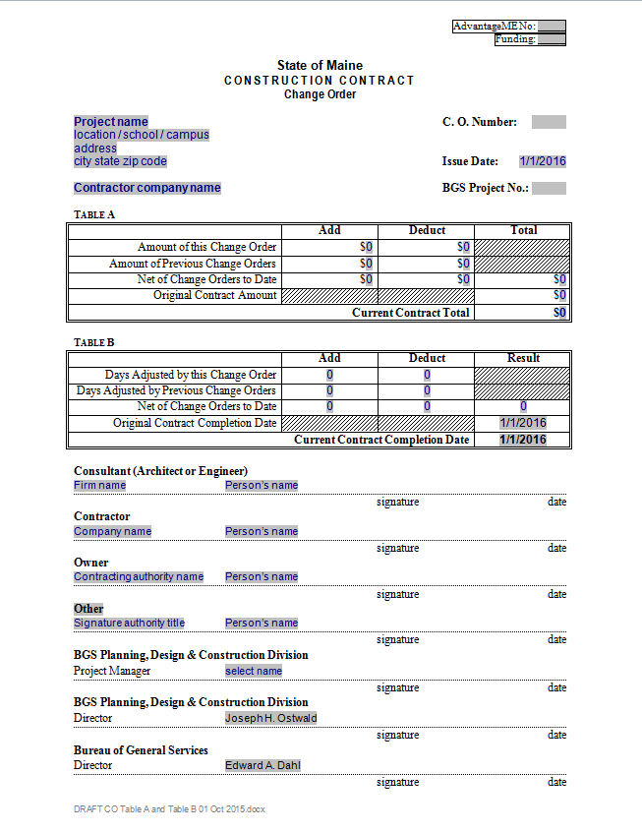

- One or more sheets with a Table C per sheet summarizes the Change Order items

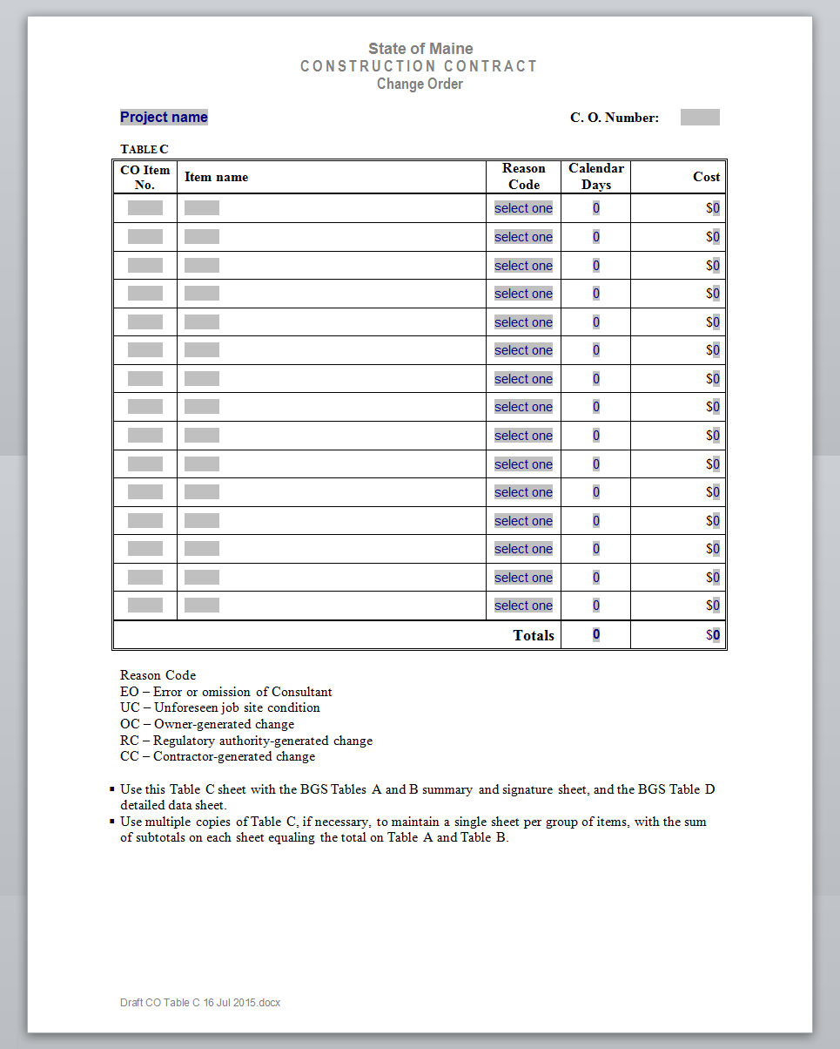

- One or more sheets with a Table D shows data for each Change Order item with signed approvals, and supporting documentation attached.

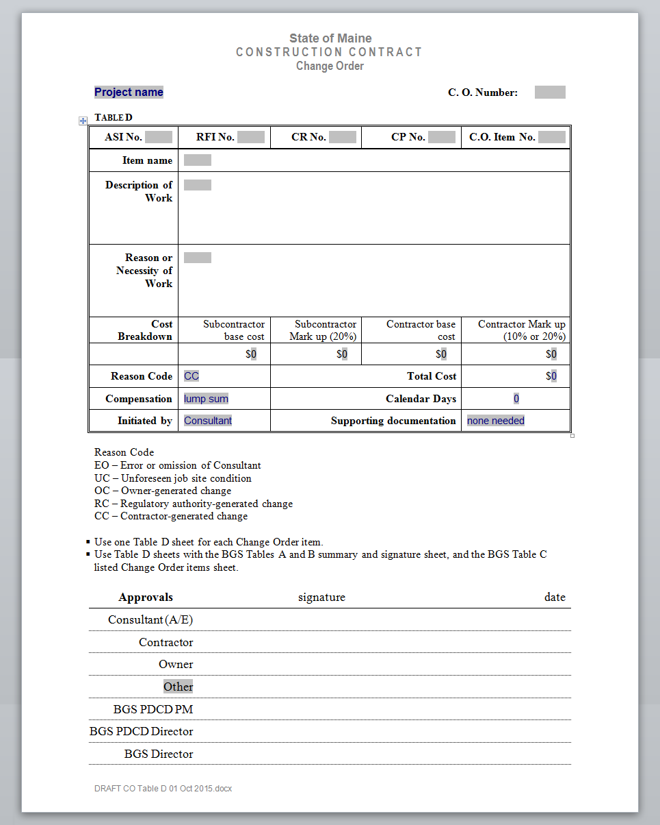

- The Consultant shall:
  - Complete the basic cover sheet data.
  - Compile all three sections of the Change Order form and distribute it for approval.
  - Complete the basic data for the second section, Table C. Number and provide a brief, descriptive item name for each Change Order item. Include the reason for the change, schedule impact, if any, and the cost.
  - Copy Table C if necessary, to maintain a single sheet per group of items, subtotaled on each sheet.
  - Assure that all information in Table C coincides with the Contractor-provided information.
  - Sign and date each Change Order item indicating approval to include on a Change Order form.
  - Sign and date the cover sheet indicating approval to proceed with the work.

- The Contractor shall:
  - Complete all of the basic information for the third section - Table D - including the supporting documentation for each Change Order item on succeeding pages, as necessary.
  - Describe the scope of work and cost, plus the rationale for extension of contract completion date, if any. Include a brief description of and reason for the work, the cost, and schedule impact, if any.
  - Copy Table D as needed – one sheet for each Change Order item.
  - Sign and date each Change Order item indicating approval to include on a Change Order form.
  - Sign and date the cover sheet indicating approval to proceed with the work.

- The Owner shall:
  - Participate in the development of Change Order Requests, Change Proposals, and Change Order documents as necessary.
  - Sign and date each Change Order item indicating approval to include on a Change Order form.
  - Sign and date the cover sheet indicating approval to proceed with the work.

- The “Other” and the BGS representative shall:
  - Participate in the development of Change Order Requests, Change Proposals, and Change Order documents as necessary.
  - Sign and date each Change Order item indicating approval to include on a Change Order form.
  - Sign and date the cover sheet indicating approval to proceed with the work.

- Note:
  - The “Other” signature slot is optional for an Owner’s Representative or a secondary State of Maine agency.
  - The BGS signature slot is for the Division of Planning, Design & Construction or another representative of the Bureau.
  - All parties shall sign and date each Change Order item indicating approval to include on a Change Order form.
  - All parties shall sign and date the cover sheet indicating approval to proceed with the work.
  - The reason, contract time impact and cost of the approved work shall be as defined in Tables A, B and C.
  - The Change Order is not valid until signed by all parties.

Frequently Asked Questions

- What is a "public improvement"?
Title 5, §1741 of State of Maine statute, Definitions, reads in part: "public improvement" means the construction, major alteration or repair of buildings or public works now owned or leased or constructed, acquired or leased by the State or any department, officer, board, commission or agency of the State, or constructed, acquired or leased, in whole or in part with state funds..."

- Is there a distinction between minor and major "public improvements"?
A "major alteration or repair" means an activity that materially changes a facility such that the cost of the work exceeds $5,000, or the governing codes and regulations regarding accessibility, health, life safety or general welfare are effected in any way.

Accordingly, a "minor" project is under $5,000 in construction cost and does not have a code implication. A PIP request should be submitted if there is any doubt about cost or scope. BGS will respond to each submission, however prior approval by BGS of under $5,000 projects is not required.

- Does a PIP request need to be submitted if the proposed project was included in the biennial budget request previously?
If the project is proposed to commence soon or if the objective is such that actions or important decisions need to be made immediately, a PIP request should be submitted, noting the change in character of the project.

- Does an agency need to submit a PIP request for repair or maintenance projects?
No. Minor repairs and maintenance are not "public improvements" although they affect public improvements. A reroofing project would require a PIP request; small patching or annual roof inspections would not require a PIP request. Please contact BGS if you would like to discuss proposed projects.

- What is the advertising requirement for a Request for Qualifications (RFQ)?
The rule for architect and engineer procurement indicates that the Owner “…shall advertise in the…Kennebec Journal…and in a daily newspaper that serves the area in which the project is located.” BGS advises Owners to post RFQ ads at least one day, with a due date no sooner than two weeks after the ad is published.

These required advertisements should also be posted on the BGS website on the same day the newspaper ad is published. The BGS posting is maintained until the response due date.

- May the Architect or Engineer who completed a preliminary study or conceptual design be retained to complete the design and construction administration of a project?
If the original RFQ for architect and engineer services specifically solicited for those services, and if the selection process included questions and scoring on those qualifications, then the answer is yes, at the Owner’s discretion.

The information developed by the architect or engineer in the preliminary study or conceptual design phase is the property of the Owner, so there would be no problem sharing that information with a different Consultant. A particular firm’s familiarity with the data and the facilities should not be over-stated or carry too much weight in subsequent RFQ evaluations.

- Can non-specific architect and engineer services be procured to be carried out over a designated period of time, or for a facility or campus using a “retainer” or “on call” type of agreement?
No. RFQs for architect and engineer services shall be based on a specific project, with the procurement focusing on selecting the best qualified firm for each specific project.

- Can a BGS Architect-Engineer Agreement be used on public improvement projects for the services of surveyors, property appraisers, industrial hygienists and other professionals who are not Architects or Engineers?
No. The proper contract form for those disciplines not identified on the BGS Professional Services Prequalification List is a Division of Procurement Services contract. The procurement for those services follows the typical “best value” evaluation process.

- What is the advertising requirement for an Invitation for Bid (IFB)?
The statute reads, regarding the quantity of ads: “…advertise…not less than 2 weeks…” BGS expects Owners to advertise at least once in each of two consecutive weeks, individual postings preferably spaced seven days apart, but more than three days apart. Usually the ads are placed in both the Kennebec Journal and another paper that serves the area of the project, at a minimum.

Regarding the timing of the last ad before bids are opened it reads: "... The last advertisement must be at least one week before the time named in the advertisement for the closing of such bids..." Since mandatory pre-bid conferences directly impact that timing, there are two scenarios to consider- with and without a mandatory pre-bid conference.

If there is a mandatory pre-bid conference included in the bid process, we use the date of the pre-bid conference as the point from which the minimum seven-day period starts before the bid closing date. A mandatory pre-bid conference should be scheduled to occur after the date of the second advertisement. The reason to heed the date of the mandatory pre-bid conference is because that event effectively establishes the list of potentially eligible bidders.

If there is no mandatory pre-bid conference, the date of the second ad is the point from which the minimum seven-day period starts before the bid closing date.

These required advertisements should also be posted on the BGS website. The BGS posting is maintained until the bid due date.

The List can be found on the BREM website: http://www.maine.gov/bgs/constrpublic/prof_services/PQ_disciplines.htm
The Rule is 18 554 Bureau of General Services, Chapter1, Procedures for Procurement of Professional Architectural and Engineering Services.
The webpage for RFQs: http://www.maine.gov/bgs/constrpublic/prof_services/RFQ_profs.htm
See table below for standard criteria and definitions.
Title 5 §§1747-1749.

