
STATE OF MAINE REQUEST FOR PROPOSALS

RFP SUBMITTED QUESTIONS & ANSWERS SUMMARY

RFP NUMBER AND TITLE: | RFP #202504059 Juvenile Justice Restorative Practices Initiative
RFP ISSUED BY: | Maine Department of Corrections
SUBMITTED QUESTIONS DUE DATE: | May 9th, 2025
QUESTION & ANSWER SUMMARY ISSUED: | May 12th, 2025
PROPOSAL DUE DATE: | May 19th, 2025, no later than 11:59 p.m. local time
PROPOSALS DUE TO: | Proposals@maine.gov

Provided below are submitted written questions received and the Department’s answer.

1 | RFP Section & Page Number | Question
1 | N/A | What is the total funding for Region 1, by period of performance?  - Initial Period (8/1/2025-6/30/2027)  - Renewal Period #1 (7/1/2027 - 6/30/2029)  - Renewal Period #2 (7/1/2029 - 6/30/2030)
1 | Answer
1 | - Initial Performance Period (8/1/2025-6/30/2027)—Total Funding: $656,700.00  - Renewal Period #1 (7/1/2027 - 6/30/2029)—Total Funding: $656,700.00  - Renewal Period #2 (7/1/2029 - 6/30/2030)—Total Funding: $656,700.00

2 | RFP Section & Page Number | Question
2 | n/a | Can you disclose the remaining budget from the previous RFP that is available for Region 1/this current RFP
2 | Answer
2 | Total Funding: $656,700.00 for an initial 2- year period.

3 | RFP Section & Page Number | Question
3 | Sec. IV Cost Proposal, Pg. 12 | The RFP states: “Bidders must submit a cost proposal that covers the initial period starting 08/01/2025 and ending on 06/30/2027.” Does this mean that the cost proposal document should outline the cost for two years, presumably totaling 2x what one year would cost the applicant?
3 | Answer
3 | Yes, the budget should be for the initial project period, which is 08/01/2025 to 6/30/2027, which is 23 months due to the delay in award.

4 | RFP Section & Page Number | Question
4 | Section II and III, pgs 11-12 | Can you provide an example/template of how you would like the organizational chart and work plan implementation portion of the RFP to look
4 | Answer
4 | The organization of this is at the discretion of the provider, but an example of a work plan could look like this:  The organization of this is at the discretion of the provider, an example of an organization chart could look like this (this was pulled from google):  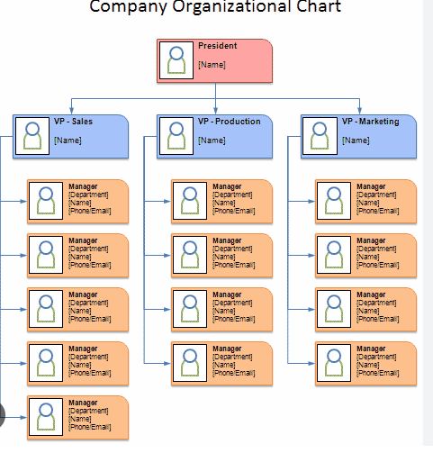
  Task/Objective | Responsible Party | Timeline for Completion
  Example: Hire Staff | Director | 09/01/2025

