
STATE OF MAINE
DEPARTMENT OF MARINE RESOURCES
MARINE RESOURCES LABORATORY
P.O. BOX 8, 194 MCKOWN POINT RD
W. BOOTHBAY HARBOR, MAINE
04575-0008

PATRICK C. KELIHER
COMMISSIONER
JANET T. MILLS
GOVERNOR

April 5, 2024

SUBJECT: Notice of Cancellation of RFP# 202402051 Lobster Trap Survey Vessel

This notice is regarding the subject Request for Proposals (RFP), issued by the State of Maine Department of Marine Resources for Lobster Trap Survey Vessel RFP. Pursuant to Part I.B.2 of the RFP, The Department has decided to cancel the RFP and no award will be made.

The Department intends to reissue the RFP in the near future.

Sincerely,
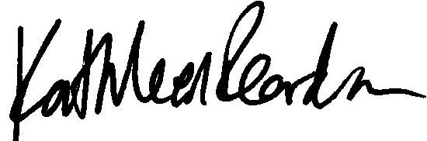

Kathleen Reardon
Marine Resources Scientist III, Lobster Fishery Scientist
Maine Department of Marine Resources

