STATE OF MAINE
Department of Economic & Community Development
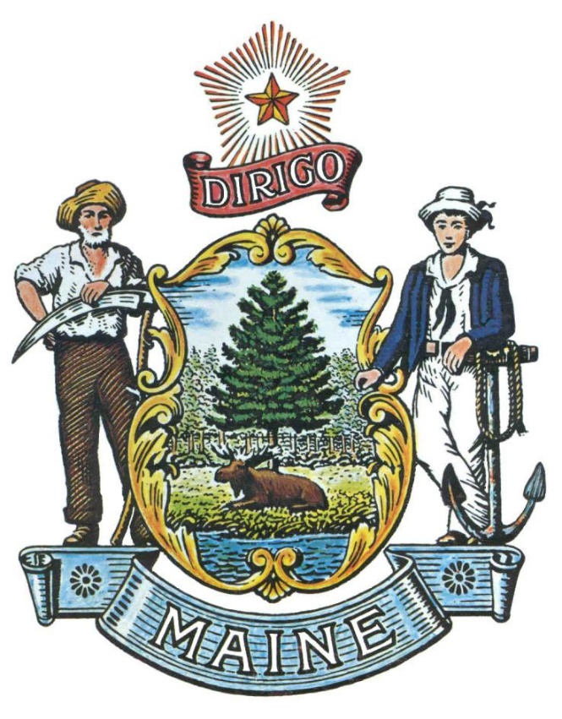
RFA# 202301010

Rural Workforce Recruitment and Retention Grant Program

Grant Coordinator | All communication regarding the RFA must be made through the RFA Coordinator identified below.  Name: Ben Sturtevant Title: RFA Coordinator  Contact Information: ben.sturtevant@maine.gov
Submitted Questions Due | All questions must be received by the RFA Coordinator identified above by:  Date: February 28, 2023 no later than 11:59 p.m., local time
Application  Submission | Proposals must be received by the Division of Procurement Services by:  Submission Deadline: March 8, 2023, no later than 11:59 p.m., local time.  Proposals must be submitted electronically to the following address:  Electronic (e-mail) Submission Address: Proposals@maine.gov

State of Maine - Department of Economic & Community Development
RFA# 202301010
Rural Workforce Recruitment and Retention Grant Program

TABLE OF CONTENTS

 | Page
APPLICATION DETAILS AND INSTRUCTIONS | 4
- PURPOSE AND BACKGROUND | 4
- ELIGIBILITY TO SUBMIT BIDS | 4
- AWARDS | 4
- APPEAL OF CONTRACT AWARDS  - REPORTING REQUIREMENTS | 5
KEY PROCESS EVENTS | 6
- SUBMITTING QUESTIONS  - QUESTION & ANSWER SUMMARY | 6
- AMENDMENTS TO THE REQUEST FOR APPLICATIONS | 6
- APPLICATION SUBMISSION | 6
EVALUATION
 | 8
APPLICATION AND DOCUMENTS | 9
- APPLICATION COVER PAGE | 9
- DEBARMENT, PERFORMANCE and NON-COLLUSION CERTIFICATION | 10
- APPLICATION FORM | 11

RFA TERMS/ACRONYMS with DEFINITIONS

The following terms and acronyms, as referenced in the RFA, shall have the meanings indicated below:

Term/Acronym | Definition
DECD | Department of Economic and Community Development
RFA | Request for Application
State | State of Maine
Economic Development Organization (EDO) | EDOs are entities, typically public and often a unit of government, that are generally established to assist existing and new businesses located in a particular geographic area through a variety of activities including grants, loans, provision of information and expertise, or creation of industrial parks. EDOs may also offer resources for starting a business, relocating your business, obtaining business licenses and permits, and information on job resources and workforce development.

State of Maine - Department of Economic & Community Development
RFA# 202301010
Rural Workforce Recruitment and Retention Grant Program

APPLICATION DETAILS AND INSTRUCTIONS
- Purpose and Background
The Rural Workforce Recruitment and Retention Grant Program will provide funding to support the attraction of workforce and talent to four of Maine’s rural counties that have experienced significant population decline or stagnation. Aroostook, Washington, Somerset, and Piscataquis counties represent over 52% of Maine’s land but just 12% of population. These counties have experienced a 13% decline in population over the last 30 years and as populations continue to age out of the workforce and young residents continue to seek opportunity outside these counties, there is significant demand to attract and retain qualified workers to these counties.
The four counties listed above are rich in forests, fertile soil, and abundant fisheries. Each has a proud history contributing to the state’s economy and providing quality jobs to generations of Mainers. This grant program is intended to provide funds in 2023 to Economic Development Organizations that represent the four counties above to engage in workforce attraction activities.
- Eligibility to Submit Applications
Applicants must be an economic development organization (EDO) that services Aroostook, Piscataquis, Somerset, or Washington counties. EDOs may collaborate on an application. Grants will be awarded for a maximum of $100,000 per county. More than one EDO may be a Grantee for a county they service, but only if they submit a joint application. Grants may be used over a two-year period starting upon contract date. EDOs will be required to provide 1:1 matching funds (in-kind match eligible).
- Appeal of Contract Awards
Any person aggrieved by the award decision that results from this Request for Applications may appeal the decision to the Director of the Bureau of General Services in the manner prescribed in 5 MRSA § 1825-E and 18-554 Code of Maine Rules, Chapter 120 (found here: Chapter 120). The appeal must be in writing and filed with the Director of the Bureau of General Services, 9 State House Station, Augusta, Maine, 04333-0009 within 15 calendar days of receipt of notification of contract award.

- Contract Terms
Applicants awarded through this RFA process will be conditionally awarded a contract for up to a two (2) year period. The period of performance is anticipated to be June 1st, 2023 through June 30th, 2025. The Department reserves the right to terminate contract negotiations with an awarded Bidder who submits a proposed contract significantly different from the proposal they submitted in response to the advertised RFA.
- Reporting Requirements
Semi-annual reports due on January 1 and July 1 are due to the Department. Reports to include:
- Summary of activity
- Summary of expenses
- Budget breakdown
- Changes to original application/intended use of funds
- Update on target metrics

State of Maine - Department of Economic & Community Development
RFA# 202301010
Rural Workforce Recruitment and Retention Grant Program

KEY PROCESS EVENTS

- Submitting Questions
Any questions must be submitted by e-mail to the Grant Coordinator identified on the Grant RFPs and RFAs webpage by 2/28/23 at 11:59 p.m. local time. Submitted Questions must include the subject line: “RFA# 202301010 Questions”. The Department assumes no liability for assuring accurate/complete/on time e-mail transmission and receipt.
- Question & Answer Summary
Responses to all questions will be compiled in writing and posted on the following website: Grant RFPs and RFAs. It is the responsibility of all interested parties to go to this website to obtain a copy of the Question & Answer Summary. Only those answers issued in writing on this website will be considered binding.
- Amendments to the Request for Applications
All amendments (if any) released in regard to this Request for Applications will be posted on the following website: Grant RFPs and RFAs. It is the responsibility of all interested parties to go to this website to obtain amendments. Only those amendments posted on this website are considered binding.
- Application Submission

  - Applications Due: Applications must be received by March 8th, 2023 at 11:59 p.m. local time. Applications received after the 11:59 p.m. deadline will be ineligible for award consideration for that annual application enrollment period.

  - Submission Instructions: Applications are to be submitted to the State of Maine Division of Procurement Services, via email, to Proposals@maine.gov.
    - Only applications received by e-mail will be considered. The Department assumes no liability for assuring accurate/complete e-mail transmission and receipts.
    - E-mails containing links to file sharing sites or online file repositories will not be accepted as submissions. Only e-mail applications that have the actual requested files attached will be accepted.
    - Encrypted e-mails received which require opening attachments and logging into a proprietary system will not be accepted as submissions. Please check with your organization’s Information Technology team to ensure that your security settings will not encrypt your proposal submission.
    - File size limits are 25MB per e-mail. Applicants may submit files separately across multiple e-mails, as necessary, due to file size concerns. All e-mails and files must be received by the due date and time listed above.
    - Applicants are to insert the following into the subject line of their email submission: “RFA# 202301010 Application Submission – [Applicant’s Name]”
    - Applications are to be submitted as a single, typed, PDF or WORD file and must include pages 7-10 of this RFA document.

State of Maine - Department of Department of Economic and Community Development
RFA# 202301010
Rural Workforce Recruitment and Retention Grant Program

APPLICATION EVALUATION AND SELECTION

- Scoring Weights and Process
  - Scoring Weights: The score will be based on a 100-point scale and will measure the degree to which each application meets the following criteria.
Scoring Criteria | Points Available
Part 1 – Eligibility | Pass/Fail
Part 2 – Applicant Experience | 20
Part 3 – Program Design | 30
Part 4 – Intended outputs & outcomes | 20
Part 5 – Project Sustainability | 10
Part 6 – Budget & Narrative | 20
Total Points | 100 points

  - Scoring Process: The Grant Review Team will use a consensus approach to evaluate and score all sections listed above. Members of the review team will not score those sections individually but, instead, will arrive at a consensus as to assignment of points for each of those sections.

  - Regarding the proposed funds requested and the proposed work, the Grant Review Team will consider the degree to which the project represents a good return for the investment (money, time) as well as whether the project work and cost estimates (tasks & budget) are reasonable for the expected outcomes, along with the amount and quality of proposed matching funds or services.

State of Maine - Department of Economic & Community Development
RFA# 202301010
Rural Workforce Recruitment and Retention Grant Program

APPLICATION COVER PAGE

Handwritten applications will not be accepted.
Applicant’s Organization Name: |  | Click or tap here to enter text.
Tel: | Click or tap here to enter text. |  | E-mail: | Click or tap here to enter text.
Headquarters’ Street Address: |  | Click or tap here to enter text.
Headquarters’ City/State/Zip |  | Click or tap here to enter text.
Point of Contact for Application (Name and Title) |  | Click or tap here to enter text.
Tel: | Click or tap here to enter text. |  | E-mail: | Click or tap here to enter text.
Headquarters’ Street Address: |  | Click or tap here to enter text.
Headquarters’ City/State/Zip |  | Click or tap here to enter text.
Dollar Amount of Application: |  | Click or tap here to enter text.

- No personnel currently employed by the Department or any other State agency participated, either directly or indirectly, in any activities relating to the preparation of the Applicant’s application.
- No attempt has been made, or will be made, by the Applicant to induce any other person or firm to submit or not to submit an application.
- The above-named organization is the legal entity entering into the resulting agreement with the Department should they be awarded a contract.
- The undersigned is authorized to enter contractual obligations on behalf of the above-named organization.
To the best of my knowledge, all information provided in the enclosed application, both programmatic and financial, is complete and accurate at the time of submission.
Name (Print): Click or tap here to enter text. | Title: Click or tap here to enter text.
Authorized Signature: | Date: Click or tap here to enter text.
State of Maine - Department of Department of Economic and Community Development
RFA# 202301010
Rural Workforce Recruitment and Retention Grant Program
DEBARMENT, PERFORMANCE and NON-COLLUSION CERTIFICATION
Applicant’s Organization Name: | Click or tap here to enter text.

By signing this document, I certify to the best of my knowledge and belief that the aforementioned organization, its principals and any subcontractors named in this proposal:
- Are not presently debarred, suspended, proposed for debarment, and declared ineligible or voluntarily excluded from bidding or working on contracts issued by any governmental agency.
- Have not within three years of submitting the proposal for this contract been convicted of or had a civil judgment rendered against them for:
  - Fraud or a criminal offense in connection with obtaining, attempting to obtain, or performing a federal, state, or local government transaction or contract.
  - Violating Federal or State antitrust statutes or committing embezzlement, theft, forgery, bribery, falsification or destruction of records, making false statements, or receiving stolen property.
- Are not presently indicted for or otherwise criminally or civilly charged by a governmental entity (Federal, State or Local) with commission of any of the offenses enumerated in paragraph (b) of this certification.
- Have not within a three (3) year period preceding this proposal had one or more federal, state, or local government transactions terminated for cause or default.
- Have not entered into a prior understanding, agreement, or connection with any corporation, firm, or person submitting a response for the same materials, supplies, equipment, or services and this proposal is in all respects fair and without collusion or fraud. The above-mentioned entities understand and agree that collusive bidding is a violation of state and federal law and can result in fines, prison sentences, and civil damage awards.
Failure to provide this certification may result in the disqualification of the Applicant’s application, at the discretion of the Department.

Name (Print): Click or tap here to enter text. | Title: Click or tap here to enter text.
Authorized Signature: | Date: Click or tap here to enter text.
State of Maine - Department of Department of Economic and Community Development
RFA# 202301010
Rural Workforce Recruitment and Retention Grant Program

APPLICATION
The Applicant is asked to be brief and concise in providing written information required in the application.

Project Title
Provide a descriptive project title in 15 words or less
Duration of Project
Start Date: |  |  | End Date:
Overview of the Program
Describe the general overview of the program.
Identification of Need
Project Description
Please provide a summary of the project you are proposing in order to address the identified needs.
Project Budget
The budget must include your overall projected expenses for the proposed project/program.
Budget Category | Amount Requested | Explanation of expense
Personnel (salary and benefits)
Instructional materials and supplies
Non-instructional materials and supplies
Contracted services
Technology access
Transportation
Other (specify)
Other (specify)
TOTAL REQUEST
Budget Narrative (one page maximum)
In the space below, please provide a detailed explanation of your anticipated grant-supported expenses in each of the above budget categories.

