STATE OF MAINE
Governor’s Office of Policy Innovation and the Future

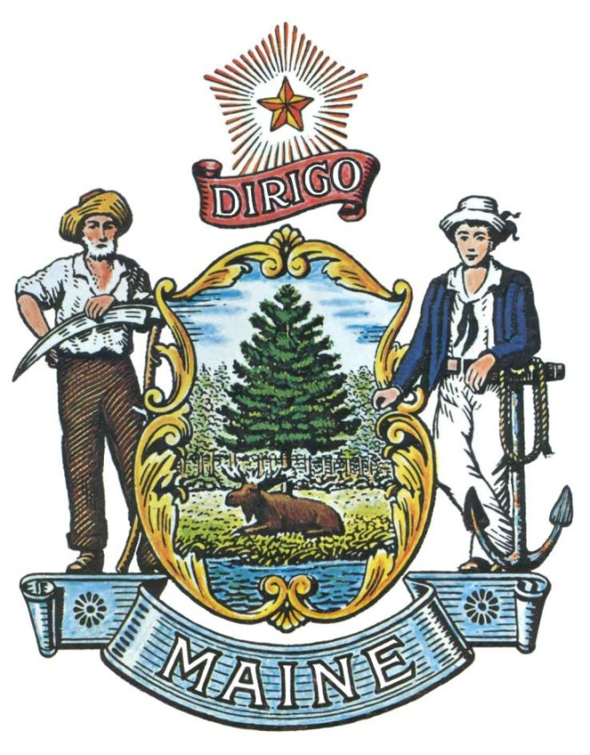

RFA# 202111181

Community Resilience Partnership
Service Provider Grant

RFA Coordinator | All communication regarding the RFA must be made through the RFA Coordinator identified below.  Name: Brian Ambrette Title: Senior Climate Resilience Coordinator  Contact Information: brian.ambrette@maine.gov
Informational Meeting | Date: December 14, 2021 Time: 1:00 p.m., local time  Location: https://mainestate.zoom.us/meeting/register/tZYvf-2trzssGtbW1BdV2IvHQjNEkNctxve7
Submitted Questions | All questions must be submitted, by e-mail, to the RFA Coordinator no later than January 11, 2022 at 11:59 pm and must include “RFA# 202111181 Questions” in the subject line of the e-mail.
Application Submission Period | Applications must be received by the Division of Procurement Services by:  Initial Submission Deadline: February 15, 2022, no later than 11:59 p.m., local time. Applications must be submitted electronically to the Division of Procurement Services at proposals@maine.gov and must include “RFA# 202111181 Application Submission” in the subject line of the e-mail.

TABLE OF CONTENTS
 | Page
DEFINITIONS | 3
DETAILS AND INSTRUCTIONS | 4
- Application Purpose and Background
- General Provisions
- Eligibility to Submit Applications
- Number of Awards
- Contract Terms
- Biannual Application Submittals
ACTIVITIES AND REQUIREMENTS  - Grants  - Application Components | 7
KEY PROCESS EVENTS | 9
- Informational Meeting
- Submitting Questions about the Request for Applications
- Amendments to the Request for Applications
- Submitting an Application

APPLICATION EVALUATION AND SELECTION | 11
- Scoring Weight and Process

RFA TERMS/ACRONYMS with DEFINITIONS

The following terms and acronyms, as referenced in the RFA, shall have the meanings indicated below:

Term/Acronym | Definition
Department | Governor’s Office of Policy Innovation and the Future
RFA | Request for Application
State | State of Maine
Service Provider Grant | Grant to a service provider to provide assistance to a Group of communities in Maine to prepare for and enroll in the Community Resilience Partnership and then to apply for grant funds to implement priority climate and energy projects.
Group | Two (2) to five (5) communities submitting an application for grant funding together.
Community Action Grant | Upon enrollment in the Community Resilience Partnership, Municipalities and Tribal Governments are eligible for Community Action Grants for projects that reduce energy use and costs, transition to clean energy, and make communities in Maine more resilient to climate change.  Please see RFA 202111178 – Community Action Grant for more information.

Community Resilience Partnership
Service Provider Grant

Details and Instructions

Application Purpose and Background

The Governor’s Office of Policy Innovation and the Future (Department) is seeking applications for Service Provider Grants as defined in this Request for Application (RFA) document. A Service Provider Grant is a grant to an eligible service provider to provide assistance to a Group of two (2) to five (5) communities in Maine to prepare for and enroll in the new Community Resilience Partnership and then apply for grant funds for priority climate and energy projects. This document provides the Application to be used for submittal, instructions for submitting applications, the procedure and criteria by which the awarded Applicants will be selected.

The Community Resilience Partnership provides grants and assistance to municipalities and Tribal Governments for projects that reduce energy use and costs, transition to clean energy and make communities in Maine more resilient to climate change.
Municipalities and Tribal Governments--those that have already taken significant climate action as well as those considering their early steps--are eligible for Community Action Grants upon completion of program enrollment.

Service provider organizations are eligible for Service Provider Grants to provide assistance to Municipalities and Tribal Governments to prepare for and enroll in the Community Resilience Partnership and then apply for grant funds for priority projects.

Funding for the Community Resilience Partnership is provided in the State biennial budget. For this round of Service Provider Grants up to $500,000 has been allocated.

Service provider organizations may include regional planning organizations, councils of governments, regional economic development organizations, county governments, non-profit organizations, academic institutions and cooperative extension programs, and for-profit enterprises. Generally, municipalities are not eligible for Service Provider Grants. However, in special cases, a community that can demonstrate robust in-house capacity may apply for a Service Provider Grant to provide relevant services to smaller towns in the same region.

Desired outcomes from the Service Provider Grants are new enrollments in the Community Resilience Partnership and a list of priority community and Group-wide climate and energy projects, as well as assistance seeking funding for those priority projects.

General Provisions

- From the time this RFA is issued until award notification is made, all contact with the State regarding this RFA must be made through the RFA Coordinator identified on the cover page of this RFA. No other person/State employee is empowered to make binding statements regarding this RFA. Violation of this provision may lead to disqualification from the application process, at the State’s discretion.
- The Applicant shall take careful note that in evaluating its application submitted in response to this RFA the Department will consider materials provided in the application and internal Departmental information of previous contract history, if any, with the Applicant. The Department also reserves the right to consider other reliable references and publicly available information in evaluating the Applicant’s experience and capabilities.
- All submissions in response to this RFA will be public records, available for public inspection pursuant to the State of Maine Freedom of Access Act (FOAA) (1 M.R.S. § 401 et seq.).
- All applicable laws, whether or not herein contained, shall be included by this reference. It shall be the Applicant’s responsibility to determine the applicability and requirements of any such laws and to abide by them.

Eligibility to Submit Applications

In order to be considered for Grant funding under this application process, Applicants must:

  - Eligible organizations include regional planning organizations, councils of governments, regional economic development organizations, county governments, non-profit organizations, academic institutions and cooperative extension programs, and for-profit enterprises.

Generally, municipalities are not eligible for Service Provider Grants. However, in special cases, a community that can demonstrate robust in-house capacity may apply for a Service Provider Grant to provide relevant services to smaller towns in the same region.

  - Service Provider Applicants must recruit two (2) to five (5) communities as part of the application for a Service Provider Grant. Applications must include a letter of support from each community in the proposed Group.

Number of Awards

The Department anticipates making multiple awards as a result of the RFA process.

Prospective service providers may request up to $10,000 per community in the Group. To encourage Applicants to prioritize communities that are more vulnerable to climate impacts, service providers may request an additional $2,500 for each community with elevated social vulnerability or community with a population of less than 4,000 people.

To achieve an equitable geographic distribution of regional provider investments, the State’s intent is to select at least one (1) Group from each of five regions during each grant cycle. The five regions are defined as:

1) York, Cumberland, Sagadahoc, Lincoln, Knox Counties;
2) Waldo, Hancock, Washington Counties;
3) Androscoggin, Oxford, Kennebec, Franklin, and Somerset counties;
4) Piscataquis, Aroostook, Penobscot Counties; and
5) Federally recognized Tribes in Maine.

Any person aggrieved by the award decision that results from the RFA may appeal the decision to the Director of the Bureau of General Services in the manner prescribed in 5 M.R.S.A. § 1825-E and 18-554 Code of Maine Rules Chapter 120. The appeal must be in writing and filed with the Director of the Bureau of General Services, 9 State House Station, Augusta, Maine, 04333-0009 within 15 calendar days of receipt of notification of conditional contract award.

- Contract Terms

Contracts will be for up to twelve (12) months.

- Biannual Application Submittals

This RFA offers a biannual application submittal process, pending available funds. A new application will be released and available to Applicants twice each year at Division of Procurement Services Grants RFPs and RFAs website . Applicants may apply two (2) times per year, with a maximum award of one (1) grant per provider each grant cycle.

Community Resilience Partnership
Service Provider Grant

Activities and Requirements

- Grants

- Desired outcomes from the Service Provider Grants are new enrollments in the Community Resilience Partnership program and a list of priority community and Group-wide climate and energy projects, as well as assistance seeking funding for those priority projects. The application must include a scope of work that demonstrates how the Applicant will achieve these outcomes.
- Applicants must recruit two (2) to five (5) communities and provide letters of support for each, as part of the application.
    - Applicants are strongly encouraged to include letters of support from municipal officials, local civic leaders, and state legislators.
- Once funds are awarded, communities within the service provider’s Group will have up to twelve (12) months to complete the enrollment process and submit for enrollment in the Program. However, many communities will find it possible to meet the enrollment requirements in six (6) months, in time for the next Community Action Grant deadline.
- All funded Applicants will be required to provide quarterly updates, project deliverables, and a brief project case study that communicates lessons learned.
- Assist Municipalities and Tribal Governments to become eligible for the Community Action Grant by:
              - Adopting a municipal resolution or Tribal Government to provide a letter from the Tribal Chief (sample municipal resolution available here) that establishes or designates a committee of community stakeholders or a position in municipal government or Tribal Government to coordinate activities to reduce energy use and costs, invest in renewable energy and make the community more resilient to climate change;
              - Completing the Community Resilience Self-Evaluation (available here) and the List of Community Actions (available here) to identify activities that have already been accomplished and potential next steps.
              - Holding a community workshop(s) to: a) review results of the two (2) self-assessments and b) prioritize projects for implementation.
  - The scope of work should include providing support to Group communities to identify and apply for funding for priority climate and energy projects for up to twelve (12) months.

B. Application Components
A complete and scoreable application for funding will include the following components. Specific descriptions of each component are included in the application.

- General Information/Service Provider and Group Eligibility
Applicants must complete the following documents as part of their application.
- Application Cover Page & General Assurances
- Debarment, Performance and Non-Collusion Certification
- Service Provider and Group Eligibility
  - Applicants must be an eligible entity. Service provider organizations may include regional planning organizations, councils of governments, regional economic development organizations, county governments, non-profit organizations, academic institutions and cooperative extension programs, and for-profit enterprises. Generally, municipalities are not eligible for Service Provider Grants. However, in special cases, a community that can demonstrate robust in-house capacity may apply for a Service Provider Grant to provide relevant services to smaller towns in the same region.
  - Service provider Applicants must recruit two (2) to five (5) communities as part of the application for a Service Provider Grant. Applications must include a letter of support from each community in the proposed Group.

- Capacity, Expertise, and Previous Experience

Applicants must demonstrate required capacity and expertise, as well as relevant previous experience.

- Scope of Work

Demonstrate how the Applicant will achieve outcomes including, new enrollments in the program and a list of priority community and Group-wide projects, as well as assistance seeking funding for those priority projects.

Maine’s climate response must ensure shared benefits across diverse populations of Maine people. Applicants should include robust community engagement, for example inclusive planning processes so that diverse community voices are able to participate. Climate change impacts will create the greatest hardships for already marginalized communities, and Maine must identify and promote solutions to help the people most vulnerable to climate impacts.

- Budget Proposal

- Applicants shall provide a Budget Narrative and Budget Form detailing the cost of the grant and where specific funds will be allocated.
- Up to $10,000 per community in the Group; up to an additional $2,500 for each community with elevated social vulnerability or community with a population of less than 4,000 people.
- For all Service Provider Grants, a 15% cost share is required of the Applicant.
- In-kind match is permitted.

Community Resilience Partnership
Service Provider Grant

Key Process Events

Informational Meeting

The Department will sponsor an Informational Meeting concerning the RFA via Zoom on December 14, 2021 from 1:00 p.m. You can join the meeting by clicking the following link: https://mainestate.zoom.us/meeting/register/tZYvf-2trzssGtbW1BdV2IvHQjNEkNctxve7

The purpose of the Informational Meeting is to answer and/or field questions, clarify for potential Applicants any aspect of the RFA requirements that may be necessary and provide supplemental information to assist potential Applicants in submitting responses to the RFA. Although attendance at the Informational Meeting is not mandatory, it is strongly encouraged that interested Applicants attend.

Submitting Questions about the Request for Applications

Any questions must be submitted by e-mail and received by the RFA Coordinator identified on the cover page of this RFA, as soon as possible but no later than the date and time specified on the RFA cover page. Submitted Questions must include the subject line: “RFA# 202111181 Questions”. The Department assumes no liability for assuring accurate/complete/on time e-mail transmission and receipt.

Question & Answer Summary: Responses to all questions will be compiled in writing and posted on the Division of Procurement Services Grant RFPs and RFAs website. It is the responsibility of all interested parties to go to this website to obtain a copy of the Question & Answer Summary. Only those answers issued in writing on this website will be considered binding.

Amendments to the Request for Applications

All amendments (if any) released in regard to this Request for Applications will be posted on the Division of Procurement Services Grant RFPs and RFAs website. It is the responsibility of all interested parties to go to this website to obtain amendments. Only those amendments posted on this website are considered binding.

Submitting an Application

  - Applications Due: Applications must be received no later than 11:59 p.m. local time, on the date listed on the cover page of the RFA. E-mails containing original application submissions, or any additional or revised application files, received after the 11:59 p.m. deadline will be rejected without exception.

If the need arises, the Department may reopen this RFA.

- Submission Instructions: Applications are to be submitted electronically to the State of Maine Division of Procurement services, via e-mail, to proposals@maine.gov.
  - Only applications received by e-mail will be considered. The Department assumes no liability for assuring accurate/complete e-mail transmission and receipt.
  - E-mails containing links to file sharing sites or online file repositories will not be accepted as submissions. Only e-mail applications that have the actual requested files attached will be accepted.
  - Encrypted e-mails received which require opening attachments and logging into a proprietary system will not be accepted as submissions. Please check with your organizations Information Technology team to ensure your security settings will not encrypt your proposal submission.
  - File size limits are 25MB per e-mail. Applicants may submit files across multiple e-mails, as necessary, due to file size concerns. All e-mails and files must be received by the due date and time listed above.
  - Applicants are to insert the following into the subject line of their e-mail submission: “RFA# 202111181 Application Submission – [Applicant’s Name]”.

Community Resilience Partnership
Service Provider Grant

Application Evaluation and Selection

Scoring Weights and Process
Scoring Criteria | Points Available
Criteria 1: General Information/Service Provider and Group Eligibility | Pass/Fail
Criteria 2: Capacity, Expertise, and Previous Experience | 40 points
Criteria 3: Scope of Work | 40 points
Criteria 4: Budget Proposal | 20 points
Total Points | 100 points

