STATE OF MAINE
Governor’s Energy Office

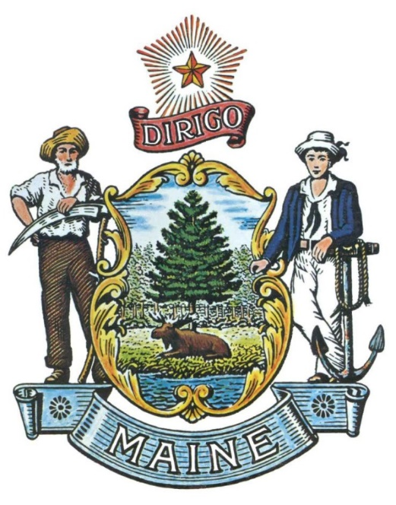

RFA# 202507101

Maine BlueTech Innovation: Offshore Wind Monitoring and Testing

RFA Coordinator | NAME: | Stephanie Watson
 | TITLE: | Offshore Wind Program Manager
 | EMAIL: | Stephanie.Watson@maine.gov
All communication regarding the RFA must be made through the RFA Coordinator.

Submitted Questions Due Date | August 11, 2025, no later than 11:59 p.m., local time
All questions must be received by the RFA Coordinator by the date and time listed above.

Application Submission Deadline | DATE: | September 17, 2025, no later than 11:59 p.m., local time.
 | TO: | Proposals@maine.gov
Applications must be received electronically by the Office of State Procurement Services by the date and time listed above.

TABLE OF CONTENTS
 | Page
RFA DEFINITIONS/ACRONYMS | 3
PART I OVERVIEW OF THE GRANT OPPORTUNITY | 5
- PURPOSE AND BACKGROUND
- GENERAL PROVISIONS
- ELIGIBILITY TO SUBMIT BIDS
- AWARDS
- CONTRACT TERM
- APPLICABLE LEGISLATION
- APPEAL OF CONTRACT AWARDS
PART II ACTIVITIES AND REQUIREMENTS | 10
PART III KEY PROCESS EVENTS | 17
- INFORMATIONAL SESSION
- SUBMISSION OF QUESTIONS
- AMENDMENTS
- APPLICATION SUBMISSION
PART IV APPLICATION EVALUATION AND SELECTION | 19
- EVALUATION PROCESS – GENERAL INFORMATION
- SCORING PROCESS
- SCORING WEIGHTS
- SELECTION AND AWARD
- CONDTRACT ADMINISTRATION AND CONDITIONS
PART V APPLICATION FORM | 21
APPENDIX A – SUBMITTED QUESTIONS FORM | 22

RFA TERMS/ACRONYMS with DEFINITIONS

The following terms and acronyms, as referenced in the RFA, have the meanings indicated below:

Term/Acronym | Definition
Blue Economy | Defined by the National Oceanic and Atmospheric Administration and adapted by Maine’s Blue Economy Task Force as “a sustainable and equitable ocean economy that optimizes innovation to expand economic opportunities in our coastal communities and to solve pressing societal needs. It is grounded in Maine’s unique marine heritage, research expertise, and location.”
Blue Economy Task Force | Maine’s Blue Economy Task Force established in 2024 by the Maine Legislature “to support Maine’s emergence as a center for blue economy innovation and opportunity in the 21st century.”
BlueTech | Blue technology, or BlueTech, refers to a broad category of technologies, systems, and projects designed to improve the world’s oceans and support a responsible blue economy. For this RFA, BlueTech must be applicable to the listed priorities for informing responsible development of floating offshore wind.
BlueTech Small Business | A company with proprietary BlueTech to be deployed and must meet the definition of a small business, as outlined by the Defined by the U.S. Small Business Administration’s Table of Size Standards.  For this RFA, a BlueTech small business must have innovative technology or monitoring approaches applicable to the listed priorities for informing responsible development of floating offshore wind.
Consortium, or Research Consortium | Maine Offshore Wind Research Consortium
DIFW | Maine Department of Inland Fisheries and Wildlife
DMR | Maine Department of Marine Resources
FOSW | Floating Offshore Wind
GEO, Office, or Department | Maine Governor’s Energy Office
Maine Clean Energy Partnership | Program established within the Maine Governor’s Energy Office to advance Maine’s energy, climate, economic development, and workforce goals.
NOWRDC | National Offshore Wind Research and Development Consortium
RFA | Request for Applications
Roadmap | Maine Offshore Wind Roadmap
ROSA | Responsible Offshore Science Alliance
RWSC | Regional Wildlife Science Collaborative
Small Business | Defined by the U.S. Small Business Administration’s Table of Size Standards
University of Maine Demonstration Site | University of Maine test site in state waters. Currently, the University of Maine has a ¼ scale floating offshore wind turbine, the VolturnUS+, deployed at the site through Fall 2026.

PART I OVERVIEW OF THE GRANT OPPORTUNITY

Purpose and Background

Purpose

The Governor’s Energy Office (GEO) is seeking applications to test innovative BlueTech and monitoring approaches as defined in this Request for Applications (RFA) document, leveraging the unique opportunity of a deployed floating offshore wind turbine in state waters. The innovative technologies and approaches sought by this RFA will support the State’s goals, plans, and programs described below to provide affordable, reliable, and clean energy for Maine’s people and businesses while growing Maine’s economy. The innovations will inform responsible floating offshore wind and coexistence with existing ocean users, support U.S. BlueTech supply chain and workforce development, and reduce costs for this abundant domestic energy source.

This document provides instructions for submitting applications, the procedure and criteria by which the awarded Applicant(s) will be selected, and the contractual terms which will govern the relationship between the State of Maine (State) and the awarded Applicant(s).

Background

The State of Maine has goals, plans and programs to provide affordable, reliable, and clean energy for Maine’s people and businesses while growing Maine’s economy. The Maine Energy Plan, Climate Action Plan, Economic Development Strategy, and the Blue Economy Task Force Report all identify offshore wind as one of the key energy sources and economic growth sectors.

In 2025, GEO published the Maine Energy Plan, a strategic plan for the state to advance affordable, reliable and clean energy for Maine’s people and economy. The Maine Energy Plan highlights the significant progress Maine has made toward achieving its energy goals to date, including investing in energy efficient technologies that are saving Maine people money and expanding homegrown clean energy to boost the state’s energy independence. The Plan outlines strategies to further reduce energy costs, ensure reliability and resilience, and increase the diversity of energy resources to meet the state law for 100 percent renewable and clean electricity by 2040, which will reduce energy costs and volatility over time. The Maine Energy Plan, along with Maine’s Climate Action Plan, includes offshore wind as an important generation source to meet Maine’s long-term energy needs, climate actions, and support the growing clean energy economy.

Maine’s Economic Development Strategy highlights compelling growth opportunities in floating offshore wind and other complementary clean energy sectors. According to the latest Maine Clean Energy Industry Report (PDF link), clean energy jobs contributed $3 billion to the state’s economy in 2023. Supported by the Governor’s Maine Jobs & Recovery Plan, GEO launched the Clean Energy Partnership, a clean energy workforce and innovation initiative that works with other state agencies, employers, schools and colleges, and workforce training organizations to expand employment opportunities in the clean energy sector to reach Governor Mills’ goal of 30,000 clean energy jobs by 2030. Through the Partnership, GEO supports workforce training programs that will ensure Maine people have the skills and resources to build careers in the clean energy field. Since 2022, GEO has awarded nearly $5 million in grants to support clean energy workforce development programs to attract new workers, provide career training and upskilling, and facilitate entry into the clean energy job market, including offshore wind. Since 2023, the office awarded over $2 million in grants to support clean energy innovation through new business accelerator and incubator programs across the State.

Maine’s abundant ocean and coastal resources make it an important location for the development of blue economy. In 2024, the Maine Legislature established the Blue Economy Task Force to produce recommendations to support growth of Maine’s blue economy and increase the State’s competitiveness domestically and globally. In their final report, the Task Force identified three key themes to categorize opportunities into a vision for the future of Maine’s blue economy that leverages research institutions, universities, nonprofits, businesses and governance expertise: Innovation, Collaboration, and Investment. The report also noted that Maine has some of the only deepwater offshore areas along the Atlantic coast in state waters, providing the unparalleled opportunity to innovate, collaborate and test deepwater technologies, such as floating offshore wind, to attract future investment in Maine.

The Maine Offshore Wind Initiative

To realize the clean energy and economic benefits of a responsible offshore wind industry, Governor Mills established the comprehensive Maine Offshore Wind Initiative in 2019. As part of Maine’s responsible approach to offshore wind, GEO has pursued an inclusive and research-driven strategy to realize the benefits presented by offshore wind while also preserving Maine’s vibrant maritime heritage, fishing industry, and the Gulf of Maine ecosystem. The initiative includes planning, research, policy and legislation – all developed through partnerships.

In February 2023, Maine released the Maine Offshore Wind Roadmap, a comprehensive plan to responsibly advance offshore wind. The Roadmap, developed over 18 months with engagement and input from stakeholders and the public, outlines how offshore wind presents a significant opportunity for Maine to reduce its reliance on expensive, imported fossil fuels, create good-paying jobs and economic investment, stabilize energy costs, advance floating offshore wind innovation, and make progress toward our statutory emissions reductions and clean energy targets. Objectives of the Roadmap are organized around five key topics – supporting economic growth and resiliency, harnessing renewable energy, advancing Maine-based innovation, supporting Maine’s seafood industry, and protecting the Gulf of Maine’s ecosystem.

With more than 80% of the world’s offshore wind resources in deep water requiring floating offshore wind technology, floating offshore wind is poised to grow significantly in the coming years. This growth can support existing and emerging Maine companies, create new jobs and career opportunities for Maine people, attract new workers and families to Maine, and deliver infrastructure investments in communities across the state. Through the development of the Roadmap, GEO worked with fishermen, scientists, and others to address head-on important questions about how offshore wind can be compatible with the Gulf of Maine’s remarkable ecosystem and existing users, which provides an informed path for advancing offshore wind in manners that protect people, communities, and the environment.

This approach, coordinated across State agencies, is outlined in the key strategies of the Roadmap and central to the state’s advancement of the Maine Offshore Wind Research Array, which is an important multi-turbine step to increase the understanding of how to maximize floating offshore wind opportunities while minimizing potential negative impacts.

To advance understanding of benefits of offshore wind and identify ways to reduce the impacts, with bipartisan support, the legislature established the Maine Offshore Wind Research Consortium (Consortium) and provided funding to support initial research priorities. The Advisory Board of the Consortium is comprised of experts representing broad perspectives including fisheries, wildlife, environmental non-governmental organizations, municipalities, industry, and state agency representatives from the Maine Department of Marine Resources (DMR), Maine Department of Inland Fish and Wildlife (DIFW), and GEO. The Advisory Board is responsible for a research strategy that, at a minimum, includes the following themes:
- Opportunities and challenges caused by the deployment of floating offshore wind projects to the existing uses of the Gulf of Maine;
- Methods to avoid and minimize the impact of floating offshore wind projects on ecosystems and existing uses of the Gulf of Maine; and
- Ways to realize cost efficiencies in the commercialization of floating offshore wind projects.

With bipartisan support from the Maine Legislature, the state has made a significant commitment to, and investment in, research to reduce costs and understand the local and regional impacts of floating offshore wind by establishing and providing initial funding for the Maine Offshore Wind Research Consortium. To date, the Research Consortium has funded six projects that advance our shared understanding of floating offshore wind. The six projects, broadly described, fall under the following topic areas:
- Fisheries coexistence
- Socioeconomic baseline inventory
- Seafloor mapping
- Baseline offshore bat monitoring
- Secondary entanglement risk assessment with reviews of cable monitoring and marine debris removal technologies
- Baseline assessment of social, economic, and cultural impacts of FOSW development on Maine’s fishing industry
For project summaries, please visit the Consortium’s website.

The Advisory Board continues to meet publicly and prioritize research questions for future funding opportunities. The Consortium collaborates with other states, as well as regional and national science and research partners, including the National Offshore Wind Research and Development Consortium (NOWRDC), the Responsible Offshore Science Alliance (ROSA), and the Regional Wildlife Science Collaborative for Offshore Wind (RWSC). The state and partners are actively seeking federal, regional, and private funding and in-kind opportunities to address the full breadth of research topics.

To expand on the above planning and investments the state and stakeholders have made to inform responsible floating offshore wind in the Gulf of Maine, this RFA aims to support projects from BlueTech small businesses and researchers at the nation-leading University of Maine demonstration site. The RFA will provide a unique in-water opportunity to test innovative BlueTech and monitoring approaches, advance supply chain and workforce development, inform coexistence between floating offshore wind and existing ocean users, and support cost reductions for floating offshore wind.

General Provisions

- From the time this RFA is issued until award notification is made, all contact with the State regarding this RFA must be made through the RFA Coordinator identified on the cover page of this RFA. No other person/State employee is empowered to make binding statements regarding this RFA. Violation of this provision may lead to disqualification from the application process, at the State’s discretion.
- Issuance of the RFA does not commit the Department to issue an award or to pay expenses incurred by an Applicant in the preparation of a response to the RFA. This includes attendance at personal interviews or other meetings, where applicable.
- All applications must adhere to the instructions and format requirements outlined in the RFA and all written supplements and amendments (such as the Summary of Questions and Answers), issued by the Department. Applications are to follow the format and respond to all questions and instructions specified in Part III of the RFA.
- Applicants will take careful note that in evaluating an application submitted in response to this RFA, the Department will consider materials provided in the application, information obtained through interviews/presentations (if any), and internal Departmental information of previous contract history with the Applicant (if any). The Department also reserves the right to consider other reliable references and publicly available information in evaluating the Applicant’s experience and capabilities.
- The application must be signed by a person authorized to legally bind the Applicant and must contain a statement that the proposal and the pricing contained therein will remain valid and binding for a period of 180 days from the date and time of the bid opening.
- The RFA and the awarded Applicant’s proposal, including all appendices or attachments, will be the basis for the final contract, as determined by the Department.
- Following announcement of an award decision, all submissions in response to this RFA will be public records, available for public inspection pursuant to the State of Maine Freedom of Access Act (FOAA) (1 M.R.S. § 401 et seq.).
- In the event that an Applicant believes any information that it submits in response to this RFA is confidential, it must mark that information accordingly, and include citation to legal authority in support of the Applicant’s claim of confidentiality. In the event that the Department receives a FOAA request that includes submissions marked as confidential, the Department shall evaluate the information and any legal authority from the Applicant to determine whether the information is an exception to FOAA’s definition of public record. If the Department determines to release information that an Applicant has marked confidential, it shall provide advance notice to the Applicant to allow for them to seek legal relief.
- The Department, at its sole discretion, reserves the right to recognize and waive minor informalities and irregularities found in applications received in response to the RFA.
- All applicable laws, whether or not herein contained, shall be included by this reference. It shall be the Applicant’s responsibility to determine the applicability and requirements of any such laws and to abide by them.

Eligibility to Submit Applications

Research institutions, colleges, universities, BlueTech companies, government, and non-governmental organizations are eligible to apply for funding, access to the permitted Castine demonstration site, and sensor integration support.

A BlueTech small business must be a company with proprietary BlueTech to be deployed to inform responsible floating offshore wind and must meet the definition of a small business, as outlined by the Defined by the U.S. Small Business Administration’s Table of Size Standards.

Awards

GEO anticipates making up to five (5) awards totaling up to $380,000 and access to the fully permitted University of Maine FOSW test site in state waters. Additional funds may be added at GEO's discretion, if available. The Department reserves the right to eliminate the lowest scoring application(s) and/or make awards for amounts less than requested, whichever is in the best interest of the State.

Contract Term

The dates of the contract period for the contract(s) resulting from this RFA are estimated and may be adjusted, as necessary, in order to comply with all procedural requirements associated with the RFA and the contracting process. The actual contract start date will be established by a completed and approved contract.

The anticipated contract term is for one year beginning in Fall 2025.

- Appeal of Contract Awards

Any person aggrieved by the award decision that results from this Request for Applications may appeal the decision to the Director of the Bureau of General Services in the manner prescribed in 5 MRSA § 1825-E and 18-554 Code of Maine Rules, Chapter 120 (found here: Chapter 120). The appeal must be in writing and filed with the Director of the Bureau of General Services, 9 State House Station, Augusta, Maine, 04333-0009 within 15 calendar days of receipt of notification of contract award.

PART II ACTIVITIES AND REQUIREMENTS

- Objective
The objective of this RFA is to offer researchers, BlueTech small businesses, and other eligible entities the unparalleled innovation opportunity of the fully deployed University of Maine demonstration turbine to meet the State’s goals for responsible floating offshore wind development for clean energy with reduced costs, reduced impacts, and economic growth. As identified in the Maine Offshore Wind Roadmap and by multiple national and international reports, in-water demonstration projects are essential to unlocking the potential of abundant, domestic offshore energy. Equinor’s Hywind floating offshore wind projects, for example, have provided key opportunities to reduce costs by nearly 70% and then another 40% with each successive deployment, inform sustainable development, develop the clean energy supply chain and workforce, and attract additional investment. Other floating demonstration projects in Europe are also proving innovative technologies, exceeding power production estimates, improving installation techniques, and providing additional habitat.
The Maine Offshore Wind Roadmap, the Maine Offshore Wind Research Consortium, the University of Maine, and multiple national and international coalitions have all identified the need for demonstration sites to test innovative BlueTech and monitoring approaches at deployed turbines to inform responsible deployment, reduce the costs of floating offshore wind development, and attract additional investment.
In Spring 2025, the University of Maine deployed a floating offshore wind demonstration project using an innovative concrete barge foundation called the VolturnUS+ in State waters at an existing University test site, approximately 600 meters off Dyce Head in Castine, Maine (Figure 1.). The floating project is the second ever deployed in the U.S. and includes a 225-kW turbine on a floating concrete barge foundation anchored to the seafloor. The project is connected to the onshore grid through an existing power cable. The project was funded through a competitive program funded by the US Department of Energy Advanced Research Projects Agency for Energy. The goal of the program is to demonstrate a new floating wind concrete foundation which can reduce construction costs significantly and maximize local job creation opportunities.
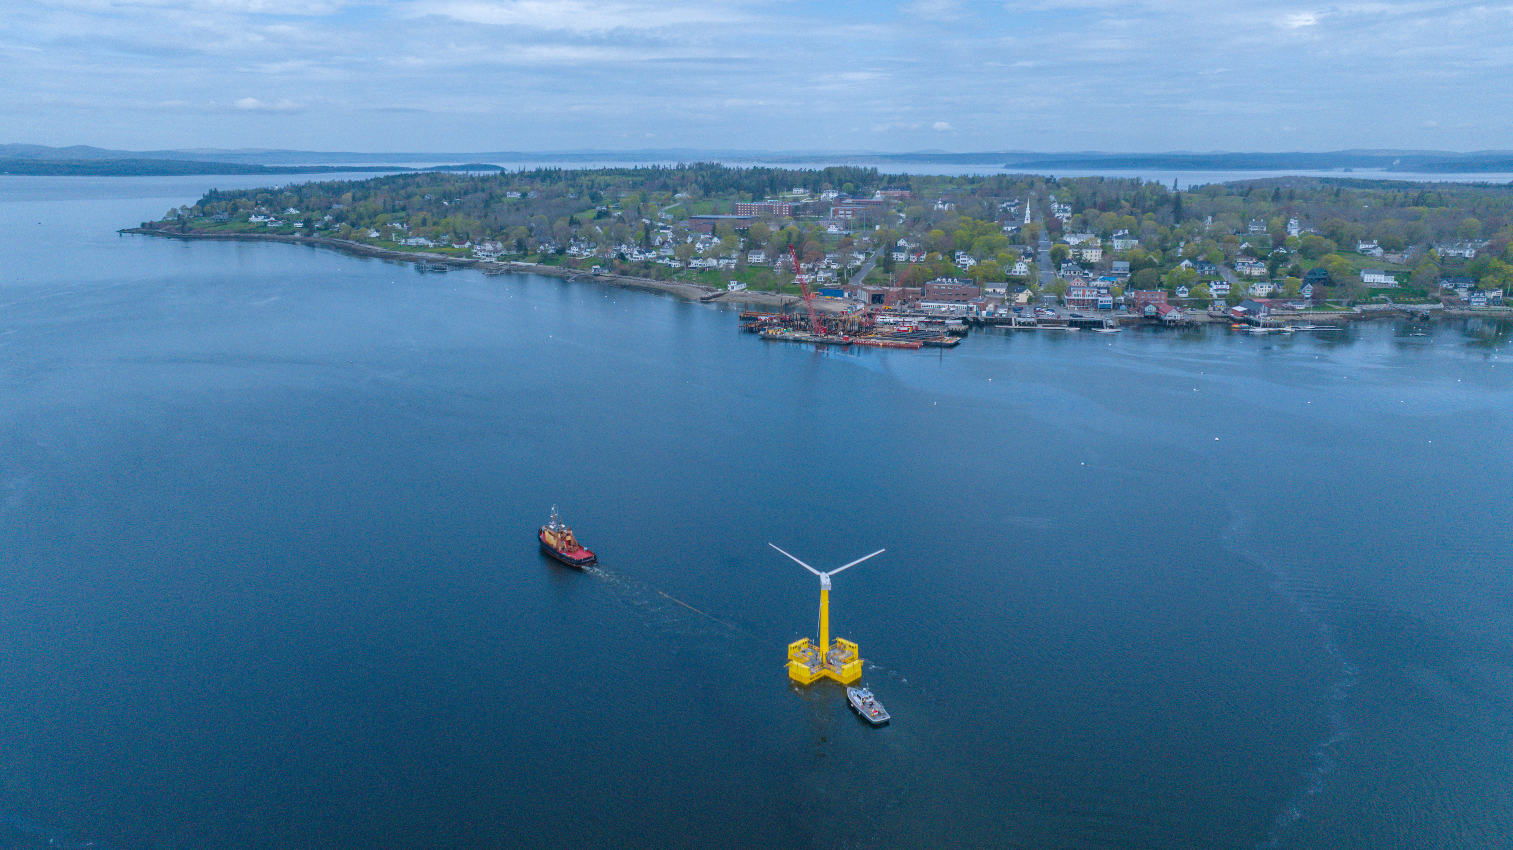
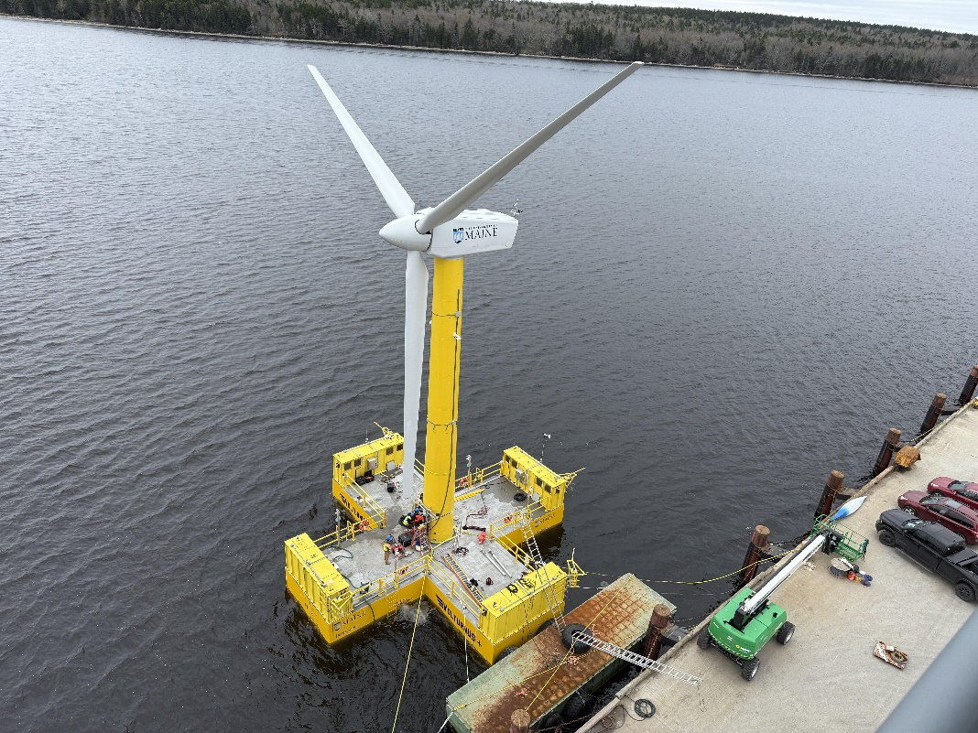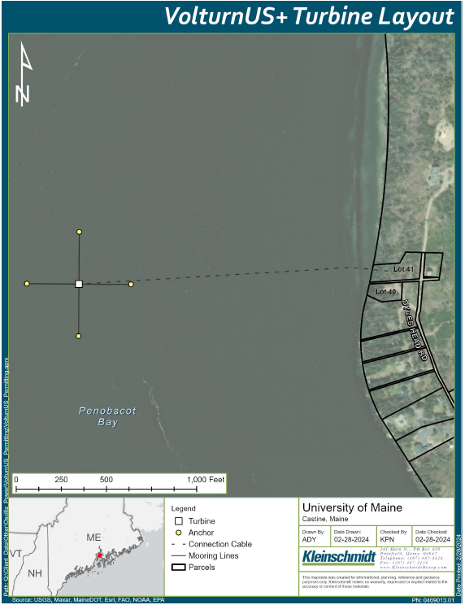
Figure 1. University of Maine VolturnUS+ floating turbine and demonstration site off Castine, Maine

The University of Maine has collaborated with many national and local partners to build and deploy the demonstration project at three locations in Maine: Trenton (construction of the floating platform), Searsport (integration of the wind turbine), and Castine (deployment and operations/maintenance site). Partners included government, post-secondary institutions, labor, and more than 26 supply chain companies. The anticipated deployment is through fall 2026.

Benefits of Testing Innovative BlueTech and Monitoring Approaches at the Deployed Demonstration Turbine

The issuing of this RFA meets multiple State goals for responsible offshore wind and addresses key stakeholder priorities identified through the Maine Offshore Wind Roadmap, Research Array, and Research Consortium processes. RFA funding will support testing innovative BlueTech or monitoring approaches at the demonstration turbine that address one or more of the following stakeholder-identified priorities and are clearly additive to existing efforts:
- Biofouling potential (on foundation, mooring lines, anchors) – Monitor biology on turbine structures
- Water Column and Seafloor Conditions (beneath and around the turbine) – Monitor physical, hydrodynamic and biological conditions
- Seafloor Conditions (near moorings/anchors) – Evaluate benthic habitat impacts from infrastructure
- Mooring Line Loads – Monitor for stress and performance
- Underwater Sound – Measure noise levels and potential ecological effects
- Bird and Bat Activity – Track presence, behavior, and potential interactions

Ongoing research, collaboration, and innovation is crucial to answering stakeholder questions, unlocking abundant clean energy, catalyzing economic growth, and ensuring the sustainable development of floating offshore wind projects in the Gulf of Maine. The benefits of this RFA to support innovative researchers and BlueTech companies at the unique in-water asset at the University of Maine demonstration site include, but are not limited to, the following:

- Leverage Investments to Meet State Goals - Expand on existing State and stakeholder investments in research and development, innovation, planning, and monitoring to unlock clean energy and economic growth for the State.

- Meet Stakeholder Priorities – Utilize a unique and strategic research platform to meet stakeholder-identified floating offshore wind priorities, demonstrating commitment to responsible development, building trust, and enhancing credibility and expertise.

- Catalyze BlueTech Innovation and Supply Chain Development - This one-of-a-kind asset provides opportunities for the deployment and testing of new BlueTech and collaborative monitoring approaches for future investment.

- Share Knowledge and Insights: In-water deployments, particularly those supported with government funding, yield valuable knowledge for strategic planning of offshore wind, drive evidence-based decision-making and best practices, and leverage opportunities for robust and innovative advancements.

- Drive Cost Reductions: Through innovation in methodologies, technologies, and practices, industry can identify cost-saving measures, resulting in reduced capital expenditures, operational costs, and maintenance expenses. By addressing uncertainties through demonstration projects, industry can effectively mitigate project risks and achieve cost savings by avoiding delays, redesigns, and inefficient environmental monitoring.

- Maintain Maine Leadership: Ongoing research, development, monitoring, and testing will maintain Maine’s strong leadership in floating offshore wind and BlueTech for the purposes of economic development

- Site and Demonstration Details

Location and Description of the Test Site
The University of Maine’s test site is in mid-coast Maine, in State waters approximately 600 meters off Dyce Head in Castine, Maine at 25 meters depth. The site is near the Maine Maritime Academy.

Description of the Demonstration Asset, Considerations, and Requirements

The fully deployed VolturnUs+ concrete floating offshore wind turbine already has much of the necessary infrastructure to support the priority activities:

- Concrete foundation dimensions are approximately 56 feet wide and 110 feet tall. Each leg of the hull is 15ft wide.
- The foundation is anchored to the seafloor using drag embedment anchors.
- The mooring system is semi-taut (chain at the top, synthetic line in the middle, chain at the seafloor).
- The foundation is integrated with a 225-kW turbine.
- The project is connected to the onshore grid through an existing power cable.
- Ethernet connection and 110V AC power are available onboard.

Additional Considerations and Requirements

In addition to meeting the required activities and priority needs of the Maine Offshore Wind Research Consortium and the broader Maine Offshore Wind Initiative, applicants must consider the following logistical, technical, and operational requirements to ensure safe and efficient operations of the floating wind platform while supporting innovative technologies and approaches for responsible floating offshore wind deployment:
- Application does not require federal permits for deployment (i.e., applications should not involve changes to lighting, moored buoys, nor sound).
- The proposed equipment should weigh less than 75 lbs.
- Small sensors (approximately 1ft x 1ft x 1ft) can be accommodated on the platform.
- Equipment will be exposed to outdoor marine conditions, including salt spray, snow/ice, and temperatures from -40 to 100 degrees F.
- Access is via work boat, with routine weekly trips, weather and vessel schedules permitting.
- All applicable US Coast Guard and other safety requirements must be followed. All access must be supervised by University of Maine personnel.
- University of Maine personnel must lead or assist with equipment installation and integration to ensure safe integration with the electrical and structural systems.
- All data intended for publication must be reviewed by University of Maine prior to release.
- Memory card access is available bi-weekly, weather permitting.
- All sensor maintenance and operations are the responsibility of the awarded Applicant but may use UMaine technicians and vessel subcontractors.

- Required Activities

Through this RFA, BlueTech or monitoring technologies would be integrated onto VolturnUS+ power and communication systems for one year with access to routine vessel transport to the site.

Applicants must thoroughly describe their plan for testing innovative BlueTech or monitoring approaches that address one or more of the following stakeholder-identified priorities at the FOSW demonstration project and specifically how the application is additive to at least one of the following existing efforts:

- Biofouling potential (on foundation, mooring lines, anchors) – Monitor biology on turbine structures
- Water Column and Seafloor Conditions (beneath and around the turbine) – Monitor physical, hydrodynamic and biological conditions
- Seafloor Conditions (near moorings/anchors) – Evaluate benthic habitat impacts from infrastructure
- Mooring Line Loads – Monitor for stress and performance
- Underwater Sound – Measure noise levels and potential ecological effects
- Bird and Bat Activity – Track presence, behavior, and potential interactions

Applicants must include the following activities in their applications:

  - Rationale and Description of Proposed Activity – A thorough description of the innovative BlueTech or monitoring approach, clearly articulating how the proposed project advances Maine’s offshore wind priorities and details the additive value proposition of the project to existing efforts. The description should also identify risks of the proposed activity and describe the risk mitigation measures.
  - Plan and Requirements for Deployment – A clear description of each task and outline of requested needs from University of Maine for technology deployment, integration, and vessel support (e.g., sensor integration details, access to vessel support beyond the routine weekly trips). Costs for needs from the University of Maine beyond weekly trips and simple installations must be described and budgeted by the applicant.
  - Plan for Access and Maintenance - A clear description of each task and outline of requested needs from University of Maine for technology deployment, integration, and vessel support (e.g., sensor integration details, access to vessel support beyond the routine weekly trips). Costs for needs from the University of Maine beyond weekly trips must be described and budgeted by the applicant.
  - Data Collection, Analysis, and Sharing Plan – A thorough plan with metrics for success to ensure high-quality non-proprietary data is made publicly available using existing portals and standards and is communicated clearly to a broad spectrum of stakeholders to optimize project results. The plan should be developed in coordination with GEO and the University of Maine, following monitoring and data sharing guidelines from regional and national entities, such as the Regional Wildlife Science Collaborative, the Responsible Offshore Science Alliance, and the National Offshore Wind Research and Development Consortium.
  - Technology Evaluation Plan (if testing a new technology) – A clear plan for evaluating the BlueTech with metrics for success.
  - Safety Communications Strategy – A clear strategy for communications to facilitate safe and efficient operations and maintenance at the demonstration site in coordination with GEO, the Maine Department of Marine Resources and the University of Maine.
  - Consultations, Deliverable Reviews, Presentations – Plan to consult with GEO, the University of Maine, and other entities identified by GEO throughout the project (kickoff meeting, monthly check ins, quarterly meetings). Plan to submit each deliverable (interim and final) twice and provide GEO two weeks to review each iteration. Plan for two virtual updates to the Advisory Board of the Maine Offshore Wind Research Consortium.
  - Gantt chart – Include a Gantt chart summarizing all tasks, milestones for key decision points, deliverables, and a monthly timeline. The chart should include who will lead and perform each task with brief biographies, along with collaborators.
  - Reports and Publications – Monthly, Quarterly, Annual, and Final Reports as described in section F below.
  - Plan to sign legal Agreements including the following: Non-disclosure agreement with the University of Maine to protect the confidentiality of their technology; Site testing and access agreement with the University of Maine; and an indemnification agreement with the University of Maine from any liabilities associated with the project.

- Allowable Use of Funds
  - Integration, operations, and/or maintenance of BlueTech or sensors, monitoring, data collection, data sharing, and data analysis

- Non-Allowable Use of Funds
  - Costs otherwise supported by the Applicant or any other entity
  - Activities that are duplicative to prior or ongoing studies

- Reporting Requirements
  - Monthly reports covering the previous month’s activities (programmatic updates, contract updates, technical assistance) are due by the 5th of each month.
  - Quarterly reports (performance narrative, budget report) are due within 30 days of the end of the quarter.
  - Annual report (performance narrative, budget report) is due within 30 days of the end of the year.
  - Final report is due within 30 days of completed scope of work and at least 30 days before the end of the grant period.

- Legal Agreements
Applicants awarded under this RFA will be expected to sign legal agreements including the following: Non-disclosure agreement with the University of Maine to protect the confidentiality of their technology; Site testing and access agreement with the University of Maine; and Indemnification agreements with the University of Maine from any liabilities associated with the project)

PART III KEY PROCESS EVENTS

Submission of Questions

  - General Instructions: It is the responsibility of all Applicants and other interested parties to examine the entire RFA and to seek clarification, in writing, if they do not understand any information or instructions.
    - Applicants and other interested parties should use Appendix A (Submitted Questions Form) for submission of questions. The form is to be submitted as a WORD document.
    - Questions must be submitted, by e-mail, and received by the RFA Coordinator identified on the cover page of the RFA as soon as possible but no later than the date and time specified on the RFA cover page.
    - Submitted Questions must include the RFA Number and Title in the subject line of the e-mail. The Department assumes no liability for assuring accurate/complete/on time e-mail transmission and receipt.

  - Question & Answer Summary: Responses to all questions will be compiled in writing and posted on the State’s Office of State Procurement Services Grant RFPs and RFAs website. It is the responsibility of all interested parties to go to this website to obtain a copy of the Question & Answer Summary. Only those answers issued in writing on this website will be considered binding.

Amendments

All amendments released in regard to this RFA will be posted on the Office of State Procurement Services Grant RFPs and RFAs website. It is the responsibility of all interested parties to go to this website to obtain amendments. Only those amendments posted on this website are considered binding.

Application Submission

  - Applications Due: Applications must be received no later than 11:59 p.m. local time, on the date listed on the cover page of the RFA.
    - Any e-mails containing original application submissions or any additional or revised application files, received after the 11:59 p.m. deadline, will be rejected without exception.

- Delivery Instructions: Applications must be submitted electronically to the State of Maine Office of State Procurement Services at proposals@maine.gov.
  - Only applications received by e-mail will be considered. The Department assumes no liability for assuring accurate/complete e-mail transmission and receipt.
          - Application submission e-mails that are successfully received by the proposals@maine.gov inbox will receive an automatic reply stating as such.
  - E-mails containing links to file sharing sites or online file repositories will not be accepted as submissions. Only e-mail application submissions that have the requested files attached will be accepted.
  - Encrypted e-mails received which require opening attachments and logging into a proprietary system will not be accepted as submissions. It is the Applicant’s responsibility to check with its organization’s information technology team to ensure that security settings will not encrypt its application submission.
  - File size limits are 25MB per e-mail. Applicants may submit files across multiple e-mails, as necessary, due to file size concerns. All e-mails and files must be received by the due date and time as described above.
  - Applicants are to insert the following into the subject line of their e-mail submission: “RFA# 202507101 Application Submission – [Applicant’s Name]”.

- Submission Contents
- Application submissions must include the Applicant’s completed Application Form (found in Part V of the RFA) and all required information and attachments as stated in the form.
- The Application Form must be submitted as a single, typed, PDF file.
- Applicants are not to provide additional attachments beyond those specified in the RFA or Application Form for the purpose of extending their response. Materials not requested will not be considered part of the application and will not be evaluated.

PART IV APPLICATION EVALUATION AND SELECTION

- Evaluation Process – General Information

  - An evaluation team, composed of qualified reviewers, will judge the merits of the proposals received in accordance with the criteria defined in the RFA.
  - Officials responsible for making decisions on the award selection will ensure that the selection process accords equal opportunity and appropriate consideration to all who are capable of meeting the specifications. The goals of the evaluation process are to ensure fairness and objectivity in review of the applications and to ensure that all contracts are awarded to the Applicants that provide the best value to the State of Maine.
  - The Department reserves the right to communicate and/or schedule interviews/presentations with Applicants, if needed, to obtain clarification of information contained in the applications received. The Department may revise the scores assigned in the initial evaluation to reflect those communications and/or interviews/presentations. Changes to applications, including updating or adding information, will not be permitted during any interview/presentation process and, therefore, Applicants must submit proposals that present their rates and other requested information as clearly and completely as possible.
  - Failure to respond to all questions and instructions throughout the RFA may result in the application being disqualified as non-responsive or receiving a reduced score. The Department, and its evaluation team, has sole discretion to determine whether a variance from the RFA specifications will result either in disqualification or reduction in scoring of a proposal.

- Scoring Process: The evaluation team will use a consensus approach to evaluate and score all sections listed below. Members of the review team will not score those sections individually but, instead, will arrive at a consensus as to assignment of points for each of those sections.

- Scoring Weights: The score will be based on a 100-point scale and will measure the degree to which each application meets the following criteria.

Scoring Criteria | Points Available
Eligibility | Pass/Fail
Qualifications and Experience | 25
Proposed Project | 40
Budget | 25
Cost Sharing | 10
Total Points | 100 points

- Selection and Award
  - Notification of conditional award selection or non-selection will be made in writing by the Department.
  - Issuance of this RFA in no way constitutes a commitment by the State to award a contract, to pay costs incurred in the preparation of a response to the RFA, or to pay costs incurred in procuring or contracting for services, supplies, physical space, personnel, or any other costs incurred by the Applicant.
  - The Department reserves the right to reject any and all applications or to make multiple awards.

- Contract Administration and Conditions
  - The awarded Applicants will be required to execute a State of Maine Service Contract with the appropriate riders as determined by the issuing Department.
  - The awarded Applicants will be required to execute legal agreements. The agreements will include a non-disclosure agreement with the University of Maine to protect the confidentiality of their technology, a site access agreement with the University of Maine, and indemnification agreements with the University of Maine from any liabilities associated with the project.
  - Allocation of funds is final upon successful negotiation and execution of the contract, subject to the review and approval of the State Procurement Review Committee. Contracts are not considered fully executed and valid until approved by the State Procurement Review Committee and funds are encumbered. No contract will be approved based on an RFP which has an effective date less than fourteen (14) calendar days after award notification to Applicants. (Referenced in the regulations of the Department of Administrative and Financial Services, Chapter 110, § 3(B)(i)). This provision means that a contract cannot be effective until at least 14 calendar days after award notification.
  - Following the award, a Contract Administrator from the Department will be appointed to assist with the development and administration of the contract and to act as administrator during the entire contract period. Department staff will be available after the award to consult with the awarded Applicants in the finalization of the contract.
  - In providing services and performing under the contract, the awarded Applicant must act as an independent contractor and not as an agent of the State of Maine.

PART V APPLICATION FORM

Applicants must use the Application Form embedded below to submit their application in response to this RFA.

The Application Form may be obtained in a Word (.docx) format by double clicking on the document icon below. Please note that the document embedded below will not be accessible if viewing the RFA in a web browser – download the RFA and view it in a desktop application to access any embedded documents.

APPENDIX A SUBMITTED QUESTIONS FORM

This form should be used by Applicants when submitting written questions to the RFA Coordinator.

If a question is not related to any section of the RFA, enter “N/A” under the RFA Section & Page Number. Add additional rows as necessary. Submit this document in WORD format, not PDF.

Organization Name:

RFA Section & Page Number | Question

https://www.thecrownestate.co.uk/media/1770/ei-offshore-wind-cost-reduction-pathways-study.pdf
https://www.renewableuk.com/media/scccdrxe/floating-offshore-wind-2050-vision-final.pdf
https://www.carbontrust.com/our-work-and-impact/guides-reports-and-tools/floating-offshore-wind-fow-demonstration-programme-project-summaries
https://www.upstreamonline.com/energy-transition/floating-offshore-wind-can-achieve-cost-parity-with-fixed-bottom-solutions-by-early-2030s-equinor/2-1-1330145
https://www.linkedin.com/pulse/value-floating-wind-demo-projects-upcoming-commercial-martin-rivals-mslue

