STATE OF MAINE
Department of Agriculture, Conservation & Forestry
Bureau of Parks & Lands

RFP# 202402029

Boundary Line Maintenance for Eastern Region Public Lands

RFP Coordinator | All communication regarding the RFP must be made through the RFP Coordinator identified below.  Name: Stephen Richardson Title: Senior Forest Engineer Technician  Contact Information: Stephen.Richardson@maine.gov
Submitted Questions Due | All questions must be received by the RFP Coordinator identified above by:  Date: March 6, 2024, no later than 11:59 p.m., local time
Proposal Submission Deadline | Proposals must be received by the Division of Procurement Services by:  Submission Deadline: March 18, 2024, no later than 11:59 p.m., local time.  Proposals must be submitted electronically to: Proposals@maine.gov

TABLE OF CONTENTS
 | Page
PUBLIC NOTICE | 3
RFP DEFINITIONS/ACRONYMS | 4
PART I INTRODUCTION | 5
- PURPOSE AND BACKGROUND
- GENERAL PROVISIONS
- ELIGIBILITY TO SUBMIT BIDS
- CONTRACT TERMS
- NUMBER OF AWARDS
PART II SCOPE OF SERVICES TO BE PROVIDED | 7
PART III KEY RFP EVENTS | 12
- BIDDERS’ CONFERENCE
- QUESTIONS
- AMENDMENTS
- SUBMITTING THE PROPOSAL
PART IV PROPOSAL SUBMISSION REQUIREMENTS | 14
PART V PROPOSAL EVALUATION AND SELECTION | 16
- EVALUATION PROCESS – GENERAL INFORMATION
- SCORING WEIGHTS AND PROCESS
- SELECTION AND AWARD
- APPEAL OF CONTRACT AWARDS
PART VI CONTRACT ADMINISTRATION AND CONDITIONS | 18
- CONTRACT DOCUMENT
- STANDARD STATE CONTRACT PROVISIONS
PART VII RFP APPENDICES AND RELATED DOCUMENTS | 19
APPENDIX A – PROPOSAL COVER PAGE
APPENDIX B – DEBARMENT, PERFORMANCE, and
NON-COLLUSION CERTIFICATION
APPENDIX C – QUALIFICATIONS and EXPERIENCE FORM
APPENDIX D – COST PROPOSAL FORM
APPENDIX E – SUBMITTED QUESTIONS FORM

PUBLIC NOTICE

*************************************************

State of Maine
Department of Agriculture, Conservation & Forestry
RFP# 202402029
Boundary Line Maintenance for Eastern Region Public Lands

The State of Maine is seeking proposals for 20 miles of boundary line maintenance and surveying work on various Public Lands Units in the Eastern Region to be completed by December 31, 2024. A surveyor’s license is required to complete this work.

A copy of the RFP, as well as the Question & Answer Summary and all amendments related to the RFP, can be obtained at: https://www.maine.gov/dafs/bbm/procurementservices/vendors/rfps

Proposals must be submitted to the State of Maine Division of Procurement Services, via e-mail, at: Proposals@maine.gov. Proposal submissions must be received no later than 11:59 p.m., local time, on 3/18/24. Proposals will be opened the following business day. Proposals not submitted to the Division of Procurement Services’ aforementioned e-mail address by the aforementioned deadline will not be considered for contract award.

*************************************************

RFP TERMS/ACRONYMS with DEFINITIONS

The following terms and acronyms, as referenced in the RFP, shall have the meanings indicated below:

Term/Acronym | Definition
Department | Department of Agriculture, Conservation & Forestry
CAD | Computer Aided Drafting
DBH | Diameter at Breast Height
GPS | Global Positioning System
RFP | Request for Proposal
State | State of Maine

State of Maine - Department of Agriculture, Conservation & Forestry
Bureau of Parks & Lands
RFP# 202402029
Boundary Line Maintenance for Eastern Region Public Lands

PART I INTRODUCTION

- Purpose and Background

The Department of Agriculture, Conservation & Forestry (Department) is seeking boundary line maintenance services as defined in this Request for Proposal (RFP) document. This document provides instructions for submitting proposals, the procedure and criteria by which the awarded Bidder will be selected, and the contractual terms which will govern the relationship between the State of Maine (State) and the awarded Bidder.

The Public Lands portion of the Maine Bureau of Parks & Lands owns over 600,000 acres statewide which requires maintenance of 1,000’s of miles of boundary (property) lines. Maintenance of these lines prevents timber trespass and other types of trespasses along with maintaining good relationships with abutters. Failure to maintain these lines periodically requires costly boundary line surveys to reestablish the lines along with increasing the chances of the aforementioned types of trespass.

- General Provisions

  - From the time the RFP is issued until award notification is made, all contact with the State regarding the RFP must be made through the RFP Coordinator. No other person/ State employee is empowered to make binding statements regarding the RFP. Violation of this provision may lead to disqualification from the bidding process, at the State’s discretion.
  - Issuance of the RFP does not commit the Department to issue an award or to pay expenses incurred by a Bidder in the preparation of a response to the RFP. This includes attendance at personal interviews or other meetings and software or system demonstrations, where applicable.
  - All proposals must adhere to the instructions and format requirements outlined in the RFP and all written supplements and amendments (such as the Summary of Questions and Answers), issued by the Department. Proposals are to follow the format and respond to all questions and instructions specified below in the “Proposal Submission Requirements” section of the RFP.
  - Bidders will take careful note that in evaluating a proposal submitted in response to the RFP, the Department will consider materials provided in the proposal, information obtained through interviews/presentations (if any), and internal Departmental information of previous contract history with the Bidder (if any). The Department also reserves the right to consider other reliable references and publicly available information in evaluating a Bidder’s experience and capabilities.
  - The proposal must be signed by a person authorized to legally bind the Bidder and must contain a statement that the proposal and the pricing contained therein will remain valid and binding for a period of 180 days from the date and time of the bid opening.
  - The RFP and the awarded Bidder’s proposal, including all appendices or attachments, will be the basis for the final contract, as determined by the Department.
  - Following announcement of an award decision, all submissions in response to this RFP will be public records, available for public inspection pursuant to the State of Maine Freedom of Access Act (FOAA) (1 M.R.S. § 401 et seq.).
  - The Department, at its sole discretion, reserves the right to recognize and waive minor informalities and irregularities found in proposals received in response to the RFP.
  - All applicable laws, whether or not herein contained, are included by this reference. It is the Bidder’s responsibility to determine the applicability and requirements of any such laws and to abide by them.

- Eligibility to Submit Bids

All interested parties licensed as Maine Professional Land Surveyors who have not had License/Disciplinary Action taken against them by the Maine Board of Licensure for Professional Land Surveyors in the last five (5) years are invited to submit bids in response to this Request for Proposals.

- Contract Term

The Department is seeking a cost-efficient proposal to provide services, as defined in the RFP, for the anticipated contract period defined in the table below. Please note, the dates below are estimated and may be adjusted, as necessary, in order to comply with all procedural requirements associated with the RFP and the contracting process. The actual contract start date will be established by a completed and approved contract.

The initial period and first renewal will have most of the work in T4 ND and T41 MD (Duck Lake Unit) with some work in the Bradley/Amherst units.

Contract Renewal: Following the initial term of the contract, the Department may opt to renew the contract for three (3) renewal periods, as shown in the table below, and subject to continued availability of funding and satisfactory performance.

The term of the anticipated contract, resulting from the RFP, is defined as follows:

Period | Start Date | End Date
Initial Period of Performance | 4/1/24 | 12/31/24
Renewal Period #1 | 1/1/25 | 12/31/25
Renewal Period #2 | 1/1/26 | 12/31/26
Renewal Period #3 | 1/1/27 | 12/31/27

- Number of Awards

The Department anticipates making one (1) award as a result of the RFP process.

PART II SCOPE OF SERVICES TO BE PROVIDED

The twenty (20) miles of boundary line maintenance as specified in this RFP is to be completed in the Initial Period of Performance. Any subsequent renewal periods, should they be utilized, will be for the completion of additional, similar, boundary line maintenance services.

BOUNDARY LINE MAINTENANCE SPECIFICATIONS

- All of the below specifications, including Linework, Painting, Surveying and Spotting are prepared as standards for maintaining boundary lines on Maine’s Public Reserved Lands. These standards are guidelines for the restoration of a previously established line where sufficient evidence still exists. The specifications are not intended to have a contractor re-survey a missing line. Use of a hand compass may be required to provide a straight line of sight for spotting, assisting in locating historical blazes and piecing together sections of line with infrequent old blazes. Lines should not be “straightened” but instead be held to the historic evidence. If insufficient historical evidence can be found, then the maintenance should be abandoned, and the contract administrator notified to confirm the lack of evidence. A site visit and discussion will follow wherein the State will determine if surveying services will be requested of the contractor.
  - State shall provide electronic location data to the contractor for the purposes of locating existing property lines and corners. Data will not be survey grade.
  - Upon completion of the work, contractor shall provide digital GPS data back to the State based on what was found for evidence on the ground. This data does not have to be survey grade data. The data should be in the form of geo-referenced .pdf files and .shp files with associated files that allow the data to be uploaded into a GIS system.

LINEWORK

- Lines serve as the legal separation between adjoining landowners as well as travel lanes and cruising ties. The objective of maintaining the line is not to clear the line location completely but to leave some healthy trees of all sizes so that the line may be maintained for the long term.
- Brushing is the removal of unnecessary limbs, trees, and other materials from the boundary line. This work will require the use of wood cutting tools, e.g. axes, chainsaw, or other tools. Brushing will be done correctly if the following is accomplished:
  - Trees within 2ft of center line will be brushed on all sides.
  - The boundary line corridor will be brushed to a 2ft – 3ft width limit.
  - Tree limbs projecting into the corridor will be trimmed back to the 3ft width limit.
  - Cut limbs to a height of 6ft on trees over 14ft high, and to no more than half the height of trees under 14ft.
  - Where small trees are grown in dense thickets, the trees are to be thinned to a 3ft spacing. The larger healthier trees should be left. Do not remove all small trees if there are not enough larger trees to carry spots. All tree species are acceptable, but alders and hazel bush should be used only as a last resort.
  - Blowdowns that cross the line can be left provided that it is limbed where it crosses the 3ft corridor.
- Any small trees that are removed should be completely severed from the stump or uprooted to ensure that the stumps are not more than 2ft high.

PAINTING

Lines will be painted to improve visibility and to aid in their location. Orange paint will be provided by the Department. Painting standards are as follows:
- Paint all fresh blazes and stems under 4” DBH within the 3ft wide boundary corridor.
- Stems 4” DBH and under should receive a strip of paint 12” long. The stems that are on the centerline should be painted completely around the bole and stems that are 1ft-3ft off of the centerline should be painted only on the side of the bole facing the centerline.
- Fresh blazes should receive paint adequate enough to cover the blaze as well as to create a ring of paint on the existing bark surrounding the blaze.
- Paint applied in error should be either removed by scraping or painting over with grey paint.
- Hardwoods shall not be painted until after sap flow stops running in the spring.
- Where possible, a tree over 4” DBH within 10ft of a corner post should receive a vertical series of 3 blazes and painted on the side facing the corner.
- All existing upright corner posts should receive fresh paint on all sizes, provided that they are intact.
- All corner monument evidence shall be noted on the provided map such as but not limited to x” rebar found with PLS #x, wooden post found upright/down, pile of stones found, iron pipe found, corner stone wall etc.

SURVEYING

In the event that the Department agrees that not enough evidence exists on a boundary line to perform standard maintenance, surveying services may be requested from the awarded Bidder to re-establish the line. The awarded Bidder will then provide an estimate of the cost of the proposed survey work, broken down as follows, prior to starting the work:

  - Research: Include all research done by a licensed surveyor to determine the location of the property line and related corners.
  - CAD: Provide digital standard survey map in .PDF and .SHP file formats upon completion of the work. If hard copies are requested these will be extra.
  - Field Work: Provide necessary field technicians and survey instruments to meet standard survey requirements.

SPOTTING

Spotting a boundary line consists of making one or more vertical cuts on one or more faces of the trees within the 3ft corridor. The objective of spotting is to create or restore visible evidence of a property line. Maintaining a line consists of re-marking existing spots (blazes) or creating new spots (blazes) where necessary to establish the line more clearly. Standards for property line maintenance on Public Lands are as follows:

  - All trees over 4 inches DBH within 2ft of the centerline will be spotted (blazed).
  - New spots will be 6-10 inches long and several inches wide.
  - Spots are a minimum of 4ft above the ground.
  - Cut into and remove several years’ growth rings on all spots but take care not to exceed 1/3 of the stem circumference.
  - Freshen existing spots that are correctly oriented by removing the callus tissue and adding fresh paint.
  - Trees under 4 inches DBH that are center or quarter blazed should have one side 1ft higher than the opposite side to ensure that the tree’s circulation is not impaired.
  - Hardwoods should not be blazed or painted until after the sap flow stops running.
  - Where possible, a tree over 4 inches DBH within 10ft of a corner post should receive a vertical series of 3 blazes and painted on the side facing the corner.

There are three (3) spotting (blazing) patterns used on Public Lands, as follows:

- Center Blazed: used when the line passes through the center of the tree. The tree is blazed on the center on each side of the tree.
- Quarter Blazed: used on t trees with centers within 1ft of the center line. The tree is blazed on quarters facing the center line.
- Side Blazed: used on trees located between 2ft and 3ft away from the center line. The tree is blazed in one spot on the side of the tree facing the center.
If a blaze is created incorrectly, a horizontal notch shall be chopped into the blazed to indicate the error.

The lower 25% of an existing blaze must be left untouched as historical evidence.

LOCATION OF WORK

Work is to be completed in the following two (2) areas, with corresponding images below. First year focus will be in Zone 3 specifically the Duck Lake area:
- Eastern Region – Zone 3
- Eastern Region – Zone 2

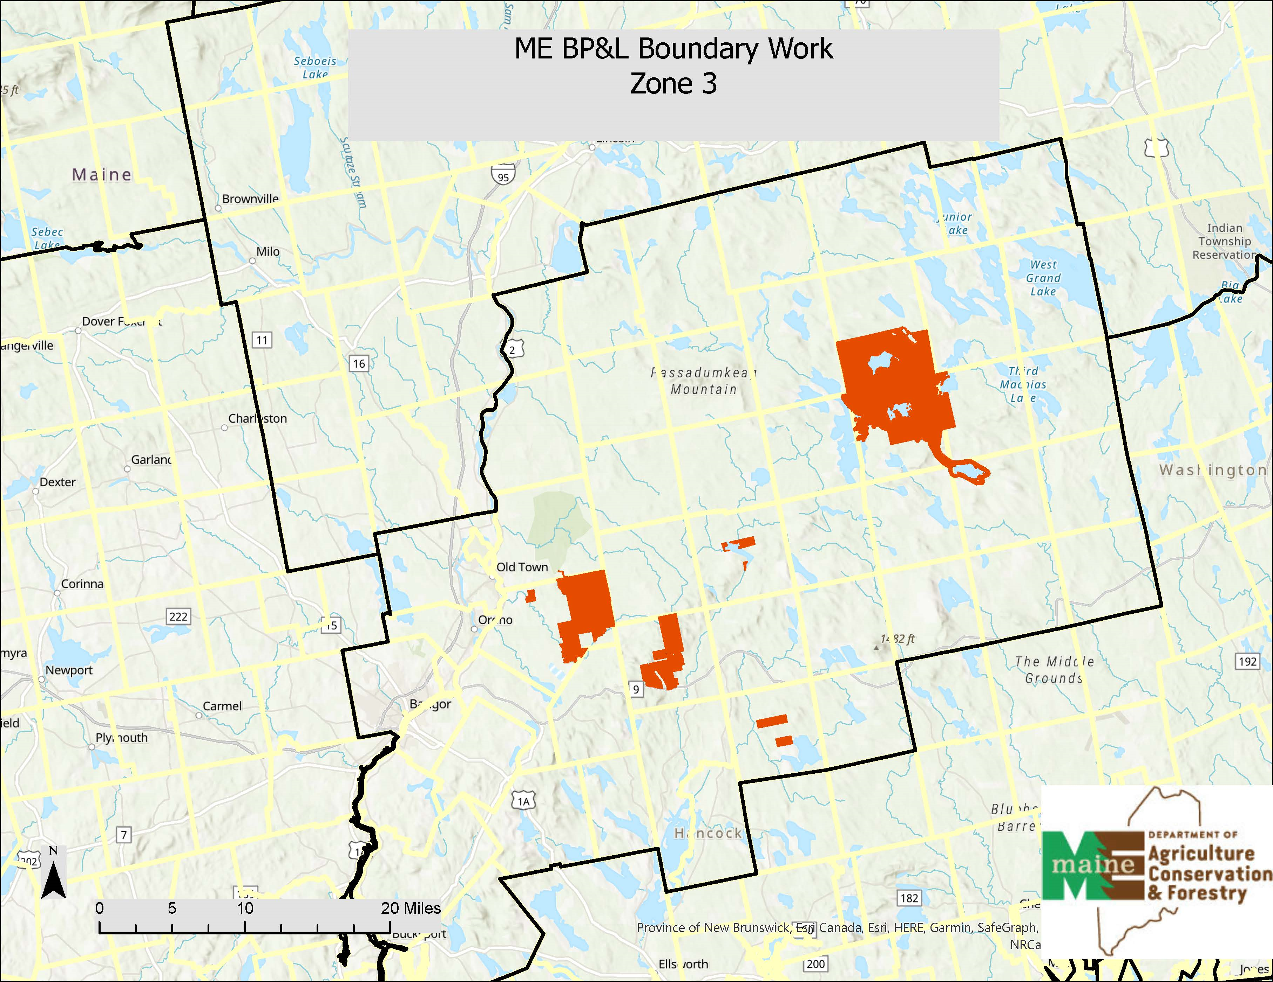

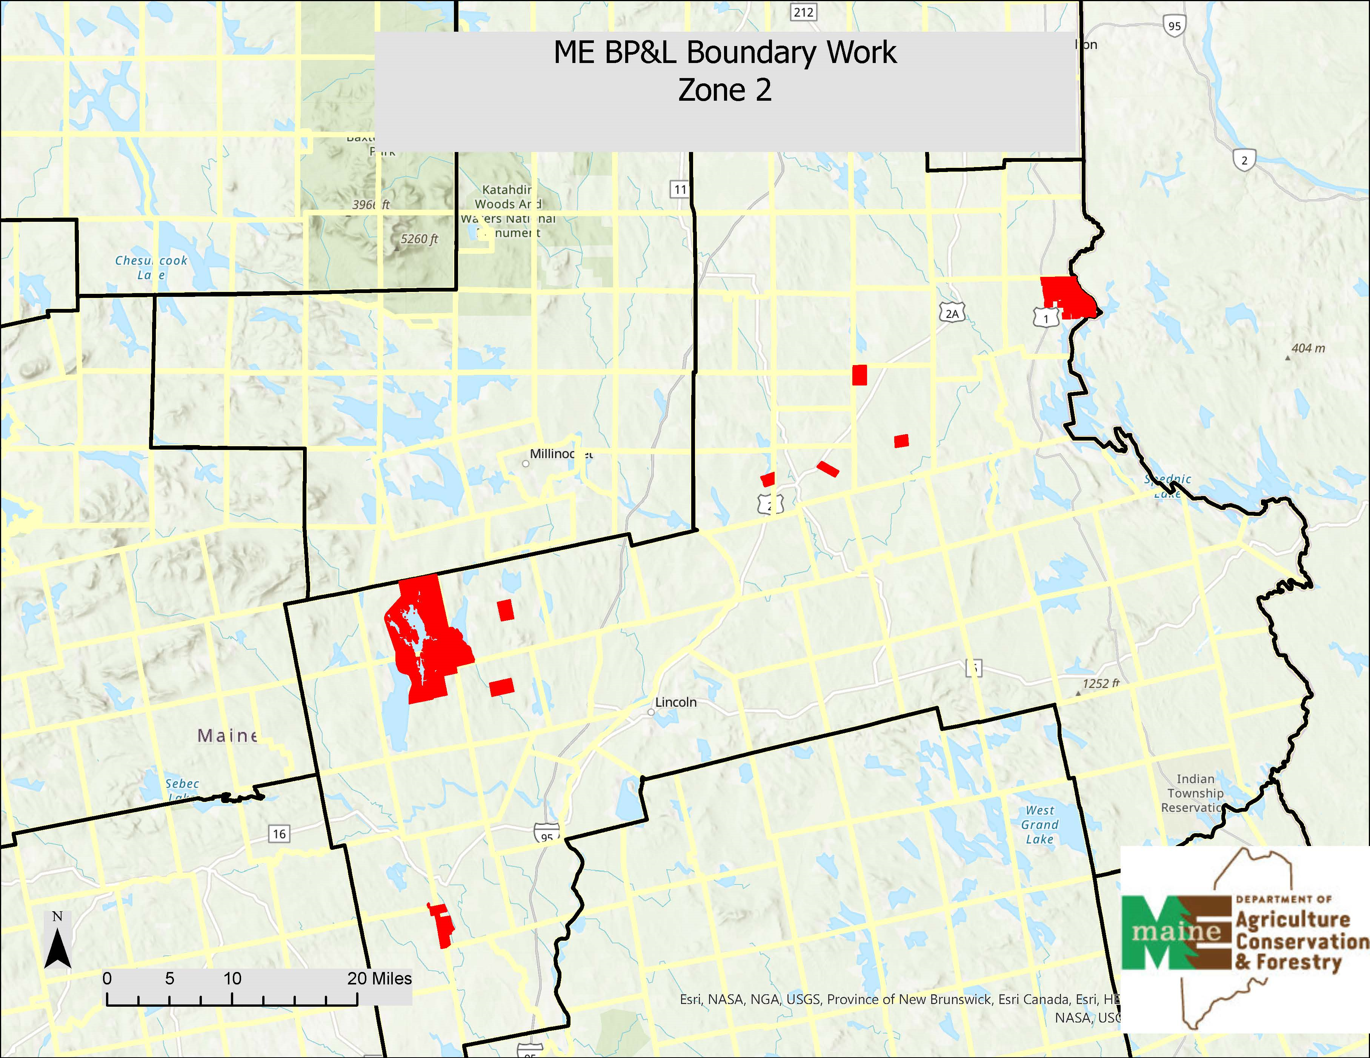
PART III KEY RFP EVENTS

- Questions

  - General Instructions: It is the responsibility of all Bidders and other interested parties to examine the entire RFP and to seek clarification, in writing, if they do not understand any information or instructions.
    - Bidders and other interested parties should use Appendix E (Submitted Questions Form) for submission of questions. The form is to be submitted as a WORD document.
    - The Submitted Questions Form must be submitted, by e-mail, and received by the RFP Coordinator identified on the cover page of the RFP as soon as possible but no later than the date and time specified on the RFP cover page.
    - Submitted Questions must include the RFP Number and Title in the subject line of the e-mail. The Department assumes no liability for assuring accurate/complete/on time e-mail transmission and receipt.

  - Question & Answer Summary: Responses to all questions will be compiled in writing and posted on the following website no later than seven (7) calendar days prior to the proposal due date: Division of Procurement Services RFP Page. It is the responsibility of all interested parties to go to this website to obtain a copy of the Question & Answer Summary. Only those answers issued in writing on this website will be considered binding.

- Amendments

All amendments released in regard to the RFP will also be posted on the following website: Division of Procurement Services RFP Page. It is the responsibility of all interested parties to go to this website to obtain amendments. Only those amendments posted on this website are considered binding.

- Submitting the Proposal

  - Proposals Due: Proposals must be received no later than 11:59 p.m. local time, on the date listed on the cover page of the RFP.
    - Any e-mails containing original proposal submissions or any additional or revised proposal files, received after the 11:59 p.m. deadline, will be rejected without exception.

  - Delivery Instructions: E-mail proposal submissions are to be submitted to the State of Maine Division of Procurement Services at Proposals@maine.gov.
    - Only proposal submissions received by e-mail will be considered. The Department assumes no liability for assuring accurate/complete e-mail transmission and receipt.
      - Proposal submission e-mails that are successfully received by the proposals@maine.gov inbox will receive an automatic reply stating as such.
    - E-mails containing links to file sharing sites or online file repositories will not be accepted as submissions. Only e-mail proposal submissions that have the actual requested files attached will be accepted.
    - Encrypted e-mails received which require opening attachments and logging into a proprietary system will not be accepted as submissions. Please check with your organization’s Information Technology team to ensure that your security settings will not encrypt your proposal submission.
    - File size limits are 25MB per e-mail. Bidders may submit files separately across multiple e-mails, as necessary, due to file size concerns. All e-mails and files must be received by the due date and time listed above.
    - Bidders are to insert the following into the subject line of their e-mail proposal submission: “RFP# 202402029 Proposal Submission – [Bidder’s Name]”
    - Bidder’s proposal submissions are to be broken down into multiple files, with each file named as it is titled in bold below, and include:

- File 1 [Bidder’s Name] – Preliminary Information:
PDF format preferred
Appendix A (Proposal Cover Page)
Appendix B (Debarment, Performance and Non-Collusion Certification)
All required eligibility documentation stated in PART IV, Section I.

- File 2 [Bidder’s Name] – Organization Qualifications and Experience:
PDF format preferred
Appendix C (Organization Qualifications and Experience Form) and all required information and attachments stated in PART IV, Section II.

- File 3 [Bidder’s Name] – Cost Proposal:
PDF format preferred
Appendix D (Cost Proposal Form) and all required information and attachments stated in PART IV, Section IV.
PART IV PROPOSAL SUBMISSION REQUIREMENTS

This section contains instructions for Bidders to use in preparing their proposals. The Department seeks detailed yet succinct responses that demonstrate the Bidder’s qualifications, experience, and ability to perform the requirements specified throughout the RFP.

The Bidder’s proposal must follow the outline used below, including the numbering, section, and sub-section headings. Failure to use the outline specified in PART IV, or failure to respond to all questions and instructions throughout the RFP, may result in the proposal being disqualified as non-responsive or receiving a reduced score. The Department, and its evaluation team, has sole discretion to determine whether a variance from the RFP specifications will result either in disqualification or reduction in scoring of a proposal. Rephrasing of the content provided in the RFP will, at best, be considered minimally responsive.

Bidders are not to provide additional attachments beyond those specified in the RFP for the purpose of extending their response. Additional materials not requested will not be considered part of the proposal and will not be evaluated. Include any forms provided in the submission package or reproduce those forms as closely as possible. All information must be presented in the same order and format as described in the RFP.

Proposal Format and Contents

Section I Preliminary Information (File #1)

  - Proposal Cover Page
Bidders must complete Appendix A (Proposal Cover Page). It is critical that the cover page show the specific information requested, including Bidder address(es) and other details listed. The Proposal Cover Page must be dated and signed by a person authorized to enter into contracts on behalf of the Bidder.

  - Debarment, Performance and Non-Collusion Certification
Bidders must complete Appendix B (Debarment, Performance and Non-Collusion Certification Form). The Debarment, Performance and Non-Collusion Certification Form must be dated and signed by a person authorized to enter into contracts on behalf of the Bidder.

  - Eligibility Requirements
Bidders must provide documentation to demonstrate meeting eligibility requirements stated in PART I, C. of the RFP. This documentation includes:
Proof of Maine Professional Land Surveyors license, and that they have not had License/Disciplinary Action taken against them by the Maine Board of Licensure for Professional Land Surveyors in the last five (5) years.
Section II Organization Qualifications and Experience (File #2)

  - Overview of the Organization
Bidders must complete Appendix C (Qualifications and Experience Form) describing their qualifications and skills to provide the requested services in the RFP. Bidders must include three examples of projects which demonstrate their experience and expertise in performing these services as well as highlighting the Bidder’s stated qualifications and skills.

  - Subcontractors
If subcontractors are to be used, Bidders must provide a list that specifies the name, address, phone number, contact person, and a brief description of the subcontractors’ organizational capacity and qualifications.

  - Organizational Chart
Bidders must provide an organizational chart. The organizational chart must include the project being proposed. Each position must be identified by position title and corresponding to the personnel job descriptions.

  - Litigation
Bidders must attach a list of all current litigation in which the Bidder is named and a list of all closed cases that have closed within the past five (5) years in which the Bidder paid the claimant either as part of a settlement or by decree. For each, list the entity bringing suit, the complaint, the accusation, amount, and outcome.

  - Licensure/Certification
Bidders may provide documentation of any applicable licensure/certification or specific credentials that are related to providing the proposed services of the RFP.

  - Certificate of Insurance
Bidders must provide a certificate of insurance on a standard ACORD form (or the equivalent) evidencing the Bidder’s general liability, professional liability and any other relevant liability insurance policies that might be associated with the proposed services.

Section III Cost Proposal (File #3)

  - General Instructions
    - Bidders must submit a cost proposal that covers the period starting 3/1/24 and ending on 12/31/25.
    - The cost proposal must include the costs necessary for the Bidder to fully comply with the contract terms, conditions, and RFP requirements.
    - No costs related to the preparation of the proposal for the RFP, or to the negotiation of the contract with the Department, may be included in the proposal. Only costs to be incurred after the contract effective date that are specifically related to the implementation or operation of contracted services may be included.

  - Cost Proposal Form Instructions
Bidders must fill out Appendix D (Cost Proposal Form), following the instructions detailed here and in the form. Failure to provide the requested information, and to follow the required cost proposal format provided, may result in the exclusion of the proposal from consideration, at the discretion of the Department.

PART V PROPOSAL EVALUATION AND SELECTION

Evaluation of the submitted proposals will be accomplished as follows:

- Evaluation Process – General Information

  - An evaluation team, composed of qualified reviewers, will judge the merits of the proposals received in accordance with the criteria defined in the RFP.
  - Officials responsible for making decisions on the award selection will ensure that the selection process accords equal opportunity and appropriate consideration to all who are capable of meeting the specifications. The goals of the evaluation process are to ensure fairness and objectivity in review of the proposals and to ensure that the contract is awarded to the Bidder whose proposal provides the best value to the State of Maine.
  - The Department reserves the right to communicate and/or schedule interviews/presentations with Bidders, if needed, to obtain clarification of information contained in the proposals received. The Department may revise the scores assigned in the initial evaluation to reflect those communications and/or interviews/presentations. Changes to proposals, including updating or adding information, will not be permitted during any interview/presentation process and, therefore, Bidders must submit proposals that present their rates and other requested information as clearly and completely as possible.

- Scoring Weights and Process

  - Scoring Weights: The score will be based on a 100-point scale and will measure the degree to which each proposal meets the following criteria.

Section I. Preliminary Information (No Points – Eligibility Requirements)
Includes all elements addressed above in Part IV, Section I.

Section II. Organization Qualifications and Experience (20 points)
Includes all elements addressed above in Part IV, Section II.

Section II. Cost Proposal (80 points)
Includes all elements addressed above in Part IV, Section IV.

  - Scoring Process: For proposals that demonstrate meeting the eligibility requirements in Section I, the evaluation team will use a consensus approach to evaluate and score Sections II above. Members of the evaluation team will not score those sections individually but, instead, will arrive at a consensus as to assignment of points for each of those sections. Section III, the Cost Proposal, will be scored as described below.

  - Scoring the Cost Proposal: The total cost proposed for conducting all the functions specified in the RFP will be assigned a score according to a mathematical formula. The lowest bid will be awarded 80 points. Proposals with higher bids values will be awarded proportionately fewer points calculated in comparison with the lowest bid.

The scoring formula is:

(Lowest submitted cost proposal / Cost of proposal being scored) x 80 = pro-rated score

No Best and Final Offers: The State of Maine will not seek or accept a best and final offer (BAFO) from any Bidder in this procurement process. All Bidders are expected to provide their best value pricing with the submission of their proposal.

  - Negotiations: The Department reserves the right to negotiate with the awarded Bidder to finalize a contract. Such negotiations may not significantly vary the content, nature or requirements of the proposal or the Department’s Request for Proposal to an extent that may affect the price of goods or services requested. The Department reserves the right to terminate contract negotiations with an awarded Bidder who submits a proposed contract significantly different from the proposal they submitted in response to the advertised RFP. In the event that an acceptable contract cannot be negotiated with the highest ranked Bidder, the Department may withdraw its award and negotiate with the next-highest ranked Bidder, and so on, until an acceptable contract has been finalized. Alternatively, the Department may cancel the RFP, at its sole discretion.

- Selection and Award

  - The final decision regarding the award of the contract will be made by representatives of the Department subject to approval by the State Procurement Review Committee.
  - Notification of conditional award selection or non-selection will be made in writing by the Department.
  - Issuance of the RFP in no way constitutes a commitment by the State of Maine to award a contract, to pay costs incurred in the preparation of a response to the RFP, or to pay costs incurred in procuring or contracting for services, supplies, physical space, personnel or any other costs incurred by the Bidder.
  - The Department reserves the right to reject any and all proposals or to make multiple awards.

- Appeal of Contract Awards

Any person aggrieved by the award decision that results from the RFP may appeal the decision to the Director of the Bureau of General Services in the manner prescribed in 5 M.R.S.A. § 1825-E and 18-554 Code of Maine Rules Chapter 120. The appeal must be in writing and filed with the Director of the Bureau of General Services, 9 State House Station, Augusta, Maine, 04333-0009 within 15 calendar days of receipt of notification of conditional contract award.

PART VI CONTRACT ADMINISTRATION AND CONDITIONS

- Contract Document

  - The awarded Bidder will be required to execute a State of Maine Service Contract with appropriate riders as determined by the issuing department.

The complete set of standard State of Maine Service Contract documents, along with other forms and contract documents commonly used by the State, may be found on the Division of Procurement Services’ website at the following link: Division of Procurement Services Forms Page

  - Allocation of funds is final upon successful negotiation and execution of the contract, subject to the review and approval of the State Procurement Review Committee. Contracts are not considered fully executed and valid until approved by the State Procurement Review Committee and funds are encumbered. No contract will be approved based on an RFP which has an effective date less than fourteen (14) calendar days after award notification to Bidders. (Referenced in the regulations of the Department of Administrative and Financial Services, Chapter 110, § 3(B)(i).)

This provision means that a contract cannot be effective until at least 14 calendar days after award notification.

  - The State recognizes that the actual contract effective date depends upon completion of the RFP process, date of formal award notification, length of contract negotiation, and preparation and approval by the State Procurement Review Committee. Any appeals to the Department’s award decision(s) may further postpone the actual contract effective date, depending upon the outcome. The contract effective date listed in the RFP may need to be adjusted, if necessary, to comply with mandated requirements.

  - In providing services and performing under the contract, the awarded Bidder must act as an independent contractor and not as an agent of the State of Maine.

- Standard State Contract Provisions

  - Contract Administration
Following the award, a Contract Administrator from the Department will be appointed to assist with the development and administration of the contract and to act as administrator during the entire contract period. Department staff will be available after the award to consult with the awarded Bidder in the finalization of the contract.

  - Payments and Other Provisions
The State anticipates paying the Contractor on the basis of net 30 payment terms, upon the receipt of an accurate and acceptable invoice and a satisfactory evaluation of the work. An invoice will be considered accurate and acceptable if it contains a reference to the State of Maine contract number, contains correct pricing information relative to the contract, and provides any required supporting documents, as applicable, and any other specific and agreed-upon requirements listed within the contract that results from the RFP.

PART VII LIST OF RFP APPENDICES AND RELATED DOCUMENTS

Appendix A – Proposal Cover Page

Appendix B – Debarment, Performance, and Non-Collusion Certification

Appendix C – Qualifications and Experience Form

Appendix D – Cost Proposal Form

Appendix E – Submitted Question Form

APPENDIX A

State of Maine
Department of Agriculture, Conservation & Forestry

PROPOSAL COVER PAGE
RFP# 202402029
Boundary Line Maintenance for Eastern Region Public Lands

Bidder’s Organization Name:
Chief Executive - Name/Title:
Tel: |  |  | E-mail:
Headquarters Street Address:
Headquarters City/State/Zip:
(Provide information requested below if different from above)
Lead Point of Contact for Proposal - Name/Title:
Tel: |  |  | E-mail:
Headquarters Street Address:
Headquarters City/State/Zip:

- This proposal and the pricing structure contained herein will remain firm for a period of 180 days from the date and time of the bid opening.
- No personnel currently employed by the Department or any other State agency participated, either directly or indirectly, in any activities relating to the preparation of the Bidder’s proposal.
- No attempt has been made, or will be made, by the Bidder to induce any other person or firm to submit or not to submit a proposal.
- The above-named organization is the legal entity entering into the resulting contract with the Department if they are awarded the contract.
- The undersigned is authorized to enter contractual obligations on behalf of the above-named organization.

To the best of my knowledge, all information provided in the enclosed proposal, both programmatic and financial, is complete and accurate at the time of submission.

Name (Print): | Title:
Authorized Signature: | Date:

APPENDIX B

State of Maine
Department of Agriculture, Conservation & Forestry
DEBARMENT, PERFORMANCE, and NON-COLLUSION CERTIFICATION
RFP# 202402029
Boundary Line Maintenance for Eastern Region Public Lands

Bidder’s Organization Name:

By signing this document, I certify to the best of my knowledge and belief that the aforementioned organization, its principals and any subcontractors named in this proposal:
- Are not presently debarred, suspended, proposed for debarment, and declared ineligible or voluntarily excluded from bidding or working on contracts issued by any governmental agency.
- Have not within three years of submitting the proposal for this contract been convicted of or had a civil judgment rendered against them for:
  - Fraud or a criminal offense in connection with obtaining, attempting to obtain, or performing a federal, state, or local government transaction or contract.
  - Violating Federal or State antitrust statutes or committing embezzlement, theft, forgery, bribery, falsification or destruction of records, making false statements, or receiving stolen property.
- Are not presently indicted for or otherwise criminally or civilly charged by a governmental entity (Federal, State or Local) with commission of any of the offenses enumerated in paragraph (b) of this certification.
- Have not within a three (3) year period preceding this proposal had one or more federal, state, or local government transactions terminated for cause or default.
- Have not entered into a prior understanding, agreement, or connection with any corporation, firm, or person submitting a response for the same materials, supplies, equipment, or services and this proposal is in all respects fair and without collusion or fraud. The above-mentioned entities understand and agree that collusive bidding is a violation of state and federal law and can result in fines, prison sentences, and civil damage awards.
Name (Print): | Title:
Authorized Signature: | Date:

APPENDIX C

State of Maine
Department of Agriculture, Conservation & Forestry

QUALIFICATIONS and EXPERIENCE FORM
RFP# 202402029
Boundary Line Maintenance for Eastern Region Public Lands

Bidder’s Organization Name:

Present a brief statement of qualifications. Describe the history of the Bidder’s organization, especially regarding skills pertinent to the specific work required by the RFP and any special or unique characteristics of the organization which would make it especially qualified to perform the required work activities. You may expand this form and use additional pages to provide this information.

APPENDIX C (continued)

Provide a description of projects that occurred within the past five years which reflect experience and expertise needed in performing the functions described in Part II – Scope of Services to be Provided of the RFP. Please note that contract history with the State of Maine, whether positive or negative, may be considered in rating proposals even if not provided by the Bidder.

Project One
Client Name:
Client Contact Person:
Telephone:
E-Mail:
Brief Description of Project

Project Two
Client Name:
Client Contact Person:
Telephone:
E-Mail:
Brief Description of Project

Project Three
Client Name:
Client Contact Person:
Telephone:
E-Mail:
Brief Description of Project

APPENDIX D

State of Maine
Department of Agriculture, Conservation & Forestry

COST PROPOSAL FORM
RFP# 202402029
Boundary Line Maintenance for Eastern Region Public Lands

Bidder’s Organization Name:
Proposed Cost: | $

Please fill out the $/Unit Price and Total Price columns of the table below. The Total Bid figure will be used in the scoring formula defined in Part V, B, 3 of the RFP.

Description | Quantity | Units | $/Unit Price | Total Price  (quantity x unit price)
Boundary line maintenance | 20 | miles
Research-Licensed Surveyor | 20 | hours
Field Technician | 60 | hours
Total Station/Survey Grade GPS | 30 | hours
CAD Tech/Mapping | 15 | hours
TOTAL BID

APPENDIX E

State of Maine
Department of Agriculture, Conservation & Forestry
RFP# 202402029
Boundary Line Maintenance for Eastern Region Public Lands

This form should be used by Bidders when submitting written questions to the RFP Coordinator as defined in Part III of the RFP.

If a question is not related to any section of the RFP, enter “N/A” under the RFP Section & Page Number. Add additional rows as necessary.

Organization Name:

RFP Section & Page Number | Question

