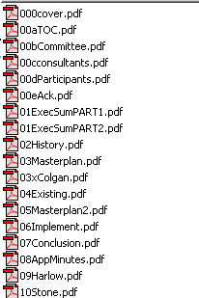
Cover =

Table of contents =

Committee section =

Consultants section =

Participants section =

Acknowledgements section =

Section 1, .
Executive Summary
(in 2 parts due to size)

Section 2, History =

Section 3, MP Process =

Section 3, Colgan inserts =

Section 4, Existing =

Section 5, The Master Plan =

Section 6, Implementation =

Section 7, Conclusion =

Section 8, Appendix, minutes =

Section 9, Harlow placeholder =

Section 10, Stone Report =

For ease in opening the reports, each section is saved as its own file.

The order of the files is numerical, keeping in the same order as the physical report.

Choose the section(s) you’d like to read and double click on the file(s). Acrobat Reader should open the pdf files you have selected.

To print a file, hit print in your acrobat program. Please note that you will have to select automatic paper handling options on your printer, as some sections have 2 different size paper (8-1/2x11 and also 11x17).

