Sample of Refurbish job

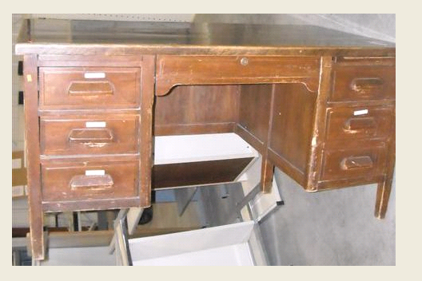

Finished desk which ended up in the Governor’s Office

