STATE OF MAINE
Department of Agriculture, Conservation and Forestry



RFP# 202306140

Rooftop Solar Photovoltaic Systems

RFP Coordinator | All communication regarding the RFP must be made through the RFP Coordinator identified below.  Name: Randy Charette Title: Deputy Commissioner  Contact Information: Randy.Charette@maine.gov
Bidders’ Conference | Date: Monday July 17, 2023, Time: 9:00 a.m., local time  Location: Microsoft Teams  https://www.microsoft.com/en-us/microsoft-teams/join-a-meeting?rtc=1  Meeting ID: 282 083 984 210 Passcode: h8xiLt
Site Walks | RSVP for all site walks to the RFP Coordinator identified above by:  Date: Tuesday, July 18, 2023, by 4:59 p.m., local time.
Submitted Questions Due | All questions must be received by the RFP Coordinator identified above by:  Date: Friday, July 28, 2023, no later than 11:59 p.m., local time
Notice of Intent to Bid | All notice of intents must be received by the RFP Coordinator identified above by:  Date: August 7, 2023, no later than 11:59 p.m., local time
Proposal Submission | Proposals must be received by the Division of Procurement Services by:  Submission Deadline: Friday, August 25, 2023, no later than 11:59 p.m., local time.  Proposals must be submitted electronically to the following address:  Electronic (e-mail) Submission Address: Proposals@maine.gov

TABLE OF CONTENTS
 | Page
PUBLIC NOTICE | 3
PART I INTRODUCTION | 4
- PURPOSE AND BACKGROUND
- GENERAL PROVISIONS
- ELIGIBILITY TO SUBMIT BIDS
- CONTRACT TERMS
- NUMBER OF AWARDS
PART II SCOPE OF SERVICES TO BE PROVIDED | 7
PART III KEY RFP EVENTS | 10
- BIDDERS’ CONFERENCE
- QUESTIONS
- AMENDMENTS
- SUBMITTING THE PROPOSAL
PART IV PROPOSAL SUBMISSION REQUIREMENTS | 13
PART V PROPOSAL EVALUATION AND SELECTION | 16
- EVALUATION PROCESS – GENERAL INFORMATION
- SCORING WEIGHTS AND PROCESS
- SELECTION AND AWARD
- APPEAL OF CONTRACT AWARDS
PART VI CONTRACT ADMINISTRATION AND CONDITIONS | 18
- CONTRACT DOCUMENT
- STANDARD STATE CONTRACT PROVISIONS
PART VII RFP APPENDICES AND RELATED DOCUMENTS | 19
APPENDIX A – PROPOSAL COVER PAGE
APPENDIX B – DEBARMENT, PERFORMANCE, and
NON-COLLUSION CERTIFICATION
APPENDIX C – QUALIFICATIONS and EXPERIENCE FORM
APPENDIX D – COST PROPOSAL FORM
APPENDIX E – SUBMITTED QUESTIONS FORM
APPENDIX F – FACILITY PHOTOS
APPENDIX G – ROOF CONDITION INFORMATION & REPORTS
APPENDIX H – ELECTRIC UTILITY BILL SAMPLE
APPENDIX I – NOTICE OF INTENT TO BID FORM

PUBLIC NOTICE

*************************************************
State of Maine
Department of Agriculture, Conservation and Forestry
RFP# 202306140
Rooftop Solar Photovoltaic Systems

The State of Maine is seeking proposals for design, procurement, permitting, installation, commissioning, and maintenance services for rooftop solar photovoltaic systems at four Department of Agriculture, Conservation and Forestry facilities located in Ashland, Augusta, and Old Town, Maine.

A copy of the RFP, as well as the Question & Answer Summary and all amendments related to the RFP, can be obtained at: https://www.maine.gov/dafs/bbm/procurementservices/vendors/rfps

A Bidders’ Conference will be held on Monday July 17, 2023, at 9 A.M. EDT. The Conference will be held virtually via Microsoft Teams (https://www.microsoft.com/en-us/microsoft-teams/join-a-meeting?rtc=1; Meeting ID: 282 083 984 210; Passcode: h8xiLt; or call-in number is +1 207-420-8737,,352928634#). Optional site walks will be held for each facility, and the dates and time can be found in the RFP Document.

Proposals must be submitted to the State of Maine Division of Procurement Services, via e-mail, at: Proposals@maine.gov. Proposal submissions must be received no later than 11:59 p.m., local time, on Friday August 25, 2023. Proposals will be opened the following business day. Proposals not submitted to the Division of Procurement Services’ aforementioned e-mail address by the aforementioned deadline will not be considered for contract award.

*************************************************

State of Maine – Department of Agriculture, Conservation and Forestry
RFP# 202306140
Rooftop Solar Photovoltaic Systems

PART I INTRODUCTION

- Purpose and Background

The Department of Agriculture, Conservation and Forestry (Department) is seeking design, procurement, permitting, installation, commissioning, and maintenance services for rooftop solar photovoltaic (PV) systems at four Department-owned facilities located in Ashland, Augusta, and Old Town, Maine.

The Department plans to complete an as-built purchase of the installed solar arrays. This document provides instructions for submitting proposals, the procedure, and criteria by which the awarded Bidder will be selected, and the contractual terms which will govern the relationship between the State of Maine (the “State”) and the awarded Bidder.

The Department has two primary goals for this project. First, the Department is seeking cost-effective solar PV solutions that will help manage the Department’s energy costs. Second, the Department aims to generate renewable energy credits (RECs) that can be retired by the Department to help meet the goals established by Governor Mills in Executive Order 13 (EO13). The Lead by Example goals stemming from EO13 include State agencies procuring clean energy and considering opportunities to use State buildings and lands for clean energy generation, where practicable.

The awarded Bidder(s) will demonstrate experience providing turnkey solar PV development services for projects located in Maine, first-hand experience and knowledge of Central Maine Power Company’s and Versant Power’s interconnection process for rooftop solar generation, a demonstrated track record of providing solar system monitoring and maintenance to non-residential end users and established onsite safety standards during construction and operations activities.

General Provisions

  - From the time the RFP is issued until award notification is made, all contact with the State regarding the RFP must be made through the RFP Coordinator. No other person/ State employee is empowered to make binding statements regarding the RFP. Violation of this provision may lead to disqualification from the bidding process, at the State’s discretion.
  - Issuance of the RFP does not commit the Department to issue an award or to pay expenses incurred by a Bidder in the preparation of a response to the RFP. This includes attendance at personal interviews or other meetings and software or system demonstrations, where applicable.
  - All proposals must adhere to the instructions and format requirements outlined in the RFP and all written supplements and amendments (such as the Summary of Questions and Answers), issued by the Department. Proposals are to follow the format and respond to all questions and instructions specified below in the “Proposal Submission Requirements” section of the RFP.
  - Bidders will take careful note that in evaluating a proposal submitted in response to the RFP, the Department will consider materials provided in the proposal, information obtained through interviews/presentations (if any), and internal Departmental information of previous contract history with the Bidder (if any). The Department also reserves the right to consider other reliable references and publicly available information in evaluating a Bidder’s experience and capabilities.
  - The proposal must be signed by a person authorized to legally bind the Bidder and must contain a statement that the proposal and the pricing contained therein will remain valid and binding for a period of 180 days from the date and time of the bid opening.
  - The RFP and the awarded Bidder’s proposal, including all appendices or attachments, will be the basis for the final contract, as determined by the Department.
  - Following announcement of an award decision, all submissions in response to this RFP will be public records, available for public inspection pursuant to the State of Maine Freedom of Access Act (FOAA) (1 M.R.S. § 401 et seq.).
  - The Department, at its sole discretion, reserves the right to recognize and waive minor informalities and irregularities found in proposals received in response to the RFP.
  - All applicable laws, whether or not herein contained, are included by this reference. It is the Bidder’s responsibility to determine the applicability and requirements of any such laws and to abide by them.

- Eligibility to Submit Bids

All interested parties are invited to submit bids in response to this Request for Proposals. To be
considered for award, Bidders must have the following staff included in the
proposed project plan:
- a North American Board of Certified Energy Practitioners (NABCEP) Certified PV Installer
- a Master Electrician licensed with the State of Maine.

- Contract Term

The Department is seeking a cost-efficient proposal to provide services, as defined in the RFP, for the anticipated contract period defined in the table below. The Department expects to execute two services contracts with the awarded Bidder, a 1) as-built purchase services contract covering the design, permitting, procurement, and installation of the systems and 2) a maintenance service agreement that includes ongoing preventative maintenance and responsive break-fix maintenance. Please note, the dates below are estimated and may be adjusted, as necessary, in order to comply with all procedural requirements associated with the RFP, the contracting process, and the final project timeline. The actual contract start date will be established by a completed and approved contract.

Contract Renewal: Following the initial term of the maintenance service agreement, the Department may opt to renew the contract for up to five years, as shown in the table below, and subject to continued availability of funding and satisfactory performance.

The term of the anticipated contract, resulting from the RFP, is defined as follows:

Period | Start Date | End Date
As-Built Purchase Services Contract | October 1, 2023 | September 30, 2024
Maintenance Service Agreement | October 1, 2024 | September 30, 2029
Maintenance Service Agreement Renewal | October 1, 2029 | September 30, 2034

- Number of Awards

The Department may make one or multiple awards as a result of the RFP process.

Bidders must submit a single proposal including all proposed facilities. Bidders are not required to propose solar installations at all four locations. However, if Bidder elects to not propose a solar installation at one or more of the facilities, Bidder must include an explanation of why Bidder chose not to do so in Appendix I (Notice of Intent).

PART II SCOPE OF SERVICES TO BE PROVIDED

- Overview
Through the RFP, the Department aims to identify a qualified partner with the necessary experience and capabilities to execute the requested scope of services detailed herein. The Department is soliciting proposals from solar providers to provide turnkey rooftop solar PV development, operations, and maintenance services at four (4) Department-owned facilities:

Facility Location | Address | Local Electric Utility | Utility Rate Class
Ashland | 45 Radar Road | Versant Power | Rate C
Augusta Bolton Hill | 21 Conservation Drive | Central Maine Power | Small General Service
Augusta Cony Road | 333 Cony Road | Central Maine Power | Medium General Service
Old Town | 87 Airport Road | Versant Power | Rate B-1

The successful Bidder(s) will have demonstrated experience designing, planning, scheduling, permitting, constructing, interconnecting, operating, and maintaining solar PV systems. The successful Bidder(s) must be familiar with Central Maine Power Company’s and Versant Power’s process and regulations for interconnecting solar generation facilities to operate in parallel with the local electric distribution system and must have established onsite safety standards for solar PV construction and maintenance activities.

The successful Bidder(s) will be responsible for all labor, materials, and administrative costs to develop the proposed solar PV installations in accordance with prudent industry standards. The RFP does not fully list all system requirements or all of Bidder’s obligations for fulfilling the scope of services.

- Facility Conditions

  - Structural Conditions
Photos of each facility’s roof are provided in Appendix F (Facility Photos). The Ashland facility’s roof and the Old Town facility’s hangar roof and office building roof were most recently replaced around 2010. The Augusta Bolton Hill facility’s roof was last replaced in 2022. The Augusta Cony Road facility’s roof was last replaced in 2010. It is the responsibility of the successful Bidder(s) to assess the building structural integrity and roof condition at each facility. Available information on roof design and condition for each facility is provided in Appendix G (Roof Condition Information & Reports).

If Bidder believes that a facility’s roof needs significant structural upgrades or other improvements to accommodate the proposed rooftop solar installation, this requirement and the associated cost must be clearly noted by Bidder in the response form included in Appendix D (Cost Proposal).

  - Electrical Conditions
Photos of each facility’s electrical panel are provided in Appendix F. If Bidder believes that a facility’s electrical panel, utility transformer, and/or onsite electric infrastructure needs to be replaced to accommodate the proposed rooftop solar installation, this requirement and the associated cost must be clearly noted by Bidder in the response form included in Appendix D (Cost Proposal).

At a minimum, the Department is seeking rooftop solar designs that can produce enough solar energy over the course of a year to equal the facility’s current annual electricity usage. System sizing that maximizes the use of available, viable rooftop space is encouraged; the Department has other electric accounts served by CMP and Versant that can utilize excess net energy billing credits under each utility’s net energy billing program.

The table below includes each facility’s monthly electricity use over the last 12 months. A recent utility invoice for each facility is included in Appendix H.

Month | Ashland Facility Monthly Usage  (kWh) | Augusta Bolton Hill Monthly Usage  (kWh) | Augusta Cony Road Monthly Usage  (kWh) | Old Town Facility Monthly Usage  (kWh)
January | 4,888 | 1,797 | 9,487 | 3,730
February | 5,861 | 1,549 | 8,534 | 4,335
March | 5,407 | 1,488 | 9,135 | 3,899
April | 4,528 | 1,423 | 8,054 | 2,728
May | 3,367 | 1,512 | 7,748 | 2,043
June | 3,691 | 1,457 | 7,716 | 1,740
July | 2,947 | 1,775 | 8,247 | 2,762
August | 3,364 | 1,761 | 8,619 | 2,417
September | 4,227 | 1,308 | 9,210 | 1,355
October | 4,532 | 1,284 | 9,087 | 2,049
November | 5,586 | 1,262 | 8,795 | 2,667
December | 5,640 | 1,519 | 9,530 | 3,406
TOTAL | 54,038 | 18,135 | 104,162 | 33,131

- Design & Construction Responsibilities
The successful Bidder(s) will be responsible for completing a full design of each proposed solar installation, which shall comply with the following requirements:
- Mounting system shall be fully ballasted. Mounting system design needs to meet applicable.
- local building code requirements with respect to snow, wind, and earthquake factors. Solar system installation cannot void the facility’s roof warranty.
- System shall be fixed tilt with an orientation that maximizes annual production.
- System layout shall meet local fire department code and ordinance requirements for roof access.
- System must comply with all electrical, fire, zoning, and ordinance requirements for the roof top application.
- All equipment and components of the solar array must be UL listed for its designed use.
- Construction must comply with the current adopted State Building Code, which includes: International Building Code, National Electric Code (NEC) and State Fire Marshall. System modules shall be UL1703 listed, and CEC-listed. Inverters shall be UL1741 listed and must be CEC-listed.

As part of a turnkey implementation of the system, the successful Bidder(s) will meet the following requirements:
- All conduit, wire, and fittings required for the full installation of the system.
- Loading and unloading of all material delivered to site and the transportation to installation site. This should include, but is not limited to, cranes/hoists, trucks, and trailers.
- The awarded Bidder shall confine their apparatus, the storage of materials and the operation of their workers to limits indicated by law, ordinance, permits or direction of the State, and shall not unreasonably encumber the premises or streets with their equipment or materials.
- Removal of all unused material from site, including, but not limited to, excess and packaging materials.
- In its proposal submission, Bidders shall confirm whether electrical circuit breakers provided by project are adequate to service the proposed system. If they are deemed inadequate, the awarded Bidder must provide new breakers, as necessary.
- The successful respondent shall acquire and process all necessary permits, utility interconnection and documentation to install the system at Bidder’s sole cost.

- Warranties
The selected Bidder(s) must include warranties on system equipment including but not limited to
modules, inverters, and racking.

- System Monitoring
Monitoring must be provided by the successful Bidder(s) to the Department and selected stakeholders through an online portal that enables the Department to view hourly, daily, and monthly solar energy generation by facility.

- Operations and Maintenance Services
The successful Bidder(s) must provide and maintain an Operations and Maintenance (O&M) plan for each proposed solar PV installation that ensures the system(s) are maintained according to prudent industry practices. The O&M plan(s) must ensure that:
  - Equipment, materials, resources, and supplies, including spare parts inventories, are available to meet the Department’s needs.
  - Sufficient operating personnel are always available and are adequately experienced and trained and licensed as necessary to maintain the solar arrays properly and efficiently and can respond to reasonably foreseeable emergency conditions at the Facility and emergencies whether caused by events on or off the Facility’s site.
  - Preventive, routine, and non-routine maintenance and repairs are performed on a basis that ensures reliable, long-term and safe operation of the Facility, and are performed by knowledgeable, trained, and experienced personnel utilizing proper equipment and tools.
  - Appropriate monitoring and testing are performed to ensure equipment is functioning as designed; and
  - Equipment is not operated in a reckless manner, in violation of manufacturer’s guidelines or in a manner unsafe to workers, the general public, or the connecting utility’s electric system or contrary to environmental laws.

PART III KEY RFP EVENTS

- Bidders’ Conference

The Department will sponsor a Bidders’ Conference concerning the RFP beginning at the date, time and location shown on the RFP cover page. The purpose of the Bidders’ Conference, which will be held virtually on Microsoft Teams, is to answer and/or field questions, clarify for potential Bidders any aspect of the RFP requirements that may be necessary, and provide supplemental information to assist potential Bidders in submitting responses to the RFP. Although attendance at the Bidders’ Conference is not mandatory, it is strongly encouraged that interested Bidders attend.

- Site Walks

Following the Bidders’ Conference, if Bidders are interested in attending the in-person site walkthrough at one or more of the four facilities, Bidder must notify the Department via email no later than 4:59 p.m., local time, on Tuesday July 18, 2023. The RSVP email should be sent to the RFP Coordinator as identified on the cover page of this RFP.

The site walk schedule is as follows:

Augusta Cony Road Facility Site Walkthrough – Wednesday July 19, 2023, 9:00 A.M. EDT
Augusta Bolton Hill Facility Site Walkthrough – Wednesday July 19, 2023, 11:00 A.M. EDT
Old Town Facility Site Walkthrough – Thursday July 20, 2023, 9:00 A.M. EDT
Ashland Facility Site Walkthrough – Thursday July 20, 2023, 2:00 P.M. EDT

Although attendance at each facility’s site walkthrough is not mandatory, it is strongly encouraged that interested Bidders attend. The Department may choose to offer an additional site walk for any location. If the Department chooses to offer an additional site walk, the date(s), time(s), and location(s) for the site walk would be published as an amendment to the RFP at least seven (7) calendar days prior to the site walk occurring.

- Notice of Intent to Bid

      - Notice of Intent Due: Bidders interested in submitting a proposal are required to submit Appendix I (Notice of Intent) by the date and time specified on the cover page of this RFP.

Failure to submit a Notice of Intent by the aforementioned deadline will automatically result in a Bidder’s proposal being disqualified from the evaluation process.

      - Submission: Notices of Intent are to be submitted only to the RFP Coordinator listed on the cover page of this RFP. The Bidder is responsible for allowing adequate time for delivery. The Department assumes no liability for assuring accurate/complete/on-time e-mail transmission and receipt.

- Questions

  - General Instructions: It is the responsibility of all Bidders and other interested parties to examine the entire RFP and to seek clarification, in writing, if they do not understand any information or instructions.
    - Bidders and other interested parties should use Appendix E – Submitted Questions Form – for submission of questions. The form is to be submitted as a WORD document.
    - The Submitted Questions Form must be submitted, by e-mail, and received by the RFP Coordinator, identified on the cover page of the RFP, as soon as possible but no later than the date and time specified on the RFP cover page.
    - Submitted Questions must include the RFP Number and Title in the subject line of the e-mail. The Department assumes no liability for assuring accurate/complete/on time e-mail transmission and receipt.

  - Question & Answer Summary: Responses to all questions will be compiled in writing and posted on the following website no later than seven (7) calendar days prior to the proposal due date: Division of Procurement Services RFP Page. It is the responsibility of all interested parties to go to this website to obtain a copy of the Question & Answer Summary. Only those answers issued in writing on this website will be considered binding.

- Amendments

All amendments released in regard to the RFP will also be posted on the following website: Division of Procurement Services RFP Page. It is the responsibility of all interested parties to go to this website to obtain amendments. Only those amendments posted on this website are considered binding.

- Submitting the Proposal

  - Proposals Due: Proposals must be received no later than 11:59 p.m. local time, on the date listed on the cover page of the RFP. E-mails containing original proposal submissions, or any additional or revised proposal files, received after the 11:59 p.m. deadline will be rejected without exception.

  - Delivery Instructions: E-mail proposal submissions are to be submitted to the State of Maine Division of Procurement Services at Proposals@maine.gov.
    - Only proposal submissions received by e-mail will be considered. The Department assumes no liability for assuring accurate/complete e-mail transmission and receipt.
    - E-mails containing links to file sharing sites or online file repositories will not be accepted as submissions. Only e-mail proposal submissions that have the actual requested files attached will be accepted.
    - Encrypted e-mails received which require opening attachments and logging into a proprietary system will not be accepted as submissions. Please check with your organization’s Information Technology team to ensure that your security settings will not encrypt your proposal submission.
    - File size limits are 25MB per e-mail. Bidders may submit files separately across multiple e-mails, as necessary, due to file size concerns. All e-mails and files must be received by the due date and time listed above.
    - Bidders are to insert the following into the subject line of their e-mail proposal submission: “RFP# 202306140 Proposal Submission – [Bidder’s Name]”
    - Bidder’s proposal submissions are to be broken down into multiple files, with each file named as it is titled in bold below, and include:

- File 1 [Bidder’s Name] – Preliminary Information:
PDF format preferred
Appendix A (Proposal Cover Page)
Appendix B (Debarment, Performance and Non-Collusion Certification)
All required eligibility documentation stated in PART IV, Section I

- File 2 [Bidder’s Name] – Organization Qualifications and Experience:
PDF format preferred
Appendix C (Organization Qualifications and Experience Form) and all required information and attachments stated in PART IV, Section II.

- File 3 [Bidder’s Name] – Proposed Services:
PDF format preferred
All required information and attachments stated in PART IV, Section III.

- File 4 [Bidder’s Name] – Cost Proposal:
PDF format preferred
Appendix D (Cost Proposal Form) and all required information and attachments stated in PART IV, Section IV.
PART IV PROPOSAL SUBMISSION REQUIREMENTS

This section contains instructions for Bidders to use in preparing their proposals. The Department seeks detailed yet succinct responses that demonstrate the Bidder’s qualifications, experience, and ability to perform the requirements specified throughout the RFP.

The Bidder’s proposal must follow the outline used below, including the numbering, section, and sub-section headings. Failure to use the outline specified in PART IV, or failure to respond to all questions and instructions throughout the RFP, may result in the proposal being disqualified as non-responsive or receiving a reduced score. The Department, and its evaluation team, has sole discretion to determine whether a variance from the RFP specifications will result either in disqualification or reduction in scoring of a proposal. Rephrasing of the content provided in the RFP will, at best, be considered minimally responsive.

Bidders are not to provide additional attachments beyond those specified in the RFP for the purpose of extending their response. Additional materials not requested will not be considered part of the proposal and will not be evaluated. Include any forms provided in the submission package or reproduce those forms as closely as possible. All information must be presented in the same order and format as described in the RFP.

Proposal Format and Contents

Section I Preliminary Information (File #1)

  - Proposal Cover Page
Bidders must complete Appendix A (Proposal Cover Page). It is critical that the cover page show the specific information requested, including Bidder address(es) and other details listed. The Proposal Cover Page must be dated and signed by a person authorized to enter into contracts on behalf of the Bidder.

  - Debarment, Performance and Non-Collusion Certification
Bidders must complete Appendix B (Debarment, Performance and Non-Collusion Certification Form). The Debarment, Performance and Non-Collusion Certification Form must be dated and signed by a person authorized to enter into contracts on behalf of the Bidder.

  - Eligibility Requirements
Bidders must provide documentation to demonstrate meeting eligibility requirements stated in PART I, C. of the RFP. This documentation includes:
- Evidence that Bidder’s project team includes a North American Board of Certified Energy Practitioners (NABCEP) Certified PV Installer and confirmation that Bidder employs a Master Electrician licensed with the State of Maine.

Section II Organization Qualifications and Experience (File #2)

  - Overview of the Organization
Bidders must complete Appendix C (Qualifications and Experience Form) describing their qualifications and skills to provide the requested services in the RFP. Bidders must include three examples of projects which demonstrate their experience and expertise in performing these services as well as highlighting the Bidder’s stated qualifications and skills.

  - Subcontractors
If subcontractors are to be used, Bidders must provide a list that specifies the name, address, phone number, contact person, and a brief description of the subcontractors’ organizational capacity and qualifications.

  - Organizational Chart
Bidders must provide an organizational chart. The organizational chart must include the project being proposed, including the staff meeting the eligibility requirements stated in Part I, C of the RFP. Each position must be identified by position title and corresponding to the personnel job descriptions.

  - Litigation
Bidders must attach a list of all current litigation in which the Bidder is named and a list of all closed cases that have closed within the past five (5) years in which the Bidder paid the claimant either as part of a settlement or by decree. For each, list the entity bringing suit, the complaint, the accusation, amount, and outcome.

  - Financial Viability
Bidders must provide a current copy of their Dun & Bradstreet Business Information Report Snapshot.

  - Licensure/Certification
Bidders may provide documentation of any applicable licensure/certification or any specific credentials related to providing the proposed services of the RFP.

  - Certificate of Insurance
Bidders must provide a certificate of insurance on a standard ACORD form (or the equivalent) evidencing the Bidder’s general liability, professional liability and any other relevant liability insurance policies that might be associated with the proposed services.

Section III Proposed Services (File #3)

  - Services to be Provided
Discuss the Scope of Services referenced above in Part II of the RFP and what the Bidder will offer. Give particular attention to describing the methods and resources you will use and how you will accomplish the tasks involved. Also, describe how you will ensure expectations and/or desired outcomes as a result of these services will be achieved. If subcontractors are involved, clearly identify the work each will perform.

  - Implementation - Work Plan
Provide a realistic work plan for the implementation of the program through the first contract period. Display the work plan in a timeline chart, assuming a notice to proceed of October 1, 2023. Concisely describe each development task, including but not limited to preliminary design, completion of the interconnection application, utility interconnection study, local permitting, equipment procurement, site mobilization, onsite construction, and system commissioning. The work plan should specify the month in which each task will be carried out and the person or position responsible for each task. If applicable, make note of all tasks to be delegated to subcontractors.

  - Workmanship & Equipment Warranty
Bidder must detail the warranty terms being offered by Bidder and the solar equipment manufacturer. Bidder must explain the workmanship guarantee proposed and cost responsibility for any responsive maintenance required for the solar system during the guarantee period. Bidder must explain which entity will be responsible for processing and enforcing equipment warranty claims during the coverage period.

  - System Specifications
Bidder must include the following information:
- Estimated load calculation for rooftop solar array and Bidder’s proposed process for determining that each facility’s roof can host the proposed solar installation.
- Technical description of proposed system, including manufacturer, model number, and cut sheets for key system components.
- Anticipated equipment life for major system components, including any major equipment replacements planned.
- Energy generation calculations, by month, for the first year of operations, with assumptions for shading and snow cover loss in power output calculations.
- Proposed monitoring solution and interface for the Department’s representatives to have online access to system data.

  - Operations and Maintenance Services
Bidder must provide an Operations and Maintenance (O&M) plan for each proposed solar PV installation, ensuring that each plan meets all requirements listed in Part II, F of the RFP. A brief summary of the prospective O&M providers’ relevant experience should be included.

Section IV Cost Proposal (File #4)

  - General Instructions
    - Bidders must submit a cost proposal that covers the period starting October 1, 2023 and ending on October 31, 2024.
    - The cost proposal must include the costs necessary for the Bidder to fully comply with the contract terms, conditions, and RFP requirements.
    - No costs related to the preparation of the proposal for the RFP, or to the negotiation of the contract with the Department, may be included in the proposal. Only costs to be incurred after the contract effective date that are specifically related to the implementation or operation of contracted services may be included.

  - Cost Proposal Form Instructions
Bidders must fill out Appendix D (Cost Proposal Form), following the instructions detailed here and in the form. Failure to provide the requested information, and to follow the required cost proposal format provided, may result in the exclusion of the proposal from consideration, at the discretion of the Department.

Bidders must specify the as-built purchase price for each proposed site. Bidder must provide a detailed payment schedule for the as-built purchase price, including each payment milestone and the associated amount due to Bidder.

Bidders must specify pricing for operations and maintenance service including preventative maintenance at least once per calendar year responsive maintenance support in the event of unplanned system outages.

PART V PROPOSAL EVALUATION AND SELECTION

Evaluation of the submitted proposals will be accomplished as follows:

- Evaluation Process - General Information

  - An evaluation team, composed of qualified reviewers, will judge the merits of the proposals received in accordance with the criteria defined in the RFP.
  - Officials responsible for making decisions on the award selection will ensure that the selection process accords equal opportunity and appropriate consideration to all who are capable of meeting the specifications. The goals of the evaluation process are to ensure fairness and objectivity in review of the proposals and to ensure that the contract is awarded to the Bidder whose proposal provides the best value to the State of Maine.
  - The Department reserves the right to communicate and/or schedule interviews/presentations with Bidders, if needed, to obtain clarification of information contained in the proposals received. The Department may revise the scores assigned in the initial evaluation to reflect those communications and/or interviews/presentations. Changes to proposals, including updating or adding information, will not be permitted during any interview/presentation process and, therefore, Bidders must submit proposals that present their rates and other requested information as clearly and completely as possible.

- Scoring Weights and Process

  - Scoring Weights: Proposals will be scored by facility. The score for each facility will be based on a 100-point scale and will measure the degree to which each proposal meets the following criteria.

Section I. Preliminary Information (No Points – Eligibility Requirements)
Includes all elements addressed above in Part IV, Section I.

Section II. Organization Qualifications and Experience (25 points)
Includes all elements addressed above in Part IV, Section II.

Section III. Proposed Services (25 points)
Includes all elements addressed above in Part IV, Section III.

Section IV. Cost Proposal (50 points)
Includes all elements addressed above in Part IV, Section IV.

  - Scoring Process: For proposals that demonstrate meeting the eligibility requirements in Section I, the evaluation team will use a consensus approach to evaluate and score Sections II & III above. Members of the evaluation team will not score those sections individually but, instead, will arrive at a consensus as to assignment of points for each of those sections. Sections IV, the Cost Proposal, will be scored as described below.

  - Scoring the Cost Proposal: The proposed purchase pricing provided in Appendix D will
be assigned a score according to a mathematical formula. The as-built purchase proposal that produces the highest 20-year net present value in electricity bill savings for the Department, as projected by the Department’s energy consultant based on the Department’s selected system configuration and sizing, will be awarded 50 points. Proposals with lower 20-year net present value projections will be awarded proportionately fewer points.

For roof and/or facility electrical upgrade costs, the Department will independently validate upgrade needs and associated cost by facility and shall apply such cost equally to each proposal when determining the 20-year net present value of each proposal.

The Department’s energy consultant shall calculate the 20-year net present value of each proposal based on the proposed system sizing and generation, proposed purchase pricing (upfront cost and ongoing costs), federal solar incentives available to the Department, and the consultant’s forecast of future net energy billing credit rates, as applicable.

The scoring formula is:
(20-year net present value of proposal being scored / Highest net present value score) x 50 = pro-rated score

No Best and Final Offers: The State of Maine will not seek or accept a best and final offer (BAFO) from any Bidder in this procurement process. All Bidders are expected to provide their best value pricing with the submission of their proposal.

  - Negotiations: The Department reserves the right to negotiate with the awarded Bidder to finalize a contract. Such negotiations may not significantly vary the content, nature or requirements of the proposal or the Department’s Request for Proposal to an extent that may affect the price of goods or services requested. The Department reserves the right to terminate contract negotiations with an awarded Bidder who submits a proposed contract significantly different from the proposal they submitted in response to the advertised RFP. In the event that an acceptable contract cannot be negotiated with the highest ranked Bidder, the Department may withdraw its award and negotiate with the next-highest ranked Bidder, and so on, until an acceptable contract has been finalized. Alternatively, the Department may cancel the RFP, at its sole discretion.

- Selection and Award

  - The final decision regarding the award of the contract will be made by representatives of the Department subject to approval by the State Procurement Review Committee.
  - Notification of conditional award selection or non-selection will be made in writing by the Department.
  - Issuance of the RFP in no way constitutes a commitment by the State of Maine to award a contract, to pay costs incurred in the preparation of a response to the RFP, or to pay costs incurred in procuring or contracting for services, supplies, physical space, personnel or any other costs incurred by the Bidder.
  - The Department reserves the right to reject any and all proposals or to make multiple awards.

- Appeal of Contract Awards

Any person aggrieved by the award decision that results from the RFP may appeal the decision to the Director of the Bureau of General Services in the manner prescribed in 5 M.R.S.A. § 1825-E and 18-554 Code of Maine Rules Chapter 120. The appeal must be in writing and filed with the Director of the Bureau of General Services, 9 State House Station, Augusta, Maine, 04333-0009 within 15 calendar days of receipt of notification of conditional contract award.

PART VI CONTRACT ADMINISTRATION AND CONDITIONS

- Contract Document

  - The awarded Bidder will be required to execute a State of Maine Service Contract with appropriate riders as determined by the issuing department.

The complete set of standard State of Maine Service Contract documents, along with other forms and contract documents commonly used by the State, may be found on the Division of Procurement Services’ website at the following link: Division of Procurement Services Forms Page

  - Allocation of funds is final upon successful negotiation and execution of the contract, subject to the review and approval of the State Procurement Review Committee. Contracts are not considered fully executed and valid until approved by the State Procurement Review Committee and funds are encumbered. No contract will be approved based on an RFP which has an effective date less than fourteen (14) calendar days after award notification to Bidders. (Referenced in the regulations of the Department of Administrative and Financial Services, Chapter 110, § 3(B)(i).)

This provision means that a contract cannot be effective until at least 14 calendar days after award notification.

  - The State recognizes that the actual contract effective date depends upon completion of the RFP process, date of formal award notification, length of contract negotiation, and preparation and approval by the State Procurement Review Committee. Any appeals to the Department’s award decision(s) may further postpone the actual contract effective date, depending upon the outcome. The contract effective date listed in the RFP may need to be adjusted, if necessary, to comply with mandated requirements.

  - In providing services and performing under the contract, the awarded Bidder must act as an independent contractor and not as an agent of the State of Maine.

- Standard State Contract Provisions

  - Contract Administration
Following the award, a Contract Administrator from the Department will be appointed to assist with the development and administration of the contract and to act as administrator during the entire contract period. Department staff will be available after the award to consult with the awarded Bidder in the finalization of the contract.

  - Payments and Other Provisions
The State anticipates paying the Contractor on the basis of net 30 payment terms, upon the receipt of an accurate and acceptable invoice. An invoice will be considered accurate and acceptable if it contains a reference to the State of Maine contract number, contains correct pricing information relative to the contract, and provides any required supporting documents, as applicable, and any other specific and agreed-upon requirements listed within the contract that results from the RFP.

PART VII LIST OF RFP APPENDICES AND RELATED DOCUMENTS

Appendix A – Proposal Cover Page

Appendix B – Debarment, Performance, and Non-Collusion Certification

Appendix C – Qualifications and Experience Form

Appendix D – Cost Proposal Form

Appendix E – Submitted Question Form

Appendix F – Facility Photos

Appendix G – Roof Condition Information

Appendix H – Electric Utility Bill Sample

Appendix I – Notice of Intent to Bid Form

APPENDIX A

State of Maine
Department of Agriculture, Conservation and Forestry

PROPOSAL COVER PAGE
RFP# 202306140
Rooftop Solar Photovoltaic Systems

Bidder’s Organization Name:
Chief Executive - Name/Title:
Tel: |  |  |  | E-mail:
Headquarters Street Address:
Headquarters City/State/Zip:
(Provide information requested below if different from above)
Lead Point of Contact for Proposal - Name/Title:
Tel: |  |  |  | E-mail:
Headquarters Street Address:
Headquarters City/State/Zip:

- This proposal and the pricing structure contained herein will remain firm for a period of 180 days from the date and time of the bid opening.
- No personnel currently employed by the Department or any other State agency participated, either directly or indirectly, in any activities relating to the preparation of the Bidder’s proposal.
- No attempt has been made, or will be made, by the Bidder to induce any other person or firm to submit or not to submit a proposal.
- The above-named organization is the legal entity entering into the resulting contract with the Department if they are awarded the contract.
- The undersigned is authorized to enter contractual obligations on behalf of the above-named organization.

To the best of my knowledge, all information provided in the enclosed proposal, both programmatic and financial, is complete and accurate at the time of submission.

Name (Print): | Title:
Authorized Signature: | Date:

APPENDIX B

State of Maine
Department of Agriculture, Conservation and Forestry
DEBARMENT, PERFORMANCE, and NON-COLLUSION CERTIFICATION
RFP# 202306140
Rooftop Solar Photovoltaic Systems

Bidder’s Organization Name:

By signing this document, I certify to the best of my knowledge and belief that the aforementioned organization, its principals and any subcontractors named in this proposal:
- Are not presently debarred, suspended, proposed for debarment, and declared ineligible or voluntarily excluded from bidding or working on contracts issued by any governmental agency.
- Have not within three years of submitting the proposal for this contract been convicted of or had a civil judgment rendered against them for:
  - Fraud or a criminal offense in connection with obtaining, attempting to obtain, or performing a federal, state, or local government transaction or contract.
  - Violating Federal or State antitrust statutes or committing embezzlement, theft, forgery, bribery, falsification or destruction of records, making false statements, or receiving stolen property.
- Are not presently indicted for or otherwise criminally or civilly charged by a governmental entity (Federal, State or Local) with commission of any of the offenses enumerated in paragraph (b) of this certification.
- Have not within a three (3) year period preceding this proposal had one or more federal, state, or local government transactions terminated for cause or default.
- Have not entered into a prior understanding, agreement, or connection with any corporation, firm, or person submitting a response for the same materials, supplies, equipment, or services and this proposal is in all respects fair and without collusion or fraud. The above-mentioned entities understand and agree that collusive bidding is a violation of state and federal law and can result in fines, prison sentences, and civil damage awards.
Name (Print): | Title:
Authorized Signature: | Date:

APPENDIX C

State of Maine
Department of Agriculture, Conservation and Forestry

QUALIFICATIONS and EXPERIENCE FORM
RFP# 202306140
Rooftop Solar Photovoltaic Systems

Bidder’s Organization Name:

Present a brief statement of qualifications. Describe the history of the Bidder’s organization, especially regarding skills pertinent to the specific work required by the RFP and any special or unique characteristics of the organization which would make it especially qualified to perform the required work activities. You may expand this form and use additional pages to provide this information.

APPENDIX C (continued)

Provide a description of projects that occurred within the past five years which reflect experience and expertise needed in performing the functions described in the “Scope of Services” portion of the RFP. For each of the project examples provided, a contact person from the client organization involved should be listed, along with that person’s telephone number and e-mail address. Please note that contract history with the State of Maine, whether positive or negative, may be considered in rating proposals even if not provided by the Bidder.

Project One
Client Name:
Client Contact Person:
Telephone:
E-Mail:
Brief Description of Project

Project Two
Client Name:
Client Contact Person:
Telephone:
E-Mail:
Brief Description of Project

APPENDIX C (continued)

Project Three
Client Name:
Client Contact Person:
Telephone:
E-Mail:
Brief Description of Project

APPENDIX D

State of Maine
Department of Agriculture, Conservation and Forestry

COST PROPOSAL FORM
RFP# 202306140
Rooftop Solar Photovoltaic Systems

Bidder’s Organization Name:
Total Proposed As-Built Purchase Price: | $

Facility Location | Facility Address | Nameplate System Size  (kWdc) | Nameplate System Size  (kWdac) | Year 1 Generation Estimate (kWh) | Annual Generation Degradation  (% per year)
Ashland | 45 Radar Road
Augusta (Bolton Hill) | 21 Conservation Drive
Augusta (Cony Road) | 333 Cony Road
Old Town | 87 Airport Road

Facility Location | Total As-Built Purchase Price ($) | Maintenance Service Agreement Fee ($) | MSA Fee Escalator  (% per year) | Years 1-10 Equipment Replacement Estimate ($) | Years 11-20  Equipment Replacement Estimate ($)
Ashland

Augusta (Bolton Hill)
Augusta (Cony Road)
Old Town

Bidder must provide a detailed payment schedule for the As-Built Purchase Price, including each payment milestone and the associated amount due to Bidder.

Bidder must provide an hourly rate schedule by position that would be used for providing responsive maintenance services and other as-requested services not covered by the as-built purchase pricing or by the maintenance service agreement.
APPENDIX D (cont.)

If Bidder believes that a facility’s roof needs significant structural or other improvements to accommodate the proposed rooftop solar installation, this requirement should be explained below and the associated cost must be clearly specified.

If Bidder believes that a facility’s electrical panel, utility transformer, and/or other onsite electric infrastructure needs to be upgraded to accommodate the proposed rooftop solar installation, this requirement should be explained below and the associated cost must be clearly specified.

Description of Electrical Equipment Issue(s) and Upgrade Need:

Total Electrical Upgrade Cost(s) Included in As-Built Purchase Price: | $

Description of Roof Issue(s) and Upgrade Need:

Total Roof Upgrade Cost(s) Included in As-Built Purchase Price: | $

APPENDIX E

State of Maine
Department of Agriculture, Conservation and Forestry

SUBMITTED QUESTIONS FORM
RFP# 202306140
Rooftop Solar Photovoltaic Systems

Organization Name:

RFP Section & Page Number | Question

* If a question is not related to any section of the RFP, state “N/A” under “RFP Section & Page Number”.
** Add additional rows, if necessary.

APPENDIX F

State of Maine
Department of Agriculture, Conservation and Forestry

FACILITY PHOTOS
RFP# 202306140
Rooftop Solar Photovoltaic Systems
Figure 1. Roof Photos at Ashland Facility
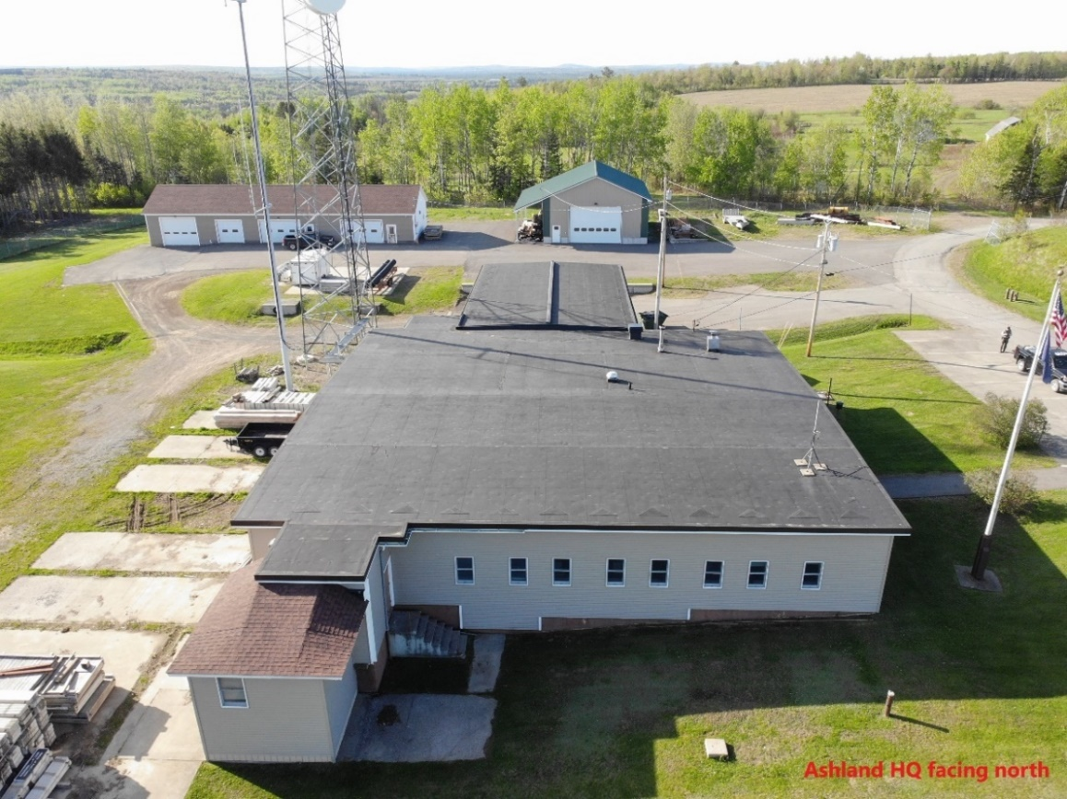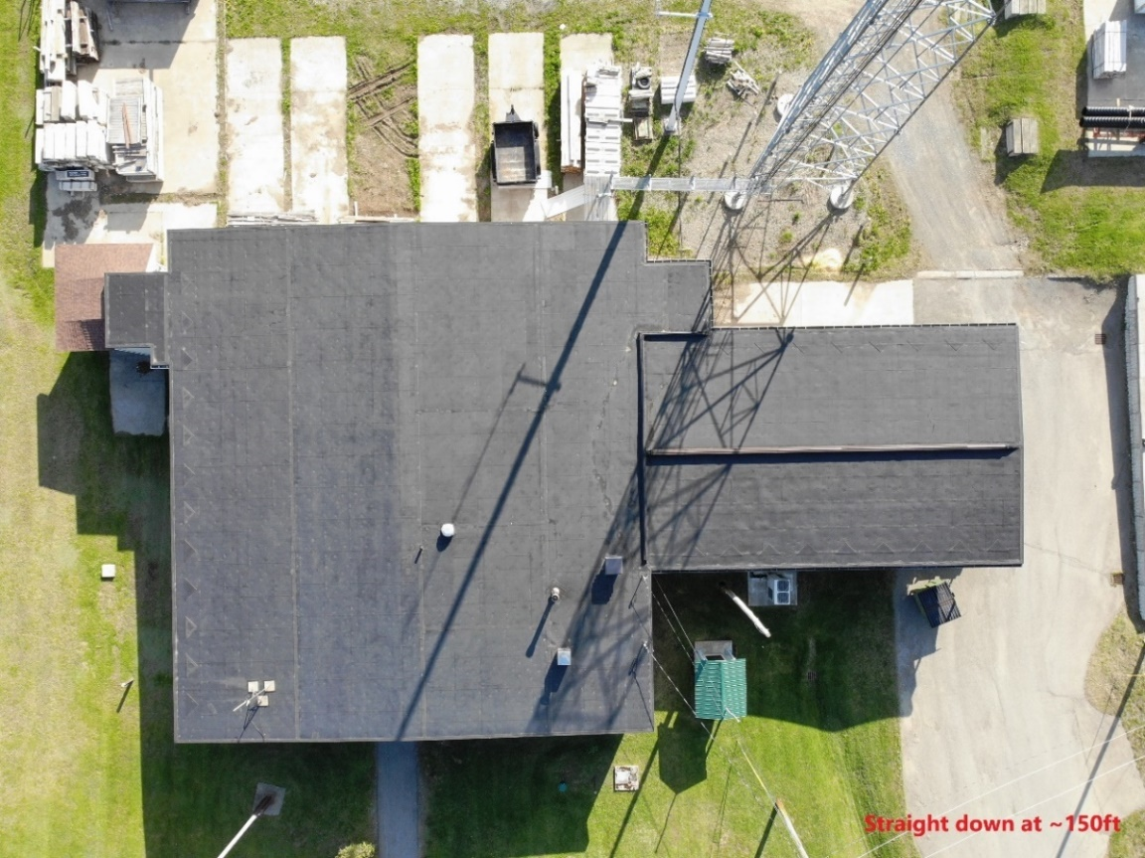
APPENDIX F (cont.)
Figure 2. Electrical Panel at Ashland Facility

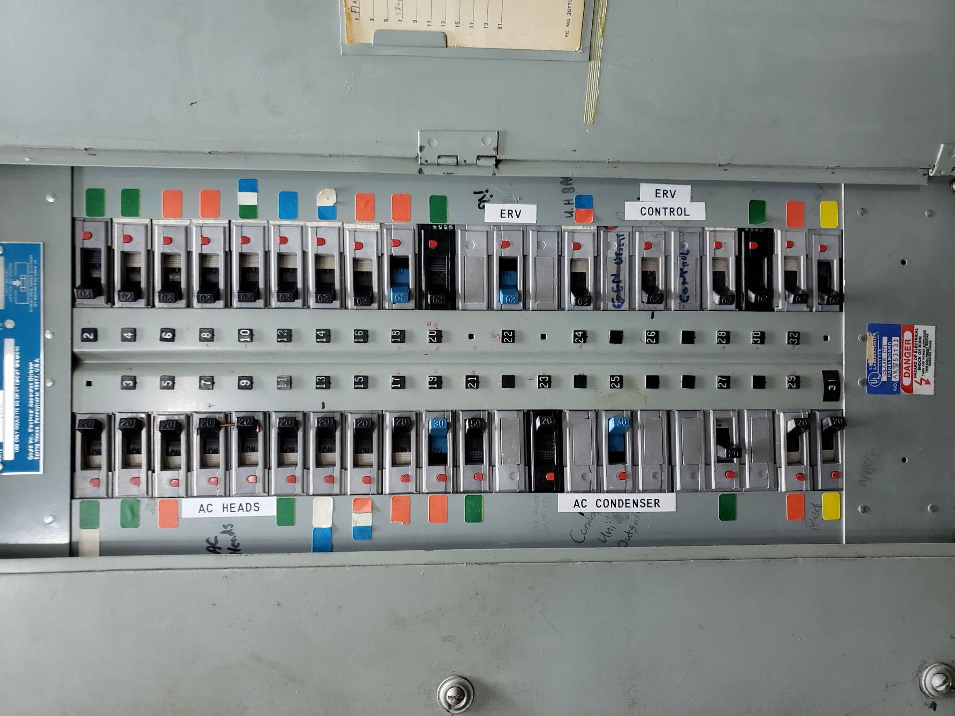

APPENDIX F (cont.)
Figure 3. Roof Photos at Augusta Bolton Hill Facility

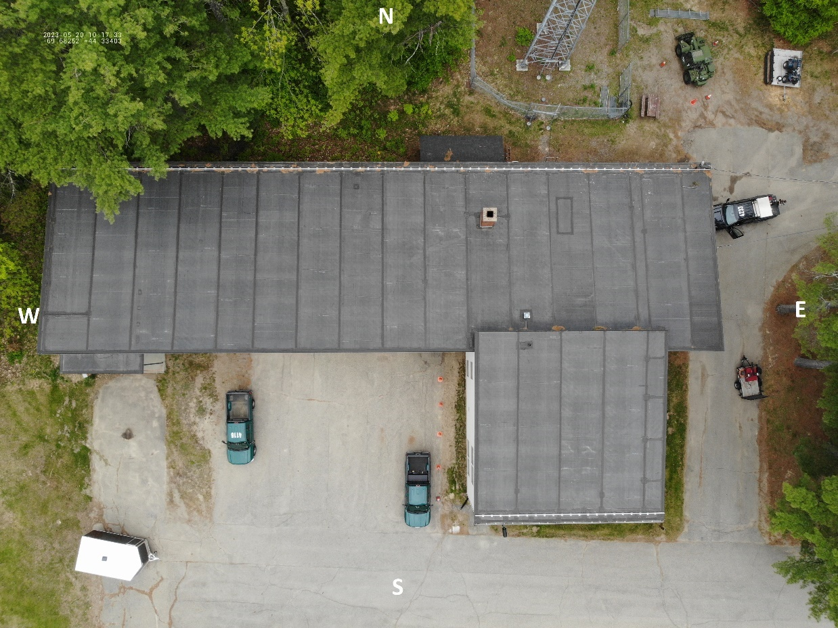

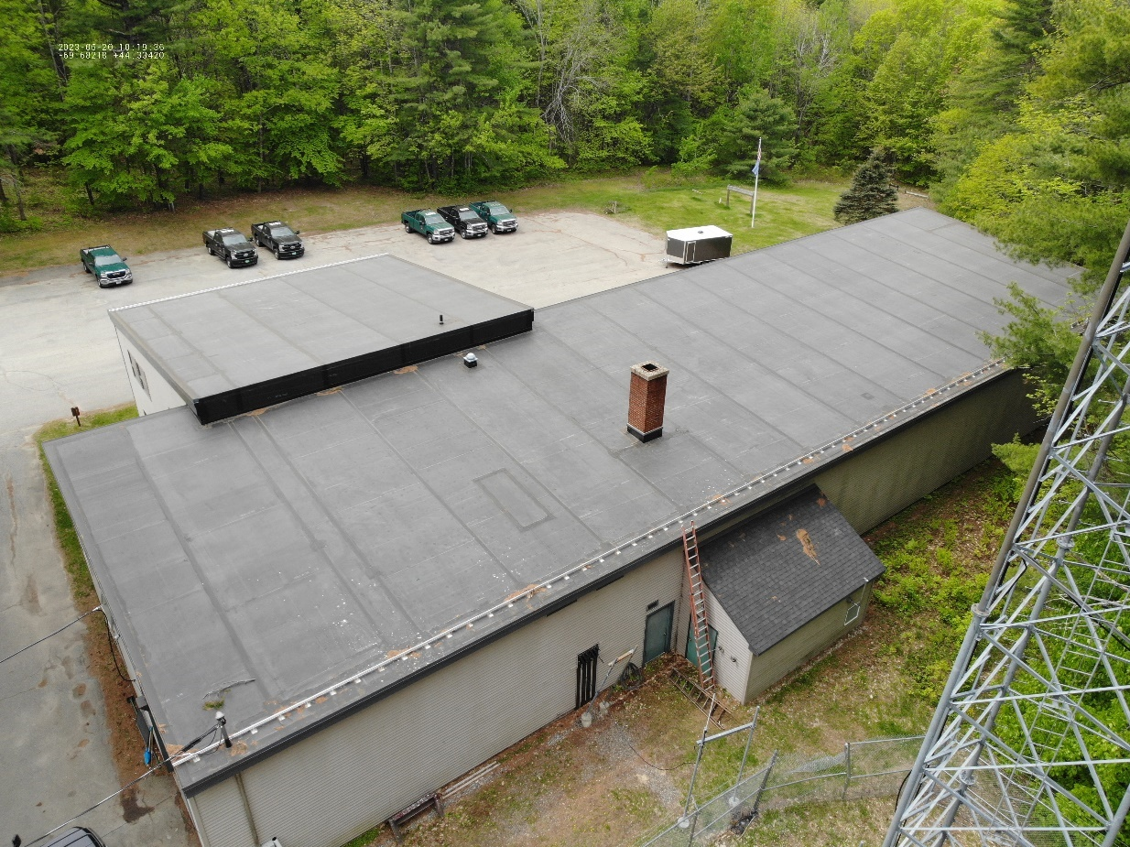

APPENDIX F (cont.)
Figure 4. Electrical Panel at Augusta Bolton Hill Facility
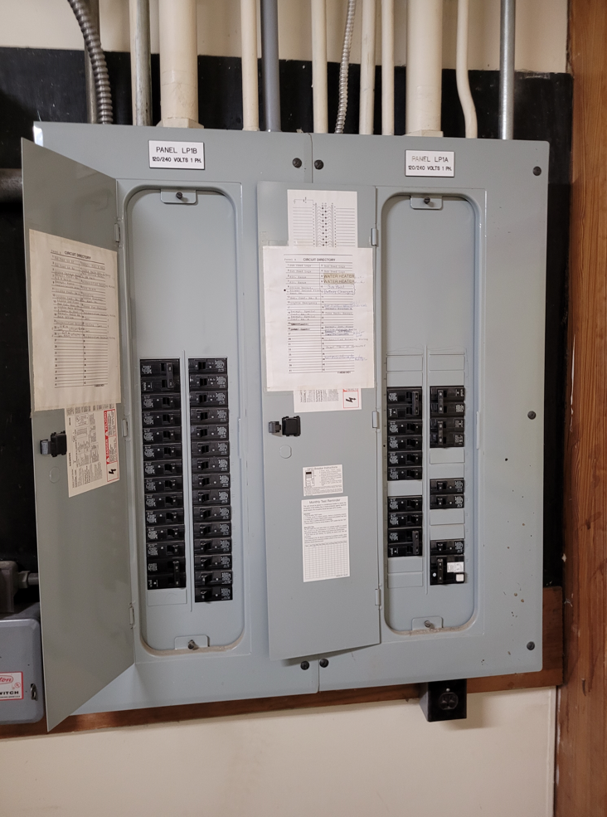

APPENDIX F (cont.)
Figure 5. Roof Photos at Augusta Cony Road Facility

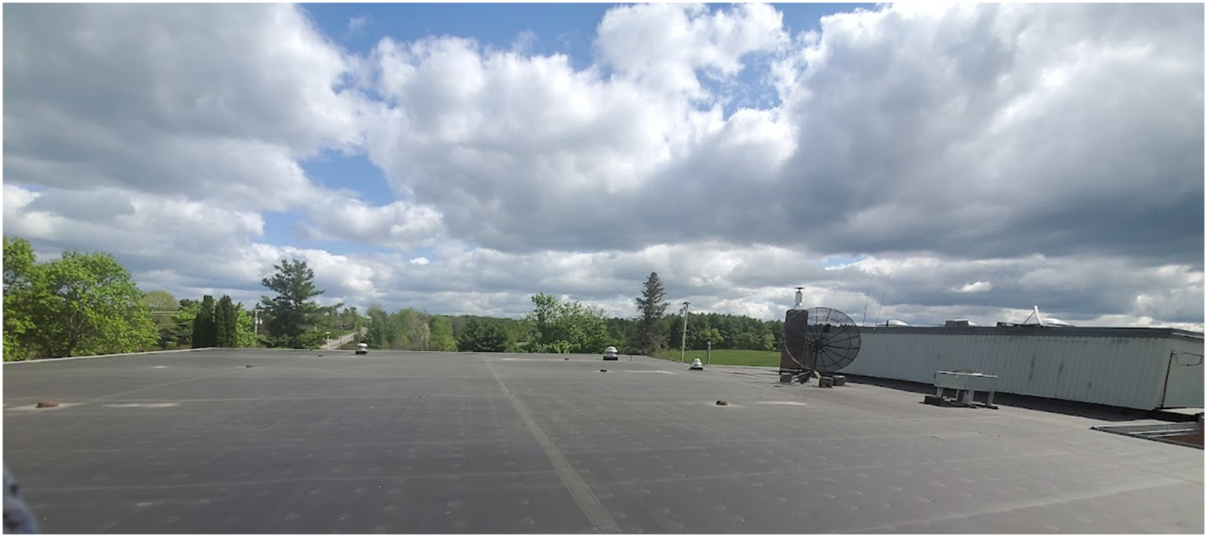

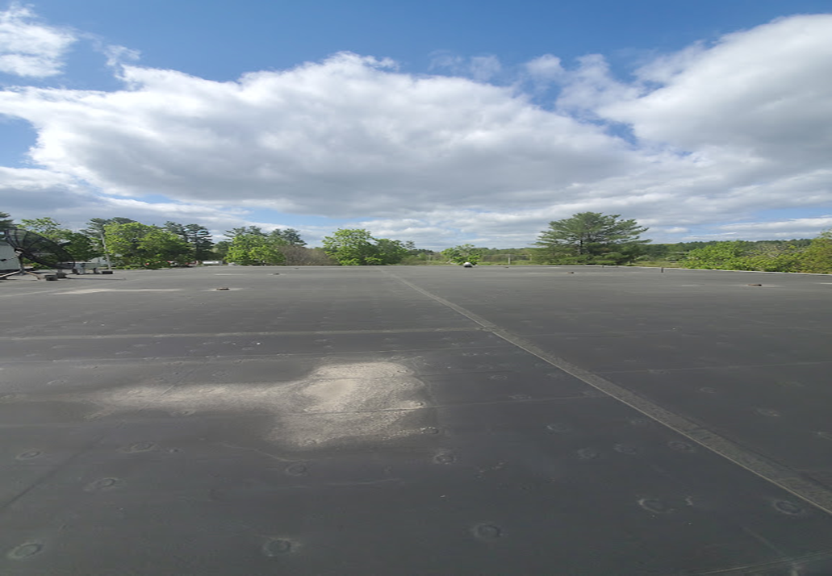

APPENDIX F (cont.)
Figure 6. Electrical Panel at Augusta Cony Road Facility

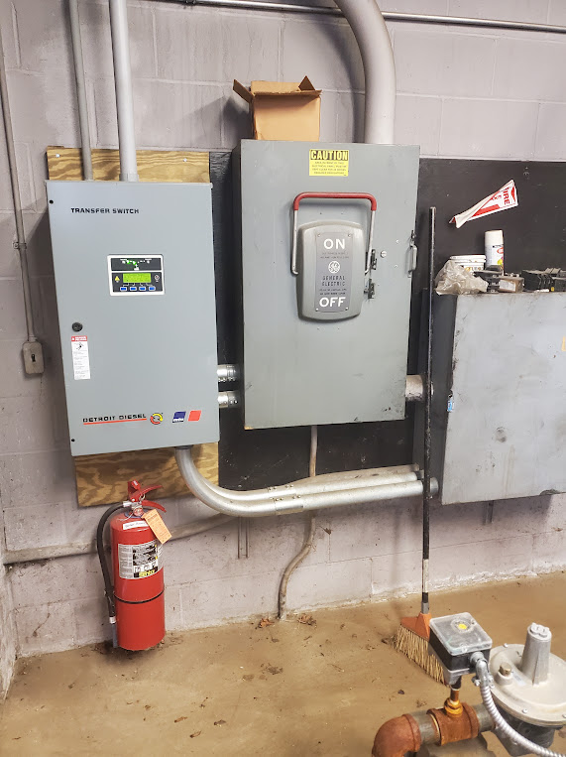

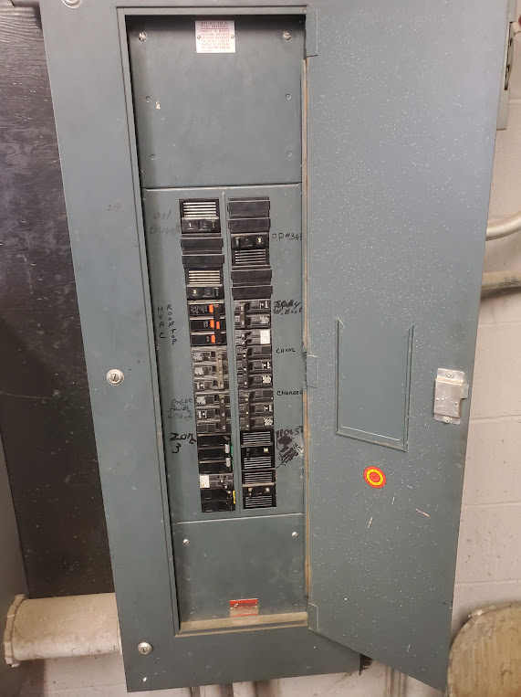
APPENDIX F (cont.)
Figure 7. Roof Photos at Old Town Hill Facility (Three Rooftops)

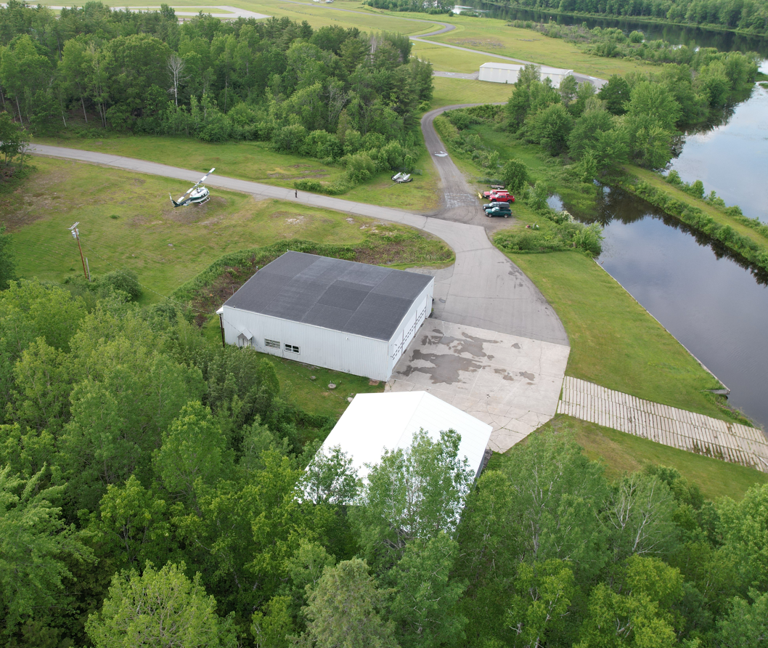

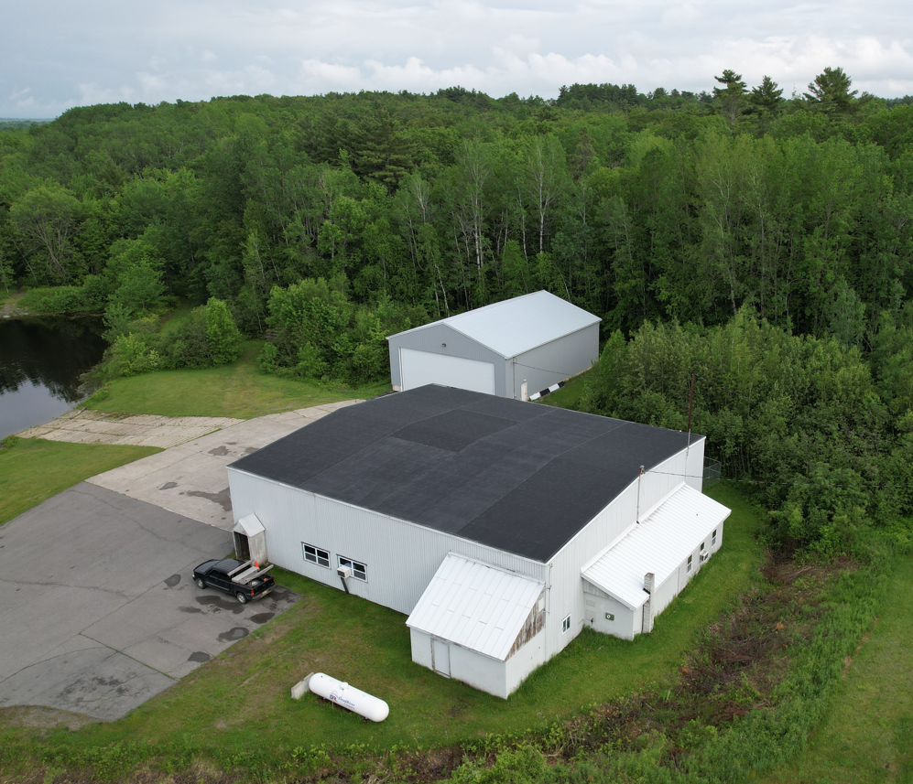
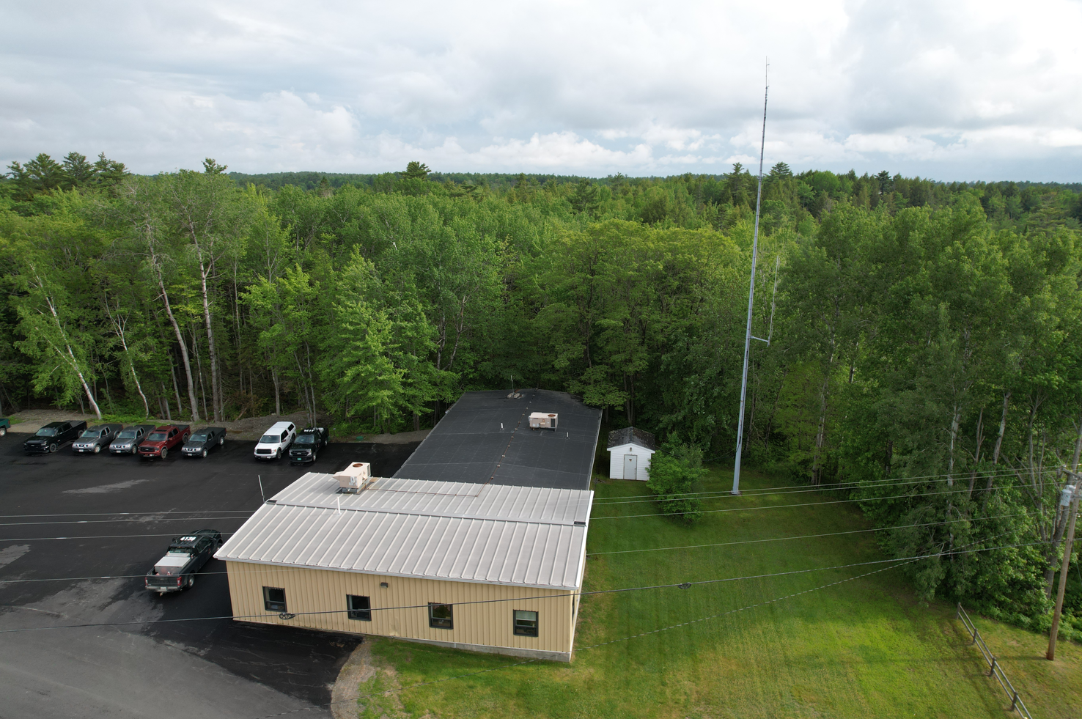

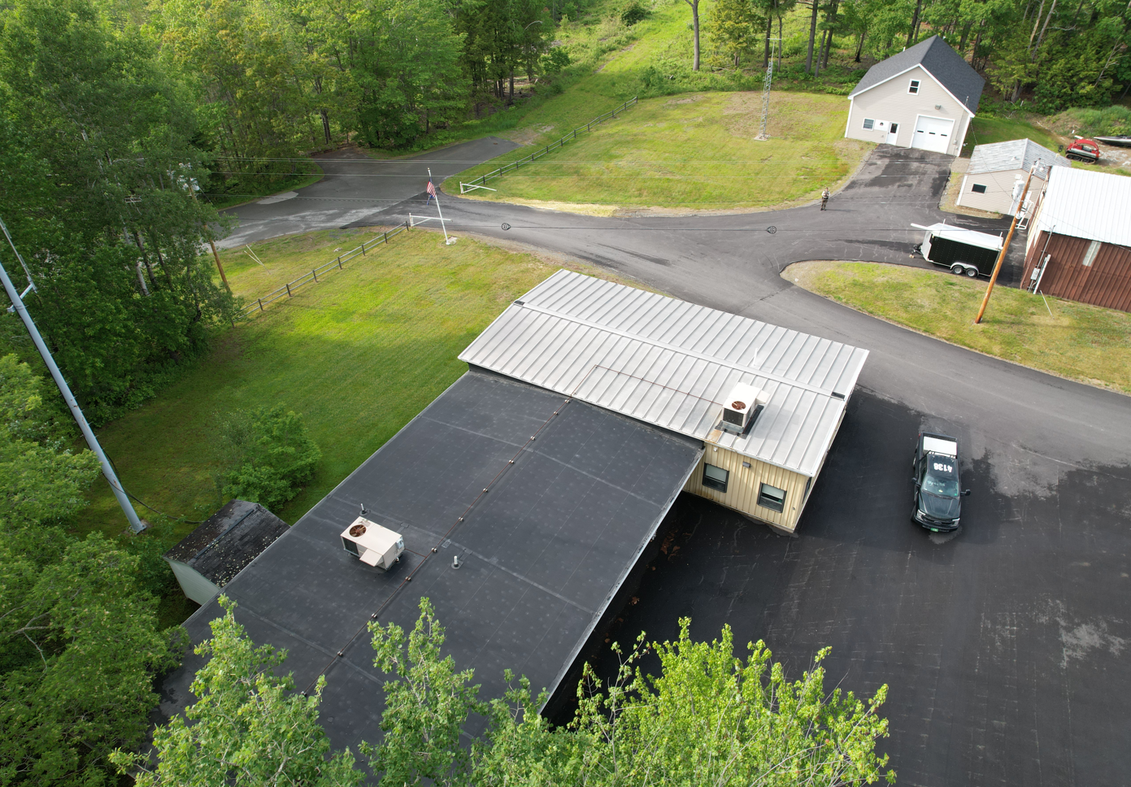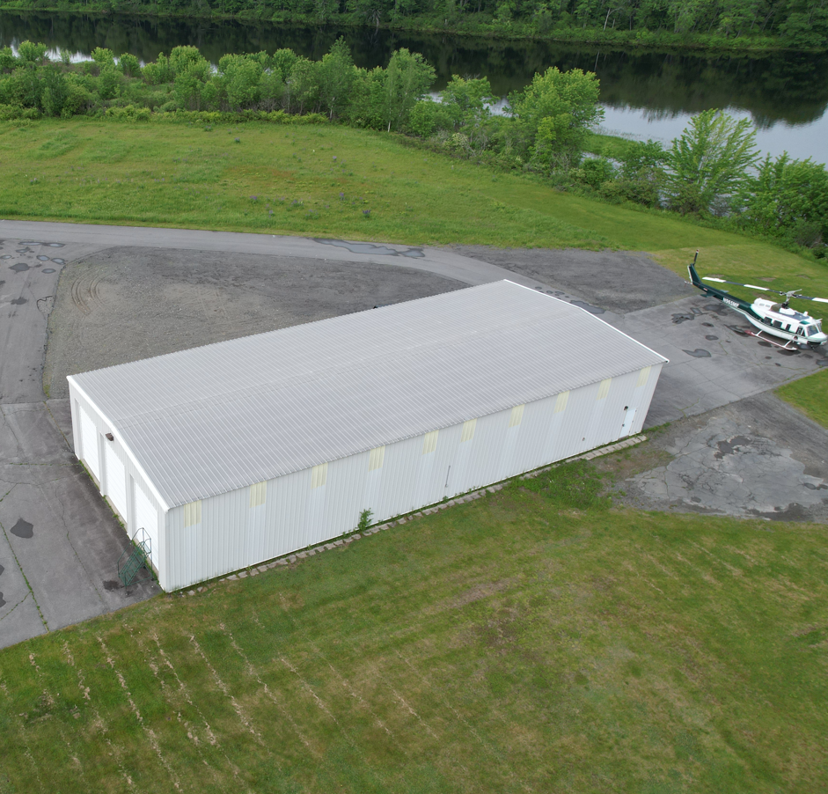

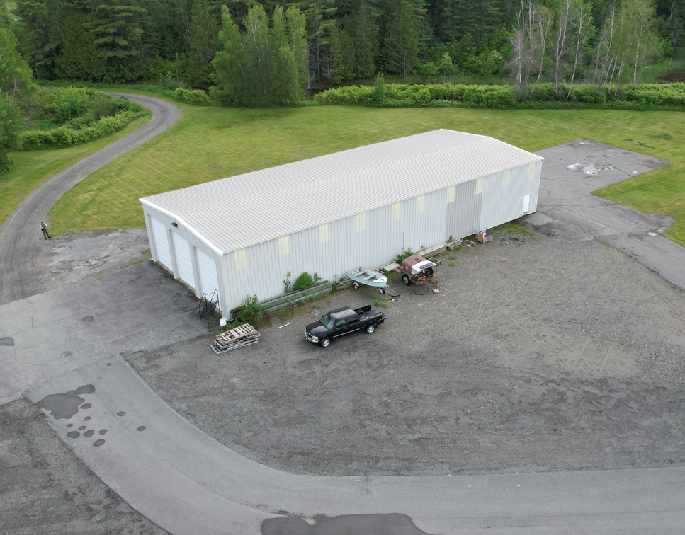
APPENDIX F (cont.)
Figure 8. Electrical Panel at Old Town Facility

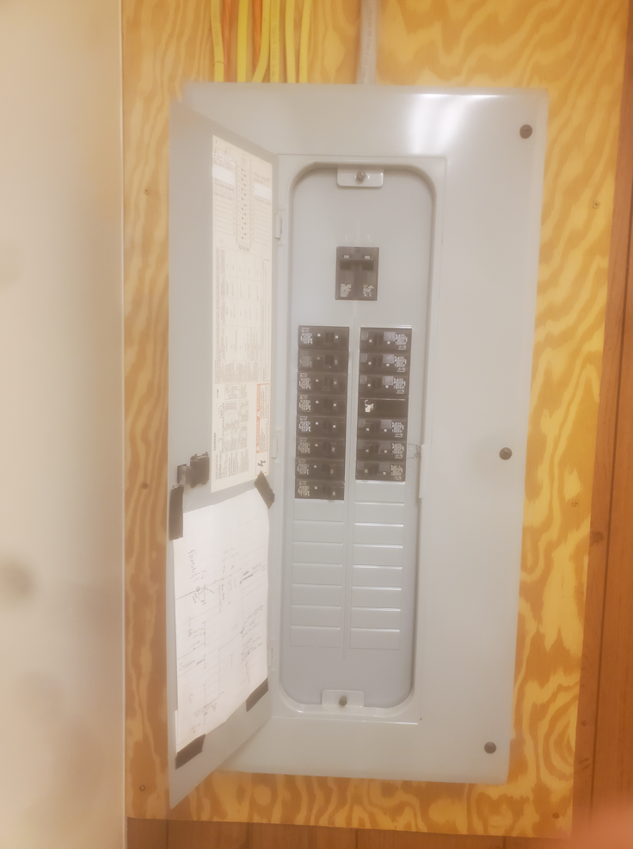

APPENDIX G

State of Maine
Department of Agriculture, Conservation and Forestry

ROOF CONDITION INFORMATION & REPORTS
RFP# 202306140
Rooftop Solar Photovoltaic Systems

Augusta (Bolton Hill):

Augusta (Cony Road):

Old Town:

Double click on the icons above to access the documents.

APPENDIX H

State of Maine
Department of Agriculture, Conservation and Forestry

ELECTRIC UTILITY BILL SAMPLE
RFP# 202306140
Rooftop Solar Photovoltaic Systems

Double click on the icon above to access the document.

APPENDIX I

State of Maine
Department of Agriculture, Conservation and Forestry

NOTICE OF INTENT TO BID FORM
RFP# 202306140
Rooftop Solar Photovoltaic Systems

Bidder’s Organization Name:
Chief Executive - Name/Title:
Tel: |  |  | E-mail:
Headquarters Street Address:
Headquarters City/State/Zip:
(Provide information requested below if different from above)
Lead Point of Contact for Proposal - Name/Title:
Tel: |  |  | E-mail:
Headquarters Street Address:
Headquarters City/State/Zip:

Signature of person authorized to enter into the contract with the Department:
Name (Print): | Title:
Authorized Signature: | Date:

Facilities included in Bidder’s proposal:
FACILITY | YES/NO | If No, please explain why Bidder has chosen not to bid.
Augusta Bolton Hill Facility | ☐Yes  ☐No
Augusta Cony Road Facility | ☐Yes  ☐No
Ashland Facility | ☐Yes  ☐No
Old Town Facility | ☐Yes  ☐No

