STATE OF MAINE
Department of Agriculture, Conservation & Forestry
Bureau of Parks & Lands – Lands Division



RFP# 202007120
Pre-Qualified Vendor List for Gravel Road Construction

RFP Coordinator | All communication, including questions and proposal submission, regarding this RFP must be made using the email address below.  Contact Information: Jacob.guimond@maine.gov
Submitted Questions Due | Questions regarding this RFP can be submitted at any time while this RFP is open. All questions must be submitted, by e-mail, to the address identified above. Please include “RFP # 202007120” in the subject line of your email.
Bidders Conference(s) | Bidders Conferences will be held in all three Public Lands Regions and are suggested but not mandatory.  Date: 10/08/2020 Time: 10:00 AM Location: 45 Radar Road Ashland  Date: 10/20/2020 Time: 9:00 AM Via Microsoft Teams Meeting*  Date: 10/20/2020 Time: 9:00 AM Via Microsoft Teams Meeting* *Interested parties can contact the RFP coordinator for meeting info
Proposal Submission | Proposals must be received by the Division of Procurement Services by:  Submission Deadline: 12/10/2020, no later than 11:59 p.m., local time  Proposals must be submitted electronically to the following address:  Electronic (email) Submission Address: Proposals@maine.gov
Open  Enrollment | Proposals will be accepted at any time after the release of this RFP while it is open. Proposals must be submitted electronically to the email address provided above. Please include “RFP# 202007120 Proposal Submission” in the subject line of your email/electronic submission.
TABLE OF CONTENTS

Page

PUBLIC NOTICE 4

RFP DEFINITIONS/ACRONYMS 5

PART I INTRODUCTION 6
- PURPOSE AND BACKGROUND 6
- GENERAL PROVISIONS 6
- ELIGIBILITY TO SUBMIT BIDS 7
- PRE-QUALIFIED VENDOR LIST TERMS 7
- MINI-BID PROCESS AND AWARDS 7

PART II SCOPE OF SERVICES TO BE PROVIDED 9
- ROAD BUILDING SPECIFICATIONS 9
- STREAM CROSSING SPECIFICATIONS 10
- GENERAL SPECIFICATIONS 11
PART III KEY RFP EVENTS 12
- BIDDERS CONFERENCE 12
- QUESTIONS 12
- AMENDMENTS 12
- SUBMITTING THE PROPOSAL 12

PART IV PROPOSAL SUBMISSION REQUIREMENTS 14
- PROPOSAL FORMAT 14
- PROPOSAL CONTENTS 15
PART V PROPOSAL EVALUATION AND SELECTION 16
- EVALUATION PROCESS – GENERAL INFORMATION 16
- SCORING WEIGHTS AND PROCESS 16
- SELECTION AND AWARD 17
- APPEAL OF CONTRACT AWARDS 17

PART VII RFP APPENDICES AND RELATED DOCUMENTS 18

APPENDIX A – PROPOSAL COVER PAGE 19
APPENDIX B – DEBARMENT, PERFORMANCE AND NON-COLLUSION CERTIFICATION 20
APPENDIX C – QUALIFICATIONS AND EXPERIENCE FORM 21
APPENDIX D – COST PROPOSAL / BID PRICE SHEET 24
APPENDIX E – EQUIPMENT LIST 25
APPENDIX F – SUBMITTED QUESTIONS FORM 26
APPENDIX G – CONSTRUCTION DIAGRAMS 27

PUBLIC NOTICE

*************************************************
State of Maine
Department of Agriculture, Conservation & Forestry
RFP# 202007120
Pre-Qualified Vendor List for Gravel Road Construction

The State of Maine is seeking proposals to be considered for inclusion on a Pre-Qualified Vendor List for constructing gravel roads on Maine’s Public Reserved Lands.

A copy of the RFP, as well as the Question & Answer Summary and all amendments related to this RFP, can be obtained at the following website: http://www.maine.gov/dafs/bbm/procurementservices/vendors/pqvls

Bidders conferences will be held in each of the three Public Lands offices. Attendance is optional, but very highly suggested:

Location: 45 Radar Road, Ashland Maine 10/08/2020 10:00 AM
Location: Virtual meeting via Microsoft Teams 10/20/2020 9:00 AM*
Location: Virtual meeting via Microsoft Teams 10/20/2020 9:00 AM*

*Interested parties should contact the RFP coordinator to request virtual meeting information

Proposals must be submitted to the State of Maine Division of Procurement Services, via e-mail, to the following email address: Proposals@maine.gov. Proposal submissions must be submitted no later than 11:59 pm, local time, on 12/10/20. Proposals will be opened at the Burton M. Cross Office Building, 111 Sewall Street - 4th Floor, Augusta, Maine the following business day. Proposals not submitted to the Division of Procurement Services’ aforementioned email address by the aforementioned deadline will not be considered for contract award.
*************************************************

RFP DEFINITIONS/ACRONYMS

The following terms and acronyms shall have the meaning indicated below as referenced in this Pre-Qualified Vendor List RFP:

Term/Acronym | Definition
Department | Department of Agriculture, Conservation & Forestry
RFP | Request for Proposal
State | State of Maine
PQVL | Pre-Qualified Vendor List
Bureau | Bureau of Parks & Lands

State of Maine - Department of Agriculture, Conservation & Forestry
Bureau of Parks & Lands – Lands Division
RFP# 202007120
Pre-Qualified Vendor List for Gravel Road Construction

PART I INTRODUCTION

A. Purpose and Background

The Department of Agriculture, Conservation & Forestry (Department) is seeking proposals to provide gravel road construction services as defined in this Request for Proposals (RFP) document. This document provides instructions for submitting proposals, the procedure and criteria by which the Provider(s) will be selected and the contractual terms which will govern the relationship between the State of Maine (State) and the awarded Bidder(s).

The Bureau of Parks & Lands is a dedicated revenue agency which derives part of its funding through timber harvesting. In order to support three-season timber harvesting, the Bureau needs a sufficient number of gravel roads constructed each year to access marketable timber. Gravel roads also provide the recreating public safe and easy access to Maine’s Public Lands.

B. General Provisions

- From the time this RFP is issued until award notification is made, all contact with the State regarding this RFP must be made through the aforementioned RFP Coordinator. No other person/ State employee is empowered to make binding statements regarding this RFP. Violation of this provision may lead to disqualification from the bidding process, at the State’s discretion.
- Issuance of this RFP does not commit the Department to issue an award or to pay expenses incurred by a Bidder in the preparation of a response to this RFP. This includes attendance at personal interviews or other meetings and software or system demonstrations, where applicable.
- All proposals should adhere to the instructions and format requirements outlined in this RFP and all written supplements and amendments (such as the Summary of Questions and Answers), issued by the Department. Proposals are to follow the format and respond to all questions and instructions specified below in the “Proposal Submission Requirements” section of this RFP.
- Bidders shall take careful note that in evaluating a proposal submitted in response to this RFP, the Department will consider materials provided in the proposal, information obtained through interviews/presentations (if any), and internal Departmental information of previous contract history with the Bidder (if any). The Department also reserves the right to consider other reliable references and publicly available information in evaluating a Bidder’s experience and capabilities.
- The proposal shall be signed by a person authorized to legally bind the Bidder and shall contain a statement that the proposal and the pricing contained therein will remain valid and binding for a period of 180 days from the date and time of the bid opening.
- The RFP and the selected Bidder’s proposal, including all appendices or attachments, shall be the basis for the final contract, as determined by the Department.
- Following announcement of an award decision, all submissions in response to this RFP will be considered public records available for public inspection pursuant to the State of Maine Freedom of Access Act (FOAA) (1 M.R.S. §§ 401 et seq.).
http://www.mainelegislature.org/legis/statutes/1/title1sec401.html
- The Department, at its sole discretion, reserves the right to recognize and waive minor informalities and irregularities found in proposals received in response to this RFP.
- The State of Maine Division of Procurement Services reserves the right to authorize other Departments to use the contract(s) resulting from this RFP, if it is deemed to be beneficial for the State to do so.
- All applicable laws, whether or not herein contained, shall be included by this reference. It shall be the Bidder’s responsibility to determine the applicability and requirements of any such laws and to abide by them.

C. Eligibility to Submit Bids

All interested parties are invited to submit bids in response to this Request for Proposals.

D. Pre-Qualified Vendor List Term

The Department is seeking a cost-efficient proposal(s) to provide services, as defined in this RFP, for the anticipated Pre-Qualified Vendor List (PQVL) period defined in the table below. Please note that the dates below are estimated and may be adjusted, as necessary, in order to comply with all procedural requirements associated with this RFP process. Utilization of a PQVL for will begin once the RFP process has been finalized.

The term of the anticipated PQVL, resulting from this RFP, is defined as follows:

Period | Start Date | End Date
Period of Performance | January 1, 2021 | Termination of RFP

This RFP offers an open enrollment for new vendors to be included on the pre-qualified vendor list. Once selected, vendors do not need to reapply during an open enrollment. Proposals will be accepted from vendors not currently on the PQVL as long as this RFP is active. Proposals submitted during the open enrollment will be evaluated, and the vendors will be notified of the decision within 30 days.

E. Mini-Bid Process and Awards

Once the pre-qualified list is established, the Department will notify all pre-qualified vendors when specific services are needed. Each vendor on the PQVL will be given a description of the particular services needed and asked to respond within a specific timeframe with information on how that vendor proposes to provide the particular services, along with the project-specific cost proposal for those services. Vendors should respond to each mini-bid with their proposal or provide a “no-bid” as a response. The Department will then select one vendor based on the project-specific cost proposal submitted during the “mini-bid” process of those pre-qualified vendors who can meet the specific service requirements.

The Department reserves the right to select vendors from the pre-qualification list without using the mini-bid process for emergencies (if the need arises). The Department also retains the discretion to issue new RFPs for specific projects. Providers for those projects will not be selected from the PQVL, but rather through the separate RFP or other procurement process based on the Department’s specific needs/timelines.

PART II SCOPE OF SERVICES TO BE PROVIDED

When awarded a project via the mini-bid process described in PART I, Section E above, the vendor will be expected to provide gravel road construction services on Maine’s Public Reserved Lands in accordance with the specifications and descriptions below. All PQVL vendors are expected to provide all equipment and personnel for completing the required services. Supervision of employees is left up to the contractor.

Road Building Specifications

- The goal is to provide a simple road structure of adequate strength to support heavy vehicle traffic in excess of 200,000 pounds and provide drainage structures to pass water at its normal level through the road corridor.
- The road is to be built with an excavator and bulldozer using the “trenching method”.
- An excavator with hydraulic thumb weighing a minimum of 25 tons and a maximum of 36 tons and bulldozer weighing a minimum of 15 tons and a maximum of 21 tons are required to perform the work.
- The road bed is to be a minimum of 3 feet in height above the high side ditch bottom unless terrain makes it impossible, as approved by the Contract Administrator.
- The top 3 feet of the road bed will not consist of organic material, topsoil or vegetative matter.
- The road surface is to be a minimum of 16 feet wide and will not consist of topsoil or organic matter. Clay may be used if approved by the Contract Administrator.
- The road surface shall be crowned to shed water.
- Stumps, protruding rocks and organic material must be grubbed from under the road bed profile and be buried in the trench.
  - Exceptions for burying debris in the trench include filling low spots and on the low side in steep side hill conditions with a gradient of 10% or more, or as determined by the Contract Administrator.
- Stumps overhanging the top of cut banks should also be removed.
- Grubbing will also include cutting down high spots and filling in low spots to minimize humps and dips in the finished road.
- Grubbing is not required in wet areas.
- Woody debris may be used as corduroy.
  - Stumps from dry areas may be turned upside down and placed in these areas.
  - The road bed height requirement of 3 feet must be maintained above the material used as corduroy.
- Cleared debris will be placed in a manner that will not impede water flowing in ditches and drains, or potentially increase sedimentation of waters.
- Ditch slopes and back slopes will be constructed at a ratio of 2:1 or flatter if terrain permits.
- All excavation and dozing shall be done within the right-of-way only.
- Functional truck turnarounds shall be constructed level with the road surface.
  - Turnaround size will be constructed to 100 feet in road surface depth and 100 feet in road surface width where it meets ROW road surface.
  - Turnarounds will be constructed approximately every 2,500 feet and no less than 200 feet from the end of the road unless otherwise specified by the Contract Administrator.
- Meeting places will be constructed approximately every 500 feet and shall be no shorter than 60 feet in road surface length with total road surface width of 28 feet. Locations will be specified by the Contract Administrator during road construction.
- Culverts will be supplied by the Bureau and installed in a location designated and marked by the Contract Administrator as construction proceeds.
- Contractor will be responsible for transporting culverts from the mouth of new road construction to installation sites.
- If a culvert is damaged when being reset, the contractor will replace the culvert at their expense.
- Cross-drain culverts will be installed at a 30-degree angle downslope and at grades 2% more than the ditch grade with free-flowing outlets to prevent ponding water.
- The high side ditch will have armored walls located directly downhill of the culvert to prevent water from bypassing the culvert.
- Surface water from turn outs and tail drains will be diverted from roads into an unscarified filter strip or vegetative area and in no case shall water be drained directly into a brook or other water course.
- Functional turnouts may be installed in addition to or instead of cross drains where specified by the Contract Administrator.
- Fill will be firmly compacted around culverts, paying special attention to the sides and lower portion.
- Tops of culverts will be covered to a depth of one-half the pipe diameter or 18 inches, whichever is greater.
- Culvert lengths should reach to the toe of the fill, without changing the side slopes of the fill.
- When a rain event interrupts construction, a trench must be dug across the road bed in low spots to allow water flow and prevent ponding or water on the high side.
- Maximum disturbed soil from the toe of the road to the undisturbed forest floor may not exceed 12’.

Stream Crossing Specifications

- Stream crossings will only be installed under the direct supervision of the Contract Administrator.
- Stream crossings will be paid for at the contracted hourly rate throughout the buffered section of the Right of Way.
  - This will require pushing acceptable ‘non-organic’ road material from borrow pits located a minimum of 75 feet on either side of the stream bank, or hauling approved material from a public lands pit.
  - This hourly rate includes the installation of the culvert, as well as closure of the borrow pits.
- When installing culverts, backfill materials are to be clean, non-erodible and non-toxic to aquatic life.
- Culverts less than or equal to 30 inches in diameter will be placed at least 8 inches deeper than the stream bed and larger culverts will be placed at a depth specified by the Contract Administrator.
- Culverts will be placed on the same slope (gradient) as the stream and in no case shall the cut in the stream bed exceed the depth required in number 4 above.
- Sides of the culvert will be compacted in 6-inch lifts with a vibrating compactor or jumping jack compactor provided by the contractor at the compactor and labor bid rates.
- Culvert inlets and outlets will be armored to reduce bank and channel erosion and sedimentation.
- Geotextile will be placed under riprap and will be provided by the Bureau of Parks & Lands.
- Seeding and mulching will be completed by the Bureau of Parks & Lands.

General Specifications

- Construction activities will be suspended during rain events resulting in greater than ½” of rain.
- Construction will be allowed to resume after conditions dry as determined by the Contract Administrator.
- Weekly quality reviews will be exercised by the Contract Administrator to evaluate contractor performance and Best Management Practices (BMP) conformance.
- Road building will only be allowed Monday through Friday during daylight hours; no weekends or nights.
- Work will only be performed when requested by the Contract Administrator.
- Road construction will cease if a 12 inch or greater snowfall event occurs, unless otherwise specified by the Contract Administrator.
- Any work that is not authorized will not be paid for.
- The road will be deemed finished when the surface is smooth and crowned and ready for traffic.
- If the material is too saturated to smooth with the bulldozer or if the road is frozen, the contractor will return at a later date to spread the dry road surface and crown the road (in dry conditions).
  - This may require coming back with a bulldozer or a grader to complete the road project.
- No litter or garbage is to be left on site or along the road.
- The Contract Administrator shall have the right to temporarily stop any and all activities under the resulting agreement in the event the Contract Administrator determines such action to be necessary to protect roads, soils, water, growth or other resources.
  - In such case, the Bureau shall not be liable for any damage, lost profits or consequential damage that the contractor may incur.
- Safety – contractor will follow all Federal OSHA requirements, found at https://www.osha.gov/dcsp/osp/stateprogs/maine.html

PART III KEY RFP EVENTS

Bidders Conference

The Department will sponsor a Bidders Conference in each of the three Lands regions concerning this RFP beginning at the dates, times and locations shown on the RFP cover page. The purpose of the Bidders’ Conference is to answer and/or field questions, clarify for potential Bidders any aspect of the RFP requirements that may be necessary and provide supplemental information to assist potential Bidders in submitting responses to the RFP. Although attendance at a Bidders Conference is not mandatory, it is strongly encouraged that interested bidders attend.

Questions

1. General Instructions
a. It is the responsibility of all Bidders and other interested parties to examine the entire RFP and to seek clarification, in writing, if they do not understand any information or instructions.
b. Bidders and other interested parties should use Appendix F – Submitted Questions Form – for submission of questions.
c. The Submitted Questions Form must be submitted to the RFP Coordinator email address identified on the cover page of this RFP.
d. Submitted Questions must include the RFP Number and Title in the subject line of the e-mail. The Department assumes no liability for assuring accurate/complete/on time e-mail transmission and receipt.

2. Question & Answer Summary: Responses to all questions will be compiled in writing and posted on the following website: http://www.maine.gov/dafs/bbm/procurementservices/vendors/pqvls . Bidders should submit questions 15-days prior to the most current proposal submission deadline in order to receive a response 7-days prior to that deadline. All other questions will be addressed after the current deadline. It is the responsibility of all interested parties to go to this website to obtain a copy of the Question & Answer Summary. Only those answers issued in writing on this website will be considered binding.

Amendments

All amendments released in regard to this RFP will also be posted on the following website: http://www.maine.gov/dafs/bbm/procurementservices/vendors/pqvls . It is the responsibility of all interested parties to go to this website to obtain amendments. Only those amendments posted on this website are considered binding.

Submitting the Proposal

- Proposals Due: Proposals must be received no later than 11:59 p.m. local time, on the date listed on the cover page of this RFP. They will be opened the next business day. Proposals received after the 11:59 p.m. deadline will be held until the next open enrollment opening.

- Delivery Instructions: Email proposal submissions are to be submitted to the State of Maine Division of Procurement Services, via email Proposals@maine.gov.
- Only proposals received by email will be considered. The Department assumes no liability for assuring accurate/complete e-mail transmission and receipt.
- Bidders are to insert the following into the subject line of their email submission:
- “RFP# 202007120 Proposal Submission”
- Bidder’s name
- Bidder’s proposals are to be sent as one document. PDF is preferred but other formats, such as MS Word, will be accepted.
d. Bidder’s proposals must include (in the order below):
- Proposal Cover Page (Appendix A)
- Debarment, Performance and Non-Collusion Certification (Appendix B)
- Organization Qualifications and Experience (Appendix C and all related/required attachments)
- Bid Price Sheet (Appendix D)
- Equipment List (Appendix E)

PART IV PROPOSAL SUBMISSION REQUIREMENTS

This section contains instructions for Bidders to use in preparing their proposals. The Bidder’s proposal must follow the outline used below, including the numbering and section and sub-section headings as they appear here. Failure to use the outline specified in this section, or to respond to all questions and instructions throughout this document, may result in the proposal being disqualified as non-responsive or receiving a reduced score. The Department, and its evaluation team for this RFP, has sole discretion to determine whether a variance from the RFP specifications should result in either disqualification or reduction in scoring of a proposal. Rephrasing of the content provided in this RFP will, at best, be considered minimally responsive. The Department seeks detailed yet succinct responses that demonstrate the Bidder’s experience and ability to perform the requirements specified throughout this document.

Proposal Format

  - All pages of a Bidder’s proposal should be numbered consecutively beginning with number 1 on the first page of the narrative (this does not include the cover page or table of contents pages) through to the end, including all forms and attachments. For clarity, the Bidder’s name should appear on every page, including Attachments. Each Attachment must reference the section or subsection number to which it corresponds.
  - The Bidder is asked to be brief and concise in responding to the RFP questions and instructions.
  - The Bidder may not provide additional attachments beyond those specified in the RFP for the purpose of extending their response. Additional materials not requested will not be considered part of the proposal and will not be evaluated.
  - Include any forms provided in the submission package or reproduce those forms as closely as possible. All information should be presented in the same order and format as described in the RFP.
  - It is the responsibility of the Bidder to provide all information requested in the RFP package at the time of submission. Failure to provide information requested in this RFP may, at the discretion of the Department’s evaluation review team, result in a lower rating for the incomplete sections and may result in the proposal being disqualified for consideration.
  - The Bidder should complete and submit the “Proposal Cover Page” provided in Appendix A of this RFP and provide it with the Bidder’s proposal. It is important that the cover page show the specific information requested, including Bidder address(es) and other details listed. The proposal cover page shall be dated and signed by a person authorized to enter into contracts on behalf of the Bidder.
  - The Bidder should complete and submit the “Debarment, Performance and Non-Collusion Certification Form” provided in Appendix B of this RFP. Failure to provide this certification may result in the disqualification of the Bidder’s proposal, at the discretion of the Department.

Proposal Contents

Section I Organization Qualifications and Experience

- Overview of the Organization
The Bidder is to complete Appendix C (Qualifications and Experience Form) describing their qualifications and skills to provide the requested services in this RFP. The Bidder is also to include three examples of projects which demonstrate their experience and expertise in performing these services as well as highlighting the Bidder’s stated qualifications and skills.

- Subcontractors
If subcontractors are to be used, provide a list that specifies the name, address, phone number, contact person, and a brief description of the subcontractors’ organizational capacity and qualifications.

- Litigation
Attach a list of all current litigation in which the Bidder is named and a list of all closed cases that have closed within the past five (5) years in which Bidder paid the claimant either as part of a settlement or by decree. For each, list the entity bringing suit, the complaint, the accusation, amount, and outcome. If no litigation will be included, write “none” on submitted attachment.

- Licensure/Certification
Provide documentation of any applicable licensure/certification or any specific credentials required to provide the proposed services.

- Certificate of Insurance
Provide a certificate of insurance on a standard Acord form (or the equivalent) evidencing the Bidder’s general liability, professional liability and any other relevant liability insurance policies that might be associated with the proposed services.

Section II Cost Proposal

- General Instructions
The Bidder is to complete Appendix D (Bid Price Sheet) ensuring each line item is completed, as well as the total cost.

Section III Equipment List

- General Instructions
The Bidder is to complete Appendix E (Equipment List).

PART V PROPOSAL EVALUATION AND SELECTION

Evaluation of the submitted proposals shall be accomplished as follows:

Evaluation Process - General Information

      - An evaluation team, comprised of qualified reviewers, will judge the merits of the proposals received in accordance with the criteria defined in the RFP, and in accordance with the most advantageous financial and economic impact considerations (where applicable) for the State.
      - Officials responsible for making decisions on the selection of a contractor shall ensure that the selection process accords equal opportunity and appropriate consideration to all who are capable of meeting the specifications. The goals of the evaluation process are to ensure fairness and objectivity in review of the proposals and to ensure that the contract is awarded to the Bidder whose proposal provides the best value to the State of Maine.
      - The Department reserves the right to communicate and/or schedule interviews/presentations with Bidders if needed to obtain clarification of information contained in the proposals received, and the Department may revise the scores assigned in the initial evaluation to reflect those communications and/or interviews/presentations. Interviews/presentations are not required, and changes to proposals will not be permitted during any interview/presentation process. Therefore, Bidders should submit proposals that present their rates and other requested information as clearly and completely as possible.

Scoring Weights and Process

- Scoring Weights: The score will be based on a 100-point scale and will measure the degree to which each proposal meets the following criteria.

Section I. Organization Qualifications and Experience (25 points)
Includes all elements addressed above in Part IV, B, Section I.

Section II. Cost Proposal (25 points)
Includes all elements addressed above in Part IV, B, Section II.

Section III. Equipment List (50 points)
Includes all elements addressed above in Part IV, B, Section III.

- Scoring Process: The review team will use a consensus approach to evaluate and score the sections above. Members of the review team will not score those sections individually but, instead, will arrive at a consensus as to assignment of points for each of those sections.

- Negotiations: The Department reserves the right to negotiate with the successful Bidder to finalize a contract at the same rate or cost of service as presented in the selected proposal. Such negotiations may not significantly vary the content, nature or requirements of the proposal or the Department’s Request for Proposals to an extent that may affect the price of goods or services requested. The Department reserves the right to terminate contract negotiations with a selected Bidder who submits a proposed contract significantly different from the proposal they submitted in response to the advertised RFP. In the event that an acceptable contract cannot be negotiated with the highest ranked Bidder, the Department may withdraw its award and negotiate with the next-highest ranked Bidder, and so on, until an acceptable contract has been finalized. Alternatively, the Department may cancel the RFP, at its sole discretion.

Selection and Award

1. The final decision regarding the award of the contract will be made by representatives of the Department subject to approval by the State Procurement Review Committee.
2. Notification of contractor selection or non-selection will be made in writing by the Department.
3. Issuance of this RFP in no way constitutes a commitment by the State of Maine to award a contract, to pay costs incurred in the preparation of a response to this request, or to pay costs incurred in procuring or contracting for services, supplies, physical space, personnel or any other costs incurred by the Bidder.
4. The Department reserves the right to reject any and all proposals or to make multiple awards.
5. Selection to be included on the PQVL is not a guarantee of work.
6. Updated documentation pertaining to Certification of Insurance, Certification/Licensure, and Rates will be required to be submitted to the RFP Coordinator by all Providers on the PQVL on an open basis.

Appeal of Contract Awards

Any person aggrieved by the award decision that results from this RFP may appeal the decision to the Director of the Bureau of General Services in the manner prescribed in 5 MRSA § 1825-E and 18-554 Code of Maine Rules, Chapter 120 (found here: https://www.maine.gov/dafs/bbm/procurementservices/policies-procedures/chapter-120 ). The appeal must be in writing and filed with the Director of the Bureau of General Services, 9 State House Station, Augusta, Maine, 04333-0009 within 15 calendar days of receipt of notification of contract award.

Since this RFP results in a PQVL, the appeal procedures mentioned above are available upon the original determination of that vendor list. The appeal procedures will not be available during subsequent competitive procedures involving only the PQVL participants if cost is the sole determining factor.

Removal from Pre-Qualified Vendors List

The Department may remove a pre-qualified vendor from the PQVL at any time, upon giving 30 days’ written notice to the pre-qualified vendor, if the Department determines that during the pre-qualification term:
  - The pre-qualified vendor failed or refused to perform its contractual obligations,
  - The pre-qualified vendor’s performance was unsatisfactory including, but not limited to, the quality and timeliness of services provided,
  - The pre-qualified vendor no longer has the ability to perform the services specified in this RFP, or
  - The pre-qualified vendor is continually “unresponsive” to providing any feedback to the Department’s mini-bid solicitations.

PART VII LIST OF RFP APPENDICES AND RELATED DOCUMENTS

- Appendix A – Proposal Cover Page

- Appendix B – Debarment, Performance and Non-Collusion Certification

- Appendix C – Qualifications and Experience Form

- Appendix D – Cost Proposal / Bid Price Sheet

- Appendix E – Equipment List

- Appendix F – Submitted Questions Form

- Appendix G – Construction Diagrams

APPENDIX A

State of Maine
Department of Agriculture, Conservation & Forestry

PROPOSAL COVER PAGE
RFP# 202007120
Pre-Qualified Vendor List for Gravel Road Construction

Bidder’s Organization Name:
Chief Executive - Name/Title:
Tel: |  |  |  | E-mail:
Headquarters Street Address:
Headquarters City/State/Zip:
(Provide information requested below if different from above)
Lead Point of Contact for Proposal - Name/Title:
Tel: |  |  |  | E-mail:
Headquarters Street Address:
Headquarters City/State/Zip:

- This proposal and the pricing structure contained herein will remain firm for a period of 180 days from the date and time of the bid opening.
- No personnel currently employed by the Department or any other State agency participated, either directly or indirectly, in any activities relating to the preparation of the Bidder’s proposal.
- No attempt has been made, or will be made, by the Bidder to induce any other person or firm to submit or not to submit a proposal.
- The above-named organization is the legal entity entering into the resulting agreement with the Department should they be awarded the contract.
- The undersigned is authorized to enter contractual obligations on behalf of the above-named organization.

To the best of my knowledge, all information provided in the enclosed proposal, both programmatic and financial, is complete and accurate at the time of submission.

Name (Print): | Title:
Authorized Signature: | Date:

APPENDIX B

State of Maine
Department of Agriculture, Conservation & Forestry

DEBARMENT, PERFORMANCE and NON-COLLUSION CERTIFICATION
RFP# 202007120
Pre-Qualified Vendor List for Gravel Road Construction

Bidder’s Organization Name:

By signing this document, I certify to the best of my knowledge and belief that the aforementioned organization, its principals and any subcontractors named in this proposal:
- Are not presently debarred, suspended, proposed for debarment, and declared ineligible or voluntarily excluded from bidding or working on contracts issued by any governmental agency.
- Have not within three years of submitting the proposal for this contract been convicted of or had a civil judgment rendered against them for:
  - Fraud or a criminal offense in connection with obtaining, attempting to obtain, or performing a federal, state or local government transaction or contract.
  - Violating Federal or State antitrust statutes or committing embezzlement, theft, forgery, bribery, falsification or destruction of records, making false statements, or receiving stolen property;
  - Are not presently indicted for or otherwise criminally or civilly charged by a governmental entity (Federal, State or Local) with commission of any of the offenses enumerated in paragraph (b) of this certification; and
  - Have not within a three (3) year period preceding this proposal had one or more federal, state or local government transactions terminated for cause or default.
- Have not entered into a prior understanding, agreement, or connection with any corporation, firm, or person submitting a response for the same materials, supplies, equipment, or services and this proposal is in all respects fair and without collusion or fraud. The above-mentioned entities understand and agree that collusive bidding is a violation of state and federal law and can result in fines, prison sentences, and civil damage awards.
Failure to provide this certification may result in the disqualification of the Bidder’s proposal, at the discretion of the Department.

Name (Print): | Title:
Authorized Signature: | Date:

APPENDIX C

State of Maine
Department of Agriculture, Conservation & Forestry

QUALIFICATIONS & EXPERIENCE FORM
RFP# 202007120
Pre-Qualified Vendor List for Gravel Road Construction

Bidder’s Organization Name:

Present a brief statement of qualifications, including any applicable licensure and/or certification. Describe the history of the Bidder’s organization, especially regarding skills pertinent to the specific work required by the RFP and any special or unique characteristics of the organization which would make it especially qualified to perform the required work activities. You may expand this form and use additional pages to provide this information.

APPENDIX C (continued)

Provide a description of projects that occurred within the past five years which reflect experience and expertise needed in performing the functions described in the “Scope of Services” portion of this RFP. For each of the project examples provided, a contact person from the client organization involved should be listed, along with that person’s telephone number and email address. Please note that contract history with the State of Maine, whether positive or negative, may be considered in rating proposals even if not provided by the Bidder.

Project One
Client Name:
Client Contact Person:
Telephone:
E-Mail:
Brief Description of Project

Project Two
Client Name:
Client Contact Person:
Telephone:
E-Mail:
Brief Description of Project
APPENDIX C (continued)

Project Three
Client Name:
Client Contact Person:
Telephone:
E-Mail:
Brief Description of Project

APPENDIX D
State of Maine
Department of Agriculture, Conservation & Forestry

COST PROPOSAL
RFP# 202007120
Pre-Qualified Vendor List for Gravel Road Construction

□ Eastern Region □ Northern Region □ Western Region □ Statewide

I hereby submit the following prices as my bid for the State of Maine’s Road Construction Services PQVL on Maine’s Public Reserved Lots.
Price Escalator Clause: The Bureau recognizes that contract prices bid for road construction equipment cannot be expected to remain fixed for an extended period, therefore, the prices bid and approved for the first year of a contract will be adjusted annually, as appropriate, based on the bid date of the contract by the following method: Unit prices for each hourly pay item will be adjusted by increasing or decreasing the unit price by the Implicit price Deflator for the Gross Domestic Product (commonly called the GDP), as published annually by the U.S. Government.

Item # | Item Description and Approx. Quantity | Unit Prices Bid  (In Words - Example: Ten dollars and fifty cents) | Unit Prices Bid  (In numbers - Example: $10.50)
1 | 13,000 feet  Road Construction
2 | 20 hours  Excavator 25 ton min. / 36 ton max.
3 | 20 hours  Dozer 15 ton min. / 21 ton max.
4 | 20 hours  Dump truck  12 yard min.
5 | 10 hours  Compactor 23” x 16” plate min. / 200 # total weight max.
6 | 10 hours  Laborer

APPENDIX E

State of Maine
Department of Agriculture, Conservation & Forestry

EQUIPMENT LIST
RFP# 202007120
Pre-Qualified Vendor List for Gravel Road Construction

Organization Name:

Equipment Description (Year, Make, Model) | Number of Units Available

APPENDIX F

State of Maine
Department of Agriculture, Conservation & Forestry

SUBMITTED QUESTIONS FORM
RFP# 202007120
Pre-Qualified Vendor List for Gravel Road Construction

Organization Name:

RFP Section & Page Number | Question

* If a question is not related to any section of the RFP, state “N/A” under “RFP Section & Page Number”.
** Add additional rows, if necessary.

APPENDIX G

State of Maine
Department of Agriculture, Conservation & Forestry

CONSTRUCTION DIAGRAMS
RFP# 202007120
Pre-Qualified Vendor List for Gravel Road Construction

Single Pipe Installation

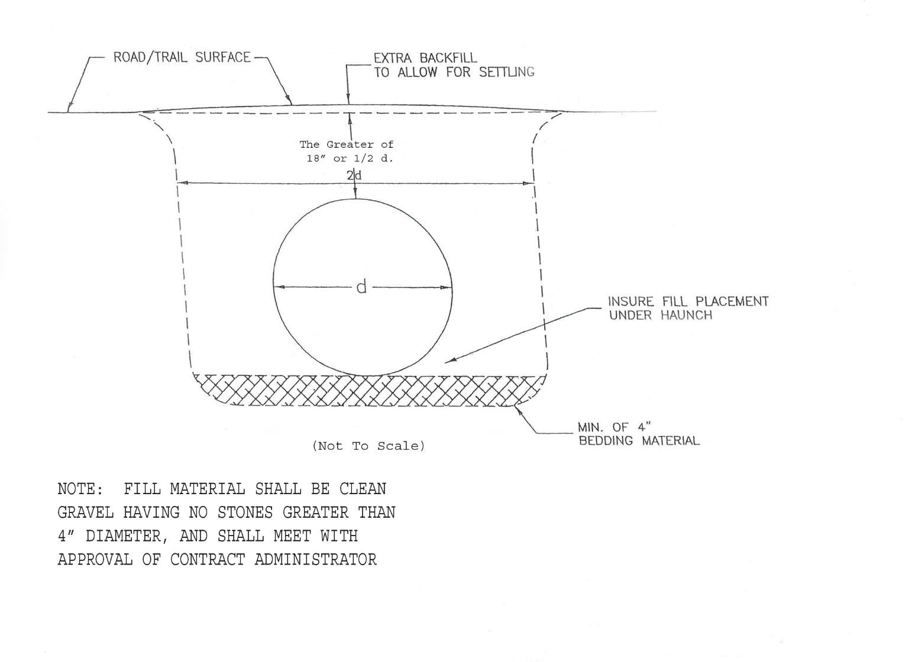

APPENDIX G Continued

RipRap Installation on Culverts with Back Slopes >2:1

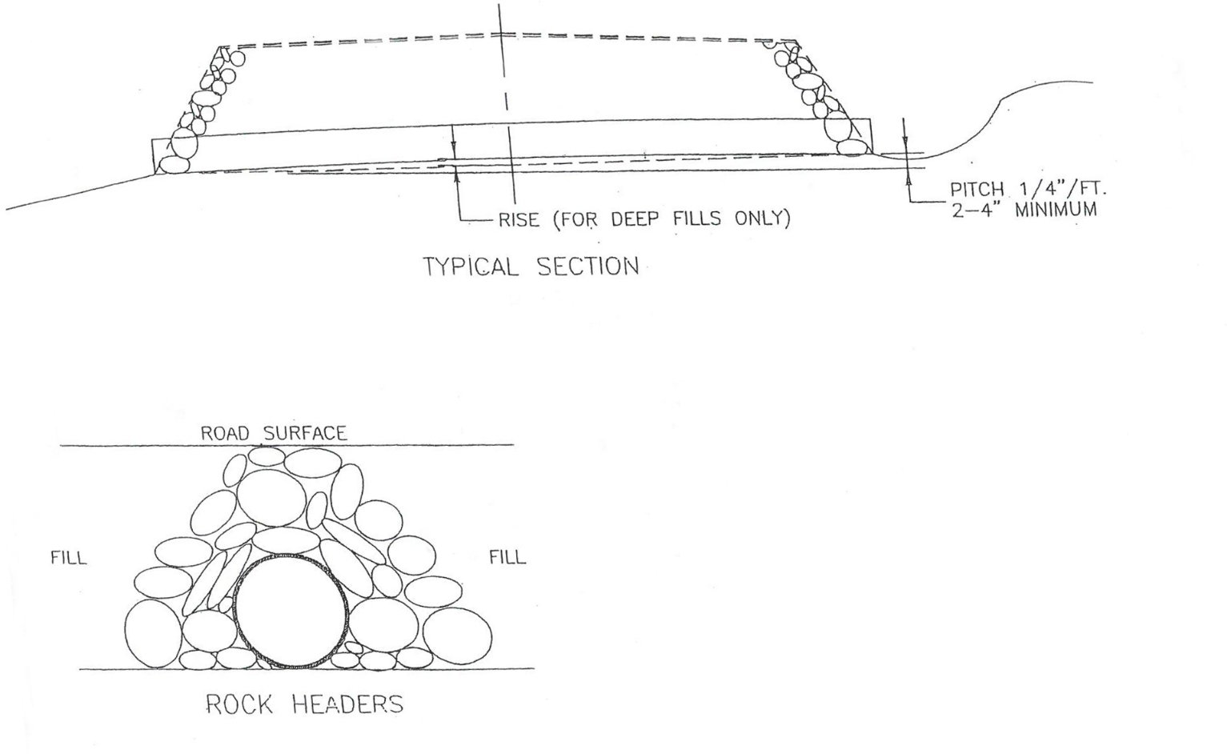

APPENDIX G Continued

Turnaround Specifications

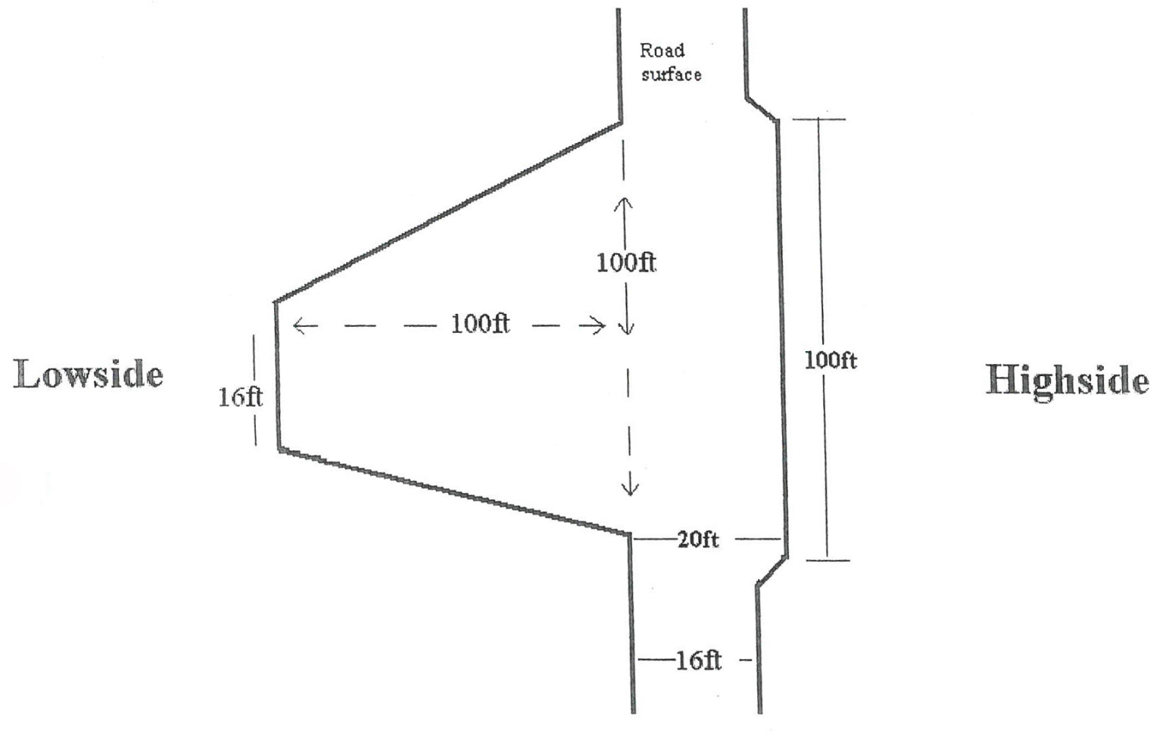

APPENDIX G Continued

Water Turnout Design

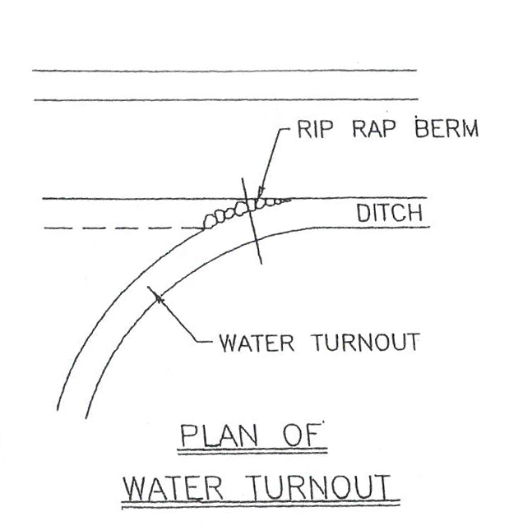

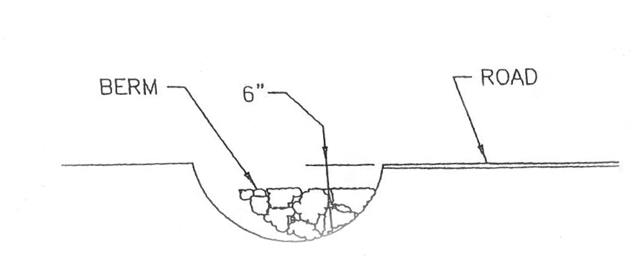

APPENDIX G Continued

BMPs Cross-Drainage Culvert Part 1
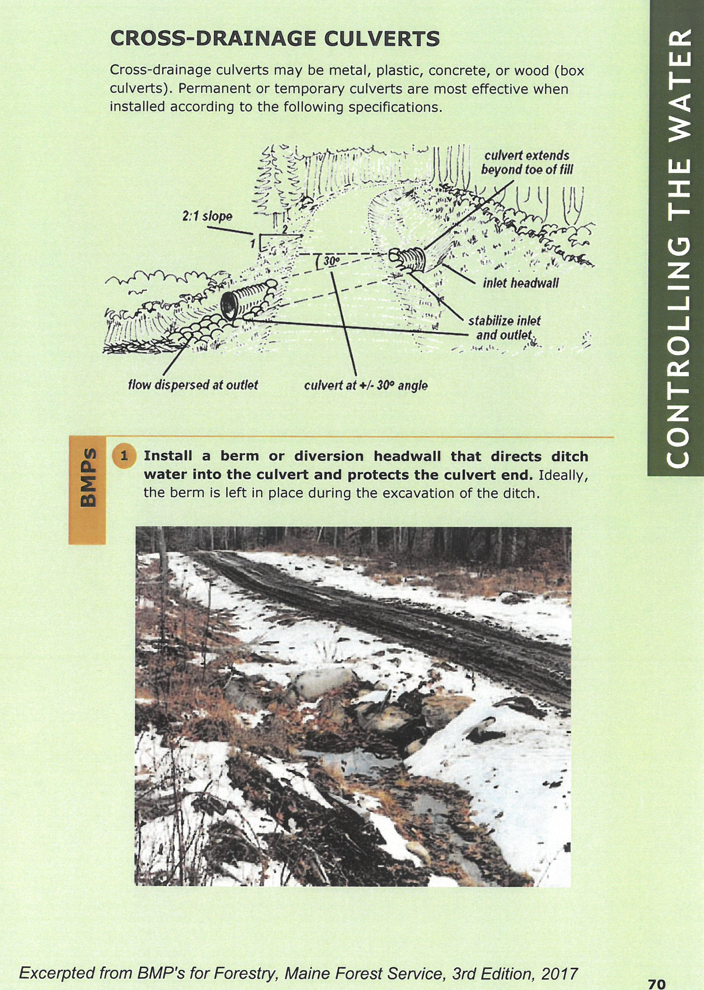

APPENDIX G Continued

BMPs Cross-Drainage Culvert Part 2
