STATE OF MAINE
Governor’s Office of Policy Innovation and the Future Children’s Cabinet
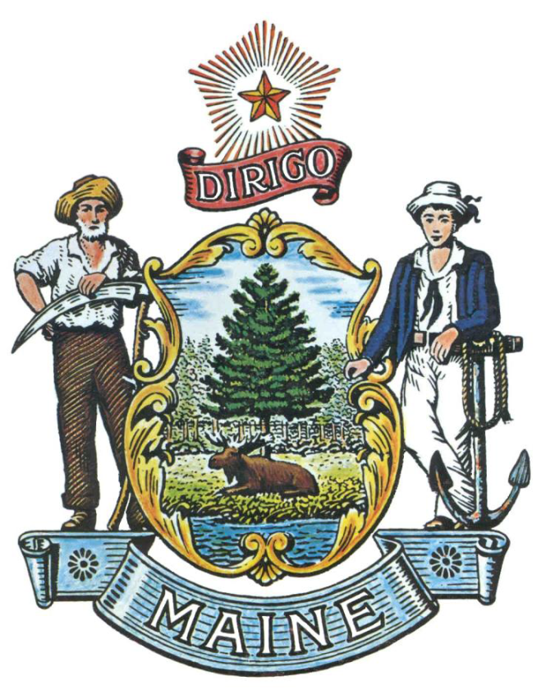

REQUEST FOR INFORMATION

RFI# 202112190

Career Exploration and Meaningful Paid Work Experience Programming
for Maine Youth

RFI Coordinator | All communication regarding this RFI must be made through the RFI Coordinator identified below.  Name: Ana Hicks Title: Senior Policy Analyst & Children’s Cabinet Coordinator  Contact Information: ana.hicks@maine.gov
Informational Meeting | Date: Monday, December 20, 2021Time: 3:00 p.m., local time  Location: Register for this meeting at this link:  https://mainestate.zoom.us/meeting/register/tZcsc-2tqjItE92Q7imyxObVVJNZEGrZKJNO
Submitted Questions Due | All questions must be submitted to the RFI Coordinator identified above by:  Date: December 30, 2021, no later than 5:00 p.m., local time
Response Submission | Submission Deadline: January 18, 2022, no later than 5:00 p.m., local time  Submit to: ana.hicks@maine.gov

TABLE OF CONTENTS

PUBLIC NOTICE 3

RFI DEFINITIONS/ACRONYMS 4

PART I INTRODUCTION 5

- PURPOSE AND BACKGROUND
- CURENT CONDITIONS
- CHALLENGE STATEMENT
- GENERAL PROVISIONS

PART II INFORMATION SOUGHT 7

- GENERAL INFORMATION
- FEEDBACK REQUESTED

PART III KEY RFI EVENTS AND PROCESSES 11

- INFORMATIONAL MEETING
- QUESTIONS
- SUBMITTING THE RESPONSE

PART IV REVIEW OF RESPONSES RECEIVED 12

RFI APPENDICES AND RELATED DOCUMENTS

RESPONSE COVER PAGE 13
SUBMITTED QUESTIONS FORM 14

PUBLIC NOTICE

*************************************************

State of Maine
Children’s Cabinet, Governor’s Office of Policy Innovation and the Future
RFI# 202112190
Career Exploration and Meaningful Paid Work Experience Programming for Maine Youth

The State of Maine, Children’s Cabinet coordinated by the Governor’s Office of Policy Innovation and the Future, is seeking information regarding Meaningful Paid Work Experience and Career Exploration programming for Maine youth.

A copy of the RFI, as well as the Question & Answer Summary and all other related documents to this RFI, can be obtained at the following website: http://www.maine.gov/dafs/bbm/procurementservices/vendors/rfis

An Informational Meeting will be held virtually on Monday, December 20, 2021 at 3:00 pm. Please email ana.hicks@maine.gov for the link to the Informational Meeting.

Responses must be submitted to: ana.hicks@maine.gov and be submitted by 5:00 pm, local time, on January 14, 2021.

*************************************************
RFI DEFINITIONS/ACRONYMS

The following terms and acronyms shall have the meaning indicated below as referenced in this Request for Information:

Term/Acronym | Definition
RFI | Request for Information
RFP | Request for Application
Respondent | Any individual or organization submitting a response to this RFI.
FOAA | Maine Freedom of Access Act
Department | Children’s Cabinet, Governor’s Office of Policy Innovation and the Future
State | State of Maine
Youth | Individuals aged 16 years old to 24 years old
Meaningful Paid Work Experience | A work-based experiential learning opportunity for youth to address a defined problem or participate in a project that is of value to an employer and provides an opportunity to reflect on the challenges and solutions. Meaningful paid work experience gives youth the opportunity to gain valuable applied experience in a business, non-profit or the government sector and make connections in professional fields they are considering for career paths. It includes an opportunity to learn foundational skills as well as 21st century skills, such as creativity, communication, collaboration, critical thinking, technology and decision making.
Career Exploration, including Extended Learning Opportunities | Career exploration connects students with workforce opportunities in their communities by providing youth with direct interaction with businesses, non-profits and/or the government sector to understand career opportunities that align with their interests. This includes extended learning opportunities, which means the acquisition of knowledge and skills, using defined objectives, through flexible instruction or study outside of the traditional classroom methodology. Career exploration includes, but is not limited, to:  - Internship  - Job Shadow  - Mentorship  - Apprenticeship  - Digital Learning  - Independent Study  - Mentorships  - Community service
Mentor | An experienced person who provides a younger or less experienced person help and advice over a determined span of time, especially at work or school through a formal relationship with professional expectations. There is a guidance expectation, mentor to mentee, for a pre-determined length of time.

State of Maine
Children’s Cabinet, Governor’s Office of Policy Innovation and the Future
RFI# 202112190
Career Exploration and Meaningful Paid Work Experience Programming
for Maine Youth

PART I INTRODUCTION

A. Purpose and Background

This Request for Information (RFI) is an information gathering and market research tool, not a formal solicitation of a specific requirement (such as in a “Request for Proposals” document). The Children’s Cabinet coordinated through the Governor’s Office of Policy Innovation and the Future (“Department”) is seeking information regarding Career Exploration and Meaningful Paid Work Experience Programming for Youth in Maine from interested parties as defined in this RFI document. This is an opportunity for interested parties to help the Department better understand a marketplace and/or specific subject matter.

The Governor’s Children’s Cabinet is seeking information regarding Meaningful Paid Work Experience and Career Exploration programming serving historically underserved youth aged sixteen (16) through twenty-four (24) in Maine. The Cabinet would like to learn more about programming in Maine that is supporting youth to access meaningful paid work experience and understand and be exposed to career opportunities and pathways to prepare them to enter the workforce or post-secondary education.

The purpose of this request for information is to gather public input on:

- Existing meaningful paid work experience and career exploration programming for key populations of youth, including but not limited to youth with disabilities, connected to the juvenile justice system, experiencing homelessness, transitioning in or out of the foster care system and with low-income and youth of color and from indigenous communities;
- Gaps in programming and supports for these groups of youth;
- Effective career exploration practices and programs; and
- What support services are critical to enable these youth to successfully participate in career exploration opportunities.

Participation in this RFI process is optional. Feedback is greatly appreciated and will inform the development of targeted efforts to serve historically underserved youth, including but not limited to those identified above.

B. Current Conditions

This RFI is part of a larger effort to expand meaningful paid work experience and career exploration programming for Maine children and youth as part of the Maine Jobs and Recovery Plan. The Children’s Cabinet is committed to ensuring that all Maine youth enter adulthood healthy, connected to the workforce and/or education. The Maine State Economic Plan sets a goal of having every Maine student participate in an internship between their junior year and their first year in college.

C. Challenge Statement

Through this RFI, the Governor’s Children’s Cabinet seeks to identify existing meaningful paid work experience and career exploration programming for youth, best practices and effective models and the barriers for expanding programming, particularly for historically underserved youth.

D. General Provisions

- All contact with the State regarding this RFI must be made through the aforementioned RFI Coordinator. No other person/ State employee is empowered to make binding statements regarding this RFI.
- This is a non-binding Request for Information. Therefore, no award shall be made as a result of the RFI process.
- Issuance of this RFI does not commit the Department to pay any expenses incurred by a Respondent in the preparation of their response to this RFI. This includes attendance at personal interviews or other meetings and software or system demonstrations, where applicable.
- Issuance of this RFI in no way constitutes a commitment by the State of Maine to issue a Request for Proposal (RFP).
- All responses should adhere to the instructions and format requests outlined in this RFI and all written supplements and amendments, such as the Summary of Questions and Answers, issued by the Department.
- All submissions in response to this RFI will be considered public records available for public inspection pursuant to the State of Maine Freedom of Access Act (FOAA) (1 M.R.S. §§ 401 et seq.): State of Maine Freedom of Access Act
- All applicable laws, whether or not herein contained, shall be included by this reference. It shall be Proposer’s/Vendor’s responsibility to determine the applicability and requirements of any such laws and to abide by them.

PART II INFORMATION SOUGHT

The Department seeks information regarding career exploration and meaningful paid work experience programming for youth aged sixteen (16) to twenty-four (24) and welcomes responses to this RFI, including creative suggestions and feedback to enhance and expedite all future processes while providing reliable and high-quality outcomes. Respondents are not required to submit responses pertaining to every question, but the Department encourages interested parties to respond to any or all relevant aspects of the RFI.

The Department seeks detailed yet succinct responses that demonstrate the Respondent’s experience and/or familiarity with the subject matter. As this is not a competitive RFP process, Respondents must not provide any specific cost or customized pricing documentation in their response.

- General Information

Provide a brief overview of yourself and your organization, if applicable.
  - Please identify yourself and any organization you represent in this RFI.
    - Name of respondent
    - Organization and affiliation
    - Address (organizational, if responding on behalf of an entity)
    - Contact information (phone number(s) and email address)

  - Please identify your experiences in providing career exploration and meaningful paid work experience to youth aged 16 to 24 in Maine.

- Feedback Requested

- Respondents are encouraged to answer all applicable questions within this RFI:

- Please describe who your organization serves (include information about age and demographics of participants) and the services, supports and programming related to meaningful paid work experience and/or career exploration, including extended learning opportunities and work-based learning.

- Please describe the staffing and mentoring provided to support youth and any relevant outcomes related to this support.
- Does your organization engage or hire young people to serve in leadership roles, such as peer navigators or mentors, in your career exploration programming?
- Does your organization hire staff who represent the targeted population?

- If your organization provides opportunities for youth to participate in meaningful paid work experience, please describe the length of these programs and if and how youth are compensated for their work.

- Are there youth who you and/or other organizations in your community are unable to engage and serve?

- Why are you unable to do so?
- Are you interested in reaching these youth and what supports would you and they need to do so?
- What kind of additional meaningful paid work experience and/or career exploration programming would you provide?

- What barriers do youth face in participating in your programs or other meaningful paid work experience and/or career exploration programs?
  - Please provide details about the specific populations you serve and the barriers that these groups of youth face.
  - Does your organization support youth to overcome these barriers and, if so, how?
  - What types of supports do you provide?
  - What supports are you unable to provide that you think could strengthen your programming?

- What kinds of partnerships has your organization established with other community programs, state agencies, and/or public schools and educational institutions (such as local community colleges or adult education) to recruit, engage and serve youth?

- Please describe models of engagement that your organization has found helpful in supporting youth to participate in meaningful paid work experience.
  - Explain the types of supports and services provided to youth in the models implemented.
  - Please share other best practices, either from existing community programming or programming from other states, that you think should be replicated in Maine to support youth to connect to meaningful paid work experience.

- Does your program work with youth to create linkages to career pathways and develop career path plans?
  - Does your program make linkages between academic studies and work-based learning to encourage on-going training and/or education?
  - If yes, how so?

- What steps have you taken to recruit and sustain engagement by employers?
    - What types of employers are engaged with your program? What sectors do they represent?
    - Does your organization conduct any type of readiness assessment with employers to determine if they need additional supports to ensure a successful partnership with participating youth?

- How do you engage and support employers to be mentors for youth and young adults participating in your programs?
  - How does your organization assess the quality of the employers participating in your programs?

- Does your organization engage parents of youth in your program?
  - If yes, please describe the ways in which you engage and/or support parents of youth.

- How does your organization track and measure the effectiveness of your meaningful paid work experience and or career exploration programming for youth?

- Would your organization apply for a grant that supports community programs to expand meaningful paid work experience and or career exploration opportunities for historically underserved youth?

PART III KEY RFI EVENTS AND PROCESSES

- Informational Meeting

The Governor’s Office of Policy Innovation and the Future will host an Informational Meeting concerning this RFI beginning at the date, time and location shown on the RFI cover page. The purpose of the Informational Meeting is to provide interested parties with additional information related to this RFI, field questions, and clarify any questions as to this RFI request.

Questions

1. General Instructions
- It is the responsibility of each interested party to examine the entire RFI and to seek clarification, in writing, if they do not understand any information or instructions.
- Interested parties should use Appendix B – Submitted Questions Form – for submission of questions.
- The Submitted Questions Form must be submitted by e-mail and received by the RFI Coordinator, identified on the cover page of this RFI, as soon as possible but no later than the date and time specified on the RFI cover page.
- Submitted Questions must include the RFI Number and Title in the subject line of the e-mail. The Department assumes no liability for assuring accurate/complete/on time e-mail transmission and receipt.

2. Question & Answer Summary
Responses to all questions will be compiled in writing and posted on the following website: http://www.maine.gov/dafs/bbm/procurementservices/vendors/rfis. It is the responsibility of all interested parties to go to this website to obtain a copy of the Question & Answer Summary. Only those answers issued in writing on this website will be considered binding.

Submitting the Response

- Responses Due
Responses must be received no later than the date and time listed in the timeline above.

- Delivery Instructions
Responses must be submitted to the RFI Coordinator, via e-mail, listed on the cover page of this RFI document.

- Response Format
Responses to this RFI may be developed in a manner that suits the respondent. A list of key questions is included within the RFI and all submissions, regardless of format will be reviewed. Respondents are asked to be brief and to respond to as many questions as possible within the RFI. Number each response to correspond to the relevant question or instruction of the RFI to allow comparison and clarity.

PART IV REVIEW OF RESPONSES RECEIVED

General Information

- The Department will review responses received for the purpose of gathering information and market research only. The Department will not score or rate responses received.

- The Department reserves the right to communicate and/or schedule interviews/presentations with Respondents, if needed, to obtain clarification of information contained in the responses received and/or additional information to enhance marketing research efforts.

APPENDIX A

STATE OF MAINE
Children’s Cabinet, Governor’s Office of Policy Innovation and the Future

RESPONSE COVER PAGE
RFI# 202112190
Career Exploration and Meaningful Paid Work Experience Programming
for Maine Youth

Lead Point of Contact - Name/Title:
Organization Name (if applicable):
Tel: |  |  | Fax:
E-Mail: |  |  | Website:
Street Address:
City/State/Zip:

APPENDIX B

State of Maine
Children’s Cabinet, Governor’s Office of Policy Innovation and

SUBMITTED QUESTIONS FORM
RFI# 202112190
Career Exploration and Meaningful Paid Work Experience Programming
for Maine Youth

Organization/Responder’s Name:

RFI Section & Page Number | Question

* If a question is not related to any section of the RFI, state “N/A” under “RFI Section & Page Number”.
** Add additional rows, if necessary.

