STATE OF MAINE
Maine Public Utilities Commission

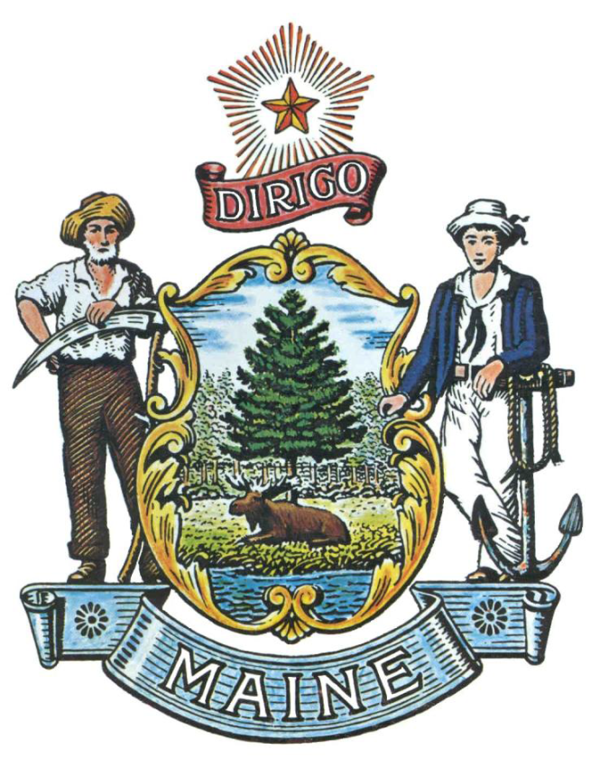

REQUEST FOR INFORMATION

RFI# 202110158

Statewide On-Line Energy Data Platform

RFI Coordinator | All communication regarding this RFI must be made through the RFI Coordinator identified below.  Name: Jamie Waterbury Title: RFI Coordinator  Contact Information: Jamie.A.Waterbury@Maine.gov
Submitted Questions Due | All questions must be submitted electronically to the RFI Coordinator identified above by:  Date: November 9, 2021, no later than 5:00 p.m., local time
Response Submission | Submission Deadline: November 29, 2021, no later than 5:00 p.m., local time  Submit to: Jamie.A.Waterbury@Maine.gov electronically via email.

TABLE OF CONTENTS

PUBLIC NOTICE 3

RFI DEFINITIONS/ACRONYMS 4

PART I INTRODUCTION 5
- PURPOSE AND BACKGROUND
- CURRENT CONDITIONS
- CHALLENGE STATEMENT AND OVERVIEW OF PROPOSED PLATFORM
C.1 High Level Contemplated Operational Model
C.2 Use and User Cases
C.3 Proposed Logical Data Model
- GENERAL PROVISIONS

PART II INFORMATION SOUGHT 14
- GENERAL INFORMATION
- FEEDBACK REQUESTED

PART III KEY RFI EVENTS AND PROCESSES 18

PART IV REVIEW OF RESPONSES RECEIVED 19

RFI APPENDICES AND RELATED DOCUMENTS
APPENDIX A - RESPONSE COVER PAGE
APPENDIX B – VENDOR SUBMITTED QUESTIONS FORM
APPENDIX C – LEGISLATIVE RESOLVE

PUBLIC NOTICE

*************************************************

REQUEST FOR INFORMATION
RFI# 202110158
Statewide On-Line Energy Data Platform

The Maine Public Utilities Commission (Commission) seeks information regarding a statewide on-line multi-user energy data platform under consideration by the State of Maine. The Maine Legislature passed a new law requiring the Commission to issue an RFI to explore the feasibility of such a platform, to include identifying possible solutions and related costs as described in the Legislative Resolve (Resolves 2021, Ch. 63). Based on the data collected from the RFI, the Commission will issue a report to the Energy, Utilities and Technology Committee of the Legislature by January 31, 2022.

A copy of the RFI, as well as the Question & Answer Summary and all other related documents to this RFI, can be obtained at the following website: http://www.maine.gov/dafs/bbm/procurementservices/vendors/rfis

Responses must be submitted to: Jamie.A.Waterbury@Maine.gov and be submitted by 5:00 pm, local time, on November 29, 2021.

*************************************************

RFI DEFINITIONS/ACRONYMS

The following terms and acronyms shall have the meaning indicated below as referenced in this Request for Information:

Term/Acronym | Definition
Department or Commission | Maine Public Utilities Commission
Platform or Portal | Proposed Multi-User On-line Energy Data system. These two terms will be used interchangeably in this document.
Resolve | Legislation directing the issuance of this RFI – included as Appendix C
Respondent | Any individual or organization submitting a response to this RFI.
RFI | Request for Information
State | State of Maine
Authenticated | User has provided appropriate credentials to access the platform
Authorized | User has received authorization from account owner as a third party who may view/export specific data
API | Application Programming Interface – backend software specification that enables exchange between systems
CSV | Comma Separated Values file for import into spreadsheet
Energy Star Portfolio Manager | A tool provided by the Federal Environmental Protection Agency (EPA) to provide benchmarking of a building's use of energy against other similar buildings.
Green Button or GBC | Standards entity Green Button Alliance, Connect My Data Standard (Connect My Data - CMD (greenbuttonalliance.org) ) and Download My Data Standard Green Button Alliance - Testing Program
XML | Extensible Markup Language – data format encoded with rules for formatting data, another method for exchanging data between systems.

State of Maine – Public Utilities Commission
RFI# 202110158
Statewide On-Line Energy Data Platform

PART I INTRODUCTION

A. Purpose and Background

This Request for Information (RFI) is an information gathering and market research tool, not a formal solicitation of a specific requirement (such as in a “Request for Proposals” document). The Maine Public Utilities Commission (“Department or Commission”) is seeking information from interested parties regarding the feasibility of a statewide on-line, multi-user, energy data platform as described in this RFI document. The Legislative Resolve directing the Commission to issue this RFI and outlining the proposed platform is included as Appendix C.

This is an opportunity for interested parties to help the Commission better understand energy data platform solutions as well as the feasibility of solutions that can address the requirements articulated in this RFI.

B. Current Conditions

Available energy use data in the State of Maine is somewhat limited. Some utilities offer a few views of meter readings in chart form, by account, primarily for residential customers. These views offer perhaps 13 months of history. These sites also offer the ability to export the account data in CSV or Green Button XML.

When entities (non-account owner) need access to data from multiple accounts, a request is made to each utility for a "one-off" download of requested data. Because they are custom products, these requests may take weeks to be fulfilled.

Utility Demographic Overview

The proposed Platform will gather data from six Maine Utilities. Two electric utilities serving 95% of the state, and four natural gas utilities. The number of customers for each utility is detailed below as of December 2020.

Utility Name | Customers
Central Maine Power Company (electric) | 559,516
Versant Power (electric) | 133,671
Maine Natural Gas | 5,003
Summit Natural Gas | 3,545
Bangor Gas | 6,899
Until | 32,871

Required Utility Data

Respondents should assume that all required data from the utilities will be provided in a standard format such that the proposed platform can effectively utilize the pertinent data.

C. Challenge Statement and Overview of Proposed Platform

There is a desire by several different entities for access to energy use information (electric and gas) for a variety of reasons, many related to reducing energy use or modifying sources of energy to shrink greenhouse gas emissions in the State of Maine. The legislation seeks to encourage and support this desire for information that is not yet readily available. There are some capabilities based on customer accounts available from utilities, but these are not available to non-customers, and customers of multiple energy sources do not have the ability to see the whole picture of their energy usage.

Prospective users of the Platform are also interested in aggregated data, from the concept of a building (e.g. a multi-tenant building with several meters/accounts) to several buildings of certain use types, etc., to neighborhoods, etc.

At a high level, the concept is for the platform to be able to provide electric and gas usage information for the following categories:

    - Residential – owner occupied or single tenant
    - Residential – multi-tenant buildings
    - Commercial/Industrial – owner occupied or single tenant
    - Commercial – multi-tenant buildings
    - Mixed Use – mix of Residential and Commercial tenants in one building
    - Government-Owned buildings – state, county, local

Therefore, the Commission is exploring what systems, software, and tools may be available in the marketplace to support this access to individual and aggregate energy usage data for multiple user types and from multiple energy sources.

C.1 High Level Contemplated Operational Model

Below is an introductory representation of what would be the sources and uses in terms of data flow of this Platform.

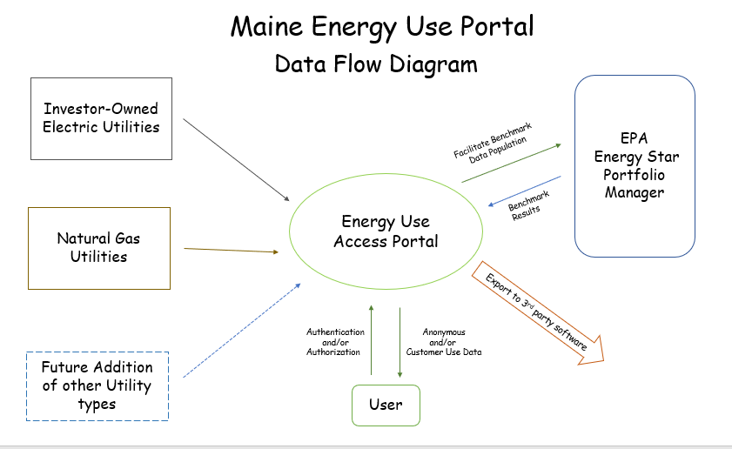

C.2 Use and User Cases

The term Use Case is used to describe how the platform will be used or accessed and is not meant to be a formal Use Case as normally used in IT/Systems projects. The Use Cases are at a very high level so as not to potentially preclude ideas that could come out of this RFI process.

Use cases 1, 2, and 3 below are framed in terms of Platform access, data authorization, and data export.

Use Case Number 1
Use Case Name | 1. User authentication to Platform
Description of Use | Any person wishing to access data through the Platform must authenticate to the Platform's Security requirements – this is for all users.
Proposed Steps of Use | - User creates account using credentials required by the Security protocols of the Platform  - System validates authentication using the Platform's security protocols and notifies user that account has been created  - User logs in using the newly created account and can access to anonymous, aggregated data
User Objectives and Estimated Benefits | Provides the ability for any person who wishes to use the Platform to authenticate themselves as valid users. This gives the user viewing capability to anonymous, aggregated energy data to explore energy use information and changes over time, etc.
Policy Development/ Change or Standard to Allow this Usage | Use of computer industry standards for secure creation and authentication to an account on the Web where Personal or Sensitive information may be available.

Use Case Number 2

Use Case Name | 2. User Authorization to Specific Customer Data in Platform
Description of Use | Any person wishing to access specific customer data through the Platform must authenticate to the Platform's Security requirements and present Authorization credentials for access to specific customer data (not-anonymous).
Proposed Steps of Use | - User with authenticated account presents Authorization from customer(s) to access customer's information  - Customer's Authorization includes time frame of data access authorized – one-time versus ongoing, historic vs. day forward  - System validates Authorization using the Platform's Data Authorization protocols and notifies user that Authorization has been granted for the specific account(s).  - User can now view specific, non-aggregated data for their authorized accounts
User Objectives and Estimated Benefits | Provides a mechanism to provide specific users access to view specific account-based energy use data to explore usage information and changes over time, etc.
Policy Development/ Change or Standard to Allow this Usage | Expressed authorization for access from each owner or tenant must be documented. Rules governing this process must be developed.

Use Case Number 3

Use Case Name | 3. Export to external software/tools
Description of Use | Any authenticated user may elect to export the data they have authorization to view
Proposed Steps of Use | - User with authenticated account, which may also have Authorization for access to specific data, queries the desired data and selects option to export.  - Export options allowed are Green Button DownloadMyData format or CSV format.
User Objectives and Estimated Benefits | Provides a mechanism to provide specific users the ability to port their data to tools that provide more robust functionality for analyzing data than provided in the Platform.
Policy Development/ Change or Standard to Allow this Usage | Expressed authorization for access from each owner or tenant must be documented. Rules governing this process must be developed.  GreenButtonAlliance standard to be a required export format.

Use Cases 4 through 8 below are framed around the anticipated different users and what the Commission understands these users would like to see and do with energy use data.

Use Case Number 4

Use Case Name | 4. Municipal and Regional Government Energy Planning
Description of Use | Sustainability managers in cities and towns wish to access energy use data by building in their town. They will use this data to develop goals and programs to encourage efficient use of energy or to encourage electrification goals.
Proposed Steps of Use | - View aggregations of building data into Groups by building use type, building size, building age, Street(s) on which building sits, customer rate class, energy supplier type (standard offer versus competitive suppliers), etc.  - View of electric and gas usage by Group where applicable  - View of usage by Group change over time
User Objectives and Estimated Benefits | Provides the ability for Municipal officials to target opportunities for energy use reduction and to view changes over time to measure success of programs.  Offers improved understanding of the effectiveness of Benchmarking requirements.
Policy Development/ Change or Standard to Allow this Usage | Creation of Threshold for access to building information without expressed authorization for access from each owner or tenant. Additionally, policy should take into consideration the sensitivity of other data such as very large or military customers.  Creation of standard/process for identifying a Building

Use Case Number 5

Use Case Name | 5. Non-Authorized Third-Party View of data by Building (non-utility entities such as, distributed energy resource providers, non-profits, researchers, etc.)
Description of Use | Third Party wishes to access energy use data by building. They will use this data to develop strategies for usage reduction or for opportunities to sell energy alternatives, to understand usage trends.
Proposed Steps of Use | - Party accesses anonymous usage data as described in threshold.  - Aggregation of building data into Groups by building use type, building size, Street(s) on which building sits.  - View of electric and gas usage by Group where applicable  - May elect to Export data to external software tools
User Objectives and Estimated Benefits | Provides the ability for Third Parties to view usage and changes over time to target opportunities for use reduction or for use of alternative energy sources, etc.
Policy Development/ Change or Standard to Allow this Usage | Creation of Threshold for access to building information without expressed authorization for access from each owner or tenant. Additionally, policy should take into consideration the sensitivity of other data such as very large or military customers.  Creation of standard/process for identifying a Building

Use Case Number 6

Use Case Name | 6. Authorized Third-Party (non-utility entities such as distributed energy resource providers, energy managers, power aggregators, etc.)
Description of Use | Third Party wishes to access energy use data as authorized by building as well as by account/meter. They will use this data to develop strategies for usage reduction or for opportunities to sell energy alternatives.
Proposed Steps of Use | - User presents Authorization credentials to system for access to energy customer information (not anonymous)  - System validates authorization  - User can see usage information for all entities for which user has authorization.  - User selects View types and time frames/intervals which display by building and at the account level.  - User can export data to Energy Star Portfolio Manager (ESPM) and can import benchmark results from ESPM.  - May elect to Export data to other external software tools
User Objectives and Estimated Benefits | Provides the ability for Third Parties to target opportunities for use reduction by alternative energy sources, etc. and to view changes over time.
Policy Development/ Change or Standard to Allow this Usage | Expressed authorization for access from each owner or tenant must be documented. Rules governing this process must be developed.  Creation of standard/process for identifying a Building

Use Case Number 7

Use Case Name | 7. Commercial Building Owners to see usage data for whole building and export into Energy Star Portfolio Manager for benchmarking
Description of Use | Owners of commercial buildings may have benchmarking requirements or may want to understand the energy usage of the building to plan improvements
Proposed Steps of Use | - Enter building identification information to retrieve, to authenticate as owner of said building. If multi-tenant building where tenants pay their energy bills, then owner must get authorization from each tenant to view whole building energy use data.  - View of electric and gas usage where applicable  - View of usage change over time  - Export building data to Energy Star Portfolio Manager to initiate Benchmarking process  - Import Benchmark results into Platform for review
User Objectives and Estimated Benefits | Provides the ability for Commercial Building Owners to more easily view the energy usage in their buildings  Provides the ability to track changes in usage over time to measure success of improvements made and to target opportunities for energy use reduction.
Policy Development/ Change or Standard to Allow this Usage | Authorization process for direct access to owner's accounts.  Creation of standard/process for identifying a Building.

Use Case Number 8

Use Case Name | 8. Residential Customers to see usage data for their home or apartment
Description of Use | Residents of homes and apartments want to understand the energy they use in order to identify opportunities for conservation or improvements
Proposed Steps of Use | - Enter Account information to achieve authorization to view data associated to the meter/account for electric and gas usage as applicable.  - Ability to retrieve interval data down to 15 minutes  - View of usage change over time, up to 4 years
User Objectives and Estimated Benefits | Provides the ability for Residential Customers to more easily view their total energy usage by bringing Gas and Electric data together.  Provides the ability to track changes in usage over time to target opportunities for energy use reduction and to measure success of improvements/changes made.
Policy Development/ Change or Standard to Allow this Usage | Authorization process for direct access to owner's accounts.

C.3 Proposed Logical Data Model

The following is a high-level overview of the data aspects of the Platform. The Platform will combine all required utility data into a single, cohesive data set that can be interpreted and processed by third-parties. For purposes of the RFI response, please assume that data will be standardized and coordinated across the six utilities.

The State of New Hampshire has developed a detailed understanding of the data needs for an effective platform. This RFI relies heavily on the good work conducted in New Hampshire. The following chart describes some of the data elements necessary for the proposed platform. The fields detailed in the chart below provide a framework for this RFI using common utility terms, units of measurements, etc. This information and data model will allow for multi-utility data to be combined using tools such as APIs and hopefully remove ambiguity around utility data differences.

Other elements of these integration tools, including how authentication and authorization is handled, how requests and responses are formed, status codes to be used, etc. will also need to be defined at some future point to ensure the data platform is implemented consistently.
The intent is that these elements, where applicable, will be based on the Green Button Alliance Connect and Download standards.

Below are the data components considered necessary for the Platform to offer to its users. Definitions are not fleshed out at this point in the process of planning a solution but are included to assist with scoping and rough estimations. It is important to know that this is very much a draft and will be refined and enhanced in the design and development of a Platform.

C.3.1 Envisioned Data Fields

Field Category/Field | Expected Value
Electric or Gas Service Point Information:
Distribution Company | Utility Name or ID bringing energy to the service point
Energy Type Commodity | Gas or Electric
Service Location Address | Ideally 9-1-1 address, or location description
Meter ID
Meter Reading Previous
Meter Reading Current
Measured Consumption last month
Measured Consumption this month
Average Demand/Load
Average Demand Peak
Peak Time
Customer Information:
Account Number
Customer Name
Customer Email
Customer Phone
Customer Account Address | Customer mailing address
Customer Rate Code | Service class
Tariff
Energy Supplier | Supply Company Name/ID or Standard Offer
Account Start Date
Account End Date
Billing Period | Start and End Date
Bill amount | Current Bill Total
Customer Charge
Delivery Charge
Standard Offer/CEP Charge
Tax | Dollar amount

C.3.2 Aggregated Data

While the above model outlines customer specific data to be available in the Platform, aggregated data is also highly sought after through this model. Aggregation must protect individual account owners' privacy. Here are some thoughts on how data might be aggregated for this purpose.

- Aggregation for unauthorized users must be anonymous in terms of personal identification data. A policy threshold for inclusion in an aggregation is expected to be developed to guide the aggregation and view process.

- One desired aggregation is by building for commercial buildings. This aggregation likely would use a threshold so that data would be available where tenants make up more than a threshold number of units/accounts/meters.

- Where a single account/customer can be identified in an aggregation (e.g. one customer uses 90% of the energy used in a multi-tenant building or single customer commercial building with no personal information but identifiable by size or location), the aggregation algorithms should either omit that customer or somehow anonymize the data.

- Aggregation granularity starts with the building level and offers/allows further aggregation by building use type, customers type/rate class, street, neighborhood, town.

D. General Provisions of the RFI

- All contact with the State regarding this RFI must be made through the aforementioned RFI Coordinator. No other person/ State employee is empowered to make binding statements regarding this RFI.
- This is a non-binding Request for Information. Therefore, no award shall be made as a result of the RFI process.
- Issuance of this RFI does not commit the Commission to pay any expenses incurred by a Respondent in the preparation of their response to this RFI. This includes attendance at personal interviews or other meetings and software or system demonstrations, where applicable.
- Issuance of this RFI in no way constitutes a commitment by the State of Maine to issue a Request for Proposal (RFP).
- All responses should adhere to the instructions and format requests outlined in this RFI and all written supplements and amendments, such as the Summary of Questions and Answers, issued by the Commission.
- All submissions in response to this RFI will be considered public records available for public inspection pursuant to the State of Maine Freedom of Access Act (FOAA) (1 M.R.S. §§ 401 et seq.): State of Maine Freedom of Access Act
- All applicable laws, whether or not herein contained, shall be included by this reference. It shall be Proposer’s/Vendor’s responsibility to determine the applicability and requirements of any such laws and to abide by them.

PART II INFORMATION SOUGHT

The Commission seeks information regarding Multi-Utility, Multi-User Energy Use Data Platforms and encourages responses to this RFI to help the Commission provide the Legislature with knowledge of both existing systems as well as a sense of what it would take to have a system that meets all aspects detailed in this RFI. Respondents are not required to submit responses pertaining to every question, but the Commission encourages interested parties to respond to any or all relevant aspects of the RFI.

The Commission seeks detailed yet succinct responses that demonstrate the Respondent’s experience and familiarity with the subject matter. The Commission is very interested in cost information, but because this is not a competitive RFP process, Respondents must not provide any specific cost or customized pricing documentation in their response. See section B.5 below.

- General Information

Provide a brief overview of yourself and your organization, if applicable.

A.1. Please identify yourself and any organization you represent in this RFI.
    - Name of respondent
    - Organization and affiliation
    - Address (organizational, if responding on behalf of an entity)
    - Contact information (phone number(s) and email address)

A.2. Please identify your experiences in providing Multi-Utility, Multi-User, Energy Use Data Systems.

- Feedback Requested

Below is a list of questions the Commission has developed to help explore how an Energy Use Platform, as expressed in the Legislation, might work. The Commission seeks information about the data aspects of the Respondent's solution as well as the proposed platform solution. These questions are not exhaustive, Respondents are encouraged to fill in gaps that would help to flesh out the solution. Respondents may elect to skip some questions, but the State of Maine would benefit from any input the Respondent can offer based on their experience in this industry space.

B.1 Data Exchange Questions
B.1.1 What common energy related data can be obtained and used in a wide range of applications and business uses?

  - What data does the Respondent's solution currently use?

  - Does the Respondent feel it is feasible to collect all of the data contemplated in this RFI?

B.1.2 Please describe the software, methods, and processes used in your software implementations to "Pull" data from utilities, both Electric and Gas. Please include the granularity of data you import and the import timing. Please describe the challenges and limitations you have encountered as you design and build these import mechanisms to retrieve data from these entities.

B.1.3 What has been required of participating utilities in order to implement a successful platform?

B.1.4 How does your system protect utility customers from unauthorized disclosure of personally identifiable information and ensure customer privacy rights?

B.1.5 Have you included imports to your software from Energy Star Portfolio Manager such as Benchmark results for buildings? Please describe the challenges, limitations, and opportunities you have experienced with interaction to the Portfolio Manager.

B.2 Questions on Security, Standards, and Policies
B.2.1 What specific and well-documented standards for data accuracy, retention, availability, privacy and security are required to implement a successful Platform?
  - In terms of data accuracy standards, data interval offerings, and data retention,
    - What has worked well?
    - Conversely, what has/does not work well?
B.2.2 Please list the web security standards you have employed in the implementation of Platform account creation and authentication.
B.2.3 Does your system allow for the sharing of individual customer energy data and provide an opt-in option for utility customers to share data with 3rd parties? If yes,
a. Please describe the methods and/or software you have used to receive, certify, and respond to user requests for authorization to access customer specific data?
b. Do you accommodate both one-time and ongoing authorization?
c. Is there a significant human component in your authorization process?
B.2.4 Have you developed the ability to associate meters and/or accounts to a building, or to define what is a building and to identify a building? Does the concept of a building play a role in your system?
B.2.5 Have you incorporated non-authorized, multi-customer data aggregation in your implementations? If yes,
a. Please describe the process used to remove identifying information.
b. Is a threshold implemented to avoid inclusion of identifying information even when personal information is not present?
B.2.6 What are the usage entity types (building types, account types) your system accommodates? Does your system include residential accounts? Are there any opportunities to include Electric Vehicle Charging Stations as usage entities?
B.2.7 How does your solution satisfy requirements for certification from the Green Button Alliance and support the Green Button "Connect My Data" standard (the energy service provider interface of the North American Energy Standards Board, REQ.21) Connect My Data - CMD (greenbuttonalliance.org).

B.3 Questions regarding Platform functionality
B.3.1 Please offer suggestions for minimum required information/data and functionality to support the basic objectives of the Platform, based on the directives listed in the Resolve (Appendix C).
B.3.2 Please describe the data export functionality in your implementations, include discussion of export of aggregated information.
B.3.3 Please describe the Data Viewing functionality offered in your system.
- Can users view multiple energy type data (electric and gas) for a single location (building, unit, customer, etc.)
- Can these be viewed together in a normalized fashion (e.g. gas and electric expressed in a single unit of measure for comparison)?
- Can users view aggregated data and if yes, in what ways?
- Does your system incorporate charts and/or maps?
- Do your Views show comparisons of the use of similar entities (buildings, etc.)?
- Does your system accommodate Net Metering data (e.g. usage data flowing two ways through the electric utilities)?

B.4 Questions on Governance, Scalability, etc.
B.4.1 In your experience implementing your software, who have been the primary users of the energy usage data and software functionality?
B.4.2 In your experience, what entity(ies) have owned/licensed your software? Who hosts the platform?

B.4.3 In your experience, how have your implementations been funded?

B.4.4 In your experience, how have your implementations been governed?

B.4.5 Has your solution included a provision for voluntary participation of consumer-owned transmission and distribution utilities and municipal power districts, and if yes, how has your infrastructure accommodated this inclusion?

B.4.6 Are you aware of any state, county, or large city that has implemented a Platform similar to that contemplated by this RFI?

B.4.7 Please offer any additional information that we have not requested but would be important to consider in our next steps.

B.5 General Cost Information
Please provide cost information by answering the questions below. Because this is not a competitive RFP process, please use costs that resulted from a similar solution to the Platform discussed in this RFI.
Respondents must not provide any specific cost or customized pricing documentation in their response.
B.5.1 Provide a brief description of the similar implemented solution used to complete the table below. Include the length of the contract, who it served, and what factors had the greatest influence on the cost of the system, e.g. number of account records, number of desired views, number of participating utilities, other? If the Respondent has two similar implemented solutions, please provide the chart below for each solution.

Similar Implemented Solution | Dollars
Start-up Costs
Utility Interfaces Estimate (per utility)
Annual Operating Costs

B.5.2 What factors (impacting cost of the solution) would need to be adjusted from the similar solution provided above in order to meet the scope of the Platform in Maine, as described in this RFI? What other considerations would need to be taken to meet Maine’s needs?

B.5.3 What kinds of resources made up the annual operating costs calculation?

B.5.4 Please describe the system development and implementation process for the similar implemented solution provided above. Please include information such as how long implementation (such as described in this RFI) took and what the major tasks involved in the implementation for this kind of system were.

PART III KEY RFI EVENTS AND PROCESSES

Questions from Potential Respondents

1. General Instructions
- It is the responsibility of each interested party to examine the entire RFI and to seek clarification, in writing, if they do not understand any information or instructions.
- Respondents should use Appendix B – Submitted Questions Form – for submission of their questions to the Commission.
- The Submitted Questions Form must be submitted by e-mail and received by the RFI Coordinator, identified on the cover page of this RFI, as soon as possible but no later than the date and time specified on the RFI cover page.
- Submitted Questions must include the RFI Number and Title in the subject line of the e-mail. The Commission assumes no liability for assuring accurate/complete/on time e-mail transmission and receipt.

2. Question & Answer Summary
Responses to all questions will be compiled in writing and posted on the following website: http://www.maine.gov/dafs/bbm/procurementservices/vendors/rfis. It is the responsibility of all interested parties to go to this website to obtain a copy of the Question & Answer Summary. Only those answers issued in writing on this website will be considered binding.

Submitting the Response

- Responses Due
Responses must be received no later than the date and time listed in the timeline on the first/cover page of this RFI.

- Delivery Instructions
Responses must be submitted to the RFI Coordinator, via e-mail, listed on the cover page of this RFI document.

- Response Format
Responses to this RFI may be developed in a manner that suits the Respondent. A list of key questions is included within the RFI and all submissions, regardless of format will be reviewed. Respondents are asked to be brief and to respond to as many questions as possible within the RFI. Number each response to correspond to the relevant question or instruction of the RFI to allow comparison and clarity.

PART IV REVIEW OF RESPONSES RECEIVED

General Information

- The Commission will review responses received for the purpose of gathering information and market research only. The Commission will not score, or rate responses received.

- The Commission reserves the right to communicate and/or schedule interviews/presentations with Respondents, if needed, to obtain clarification of information contained in the responses received and/or additional information to enhance marketing research efforts.

APPENDIX A

STATE OF MAINE
Maine Public Utilities Commission

RESPONSE COVER PAGE
RFI# 202110158
Statewide On-Line Energy Data Platform

Lead Point of Contact - Name/Title:
Organization Name (if applicable):
Tel: |  |  | Fax:
E-Mail: |  |  | Website:
Street Address:
City/State/Zip:

APPENDIX B

State of Maine
Maine Public Utilities Commission

SUBMITTED QUESTIONS FORM
RFI# 202110158
Statewide On-Line Energy Data Platform

Organization/Responder’s Name:

RFI Section & Page Number | Question

* If a question is not related to any section of the RFI, state “N/A” under “RFI Section & Page Number”.
** Add additional rows, if necessary.

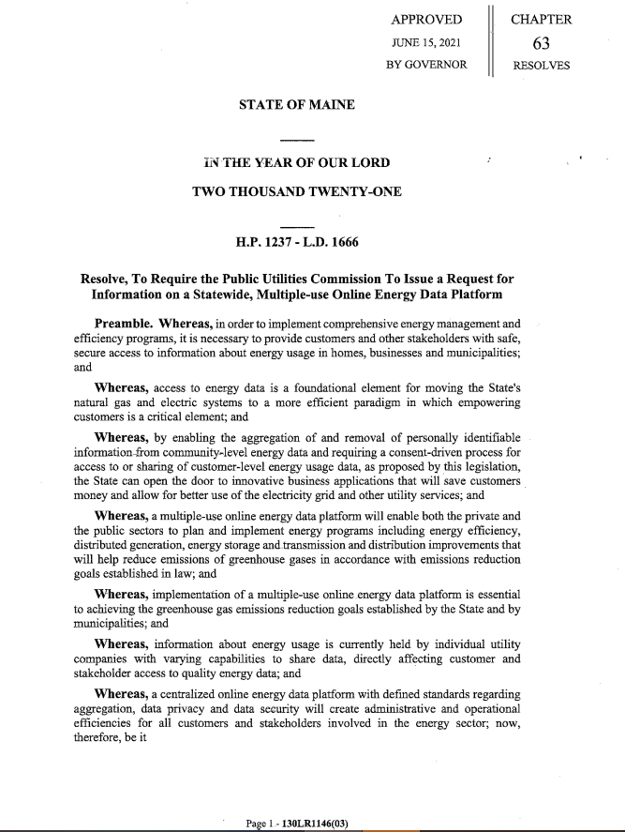
APPENDIX C Chapter 63 Resolve
