STATE OF MAINE
Department of Marine Resources
Bureau of Public Health

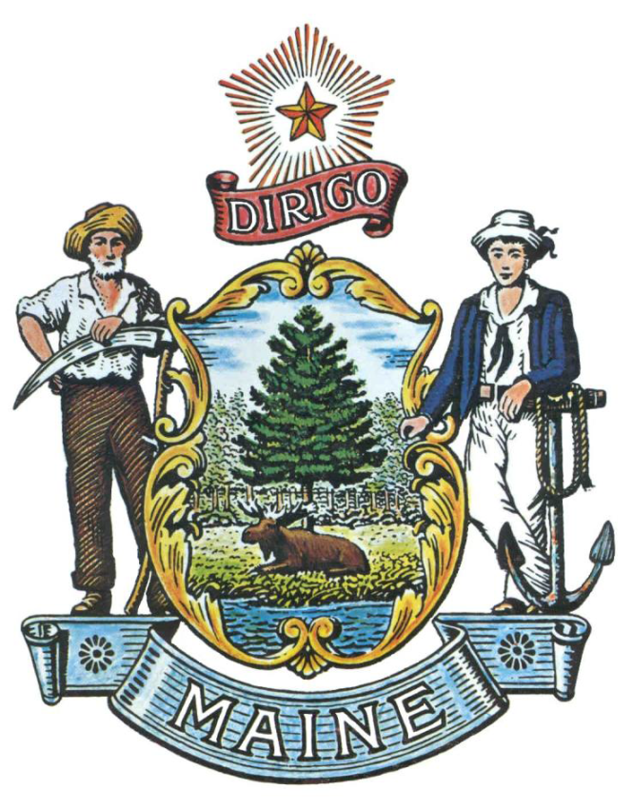

REQUEST FOR INFORMATION

RFI# 202002034

Hard Clam Dredge Survey

RFI Coordinator | All communication regarding this RFI must be made through the RFI Coordinator identified below.  Name: Sheena Glover Title: Shellfish Program Coordinator  Contact Information: sheena.glover@maine.gov
Response Submission | Submission Deadline: April 15, 2020, no later than 5:00 p.m., local time  Submit to: dmrpublichealthdiv@maine.gov

TABLE OF CONTENTS

PUBLIC NOTICE 3

RFI DEFINITIONS/ACRONYMS 4

PART I INTRODUCTION 5

- PURPOSE AND BACKGROUND
- CURENT CONDITIONS
- CHALLENGE STATEMENT
- GENERAL PROVISIONS

PART II INFORMATION SOUGHT 7

- GENERAL INFORMATION
- FEEDBACK REQUESTED

PART III KEY RFI EVENTS AND PROCESSES 8

- INFORMATIONAL MEETING
- QUESTIONS
- SUBMITTING THE RESPONSE

PART IV REVIEW OF RESPONSES RECEIVED 9

RFI APPENDICES AND RELATED DOCUMENTS 10

RESPONSE COVER PAGE
SUBMITTED QUESTIONS FORM

PUBLIC NOTICE

*************************************************
State of Maine
Department of Marine Resources Bureau of Public Health
RFI# 202002034
Hard Clam Dredge Survey

The State of Maine, Department of Marine Resources Bureau of Public Health is seeking information regarding vessel services to conduct a scientific dredge survey of hard clam populations in the New Meadows River between June and October 2020.

A copy of the RFI, as well as the Question & Answer Summary and all other related documents to this RFI, can be obtained at the following website: http://www.maine.gov/dafs/bbm/procurementservices/vendors/rfis

Responses must be submitted to: dmrpublichealthdiv@maine.gov and be submitted by 5:00 pm, local time, on April 15, 2020.

*************************************************
RFI DEFINITIONS/ACRONYMS

The following terms and acronyms shall have the meaning indicated below as referenced in this Request for Information:

Term/Acronym | Definition
RFI | Request for Information
RFP | Request for Proposal
State | State of Maine
Department | Department of Marine Resources Bureau of Public Health
FOAA | Maine Freedom of Access Act
Respondent | Any individual or organization submitting a response to this RFI.

State of Maine - Department of Marine Resources Bureau of Public Health
RFI# 202002034
Hard Clam Dredge Survey

PART I INTRODUCTION

A. Purpose and Background

This Request for Information (RFI) is an information gathering and market research tool, not a formal solicitation of a specific requirement (such as in a “Request for Proposals” document). The Department of Marine Resources (“Department”) is seeking information regarding vessel services to conduct a scientific dredge survey of hard clam populations in the New Meadows River between June and October 2020 from interested parties as defined in this RFI document. This is an opportunity for interested parties to help the Department better understand the current marketplace and/or specific subject matter.

The purpose of this project is to survey and estimate the hard clam (Mercenaria mercenaria) population in the New Meadows River using dredge gear in shallow subtidal waters.
Currently, dredging of hard clams is not permitted in the New Meadows River north of Indian Point in the town of Harpswell. Hand harvest is allowed and is focused primarily in two smaller bodies of water referred to as the New Meadows Lakes, near the north end of the estuary. The Department initiated Chapter 10 regulations in 2018 closing the river to dredging with a sunset of December 31, 2020. Prior to the regulation sunsetting the Department must assess the hard clam resource and will determine if a dredge fishery is sustainable.
The data collected through this dredge survey will enable the Department to determine the overall population numbers, size ranges, and harvestable bushels of hard clams present in the New Meadows River. The methods used will include a dredge that is towed for a survey transect of 100 feet per tow, replicated over a series of predetermined locations throughout the river. The survey will incorporate a range of sediment types and depths.

B. Current Conditions

The Department initiated Chapter 10 regulations in 2018 closing the river to dredging with a sunset of December 31, 2020. Prior to the regulation sunsetting the Department assess the hard clam resource and determine if a dredge fishery is sustainable.

C. Challenge Statement

The RFI is intended to explore an overarching question: The Department is looking for vessels willing to complete the dredge survey for population assessment.

D. General Provisions

- All contact with the State regarding this RFI must be made through the aforementioned RFI Coordinator. No other person/ State employee is empowered to make binding statements regarding this RFI.
- This is a non-binding Request for Information. Therefore, no award shall be made as a result of the RFI process.
- Issuance of this RFI does not commit the Department to pay any expenses incurred by a Respondent in the preparation of their response to this RFI. This includes attendance at personal interviews or other meetings and software or system demonstrations, where applicable.
- Issuance of this RFI in no way constitutes a commitment by the State of Maine to issue a Request for Proposal (RFP).
- All responses should adhere to the instructions and format requests outlined in this RFI and all written supplements and amendments, such as the Summary of Questions and Answers, issued by the Department.
- All submissions in response to this RFI will be considered public records available for public inspection pursuant to the State of Maine Freedom of Access Act (FOAA) (1 M.R.S. §§ 401 et seq.): State of Maine Freedom of Access Act
- All applicable laws, whether or not herein contained, shall be included by this reference. It shall be Proposer’s/Vendor’s responsibility to determine the applicability and requirements of any such laws and to abide by them.

PART II INFORMATION SOUGHT

The Department seeks information regarding Hard Clam Dredge Survey and welcomes responses to this RFI, including creative suggestions and feedback to enhance and expedite all future processes while providing efficient, reliable and high-quality outcomes. Respondents are not required to submit responses pertaining to every question, but the Department encourages interested parties to respond to any or all relevant aspects of the RFI.

The Department seeks detailed yet succinct responses that demonstrate the Respondent’s experience and/or familiarity with the subject matter. As this is not a competitive RFP process, Respondents must not provide any specific cost or customized pricing documentation in their response.

- General Information

Provide a brief overview of yourself and your organization, if applicable.

  - Please identify yourself and any organization you represent in this RFI.
    - Name of respondent
    - Organization and affiliation
    - Address (organizational, if responding on behalf of an entity)
    - Contact information (phone number(s) and email address)

  - Please identify your experiences in providing Hard Clam Dredge services.

- Departmental Need

The Department is looking for a vessel with Captain and crew that will be expected to be available for up to five (5) days within the time period stated below during which they will complete the surveys. Days to be worked will be determined by negotiations between Provider and Department.
The Department expects the Captain, crew and vessel to:
- Provide their vessel ready for work at agreed-upon dates, times and places. This includes:
    - A suitable vessel for deploying the Provider-supplied industry-standard hard clam dredge;
    - Electronics; VHF radio, radar, GPS, and depth sounder;
    - Adequate fuel;
    - Sheltered space for sorting, weighing, and measuring samples;
    - Mooring(s) with convenient dockside access in the survey area.
- Provide a Captain who:
    - Is knowledgeable of Maine coastal waters and commercial hard clam beds;
    - Is skilled in navigation, boat handling and commercial towing operations;
- Provide safety equipment including survival suits to accommodate Captain, crew and two (2) scientists along with US Coast Guard Fishing Vessel Safety Examination sticker.
- Complete the specified trips on schedule, except if delayed by weather. (Vessel bears risk and expense of weather delays.)
- Participate in planning meetings required to organize the project.
- Feedback Requested

- Do you have the equipment and man power to fulfill this need?
- Are you familiar with the area in question?
- Do you foresee any issues that the Department may not have anticipated?
- Do you have any ideas of different methods that may accomplish this task?

PART III KEY RFI EVENTS AND PROCESSES

1. General Instructions
- It is the responsibility of each interested party to examine the entire RFI and to seek clarification, in writing, if they do not understand any information or instructions.
- Interested parties should use Appendix B – Submitted Questions Form – for submission of questions.
- The Submitted Questions Form must be submitted by e-mail and received by the RFI Coordinator, identified on the cover page of this RFI, as soon as possible but no later than the date and time specified on the RFI cover page.
- Submitted Questions must include the RFI Number and Title in the subject line of the e-mail. The Department assumes no liability for assuring accurate/complete/on time e-mail transmission and receipt.

2. Question & Answer Summary
Responses to all questions will be compiled in writing and posted on the following website: http://www.maine.gov/dafs/bbm/procurementservices/vendors/rfis. It is the responsibility of all interested parties to go to this website to obtain a copy of the Question & Answer Summary. Only those answers issued in writing on this website will be considered binding.

Submitting the Response

- Responses Due
Responses must be received no later than the date and time listed on the cover page of this RFI document.

- Delivery Instructions
Responses must be submitted to the RFI Coordinator, via e-mail, listed on the cover page of this RFI document.

- Response Format
Responses to this RFI may be developed in a manner that suits the respondent. A list of key questions is included within the RFI and all submissions, regardless of format will be reviewed. Respondents are asked to be brief and to respond to as many questions as possible within the RFI. Number each response to correspond to the relevant question or instruction of the RFI to allow comparison and clarity.

PART IV REVIEW OF RESPONSES RECEIVED

General Information

- The Department will review responses received for the purpose of gathering information and market research only. The Department will not score or rate responses received.

- The Department reserves the right to communicate and/or schedule interviews/presentations with Respondents, if needed, to obtain clarification of information contained in the responses received and/or additional information to enhance marketing research efforts.

APPENDIX A

STATE OF MAINE
Department of Marine Resources
Bureau of Public Health
RESPONSE COVER PAGE
RFI# 202002034
Hard Clam Dredge Survey

Lead Point of Contact - Name/Title:
Organization Name (if applicable):
Tel: |  |  | Fax:
E-Mail: |  |  | Website:
Street Address:
City/State/Zip:

APPENDIX B

State of Maine
Department of Marine Resources
Bureau of Public Health

SUBMITTED QUESTIONS FORM
RFI# 202002034
Hard Clam Dredge Survey

Organization/Responder’s Name:

RFI Section & Page Number | Question

* If a question is not related to any section of the RFI, state “N/A” under “RFI Section & Page Number”.
** Add additional rows, if necessary.

