**STATE OF MAINE**

**Department of Administrative and Financial Services**

*Bureau of Real Estate Management*

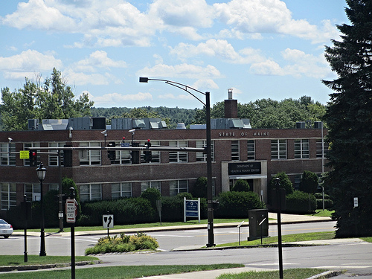

**REQUEST FOR INFORMATION**

**RFI# 201802014**

**Development Opportunity (2.73+/- Acres) at:**

**DHHS Property**

**221 State Street**

**Augusta, Maine**

**Responses Due By:** Wednesday, March 28th, 2018; 4:00 PM EST

Table of Contents

Overview of the Development Opportunity 3

Highlights of Opportunity 3

Capitol Area - Augusta, Maine 4

Development Opportunity Site at 221 State Street, Augusta, Maine 5

Zoning: Capital-Commerce Districts 5

Description of 221 State Street Property and Adjacent Parcels 6

Objectives of the RFI 7

Site Background, Previous Master Planning and Campus Investment 8

221 State Street Property Guiding Principles 8

Augusta State Facilities Master Plan 9

Response Requested Materials, Process and Schedule 10

Requested Materials 10

Response Process 10

Pre-Submission Meeting 11

Questions and Clarification 11

**Attachments 12**

Background on State of Maine Properties 12

General Information for Respondents 13

Building Condition Assessment 14

# Overview of the Development Opportunity

The State of Maine Bureau of Real Estate Management (BREM) is issuing this Request for Information (RFI) to seek information from potential developers interested in providing development services to the BREM for a mixed development opportunity (state & private) on a 2.73-acre site know as 221 State Street Property in the Capitol Area.

The timeline for development potential would begin December 2020. The following major developments will be completed prior to development of the site:

1. Completion of 109 Capitol Street for consolidation of Department of Health and Human Services offices. Planned completion is July 2019.
2. Completion of the consolidated state laboratories on the East Campus in the Greenlaw Building. Planned completion is December 2020.

## 

## Highlights of Opportunity

The 221 State Street property presents several attractive features as a site for future development:

* + **Proximity to Capitol Area Augusta:** 221 State Street is located within walking distance of the State Capitol, State Library & Museum, 19 Union St, Parking Garage, Governor Hill Mansion, YMCA & Augusta Police Department.
  + **Nearby waterfront access and park:** the site is adjacent to Capitol Park and within walking distance to the Rail Trail along the riverfront, both of which provide maintained walking paths.
  + **Barriers to entry:** None known
  + **Strong partner in the State of Maine:** Past partners are encouraged to apply.
  + **Opportunity:** The location has desirable property centrally located to State Government facilities, consisting of 2.73 acres with associated parking and a 73,000 SF building which is an existing lab and office space. The property could allow for a valuable development opportunity when considering the whole property and location. A joint opportunity with the State of Maine may allow for more.
  + **Tax Implications:** Tax increment financing available from the city should be explored with the City of Augusta.
  + **Potential Future State Facility Needs:** State Parking Garage, office space for agencies within the Burton M. Cross Office Building and Cultural Building.

## Capitol Area - Augusta, Maine

## 

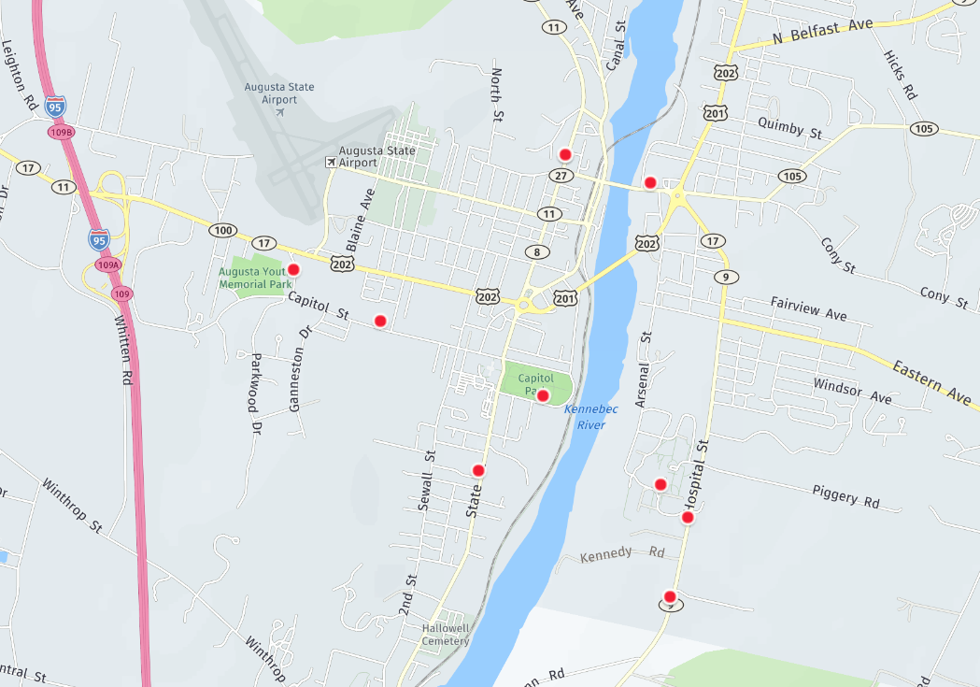

Project Location

**Development Opportunity Site 221 State Street, Augusta, Maine**

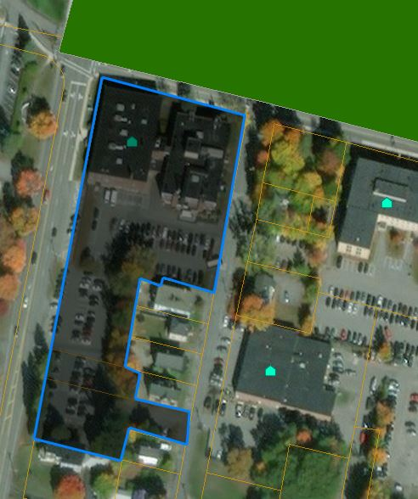

**Zoning: Capital-Commerce Districts**

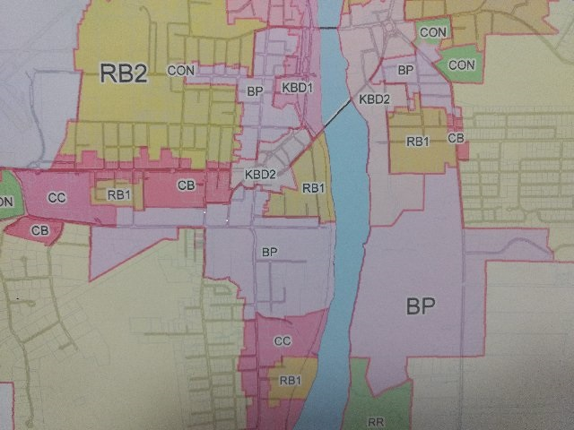

Project Location

Institutional/Business/Professional Subdistrict (BP)

## Description of 221 State Street Property and Adjacent Parcels

The 221 State Street Property site includes access from Union, Columbia, and State Streets. The geographic layout lends itself to multiple opportunities for site layout and development potential. The site has an existing 73,000 SF brick building (see existing building assessment) and parking for over 100 vehicles. The property is currently the site of the Department of Health and Human Services and the State of Maine Health Environmental Testing Laboratory.

The adjacent parcels are a mix of park, government, single and multi-family use parcels all in the BP Sub-district. The zoning allows for major health and government institutions and related business and professional offices. Dimensional requirements for all uses:

1. Impervious surface ratio: 0.95
2. Floor area ratio: 0.74
3. Maximum height: 42 feet
4. Density: 2,500 square feet of land per dwelling unit.

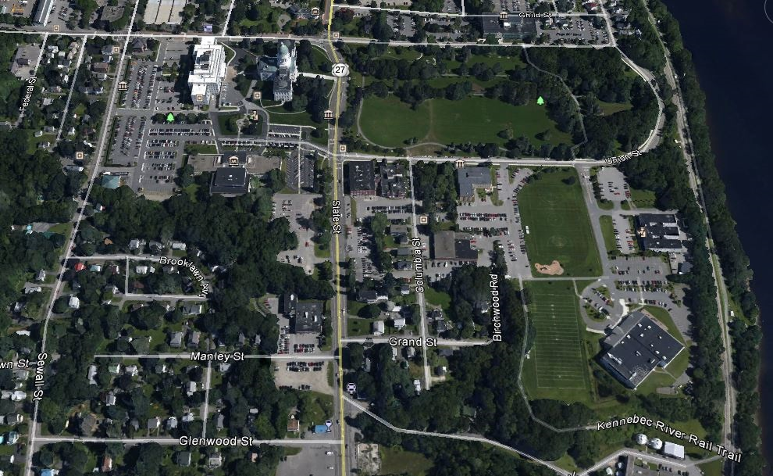

Project Location

## Objectives of the RFI

The State of Maine, Bureau of Real Estate Management wishes to engage a Developer to conceptualize a vision to transform the property at 221 State Street into a viable vibrant development; a mixed-use destination where a diverse community lives, learns and thrives, integrated with and complementary to the Capitol campus that optimizes its value and augments the Capitol/riverfront neighborhood with productive uses, serving as an integral facility that supports the seat of government as a unique, attractive property, all accomplished by leveraging a mix of public and private development that will facilitate a more effective development of the Capitol Area.

The development should incorporate the following goals:

1. Maximize the economic value through a planned development.
2. Allow for integration of State facilities.
3. Meet State financial requirements for the structure of the development.
4. Follow the planning/development rules:
5. State
6. City
7. Capital Planning Commission.

Rules: <https://www.maine.gov/bgs/documents/CPCRulesFinal.pdf>

1. Legislative council approval.

# Site Background, Previous Master Planning and Campus Investment

# The Augusta State Facilities Master Plan was developed in March of 2001. Though most of the objectives of that plan have either changed or been implemented, the overall concept of utilizing property with existing infrastructure still exists as well as consolidating state resources to the West and East Campus. This development approach is still an important component of state facilities management. A shift has been a cooperative effort to combine both private and state resources to bring redevelopment to older state facilities.

**221 State Street Property Guiding Principles**

# Complement the City of Augusta's Capitol Area: Design and layout would complement surrounding architecture and property use.

# Integrate with the State of Maine’s strategic vision: Support its mission and community life; strengthen the state/ community partnership; and promote economic opportunity.

# Integrate with the 221 State Street: Connect property to the capitol campus and improve connectedness throughout the City and the Kennebec River by consolidating resources to the west campus site.

# Integrate with the neighborhood: Maintain a vision of respectful, meaningful integration. Improve the State's positioning among its neighbors as an accessible public destination. Develop 221 State Street as the gateway between the Capitol campus and the Riverfront.

# Take advantage of 221 State Street's unique setting: Buildings and landscape design should take full advantage of the natural beauty of Capitol Park and riverfront setting. Among other things, design should maximize access to the state capitol building and surrounding facilities.

# Bolster the State's commitment to sustainability and environmental protection: Make state-of-the-art energy efficiency (Mini-Combined Heat and Power) while utilizing Maine based companies.

# Partner with State and local entities to improve the infrastructure: Improve infrastructure, including the addition of pedestrian and bike pathways to minimize vehicular traffic for access to the state capitol.

# Engage stakeholders and experts: Establish a robust development process that includes participation and input from internal and external stakeholders, and experts. Draw upon the experiences of local, state, and private entities to identify best practices.

**Augusta State Facilities Master Plan**

# 

**Response Requested Materials, Process and Schedule**

The Bureau seeks to obtain information, on a preliminary basis, to assess the interest of market participants in the potential development of the 221 State Street property. While the Bureau believes that a form of a public and private use development may be in the interest of the State, it seeks information about how this site may be developed. The Bureau will use the information gathered through this RFI process to be bettered informed in determining the next course of action, which may include issuing a RFP.

## Requested Materials

Transmittal Letter

A transmittal letter prepared on the respondent’s business stationary should accompany each response. The letter should indicate the developer’s primary representative with all contact information for all future Bureau correspondence related to the response.

Approach to Development

Provide a summary of the overall approach that the respondent would propose for development of the (221 State Street). The Bureau welcomes respondent’s alternative transaction structures for consideration, provided that the respondents compare how alternative structures would impact the ability of the Bureau to achieve the objectives for the 221 State Street Development Project.

Technical Qualifications

Please provide the following background information on your company, prior experience, project team, management approach, financial model, etc.:

* + - Name, years in business, firm overview, capabilities, legal status, and company Federal ID number
    - Contact information
    - List and biographical information for company officers and/or principals
    - Names, qualifications, resumes, relevant experience, and brief description of roles/responsibilities
    - Information on projects of similar scope that the team has successfully worked on in the past 3-5 years
    - Experience with and approach to working on mixed use public and private developments.

## 

## Response Process

Full submissions are to be submitted, by email, to Senior Resource Analyst John Blais: [john.a.blais@maine.gov](mailto:john.a.blais@maine.gov). Submissions must be received no later than **Wednesday, March 28, 2018; 4:00 PM EST**. Bureau reserves the right to extend the deadline for submission. Email subject line must refer to RFI# 201802014 - 221 State Street Property.

The Department will review responses received for the purpose of gathering information and market research. The Department will not score or rate responses received.

The Department reserves the right to communicate and/or schedule interviews/presentations with Respondents, if needed, to obtain clarification of information contained in the responses received.

**Pre-Submission Meeting:**

Date: **Wednesday, March 7, 2018**

Time: 2:00 PM, local time

Location: Room 400, Cross Office Building, 4th floor, 111 Sewall Street, Augusta

**Questions and Clarification**

Requests for clarification of the intent or content of the RFI, and any other questions from prospective respondents regarding the Project or this RFI, must be submitted to the Bureau in writing via e-mail.

All questions must be submitted in writing by email, directed to the following:

* Attn: John Blais ([john.a.blais@maine.gov](mailto:john.a.blais@maine.gov))

Submitted Question Deadline: **Wednesday,** **March 14**, **2018,** no later than 5:00 p.m., local time.

The State shall post on its website (http://www.maine.gov/purchases/venbid/rfp.shtml) any and all addenda. All addenda will be posted not less than seven (7) days prior to the date on which submissions are due.

**Attachment A**

**Background on State of Maine Properties**

Governor LePage recognized early on in his administration that to protect the state’s significant investment in buildings, facilities and other structures and to provide a high level of service to our public, we must dedicate resources and support innovative relationships with our private partners to avoid higher future costs and inefficient operations.

Bureau of Real Estate Management currently manages approximately 70 state owned facilities and over 200 leased facilities spanning all of Maine. Maintenance and management of our portfolio is the responsibility of over 110 civil servants, all of whom provide the best service to our tenant agencies with a focus on providing a comfortable and energy efficient work space.

On the Augusta East Campus, the Bureau has been actively redeveloping buildings that had been abandoned or little used since the closure of AMHI in the 1990s. We have successfully completed projects that renovated the Marquardt Building that now houses the Department of Marine Resources and the Natural Resources Service Center as well as remediating and removing hazardous materials from many buildings on the East Campus. We also made significant upgrades to the Mechanical Building that now houses the Maine Conservation Corps and Southern Region Parks, and provides space for a redundant Building Control Center and Capitol Police. We have paved new parking lots and are about to enter the final phase of a major paving project on the East Campus that will significantly upgrade the driving and parking experience on the campus.

Later this year, we will finish reconstruction of the Deering building which will provide a modern, energy efficient office space for the Bureau of Agriculture’s 100 plus employees. When the building reopens in December 2018, Bureau employees will have a modern, energy efficient work space that is climate controlled and newly renovated.

Currently in the design phase, we are redeveloping the Greenlaw building on the campus which will provide space for a state-of-the-art unified lab building that will house the DHHS Health & Environmental Testing lab and the Air and Soil labs at DEP. This building will support efficient use of space and utilize advanced technology to deliver services to the public in a much improved and efficient work space. This project is one of two projects that is linked to the redevelopment of 221 State Street as well the development of 109 Capitol Street described below.

The 109 Capitol Street re-development project has transformed the capitol complex into a major construction zone on the site of the former DOT fleet service facility. Last year, the Maine DOT sold its property on Capitol Street to developers who had committed to building a state of the art, energy efficient building with the intention of leasing the facility back to the state to house hundreds of DHHS employees who are currently working in less than ideal office space on 221 and 242 State Street. This unique arrangement with our private partners allows the state to divest itself of an abandoned nearly 100-year-old eyesore next door to the Capitol Building giving the area a much-needed facelift. It also provides hundreds of DHHS employees with one modern facility to call home. This also benefits the City of Augusta by generating property tax revenues that will help provide relief to other taxpayers in the city. This is the first new construction in the capital complex in nearly 50 years – truly a once in a generation opportunity. The new building will be opened in the summer of 2019 and will serve as a fitting accomplishment for an administration dedicated to investing in the future of our taxpayer supported properties.

**Attachment B**

**General Information for Respondents**

The issuance of this RFI does not create any contractual rights in respondents or contractual obligations by the Bureau. The Bureau reserves the right to modify or retract this RFI, in whole or in part, prior to the date fixed for submission of responses, by issuance of an addendum or addenda, which shall be posted on the Bureau’s website, or to take any other action related to the RFI and any submissions as the Bureau may deem to be in its best interest. The Bureau may extend the deadline for submission of responses if, in the Bureau’s sole discretion, such extension is necessary for any reason. It is the responsibility of each respondent to consult any and all addenda that may be issued in connection with this RFI.

All expenses and costs associated with developing or submitting a response to this RFI, or associated with oral or written clarification thereof, including all presentation materials and related costs and travel expenses, shall be borne solely by the responding firm and under no circumstances shall the Bureau be responsible for any such cost or expense incurred by any responding firm. The Bureau assumes no responsibility for these costs and expenses.

Should the Bureau determine, in its sole discretion, to proceed with a procurement process for the 221 State Street property, a Request for Qualifications and/or a Request for Proposals may be issued. The Bureau reserves the right to request clarification of any aspect of any submission or to request additional information.

In submitting a response, the respondent acknowledges and agrees that all documentation and/or materials submitted shall become and remain the property of the Bureau. The Bureau shall have the right to use all or any portions of any response, as it considers necessary or desirable, in connection with the Project. The respondent thereby grants to the Bureau an unrestricted royalty-free license to use the response and all materials submitted in connection with the project.

Once the Bureau has completed its review of the responses and the review process has been completed, responses submitted to the Bureau in response to this RFI may be considered public records as defined by Maine Freedom of Access Act (FOAA), Title 1, M.R.S. §400: <http://www.mainelegislature.org/legis/statutes/1/title1sec401.html>

**Attachment C**

**Building Condition Assessment**

