STATE OF MAINE
Department of Education
Office of School and Student Supports

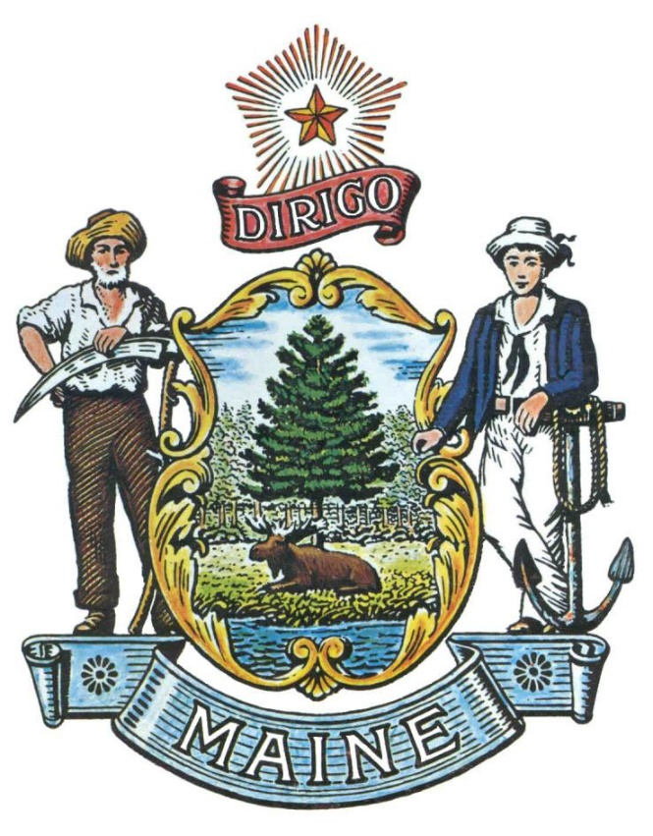

RFA# 202211180

Restorative Practices for System Involved Youth in Maine Schools

RFA Coordinator | All communication regarding the RFP must be made through the RFP Coordinator identified below.  Name: Bethany Cunningham Title: Project Manager, Office of School & Student Supports  Contact Information: Bethany.Cunningham@maine.gov
Informational Meeting | Date: November 28, 2022 Time: 4:00 p.m., local time  Location: https://mainestate.zoom.us/j/81803613490
Submitted Questions Due | All questions must be received by the RFA Coordinator identified above by:  Date: December 1, 2022, no later than 11:59 p.m., local time
Application Submission | Proposals must be received by the Division of Procurement Services by:  Submission Deadline: December 15, 2022, no later than 11:59 p.m., local time.  Proposals must be submitted electronically to the following address:  Electronic (e-mail) Submission Address: Proposals@maine.gov

PUBLIC NOTICE

*************************************************

State of Maine
Department of Education
RFA# 202211180
Restorative Practices for System Involved Youth in Maine Schools

The State of Maine is seeking applications to provide funding to Maine Schools in need of establishing or expanding support for System Involved Youth.

A copy of the RFA, as well as the Question & Answer Summary and all amendments related to the RFA, can be obtained at: https://www.maine.gov/dafs/bbm/procurementservices/vendors/grants

An Informational Meeting will be held on November 28, 2022 at 4:00 PM at the following location: https://mainestate.zoom.us/j/81803613490
Applications must be submitted to the State of Maine Division of Procurement Services, via e-mail, at: proposals@maine.gov. Applications must be received no later than 11:59 p.m., local time, on December 15, 2022. Applications will be opened the following business day. Applications not submitted to the Division of Procurement Services’ aforementioned e-mail address by the aforementioned deadline will not be considered for award.

*************************************************

RFA TERMS/ACRONYMS with DEFINITIONS

The following terms and acronyms, as referenced in the RFA, shall have the meanings indicated below:

Term/Acronym | Definition
At-Risk Youth | Students who are currently or have a high probability of dropping out of their school, requiring emotional health support, and/or becoming involved with the criminal justice system. Factors that can create an At-Risk student can include emotional or behavioral problems, truancy, low academic performance, showing a lack of interest for academics, homelessness, pregnancy, health and financial issues, domestic violence and more.
Community Stakeholder | A provider of one or more of the following services to students:  A. Mental health treatment and counseling services;  B. Career development services;  C. Police Officers/Juvenile Community Corrections Officers;  D. Mentoring, including peer mentoring;  E. Community service and service-learning opportunities
Department | Department of Education
Restorative Practices | Restorative practices are specific guidelines used in schools to create an equitable and positive school culture that promotes collaborative problem-solving among staff and students and addresses conflict and undesirable behavior in a victim centered, nonpunitive response that encourages accountability and restoration to individuals and community.
RFA | Request for Application
State | State of Maine
System Involved Youth | For the purposes of meeting the intent of LD756 and for the ME DOE’s implementation of the statute, the term juveniles involved in the juvenile legal system will be interpreted to mean youth at risk, or on a pathway, and or indirectly or directly involved in the juvenile justice system – this will further constitute the term “systems involved youth”. Systems involved youth shall mean – youth (under 18 year of age or currently considered a student in a prek-12 learning institution) that have engaged in substantial behaviors that have been demonstrated to lead to educational and/or juvenile justice system involvement to include suspension, expulsion, arrest and incarceration. This demographic will be the focus of this legislation to increase access to restorative processes in their schools through the expansion of school based restorative practices, connection to work and vocational opportunities, and increased access to mentoring services.

RFA# 202211180
Restorative Practices for System Involved Youth in Maine Schools

- Application Purpose

Through this application, the Department intends to provide funding to Maine Schools to develop, implement, continue, and/or expand programs that facilitate the academic success of System Involved Youth consistent with the purpose of LD 756.
Specifically, the funding provided under this RFA process is to establish and/or expand:
- School-based restorative justice programs;
- Mentoring services for juveniles involved in the juvenile legal system; and/or
- In collaboration with the Department of Labor, workforce development and educational or vocational programs for juveniles involved in the juvenile legal system.

Priority will be given to proposals that meet all three (3) of the above criteria, but funding can be provided to applications that only meet one (1) or two (2).

Through this RFA, the Department of Education is especially interested in creating partnerships with Maine schools for sustainable and consistent programming for system involved students to access the necessary skills to reduce recidivism and reach post-secondary transition goals that are specifically designed to fit the needs of the school.

The following list provides some examples of activities that may be supported with these funds:
- Collaborating with the Department and/or its Restorative Practices Office to develop a sustainable, multi-disciplinary approach including mental health services, safety & law enforcement personnel, restorative practices, mentors and career development.
- Providing specialized instructional support services (including violence prevention and counseling), referrals for such services, and activities to address the identified needs of individual At-Risk and System Involved Youth.
- Attracting, engaging, and retaining At-Risk and System Involved Youths who are not enrolled in schools and programs provided to System Involved Youth.
- Coordinating school services for At-Risk and System Involved Youth with those of other agencies.
- Expediting the evaluation of the needs of At-Risk and System Involved Youth and their eligibility for specific programs and services.
- Academically accredited professional development for school personnel to heighten their understanding of the needs of At-Risk and System Involved Youth.
All communication regarding this Request for Applications must be made via email to the RFA Coordinator identified on the Grant RFPs and RFAs webpage.

- Eligibility to Submit Applications

Any School Administrative Unit (SAU) as defined under 20-A MRSA §1, 26, private school approved by the Department under 20-A M.R.S. Chapter 117, CTE Region as defined under 20-A MRSA Chapter 313, Subchapter 4, or the Education in the Unorganized Territory (EUT) that currently operates a school with middle and/or high-school aged students and works with At-Risk and/or System Involved Youth is eligible to apply for the funding under this RFA.

Eligible entities can work together to submit one (1) combined application but must indicated one (1) entity as the fiscal agent for the proposal.

- Allowed Activities
The following activities are allowable under this funding:
- Increasing capacity by hiring staff, dedicating resources, and/or planning partnerships with community stakeholders, among other strategies.
- Identifying At-Risk and System Involved Youth and to engage System Involved Youth and their families with resources in Restorative Practices, Mentoring Services and/or Workforce Development or Vocational Programs.
- Establishing or expanding a long-term, sustainable process, to support System Involved Youth or prevent them from entering the system through Community and School programs.
- Expenses necessary to facilitate the retention, and educational success of System Involved Youth.
  - As an example, this could include:
    - providing wraparound services (which would be provided in collaboration with the Department and/or its Restorative Practices Office)
    - contracts for mentoring, workplace development and/or vocational programs with community stakeholders
    - providing trauma-informed care, social-emotional support, mental health and/or addiction services
Overall, costs must be reasonable and necessary and align with the purpose of, and other requirements in, the LD 756 enactment.

- Awards

The Department anticipates making multiple awards. The Department reserves the right to make awards at amounts less than that requested.

The Department intends to issue awards up to a total of $1,000,000.

If the amount of funding requested exceeds $1,000,000, then the awards will be issued based on Highest scoring applicants and then down the list by score.

Any person aggrieved by the award decision that results from the RFA may appeal the decision to the Director of the Bureau of General Services in the manner prescribed in 5 M.R.S.A. § 1825-E and 18-554 Code of Maine Rules Chapter 120. The appeal must be in writing and filed with the Director of the Bureau of General Services, 9 State House Station, Augusta, Maine, 04333-0009 within 15 calendar days of receipt of notification of conditional contract award.

RFA# 202211180
Restorative Practices for System Involved Youth in Maine Schools

KEY PROCESS EVENTS

- Submitting Questions about the Request for Applications
Any questions must be submitted by e-mail to the Grant Coordinator identified on the Grant RFPS and RFAs webpage by December 1, 2022 at 11:59 p.m. local time. Submitted Questions must include the subject line: “RFA# 202211180 Questions”. The Department assumes no liability for assuring accurate/complete/on time e-mail transmission and receipt.

Question & Answer Summary: Responses to all questions will be compiled in writing and posted on the following website: Grant RFPS and RFAs. It is the responsibility of all interested parties to go to this website to obtain a copy of the Question & Answer Summary. Only those answers issued in writing on this website will be considered binding.

- Amendments to the Request for Applications
All amendments (if any) released in regard to this Request for Applications will be posted on the following website: Grant RFPs and RFAs. It is the responsibility of all interested parties to go to this website to obtain amendments. Only those amendments posted on this website are considered binding.

- Submitting your Application
- Applications Due: Applications must be received by December 15, 2022, at 11:59 p.m. local time. Applications received after the 11:59 p.m. deadline will be ineligible for award consideration for that annual application enrollment period.
- Submission Instructions: Applications are to be submitted to the State of Maine Division of Procurement Services, via e-mail, to proposals@maine.gov.
  - Only applications received by e-mail will be considered. The Department assumes no liability for assuring accurate/complete e-mail transmission and receipt.
  - E-mails containing links to file sharing sites or online file repositories will not be accepted as submissions. Only e-mail applications that have the actual requested files attached will be accepted.
  - Encrypted e-mails received which require opening attachments and logging into a proprietary system will not be accepted as submissions. Please check with your organizations Information Technology team to ensure that your security settings will not encrypt your proposal submission.
  - File size limits are 25MB per e-mail. Applicants may submit files separately across multiple e-mails, as necessary, due to file size concerns. All e-mails and files must be received by the due date and time listed above.
  - Applicants are to insert the following into the subject line of their e-mail submission: “RFA# 202211180 - Application Submission – [Applicant’s Name]”
  - Applications are to be submitted as a single, typed, PDF or WORD file and must include:
    - Application Cover Page
    - Debarment, Performance and Non-Collusion Certification
    - Application
    - Written Narrative

RFA #202211180
Restorative Practices for System Involved Youth in Maine Schools

APPLICATION EVALUATION AND SELECTION

- Scoring Weights and Process
For applications that meet the eligibility requirements in Section I, the Grant Review Team will use a consensus approach to evaluate and score Sections II & III below. Members of the Grant Review Team will not score those sections individually but, instead, will arrive at a consensus as to the assignment of points for each of those sections.

Scoring Weights: The score will be based on a 100-point scale and will measure the degree to which each application meets the following criteria.

Scoring Criteria | Points Available
Part I – Eligibility (A)  Is either a  - A SAU as defined under 20-A MRSA §1, 26;  - Private school approved by the Department, under 20-A M.R.S. Chapter 117;  - CTE Region as defined under 20-A MRSA Chapter 313, Subchapter 4; or  - Schools in the Education in the Unorganized Territory (EUT)  AND  - Currently operates a school with Middle and/or High-School aged students that works with At-Risk and/or System Involved Youth. | Pass/Fail
Part II – Project Narrative (B) | 30
Part III – Needs Assessment (C) | 25
Part IV – Measurement of Outcomes (D) | 10
Part V – Budget & Budget Narrative (E)
Budget is reasonable and justifiable for accomplishing set goals | 25
The project represents using funds to establish or expand a sustainable program | 10
Total Available Points | 100

State of Maine
Department of Education

APPLICATION COVER PAGE
RFP# 202211180
Restorative Practices for System Involved Youth in Maine Schools

Name of School or District:
Superintendent’s Name:
Tel: |  |  |  | E-mail:
Street Address:
City/State/Zip:
(Provide information requested below if different from above)
Point of Contact for Application - Name/Title:
Tel: |  |  |  | E-mail:
Street Address:
City/State/Zip:

- No personnel currently employed by the Department or any other State agency participated, either directly or indirectly, in any activities relating to the preparation of the Bidder’s proposal.
- No attempt has been made, or will be made, by the Bidder to induce any other person or firm to submit or not to submit a proposal.
- The above-named organization is the legal entity entering into the resulting contract with the Department if they are awarded the contract.
- The undersigned is authorized to enter contractual obligations on behalf of the above-named organization.

To the best of my knowledge, all information provided in the enclosed proposal, both programmatic and financial, is complete and accurate at the time of submission.

Name (Print): | Title:
Authorized Signature: | Date:

State of Maine
Department of Education
DEBARMENT, PERFORMANCE, and NON-COLLUSION CERTIFICATION
RFP# 202211180
Restorative Practices for System Involved Youth in Maine Schools

Applicant’s School/District Name:

By signing this document, I certify to the best of my knowledge and belief that the aforementioned organization, its principals and any subcontractors named in this proposal:
- Are not presently debarred, suspended, proposed for debarment, and declared ineligible or voluntarily excluded from bidding or working on contracts issued by any governmental agency.
- Have not within three years of submitting the proposal for this contract been convicted of or had a civil judgment rendered against them for:
  - Fraud or a criminal offense in connection with obtaining, attempting to obtain, or performing a federal, state, or local government transaction or contract.
  - Violating Federal or State antitrust statutes or committing embezzlement, theft, forgery, bribery, falsification or destruction of records, making false statements, or receiving stolen property.
- Are not presently indicted for or otherwise criminally or civilly charged by a governmental entity (Federal, State or Local) with commission of any of the offenses enumerated in paragraph (b) of this certification.
- Have not within a three (3) year period preceding this proposal had one or more federal, state, or local government transactions terminated for cause or default.
- Have not entered into a prior understanding, agreement, or connection with any corporation, firm, or person submitting a response for the same materials, supplies, equipment, or services and this proposal is in all respects fair and without collusion or fraud. The above-mentioned entities understand and agree that collusive bidding is a violation of state and federal law and can result in fines, prison sentences, and civil damage awards.
Name (Print): | Title:
Authorized Signature: | Date:

State of Maine
Department of Education
Application Form
RFP# 202211180
Restorative Practices for System Involved Youth in Maine Schools

- Applicant Eligibility Information
Organization is applying as a:
☐ A SAU as defined under 20-A MRSA §1, 26
☐ A Private school approved by the Department under 20-A M.R.S. Chapter 117
☐A CTE Region as defined under 20-A MRSA Chapter 313, Subchapter 4
☐ The Education in the Unorganized Territory (EUT)
☐ By checking this box, the applicant confirms that it currently operates a school with middle and/or high-school aged students and works with At-Risk and/or System Involved Youth.

List any application partners (other eligible entities that are participating in this proposal) below

- Project Narrative
Describe the proposed effort(s) which the Applicant is applying for. Ensure the narrative addresses the need and details listed below in B. Identification of Need and describe the Applicant’s intention to establish or expand restorative justice and practice initiatives, mentoring, and/or workforce development and educational or vocational programs in their school(s). The Narrative should describe how Applicant will create consistency programming for system involved students.

The response must be no longer than two (2) pages in length.
.

- Identification of Need
Identify the characteristics and level of need. Include any available supporting data and details regarding number of students impacted by funds and utilization of school resources and any community stakeholders. Provide supporting data, if available, of need for funds (for example: rate of in-school and out of school suspensions, removal from classes, frequency or number of behavioral interventions, detention rates, number of MTSS Tier 3 identified students).

- Measurement of Outcomes
Explain how the plan will be measured and evaluated to determine outcomes.

- Budget
Provide the information below on the operation budget or cost estimates for the use of requested funds.
Budget Category | Amount Requested | Explanation of expense
Personnel (salary and benefits)
Contracted services
Other (specify)
Other (specify)
TOTAL REQUEST
Budget Narrative
Please provide a detailed explanation of your anticipated grant-supported expenses in each of the above budget categories and describe how the plan will be a sustainable solution.

The response must be no longer than one (1) page in length.

.

