STATE OF MAINE
Department of Economic and Community Development

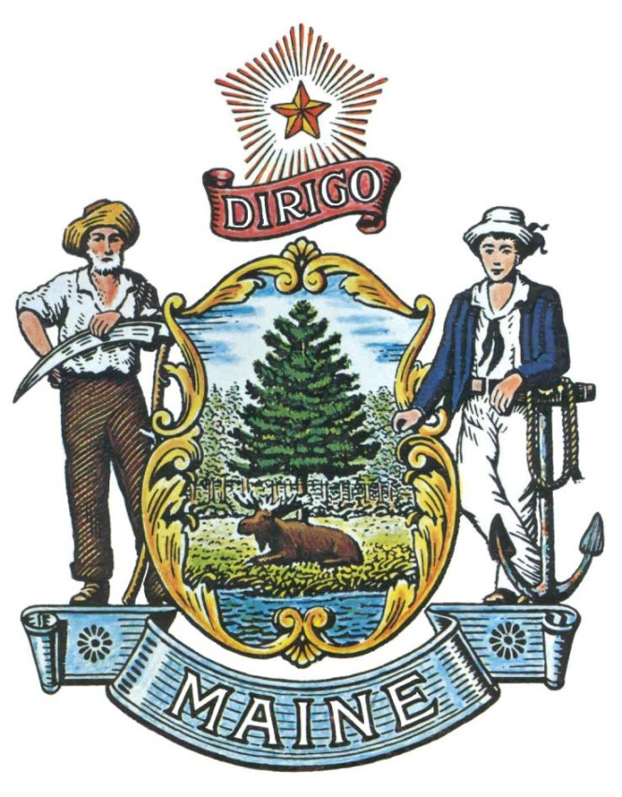
RFA# 202205086
Diversity, Equity, Inclusion and Belonging Communities of Practice
FY2023 Application

RFA Coordinator | All communication regarding the RFA must be made through the RFA Coordinator identified below.  Name: Julia Trujillo Luengo Title: RFA Manager  Contact Information: Julia.Trujillo.Luengo@maine.gov
Submitted Questions | All questions must be submitted, by e-mail, to the RFA Coordinator no later than July 21st, 2022 at 11:59 pm and must include “RFA# 202205086” in the subject line of the e-mail.
Application Submission Period | Applications must be received by the Division of Procurement Services by:  Submission Deadline: August 10th, 2022 no later than 11:59 p.m., local time. Applications must be submitted electronically to the Division of Procurement Services at proposals@maine.gov and must include “RFA# 202205086” in the subject line of the e-mail.

TABLE OF CONTENTS
 | Page
DEFINITIONS
DETAILS AND INSTRUCTIONS | 4
- Application Purpose and Background
- General Provisions
- Eligibility to Submit Applications
- Number of Awards
- Contract Terms
- Annual Application Submittals
ACTIVITIES AND REQUIREMENTS | 8
KEY PROCESS EVENTS | 10
- Submitting Questions about the Request for Applications
- Amendments to the Request for Applications
- Submitting an Application

APPLICATION EVALUATION AND SELECTION | 12
- Scoring Process
- Scoring Weights
PART VII RFP APPENDICES AND RELATED DOCUMENTS | 13
APPENDIX A – GRANT FUNDING APPLICATION – COVER PAGE
APPENDIX B – DEBARMENT, PERFORMANCE, and
NON-COLLUSION CERTIFICATION
APPENDIX C – APPLICATION FORM
APPENDIX D – FUNDING GUIDELINES
APPENDIX E – PERFORMANCE STANDARDS

RFA TERMS/ACRONYMS with DEFINITIONS

The following terms and acronyms, as referenced in the RFA, shall have the meanings indicated below:

Term/Acronym | Definition
Community of Practice (COP) | A community of practice is a group of people who share a common concern, a set of problems, or an interest in a topic and who come together to fulfill both individual and group goals.
Department | Department of Economic and Community Development
Memorandum of Agreement (MOA) | An MOA is a document written between parties to cooperatively work together on an agreed upon project or meet an agreed upon objective. The purpose of an MOA is to have a written formal understanding of the agreement between parties.
RFA | Request for Application

Diversity, Equity, Inclusion and Belonging Communities of Practice
FY 2023 Grant Funding
RFA# 202205086
Details and Instructions

Application Purpose and Background

Maine’s 10 Year Economic Plan boldly acknowledged that Maine’s economic prosperity, and recovery, begins and starts with talent. Maine remains the oldest state in the nation, with Census data recently released that still puts the number of births in Maine significantly below than the number of people dying. In order for the economy to continue to grow and recover, the State must attract over 75,000 net new workers to Maine by 2029.

Furthermore, the COVID-19 pandemic dramatically impacted the financial stability of so many Mainers and their families. Maine’s racial and ethnic minorities, among several other demographic groups, were disproportionately and significantly impacted by the adverse economic impacts of this pandemic. Despite comprising 9% of Maine’s population, they accounted for 40% of those that contracted COVID19. Similarly, according to the Small Business Credit Survey 2021 Report on Firms Owned by People of Color, “while 79% of White-owned firms received all of the PPP funding they sought, that share dropped to 43% for Black-owned firms”. Furthermore, “Black-owned applicant firms were five times as likely as white-owned firms to receive none of the Paycheck Protection Program (PPP) funding for which they applied (20% compared to 4%)”.

Despite these devastating effects, Maine’s stakeholders, community groups, nonprofit organizations and many others working in diversity, equity, inclusion, belonging or immigrant integration efforts have been working tirelessly to ensure already pre-existing disparities did not deepen. Even in the adversity and challenges listed above, the pandemic also brought about unprecedented coalitions and collaborative work at the local, regional and state level that were paramount for the stability of countless of small businesses, individuals and families.

The pandemic also had devastating negative impacts on some of Maine’s key industries, including but not limited to:

Health Care & Social Assistance;

Construction, Trades, Logistics; Manufacturing;

Education & Child Care;

Agriculture, Fishing, & Forestry;

Information and Clean Energy.

The Department Economic and Community Development (Department) is releasing this Request for Applications (RFA) to identify and fund up to three (3) Communities of Practice (COP) in Maine to design and execute a meaningful, impactful and outcome-based regional or local action plan to support the economic recovery of at least one key industry listed above through a diversity, equity, inclusion and belonging lens. The ultimate outcomes of this COP and Action Plan are to:

- Achieve collective outcomes that would support the recovery of key impacted industries in tandem with the upward economic mobility of Maine’s racial, ethnic and/or linguistic minorities.
- Support existing best practices by scaling or expanding them for the benefit of other regions, localities or industries (from the list above).
- Encourage cross-sector collaboration to achieve collective results in diversity, equity, inclusion and belonging planning to support at least one key impacted industry.
- Share strategies and lessons learned across regions in Maine.
- Participate in common technical assistance opportunities to advance goals set forth by each of the COPs and/or by common themes identified by the Department.

Successful applicants shall demonstrate shared competence and commitment among all stakeholders in the COP; a set of clear objectives; how they will work together to achieve these and a clear result-oriented strategy to obtain desired outcomes. Lastly, they must clearly delineate desired results for the unique regional and/or local landscape with the specific industry challenges they seek to address.

General Provisions

- From the time this RFA is issued until award notification is made, all contact with the State regarding this RFA must be made through the RFA Coordinator identified on the cover page of this RFA. No other person/State employee is empowered to make binding statements regarding this RFA. Violation of this provision may lead to disqualification from the application process, at the State’s discretion.
- The Applicant shall take careful note that in evaluating its application submitted in response to this RFA the Department will consider materials provided in the application and internal Departmental information of previous contract history, if any, with the Applicant. The Department also reserves the right to consider other reliable references and publicly available information in evaluating the Applicant’s experience and capabilities.
- All submissions in response to this RFA will be public records, available for public inspection pursuant to the State of Maine Freedom of Access Act (FOAA) (1 M.R.S. § 401 et seq.).
- All applicable laws, whether or not herein contained, shall be included by this reference. It shall be the Applicant’s responsibility to determine the applicability and requirements of any such laws and to abide by them.

Eligibility to Submit Applications

In order to be considered for Grant funding under this application process, applicants must:

- Identify a lead applicant within the Community of Practice and up to (but no more than) ten additional members.
  - The lead and other individual members may be:
    - A community-based organization,
    - Non-profit organization (501 c3 or 501 c6),
    - Municipality or town government,
    - Tribal government,
    - County government and/or
    - Private enterprises.
- The COPs must have representation from the industries and demographics they seek to support and recover.
- Demonstrate a diverse and wide range of skills, experience and interests among COP membership.
  - The make-up of members shall align with the proposed approach to the collective challenge(s) the COP seeks to address.
- Exhibit a wide range of degrees of experience in its members in diversity, equity, inclusion and belonging work, coupled with level of influence to impact overall results for the COP.
- Frame a clear set of measurable challenges that the COP seeks to address within the scope of this RFA.
  - Specifically list which groups among the racial, ethnic and linguistically diverse categories listed below, the COP aims to uniquely support:
    - Race:
      - American Indian or Alaska Native
      - Asian
      - Black or African American
      - Native Hawaiian or Other Pacific Islander
      - White
    - Ethnicity:
      - Hispanic
      - Not Hispanic
    - Primary Languages:
      - Arabic
      - French
      - Portuguese
      - Somali
      - Spanish
      - Other (please list)
For more information regarding the Minimal Standards for Collecting Race and Ethnicity Data, visit the Federal Register
  - Which impacted industry(ies) will be the focus its efforts:
    - Clean Energy
    - Agriculture, Forestry, and Fisheries
    - Healthcare and social assistance
    - Information
    - Infrastructure (construction, building trades, broadband, logistics)
    - Leisure and hospitality
    - Manufacturing
    - Education
    - Retail
- If the COP proposes direct service to individuals as part of its overall strategy, the COP shall demonstrate how the lead applicant or its members, will comply with existing confidentiality standards to ensure the privacy of all information collected from individuals.
- If the COP proposes direct service to individuals, individual level reporting parameters should be followed by the Applicant and its sub-recipients.
- Collect, track and share progress metrics related to program performance standards, key performance indicators (KPIs) and measurable outcomes, including individual outcomes and demographic information if serving individuals (Appendix E)
- Ensure compliance per American Rescue Plan Final Treasury Guidance.

Number of Awards

The grant funding for this program is $975,000. The Department intends to make up to three (3) awards of a maximum of $325,000 each. The Department reserves the right to make fewer (or no) awards, or make awards at amounts less than requested, in the best interest of the State.

Any person aggrieved by the award decision that results from the RFA may appeal the decision to the Director of the Bureau of General Services in the manner prescribed in 5 M.R.S.A. § 1825-E and 18-554 Code of Maine Rules Chapter 120. The appeal must be in writing and filed with the Director of the Bureau of General Services, 9 State House Station, Augusta, Maine, 04333-0009 within 15 calendar days of receipt of notification of conditional contract award.

- Contract Terms

Applicants awarded through this RFA process will be conditionally awarded a contract for up to a two (2) year period. The period of performance is anticipated to be September 1st, 2022 through June 30th, 2024.

Diversity, Equity, Inclusion and Belonging Communities of Practice
FY 2023 Grant Funding
RFA# 202205086
Activities and Requirements

- COP Plan Requirements

- Domain: Community members have a shared and clear interest, competence and commitment in the area of diversity, equity, inclusion and/or belonging.
  - This shared domain creates common ground, inspires members to participate, guides their learning, and gives meaning to their actions.
- Community: Members pursue this interest through joint activities, discussions, problem-solving opportunities, information sharing and relationship building.
  - A strong community fosters interaction and encourages a willingness to share ideas.
- Practice: Community members are actual practitioners in this domain of interest and build a shared repertoire of resources and ideas that they take back to their practice.
  - While the domain provides the general area of interest for the community, the practice is the specific focus around which the community develops, shares and maintains its core of collective knowledge.

- Collaboration Requirements

- Maintain collaboration with identified COP partners through a Memorandum of Agreement (MOA). The MOA must include, at a minimum:
  - Specific level of support provided by primary Applicant and sub-contractors.
  - Clear expectations of sub-contractors for referrals and other processes to effectively execute collaboration.
  - Clear identification of responsibility for ongoing maintenance and reporting by primary applicant.
- The COP must have representation from the key industries and demographic groups it seeks to help recover.
- The COP shall participate in at least two (2) opportunities presented by the Department to facilitate co-learning and sharing of best practices across all COP awardees.

Reports

  - Track and record all data/information necessary to complete the required reports listed in Table 1:

Table 1 – Required Reports
Name of Report |  | Description
a. | Quarterly Narrative Report | KPI data (page 16) and narrative on impact, reach, operations, success, and barriers.
b. | Quarterly Financial Report | Includes information on expenditures, as detailed in the grant application.
c. | Contract Closeout Report | Includes information on performance metrics met and total expenditures.

Submit all the required reports to the Department in accordance with the timelines established in Table 2:

Table 2 – Required Reports Timelines
Name of Report |  | Period Captured by Report | Due Date
b. | Quarterly Narrative Report | Each quarter | Fifteen (15) days after each quarter
c. | Quarterly Financial Report | Each quarter | Thirty (30) days after each quarter
d. | Contract Closeout Report | Entire contract period | Sixty (60) days following the close of the contract period.

Diversity, Equity, Inclusion and Belonging Communities of Practice
FY 2023 Grant Funding
RFA# 202205086
Key Process Events

Submitting Questions about the Request for Applications

Any questions must be submitted by e-mail and received by the RFA Coordinator identified on the cover page of this RFA, as soon as possible but no later than the date and time specified on the RFA cover page. Submitted Questions must include the subject line: “RFA# 202205086 Questions”. The Department assumes no liability for assuring accurate/complete/on time e-mail transmission and receipt.

Question & Answer Summary: Responses to all questions will be compiled in writing and posted on the Division of Procurement Services Grant RFPs and RFAs website. It is the responsibility of all interested parties to go to this website to obtain a copy of the Question & Answer Summary. Only those answers issued in writing on this website will be considered binding.

Amendments to the Request for Applications

All amendments (if any) released in regard to this Request for Applications will be posted on the Division of Procurement Services Grant RFPs and RFAs website. It is the responsibility of all interested parties to go to this website to obtain amendments. Only those amendments posted on this website are considered binding.

Submitting an Application

  - Applications Due: Applications must be received no later than 11:59 p.m. local time, on the date listed on the cover page of the RFA. E-mails containing original application submissions, or any additional or revised application files, received after the 11:59 p.m. deadline will be rejected without exception.

- Submission Instructions: Applications are to be submitted electronically to the State of Maine Division of Procurement services, via e-mail, to proposals@maine.gov.
  - Only applications received by e-mail will be considered. The Department assumes no liability for assuring accurate/complete e-mail transmission and receipt.
  - E-mails containing links to file sharing sites or online file repositories will not be accepted as submissions. Only e-mail applications that have the actual requested files attached will be accepted.
  - Encrypted e-mails received which require opening attachments and logging into a proprietary system will not be accepted as submissions. Please check with your organizations Information Technology team to ensure your security settings will not encrypt your proposal submission.
  - File size limits are 25MB per e-mail. Applicants may submit files across multiple e-mails, as necessary, due to file size concerns. All e-mails and files must be received by the due date and time listed above.

  - Applicants are to insert the following into the subject line of their e-mail submission: “RFA# 202205086 Application Submission – [Applicant’s Name]”.
  - Applications are to be submitted as a single, typed, PDF or WORD file and must include:

- Application Cover Page (Appendix A);
- Debarment, Performance and Non-Collusion Certification (Appendix B);
- Grant Application/Logic Model (Appendix C);
- Budget and Budget Narrative (Appendix D);
- Key Performance Indicators (Appendix E); and
- Valid certificate of insurance on a standard Acord form (or the equivalent) evidencing the Applicant’s general liability, professional liability and any other relevant liability insurance policies.

Diversity, Equity, Inclusion and Belonging Communities of Practice
RFA# 202205086
FY 2023 Grant Funding
Application Evaluation and Selection

- Scoring Weights: The score will be based on a 100-point scale and will measure the degree to which each application meets the following criteria.

Scoring Criteria | Points Available
Part 1 – Eligibility | Pass/Fail
Part 2 – Applicant Experience | 20
Part 3 – Program Design | 30
Part 4 – Intended outputs & outcomes | 20
Part 5 – Project Sustainability | 10
Part 6 – Budget & Narrative | 20
Total Points | 100 points

- Scoring Process: The grant review team will use a consensus approach to evaluate and score all sections listed above. Members of the review team will not score those sections individually but, instead, will arrive at a consensus as to assignment of points for each of those sections.

Diversity, Equity, Inclusion and Belonging Community of Practice
FY 2023 Grant Funding
RFA# 202205086
APPLICATION FORM

The entire application, including all relevant appendices, may be obtained in a Word (.docx) format by double clicking on the document icon below.

