STATE OF MAINE
Department of Health and Human Services
Maine Center for Disease Control and Prevention

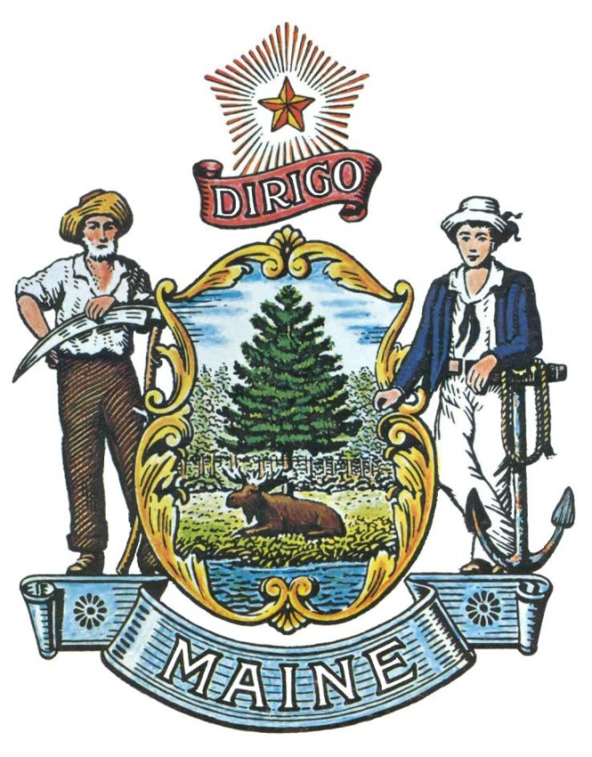

RFA# 202011167

Grant Funding for Healthcare and Public Health Entities to Supplement Local Influenza Vaccination Activities

RFA Coordinator | All communication regarding the RFA must be made through the RFA Coordinator identified below.  Name: Brandon Martin Title: RFP Manager  Contact Information: brandon.martin@maine.gov
Submitted Questions | Questions regarding this RFA can be submitted at any time while this RFA is open. All questions must be submitted, by e-mail, to the RFA Coordinator and must include “RFA# 202011167 Question” in the subject line of the email.
Application Submission Period | Applications will be accepted during the open application period, which will begin with the release of this RFA and conclude with the award of all nine (9) Districts. Applications must be submitted electronically to the Division of Procurement Services at proposal@maine.gov and must include “RFA# 202011167 Application Submission” in the subject line of the email.
State of Maine - Department of Health and Human Services
Maine Center for Disease Control and Prevention
RFA# (Inserted by Procurement Services when assigned/approved)
Grant Funding for Healthcare and Public Health Entities to Supplement Local Influenza Vaccination Activities

- Background and Purpose

The Department of Health and Human Services (Department) is providing grant funding to Healthcare and Public Health Entities to serve as a lead partnering agency in one (1) of the nine (9) Local Public Health Districts (District) to increase access to vaccination services. Increasing influenza vaccination coverage is an essential step to decrease the stress on the health care system at a time when SARS-CoV-2 (COVID-19) is expected to be circulating. The primary purpose of this initiative is to enhance influenza vaccination coverage in all age groups. While influenza vaccinations will be made available to all Maine residents, efforts will be targeted specifically for populations with low influenza vaccination coverage, populations at high risk for complications from influenza and COVID-19, populations with known coverage disparities, and providers/partners that work with these populations.

The funding provided as a result of this Request for Application (RFA) is part of the “Paycheck Protection Program and Health Care Enhancements Act (P.L. 116-139), provided to states and territories funded under CDC-RFA-IP19-1901, “Immunization and Vaccines for Children”, which funds the Vaccines for Children (VFC) Program. The VFC Program aids to help families by providing free vaccines to providers who serve eligible children, allowing these facilities to provide Advisory Committee on Immunization Practices (ACIP) recommended vaccines with little to no out-of-pocket costs to the parents. Under the Cooperative Agreement, the Maine Immunization Program (MIP) under the Department provider oversight of Public Vaccines as outlined in the Immunization Program Operations Manual (IPOM) and Vaccines for Children Program (VFC Program) Operations Guide at the State level.

Agencies who are provided funding will coordinate with local partners to promote and facilitate influenza vaccination in their designated areas. Agencies who submit a qualifying application will be provided funding from MIP, as well as technical assistance and guidance to promote influenza vaccination. Ideal agencies will have experience with immunization and a history of establishing partnerships to meet mutual objectives. Awarded agencies will be simultaneously planning for COVID-19 vaccination in their areas; therefore, priority will be given to agencies that have the capacity to maintain the level of work over the duration of the pandemic.

- General Provisions

- From the time this RFA is issued until award notification is made, all contact with the State regarding this RFA must be made through the RFA Coordinator identified on the cover page of this RFA. No other person/State employee is empowered to make binding statements regarding this RFA. Violation of this provision may lead to disqualification from the application process, at the State’s discretion.
- Issuance of this RFA does not commit the Department to issue an award or to pay expenses incurred by an Applicant in the preparation of an application to this RFA. This includes attendance at personal interviews or other meetings and software or system demonstrations, where applicable.
- The Applicant shall take careful note that in evaluating its application submitted in response to this RFA the Department will consider materials provided in the application and internal Departmental information of previous contract history, if any, with the Applicant. The Department also reserves the right to consider other reliable references and publicly available information in evaluating the Applicant’s experience and capabilities.
- All submissions in response to this RFA will be public records, available for public inspection pursuant to the State of Maine Freedom of Access Act (FOAA) (1 M.R.S. §§ 401 et seq.).
- All applicable laws, whether or not herein contained, shall be included by this reference. It shall be the Applicant’s responsibility to determine the applicability and requirements of any such laws and to abide by them.

Eligibility

All Healthcare or public health agencies (i.e. Federally Qualified Health Centers, healthcare systems, universities, and local public health organizations) who have been providing healthcare services in the State for at least two (2) years are invited to apply.

Contract Term

The Department intends to provide a one-time award to up to nine (9) agencies, one for each District, for a total grant amount of $172,265 ($19,140 potential average amount per agency) to fund work efforts during the 2020-2021 influenza season. The table below outlines the anticipated contract period:

Period | Start Date | End Date
Period of Performance | Upon Award | 6/30/2021

- Awards

The Department intends for the application process to remain open until all nine (9) Local Public Health Districts (District) are assigned a lead partnering agency.

The Department reserves the right to determine which applications per District will result in a contract. Applications will be reviewed by District and in order of receipt based on the date and time the Applicant’s email is received by the Division of Procurement Services. Applications will be reviewed to determine if the Applicant meets the Department expectations and qualifications of this RFA. The first qualifying application per District will be awarded and no further applications per District will be reviewed thereafter.

If additional funding is made available at a later date, the additional work will be offered to the agencies under contract, based on the needs of each District. If the agencies under contract cannot accept an increase to the scope of the program, then the Department will review the unevaluated applications in the order received and make a conditional award to the next qualified Applicant.

Any person aggrieved by the award decision that results from this Request for Applications may appeal the decision to the Director of the Bureau of General Services in the manner prescribed in 5 M.R.S.A. § 1825-E and 18-554 Code of Maine Rules Chapter 120. The appeal must be in writing and filed with the Director of the Bureau of General Services, 9 State House Station, Augusta, Maine, 04333-0009 within 15 calendar days of receipt of notification of conditional contract award.

District Key
District 1 | York
District 2 | Cumberland
District 3 | Western
District 4 | Midcoast
District 5 | Central
District 6 | Penquis
District 7 | Downeast
District 8 | Aroostook
District 9 | Tribal Health
Local Public Districts
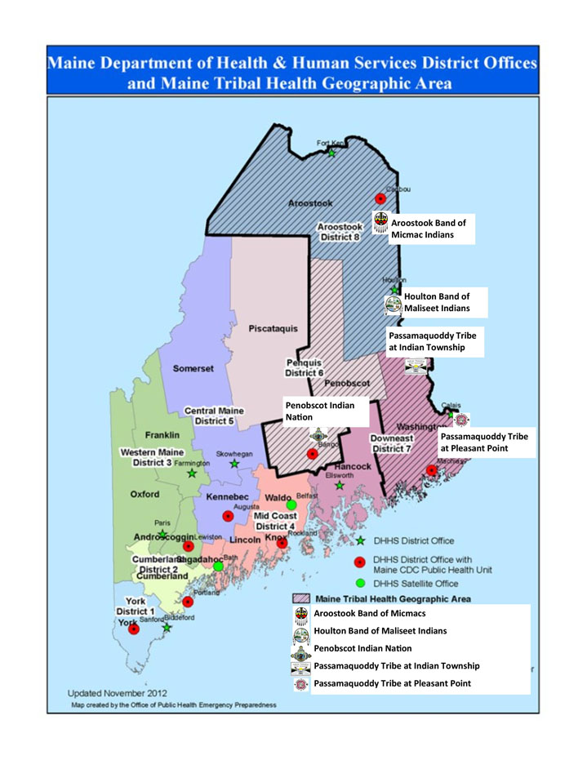
PART II – Grant Funding Requirements

Agencies receiving funding may coordinate with other agencies and programs such as District Liaisons (DL), Public Health Nursing (PHN), and others to carry out activities that will increase influenza vaccine coverage across the assigned District. Each agency receiving funding will be conducting similar work but will have the ability to tailor their approach to their communities. Agencies will be required to submit weekly progress reports. Applicant may choose one or more of the activities listed below and must submit a narrative and budget based on the activities selected.

- Agencies Requirements

      - Have experience with immunization and a history of establishing partnerships to meet mutual objectives.
      - Have the capacity to simultaneously planning for COVID-19 vaccination in their areas while maintaining the level of work over the duration of the pandemic

- Agency Activities

        - Partner and plan for vaccination activities with critical organizations, such as: Community Health Centers (CHCs);
          - Federally Qualified Health Centers (FQHCs);
          - Pharmacies;
          - Long-term care facilities (LTCFs);
          - Assisted living centers;
          - Nursing homes;
          - Organizations and businesses that employ critical workforce;
          - First responder organizations;
          - Non-traditional providers and locations that serve high-risk populations; and
          - Other locations that serve high-risk individuals.
        - Organize mass vaccination clinics.
        - Implement vaccine “strike teams” to conduct vaccination clinics and services in non-traditional settings and/or to supplement the work of local health departments.
        - Enhance messaging (including through translation) to promote flu vaccination among high-risk populations.
        - Partner with school districts to provide school-located vaccination clinics.
        - Implement other innovative activities to conduct vaccination services, such as curbside vaccination, drive-thru vaccination, college campus activities.
        - Provide supplies and training to providers and partners for vaccine transport for temporary mass vaccination clinics.
        - Other activities may be considered if they adhere to Immunization Program Operations Manual (IPOM) requirements.

PART III - KEY PROCESS EVENTS

Submitting Questions about the Request for Applications

Questions regarding this RFA can be submitted at any time while the application is open. Any questions must be submitted by e-mail to the RFA Coordinator identified on the cover page of this RFA. Submitted Questions must include the subject line: “RFA# 202011167 Questions”. The Department assumes no liability for assuring accurate/complete/on time e-mail transmission and receipt.

Question & Answer Summary: Responses to all questions will be compiled in writing and posted on the Division of Procurement Services Grant RFPs and RFAs website. It is the responsibility of all interested parties to go to this website to obtain a copy of the Question & Answer Summary. Only those answers issued in writing on this website will be considered binding.

Amendments to the Request for Applications

All amendments (if any) released in regard to this Request for Applications will be posted on the Division of Procurement Services Grant RFPs and RFAs website. It is the responsibility of all interested parties to go to this website to obtain amendments. Only those amendments posted on this website are considered binding.

Submitting an Application

The application period will remain open and applications will be accepted until all nine (9) Local Public Health Districts are assigned a lead partnering agency.

Applications are to be submitted electronically to proposals@maine.gov. Applicants are to insert the following into the subject line of their email submission: “RFA# 202011167 Application Submission – [Applicant’s Name]”. Only applications received by email will be considered. The Department assumes no liability for assuring accurate/complete e-mail transmission and receipt.

Applications are to be submitted as a single, typed, PDF file and must include only the “Application” pages in this RFA document, including:

- Application Cover Page (page 7);
- Debarment, Performance and Non-Collusion Certification (page 8);
- Grant Funding for Healthcare and Public Health Entities to Supplement Local Influenza Vaccination Activities Application (page 9); and
- All requested documentation (page 10).

STATE OF MAINE
Department of Health and Human Services
RFA# 202011167
Grant Funding for Healthcare and Public Health Entities to Supplement Local Influenza Vaccination Activities

Grant Funding Application – Cover Page

Applicant’s Organization Name:
Name/Title of Person Responsible for Submitting Application:
Tel: |  |  |  | E-mail:
Headquarters Street Address:
Headquarters City/State/Zip:
(Provide information requested below if different from above)
Point of Contact for Application - Name/Title:
Tel: |  |  |  | E-mail:
Street Address:
City/State/Zip:

- No personnel currently employed by the Department or any other State agency participated, either directly or indirectly, in any activities relating to the preparation of the Applicant’s application.
- No attempt has been made, or will be made, by the Applicant to induce any other person or firm to submit or not to submit an application.
- The above-named organization is the legal entity entering into the resulting agreement with the Department should they be awarded a contract.
- The undersigned is authorized to enter contractual obligations on behalf of the above-named organization.

To the best of my knowledge, all information provided in the enclosed application, both programmatic and financial, is complete and accurate at the time of submission.

Name (Print): | Title:
Authorized Signature: | Date:
STATE OF MAINE
Department of Health and Human Services
RFA# 202011167
Grant Funding for Healthcare and Public Health Entities to Supplement Local Influenza Vaccination Activities

DEBARMENT, PERFORMANCE and NON-COLLUSION CERTIFICATION

By signing this document, I certify to the best of my knowledge and belief that the aforementioned organization, its principals and any subcontractors named in this application:

- Are not presently debarred, suspended, proposed for debarment, and declared ineligible or voluntarily excluded from bidding or working on contracts issued by any governmental agency.
- Have not within three years of submitting the application for this contract been convicted of or had a civil judgment rendered against them for:
  - Fraud or a criminal offense in connection with obtaining, attempting to obtain, or performing a federal, state or local government transaction or contract.
  - Violating Federal or State antitrust statutes or committing embezzlement, theft, forgery, bribery, falsification or destruction of records, making false statements, or receiving stolen property;
  - Are not presently indicted for or otherwise criminally or civilly charged by a governmental entity (Federal, State or Local) with commission of any of the offenses enumerated in paragraph (b) of this certification; and
  - Have not within a three (3) year period preceding this application had one or more federal, state or local government transactions terminated for cause or default.
- Have not entered into a prior understanding, agreement, or connection with any corporation, firm, or person submitting a response for the same materials, supplies, equipment, or services and this application is in all respects fair and without collusion or fraud. The above-mentioned entities understand and agree that collusive bidding is a violation of state and federal law and can result in fines, prison sentences, and civil damage awards.

Failure to provide this certification may result in the disqualification of the Applicant’s application, at the discretion of the Department.

Organization Name:
Name (Print): | Title:
Authorized Signature: | Date:

STATE OF MAINE
Department of Health and Human Services
RFA# 202011167
Grant Funding for Healthcare and Public Health Entities to Supplement Local Influenza Vaccination Activities

APPLICATION

- Applicants must be brief and concise in providing written information required in this application.
- Incomplete application will not be accepted.
- Accepted Applications will require the Applicant to enter into a State of Maine Service Contract with appropriate riders as determined by the Department.
- Only one application can be submitted per District.

Organization Name: | Click or tap here to enter text.
Local Public Health District: | Choose an item.
Describe the agency’s experience with immunization and history of establishing partnerships.
Click or tap here to enter text.

Describe the agency’s capacity to simultaneously plan for COVID-19 vaccination in the assigned District and to maintain the level of work over the duration of the pandemic.
Click or tap here to enter text.

Describe the activities the agency intends to implement that will increase influenza vaccine coverage across the assigned District and related communities (Part II):
Click or tap here to enter text.

What other agencies and programs such as District Liaisons (DL), Public Health Nursing (PHN), and others does the agency intend on coordinating with?
Click or tap here to enter text.

Describe the agency’s ability to submit weekly progress reports.
Click or tap here to enter text.

Documentation required to be submitted with the application:
- Valid certificate of insurance on a standard ACORD form evidencing the Agency’s general liability, professional liability, and any other relevant liability insurance.
- Detailed budget identifying how grant funding will be utilized if awarded.
The Budget Form may be obtained in an Excel (.xlsx) format by double clicking on the document icon below.

The Budget Form Instructions may be obtained in a PDF (.pdf) format by double clicking on the document icon below.

Budget Narrative: Include a brief budget narrative to explain the basis for determining the expenses submitted on the budget forms.

