LilyPad PPe ordering
guide

Introduction
The purpose of this training guide is to provide guidance on how to efficiently use the LilyPad for Fishbowl inventory management software. It is intended for those state employees responsible for ordering/approving and receiving (PPE) Personal Protective Equipment for their assigned areas and colleagues. The use of PPE will allow your team members to re-enter the workplace with a focus on safety for you, your colleagues, and customers.

Note: For best performance, we recommend using Google Chrome, Safari, Firefox, or MS Edge as your web browser. We do not recommend Internet Explorer.

- LilyPad User enters address: https://stateofmaine.lp4fb.com/ for the Central Warehouse login page.
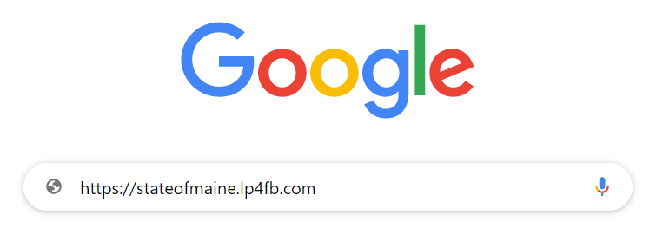
- Enter your user id and your password that was sent to you in an email from the central warehouse.

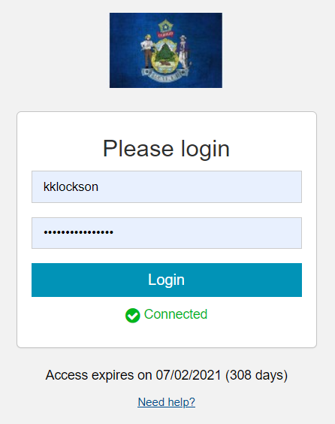

- You have entered the STATE AGENCY PPE Home Page where you can view and order items in the amounts approved by the Department. There will be no unit pricing or totals in this system as there is no charge.

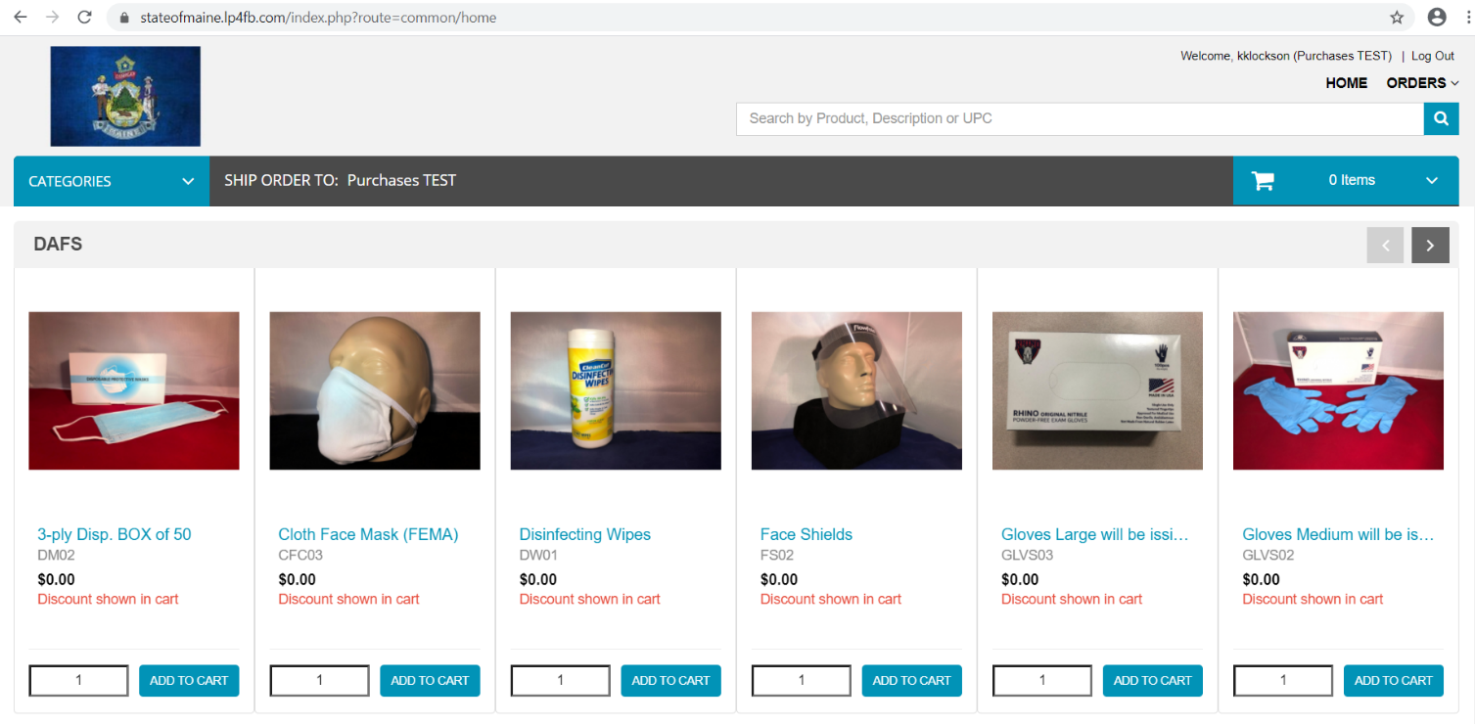

- Select the Categories dropdown and choose the DAFS option to view all the DAFS PPE items.
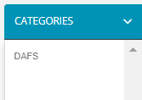
NOTE: Before ordering face shields, you must have an approved medical/ADA accommodation and/or they must be a job/department requirement.

- Enter the approved quantity your first item, by unit of measure, and select the button.

- You will receive a floating pop-up message stating: Success! “item” added to your cart.

- Repeat step 4 with each additional item(s) that you are ordering.
NOTE: If Procurement has not received an item shipment or the stock levels have been exhausted, you will receive an ‘INSUFFICIENT INVENTORY’ message. We will send a broadcast email when stock arrives. Our min/max levels will be established over time based on usage rates.

- At any time, you can view your shopping cart by selecting the shopping car drop-down arrow.

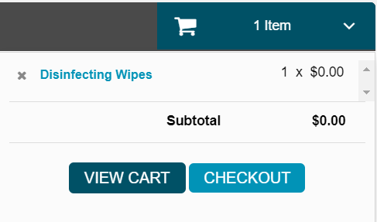

- Select the button to confirm your item(s) and quantity.

- In the “Shopping Cart” screen, you can save the order and return later to complete it or empty your cart to start over.

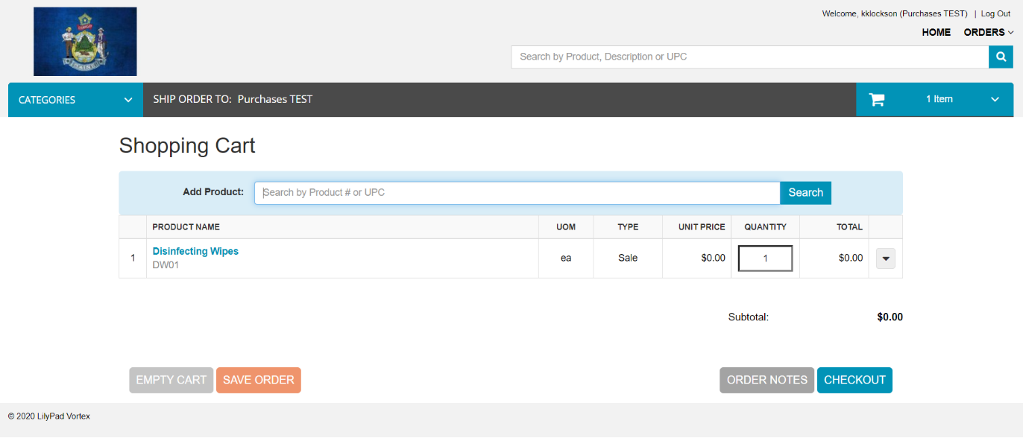

- When you are ready to complete your order, select the button and the Checkout screen will appear.

- A. Please leave the default “Req Ship Date”. The Central Warehouse will be processing these on a first come, first serve basis, B. Enter your “Dept-Div” (e.g. DAFS-State Postal) in the “Customer PO” field, and C. Enter the “Receiver” of the items name, “Hours to Receive”, and “Dock” or “No Dock” in the “Notes” field indicating whether your shipping location has a loading dock or not. *(Optionally, you can access the Notes field by selecting the 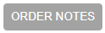 button in previous “Shopping” Cart screen.)

C. Enter : “Receiver’s Name”, “Hours to receive”, & “Dock” or “No Dock”
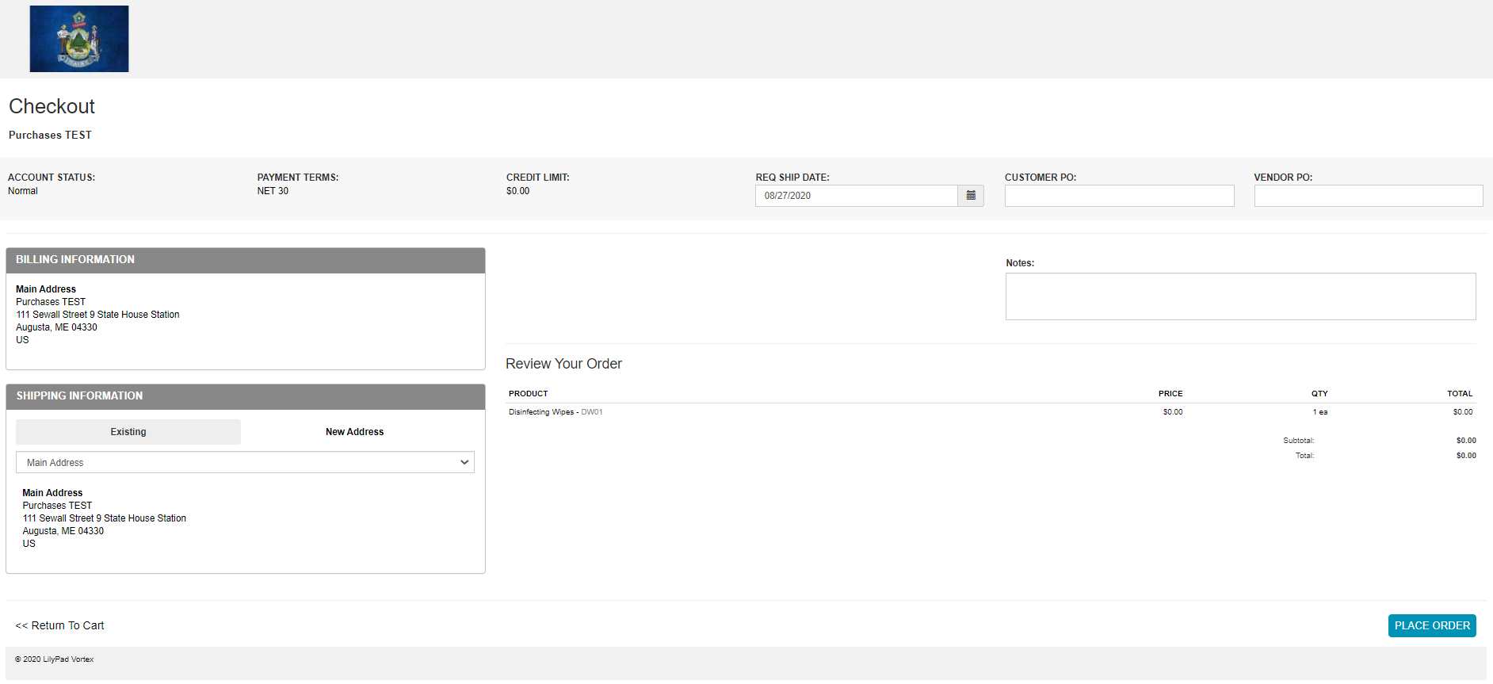
A. Leave the Default Req Ship Date
B. Enter your “Dept-Div”

- Confirm the “Shipping Information” which is the central location for receiving all items. If you are having your order delivered in the Greater Augusta Area and have a State House Station Number assigned to you by State Postal please include this below your street address. If incorrect, select the “New Address” tab and update your information, confirming the phone number that a freight delivery person may need to call regarding delivery concerns.

- Confirm order items and quantities. If incorrect, press “<< Return to Cart” link in the lower, left-hand corner.
- After reviewing and confirming your order, select the 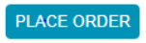 button.

- Your order has been sent to our Fishbowl inventory management system for approval and processing.

- You can log in at any time to review your “Saved”, “Submitted” and “Pending” orders. Once logged in, select the “Orders” dropdown in the upper right-hand corner of the LilyPad application to review the status of your order(s).

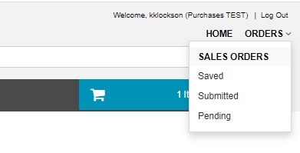

- Congratulations! You have completed your PPE order. If you have any questions, please contact us at CentralWarehouse@maine.gov.

