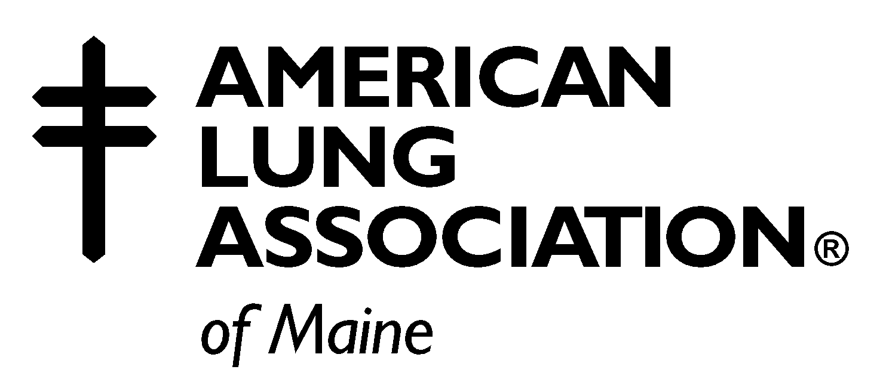

TOBACCO TREATMENT
SPECIALIST CERTIFICATION

The certification of trained Tobacco Treatment Specialists is a program of the American Lung Association of Maine (ALAME).

Tobacco treatment is based on the Clinical Practice Guideline: Treating Tobacco Use and Dependence (U.S. Public Health Service, June 2000). The Guideline contains strategies and recommendations to assist tobacco treatment specialists and clinicians to deliver effective, evidence-based treatment for tobacco use and dependence.

The Certified Tobacco Treatment Specialist (TTS-C) is a trained health professional who specializes in the treatment of tobacco dependence as part of his or her professional role. The TTS-C demonstrates the knowledge and skills to provide current and effective treatment for tobacco dependence. The TTS-C also serves as a resource and consultant to other healthcare professionals. The TTS-C can also provide the most effective and appropriate treatment to special populations, e.g. patients with a variety of co-morbidities, chemical dependency, or pregnancy.

ALAME has organized a commission of professionals with expertise and experience in addiction and substance abuse; counseling and intensive tobacco treatment to oversee the certification of qualified individuals as certified tobacco treatment specialists.

Purpose of Certification

- Provide quality assurance to clients, third party payers, employers, and referring health care
providers
- Ensure best practice performance standards

Eligibility Criteria

- Graduate of the 2-day Intensive Tobacco Training provided by the Partnership for a Tobacco Free
Maine (PTM)

- Minimum of a 2-year degree in a health-related field such as but not limited to health education,
mental health or nursing. A complete listing is on the application form.

- Documented 240 hours experience in intensive tobacco treatment* in the last three years.
  - You may include hours from the past 3 years up to and including hours completed until your case study is submitted for review by the TTS-C Commission.
*Refer to Practice Components of an Intensive Tobacco Treatment Intervention

Certification Process – Each step must be successfully completed before moving on

Step 1: Complete and submit application Tobacco Treatment Certification Commission for review and
acceptance
** The application requires the documentation of 240 hours of intensive tobacco treatment
in the last three years, hours may continue to be accrued up until your case study is
submitted for review

Step 2: Pass the TTS-C written certification examination

Step 3: Prepare and submit a case study of an intensive tobacco treatment intervention to the
Commission for review and acceptance

Step 4: Demonstrate application of the Core Competencies of a Tobacco Treatment Specialist by
successfully presenting your case study before the Commission once the case study has been
accepted

Examination Fee $150

Certification Examination

The exam consists of multiple choice and essay questions. It is based on the Clinical Practice Guideline, and on core competencies: Biology of Nicotine Dependence, Patient/Client Intake and Assessment, Counseling, Pharmacology of Tobacco Treatment, Treatment of Special Populations, Relapse Prevention, Organizational Needs.

Program History

The American Lung Association of Maine (ALAME) worked in partnership with the Center for Tobacco Independence (CTI) and the Partnership for a Tobacco-Free Maine (PTM) to develop the Maine Tobacco Treatment Specialist Certification Program. A key program element is the separation that exists between the training program and the certification process. CTI is responsible for the training and ALAME is responsible for the certification process. This was done to model other best practice professional certification programs and to avoid any conflicts that could result from a single entity being responsible for training and certification.

For More Information

Contact: The American Lung Association of Maine at 1-800-499-5864
or
Email Lee Scott at lscott@lungme.org

