

quarterly report on
organizational performance excellence

THIRD state fiscal quarter 2016
January, February, March 2016

Jay Harper
Superintendent
April 22, 2016

THIS PAGE INTENTIONALLY LEFT BLANK

Table of Contents

GLOSSARY OF TERMS, ACRONYMS, AND ABBREVIATIONS i

INTRODUCTION iii

CONSENT DECREE

STANDARDS FOR DEFINING SUBSTANTIAL COMPLIANCE

CONSENT DECREE PLAN 1

PATIENT RIGHTS 1

ADMISSIONS 2

PEER SUPPORTS 9

TREATMENT PLANNING 10

MEDICATIONS 14

DISCHARGES 15

STAFFING AND STAFF TRAINING 19

USE OF SECLUSION AND RESTRAINTS 24

PATIENT ELOPEMENTS 39

PATIENT INJURIES 41

PATIENT ABUSE, NEGLECT, EXPLOITATION, INJURY OR DEATH 45

PERFORMANCE IMPROVEMENT AND QUALITY ASSURANCE 46

RECOMMENDATIONS FROM COURT MASTER 47

JOINT COMMISSION PERFORMANCE MEASURES

HOSPITAL-BASED INPATIENT PSYCHIATRIC SERVICES (HBIPS) 49

ADMISSION SCREENING (INITIAL ASSESSMENT) 51

HOURS OF RESTRAINT USE 52

HOURS OF SECLUSION USE 53

PATIENTS DISCHARGED ON MULTIPLE ANTIPSYCHOTIC MEDICATIONS 54

PATIENTS DISCHARGED ON MULTIPLE ANTIPSYCHOTIC MEDICATIONS

WITH JUSTIFICATION 56

POST DISCHARGE CONTINUING CARE PLAN CREATED 58

POST DISCHARGE CONTINUING CARE PLAN TRANSMITTED 59

JOINT COMMISSION PRIORITY FOCUS AREAS

CONTRACT PERFORMANCE INDICATORS 60

ADVERSE REACTIONS TO SEDATION OR ANESTHESIA 62

HEALTHCARE ACQUIRED INFECTIONS MONITORING & MANAGEMENT 64

MEDICATION ERRORS AND ADVERSE DRUG REACTIONS 68

INPATIENT CONSUMER SURVEY 74
FALL REDUCTION STRATEGIES 81

STRATEGIC PERFORMANCE EXCELLENCE

PROCESS IMPROVEMENT PLANS 82

ADMISSIONS 85

CAPITAL COMMUNITY CLINIC – DENTAL CLINIC 91

CAPITAL COMMUNITY CLINIC – MEDICATION MANAGEMENT CLINIC 95

DIETARY SERVICES 97

EMERGENCY MANAGEMENT 100
HARBOR TREATMENT MALL 104

HEALTH INFORMATION TECHNOLOGY (MEDICAL RECORDS) 105

HOUSEKEEPING 109

HUMAN RESOURCES 110

MEDICAL STAFF 112

NURSING 126

OUTPATIENT SERVICES 128

PEER SUPPORT 129

PHARMACY SERVICES 132

PSYCHOLOGY 136

REHABILITATION SERVICES 138

SAFETY & SECURITY 140

THIS PAGE INTENTIONALLY LEFT BLANK

Glossary of Terms, Acronyms & Abbreviations

ADC | Automated Dispensing Cabinets (for medications)
ADON | Assistant Director of Nursing
AOC | Administrator on Call
CCM | Continuation of Care Management (Social Work Services)
CCP | Continuation of Care Plan
CH/CON | Charges/Convicted
CMS | Centers for Medicare & Medicaid Services
CIVIL | Voluntary, No Criminal Justice Involvement
CIVIL-INVOL | Involuntary Civil Court Commitment (No Criminal Justice Involvement)
CoP | Community of Practice or  Conditions of Participation (CMS)
CPI | Continuous Process (or Performance) Improvement
CPR | Cardio-Pulmonary Resuscitation
CSP | Comprehensive Service Plan
DCC | Involuntary District Court Committed
DCC-PTP | Involuntary District Court Committed, Progressive Treatment Plan
GAP | Goal, Assessment, Plan Documentation
HOC | Hand off Communication
IMD | Institute for Mental Disease
ICDCC | Involuntary Civil District Court Commitment
ICDCC-M | Involuntary Civil District Court Commitment, Court Ordered Medications
ICDCC-PTP | Involuntary Civil District Court Commitment, Progressive Treatment Plan
IC-PTP+M | Involuntary Commitment, Progressive Treatment Plan, Court Ordered Medications
ICRDCC | Involuntary Criminal District Court Commitment
INVOL CRIM | Involuntary Criminal Commitment
INVOL-CIV | Involuntary Civil Commitment
ISP | Individualized Service Plan
IST | Incompetent to Stand Trial
JAIL TRANS | A patient who has been transferred to RPC from jail.
JTF | A patient who has been transferred to RPC from jail.
LCSW | Licensed Clinical Social Worker
LEGHOLD | Legal Hold
LPN | Licensed Practical Nurse
MAR | Medication Administration Record
MHW | Mental Health Worker
MRDO | Medication Resistant Disease Organism (MRSA, VRE, C-Dif)
NASMHPD | National Association of State Mental Health Program Directors

i
NCR | Not Criminally Responsible
NOD | Nurse on Duty
NP | Nurse Practitioner
NPSG | National Patient Safety Goals (established by The Joint Commission)
NRI | NASMHPD Research Institute, Inc.
OPS | Outpatient Services Program (formally the ACT Team)
OT | Occupational Therapist
PA or PA-C | Physician’s Assistant (Certified)
PCHDCC | Pending Court Hearing
PCHDCC+M | Pending Court Hearing for Court Ordered Medications
PPR | Periodic Performance Review – a self-assessment based upon TJC standards that are conducted annually by each department head.
PSD | Program Services Director
PTP | Progressive Treatment Plan
PRET | Pretrial Evaluation
R.A.C.E. | Rescue/Alarm/Confine/Extinguish
RN | Registered Nurse
RPC | Riverview Psychiatric Center
RT | Recreation Therapist
SA | Substance Abuse
SAMHSA | Substance Abuse and Mental Health Services Administration (Federal)
SAMHS | Substance Abuse and Mental Health Services, Office of (Maine DHHS)
SBAR | Acronym for a model of concise communications first developed by the US Navy Submarine Command. S = Situation, B = Background, A = Assessment, R = Recommendation
SD | Standard Deviation – a measure of data variability.  Staff Development.
Seclusion, Locked | Patient is placed in a secured room with the door locked.
Seclusion, Open | Patient is placed in a room and instructed not to leave the room.
SRC | Single Room Care (seclusion)
STAGE III | 60 Day Forensic Evaluation
TJC | The Joint Commission (formerly JCAHO, Joint Commission on Accreditation of Healthcare Organizations)
URI | Upper Respiratory Infection
UTI | Urinary Tract Infection
VOL | Voluntary – Self
VOL-OTHER | Voluntary – Others (Guardian)

ii

Introduction

The Riverview Psychiatric Center Quarterly Report on Organizational Performance Excellence has been created to highlight the efforts of the hospital and its staff members to provide evidence of a commitment to patient recovery, safety in culture and practices, and fiscal accountability. The report is structured to reflect a philosophy and contemporary practices in addressing overall organizational performance in a systems improvement approach instead of a purely compliance approach. The structure of the report also reflects a focus on meaningful measures of organizational process improvement while maintaining measures of compliance that are mandated through regulatory and legal standards.

The methods of reporting are driven by a nationally accepted focused approach that seeks out areas for improvement that were clearly identified as performance priorities. The American Society for Quality, National Quality Forum, Baldrige National Quality Program and the National Patient Safety Foundation all recommend a systems-based approach where organizational improvement activities are focused on strategic priorities rather than compliance standards.

There are three major sections that make up this report:

The first section reflects compliance factors related to the Consent Decree and includes those performance measures described in the Order Adopting Compliance Standards dated October 29, 2007. Comparison data is not always available for the last month in the quarter and is included in the next report.

The second section describes the hospital’s performance with regard to Joint Commission performance measures that are derived from the Hospital-Based Inpatient Psychiatric Services (HBIPS) that are reflected in The Joint Commissions quarterly ORYX Report and priority focus areas that are referenced in The Joint Commission standards:
I. Data Collection (PI.01.01.01)
II. Data Analysis (PI.02.01.01, PI.02.01.03)
III. Performance Improvement (PI.03.01.01)

The third section encompasses those departmental process improvement projects that are designed to improve the overall effectiveness and efficiency of the hospital’s operations and contribute to the system’s overall strategic performance excellence. Several departments and work areas have made significant progress in developing the concepts of this new methodology.

As with any change in how organizations operate, there are early adopters and those whose adoption of system changes is delayed. It is anticipated that over the next year, further contributors to this section of strategic performance excellence will be added as opportunities for improvement and methods of improving operational functions are defined.

iii

THIS PAGE INTENTIONALLY LEFT BLANK

Consent Decree Plan

V1) The Consent Decree Plan, established pursuant to paragraphs 36, 37, 38, and 39 of the Settlement Agreement in Bates v. DHHS defines the role of Riverview Psychiatric Center in providing consumer-centered inpatient psychiatric care to Maine citizens with serious mental illness that meets constitutional, statutory, and regulatory standards.

The following elements outline the hospital’s processes for ensuring substantial compliance with the provisions of the Settlement Agreement as stipulated in an Order Adopting Compliance Standards dated October 29, 2007.

Patient Rights

V2) Riverview produces documentation that patients are routinely informed of their rights upon admission in accordance with ¶ 150 of the Settlement Agreement;

Indicators | 4Q2015 | 1Q2016 | 2Q2016 | 3Q2016
- Patients are routinely informed of their rights upon admission. | 100%  45/45 | 100%  79/79 | 80%  16/20 | 95%  61/64

Patients are informed of their rights and asked to sign that information has been provided to them. If they refuse, staff documents the refusal and signs, dates & times the refusal.

3Q2016: 26 signed, 30 declined, 4 lacked capacity, 1 not applicable.

V3) Grievance tracking data shows that the hospital responds to 90% of Level II grievances within five working days of the date of receipt or within a five-day extension.

Indicators | 4Q2015 | 1Q2016 | 2Q2016 | 3Q2016
- Level II grievances responded to by RPC on time. | 100%  1/1 | 100%  1/1 | 0%  0/0 | 0%  0/0
- Level I grievances responded to by RPC on time. | 52%  45/86 | 78%  129/165 | 51%  49/97 | 60%  46/77

Admissions

V4) Quarterly performance data shows that in 4 consecutive quarters, 95% of admissions to Riverview meet legal criteria:

ADMISSIONS | 4Q2015 | 1Q2016 | 2Q2016 | 3Q2016 | TOTAL
CIVIL: | 25 | 30 | 37 | 37 | 129
VOL | 1 | 2 | 1 | 1 | 5
INVOL | 2 | 4 | 5 | 7 | 18
DCC | 20 | 23 | 31 | 29 | 103
DCC-PTP | 2 | 1 | 0 | 0 | 3
FORENSIC: | 20 | 34 | 21 | 27 | 102
60 DAY EVAL | 6 | 19 | 11 | 13 | 49
JAIL TRANSFER | 0 | 2 | 1 | 5 | 8
IST | 13 | 6 | 7 | 3 | 29
NCR | 1 | 7 | 2 | 6 | 16
TOTAL | 45 | 64 | 58 | 64 | 231

V5) Quarterly performance data shows that in 3 out of 4 consecutive quarters, the % of readmissions within 30 days of discharge does not exceed one standard deviation from the national mean as reported by NASMHPD

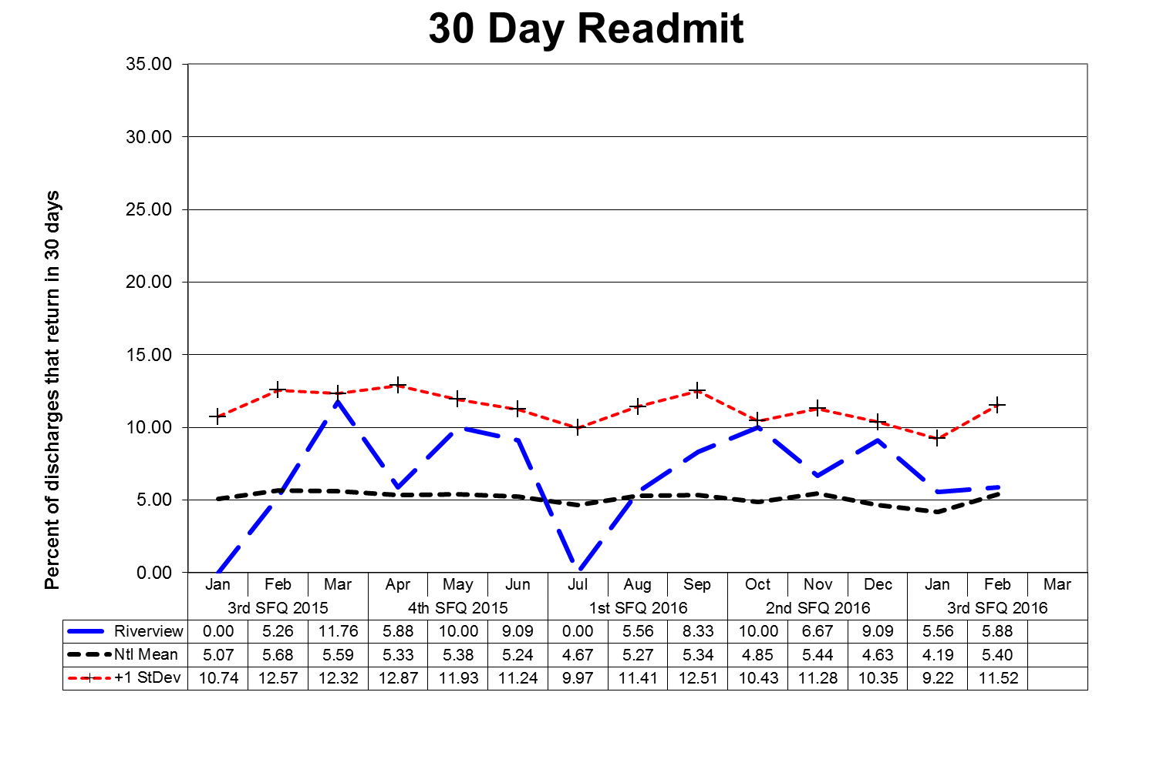
This graph depicts the percent of discharges from the facility that returned within 30 days of a discharge of the same patient from the same facility. For example; a rate of 10.0 means that 10% of all discharges were readmitted within 30 days.

Reasons for patient readmission are varied and may include decompensating or lack of compliance with a PTP. Specific causes for readmission are reviewed with each patient upon their return. These graphs are intended to provide an overview of the readmission picture and do not provide sufficient granularity to determine trends for causes of readmission. Between August 2013 and November 2014, the Lower Saco Unit was decertified; patients had to be discharged and readmitted in our Meditech Electronic Medical Record system whenever they transferred units within the hospital (either from or to Lower Saco), which caused them to show up as a 30 Day Readmission, even though they never left the hospital.

The graphs shown on the next page depict the percent of discharges from the facility that returned within 30 days of a discharge of the same patient from the same facility stratified by forensic or civil classifications. For example; a rate of 10.0 means that 10% of all discharges
were readmitted within 30 days.
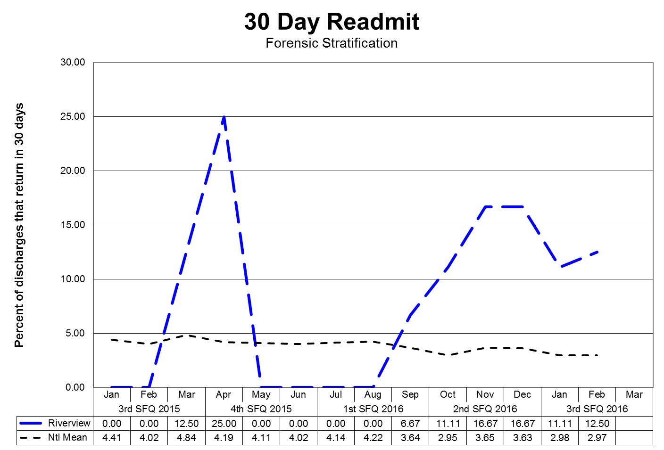
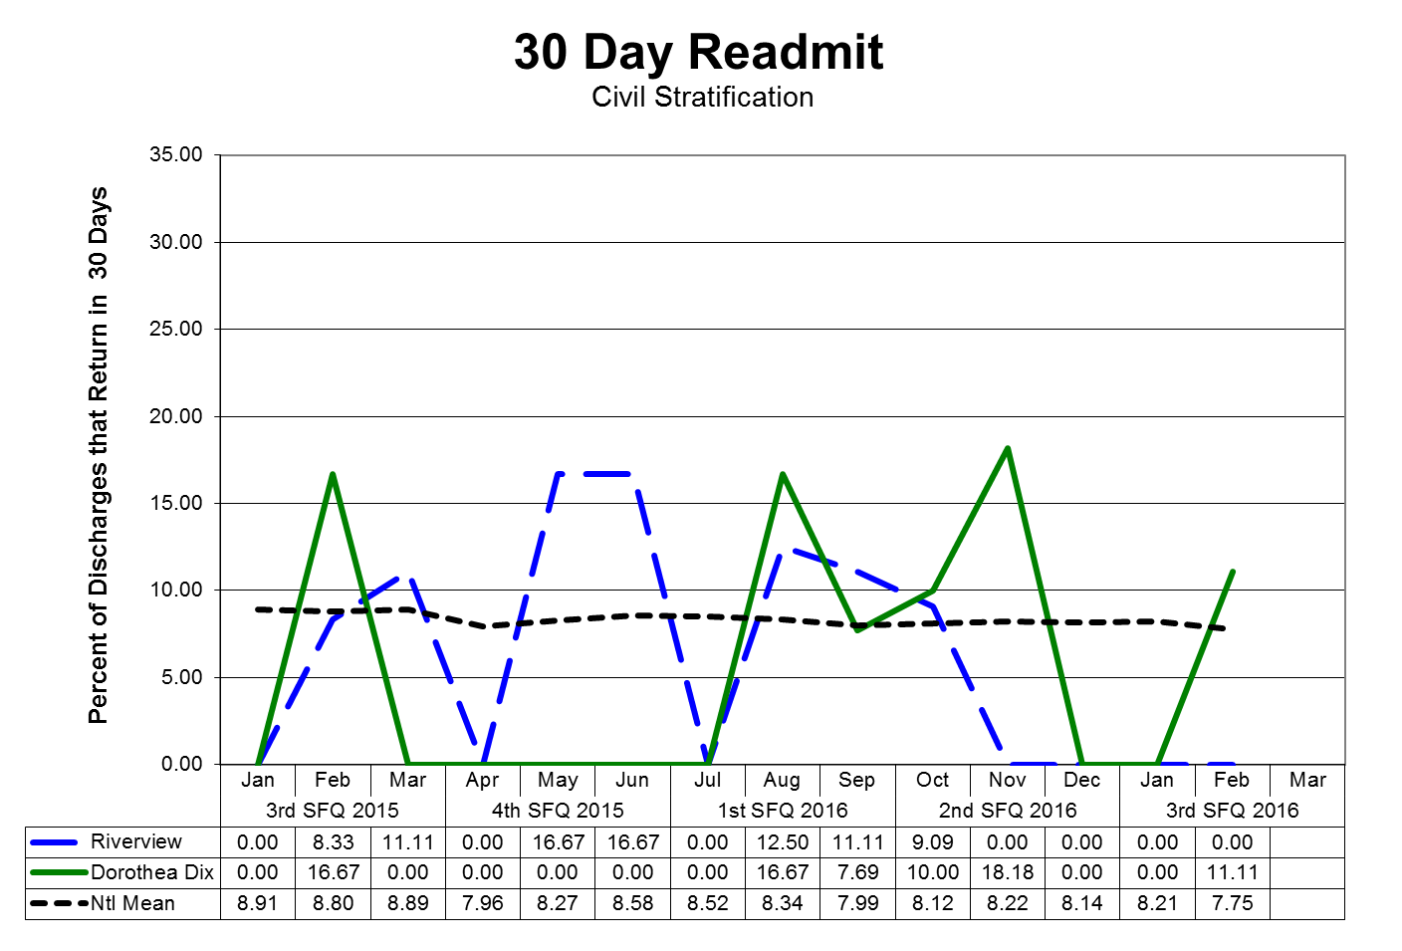
V6) Riverview documents, as part of the Performance Improvement & Quality Assurance process, that the Director of Social Work reviews all readmissions occurring within 60 days of the last discharge; and for each patient who spent fewer than 30 days in the community, evaluated the circumstances to determine whether the readmission indicated a need for resources or a change in treatment and discharge planning or a need for different resources and, where such a need or change was indicated, that corrective action was taken;

REVIEW OF READMISSION OCCURRING WITHIN 60 DAYS

Indicators | 4Q2015 | 1Q2016 | 2Q2016 | 3Q2016
Director of Social Services reviews all readmissions occurring within 60 days of the last discharge, and for each patient who spent fewer than 30 days in the community, evaluated the circumstances of the readmission to determine an indicated need for resources or a change in treatment and discharge planning or the need for alternative resources; and, where such a need or change was indicated, that corrective action was taken. | 100%  2/2 | 100%  5/5 | 100%  4/4 | 100%  5/5

3Q2016: Five patients were re-admitted in 3Q2016. Of the 5 re-admitted, all spent less than 30 days in the community. Patient 1 spent 11 days in the community post discharge to a general hospital for a surgery and was re-admitted after completing rehabilitation. Patient 2 was discharged to a PMNI placement with the additional support of an OPS team. Patient became dis-regulated related to a complex medical issue affecting the psychiatric presentation and was re-admitted to the hospital after 14 days in the community. Patient 3 was a forensic discharge from an evaluation and re-admitted after 21 days for an IST evaluation. Patient 4 was a community discharge that stopped taking medications and refused service providers to enter the patient’s residence and returned within 18 days of discharge. Patient 5 was a stage evaluation readmitted after court for discharge planning after 26 days.

Reduction of Re-Hospitalization for Outpatient Services Programs (OPS) Patients

Indicators | 4Q15 | 1Q16 | 2Q16 | 3Q16
- The Program Service Director of the Outpatient Services Program will review all patient cases of re-hospitalization from the community for patterns and trends of the contributing factors leading to re-hospitalization each quarter. The following elements are considered during the review:  - Length of stay in community  - Type of residence (group home, apartment, etc.)  - Geographic location of residence  - Community support network  - Patient demographics (age, gender, financial)  - Behavior pattern/mental status  - Medication adherence  - Level of communication with Outpatient Treatment | 100%  1/1 | 100%  6/6 | 100%  2/2 | 100%  3/3
- Outpatient Services will work closely with inpatient treatment team to create and apply discharge plan incorporating additional supports determined by review noted in #1. | 100% | 100% | 100% | 100%

3Q2016: Three patients returned to RPC; two patients remain at RPC and one has returned to the community. Patient 1 was medically compromised, patient 2 had homicidal inclination/anxiety, and patient 3had rapid decompensation on medication.

V7) Riverview certifies that no more than 5% of patients admitted in any year have a primary diagnosis of mental retardation, traumatic brain injury, dementia, substance abuse or dependence.

PATIENT ADMISSION DIAGNOSIS | 4Q15 | 1Q16 | 2Q16 | 3Q16 | TOTAL
ADJUSTMENT DISORDER WITH DEPRESSED MOOD |  |  | 1 |  | 1
ADJUSTMENT DISORDER W/ MIXED DISTURBANCE OF EMOTIONS & CONDUCT | 1 | 1 |  |  | 2
ANTISOCIAL PERSONALITY |  | 1 |  | 1 | 2
ATTENTION DEFICIT W/ HYPERACTIVITY |  | 1 |  |  | 1
ANXIETY DISORDER, UNSPECIFIED |  |  |  | 1 | 1
AUTISTIC DISORDER |  |  | 1 |  | 1
BIPOLAR DISORD, CRNT EPISODE MANIC W/O PSYCH FEATURES, MILD |  |  | 1 |  | 1
BIPOLAR DISORD, CRNT EPSD DEPRESS, SEVERE, W PSYCH FEATURES |  |  | 1 | 3 | 4
BIPOLAR DISORDER, UNSPECIFIED |  | 10 | 6 | 6 | 22
BIPOLAR I DISORDER, SINGLE MANIC EPISODE, SEVERE, SPEC W/ PSYCHOTIC BEHAV | 1 | 1 |  |  | 2
BIPOLAR I DISORDER, SINGLE MANIC EPISODE, SEVERE, W/O PSYCHOTIC FEATURES | 1 | 1 |  |  | 2
BIPOLAR I, REC EPIS OR CURRENT MANIC, IN PARTIAL OR UNSPEC REMISSION | 1 | 1 |  |  | 2
BIPOLAR I, REC EPIS OR CURRENT MANIC, SEVERE, W/ PSYCHOTIC BEHAV |  | 2 |  |  | 2
BIPOLAR II DISORDER |  |  |  | 1 | 1
BORDERLINE PERSONALITY DISORDER |  |  |  | 1 | 1
DELUSIONAL DISORDERS | 1 | 1 | 1 |  | 3
DEMENTIA IN OTH DISEASES CLASSD ELSWHR W/ BEHAVIORAL DISTURB |  |  | 1 | 1 | 2
DEPRESSIVE DISORDER NEC |  | 3 |  |  | 3
DEPRESSIVE DISORDER-SEVERE | 2 |  |  |  | 2
DEPRESSIVE DISORDER-UNSPEC |  | 1 |  |  | 1
IMPULSE CONTROL DISORDER NOS | 1 |  |  |  | 1
MAJOR DEPRESSV DISORDER, RECURRENT SEVERE W/PSYCH FEATURES |  |  | 1 |  | 1
MAJOR DEPRESSV DISORD, SINGLE EPSD, SEVERE W PSYCH FEATURES |  |  |  | 1 | 1

PATIENT ADMISSION DIAGNOSIS | 4Q15 |  | 1Q16 | 2Q16 | 3Q16 |  | TOTAL
MAJOR DEPRESSIVE DISORDER, SINGLE EPISODE, UNSPECIFIED |  |  |  |  | 2 |  | 2
MILD COGNITIVE IMPAIRMENT, SO STATED |  |  |  |  | 1 |  | 1
OTHER DEPRESSIVE EPISODES |  |  |  |  | 1 |  | 1
OTH PSYCH DISORDER NOT DUE TO A SUB OR KNOWN PHYSIOLOGICAL CONDITION |  |  |  | 1 |  |  | 1
OTHER SCHIZOPHRENIA |  |  |  | 2 |  |  | 2
OTHER SPEC PERVASIVE DEVELOPMENT DIS, CURRENT OR ACTIVE STATE | 2 |  |  |  |  |  | 2
PARANOID SCHIZOPHRENIA |  |  |  | 1 |  |  | 1
PARANOID SCHIZOPHRENIA-CHRONIC W/EXACERBATION |  |  |  |  |  |  | 0
PARANOID SCHIZOPHRENIA-UNSPEC | 1 |  | 1 |  |  |  | 2
POSTTRAUMATIC STRESS DISORDER | 8 |  | 5 | 2 | 3 |  | 18
PSYCHOSIS NOS |  |  | 4 |  |  |  | 4
RECURRENT DEPRESSIVE DISORDER-PSYCHOTIC | 1 |  | 1 |  |  |  | 2
SCHIZOAFFECTIVE DISORDER, BIPOLAR TYPE |  |  |  | 14 | 14 |  | 28
SCHIZOAFFECTIVE DISORDER, CHRONIC W/EXACER | 17 |  |  |  |  |  | 17
SCHIZOAFFECTIVE DISORDER, DEPRESSIVE TYPE |  |  |  |  | 2 |  | 2
SCHIZOAFFECTIVE DISORDER, UNSPECIFIED |  |  | 14 | 6 | 3 |  | 23
SCHIZOPHRENIA NOS-CHRONIC | 5 |  |  |  |  |  | 5
SCHIZOPHRENIA, UNSPECIFIED | 1 |  | 14 | 9 | 14 |  | 38
UNSPECIFIED ALCOHOL-INDUCED MENTAL DISORDERS | 2 |  |  |  |  |  | 2
UNSPECIFIED MOOD DISORDER ( EPISODIC ) |  |  | 2 |  |  |  | 2
UNSPECIFIED MODD DISORDER (AFFECTIVE) |  |  |  |  | 1 |  | 1
UNSP PSYCHOSIS NOT DUE TO A SUBSTANCE OR KNOWN PHYSICAL COND |  |  |  | 11 | 8 |  | 19
Total Admissions | 45 |  | 64 | 59 | 64 |  | 232
Admitted with primary diagnosis of mental retardation, traumatic brain injury, dementia, substance abuse or dependence. |  | 0% | 0% | <1% |  | <1% | < 1%

Peer Supports

Quarterly performance data shows that in 3 out of 4 consecutive quarters:

V8) 100% of all patients have documented contact with a peer specialist during hospitalization;

V9) 80% of all treatment meetings involve a peer specialist.

Indicators | 4Q2015 |  | 1Q2016 | 2Q2016 | 3Q2016
- Attendance at Comprehensive Treatment Team meetings. (v9) | *96%  383/414 |  | *89%  331/401 | *86%  446/515 | *91%  442/484
- Attendance at Service Integration meetings. (v8) | 66%  12/31 |  | *97%  61/63 | 96%  47/49 | *86%  56/65
- Contact during admission. (v8) | 100%  45/45 |  | 100%  64/64 | 100%  49/49 | 100%  64/64
- Community Integration/Bridging Inpatient & OPS.  Inpatient trips  OPS | 100%  25  142 |  | 100%  58  127 | 100%  91  131 | 100%  26  204
- Peer Support will make an attempt to assist all patients in recognizing their personal medicine and filling out form. | 100%  45/45 |  | 0%  0/64 | 82%  40/49 | 78%  50/64
- Peer Support will make a documented attempt to have patients fill out a survey before discharge or annually to evaluate the effectiveness of the peer support relationship during hospitalization. | 62%  28/45 |  | 22%  14/63 | 41%  20/49 | 46%  30/65
- Grievances responded to on time by Peer Support, within 1 day of receipt. | 100%  86/86 |  | 100%  161/161 | 100%  97/97 | 100%  77/77
- Peer Specialist will meet with resident’s within 48 hours of admission and complete progress note to document meeting. | New Indicator Added  FY 2016 | 100%  64/64 |  | 100%  49/49 | 100%  64/64
- Each resident has documented contact with a peer supporter during their hospitalization (target is 100%). | New Indicator Added  FY 2016 | 100%  64/64 |  | 100%  49/49 | 100%  64/64

Treatment Planning

V10) 95% of patients have a preliminary treatment and transition plan developed within 3 working days of admission;

Indicators | 4Q2015 | 1Q2016 | 2Q2016 | 3Q2016
1. Service Integration Meeting and form completed by the end of the 3rd day. | 100%  45/45 | 100%  45/45 | 100%  45/45 | 100%  45/45
2. Patient participation in Service Integration Meeting. | 95%  43/45 | 93%  42/45 | 95%  43/45 | 97%  44/45
3. Social Worker participation in Service Integration Meeting. | 100%  45/45 | 100%  45/45 | 100%  45/45 | 100%  45/45
4. Initial Comprehensive Psychosocial Assessments completed within 7 days of admission. | 95%  43/45 | 97%  44/45 | 95%  43/45 | 95%  43/45
5. Initial Comprehensive Assessment contains summary narrative with conclusion and recommendations for discharge and Social Worker role. | 100%  45/45 | 100%  45/45 | 100%  45/45 | 100%  45/45
6. Annual Psychosocial Assessment completed and current in chart. | 100%  10/10 | 100%  10/10 | 100%  10/10 | 100%  10/10

3Q2016:
2. One patient declined to meet for the Service Integration meeting and declined on follow up.
4. Two Comprehensive Psychosocial Assessments were not completed within the 7 day timeframe.

V11) 95% of patients also have individualized treatment plans in their records within 7 days thereafter;

Indicators | 4Q2015 | 1Q2016 | 2Q2016 | 3Q2016
- Progress notes in GAP/Incidental/Contact format will indicate at minimum weekly 1:1 meeting with all patients on assigned CCM caseload. | 100%  45/45 | 91%  41/45 | 96%  43/45 | 89%  40/45
- Treatment plans will have measurable goals and interventions listing patient strengths and areas of need related to transition to the community or transition back to a correctional facility. | 100%  45/45 | 100%  45/45 | 100%  45/45 | 100%  45/45

3Q2016: During chart audits, four charts had a late progress note for the prior week. A meeting was held with the patient, but the note was a late entry. Issue was discussed with individual team members and support was given in supervision.

V12) Riverview certifies that all treatment modalities required by ¶155 are available.

The treatment modalities listed below as listed in ¶155 are offered to all patients according to the individual patient’s ability to participate in a safe and productive manner as determined by the treatment team and established in collaboration with the patient during the formulation of the individualized treatment plan.

Treatment Modality | Provision of Services Normally by….
Treatment Modality | Medical Staff  Psychology | Nursing | Social  Services | Rehabilitation Services/  Treatment Mall
Group and Individual Psychotherapy | X
Psychopharmacological Therapy | X
Social Services |  |  | X
Physical Therapy |  |  |  | X
Occupational Therapy |  |  |  | X
ADL Skills Training |  | X |  | X
Recreational Therapy |  |  |  | X
Vocational/Educational Programs |  |  |  | X
Family Support Services and Education |  | X | X | X
Substance Abuse Services | X
Sexual/Physical Abuse Counseling | X
Introduction to Basic Principles of Health, Hygiene, and Nutrition |  | X |  | X

An evaluation of treatment planning and implementation, performed in accordance with Attachment D, demonstrates that, for 90% of the cases reviewed:

V13) The treatment plans reflect:

- Screening of the patient’s needs in all the domains listed in ¶61;
- Consideration of the patient’s need for the services listed in ¶155;
- Treatment goals for each area of need identified, unless the patient chooses not, or is not yet ready, to address that treatment goal;
- Appropriate interventions to address treatment goals;
- Provision of services listed in ¶155 for which the patient has an assessed need;
- Treatment goals necessary to meet discharge criteria; and
- Assessments of whether the patient is clinically safe for discharge;

V14) The treatment provided is consistent with the individual treatment plans;

V15) If the record reflects limitations on a patient’s rights listed in ¶159, those limitations were imposed consistent with the Rights of Recipients of Mental Health Services

An abstraction of pertinent elements of a random selection of charts is periodically conducted to determine compliance with the compliance standards of the consent decree outlined in parts V13, V14, and V15.

This review of randomly selected charts revealed substantial compliance with the consent decree elements. Individual charts can be reviewed by authorized individuals to validate this chart review.

Medications

V16) Riverview certifies that the pharmacy computer database system for monitoring the use of psychoactive medications is in place and in use, and that the system as used meets the objectives of ¶168.
Riverview utilizes a Pyxis Medstation 4000 System for the dispensing of medications on each patient care unit. A total of six devices, one on each of the four main units and in each of the two special care units, provide access to all medications used for patient care, the pharmacy medication record, and allow review of dispensing and administration of pharmaceuticals.

A database program, HCS Medics, contains records of medication use for each patient and allows access by an after-hours remote pharmacy service to these records, to the Pyxis Medstation 4000 System. The purpose of this after-hours service is to maintain 24 hour coverage and pharmacy validation and verification services for prescribers.

Records of transactions are evaluated by the Director of Pharmacy and the Clinical Director to validate the appropriate utilization of all medication classes dispensed by the hospital. The Pharmacy and Therapeutics Committee, a multidisciplinary group of physicians, pharmacists, and other clinical staff, evaluate issues related to the prescribing, dispensing, and administration of all pharmaceuticals.

The system as described is capable of providing information to process reviewers on the status of medications management in the hospital and to ensure the appropriate use of psychoactive and other medications.

The effectiveness and accuracy of the Pyxis Medstation 4000 System is analyzed regularly through the conduct of process improvement and functional efficiency studies. These studies can be found in the Medication Management and Pharmacy Services sections of this report.

Discharges

Quarterly performance data shows that in 3 consecutive quarters:

V17) 70% of patients who remained ready for discharge were transitioned out of the hospital within 7 days of a determination that they had received maximum benefit from inpatient care;

V18) 80% of patients who remained ready for discharge were transitioned out of the hospital within 30 days of a determination that they had received maximum benefit from inpatient care;

V19) 90% of patients who remained ready for discharge were transitioned out of the hospital within 45 days of a determination that they had received maximum benefit from inpatient care (with certain patients excepted, by agreement of the parties and Court Master).

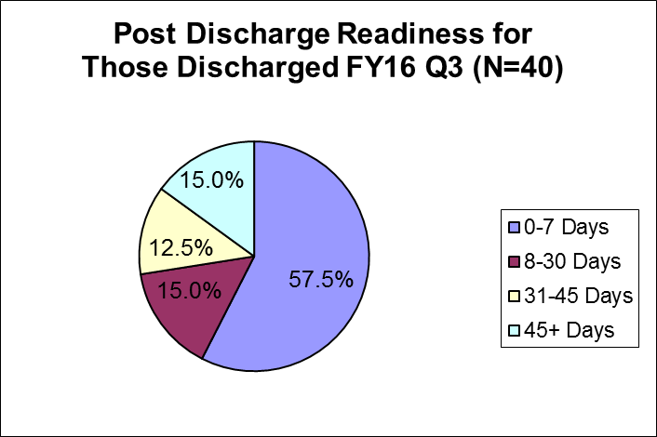
Cumulative percentages & targets are as follows:

Within 7 days = (23) 58% (target 70%)

Within 30 days = (6) 73% (target 80%)

Within 45 days = (5) 86% (target 90%)

Post 45 days = (6) 10.7% (target 0%)

Barriers to Discharge Following Clinical Readiness:

Residential Supports (0)  No barriers in this area | Housing (13)  - 5 patients discharged 8-30 days post clinical readiness (9, 14, 15, 16, 24 days)  - 2 patient discharged 31-45 days post clinical readiness (34, 35 days)  - 6 patients discharged 45+ days post clinical readiness (49, 51, 58, 65, 83, 145 days)
Treatment Services (2)
Two patients were discharged at 36 and 45 days respectively with treatment service barriers (PTP)
Other (0)
No barriers in this area
The previous four quarters are displayed in the table below:

Target >> |  | Within 7 days | Within 30 days | Within 45 days | 45+ days
 |  | 70% | 80% | 90% | < 10%
2Q2016 | N=40 | 67.9% | 85.7% | 89.3% | 10.7%
1Q2016 | N=34 | 64.7% | 82.3% | 91.1% | 8.9%
4Q2015 | N=29 | 65.6% | 86.2% | 93.1% | 6.9%
3Q2015 | N=38 | 78.9% | 86.8% | 89.4% | 10.6%

An evaluation of treatment and discharge planning, performed in accordance with Attachment D, demonstrates that, for 90% of the cases reviewed:

V20) Treatment and discharge plans reflect interventions appropriate to address discharge and transition goals;

V20a) For patients who have been found not criminally responsible or not guilty by reason of insanity, appropriate interventions include timely reviews of progress toward the maximum levels allowed by court order; and the record reflects timely reviews of progress toward the maximum levels allowed by court order;

V21) Interventions to address discharge and transition planning goals are in fact being implemented;

V21a) For patients who have been found not criminally responsible or not guilty by reason of insanity, this means that, if the treatment team determines that the patient is ready for an increase in levels beyond those allowed by the current court order, Riverview is taking reasonable steps to support a court petition for an increase in levels.

Indicators | 4Q2015 | 1Q2016 | 2Q2016 | 3Q2016
- The Patient Discharge Plan Report will be updated/reviewed by each Social Worker minimally one time per week. | 100%  12/12 | 100%  12/12 | 100%  12/12 | 100%  13/13
- The Patient Discharge Plan Report will be reviewed/updated minimally one time per week by the Director of Social Services. | 100%  12/12 | 100%  12/12 | 100%  12/12 | 100%  13/13
3. The Patient Discharge Plan Report will be sent out weekly as indicated in the approved court plan. | 92%  11/12 | 83%  10/12 | 92%  11/12 | 92%  12/13
- Each week the Social Work team and Director will meet and discuss current housing options provided by the respective regions and prioritize referrals. | 100%  12/12 | 100%  12/12 | 92%  11/12 | 100%  13/13

3Q2016:
3. On one occasion the report was not sent out during the week, it was presented at the Wednesday Housing Meeting and a two week report was sent the following week.
V22) The Department demonstrates that 95% of the annual reports for forensic patients are submitted to the Commissioner and forwarded to the court on time.

Indicators | 4Q2015 | 1Q2016 | 2Q2016 | 3Q2016
- Institutional Reports will be completed, reviewed internally, and delivered to the court within 10 business days of request. | 66%  2/3 | 66%  2/3 | 0%  0/6 | 14%  1/7
- The assigned CCM will review the new court order with the patient and document the meeting in a progress note or treatment team note. | 100%  3/3 | 100%  3/3 | 100%  3/3 | 100%  8/8
- Annual Reports (due in December) to the Commissioner for all inpatient NCR patients are submitted annually | N/A | N/A | 0%  0/25 | 100%  25/25

3Q2016:
1. Seven Institutional Reports were done in the quarter. One of the reports was completed in the 10 business day timeframe. We continue to monitor the process and recognize that the complexities of these reports in some cases make it exceptionally challenging to complete in 10 days with the multi-disciplinary collaboration and input required for completion. All NCR patients that filed in the quarter have been on a docket or a pending docket in the proceeding months and have not had adverse outcomes due to this challenging deadline as all reports were filed within the guidelines and expectations of State Forensic Services and the Court.
2. All of the 25 NCR annual reports were completed in the 3rd quarter.

Staffing and Staff Training

V23) Riverview performance data shows that 95% of direct care staff have received 90% of their annual training.

Indicators | 1Q2016 | 2Q2016 | 3Q2016 | 4Q2016 | YTD
1. Riverview and Contract staff will attend CPR training bi-annually. | 100%  55/55 | 100%  47/47 | 100%  41/41 |  | 100%  143/143
2. Riverview and Contract staff will attend Annual training. | 86%  89/104 | 97%  56/58 | 80%  16/20 |  | 88%  161/182
3. Riverview and contract staff will attend MOAB training bi-annually | 100%  28/28 | 100%  11/11 | 82%  94/115 |  | 86%  133/154

3Q2016:
2. Four employees are out of compliance for the quarter. Employees and their supervisors have been notified and corrective action is being taken.
3. Due to staff shortages, some employees due for MAOB recertification were unable to attend to ensure adequate unit coverage. The Hospital is developing a plan to ensure employees will be recertified in the imminent future.

Responsible Party: Susan Bundy, Director of Staff Development

I. Measure Name: Ongoing Education and Training

Measure Description: HR.01.05.03 requires that staff will participate in ongoing education and training to increase and maintain their competency.

Type of Measure: Performance Improvement

Goal: 90% of direct support staff will attend Non Violent Communication and Motivational Interviewing training by June 2016. Attendance will be tracked by Staffing and Organizational Development. Progress will be reported quarterly.

Progress: To date, 216 out of 375 current employees have attended Non-Violent Communication (NVC) Training. 85 have attended eight hour NVC Training. 111 employees have attended Motivational Interviewing training to date.

Comments: Motivational Interviewing was offered in January and March 2016. Twenty-two staff attended.

II. Measure Name: Seclusion and Restraint Reduction

Measure Description: Because restraint and seclusion have the potential to produce serious consequences, such as physical and psychological harm, loss of dignity, violation of the rights of an individual served, and even death, organizations continually explore ways to prevent, reduce, and strive to eliminate restraint and seclusion through effective performance improvement initiatives.

Type of Measure: Performance Improvement

Goal: RPC will decrease the use of seclusion and restraint by 50%.

FY 2015 | Manual Holds | Mechanical Restraints | Locked Seclusion | Total Events Per Quarter
Quarter 1 | 99 | 10 | 105 | 214
Quarter 2 | 107 | 16 | 97 | 220
Quarter 3 | 61 | 1 | 62 | 124
Quarter 4 | 94 | 4 | 92 | 190
Total # of events | 361 | 31 | 356 | 748
*Average # of events per month in FY 2015: 62.3
FY 2016 | Manual Holds | Mechanical Restraints | Locked Seclusion | Total Events Per Quarter
Quarter 1 | 95 | 6 | 75 | 176
Quarter 2 | 61 | 0 | 43 | 104
Quarter 3 | 108 | 0 | 72 | 180
Quarter 4
Total # of events | 264 | 6 | 190 | 460
*Average # of events per month in FY 2016 to date: 51

Action Plan:
Staff will receive initial and ongoing education training in MOAB, Non Violent Communication, Motivational interviewing to assist in establish therapeutic relationships so that, when a crisis begins, staff will be more influential and effective in preventing the use of seclusion and restraint.
Staff development will provide ongoing education to reinforce the organization’s commitment to ensuring a caring, respectful, therapeutic environment. Data gathered through hospital performance measures will be analyzed to determine progress.

V24) Riverview certifies that 95% of professional staff have maintained professionally-required continuing education credits and have received the ten hours of annual cross-training required by ¶216;

DATE | HRS |  | TITLE |  | PRESENTER
4Q2015 | 17 |  | April – June 2015
1Q2016 | 4 |  | July – September 2015
2Q2016 | 19 |  | October – December 2015
1/7/2016 | 1 |  | Health Effects of Physical Restraint of Psychiatric Patients |  | John Kootz, MD
1/14/2016 | 1 |  | Which Symptoms are the Most Severe Amongst Psychiatric Inpatients with Histories of Psychosis? Who are Non-adherent with Medications? A new research study. |  | Graham Danzer,  Psych Intern
1/19/2016 | 1 |  | Medical Staff PI & QA Committee |  | William Nelson MD
1/21/2016 | 1 |  | Promoting Equal Status for Women in Kenya |  | Sarah Malcolm, LMSW-CC
1/28/2016 | 1 |  | Addressing the Elephant: Co-Occurring Disorders and Effective Treatment |  | James Given, LADC
2/4/2016 | 1 |  | Name the Unnamable: Addressing Burnout Among Professional Caregivers in Mental Health Facility |  | James Weathersby, Chaplain
2/11/2016 | 1 |  | Sensory Processing Styles: There's no "right" or "wrong" |  | Amy Walsh, MS OTR/L Jeremy Richardson, MOT OTR/L  Maureen Martin, MOT OTR/L
2/25/2016 | 1 |  | Eating Disorders: An overview of Anorexia and Bulimia |  | Sarah Perry, PharmD
3/3/2016 | 1 |  | Sell v. United States: A look at the history and a review of the first Riverview case |  | Miriam Davidson, PMHNP
3/10/2016 | 1 |  | Mindfulness at Riverview |  | Nancy Hathaway
3/17/2016 | 2 |  | Team Presentation of an NCR Patient |  | Art DiRocco, PhD  Elizabeth Houghton-Faryna, PsyD
3/24/2016 | 1 |  | Exposure Therapy as a Transdiagnostic Treatment Procedure |  | Robert Brady, PhD
3/28/2016 | 1 | Trauma Informed Care |  | Jessica Lloyd, Psych Intern
V25) Riverview certifies that staffing ratios required by ¶202 are met, and makes available documentation that shows actual staffing for up to one recent month;

Staff Type | Consent Decree Ratio
General Medicine Physicians | 1:75
Psychiatrists | 1:25
Psychologists | 1:25
Nursing | 1:20
Social Workers | 1:15
Mental Health Workers | 1:6
Recreational/Occupational Therapists/Aides | 1:8

With 92 beds, Riverview regularly meets or exceeds the staffing ratio requirements of the consent decree.

Staffing levels are most often determined by an analysis of unit acuity, individual monitoring needs of the patients who reside on specific units, and unit census.

V26) The evaluation of treatment and discharge planning, performed in accordance with Attachment D, demonstrates that staffing was sufficient to provide patients access to activities necessary to achieve the patients’ treatment goals, and to enable patients to exercise daily and to recreate outdoors consistent with their treatment plans.

Treatment teams regularly monitor the needs of individual patients and make recommendations for ongoing treatment modalities. Staffing levels are carefully monitored to ensure that all treatment goals, exercise needs, and outdoor activities are achievable. Staffing does not present a barrier to the fulfillment of patient needs. Staffing deficiencies that may periodically be present are rectified through utilization of overtime or mandated staff members.

Use of Seclusion and Restraints

V27) Quarterly performance data shows that, in 5 out of 6 quarters, total seclusion and restraint hours do not exceed one standard deviation from the national mean as reported by NASMHPD;

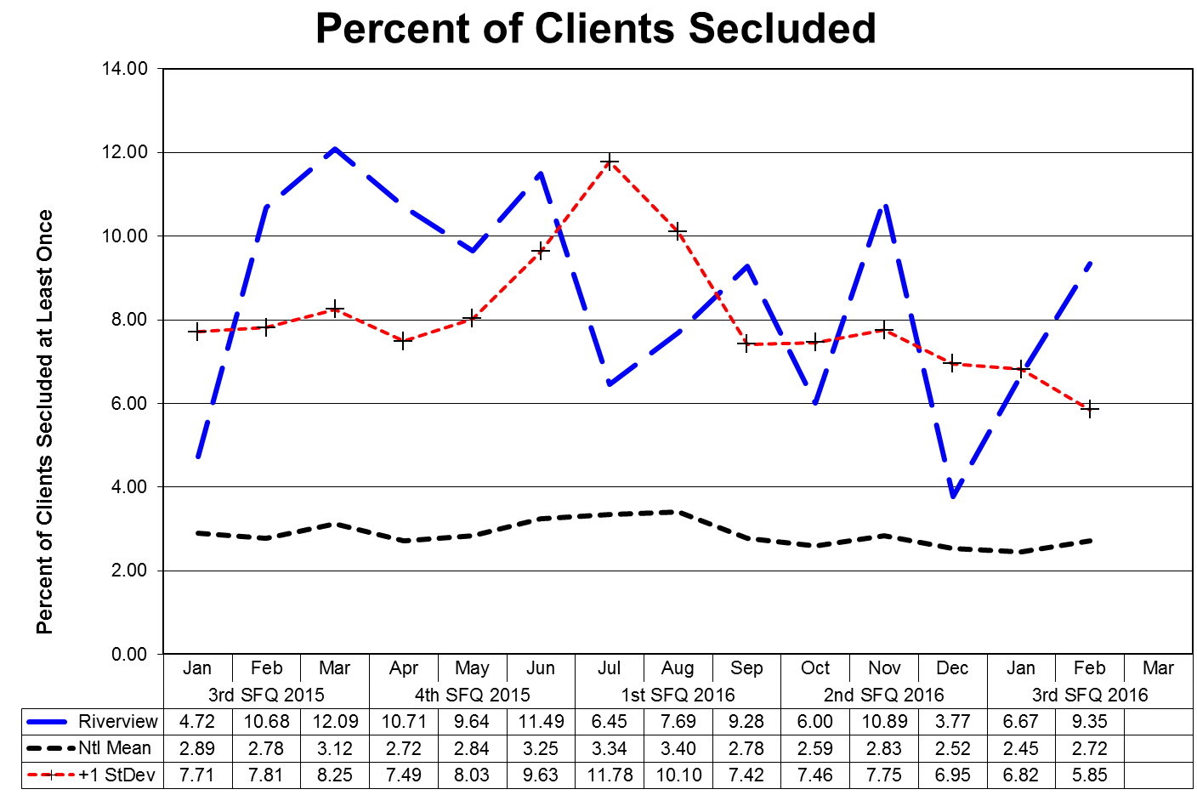

This graph depicts the percent of unique patients who were secluded at least once. For example, rates of 3.0 means that 3% of the unique patients served were secluded at least once.

The following graphs depict the percent of unique patients who were secluded at least once stratified by forensic or civil classifications. For example; rates of 3.0 means that 3% of the unique patients served were secluded at least once. The hospital-wide results from Dorothea Dix are compared to the civil population results at Riverview due to the homogeneous nature of these two sample groups.

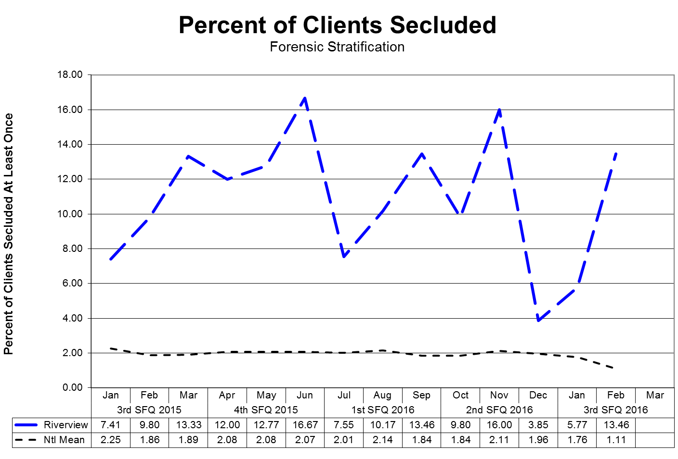
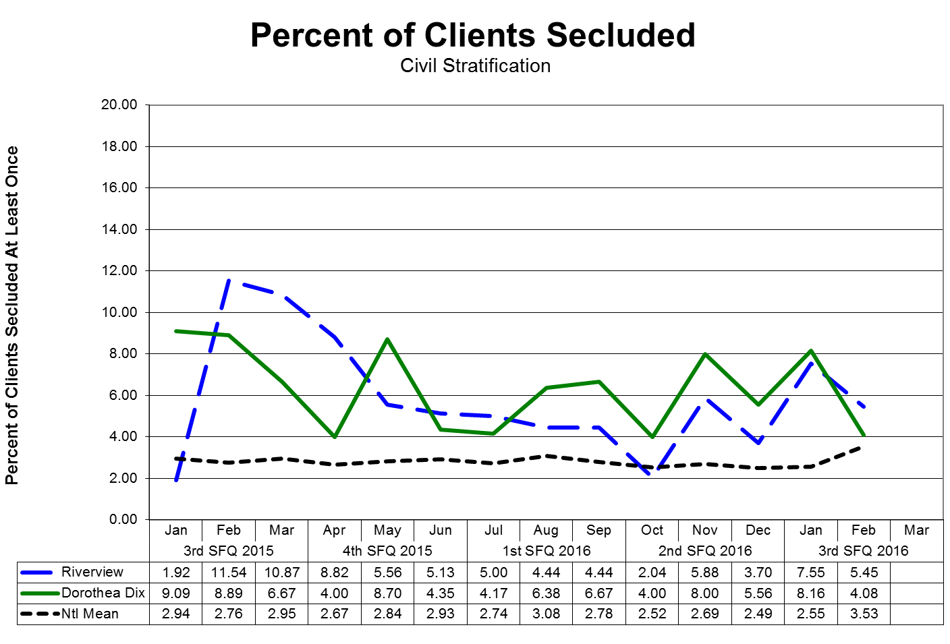
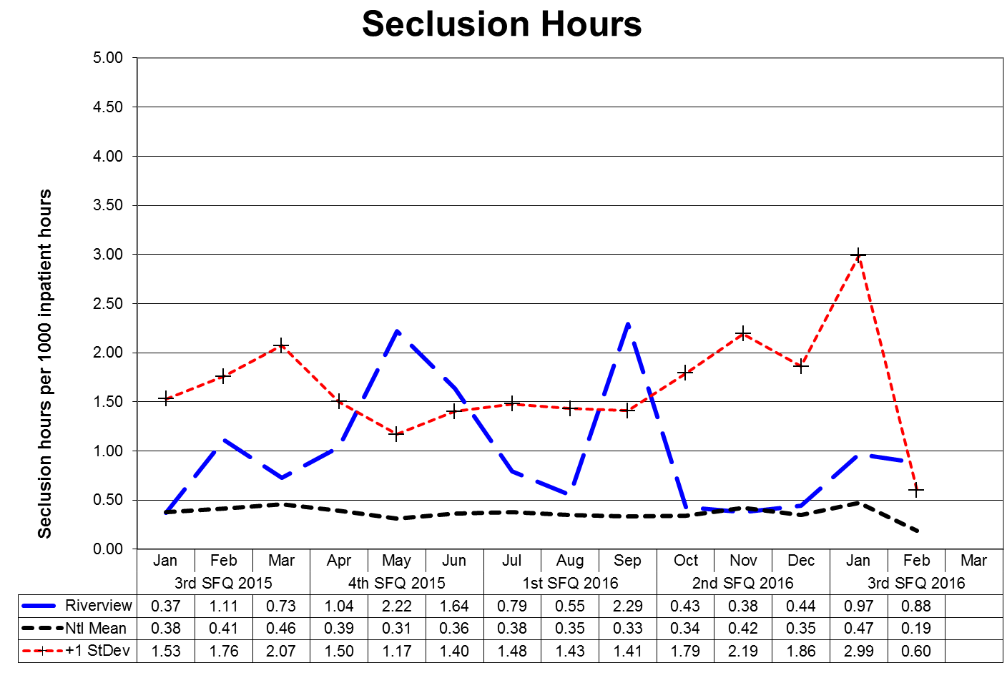

This graph depicts the number of hours patients spent in seclusion for every 1000 inpatient hours. For example, a rate of 0.8 means that 1 hour was spent in seclusion for each 1250 inpatient hours.

The following graphs depict the number of hours patients spent in seclusion for every 1000 inpatient hours stratified by forensic or civil classifications. For example, a rate of 0.8 means that 1 hour was spent in seclusion for each 1250 inpatient hours. The hospital-wide results from Dorothea Dix are compared to the civil population results at Riverview due to the homogeneous nature of these two sample groups.

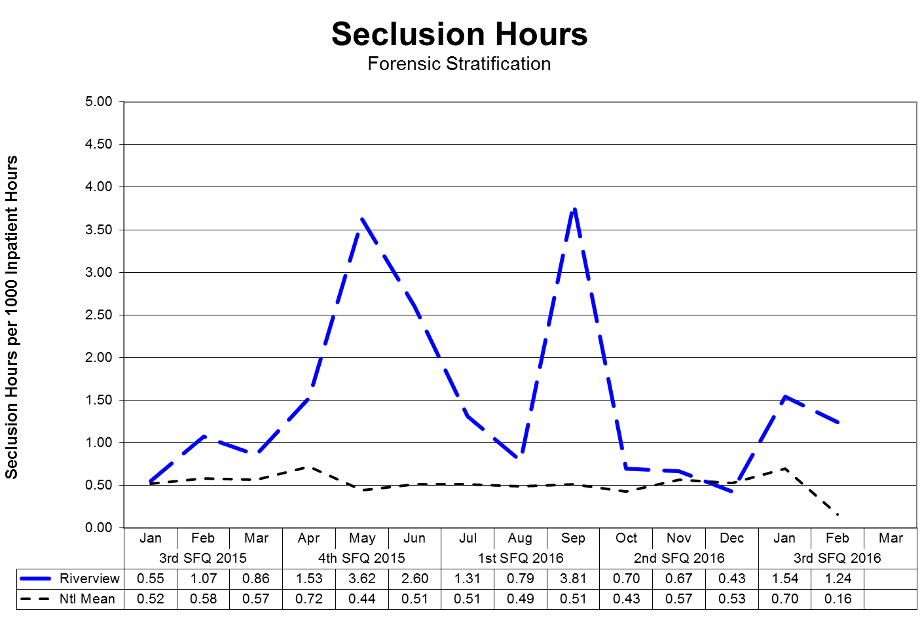
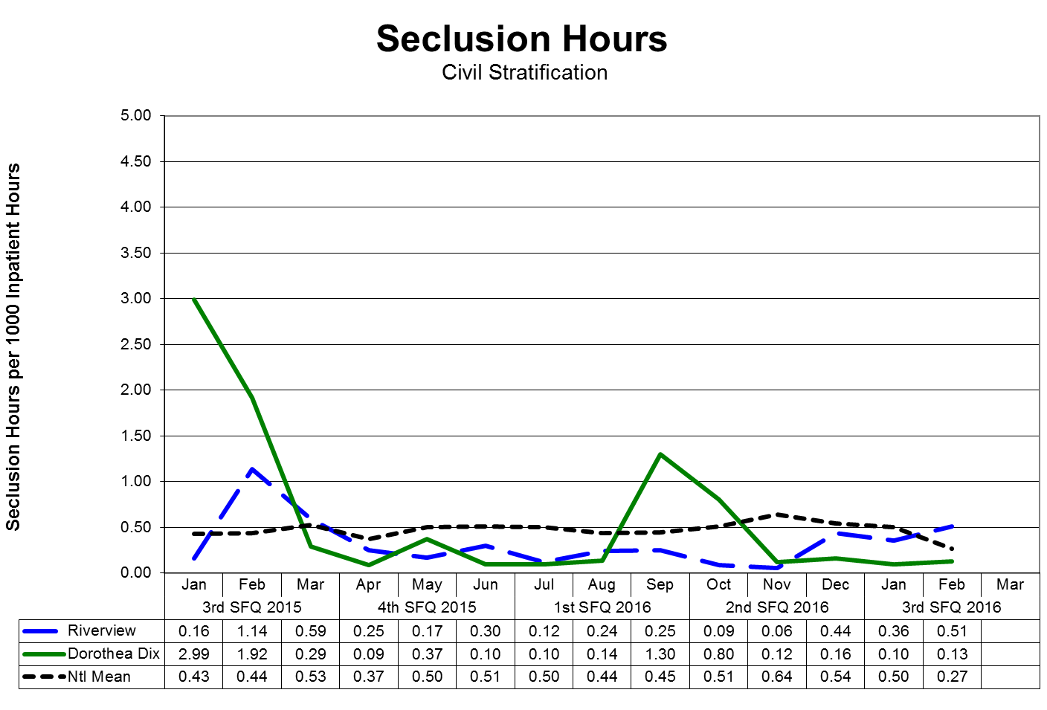
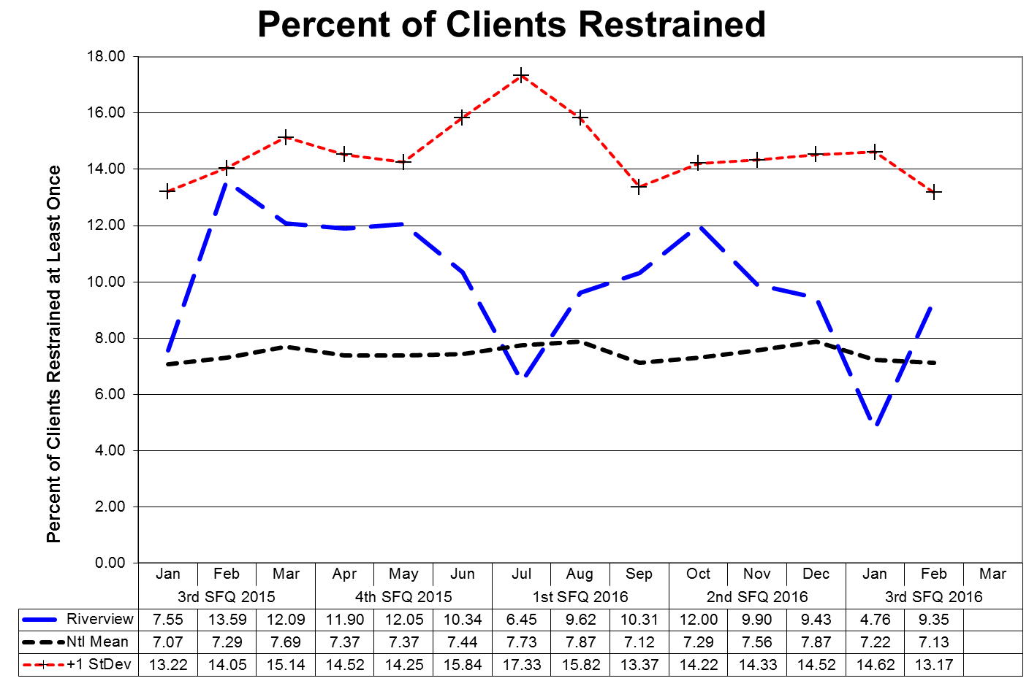
This graph depicts the percent of unique patients who were restrained at least once and includes all forms of restraint of any duration. For example; a rate of 4.0 means that 4% of the unique patients served were restrained at least once.

The following graphs depict the percent of unique patients who were restrained at least once stratified by forensic or civil classifications, and includes all forms of restraint of any duration. For example; a rate of 4.0 means that 4% of the unique patients served were restrained at least once. The hospital-wide results from Dorothea Dix are compared to the civil population results at Riverview due to the homogeneous nature of these two sample groups.

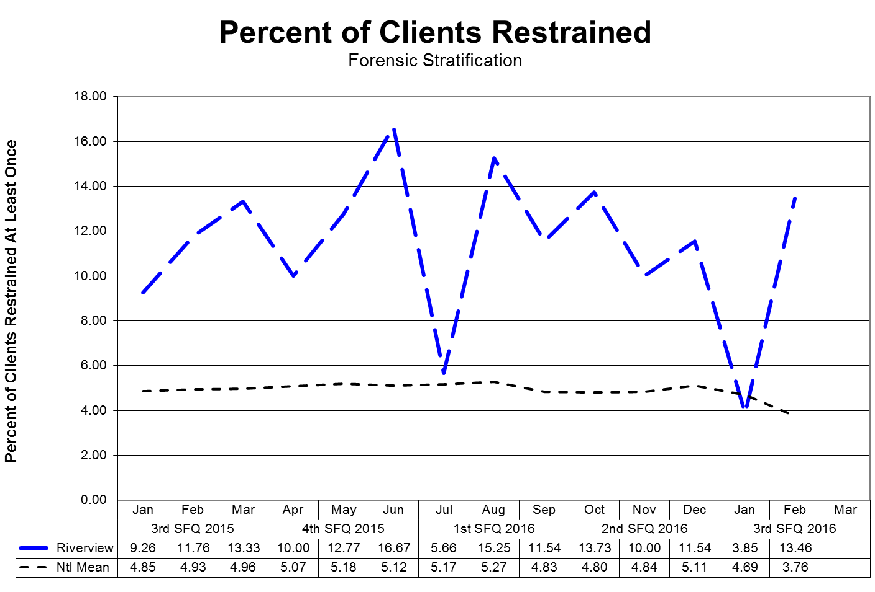
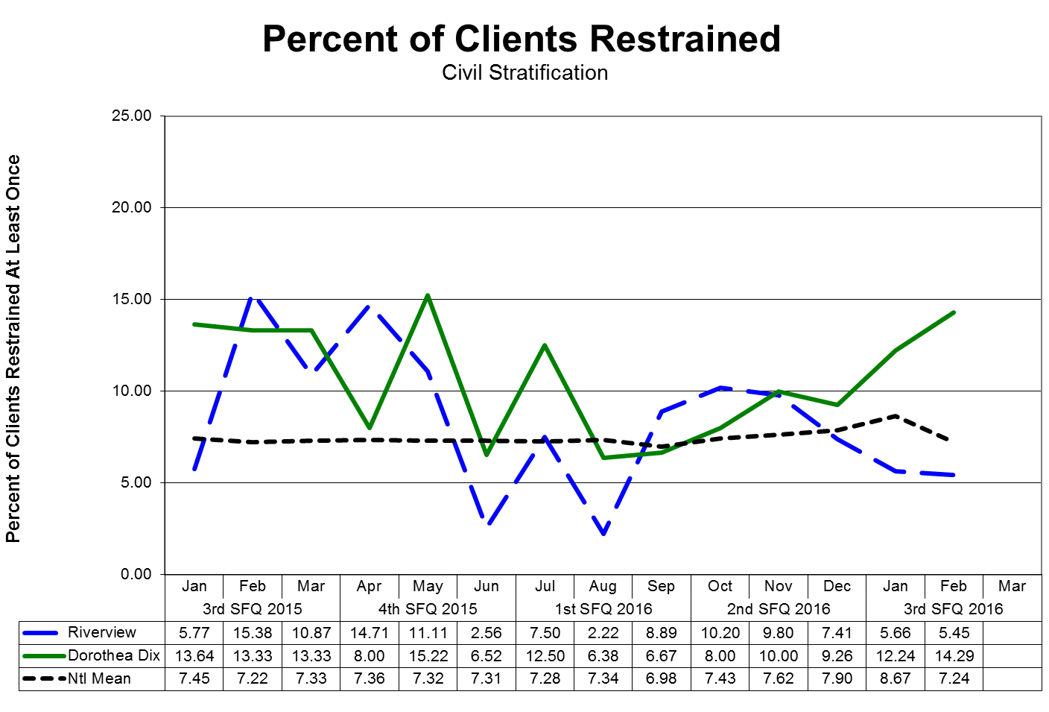

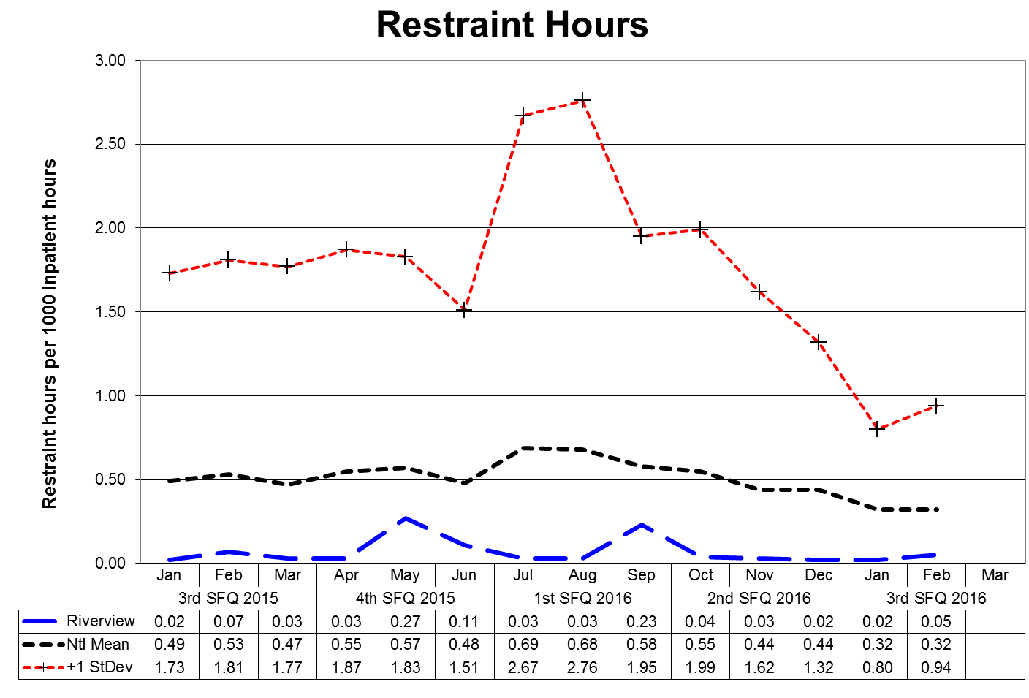

This graph depicts the number of hours patients spent in restraint for every 1000 inpatient hours - includes all forms of restraint of any duration. For example; a rate of 1.6 means those 2 hours were spent in restraint for each 1250 inpatient hours.

The following graphs depict the number of hours patients spent in restraint for every 1000 inpatient hours stratified by forensic or civil classifications - includes all forms of restraint of any duration. For example; a rate of 1.6 means those 2 hours were spent in restraint for each 1250 inpatient hours. The hospital-wide results from Dorothea Dix are compared to the civil population results at Riverview due to the homogeneous nature of these two sample groups.

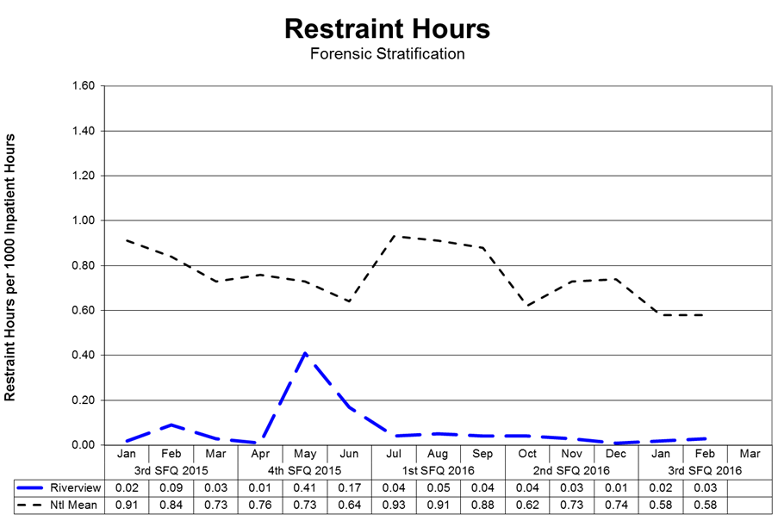

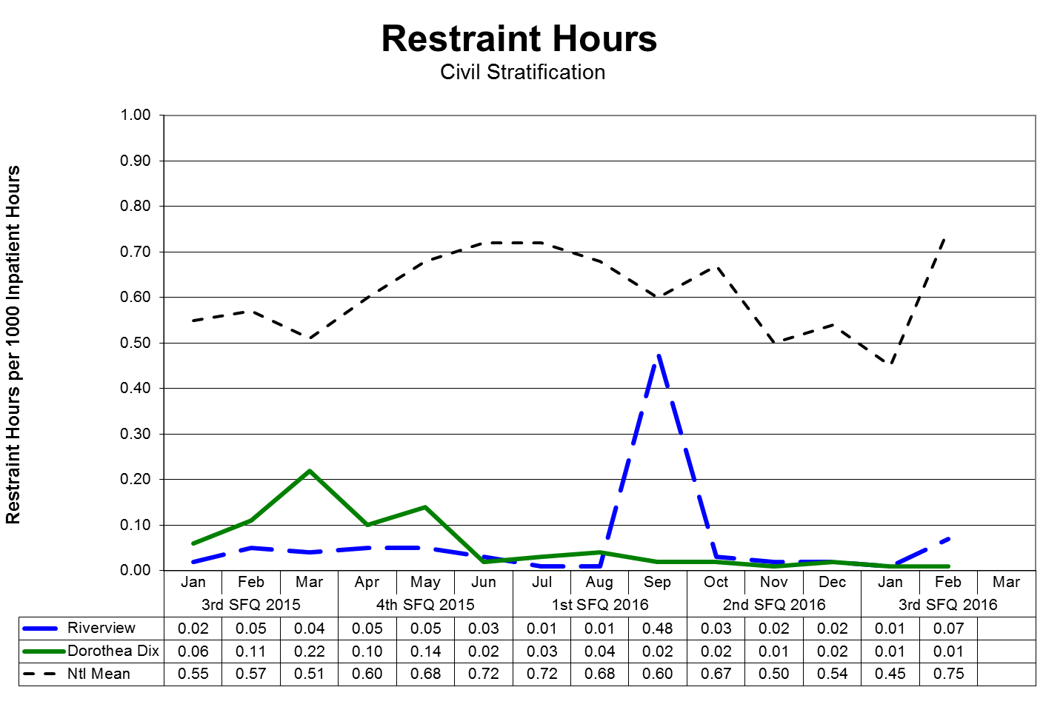
Confinement Event Detail
3Q2016

28% (24/86) of the average hospital population experienced some form of confinement event during 3Q2016. Five of these patients (6% of the average hospital population) accounted for 69% of the containment events.

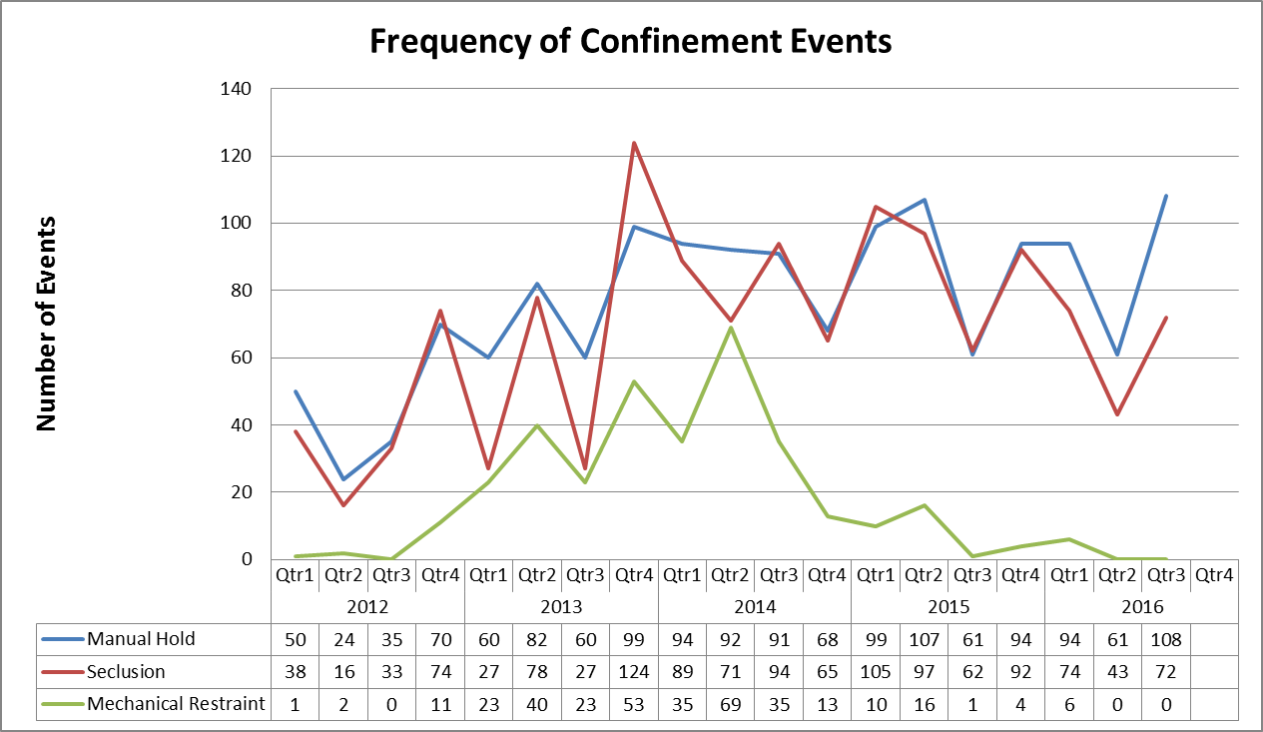

V28) Riverview demonstrates that, based on a review of two quarters of data, for 95% of seclusion events, seclusion was employed only when absolutely necessary to protect the patient from causing physical harm to self or others or for the management of violent behavior;

Factors of Causation Related to Seclusion Events:

 | 4Q2015 | 1Q2016 | 2Q2016 | 3Q2016 | Total
Danger to Others/Self | 74 | 43 | 35 | 42 | 194
Danger to Others |  |  | 23 | 29 | 52
Danger to Self |  |  |  | 1 | 1
% Dangerous Participation | 100% | 100% | 100% | 100% | 100%
Total Events | 74 | 43 | 58 | 72 | 247

V29) Riverview demonstrates that, based on a review of two quarters of data, for 95% of restraint events involving mechanical restraints, the restraint was used only when absolutely necessary to protect the patient from serious physical injury to self or others;

Factors of Causation Related to Mechanical Restraint Events:

 | 4Q2015 | 1Q2016 | 2Q2016 | 3Q2016 | Total
Danger to Others/Self | 6 |  |  |  | 6
Danger to Others |  |  |  |  | 0
Danger to Self |  |  |  |  | 0
% Dangerous Participation | 100% | 100% | 100% | 100% | 100%
Total Events | 6 | 0 | 0 | 0 | 6

V30) Riverview demonstrates that, based on a review of two quarters of data, for 95% of seclusion and restraint events, the hospital achieved an acceptable rating for meeting the requirements of paragraphs 182 and 184 of the Settlement Agreement, in accordance with a methodology defined in Attachments E-1 and E-2.

See Pages 35-39

Confinement Events Management
Seclusion Events (72) Events

Standard | Threshold | Compliance
The record reflects that seclusion was absolutely necessary to protect the patient from causing physical harm to self or others, or if the patient was examined by a physician or physician extender prior to implementation of seclusion, to prevent further serious disruption that significantly interferes with other patients’ treatment. | 95% | 100%
The record reflects that lesser restrictive alternatives were inappropriate or ineffective. This can be reflected anywhere in record. | 90% | 100%
The record reflects that the decision to place the patient in seclusion was made by a physician or physician extender. | 90% | 99%
The decision to place the patient in seclusion was entered in the patient’s records as a medical order. | 90% | 99%
The record reflects that, if the physician or physician extender was not immediately available to examine the patient, the patient was placed in seclusion following an examination by a nurse. | 90% | 100%
The record reflects that the physician or physician extender personally evaluated the patient within 30 minutes after the patient has been placed in seclusion, and if there is a delay, the reasons for the delay. | 90% | 100%
The record reflects that the patient was monitored every 15 minutes. (Compliance will be deemed if the patient was monitored at least 3 times per hour.) | 90% | 100%
Individuals implementing seclusion have been trained in techniques and alternatives. | 90% | 100%
The record reflects that reasonable efforts were taken to notify guardian or designated representative as soon as possible that patient was placed in seclusion. | 75% | 100%

Confinement Events Management
Seclusion Events, Continued (72) Events

Standard | Threshold | Compliance
The medical order states time of entry of order and that number of hours in seclusion shall not exceed 4. | 85% | 100%
The medical order states the conditions under which the patient may be sooner released. | 85% | 100%
The record reflects that the need for seclusion is re-evaluated at least every 2 hours by a nurse. | 90% | 100%
The record reflects that the 2 hour re-evaluation was conducted while the patient was out of seclusion room unless clinically contraindicated. | 70% | 100%
The record includes a special check sheet that has been filled out to document reason for seclusion, description of behavior and the lesser restrictive alternatives considered. | 85% | 100%
The record reflects that the patient was released, unless clinically contraindicated, at least every 2 hours or as necessary for eating, drinking, bathing, toileting or special medical orders. | 85% | 100%
Reports of seclusion events were forwarded to Clinical Director and Patient Advocate. | 90% | 100%
The record reflects that, for persons with mental retardation, the regulations governing seclusion of patients with mental retardation were met. | 85% | 100%
The medical order for seclusion was not entered as a PRN order. | 90% | 100%
Where there was a PRN order, there is evidence that physician was counseled. | 95% | N/A

Confinement Events Management
Mechanical Restraint Events (0) Events

Standard | Threshold | Compliance
The record reflects that restraint was absolutely necessary to protect the patient from causing serious physical injury to self or others. | 95% | N/A
The record reflects that lesser restrictive alternatives were inappropriate or ineffective. | 90% | N/A
The record reflects that the decision to place the patient in restraint was made by a physician or physician extender | 90% | N/A
The decision to place the patient in restraint was entered in the patient’s records as a medical order. | 90% | N/A
The record reflects that, if a physician or physician extended was not immediately available to examine the patient, the patient was placed in restraint following an examination by a nurse. | 90% | N/A
The record reflects that the physician or physician extender personally evaluated the patient within 30 minutes after the patient has been placed in restraint, or, if there was a delay, the reasons for the delay. | 90% | N/A
The record reflects that the patient was kept under constant observation during restraint. | 95% | N/A
Individuals implementing restraint have been trained in techniques and alternatives. | 90% | N/A
The record reflects that reasonable efforts taken to notify guardian or designated representative as soon as possible that patient was placed in restraint. | 75% | N/A
The medical order states time of entry of order and that number of hours shall not exceed four. | 90% | N/A
The medical order shall state the conditions under which the patient may be sooner released. | 85% | N/A

Confinement Events Management
Mechanical Restraint Events, Continued (0) Events

Standard | Threshold | Compliance
The record reflects that the need for restraint was re-evaluated every 2 hours by a nurse. | 90% | N/A
The record reflects that re-evaluation was conducted while the patient was free of restraints unless clinically contraindicated. | 70% | N/A
The record includes a special check sheet that has been filled out to document the reason for the restraint, description of behavior and the lesser restrictive alternatives considered. | 85% | N/A
The record reflects that the patient was released as necessary for eating, drinking, bathing, toileting or special medical orders. | 90% | N/A
The record reflects that the patient’s extremities were released sequentially, with one released at least every fifteen minutes. | 90% | N/A
Copies of events were forwarded to Clinical Director and Patient Advocate. | 90% | N/A
For persons with mental retardation, the applicable regulations were met. | 85% | N/A
The record reflects that the order was not entered as a PRN order. | 90% | N/A
Where there was a PRN order, there is evidence that physician was counseled. | 95% | N/A
A restraint event that exceeds 24 hours will be reviewed against the following requirement: If total consecutive hours in restraint, with renewals, exceeded 24 hours, the record reflects that the patient was medically assessed and treated for any injuries; that the order extending restraint beyond 24 hours was entered by Clinical Director (or if the Clinical Director is out of the hospital, by the individual acting in the Clinical Director’s stead) following examination of the patient; and that the patient’s guardian or representative has been notified. | 90% | N/A

Patient Elopements

V31) Quarterly performance data shows that, in 5 out of 6 quarters, the number of patient elopements does not exceed one standard deviation from the national mean as reported by NASMHPD.

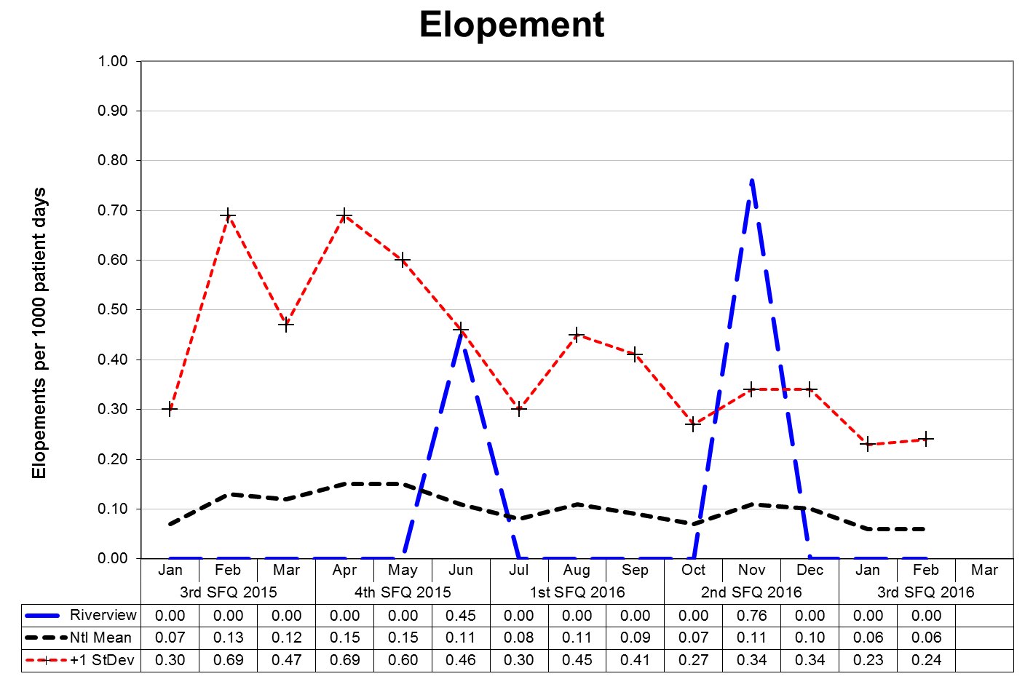

This graph depicts the number of elopements that occurred for every 1000 inpatient days. For example, a rate of 0.25 means that 1 elopement occurred for each 4000 inpatient days. An elopement is defined as any time a patient is “absent from a location defined by the patient’s privilege status regardless of the patient’s leave or legal status.”

The following graphs depict the number of elopements stratified by forensic or civil classifications that occurred for every 1000 inpatient days. For example, a rate of 0.25 means that 1 elopement occurred for each 4000 inpatient days. The hospital-wide results from Dorothea Dix are compared to the civil population results at Riverview due to the homogeneous nature of these two sample groups.

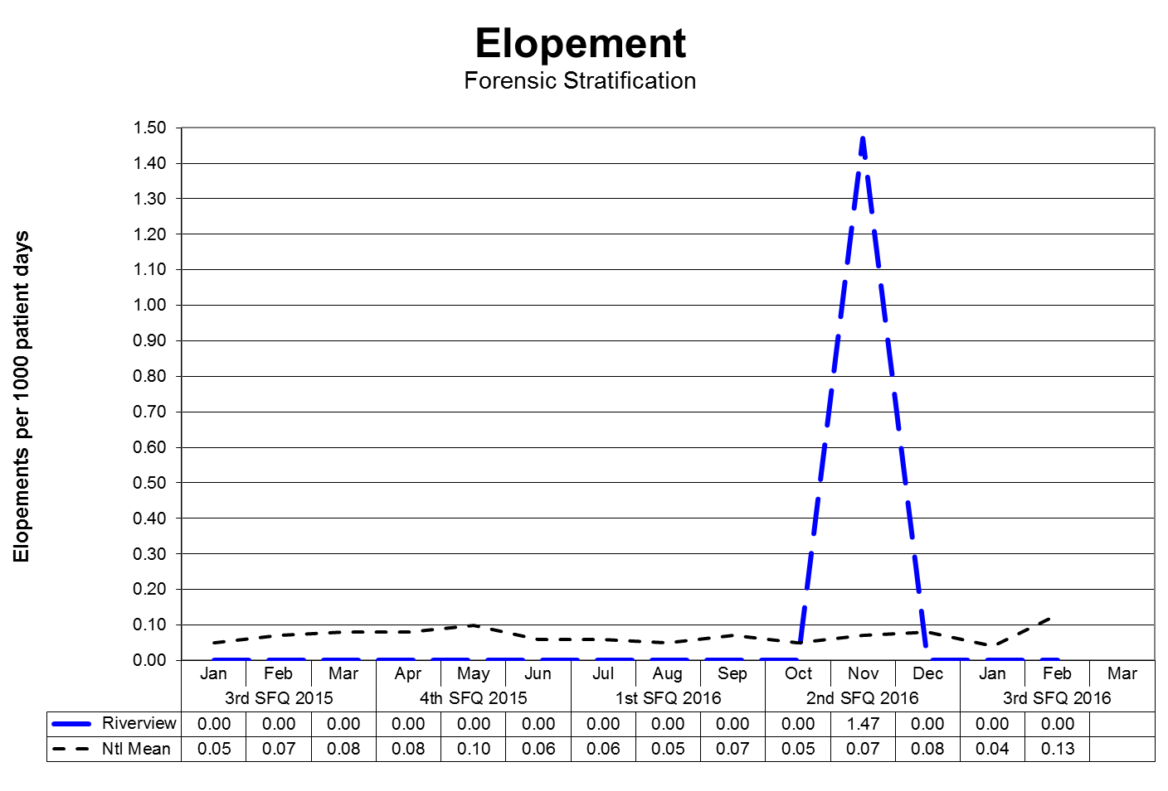
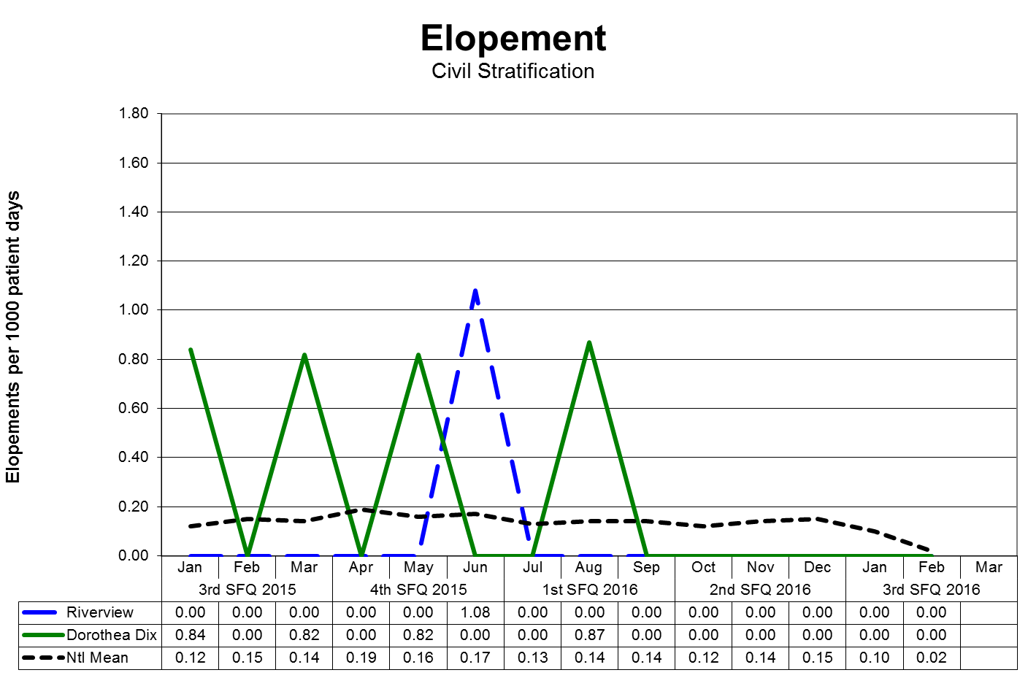

Patient Injuries

V32) Quarterly performance data shows that, in 5 out of 6 quarters, the number of patient injuries does not exceed one standard deviation from the national mean as reported by NASMHPD.

The NASMHPD standards for measuring patient injuries differentiate between injuries that are considered reportable to the Joint Commission as a performance measure and those injuries that are of a less severe nature. While all injuries are currently reported internally, only certain types of injuries are documented and reported to NRI for inclusion in the performance measure analysis process.

“Non-reportable” injuries include those that require: 1) No Treatment, or 2) Minor First Aid

Reportable injuries include those that require: 3) Medical Intervention, 4) Hospitalization or where, 5) Death Occurred.

- No Treatment – The injury received by a patient may be examined by a clinician but no treatment is applied to the injury.
- Minor First Aid – The injury received is of minor severity and requires the administration of minor first aid.
- Medical Intervention Needed – The injury received is severe enough to require the treatment of the patient by a licensed practitioner, but does not require hospitalization.
- Hospitalization Required – The injury is so severe that it requires medical intervention and treatment as well as care of the injured patient at a general acute care medical ward within the facility or at a general acute care hospital outside the facility.
- Death Occurred – The injury received was so severe that if resulted in, or complications of the injury lead to, the termination of the life of the injured patient.

The comparative statistics graph only includes those events that are considered “Reportable” by NASMHPD.

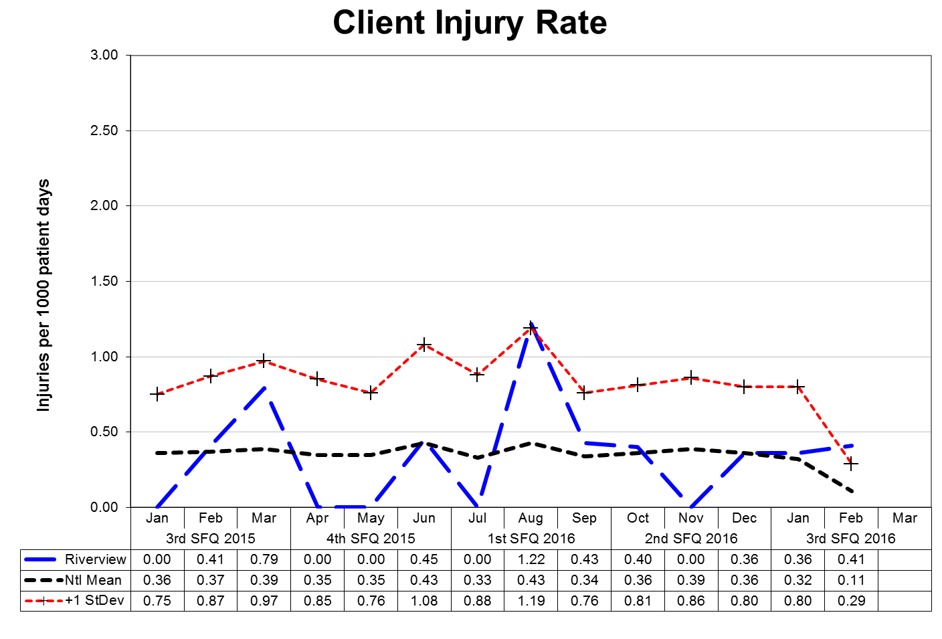
This graph depicts the number of patient injury events that occurred for every 1000 inpatient days. For example, a rate of 0.5 means that 1 injury occurred for each 2000 inpatient days.

The following graphs depict the number of patient injury events stratified by forensic or civil classifications that occurred for every 1000 inpatient days. For example, a rate of 0.5 means that 1 injury occurred for each 2000 inpatient days. The hospital-wide results from Dorothea Dix are compared to the civil population results at Riverview due to the homogeneous nature
of these two sample groups.

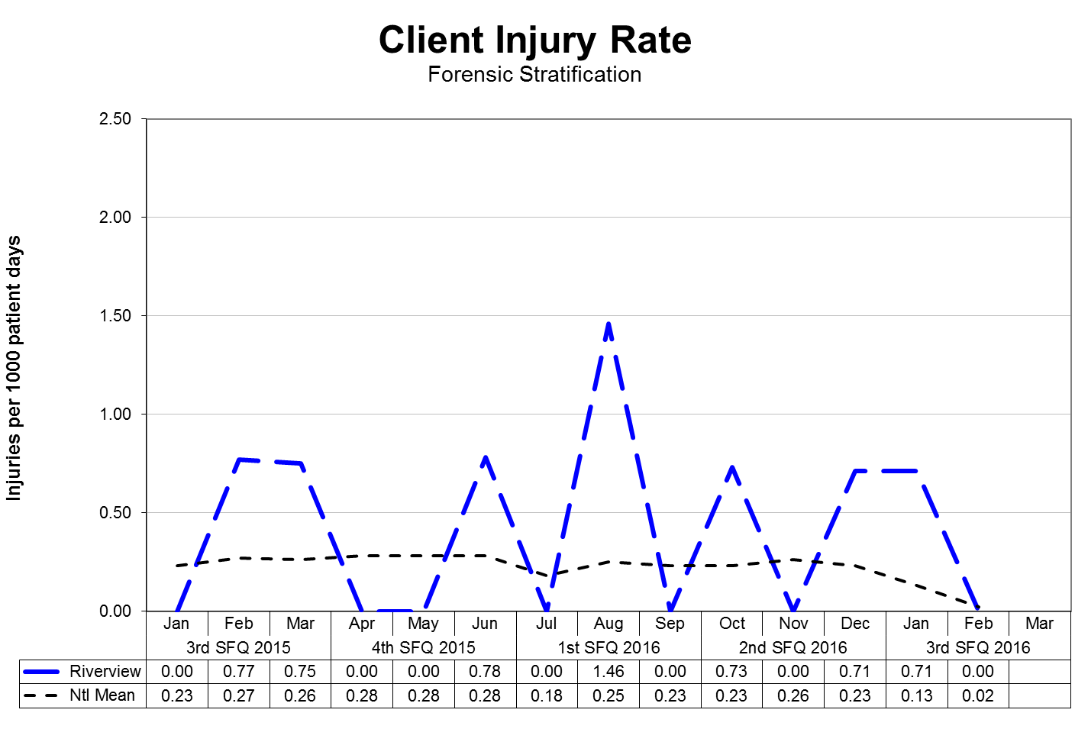

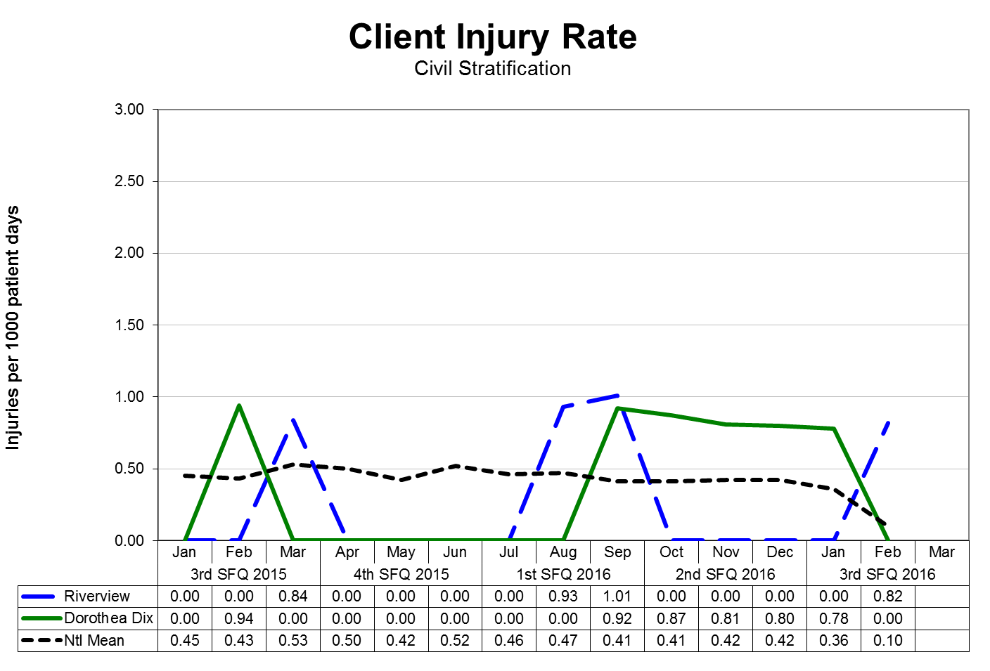
Type and Cause of Injury by Month

Type - Cause | January | February | March | 3Q2016
Accident – Fall | 1 | 1 | 1 | 3
Accident – Other |  | 1 | 4 | 5
Assault – Patient to Patient | 2 |  | 1 | 3
Injury – Other |  | 2 | 8 | 10
Self-Injurious Behavior | 1 |  |  | 1
Total | 4 | 4 | 14 | 22

Severity of Injury by Month

Severity | January | February | March | 3Q2016
No Treatment | 1 | 1 | 6 | 8
Minor First Aid | 2 | 3 | 8 | 13
Medical Intervention Required | 1 |  |  | 1
Hospitalization Required
Death Occurred
Total | 4 | 4 | 14 | 22

Note: Previous quarterly report numbers may have been higher as they included data on incidents as well as injuries. This report has been modified to only include injuries. Per NASMHPD, injuries occur when harm or damage is done.

Due to changes in reporting standards related to “criminal” events as defined by the “State of Maine Rules for Reporting Sentinel Events”, effective February 1, 2013, as defined the by “National Quality Forum 2011 List of Serious Reportable Events,” the number of reportable “assaults” that occur as the result of patient interactions increased significantly. This change is due primarily as a result of the methods and rules related to data collection and abstraction.
Further information on Fall Reduction Strategies can be found under The Joint Commission Priority Focus Areas section of this report.
Patient Abuse, Neglect, Exploitation, Injury or Death

V33) Riverview certifies that it is reporting and responding to instances of patient abuse, neglect, exploitation, injury or death consistent with the requirements of ¶ 192-201 of the Settlement Agreement.

Type of Allegation | 4Q2015 | 1Q2016 | 2Q2016 | 3Q2016 | Total
Abuse Verbal | 5 | 8 | 11 | 8 | 32
Abuse Physical | 9 | 14 | 11 | 13 | 47
Abuse Sexual | 6 | 27 | 9 | 11 | 53
Neglect | 0 | 3 | 2 | 1 | 6
Coercion/Exploitation | 3 | 2 | 4 | 6 | 15
Total | 23 | 54 | 37 | 39 | 153

Riverview utilizes several vehicles to communicate concerns or allegations related to abuse, neglect, or exploitation:
- Staff members complete an incident report upon becoming aware of an incident or an allegation of any form of abuse, neglect, or exploitation.
- Patients have the option to complete a grievance or communicate allegations of abuse, neglect, or exploitation during any interaction with staff at all levels, Peer Support personnel, or the Patient Advocate(s).
- Any allegation of abuse, neglect, or exploitation is reported both internally and externally to appropriate stakeholders, including:
- Superintendent and/or AOC
- Adult Protective Services
- Guardian
- Patient Advocate
- Allegations are reported to the Risk Manager through the incident reporting system and fact-finding or investigations occur at multiple levels. The purpose of this investigation is to evaluate the event to determine if the allegations can be substantiated or not and to refer the incident to the patient’s treatment team, hospital administration, or outside entities.
- When appropriate to the allegation and circumstances, investigations involving law enforcement, family members, or human resources may be conducted.
- The Human Rights Committee, a group consisting of consumers, family members, providers, and interested community members, and the Medical Executive Committee receive a report on the incident of alleged abuse, neglect, and exploitation monthly.
Performance Improvement and Quality Assurance

V34) Riverview maintains Joint Commission accreditation;

Riverview successfully completed an accreditation survey with The Joint Commission on in 2013 and is due for an upcoming reaccreditation visit in 2016. The hospital is currently completing its annual application for an accreditation visit in the fall of 2016.

V35) Riverview maintains its hospital license;

Riverview maintains its licensing status as required through the Maine Department of Health and Human Services Division of Licensing and Regulatory Services. The hospital is licensed through October 31, 2016.

V36) The hospital seeks CMS certification;

The hospital was terminated from the Medicare Provider Agreement on September 2, 2013 for failing to show evidence of substantial compliance in eight areas by August 27, 2013. Plans are being developed to apply for certification in 2016.

V37) Riverview conducts quarterly monitoring of performance indicators in key areas of hospital administration, in accordance with the Consent Decree Plan, the accreditation standards of The Joint Commission, and according to a QAPI plan reviewed and approved by the Advisory Board each biennium, and demonstrates through quarterly reports that management uses that data to improve institutional performance, prioritize resources and evaluate strategic operations.

Riverview complies with this element of substantial compliance as evidenced by the current Integrated Plan for Performance Excellence, the data and reports presented in
this document, the work of the Integrated Performance Excellence Committee, and sub-groups of this committee that are engaged in a transition to an improvement orientated methodology that is supported by The Joint Commission and is consistent with modern principles of process management and strategic methods of promoting organizational performance excellence. The Advisory Board approved the Integrated Plan for Performance Excellence in August 2015.

Recommendation from Court Master
February 9, 2016

Court Master Recommendation | Riverview Action
I recommend that Riverview implement unit based staffing on a pilot basis in one of the four units on or before April 4, 2016 with implementation on all other units to be completed on or before August 1, 2016. | The Upper Kennebec Unit moved to unit based staffing on April 4, 2016. The hospital has entered into a contract with Applied Management Services to assist in developing unit based/acuity based staffing models for the entire hospital. The contract has two components: first, an analysis of current staffing models and recommendations based on those findings and second installation of a software program that allows the hospital to monitor patient acuity and assign unit staff based on the acuity. Initial meetings with the vendor have occurred and the vendors software is being updated to work on State of Maine servers.
I recommend that the newly created positions for acuity specialists not be counted for purposes of determining compliance with the staffing ratios for mental health workers required by the Consent Decree. This change is designed to ensure that acuity specialists are assigned to their designated tasks and not used as substitutes for mental health workers | The Director of Nursing notified the staffing office of this change. Acuity Specialists are no longer counted for purposes of determining compliance with staffing ratios for mental health workers.
I recommend that an annual review of restrictive practices and the management system being used by the hospital be conducted by a fully independent consultant, with the report of the first review due on or before July 1, 2016. The scope of the review and the selection of the independent consultant to require the approval of the Court Master. | The hospital presented the Court Master with the name of a potential Vendor. After reviewing the proposal the Court Master declined permission and submitted the name of a consultant. The hospital is currently in negotiation with the proposed consultant.
I recommend that the mental health workers who are most familiar with the patients be invited by the charge nurse on the unit to attend at least the initial portion of the treatment team meetings for those patients in order to provide input and observations, and that acuity specialists be invited to attend whenever it is deemed appropriate by the charge nurse. Current and relevant portions of the treatment plans, such as interventions, shall be maintained on the unit and reviewed with the charge nurse by the mental health workers assigned to those patients. | Changes are in process to determine how to best use the knowledge of the mental health workers in the treatment team meetings. This is being reviewed and implemented on each unit in the hospital. Processes for ensuring that the most current treatment information is being made available to all staff on an ongoing basis.
I recommend that unit activity logs be maintained on each unit and that the logs be reviewed at least on a monthly basis to determine whether any limitation in a patient’s access to treatment, services or outdoor areas has occurred. | Unit activity logs are maintained on each unit. Nurse educators are training staff on the required documentation regarding any limitations to treatment, services or outdoor activities.

Hospital-Based Inpatient Psychiatric Services (ORYX Data Elements)

The Joint Commission Quality Initiatives
In 1987, The Joint Commission announced its Agenda for Change, which outlined a series of major steps designed to modernize the accreditation process. A key component of the Agenda for Change was the eventual introduction of standardized core performance measures into the accreditation process. As the vision to integrate performance measurement into accreditation became more focused, the name ORYX® was chosen for the entire initiative. The ORYX initiative became operational in March of 1999, when performance measurement systems began transmitting data to The Joint Commission on behalf of accredited hospitals and long term care organizations. Since that time, home care and behavioral healthcare organizations have been included in the ORYX initiative.

The initial phase of the ORYX initiative provided healthcare organizations a great degree of flexibility, offering greater than 100 measurement systems capable of meeting an accredited organization’s internal measurement goals and The Joint Commission’s ORYX requirements. This flexibility, however, also presented certain challenges. The most significant challenge was the lack of standardization of measure specifications across systems. Although many ORYX measures appeared to be similar, valid comparisons could only be made between health care organizations using the same measures that were designed and collected based on standard specifications. The availability of over 8,000 disparate ORYX measures also limited the size of some comparison groups and hindered statistically valid data analyses. To address these challenges, standardized sets of valid, reliable, and evidence-based quality measures have been implemented by The Joint Commission for use within the ORYX initiative.

Hospital-Based Inpatient Psychiatric Services (HBIPS) Core Measure Set
Driven by an overwhelming request from the field, The Joint Commission was approached in late 2003 by the National Association of Psychiatric Health Systems (NAPHS), the National Association of State Mental Health Program Directors (NASMHPD) and the NASMHPD Research Institute, Inc. (NRI) to work together to identify and implement a set of core performance measures for hospital-based inpatient psychiatric services. Project activities were launched in March 2004. At this time, a diverse panel of stakeholders convened to discuss and recommend an overarching initial framework for the identification of HBIPS core performance measures. The Technical Advisory Panel (TAP) was established in March 2005 consisting of many prominent experts in the field.

The first meeting of the TAP was held May 2005 and a framework and priorities for performance measures was established for an initial set of core measures. The framework consisted of seven domains:

- Assessment
- Treatment Planning and Implementation
- Hope and Empowerment
- Patient Driven Care
- Patient Safety
- Continuity and Transition of Care
- Outcomes
The current HBIPS standards reflected in this report are designed to reflect these core domains in the delivery of psychiatric care.

Admissions Screening (HBIPS 1)
For Violence Risk, Substance Use, Psychological Trauma History, and Patient Strengths

Description
Patients admitted to a hospital-based inpatient psychiatric setting who are screened within the first three days of admission for all of the following: risk of violence to self or others, substance use, psychological trauma history, and patient strengths.

Rationale
Substantial evidence exists that there is a high prevalence of co-occurring substance use disorders as well as history of trauma among persons admitted to acute psychiatric settings. Professional literature suggests that these factors are under-identified yet integral to current psychiatric status and should be assessed in order to develop appropriate treatment (Ziedonis, 2004; NASMHPD, 2005). Similarly, persons admitted to inpatient settings require a careful assessment of risk for violence and the use of seclusion and restraint. Careful assessment of risk is critical to safety and treatment. Effective, individualized treatment relies on assessments that explicitly recognize patients’ strengths. These strengths may be characteristics of the individuals themselves, supports provided by families and others, or contributions made by the individuals’ community or cultural environment (Rapp, 1998). In the same way, inpatient environments require assessment for factors that lead to conflict or less than optimal outcomes.

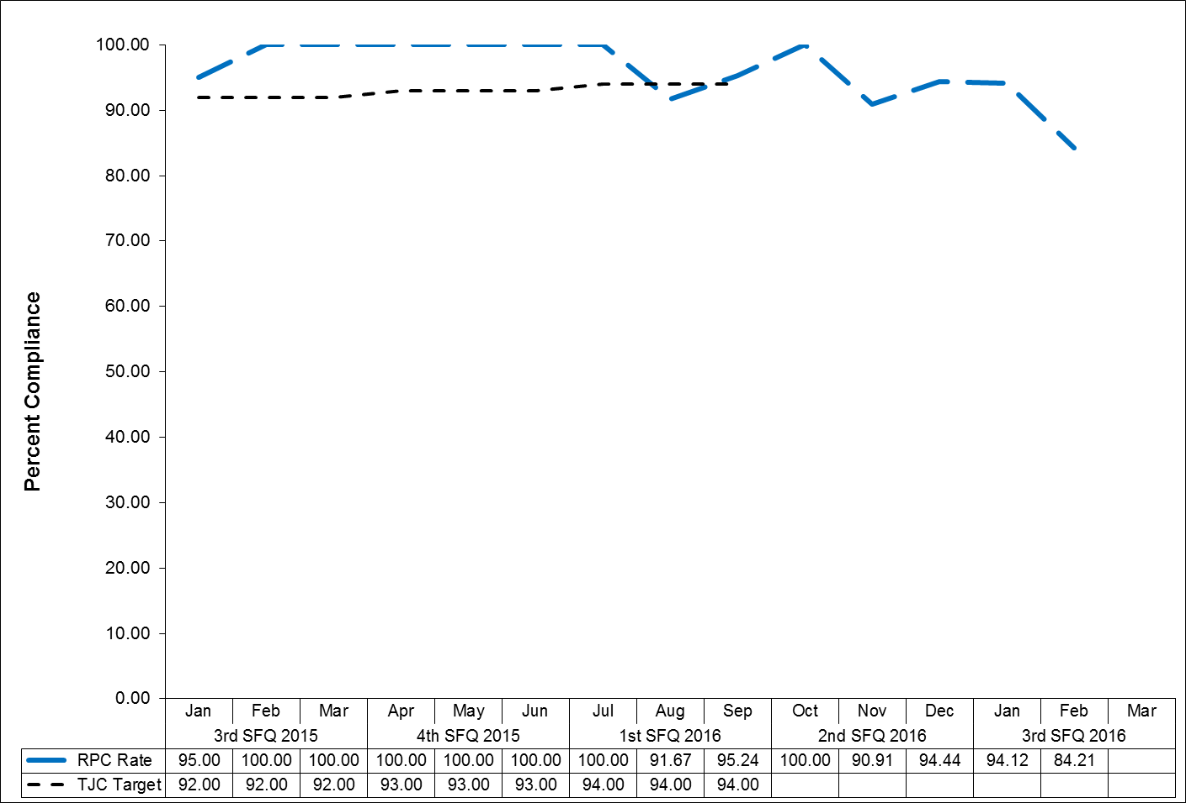
Physical Restraint (HBIPS 2)
Hours of Use

Description
The total number of hours that all patients, admitted to a hospital-based inpatient psychiatric setting, were maintained in physical restraint.

Rationale
Mental health providers that value and respect an individual’s autonomy, independence and safety seek to avoid the use of dangerous or restrictive interventions at all times (Donat, 2003). The use of seclusion and restraint is limited to situations deemed to meet the threshold of imminent danger and when restraint and seclusion are used; such use is rigorously monitored and analyzed to prevent future use. Providers also seek to prevent violence or aggression from occurring in their treatment environments by focusing their attention on prevention activities that have a growing evidence base (Donat, 2003).

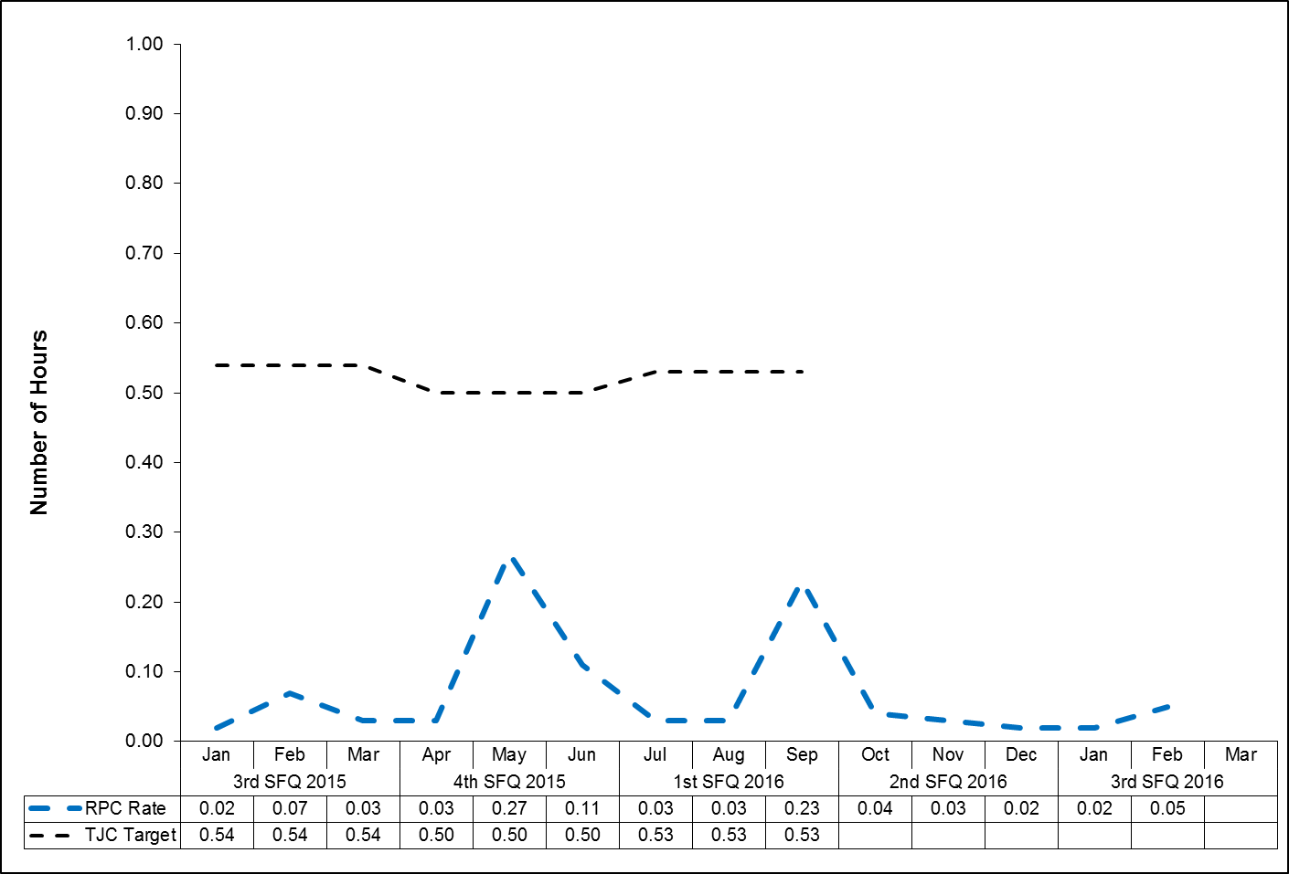
Seclusion (HBIPS 3)
Hours of Use

Description
The total number of hours that all patients, admitted to a hospital-based inpatient psychiatric setting, were held in seclusion.

Rationale
Mental health providers that value and respect an individual’s autonomy, independence and safety seek to avoid the use of dangerous or restrictive interventions at all times (Donat, 2003). The use of seclusion and restraint is limited to situations deemed to meet the threshold of imminent danger and when restraint or seclusion are used; such use is rigorously monitored and analyzed to prevent future use. Providers also seek to prevent violence or aggression from occurring in their treatment environments by focusing their attention on prevention activities that have a growing evidence base (Donat, 2003).

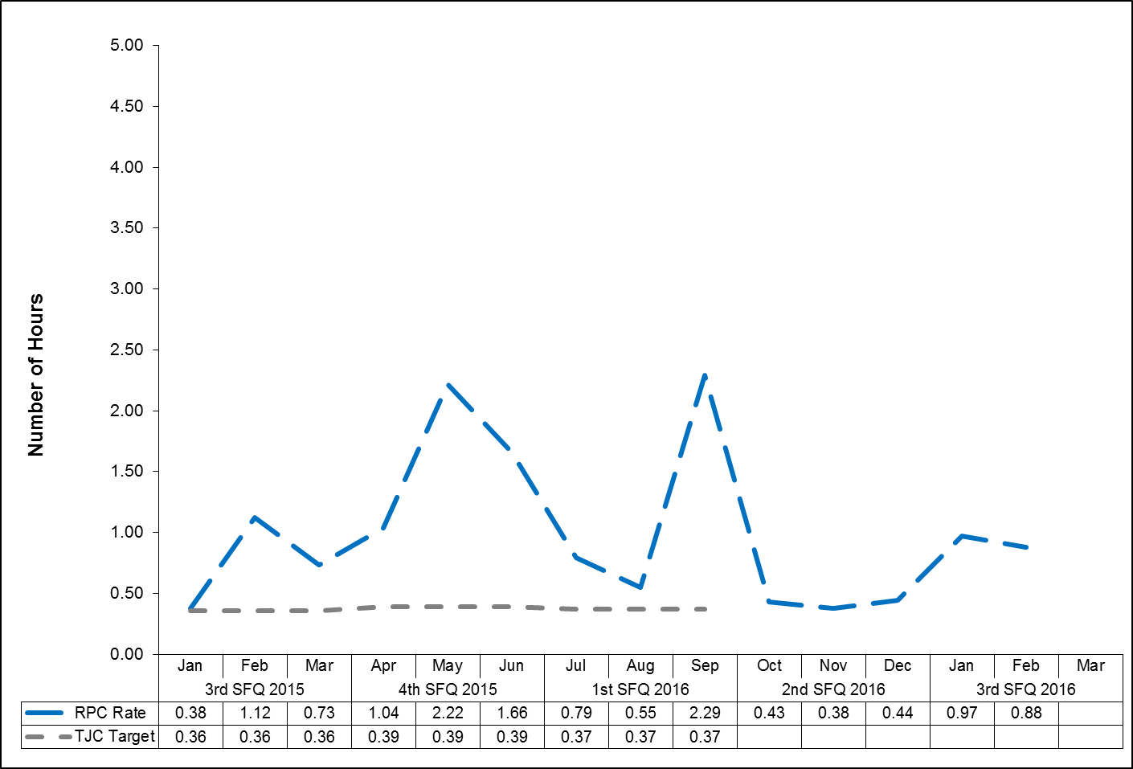

Multiple Antipsychotic Medications on Discharge (HBIPS 4)

Description
Patients discharged from a hospital-based inpatient psychiatric setting on two or more antipsychotic medications.

Rationale
Research studies have found that 4-35% of outpatients and 30-50% of inpatients treated with an antipsychotic medication concurrently received 2 or more antipsychotics (Covell, Jackson, Evans, & Essock, 2002; Ganguly, Kotzan, Miller, Kennedy, & Martin, 2004; Gilmer, Dolder, Folsom, Mastin, & Jeste, 2007; Kreyenbuhl, Valenstein, McCarthy, Ganocyz, & Blow, 2006; Stahl & Grady, 2004). One study reported 4.6% of patients concurrently received 3 or more antipsychotics (Jaffe & Levine, 2003). These findings are seen across diverse sectors: state mental health authorities, the Veterans Health System and Medicaid-financed care. Antipsychotic polypharmacy can lead to greater side effects, often without improving clinical outcomes (Ananth, Parameswaran, & Gunatilake, 2004; Stahl & Grady, 2004). As a result, a range of stakeholders have called for efforts to reduce unnecessary use of multiple antipsychotics (Centorrino, Gören, Hennen, Salvatore, Kelleher, & Baldessarini, 2004; Gilmer, Dolder, Folsom, Mastin, & Jeste, 2007; National Association of State Mental Health Program Directors, 2001; University HealthSystem Consortium, 2006). Practice guidelines recommend the use of a second antipsychotic only after multiple trials of a single antipsychotic have proven inadequate (American Psychiatric Association [APA] Practice Guidelines, 2004). Randomized controlled trials (RCTs) provide some evidence to support augmentation with a second antipsychotic in treatment resistant patients. Most of these studies were limited to augmentation of clozapine with another second-generation antipsychotic (Tranulis, Skalli, Lalonde, & Nicole, 2008). Among patients without a documented history of previous treatment failures of antipsychotic monotherapy, multiple RCTs and other controlled trials failed to show
a benefit of antipsychotic polypharmacy over monotherapy (Ananth, Parameswaran, & Gunatilake, 2004; Centorrino, Gören, Hennen, Salvatore, Kelleher, & Baldessarini, 2004; Potkin, Thyrum, Alva, Bera, Yeh, & Arvanitis, 2002; Shim et al., 2007; Stahl,& Grady, 2004). Clinical circumstances, such as shorter inpatient stays, may require hospitals to discharge a patient on multiple antipsychotics with an aftercare plan to transition to monotherapy. In such cases, effective communication between the inpatient and aftercare clinician is an essential element of care.

Multiple Antipsychotic Medications on Discharge (HBIPS 4)

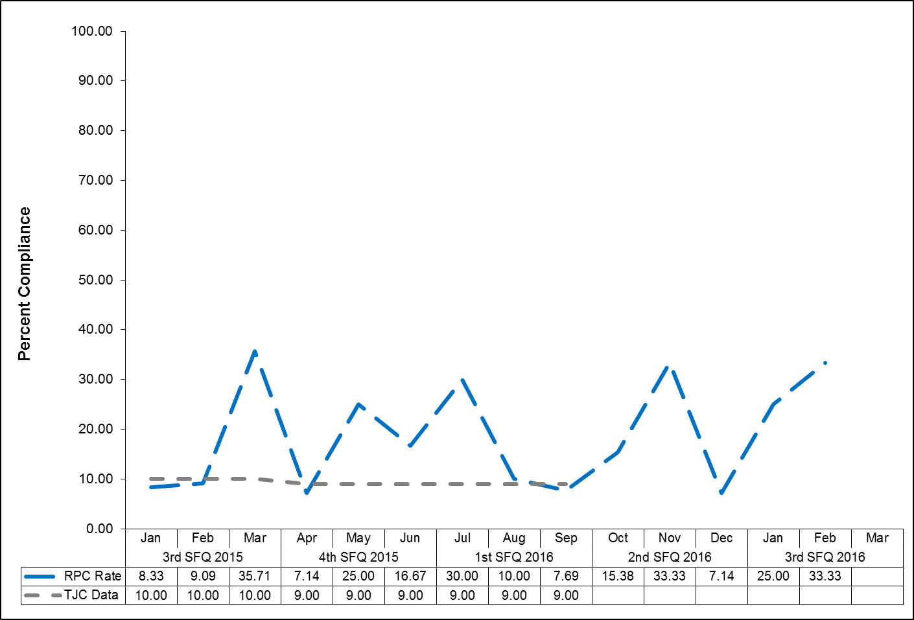

Multiple Antipsychotic Medications at Discharge with Justification (HBIPS 5)

Description
Patients discharged from a hospital-based inpatient psychiatric setting on two or more antipsychotic medications with appropriate justification.

Rationale
Research studies have found that 4-35% of outpatients and 30-50% of inpatients treated with an antipsychotic medication concurrently received 2 or more antipsychotics (Covell, Jackson, Evans, & Essock, 2002; Ganguly, Kotzan, Miller, Kennedy, & Martin, 2004; Gilmer, Dolder, Folsom, Mastin, & Jeste, 2007; Kreyenbuhl, Valenstein, McCarthy, Ganocyz, & Blow, 2006; Stahl & Grady, 2004). One study reported 4.6% of patients concurrently received 3 or more antipsychotics (Jaffe & Levine, 2003). These findings are seen across diverse sectors: state mental health authorities, the Veterans Health System and Medicaid-financed care. Antipsychotic polypharmacy can lead to greater side effects, often without improving clinical outcomes (Ananth, Parameswaran, & Gunatilake, 2004; Stahl & Grady, 2004). As a result, a range of stakeholders have called for efforts to reduce unnecessary use of multiple antipsychotics (Centorrino, Gören, Hennen, Salvatore, Kelleher, & Baldessarini, 2004; Gilmer, Dolder, Folsom, Mastin, & Jeste, 2007; National Association of State Mental Health Program Directors, 2001; University HealthSystem Consortium, 2006). Practice guidelines recommend the use of a second antipsychotic only after multiple trials of a single antipsychotic have proven inadequate (American Psychiatric Association [APA] Practice Guidelines, 2004). Randomized controlled trials (RCTs) provide some evidence to support augmentation with a second antipsychotic in treatment resistant patients. Most of these studies were limited to augmentation of clozapine with another second-generation antipsychotic (Tranulis, Skalli, Lalonde, & Nicole, 2008). Among patients without a documented history of previous treatment failures of antipsychotic monotherapy, multiple RCTs and other controlled trials failed to show a benefit of antipsychotic polypharmacy over monotherapy (Ananth, Parameswaran, & Gunatilake, 2004; Centorrino, Gören, Hennen, Salvatore, Kelleher, & Baldessarini, 2004; Potkin, Thyrum, Alva, Bera, Yeh, & Arvanitis, 2002; Shim et al., 2007; Stahl,& Grady, 2004). Clinical circumstances, such as shorter inpatient stays, may require hospitals to discharge a patient on multiple antipsychotics with an aftercare plan to transition to monotherapy. In such cases, effective communication between the inpatient and aftercare clinician is an essential element of care.

Multiple Antipsychotic Medications at Discharge with Justification (HBIPS 5)

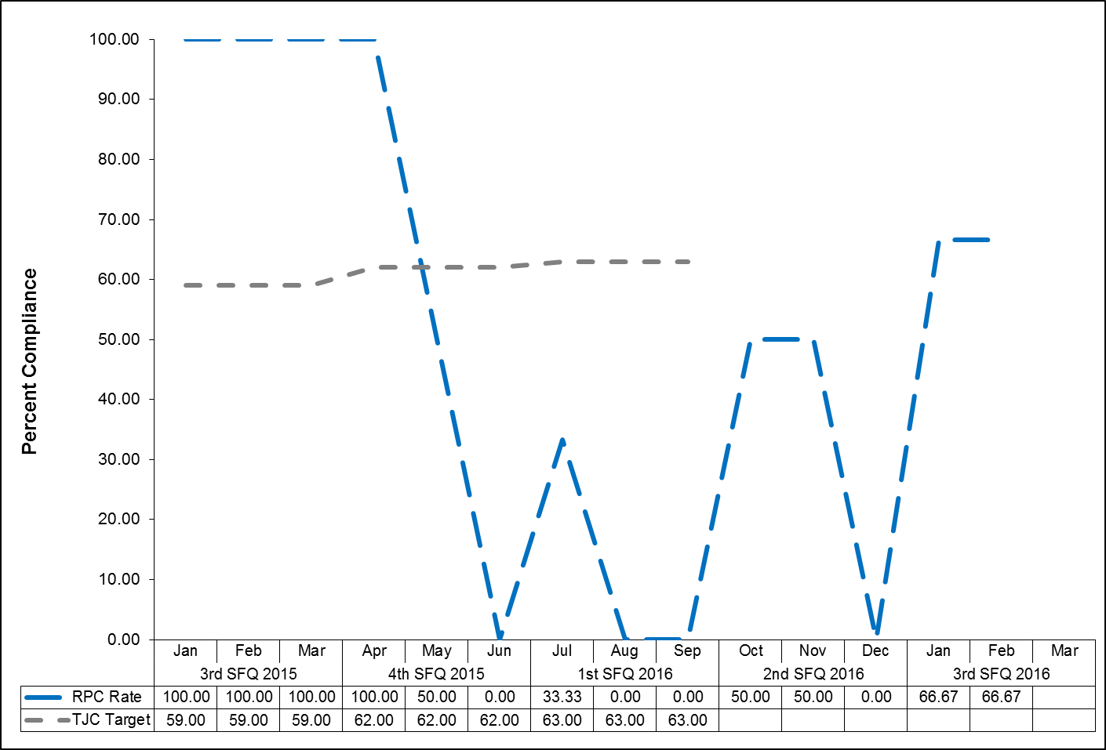

Post Discharge Continuing Care Plan (HBIPS 6)

Description
Patients discharged from a hospital-based inpatient psychiatric setting with a continuing care plan created.

Rationale
Patients may not be able to fully report to their next level of care health-care provider their course of hospitalization or discharge treatment recommendations. The aftercare instructions given the patient may not be available to the next level of care provider at the patient’s initial intake or follow-up appointment. In order to provide optimum care, next level of care providers need to know details of precipitating events immediately preceding hospital admission, the patient’s treatment course during hospitalization, discharge medications and next level of care recommendations (American Association of Community Psychiatrists [AACP], 2001).

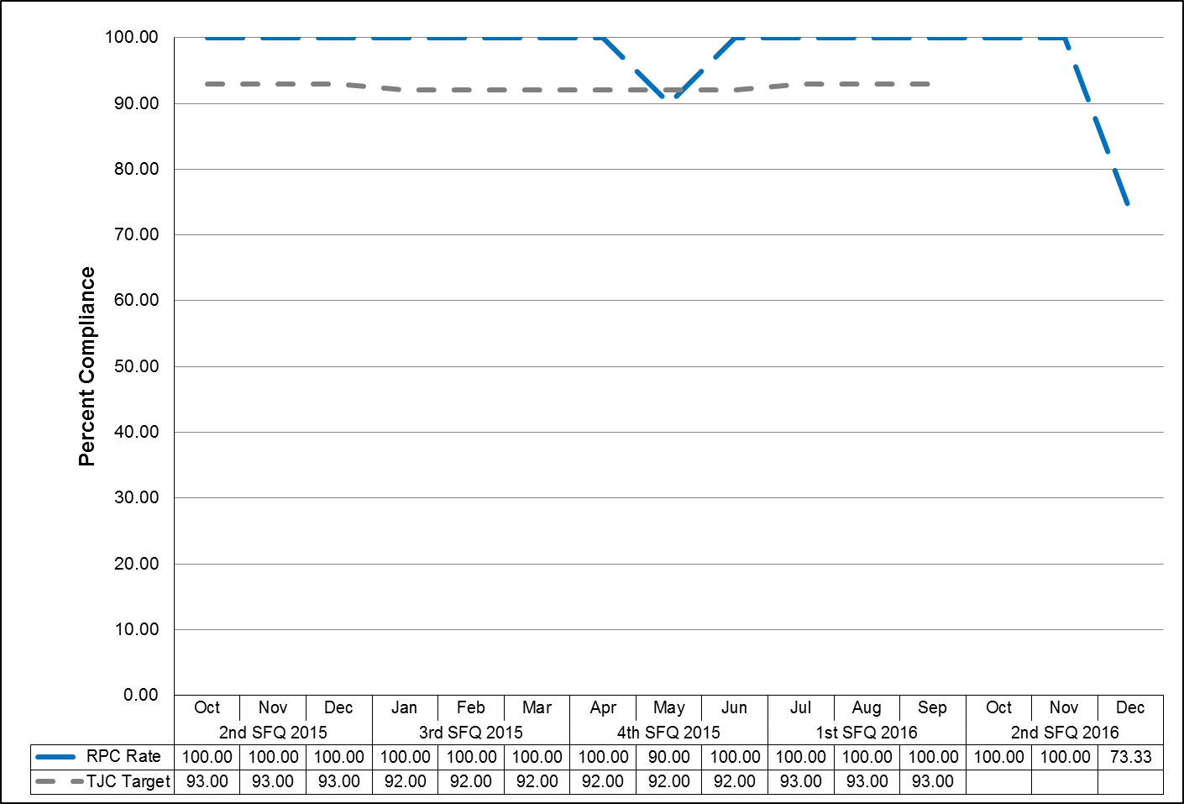

Note: The Joint Commission discontinued this measure effective 12/31/2015.

Post Discharge Continuing Care Plan Transmitted (HBIPS 7)
To Next Level of Care Provider on Discharge

Description
Patients discharged from a hospital-based inpatient psychiatric setting with a continuing care plan provided to the next level of care clinician or entity.

Rationale
Patients may not be able to fully report to their next level of care health-care provider their course of hospitalization or discharge treatment recommendations. The aftercare instructions given the patient may not be available to the next level of care provider at the patient’s initial intake or follow-up appointment. In order to provide optimum care, next level of care providers need to know details of precipitating events immediately preceding hospital admission, the patient’s treatment course during hospitalization, discharge medications and next level of care recommendations (American Association of Community Psychiatrists [AACP], 2001).

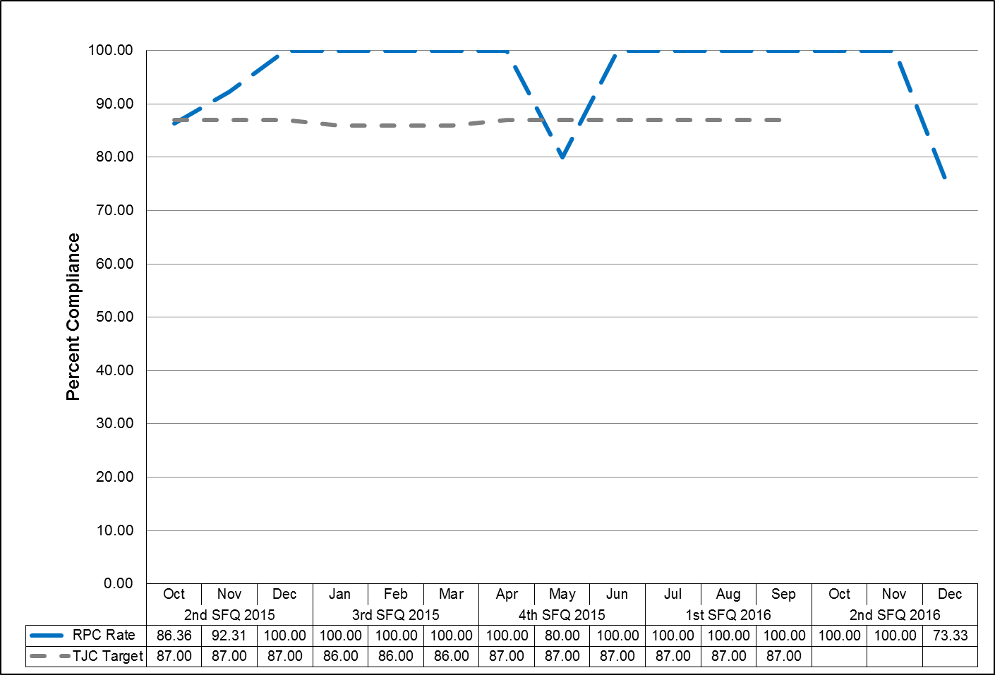

Note: The Joint Commission discontinued this measure effective 12/31/2015.

Contract Performance Indicators

TJC LD.04.03.09 The same level of care should be delivered to patients regardless of whether services are provided directly by the hospital or through contractual agreement. Leaders provide oversight to make sure that care, treatment, and services provided directly are safe and effective. Likewise, leaders must also oversee contracted services to make sure that they are provided safely and effectively.

3Q2016 Results
Contractor | Program Administrator | Summary of Performance
Amistad Peer Support Services | Dr. William Nelson  Clinical Director | All indicators met or exceeded standards.
Community Dental, Region II | Dr. William Nelson  Clinical Director | All indicators met or exceeded standards.
Comprehensive Pharmacy Services | Dr. William Nelson  Clinical Director | All indicators met standards.
Comtec Security | Richard Levesque  Director of Support Services | All indicators met standards.
Cummins Northeast | Richard Levesque  Director of Support Services | All indicators met standards.
Dartmouth Medical School | Jay Harper  Superintendent | All indicators met standards.
Disability Rights Center | Jay Harper  Superintendent | All indicators met standards.
G & E Roofing | Richard Levesque  Director of Support Services | Indicator exceeded standards.
Goodspeed & O’Donnell | Dr. William Nelson  Clinical Director | No services were provided during this timeframe.
Liberty Healthcare – After Hours Coverage | Dr. William Nelson  Clinical Director | All indicators exceeded standards.
Liberty Healthcare – Physician  Staffing | Dr. William Nelson  Clinical Director | All indicators met standards.
Main Security Surveillance | Richard Levesque  Director of Support Services | All indicators met standards.
Maine General Community Care/HealthReach | Dr. William Nelson  Clinical Director | All indicators met standards.
Maine General Medical Center – Laboratory Services | Dr. William Nelson  Clinical Director | All indicators met standards.

Contractor | Program Administrator | Summary of Performance
MD-IT Transcription Service | Samantha Brockway  Medical Records Administrator | All indicators met standards.
Mechanical Services | Richard Levesque  Director of Support Services | No services were provided during this timeframe.
Medical Staffing and Services of Maine | Dr. William Nelson  Clinical Director | All indicators met standards.
Motivational Services | Dr. William Nelson  Clinical director | All indicators met or exceeded standards.
Occupational Therapy Consultation and Rehabilitation Services | Janet Barrett  Director of Rehabilitation | All indicators met or exceeded standards.
Otis Elevator | Richard Levesque  Director of Support Services | All indicators met standards.
Pine Tree Legal Assistance | Dr. William Nelson  Clinical Director | No services were provided during this timeframe.
Project Staffing | Cindy Michaud  Business Services Manager | All indicators met or exceeded standards.
Protection One | Richard Levesque  Director of Support Services | Indicator met standards.
Securitas Security Services | Philip Tricarico  Safety Compliance Officer | All indicators met or exceeded standards.
UniFirst Corporation | Richard Levesque  Director of Support Services | One indicator did not meet standards: The provider will submit monthly infection control measures reports. All other indicators met standards.
Waste Management | Debora Proctor  Executive Housekeeper | All indicators met standards.

Adverse Reactions to Sedation or Anesthesia

TJC PI.01.01.01 EP6: The hospital collects data on the following: adverse events related to using moderate or deep sedation or anesthesia. (See also LD.04.04.01, EP 2)

Capital Community Clinic - Dental Clinic

Dental Clinic Timeout/Identification of Patient

Indicators | 4Q2015 | 1Q2016 | 2Q2016 | 3Q2016 | Total
National Patent Safety Goals  Goal 1: Improve the accuracy of Patient  Identification.  Capital Community Dental Clinic assures accurate patient identification by: asking the patient to state his/her name and date of birth.  A time out will be taken before the procedure to verify location and numbered tooth. The time out section is in the progress notes of the patient chart. This page will be signed by the Dentist as well as the Dental Assistant. | April  100%  3/3  May  N/A  0/0  June  100%  1/1  Total  100%  4/4 | July  100%  3/3  Aug  N/A  0/0  Sept  N/A  0/0  Total  100%  3/3 | Oct  100%  2/2  Nov  100%  1/1  Dec  100%  1/1  Total  100%  4/4 | Jan  100%  5/5  Feb  100%  3/3  Mar  N/A  0/0  Total  8/8 | 100%  19/19

Dental Clinic Post Extraction Prevention of Complications and Follow-up

Indicators | 4Q2015 | 1Q2016 | 2Q2016 | 3Q2016 | Total
- All patients with tooth extractions will be assessed and have teaching post procedure on the following topics, as provided by the Dentist or Dental Assistant:  - Bleeding  - Swelling  - Pain  - Muscle soreness  - Mouth care  - Diet  - Signs/symptoms of infection  - The patient, post procedure tooth extraction, will verbalize understanding of the above by repeating instructions given by Dental Assistant/Hygienist.  - Post dental extraction patients will receive a follow-up phone call from the clinic within 24 hours of procedure to assess for post procedure complications | April  100%  3/3  May  N/A  0/0  June  100%  1/1  Total  100%  4/4 | July  100%  3/3  Aug  N/A  0/0  Sept  N/A  0/0  Total  100%  3/3 | Oct  100%  2/2  Nov  100%  1/1  Dec  100%  1/1  Total  100%  4/4 | Jan  100%  5/5  Feb  100%  3/3  Mar  N/A  0/0  Total  8/8 | 100%  19/19

Healthcare Acquired Infections Monitoring and Management

NPSG.07.03.01 Implement evidence-based practices to prevent health care–associated infections due to multidrug-resistant organisms in acute care hospitals.

Infection Control

Responsible Party: Rebecca Eastman, Infection Control RN

I. Measure Name: Hospital Associated Infection (HAI) Rate

Measure Description: Monitor and Measure of Hospital Associated Infections

Measure Type: Quality Assurance

Results
Target | Unit | Baseline | 4Q2015 | 1Q2016 | 2Q2016 | 3Q2016 | YTD
Within 1 STDV of the Mean | Hospital Associated Infection Rate | FY 2014  1 STDV within the mean | 4 HAI/IC  Rate 0.83 | 12 HAI/IC  Rate 1.4 | 7 HAI/IC Rate 1 | 11 HAI/IC Rate 1.2 | HAI/IC 1.11
Actual  Outcome | Hospital Associated Infection Rate | FY 2014  1 STDV within the mean | 1 STDV within the mean | 1 STDV within the mean | At 1 STDV | 1 STDV within the mean

A Hospital Acquired Infection (HAI) is any infection present, incubating or exposed to more than 72 hours after admission (unless the patient is off hospital grounds during that time) or declared by a physician, a physician’s assistant or advanced practice nurse to be a HAI.

A Present on Admission (POA) any infection present, incubating or exposed to prior to admission; while on pass; during off-site medical, dental, or surgical care; by a visitor, any prophylaxis treatment of a condition or treatment of a condition for which the patient has a history of chronic infection no matter how long the patient has been hospitalized; or declared by the physician, physician’s assistant, or advanced practice nurse to be a community acquired infection.

An Idiosyncratic Infection is any infection that occurs after admission and is the result of the patient’s action toward himself or herself.

Infections:

Lower Kennebec:
Skin Infection (HAI)
Fungal Infection (POA)

Lower Kennebec SCU:
Urinary Tract Infection (HAI)
Urinary Tract Infection (HAI)

Lower Saco:
Chronic Sinusitis/Bronchitis (HAI)
Fungal Dermatitis (HAI)
Dental Abscess (POA)

Lower Saco SCU:
Cellulitis Leg and Toe (POA)
Foot Ulcer (HAI)

Upper Saco:
Erysipelas (HAI)

Upper Kennebec:
Otitis External (HAI)
Bacterial Vaginitis (HAI)
Ingrown Toenail (HAI)
Urinary Tract Infection (HAI)

Data Analysis:
Total Infections: 14
HAI: 11
POA: 3
Idiosyncratic Infections: 0

Plan: Ongoing surveillance

II. Measure Name: Employee Hand Hygiene Rate
Measure Description:
- Staff will observe the hand hygiene practice of nurses as they pass medications. (10 observations per month)
- Staff will do ten (10) hand hygiene observations per month (before & after patient contact) in the milieu on the 7-3 shift.
- Staff will do ten (10) hand hygiene observations per month (before & after patient contact) in the milieu on the 3-11 shift

Measure Type: Performance Improvement

Results
 | Unit | Baseline | 1Q2016 | 2Q2016 | 3Q2016 | 4Q2016 | YTD
Target | Employee  Hand Hygiene Compliance | 80%  FY 2015 | >90% | >90% | >90% | >90% | >90%
Actual | Employee  Hand Hygiene Compliance | 80%  FY 2015 | 95% | No data available | 42% |  | 69%

Data:
Upper Saco Meds – no data Upper Kennebec Meds –100%
Upper Saco Milieu 7-3 – no data Upper Kennebec Milieu 7-3 – 100%
Upper Saco Milieu 3-11 – no data Upper Kennebec Milieu 3-11 – 100%

Lower Kennebec Meds – 33% Lower Saco Meds – 50%
Lower Kennebec Milieu 7-3 – 33% Lower Saco Milieu 7-3 –33%
Lower Kennebec Milieu 3-11 –no data Lower Saco Milieu 3-11 – 50%

Plan: Continue to monitor and measure.

III. Measure Name: Assisting Patients with Daily Hygiene

Measure Description: Staff offer hand gel to patients prior to breakfast, lunch, and dinner, ten (10) days per month.

Measure Type: Quality Assurance

Results
 | Unit | Baseline | 1Q2016 | 2Q2016 | 3Q2016 | 4Q2016 | YTD
Target | Employee  Hand Hygiene Compliance | 98%  FY 2015 | >90% | >90% | >90% | >90% | >90%
Actual | Employee  Hand Hygiene Compliance | 98%  FY 2015 | 95% | No data available | 81% |  | 88%

Data:
The mean compliance rate for January 2016 is 78%.
The mean compliance rate for February 2016 is 97%.
The mean compliance rate for March 2016 is 67%.

Plan: Continue to monitor and measure.

Medication Errors and Adverse Reactions

TJC PI.01.01.01 EP14: The hospital collects data on the following: Significant medication errors. (See also LD.04.04.01, EP 2; MM.08.01.01, EP 1)

TJC PI.01.01.01 EP15: The hospital collects data on the following: Significant adverse drug reactions. (See also LD.04.04.01, EP 2; MM.08.01.01, EP 1)

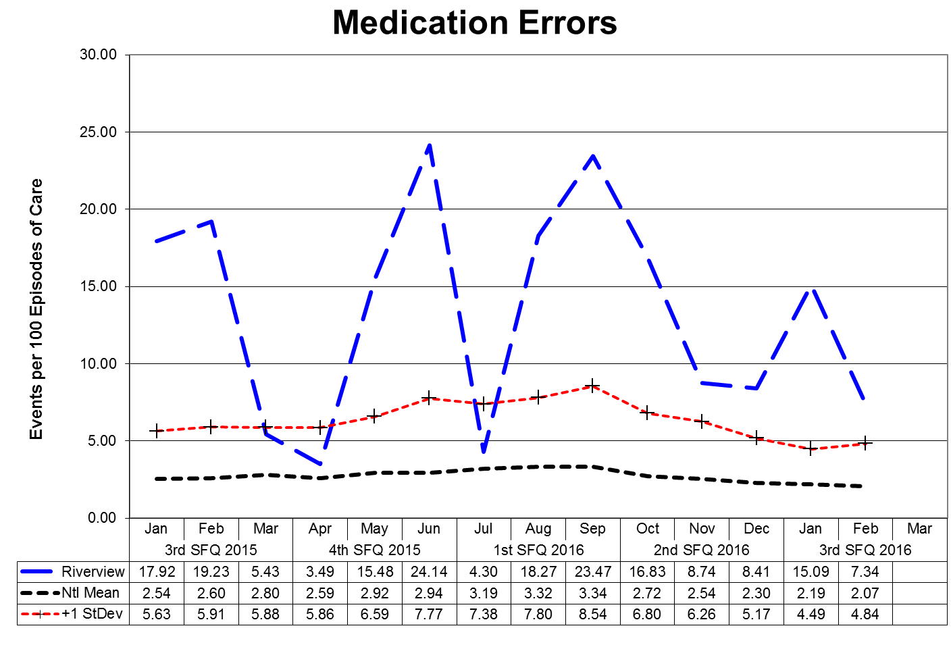
This graph depicts the number of medication error events that occurred for every 100 episodes of care (duplicated patient count). For example, a rate of 1.6 means that 2 medication error events occurred for each 125 episodes of care.

The following graphs depict the number of medication error events that occurred for every 100 episodes of care (duplicated patient count) stratified by forensic or civil classifications. For example, a rate of 1.6 means that 2 medication error events occurred for each 125 episodes of care. The hospital-wide results from Dorothea Dix are compared to the civil population results at Riverview due to the homogeneous nature of these two sample groups.

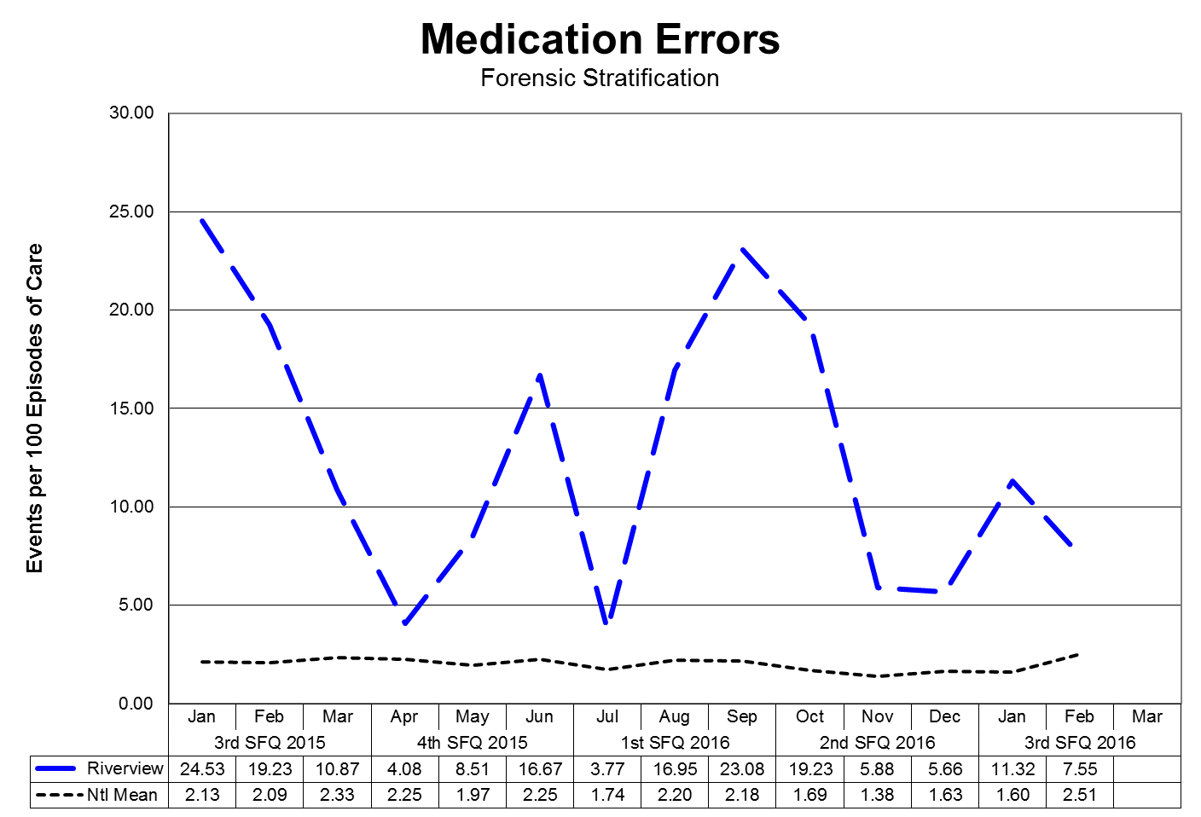

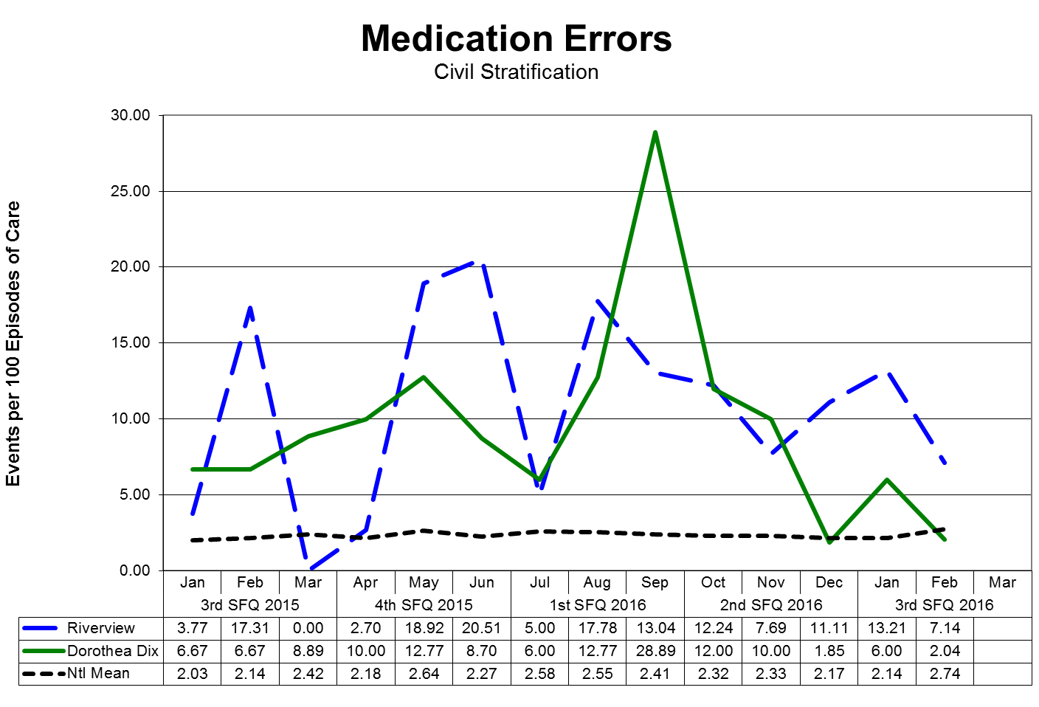

Medication Variances

Medication variances are classified according to four major areas related to the area of service delivery. The error must have resulted in some form of variance in the desired treatment or outcome of care. A variance in treatment may involve one incident but multiple medications; each medication variance is counted separately irrespective of whether it involves one error event or many. Medication error classifications include:

Prescribing
- An error of prescribing occurs when there is an incorrect selection of drug, drug dose, dosage form, quantity, route, concentration, rate of administration, or instructions for use of a drug product ordered or authorized by physician or other legitimate prescriber. Errors may occur due to improper evaluation of indications, contraindications, known allergies, existing drug therapy and other factors. Illegible prescriptions or medication orders that lead to patient level errors are also defined as errors of prescribing in identifying and ordering the appropriate medication to be used in the care of the patient.
Dispensing
- An error of dispensing occurs when the incorrect drug, drug dose or concentration, dosage form, or quantity is formulated and delivered for use to the point of intended use.
Administration
- An error of administration occurs when there is an incorrect selection and administration of drug, drug dose, dosage form, quantity, route, concentration, rate of administration, or instructions for use of a drug product ordered or authorized by physician or other legitimate prescriber.
Complex
- An error which resulted from two or more distinct errors of different types is classified as a complex error.

Review, Reporting and Follow-up Process:
The Medication Variances Process Review Team (PRT) meets weekly to evaluate the causation factors related to the medication variances reported on the units and in the pharmacy and makes recommendations, through its multi-disciplinary membership, for changes to workflow, environmental factor, and patient care practices. The team consists of the Clinical Director (or designee), the Director of Nursing (or designee), the Director of Pharmacy (or designee), and the Clinical Risk Manager or the Performance Improvement Manager.

The activities and recommendations of the Medication Variances PRT are reported monthly to the Integrated Performance Excellence Committee.

Administration Process
Medication Errors Related to Staffing Effectiveness

Date | Omit | Type of Error | Float | New | O/T | Unit | Staff Mix
 |  |  |  |  |  |  | RN | LPN | MHW
1/4/2016 | N | WRONG TIME X1/PYXIS ERROR | N | N | N | UK | 2 | 1 | 4
1/6/2016 | N | WRONG TIME  X1/GIVEN EARLY | Y | N | N | LSS | 3 | 0 | 6
1/8/2016 | Y | OMISSON X3 | Y | N | N | LKM
1/8/2016 | N | EXTRA DOSE X1/NO CURRENT ORDER | N | N | N | US | 3 | 1 | 5
1/15/2016 | N | EXTRA DOSE X1/NO CURRENT ORDER | N | N | N | LSS | 4 | 1 | 9
1/15/2016 | N | EXTRA DOSE X1/NO CURRENT ORDER | N | N | N | US | 3 | 1 | 5
1/15/2016 | N | WRONG TIME/GIVEN LATE | N | N | Y | LKM | 2 | 0 | 5
1/15/2016 | N | WRONG TIME/GIVEN LATE | N | N | Y | LKM | 2 | 0 | 5
1/16/2016 | N | EXTRA DOSE X4/EXPIRED ORDER | N | N | N | UK | 3 | 0 | 4
1/19/2016 | Y | OMISSION X1 | N | N | N | LKS | 2 | 1 | 6
1/21/2016 | Y | OMISSION X7 | N | N | N | US | 2 | 0 | 7
1/23/2016 | N | EXTRA DOSE X 1 | N | N | N | LSS | 2 | 1 | 8
1/29/2016 | Y | OMISSION X3 | N | N | N | LKM | 3 | 0 | 7
2/9/2016 | N | WRONG TIME X1 | Y | N | N | LKM | 3 | 1 | 6
2/9/2016 | Y | OMISSION X1 | N | N | N | LKM | 3 | 1 | 6
2/10/2016 | N | WRONG TIME X5 | N | N | N | LKSC
2/11/2016 | Y | OMISSION X1 | Y | N | N | UK | 3 | 1 | 4
2/15/2016 | Y | OMISSION X5 | Y | N | N | LSS | 3 | 1 | 7
2/17/2016 | Y | OMISSION X1 | Y | N | N | LSS | 3 | 1 | 8
2/20/2016 | Y | OMISSON X1 | N | N | N | LKS | 3 | 1 | 7
2/23/2016 | N | EXTRA DOSE X4/NO CURRENT ORDER | N | N | N | US | 3 | 0 | 4
3/1/2016 | N | WRONG TIME X1/GIVEN EARLY | N | N | N | LSM | 2 | 0 | 4
3/9/2016 | Y | OMISSION X1/IM BACKUP NOT GIVEN | N | N | N | UK | 2 | 1 | 3
3/16/2016 | N | WRONG DOSE X1 | Y | N | N | LKM | 4 | 0 | 7
3/18/2016 | N | EXTRA DOSE X43/NO CURRENT ORDER | N | N | N | LSS | 3 | 2 | 4
3/22/2016 | N | WRONG DOSE X1 | N | N | N | LSS | 3 | 1 | 4
3/23/2016 | Y | OMISSION X2 | N | N | N | UK | 2 | 1 | 4
3/25/2016 | N | EXTRA DOSE X2 | N | Y | N | LSS | 3 | 1 | 7
Totals | 26 |  | 13 | 2 | 2 | LS: 56 | US: 13 | LK: 18 | UK:  9
Percent | 27% | 96  Total Errors | 14% | 2% | 2% | 58% | 14% | 19% | 9%

*Each dose of medication is documented as an individual variance (error)

Type of Error | # of Errors
Extra Dose | 57
Omission | 26
Wrong Dose | 2
Wrong Time | 11
Total | 96

Dispensing Process

Measure | Unit | Baseline 2015 | Goal | 4Q 2015 | 1Q 2015 | 2Q  2016 | 3Q  2016
1. Controlled Substance Loss Data: Daily Pyxis-CII Safe Compare Report. | All | 0.19% | Target:  Actual: | 0%  0% | 0%  0% | 0%  0% | 0%  0%
2. Controlled Substance Loss Data: Monthly CII Safe Vendor Receipt Report. | Rx | 0  month | Target:  Actual: | 0  0 | 0  0 | 0  0 | 0  0
3. Controlled Substance Loss Data: Monthly Pyxis Controlled Drug discrepancies. | All | 0  month | Target:  Actual: | 0  0 | 0  0 | 0  0 | 0  0
4. Medication Management Monitoring: Measures of drug reactions, adverse drug events and other management data. | Rx | 8  year | Target:  Actual: | 0  3 | 0  0 | 0  0 | 0  1
5. Medication Management Monitoring: Resource Documentation Reports of Clinical Interventions. | Rx | 99  Quarter/  0 month | Target:  Actual: | 100%  56 | 100%  31 | 100%  144 | 100%  128
6. Psychiatric Emergency Process: Monthly audit of all psych emergencies measures against 9 criteria. | All | 100% | Target:  Actual: | 100%  94% | 100%  78% | 100%  98% | 100%  90%
7. Operational Audit:  Monthly audit of 3 operational indicators from CPS contract. | Rx | 100% | Target:  Actual: | 100%  100% | 100%  100% | 100%  100% | 100%  100%

Note: Previous figures for Criteria #3 were reported on the number of discrepancies discovered in Pyxis. This number is not reflective of the number of controlled substances lost, but rather the number of times a simple mistake, such as a miscount, occurred. To ensure accuracy pharmacy staff reviewed past logs of controlled substances and found no substances unaccounted for.

Inpatient Consumer Survey

TJC PI.01.01.01 EP16: The hospital collects data on the following: Patient perception of the safety and quality of care, treatment, and services.

The Inpatient Consumer Survey (ICS) is a standardized national survey of customer satisfaction. The National Association of State Mental Health Program Directors Research Institute (NRI) collects data from state psychiatric hospitals throughout the country in an effort to compare the results of patient satisfaction in six areas or domains of focus. These domains include Outcomes, Dignity, Rights, Participation, Environment, and Empowerment.

Inpatient Consumer Survey (ICS) has been recently endorsed by NQF, under the Patient Outcomes Phase 3: Child Health and Mental Health Project, as an outcome measure to assess the results, and thereby improve care provided to people with mental illness. The endorsement supports the ICS as a scientifically sound and meaningful measure to help standardize performance measures and assures quality of care.

Rate of Response for the Inpatient Consumer Survey:

Due to the operational and safety need to refrain from complete openness regarding plans for discharge and dates of discharge for forensic patients, the process of administering the inpatient survey is difficult to administer. Whenever possible, Peer Support staff work to gather information from patients on their perception of the care provided to then while at Riverview Psychiatric Center.

The Peer Support group has identified a need to improve the overall response rate for the survey. This process improvement project is defined and described in the section on Patient Satisfaction Survey Return Rate of this report.

There is currently no aggregated date on a forensic stratification of responses to the survey.

Note: When the Riverview field is blank for a month it means that no patients responded to the survey questions on that page in that particular month.

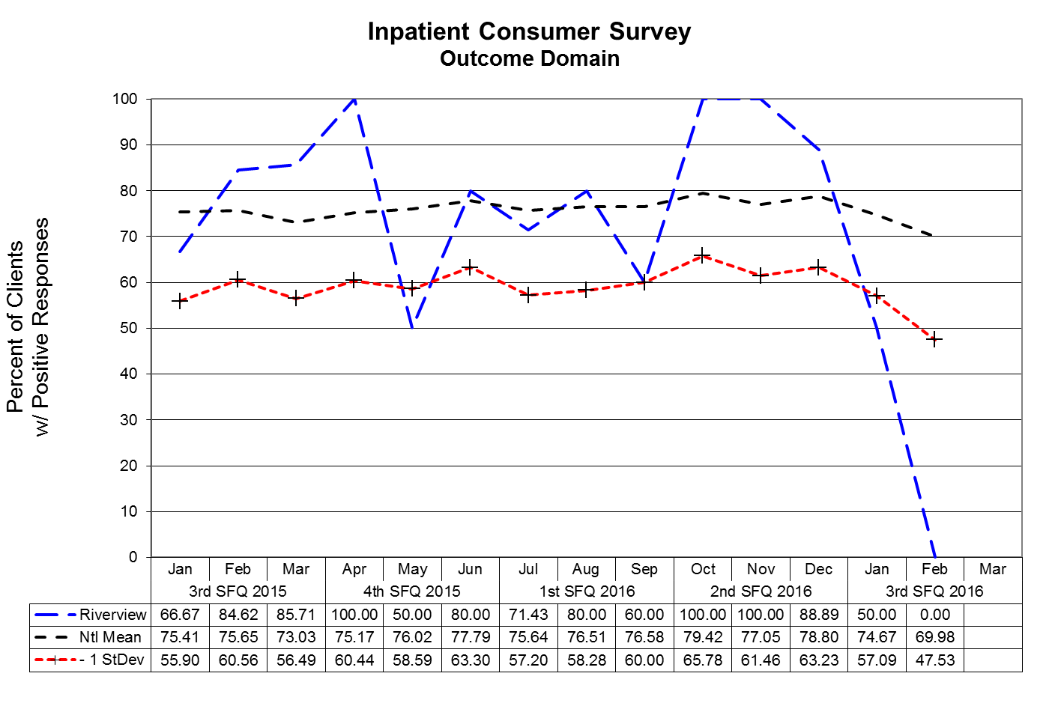
Outcome Domain Questions:
- I am better able to deal with crisis.
- My symptoms are not bothering me as much.
- I do better in social situations.
- I deal more effectively with daily problems.

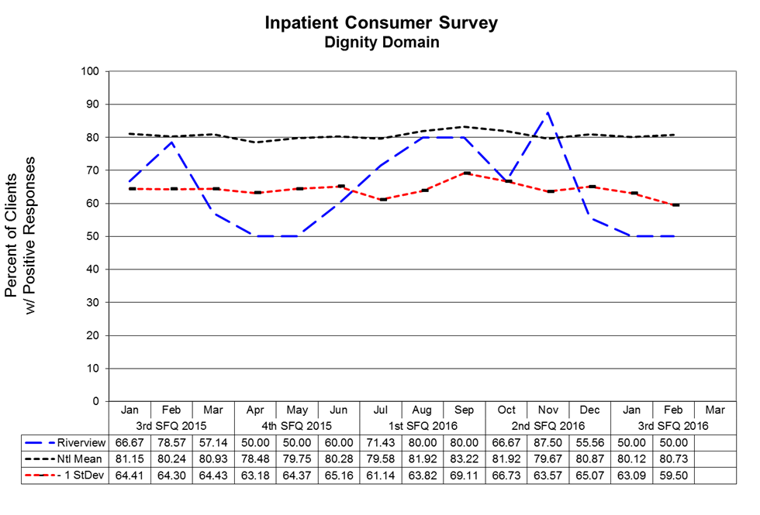
Dignity Domain Questions:
- I was treated with dignity and respect.
- Staff here believed that I could grow, change and recover.
- I felt comfortable asking questions about my treatment and medications.
- I was encouraged to use self-help/support groups.

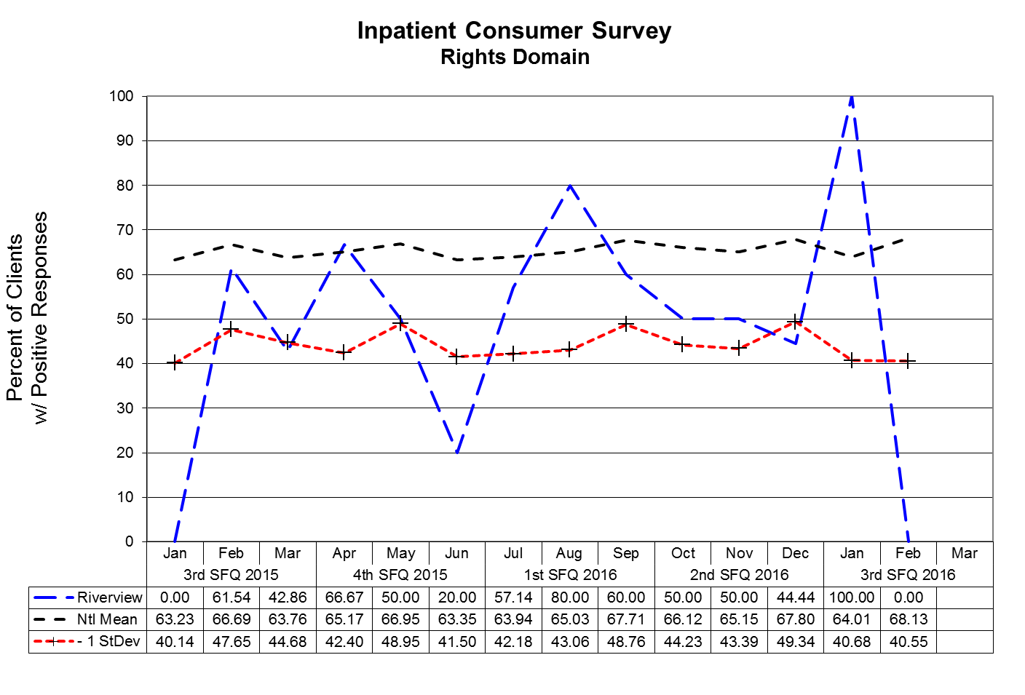
Rights Domain Questions:
- I felt free to complain without fear of retaliation.
- I felt safe to refuse medication or treatment during my hospital stay.
- My complaints and grievances were addressed.

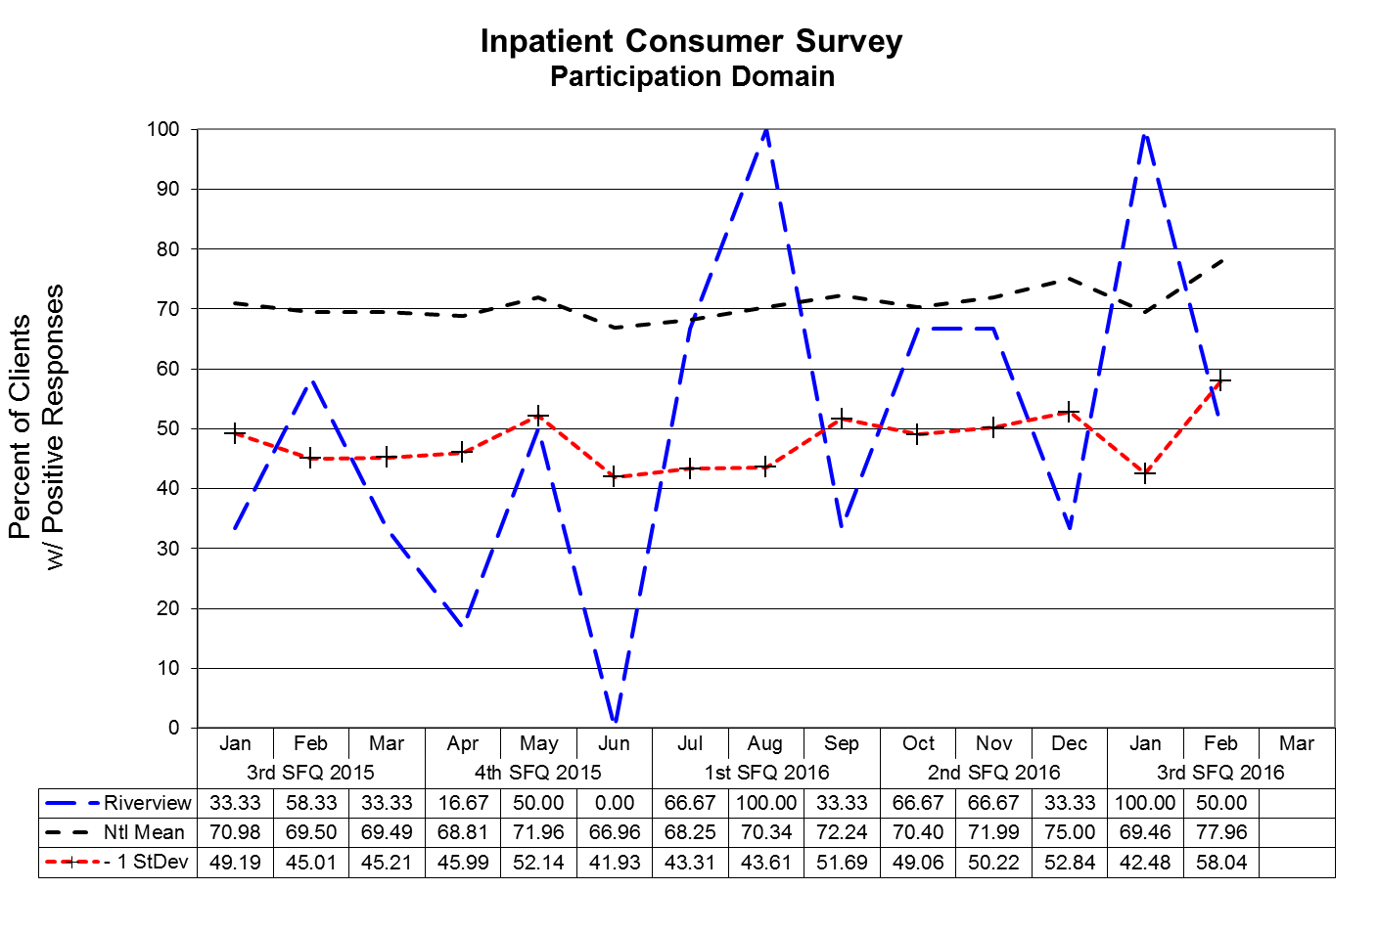
Participation Domain Questions:
- I participated in planning my discharge.
- Both I and my doctor or therapists from the community were actively involved in my hospital treatment plan.
- I had an opportunity to talk with my doctor or therapist from the community prior to discharge.

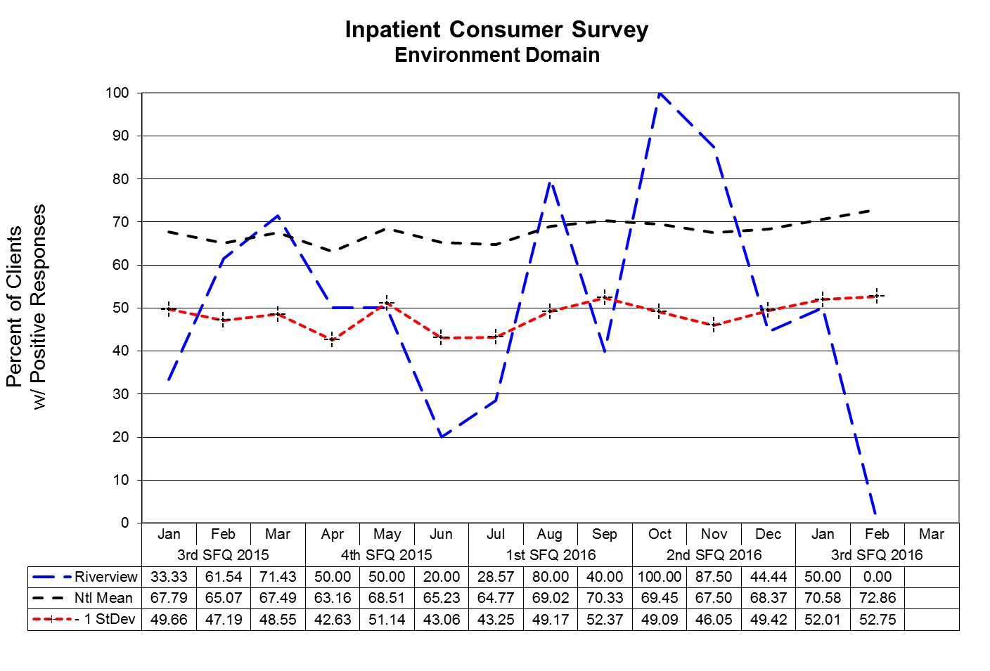
Environment Domain Questions:
- The surroundings and atmosphere at the hospital helped me get better.
- I felt I had enough privacy in the hospital.
- I felt safe while I was in the hospital.
- The hospital environment was clean and comfortable.

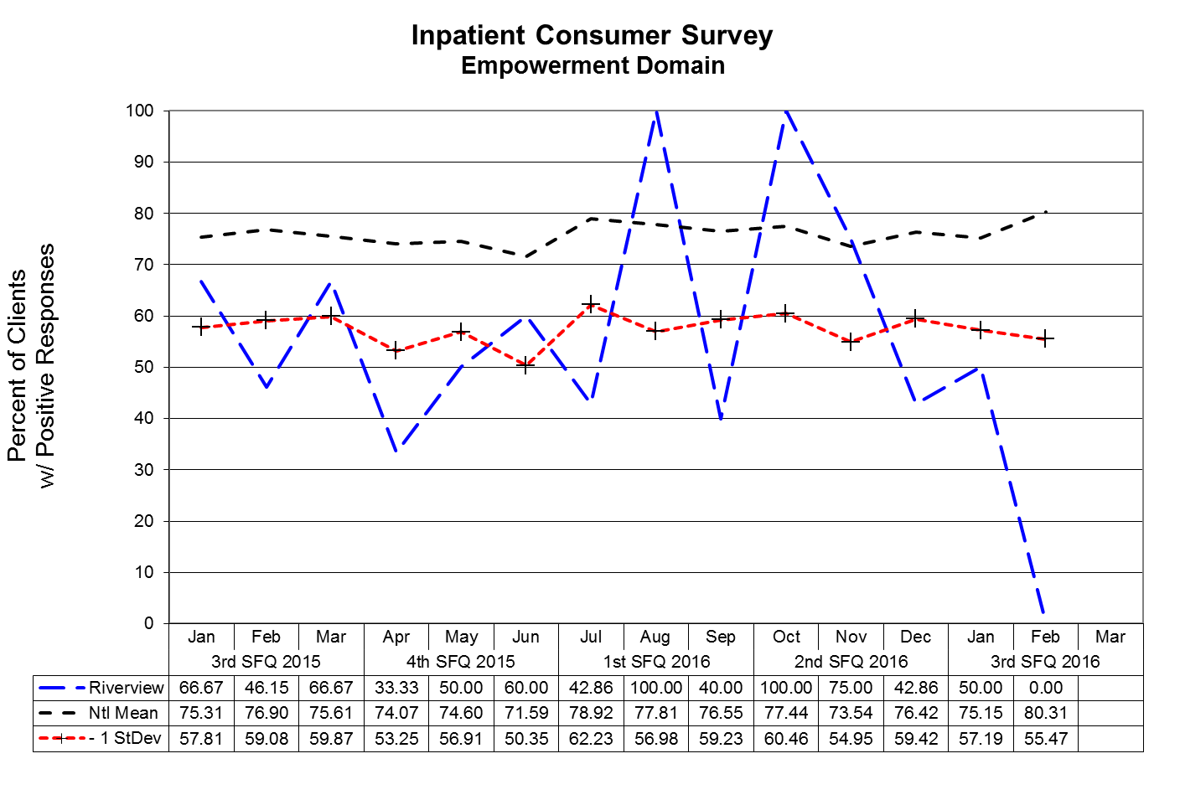
Empowerment Domain Questions:
- I had a choice of treatment options.
- My contact with my Doctor was helpful.
- My contact with nurses and therapists was helpful.

Fall Reduction Strategies

TJC PI.01.01.01 EP38: The hospital evaluates the effectiveness of all fall reduction activities including assessment, interventions, and education.

TJC PC.01.02.08: The hospital assesses and manages the patient's risks for falls.
EP01: The hospital assesses the patient’s risk for falls based on the patient population and setting.
EP02: The hospital implements interventions to reduce falls based on the patient’s assessed risk.
The Falls Risk Management Team has been created to be facilitated by a member of the team with data supplied by the Risk Manager. The role of this team is to conduct root cause analyses on each of the falls incidents and to identify trends and common contributing factors and to make recommendations for changes in the environment and process of care for those patients identified as having a high potential for falls.

Type of Fall by Patient and Month:

Process Improvement Plans
Priority Focus Areas for Strategic Performance Excellence

In an effort to ensure that quality management methods used within the Maine Psychiatric Hospitals System are consistent with modern approaches of systems engineering, culture transformation, and process focused improvement strategies and in response to the evolution of Joint Commission methods to a more modern systems-based approach instead of compliance-based approach
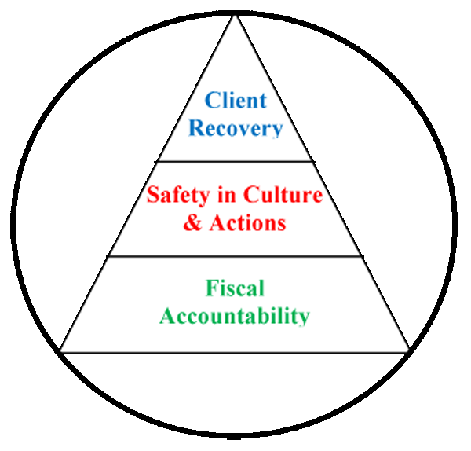
Building a framework for patient recovery by ensuring fiscal accountability
and a culture of organizational safety through the promotion of…

- The conviction that staff members are concerned with doing the right thing in support of patient rights and recovery;
- A philosophy that promotes an understanding that errors most often occur as a result of deficiencies in system design or deployment;
- Systems and processes that strive to evaluate and mitigate risks and identify the root cause of operational deficits or deficiencies without erroneously assigning blame to system stakeholders;
- The practice of engaging staff members and patients in the planning and implementing of organizational policy and protocol as a critical step in the development of a system that fulfills ethical and regulatory requirements while maintaining a practicable workflow;
- A cycle of improvement that aligns organizational performance objectives with key success factors determined by stakeholder defined strategic imperatives;
- Enhanced communications and collaborative relationships within and between cross-functional work teams to support organizational change and effective process improvement;
- Transitions of care practices where knowledge is freely shared to improve the safety of patients before, during, and after care;
- A just culture that supports the emotional and physical needs of staff members, patients, and family members that are impacted by serious, acute, and cumulative events.

Strategic Performance Excellence Model Reporting Process

Department of Health and Human Services Goals

Protect and enhance the health and well-being of Maine people
Promote independence and self sufficiency
Protect and care for those who are unable to care for themselves
Provide effective stewardship for the resources entrusted to the Department

Dorothea Dix and Riverview Psychiatric Centers
Priority Focus Areas

Ensure and Promote Fiscal Accountability by…
Identifying and employing efficiency in operations and clinical practice
Promoting vigilance and accountability in fiscal decision-making.

Promote a Safety Culture by…
Improving Communication
Improving Staffing Capacity and Capability
Evaluating and Mitigating Errors and Risk Factors
Promoting Critical Thinking
Supporting the Engagement and Empowerment of Staff Members

Enhance Patient Recovery by…
Develop Active Treatment Programs and Options for Patients
Supporting patients in their discovery of personal coping and improvement activities.

Each Department Determines Unique Opportunities and
Methods to Address the Hospital Goals

The Quarterly Report Consists of the Following:

DEFINE
Opportunities for Improvement (OFIs)
Performance Objectives
Opportunities for Improvement (OFI’s)

MEASURE
Current
Performance

ANALYZE
Identify Root
Causes of
Performance
Gaps
Current Work Flow
Process
Current
Performance
Gaps

Develop
Systems to Sustain Improvements
Implement
the Planned Changes
Validate Improvements Achieved
CONTROL
Establish Incremental Goals & Measures
Work Process Plans and Procedures
IMPROVE
Admissions

Responsible Party: Jamie Meader, RN, Admissions Nurse

Number of Admissions:

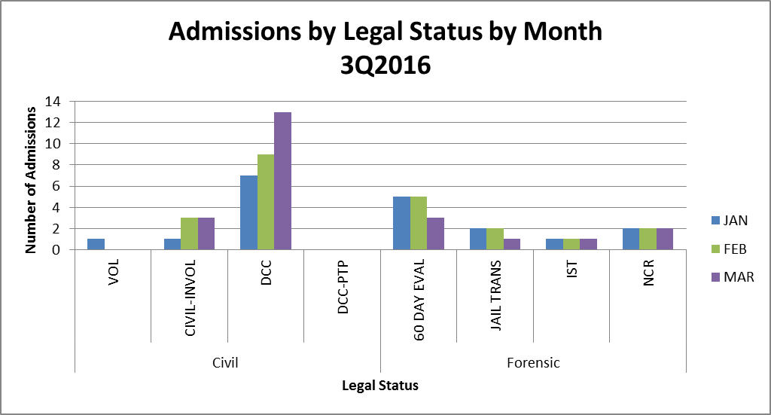

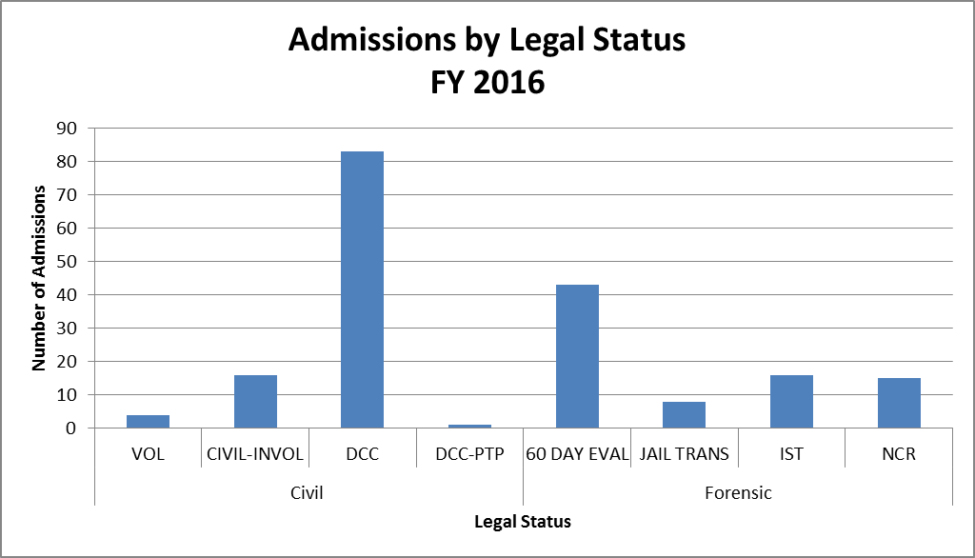
Average Number of Wait Days:
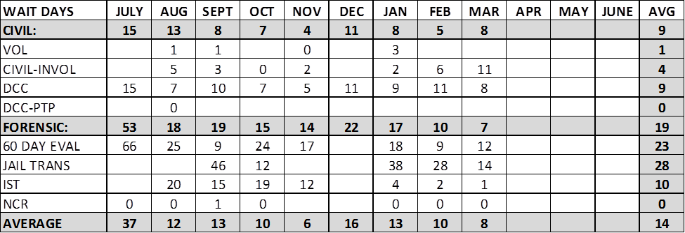
*If a field is blank it means that there were no admissions for that legal status and timeframe

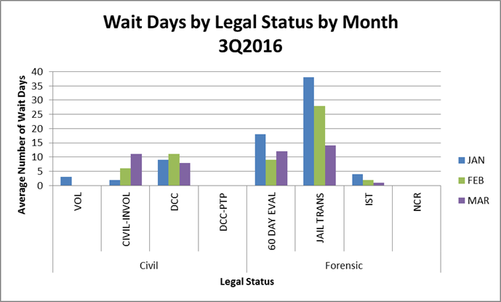

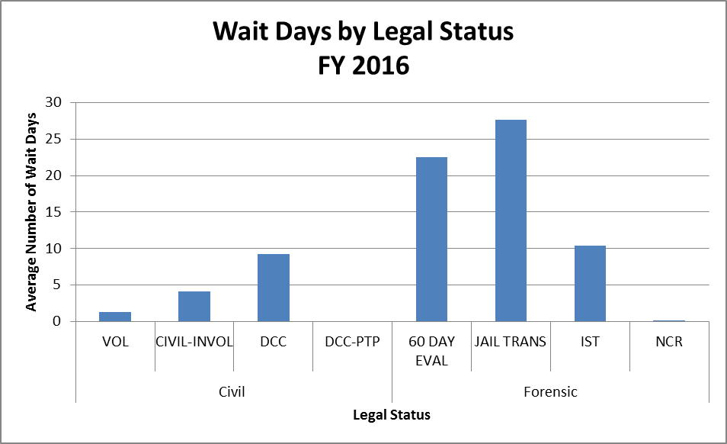
Number of Discharges:

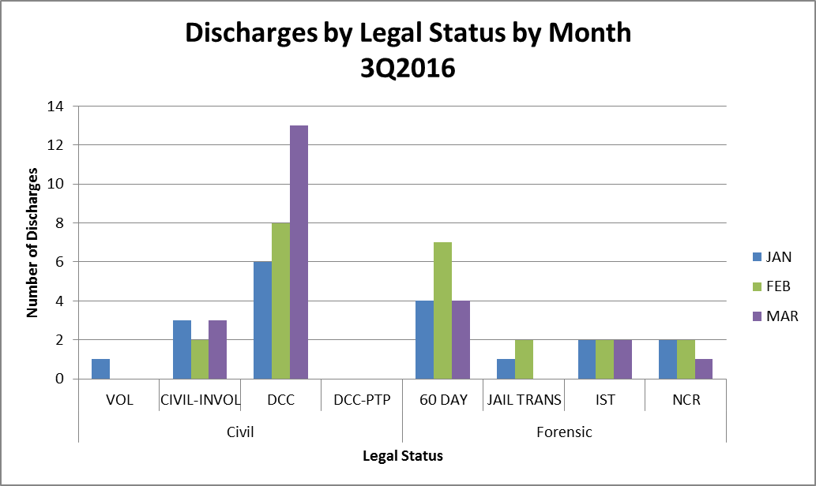

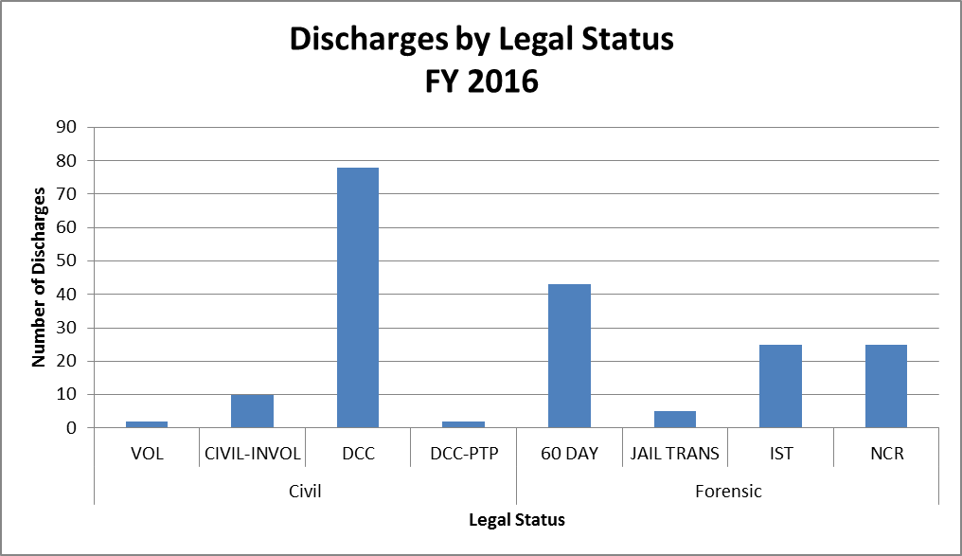
Average Length of Stay (Days):

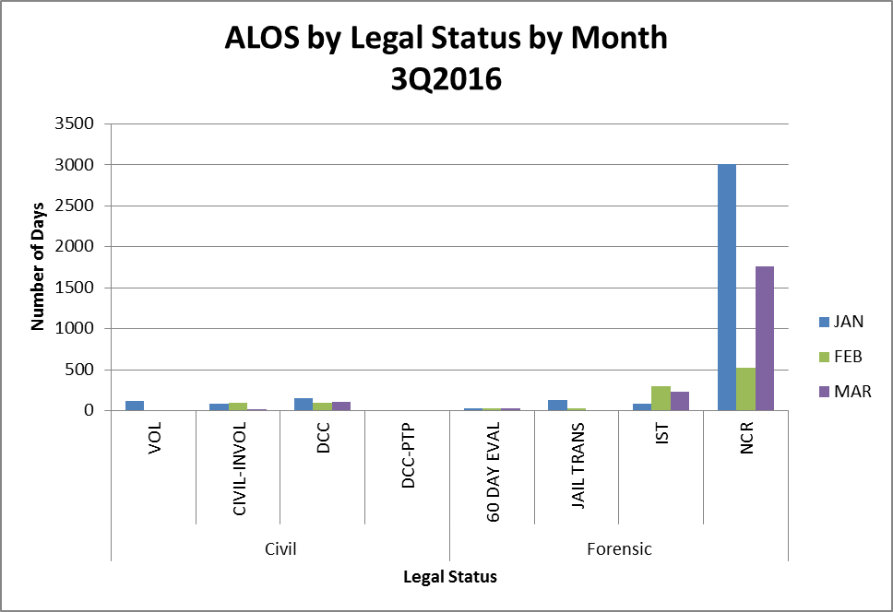

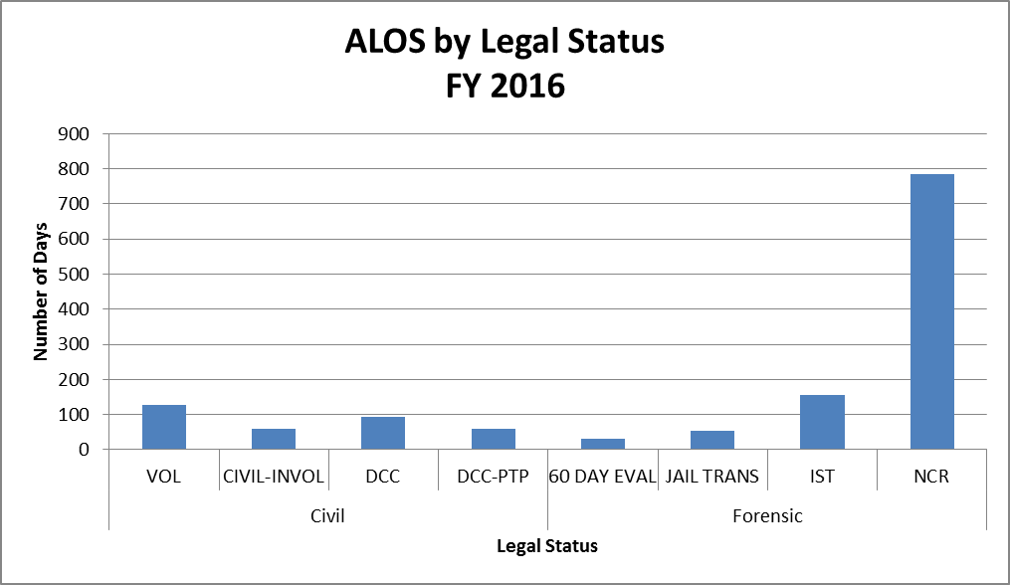
I. Measure Name: NCR Admissions

Measure Description: Admittance of all NCR patients within 24 hours of referral

Type of Measure: Quality Assurance

Results
 | Unit | Baseline | 1Q2016 | 2Q2016 | 3Q2016 | 4Q2016 | YTD
Target | NCR referrals admitted within 24 hours | N/A | 100% | 100% | 100% | 100% | 100%
Actual | NCR referrals admitted within 24 hours | N/A | 86%  6/7 | 100%  2/2 | 100%  6/6 |  | 93%  14/15

Data Analysis: Six NCR admissions occurred this quarter and all were admitted on the day of referral.

Action Plan: Continue to gather data on wait days for NCR admissions. Keep one bed available on the Forensic unit for NCR admissions at all times.

 | January  2016 | February 2016 | March  2016 | 3Q2016
# of NCR Admissions | 2 | 2 | 2 | 6  (Total)
Wait Days | 0 | 0 | 0 | 0  (Average)

II. Measure Name: Jail Transfer Bed

Measure Description: Keep one Jail Transfer bed open and track length of stay and legal outcomes.

Type of Measure: Performance Improvement

Data Analysis: Five Jail Transfers were admitted this quarter.
- 1st JTF admitted in January waited 30 days for admission and had a LOS of 36 days. While in the hospital, an inpatient evaluation was ordered. Patient met with SFS and was returned to jail.
- 2nd JTF admitted in January waited 45 days for admission and had a LOS of 13 days. Patient was returned to jail and charges dismissed.
- 3rd JTF admitted in February waited 42 days for admission. While in the hospital an inpatient evaluation was ordered. Patient is currently still at RPC.
- 4th JTF admitted in February waited 13 days for admission and is currently still at RPC.
- 5th JTF admitted in March waited 14 days for admission and is currently still at RPC.

Action Plan: Continue to track data and keep one bed available for jail transfers.

 | January  2016 | February 2016 | March  2016 | 3Q2016  Total
# of Jail Transfer (JTF) Admissions | 2 | 2 | 1 | 5
# of Jail Transfer (JTF) Discharges | 2 | 0 | 0 | 2

III. Measure Name: Off Shift PA Admission Paperwork

Measure Description: All required documentation will be complete and accurate for admissions on the off shifts by the PA.

Type of Measure: Performance Improvement

Results
 | Unit | Baseline | 1Q2016 | 2Q2016 | 3Q2016 | 4Q2016 | YTD
Target | Documentation complete and accurate for admissions on off shifts | N/A | 100% | 100% | 100% | 100% | 100%
Actual |  | N/A | 100%  3/3 | 50%  1/2 | N/A |  | 80%  4/5

Data Analysis: No off shift admissions occurred this quarter.

Action Plan: Continue to monitor data so paperwork is completed accurately and timely.

Capital Community Clinic
Dental Clinic

Responsible Party: Dr. Ingrid Prikryl, DMD

I. Measure Name: Yearly Periodontal Charting

Measure Description: Complete a full mouth periodontal charting.

Type of Measure: Performance Improvement

Results
 | Unit | Baseline | 1Q2016 | 2Q2016 | 3Q2016 | 4Q2016 | YTD
Target | % of appointments where full mouth periodontal charting was completed | FY 2015  42% | 50% | 55% | 60% | 65% | 75%
Actual |  | FY 2015  42% | 43% | 61% | 40% |  | 48%

Data Analysis: There was a drop in Q3 periocharting because, an influx of emergency appointments in the doctors schedule, most of which were new patients of RPC that have never had a previous appointment. To better measure will only measure periocharting on existing patients during their prophy recall appointments.

Action Plan: Charting to be completed by the hygienist during prophy appointments ONLY and not during emergency or new patient appointments.

Comments: Would like to be at 65% by the next three month recall cycle and then at 75% after 12 month recall. This is a challenge because not all patients are able and/or willing to sit for periodontal charting.
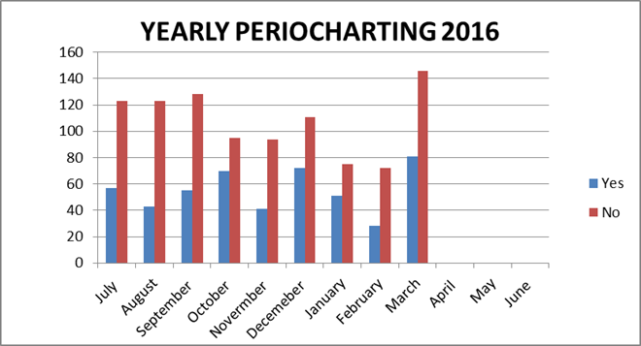
II. Measure Name: Improving Oral Hygiene

Measure Description: Monitoring patients’ oral hygiene and working to improve it

Type of Measure: Performance Improvement

Results
 | Unit | Baseline | 1Q2016 | 2Q2016 | 3Q2016 | 4Q2016 | YTD
Target | Plaque Score Monthly | Fair  (220-160) | Poor | Poor | Fair | Fair | Fair
Actual | Plaque Score Monthly | Fair  (220-160) | 221 | 248 | 150 |  | 206  (Fair)

Data Analysis: Smaller numbers demonstrate less plaque on our patients' teeth, therefore improved oral hygiene. The Q3 has decreased as we are only measuring prophy recall appointments.

Action Plan: Plaque scores should decrease in a 6 month cycle with proper oral hygiene instructions.

Comments: Trying to educate our patients on brushing DAILY and its importance for proper oral care and retention of teeth. Data collected from daily collected plaque scores as of the Q3 only on hygiene recall appointments.

III. Measure Name: Next Visit

Measure Description: Writing Next Visit in progress note.

Type of Measure: Performance Improvement

Results
 | Unit | Baseline | 1Q2016 | 2Q2016 | 3Q2016 | 4Q2016 | YTD
Target | # of progress notes with next visit documented | 66%  FY 2015 | 70% | 75% | 80% | 85% | 90%
Actual | # of progress notes with next visit documented | 66%  FY 2015 | 60% | 95% | 95% |  | 83%
Data Analysis: FY2015 YTD was 66%; therefore, it has become a performance improvement measure. We would like this measure to be at 90 – 100%.

Action Plan: Write at the end of every progress note what the next visit is going to be even if it is a 3 MRC or denture adjustment as needed.

Comments: Data collected from quarterly reviews by Community Dental; evaluate twenty random charts.

IV. Measure Name: RMH and MEDS

Measure Description: Review medical history and medications at the start of each appointment.

Type of Measure: Quality Assurance

Results
 | Unit | Baseline | 1Q2016 | 2Q2016 | 3Q2016 | 4Q2016 | YTD
Target | Daily noted | New implemented  measure | 70% | 80% | 90% | 100%
Actual | Daily noted | New implemented  measure | 90% | 95% | 100% |  | 95%

Data Analysis: As of the FY 2015 a new measure was implemented that the medical history and medication list be reviewed at each appointment.

Action Plan: Review patient medical history and medication list at the start of each appointment.

Comments: Data collected from quarterly reviews by Community Dental; evaluate twenty random charts.

V. Measure Name: Blood Pressure

Measure Description: Blood pressure and pulse taken at each dental appointment

Type of Measure: Quality Assurance

Results
 | Unit | Baseline | 1Q2016 | 2Q2016 | 3Q2016 | 4Q2016 | YTD
Target | Daily noted; Quarterly reviewed | New implemented  measure | 90-100% | 90-100% | 90-100% | 90-100% | 90-100%
Actual | Daily noted; Quarterly reviewed | New implemented  measure | 95% | 95% | 95% |  | 95%

Data Analysis: All patients that are seen prior to restorations and prophy appointments; denture patients do not always have their blood pressure taken; especially on denture deliveries.

Action Plan: Take blood pressure and pulse at the start of all dental appointments; quarterly charts reviewed.

Comments: To withstand dental care blood pressure should be less than 160/90.

Capital Community Clinic
Medication Management Clinic

Responsible Party: Robin Weeks, Medical Assistant

I. Measure Name: Reconciliation of Outpatient Medication List

Measure Description: Each visit will cover reconciliation of medical & psychotropic medications with patients.

Measure Type: Performance Improvement

Results
 | Unit | Baseline | 1Q2016 | 2Q2016 | 3Q2016 | 4Q2016 | FYTD
Target | Reconciliation completed per visit. | 2Q2015  73% | 100% | 100% | 100% | 100% | 100%
Actual | Reconciliation completed per visit. | 2Q2015  73% | 94%  59/63 | 97%  57/59 | 100%  46/46 |  | 96%  162/168

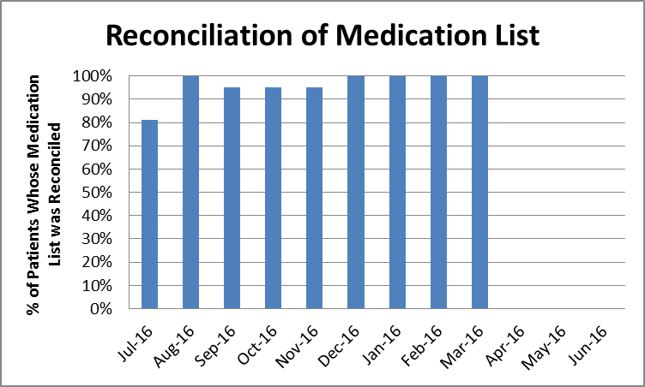

II. Measure Name: Vital Signs

Measure Description: Taking vital signs each visit will give us an idea of the effects of the prescribed medications and early detection of possible medical problems with the patient.

Measure Type: Quality Improvement

Results
 | Unit | Baseline | 1Q2016 | 2Q2016 | 3Q2016 | 4Q2016 | FYTD
Target | Reconciliation completed per visit. | Q12015  73% | 100% | 100% | 100% | 100% | 100%
Actual | Reconciliation completed per visit. | Q12015  73% | 92%  58/63 | 95%  56/59 | 93%  43/46 |  | 93%  157/168

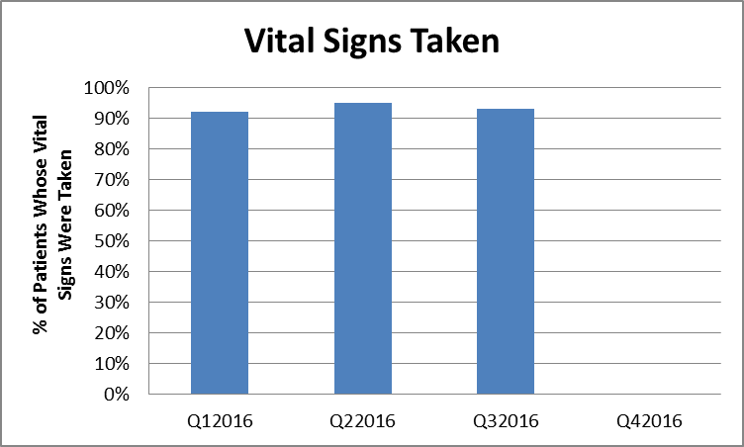

Dietary Services

Responsible Party: Kristen Piela, Dietetic Services Manager

- Measure Name: Nutrition Screen Completion

Measure Description: The Registered Dietitian will review each patient’s Nursing Admission Data to assess ongoing compliance with the completion of the Nutrition Screen tool; within 24 hours of admission.

Type of Measure: Quality Assurance

Results
 | Unit | Baseline | 1Q2016 | 2Q2016 | 3Q2016 | 4Q2016 | YTD
Target | Percent of Nutrition screens completed on time | FY 2015  95% | 95% | 95% | 95% | 95% | 95%
Actual | Percent of Nutrition screens completed on time | FY 2015  95% | 100%  60/60 | 100%  61/61 | 98%  62/63 |  | 100%  183/184

Data Analysis: Completion of the nutrition screens within 24 hours of admission has remained above target levels. This monitor began as an indicator in FY 2013.

Action Plan: To assure optimum care for our patients, this monitor will remain a quality assurance measure. As a follow up to this measure, there has been a performance improvement monitor developed to evaluate the accuracy of the screens being completed.

Comments: This is a multidisciplinary measure that has proven successful.

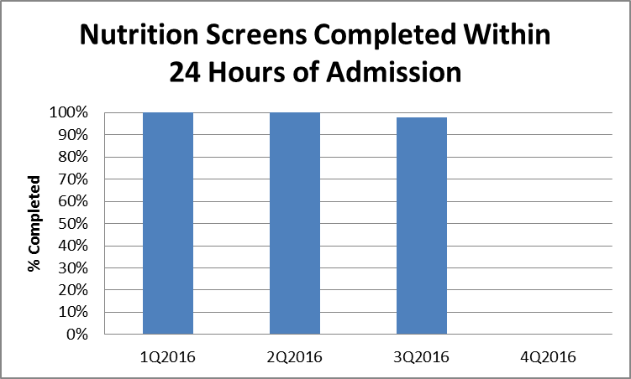
II. Measure Name: Nutrition Screen Accuracy

Measure Description: The Registered Dietitian will review every patient’s Nursing Admission Data upon admission to assess ongoing compliance with the accuracy of the Nutrition Screen tool. This screen is utilized to attain nutrition indicators that necessitate dietary intervention.

Type of Measure: Performance Improvement

Results
 | Unit | Baseline | 1Q2016 | 2Q2016 | 3Q2016 | 4Q2016 | YTD
Target | Percent of Nutrition screens completed accurately | FY 2016  Q1  68%  41/60 | Baseline  Established | 95% | 95% | 95% | 95%
Actual | Percent of Nutrition screens completed accurately | FY 2016  Q1  68%  41/60 |  | 87%  53/61 | 59/62  95% |  | 91%  112/123

Data Analysis: These results indicate there has been an 8% improvement in the accuracy of the information gathered on the nutrition screen. The nutrition screen is completed by the nurse responsible for the admission. The diagnosis on the nutrition screen that was not identified on all three occasions was the “BMI>29.

Action Plan: Met with the admitting nurse responsible for this data collection. The omission was an oversight and will be assessed on incoming patients.

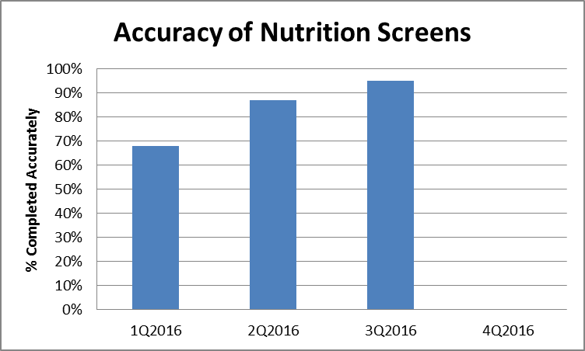
III. Measure Name: Hand Hygiene Compliance

Measure Description: Supervisory staff including the Food Service Manager and Cook III’s will observe all dietary employees as they return from break for proper hand hygiene.

Type of Measure: Performance Improvement

Results
 | Unit | Baseline | 1Q2016 | 2Q2016 | 3Q2016 | 4Q2016 | YTD
Target | Percent of Dietary employees washing hands after break | FY 2015  98%  338/346 | 95% | 95% | 95% | 95% | 93%
Actual | Percent of Dietary employees washing hands after break | FY 2015  98%  338/346 | 96%  343/356 | 94%  215/229 | 96%  276/288 |  | 96%  834/873

Data Analysis: The results of this quarter remain above 95%. There was a 2% increase in compliance. Total observations decreased by 59. One employee accounted for eight of the twelve times that handwashing wasn’t observed. Two additional employees weren’t observed washing their hands once within this rating period.

Action Plan:
- Continue to have front line supervisors monitor handwashing compliance after breaks.
- Provide a review of the proper hand washing times and techniques to staff member that is not consistently washing hands after breaks.
- Provide this Performance Improvement Measure to staff to highlight the continued success.

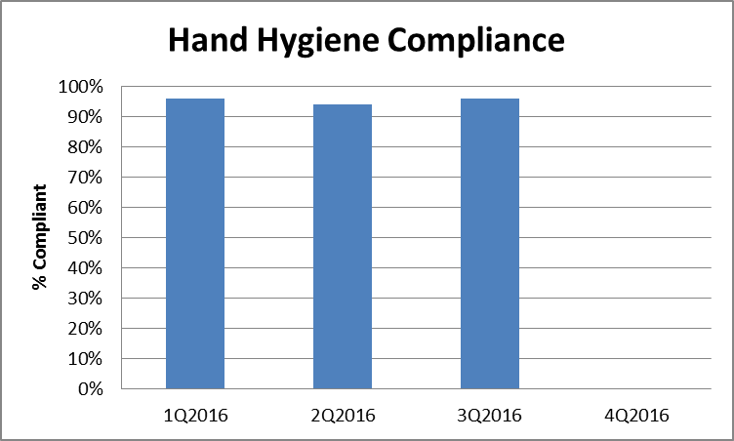
Emergency Management

Responsible Party: Robert Patnaude, Emergency Management Coordinator

I. Measure Name: Communications Equipment/Two-way radios

Measure Description: The Joint Commission states the following in EM.02.02.01: “As part of its Emergency Operations Plan, the hospital prepares for how it will communicate during emergencies. The hospital maintains reliable communications capabilities for the purpose of communicating response efforts to staff, patients, and external organizations.”

In the event of an unforeseen emergency which could impact the safety and security of patients, staff, and visitors, communications equipment, more specifically, two-way radios are a major solution to getting accurate information to and from staff in a timely manner. The objective of the Emergency Management Communications PI is to ensure compliance with The Joint Commission standard with the overall objective of ensuring that the two-way radio system is fully functional and that staff are proficient in its use.

Type of Measure: Performance Improvement

Methodology: Each month, the Emergency Management Coordinator or designee will perform a combination of partial and hospital-wide radio drills. Such drills will utilize a specific form to track the drills (see attached). In conjunction with the drills, environmental rounds will be conducted for the purpose of inspecting communications equipment. Any deficiencies shall have the appropriate corrective measure immediately instituted until compliance is met.

The numerator is the number of timely and appropriate responses by staff utilizing the two-way radios by assignments. The denominator will be the total number of two-way radios by assignments.

Baseline Data: To assure that critical emergency information is disseminated in a timely and accurate manner, a minimum of 90% compliance has been established. This data will be reported monthly to the Emergency Management Committee, IPEC, and the Environment of Care (EOC) Committee. Areas that fail to meet the threshold will be immediately reported to the aforementioned committees.

Results
 | Unit | Baseline | 1Q2016 | 2Q2016 | 3Q2016 | 4Q2016 | YTD
Target | Percent of timely and appropriate responses | FY2016  90%  144/159 | 90% | 90% | 90% | 90% | 90%
Actual | Percent of timely and appropriate responses | FY2016  90%  144/159 | 92%  147/159 | 96%  153/159 | 93%  148/159 |  | 93%  448/477

Data Analysis: With a significant amount of hands-on demonstrations, radio tests, and an increase in the use of radios, data showed that staff has become very familiar with operating the radio once the radios have been deployed. While the actual percentage of compliance is above the set threshold, what continues to be a critical issue is the fact that staff is not receiving the notification to employ the radios. The notification is going out, but either the pager is not on, the battery is dead, or the pager is not being monitored well appears to be the deficiency. We continue to investigate the most appropriate equipment such as non-battery dependent alert devices which are not so dependent on staff oversight.
Action Plan:
- Continued tests and remedial training to staff along with supporting handouts as needed.
- Increased surveillance of mass notification equipment such as alert pagers.
- Investigate various media to notify staff to employ radios.

Comments: 93% of assigned radio equipment is placed into service in a timely manner. Although this response adequately assures that the majority of occupants will receive timely and critical information, it still leaves a small population of staff who could be at harm’s way if they do not receive critical information through mass notification. During the March test, one entire patient-care unit did not respond to the initial notification. Statistically, the overall numbers appears acceptable, but an entire unit not responding is a grave concern. Follow-up is planned to prevent a reoccurrence.

Areas/Groups Monitored  N=Numerator  D=Denominator | JUL  2015 | AUG  2015 | SEPT  2015 | OCT  2015 | NOV  2015 | DEC  2015 | JAN 2016 | FEB 2016 | MAR 2016 | APR 2016 | MAY 2016 | JUNE  2016
Patient Care Areas/
# of radios
Job Coach/1 | 1/1 | 1/1 | 1/1 | 1/1 | 1/1* | 0/1** | 1/1* | 1/1* | 1/1*
OPS/2 | 2/2 | 2/2 | 1/2 | 2/2 | 2/2* | 2/2 | 2/2* | 2/2 | 2/2*
Tx Mall, Clinic, Dietary, Med Rec/5 | 5/5* | 5/5 | 3/5 | 5/5 | 5/5* | 4/5**5 | 5/5* | 5/5 | 4/5**5
US, UK, LS, LSSCU, LK, LKSCU/10 | 9/10 | 10/10 | 8/10 | 10/10 | 7/10**3 | 9/10 | 9/10**3 | 10/10 | 7/10**3
Support Services/
# of radios
Administration/3 | 3/3* | 3/3 | 3/3 | 3/3 | 3/3* | 3/3 | 3/3* | 3/3 | 3/3*
Housekeeping/  10 | 9/10 | 10/10 | 9/10 | 9/10*1 | 10/10* | 10/10 | 10/10 | 9/10*9 | 5/10**8
Maintenance/14 | 14/14 | 14/14 | 12/14 | 14/14 | 14/14* | 14/14 | 14/14 | 14/14 | 14/14*
NOD/1 | 1/1 | 1/1 | 1/1 | 1/1 | 0/1**4 | 1/1* | 1/1* | 1/1* | 1/1*
Nursing Services/1 | 1/1 | 1/1 | 0/1 | 0/1**2 | 1/1* | 0/1**6 | 1/1 | 1/1 | 1/1*
Operations/1 | 1/1 | 1/1 | 1/1 | 1/1 | 1/1 | 1/1 | 1/1 | 1/1 | 1/1*
Security/4 | 4/4 | 4/4 | 4/4 | 4/4 | 4/4 | 4/4 | 4/4 | 4/4 | 4/4*
State Forensic Services/1 | 1/1 | 1/1 | 0/1 | 1/1 | 1/1* | 0/1**7 | 1/1 | 1/1 | 1/1*
Patient Care Areas | 17/18 | 18/18 | 13/18 | 18/18 | 15/18 | 18/18 | 17/18 | 18/18 | 14/18
Support Services | 34/35 | 32/35 | 30/35 | 33/35 | 34/35 | 32/35 | 35/35 | 34/35 | 30/35
Total | 51/53 | 53/53 | 43/53 | 51/53 | 49/53 | 53/53 | 52/53 | 52/53 | 44/53

*Radio units not on duty due to shift assignment therefore given same weight in order not to have a negative impact.

EMC: Emergency Management Coordinator
Key:

**1 Did not hear test due to radio being turned down. Remedial training held for staff.
**2 General staff in area were not aware that radio was assigned to that location. EMC educated staff.
**3 Operations had to call units. Staff did not respond to the Code Triage.
**4 Staff called Operations requesting the definition of “Code Triage”. Upon further examination, the radio was dead. Not placed in charger properly. EMC educated staff.
**5 Operations called unit since staff did not respond to the “Code Triage”. Pager for alert had a dead battery. EMC educated staff. Battery replaced.
**6 Operations had to call unit since staff did not respond to the “Code Triage”. No means to receive message. Pager issued to Secretary. EMC educated staff.
**7 Operations had to call unit. Department Director only person in office. EMC to provide remedial training as requested.
**8 Housekeeping staff (Official shift start time of 0600) did not respond to the original test at 0606, but responded at the test done at 0615.
**9 One housekeeper reported that their radio was not working. After remedial training, the test was performed as expected.

Harbor Treatment Mall

Responsible Party: Marcy Pepin, RN

I. Measure: Harbor Mall Hand-Off Communication

Objectives | 1Q 2016 | 2Q 2016 | 3Q  2016 | 4Q  2016 | Total FY2016
1. Hand-off communication sheet was received at the Harbor Mall within the designated time frame. | 79%  44/56 | 93%  39/42 | 88%  37/42 |  | 86%  120/140
2. SBAR information completed from the units to the Harbor Mall. | 79%  44/56 | 93%  39/42 | 86%  36/42 |  | 85%  119/140

Define: To provide the exchange of patient-specific information between the patient care units and the Harbor Mall for the purpose of ensuring continuity of care and safety within designated time frames.

Measure: Indicator number one assessed as follows for the quarter: January 86%, February 79%, and March 100%. Indicator number two assessed as follows for quarter: January 93%, February 93%, and March 71%.
Analyze: For January, the specific time frame for being late was 3 minutes and 1 hour 15 minutes. For February, the specific time frame for being late was 5 minutes, 7 minutes, and 12 minutes. For March, all sheets turned in on time.
Improve: The results of the reports will be reviewed with the RN IVs from Lower Kennebec; Lower Saco; and Upper Saco and with the RN IIIs from UK. Data from the HOC sheets that did not arrive at the mall within the designated time-frame from the units will be reviewed. In addition, one morning or afternoon meeting with each unit to provide education regarding the importance of filling out the HOC sheets completely and submitting them to the Harbor Mall on time will be provided. We will maintain the statement at the bottom of the HOC reminding unit staff to turn the sheets in by 10 minutes after the hour to ensure that Harbor Mall leaders are made aware of any issues with the patients. This statement is highlighted in yellow.
Control: To continue to monitor the data and follow-up with any units(s) that may be having difficulties in developing or maintaining a process to meet the objectives above.
Health Information Technology (Medical Records)

Responsible Party: Samantha Brockway, Medical Records Administrator

Documentation and Timeliness:

Indicators | 3Q2016  Findings | 3Q2016  Compliance | Threshold Percentile
Records will be completed within Joint Commission standards, state requirements and Medical Staff bylaws timeframes. | 65 charts for patients released during the quarter were sampled. 100% of the charts were completed within the required timeframe. | 100% | 80%
Discharge summaries will be completed within 15 days of discharge. | 65 out of 65 discharge summaries were completed within 15 days of discharge. | 100% | 100%
Medical transcription will be timely and accurate. | Out of 741 dictated reports, 741 were completed within 24 hours. | 100% | 90%

Summary: The indicators are based on the review of all discharged records. There was 100% compliance with 30 day record completion. Weekly “charts needing attention” lists are distributed to medical staff, including the Medical Director, along with the Superintendent, Risk Manager and the Quality Improvement Manager. There was 100% compliance with timely & accurate medical transcription services

Actions: Continue to monitor.

Confidentiality:

Indicators | 3Q2016  Findings | 3Q2016  Compliance | Threshold Percentile
All patient information released from the Health Information Department will meet all Joint Commission, State, Federal & HIPAA standards. | 2,546 requests for information (138 requests for patient information and 2,408 police checks) were released. | 100% | 100%
All new employees/contract staff will attend confidentiality/HIPAA training. | All new employees/contract staff attended confidentiality/HIPAA training. | 100% | 100%
Patient Confidentiality/privacy issues tracked through incident reports. | 0 privacy-related incident reports.

Summary: The indicators are based on the review of all requests for information, orientation for all new employees/contract staff, and confidentiality/privacy-related incident reports.

No problems were found in 3Q2016 related to release of information from the Health Information Department and training of new employees/contract staff, however compliance with current law and HIPAA regulations need to be strictly adhered to requiring training, education and policy development at all levels.

Actions: The above indicators will continue to be monitored.

Release of Information for Concealed Carry Permits:

Define:
The process of conducting background checks on applicants for concealed carry permits is the responsibility of the two State psychiatric hospitals. Patients admitted to private psychiatric hospitals, voluntarily or by court order, are not subject to this review. Delays in the processing of background checks has become problematic due to an increasing volume of applications and complaints received regarding delays in the processing of these requests

Analyze:
Data collected for the 3Q2016 showed that we received 1316 applications. This is a decrease from last quarter, 2Q2016, when we received 1665 applications.

Improve:
The process has been streamlined as we have been working with the state police by eliminating the mailing of the applications from them to RPC and DDPC. RPC has reactivated the medical records email to receive lists of the applicants from the state police that include the DOB and any alias they may have had. This has cut down on paper as well as time taken sorting all the applications. OIT has also created a new patient index in which we are in the process of consolidating sources we search into this one system. Over time this will decrease time spent searching as we will no longer have to search several sources. This is ongoing.

Note: In July 2015, a new State of Maine law was approved effective October 2015. This law no longer requires citizens to have a concealed carry permit to carry a concealed weapon within the State of Maine. However, if citizens want to carry concealed outside Maine they will still need to apply for a concealed carry permit. We expect this to decrease the number of concealed carry permit applications we receive and process.

Year | FY 2015 |  |  | FY2016 |  |  |  |  |  |  |  |  | Total
Month | Apr | May | Jun | Jul | Aug | Sep | Oct | Nov | Dec | Jan | Feb | Mar | Total
# Applications Received | 732 | 713 | 516 | 353 | 302 | 304 | 634 | 489 | 542 | 401 | 439 | 476 | 5901

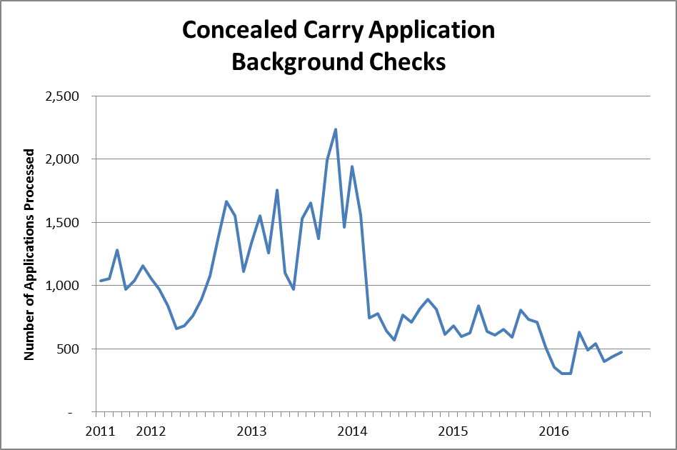

Housekeeping

Responsible Party: Debora Proctor, Housekeeping Supervisor

I. Measure Name: Patient Living Area
The Housekeeping Department will maintain an acceptable standard of cleanliness and sanitation in patient living areas.

Measure Description: The Housekeeping Supervisor or designee will perform a monthly inspection of the patient living area and record the findings on the Housekeeping Inspection Form. Any unit not meeting the threshold will be inspected every two weeks until compliance is met

Method of Monitoring: Inspection scores will be summarized monthly. Patient areas that fail to meet the threshold will be reported to the IPEC group, EOC, and the Director of Support Services. This report will include any actions taken.

Results:

Unit | Target | 1Q2016 | 2Q2016 | 3Q2016 | 4Q2016 | YTD
Lower Saco | 85% | 89% | 94% | 92% |  | 92%
Upper Saco | 85% | 87% | 88% | 88% |  | 88%
Lower Kennebec | 85% | 89% | 90% | 87% |  | 89%
Upper Kennebec | 85% | 87% | 89% | 90% |  | 89%
Overall Average | 85% | 88% | 90% | 89% |  | 90%

Data Analysis: The Housekeeping Supervisor inspected units monthly and found that window cleaning, dusting, and floor care in the nurse’s station were consistent problem areas.

Action Plan: The Housekeeping Supervisor will continue to do weekly inspections to assure that cleanliness of the environment continues to improve.

Human Resources

Person Responsible: Aimee Rice, Human Resources Manager

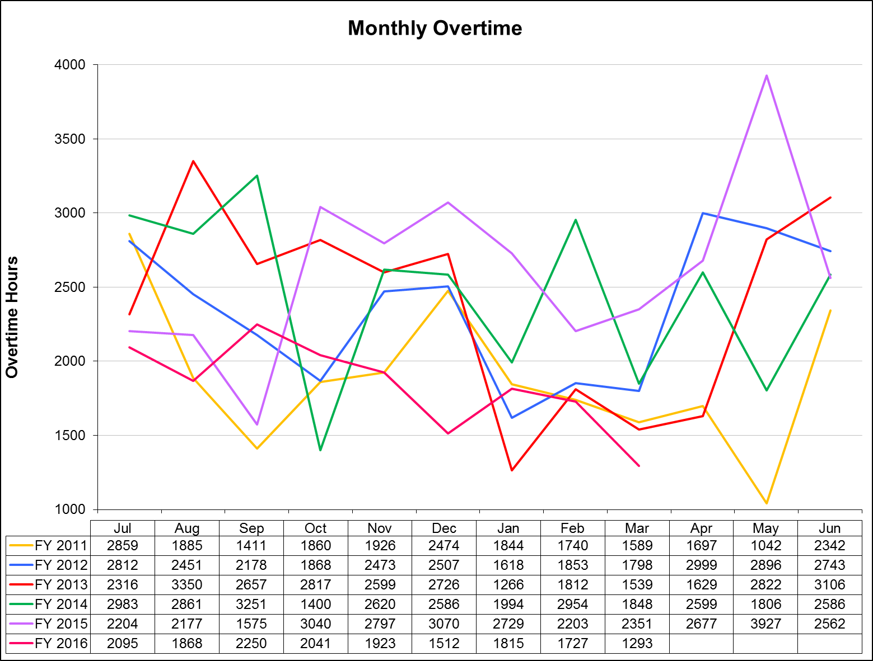

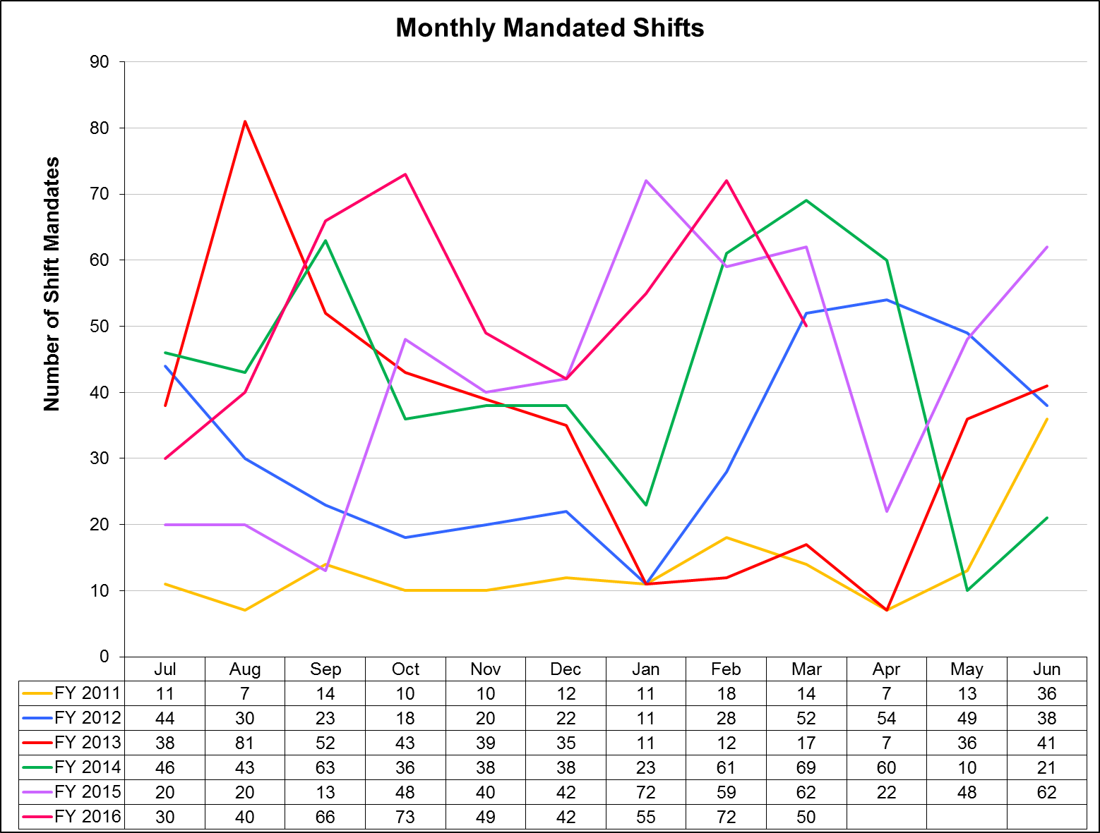
I. Measure Name: License Reviews

Measure Description: Ensuring that licenses/registry entries are verified via the appropriate source prior to hire for all licensed (or potentially licensed) new hires.

Type of Measure: Quality Assurance

Results
 | Unit | Baseline | 1Q2016 | 2Q2016 | 3Q2016 | 4Q2016 | YTD
Target | Percentage  Licenses Reviewed | FY 2014  98% | 100% | 100% | 100% | 100% | 100%
Actual | Percentage  Licenses Reviewed | FY 2014  98% | 100%  19/19 | 100%  6/6 | 100%  28/28 |  | 100%  53/53

Data Analysis: During 3Q2016, there were 36 new hires. Of those, 28 were licensed, or potentially licensed. License and CNA Registry checks were performed prior to hire on all 28.

Action Plan: No action is needed at this time.
Medical Staff

Responsible Party: Dr. William Nelson, Acting Clinical Director

Quality Improvement Plan
2015-2016

As specified in Article Seven of the Medical Staff Bylaws, the improvement and assurance of medical staff quality and performance is of paramount importance to the hospital. This plan insures that the standards of patient care are consistent across all clinical services and all specialties and categories of responsible practitioners. Through a combination of internal and external peer review, indicator monitoring, focused case reviews of adverse outcomes or sentinel events, routine case reviews of patients with less than optimal outcomes, and the establishment of performance improvement teams when clinical process problems arise, the medical staff will insure quality surveillance and intervention activities appropriate to the volume and complexity of Riverview’s clinical workload. Medical Staff Quality Improvement efforts will be fully integrated with the hospital-wide Integrated Performance Excellence Committee (IPEC) so that information can be sent to and received from other clinical and administrative units of the hospital. The Clinical Director, assisted by the President of the Medical Staff, will serve as the primary liaison between the MEC and IPEC. Oversight of the Medical Staff Performance Improvement Plan is primarily delegated to the Clinical Director in conjunction with the President of the Medical Staff, the Director of Integrated Quality and Informatics, the Superintendent, and ultimately to the Advisory Board.

The goal of the Medical Staff Quality Improvement Plan is to provide care that is:

Safe
Effective
Patient centered
Timely
Efficient
Equitable
Designed to improve clinical outcomes

To achieve this goal, medical staff members will participate in ongoing and systematic performance improvement efforts. The performance improvement efforts will focus on direct patient care processes and support processes that promote optimal patient outcomes. This is accomplished through peer review, clinical outcomes review, variance analysis, performance appraisals, and other appropriate quality improvement techniques.

1. Peer Review Activities:

- Regularly scheduled internal peer review by full time medical staff occurs on a monthly basis at the Peer Review and Quality Assurance Committee. The group of assembled clinicians will review case histories and treatment plans, and offer recommendations for possible changes in treatment plans, for any patient judged by the attending physician or psychologist, or others (including nursing, administration, the risk manager, or the Clinical Director), and upon request, to not be exhibiting a satisfactory response to their medical, psychological, or psychiatric regimens. Our goal is to discuss a case monthly. Detailed minutes of these reviews will be maintained, and the effectiveness of the reviews will be determined by recording feedback from the reviewed clinician as to the helpfulness of the recommendations, and by subsequent reports of any clinical improvements or changes noted in the patients discussed over time. Such intensive case reviews can also serve as the generator of new clinical monitors if frequent or systematic problem areas are uncovered. In addition all medical staff members (full and part-time) will have a minimum of one chart every other month peer reviewed and rated for clinical pertinence of diagnosis and treatment as well as for documentation. These may include admission histories and physicals, discharge summaries, and progress notes. The results of these chart audits are available to the reviewed practitioners and trends will be monitored by the Clinical Director as part of performance review and credentialing decisions.

- Special internal peer review or focused review. At the direction of the Clinical Director a peer chart review is ordered for any significant adverse clinical event or significant unexpected variance. Examples would be a death, seclusion or restraint of one patient for eight or more continuous hours, patient elopement, the prescribing of three or more atypical antipsychotics for the same patient at the same time, or significant patient injury attributable to a medical intervention or error.

- External peer review occurs regularly through contracts with the Maine Medical Association and the Community Dental Clinic program. We plan to continue our recent tradition of a biannual assessment of the psychiatry service and the medical service by peers in those clinical areas based on random record assessment of 25 cases in each service. An outside dentist from Community Dental will also review 20 charts of the hospital dentist for clinical appropriateness at least annually. Our contract with the Maine Medical Association also allows for special focused peer reviews of any unexpected death or when there is a question of a significant departure from the standard of care.

- MEC Subcommittee and IPEC Indicator Monitoring Activities:
The subcommittees of the MEC and the Integrated Performance Excellence Committee are the primary methods by which the medical staff monitor and analyze for trends all hospital-wide quality performance data as well as trends more specific to medical staff performance. The subcommittees, in turn, report their findings on a monthly basis to the Medical Executive Committee and to the Clinical Director for any needed action. The respective committees monitor the following indicators:
- Integrated Performance Excellence Committee (this is not a subcommittee of the Medical Staff but the Clinical Director serves as a member and is the primary liaison to the Medical Executive Committee).
  - Psychiatric Emergencies
  - Seclusion and Restraint Events
  - Staff or Patient Injuries
  - Priority I Incident Reports
  - Other clinical/administrative department monitoring activity
- Pharmacy and Therapeutics Committee:
  - Medication Errors Including Unapproved abbreviations
  - Adverse Drug Reactions
  - Pharmacy Interventions
  - Antibiotic Monitoring
  - Medication Use Evaluations
  - Psychiatric Emergency process
- Medical Records Committee:
  - Chart Completion Rate/Delinquencies
  - Clinical Pertinence of Documentation of Closed Records
- Infection Control Committee:
  - Infection Rates (hospital acquired and community acquired)
  - Staff Vaccination Rates/Titers
- Utilization Management Committee:
  - Admission Denials
  - Timeliness of Discharges After Denials
- Peer Review and Quality Assurance Committee:
- Hospital-wide Core Measures and NASMHPD Data
- Patient Satisfaction Surveys
- Administrative concerns about quality
- Special quality improvement monitors for the current year (see also the Appendix and number 6 below).
- Reports from the Human Rights Committee regarding patient rights and safety issues
- Specific case reviews

3. Performance or Process Improvement Teams:
When requested by or initiated by other disciplines or by hospital administration, or when performance issues are identified by the medical staff itself during its monitoring activities, the Clinical Director will appoint a medical staff member to an ad hoc performance improvement team. This is generally a multidisciplinary team looking at ways to improve hospital wide processes. Currently the following performance improvement teams involving medical staff are in existence or have recently completed their reviews:
- Review of treatment plans
- Lower Saco Unit

4. Miscellaneous Performance Improvement Activities:
In addition to the formal monitoring and peer review activities described above, the Clinical Director is vigilant for methods to improve the delivery of clinical care in the hospital from interactions with, and feedback from, other discipline chiefs, from patients or from their complaints and grievances, and from community practitioners who interact with hospital medical staff. These interactions may result in reports to the Medical Executive Committee, in the creation of performance improvement teams, performance of a root-cause analysis, or counseling of individual practitioners.

5. Reports of Practitioner-specific Data to Individual Practitioners:
The office of the Clinical Director will provide confidential outcomes of practitioner-specific data to each medical staff member within 30 days of the end of the fiscal year. This information will be available without the necessity of the practitioner requesting it. It will be placed in the confidential section of the practitioner’s medical staff file and freely accessible during normal business hours. The office of the Clinical Director will notify all medical staff members when the data is available for review. Each medical staff member may discuss the data with the Clinical Director at any time.

6. Process to amend the quality improvement plan, including adding or deleting any monitors or processes:
Upon the recommendation of the Clinical Director, upon recommendation of the MEC as a whole after a request from any member of the medical staff, from a recommendation of the Integrated Performance Excellence Committee, or upon recommendation of the Advisory Board, this plan may be amended with appropriate approvals at any time. Examples of when amendments might be necessary are the detection of new clinical problems requiring monitoring or when it is discovered that current monitors are consistently at or near target thresholds for six consecutive months. Should the number of active clinical monitors fall below four at any time, replacement monitors will be activated within two months of termination of the previous monitor (s). The Clinical Director, the Medical Staff President, and the MEC are jointly responsible for maintaining an active monitoring system at all times and to insure that all relevant clinical service areas or services are involved in monitoring. The Director of Integrated Quality will also assist in assuring the ongoing presence of appropriate monitors.

Quality Improvement Reporting Schedule to
Medical Executive Committee

Pharmacy & Therapeutics Committee: Chair reports monthly

Medical Records Committee: Chair reports monthly

Infection Control Committee: Chair reports monthly

Utilization Management Committee: Chair reports bimonthly

QA/PI/Peer Review Committee Clinical Director reports monthly and to
Individual practitioners as necessary

Research Committee Clinical Director reports bimonthly

CME Committee Chair reports bimonthly

Human Rights Committee (Allegations of Abuse, Clinical Director reports monthly
Neglect, and Exploitation)

I. Measure Name: Polyantipsychotic Therapy

Measure Description: The use of two or more antipsychotic medications (polyantipsychotic therapy) is discouraged as current evidence suggests little to no added benefit with an increase in adverse effects when more than one antipsychotic is used. The Joint Commission Core (TJC) Measure HBIPS-5 requires that justification be provided when more than one antipsychotic is used. Three appropriate justifications are recognized: 1) Failure of 3 adequate monotherapy trials, 2) Plan to taper to monotherapy (cross taper) and 3) Augmentation of clozapine therapy. This measure aligns itself with the HBIPS-5 core measure and requires the attending psychiatrist to provide justification for using more than one antipsychotic. In addition to the justification, the clinical/pharmacological appropriateness is also evaluated.

Type of Measure: Quality Assurance

Results
 | Unit | Baseline | 1Q2016 | 2Q2016 | 3Q2016 | 4Q2016 | YTD
Target | Justified Polyantipsychotic Therapy | 85% (2015) | 90% | 90% | 90% | 90% | 90%
Actual | Justified Polyantipsychotic Therapy | 85% (2015) | 77% | 69% | 78% |  | 75%

Data Analysis: All medication profiles in the hospital are reviewed in each month of the quarter for antipsychotic medication orders. Attending psychiatrists are required to complete a Polyantipsychotic Therapy Justification Form when a patient is prescribed more than one antipsychotic. The percentage of justified polyantipsychotic therapy amongst those patients prescribed two or more antipsychotics is reported here. This quarter we regained ground in the number of patients on justifiable polyantipsychotic therapy. An analysis of the patients on polyantipsychotic therapy yielded the following results: An average of 27 percent of inpatients were prescribed two scheduled antipsychotics which has increased since last quarter. There has been a shift from scheduled polyantipsychotic therapy toward the use of more than one antipsychotic on an as needed basis only. In March, 17 of 23 patients on antipsychotic therapy were on one scheduled agent with another agent only as needed; while in January and February, totals were 8 of 23 and 9 of 20 respectively. We have seen an increase in number of patients with triple antipsychotic therapy from baseline average of 3 to a total of 5 patients in March. One patient had standing triple antipsychotic therapy; one patient with one scheduled agent and two as needed; and the remaining three had two scheduled agents and one as needed. Also notable is that 7 of 29 polyantipsychotic therapy patients in March were on clozapine therapy. All patients either had regimens which were deemed pharmacologically rational or were documented as being in the cross-taper process.
Action Plan: This monitor was moved to Quality Assurance at the end of the second quarter. We will continue to monitor for appropriate justification of polyantipsychotic therapy. With the reorganization of the polyantipsychotic documentation process, numbers have improved from last quarter. Pharmacy has resumed alerting providers to provide justifications which may be partially responsible for this improvement as well.

Comments: This quarter saw an improvement in the number of patients on polyantipsychotic therapy and an increase in documentation of justification for polyantipsychotic therapy. With the new staff becoming more familiar with the process as well as a transition from paper documentation sheets to an excel database, continued improvement is expected. Of note, most current polyantipsychotic therapy is due to the addition of another agent only on an as needed basis which are not typically carried over to discharge. Additionally, an increase in the institutions overall number of clozapine patients in this quarter may indicate a change in the characteristics of our current census.

Graph/Chart:
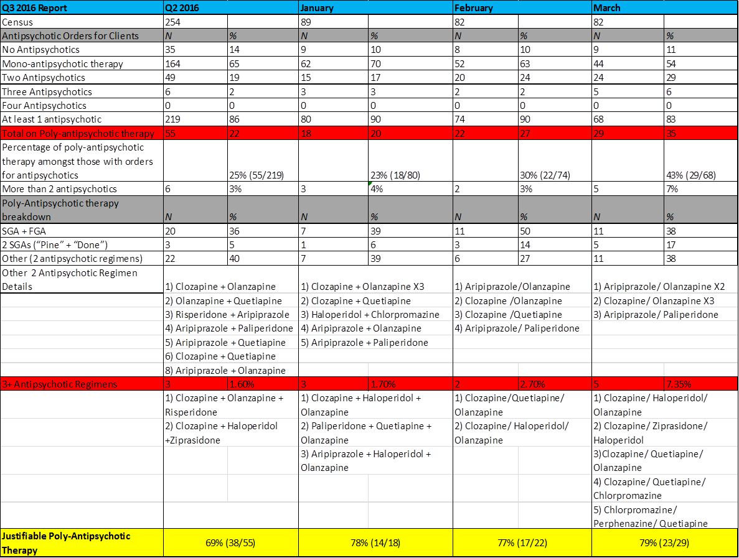
Census & Number of Patients with 0, 1, 2, 3 & 4 Orders for Antipsychotics:
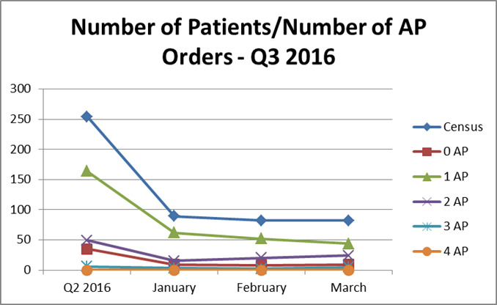

Number of Patients with 2+ Antipsychotic orders per Month:

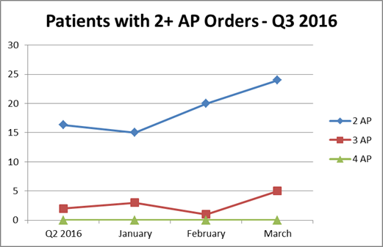

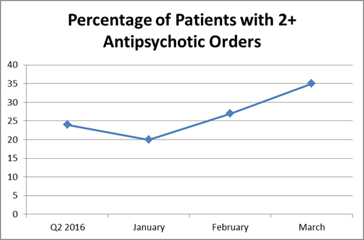

II. Measure Name: Metabolic Monitoring

Measure Description: Metabolic syndrome is a well-known side effect of second generation antipsychotics (SGAs). The majority of patients prescribed antipsychotics are prescribed an entity from the SGA sub-class. The purpose of this monitor is to ensure that we are monitoring, or attempting to monitor, SGA therapy appropriately for those patients prescribed SGAs.

Type of Measure: Performance Improvement

Results
 | Unit | Baseline | 1Q2016 | 2Q2016 | 3Q2016 | 4Q2016 | YTD
Target | Complete/Up-to-date Metabolic Parameters | 73% | 75% | 75% | 75% | 75% | 75%
Actual | Complete/Up-to-date Metabolic Parameters | 73% | 73% | 63% | 57% |  | 72%

Data Analysis: The pharmacy completed data collection of metabolic monitoring parameters for all patients in the hospital who were receiving atypical antipsychotics during the quarter. Data elements collected on all patients included BMI (Body Mass Index) and BP (blood pressure) plus lab results including HDL cholesterol, triglycerides, fasting blood sugar, and hemoglobin A1c.

Action Plan: We will continue to monitor SGA therapy by monitoring for Metabolic Syndrome. The patient’s right to refuse assessment (weight, blood pressure and lab work) has been identified as a contributing factor to not being able to fully assess their metabolic status. Thus the goal of achieving 95% completed metabolic parameters is unrealistic and has been adjusted to a more reasonable goal of 75%. We have also started incorporating documentation of patient’s refusals. This indicates that the provider is making the attempt to monitor the medication. In an attempt to streamline lab work, the Medical Staff has decided to incorporate lab work with the annual physical. This may impact this monitor going forward as data has been collected based on the most recent lab work and addition or changes in SGA therapy.

Comments: We saw a continued decrease this quarter to 57%, remaining below our goal of 75%. Of the patients that did not have complete/up-to-date parameters collected, 1% had documented refusals. For the majority of the patients, it is likely that their annual physical is not due and annual labs have not been ordered. Additionally, there has been some change over in medical staff in the last quarter. This may impact the results of this monitor negatively as the new providers become familiar with the system as well as the patients.

Graph/Chart:

 | 1Q2016 | 2Q2016 | 3Q2016 | 4Q2016
# of Patients on SGA | 105 | 198 | 192
# of Patients with Complete/Up-to-date Parameters | 59 (56%) | 124 (63%) | 109 (57%)
# of Patients Missing/Not  Up-to-date Parameters | 46 (44%) | 74 (37%) | 83 (43%)
# of Patients Meeting Criteria for Metabolic Syndrome | 32 (30%) | 61 (31%) | 57 (30%)
# of Patients without Metabolic Syndrome | 44 (42%) | 124 (63%) | 90 (47%)
# Unable to Determine | 29 (28%) | 27 (14%) | 45 (23%)
Documented Refusals | 0 | 27 (14%) | 1 (.01%)

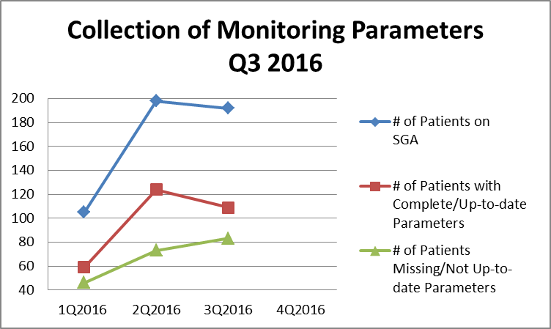

III. Measure Name: Polytherapy

Measure Description: Polytherapy is defined as “combined treatment of multiple conditions with multiple medications.” This differs from polypharmacy, the “treatment of a single condition with multiple medications from the same pharmacologic class or with the same mechanism of action” which our other monitor, Poly-antipsychotic therapy, addresses. Polypharmacy can lead to complex medication regimens and increases the chances of drug-drug interactions potentially negatively impacting or inhibiting another drug from exerting its intended therapeutic effect. When five or more medications are taken together there is almost a 100% chance of a drug-drug interaction. The purpose of this monitor is to evaluate polytherapy and actively discuss cases with the highest number of medications in an attempt to reduce polytherapy.

Type of Measure: Performance Improvement

Data Analysis: We have assessed a baseline group of patients with regards to their total number of medications prescribed and further broken it down to number of scheduled medications and number of PRN or “as needed” medications. Each month the patient medication profiles with the highest total number of medications for each unit will be reviewed at the Peer Review Committee to assess the potential for eliminating unnecessary medications. The number of actual profiles reviewed each month will be dependent on time constraints and presence/availability of the patient’s Psychiatric and Medical providers.

Action Plan: Action Plan: Our plan is to continue to review patients with numerous medication orders at the monthly Peer Review Committee Meeting. An effort will be made to obtain more information on medication adherence and PRN usage for the patients reviewed. This monitor will be reported and discussed with the Medical Staff at the Peer Review and Pharmacy & Therapeutics (P&T) Committees.

Comments: Results this quarter continue to remain similar to previous quarters. The average number of agents has likely increased due to patient specific factors including an increased number of medically fragile patients. As the number of medications per patient seems to reflect our current population this measure is being transitioned from performance improvement to quality assurance for the upcoming quarters.

Graph/Chart:

 | Baseline Average | Baseline Range | Q2 2016  Average | Q2 2016  Range | 1/20/16 Average | 1/20/16 Range | 2/22/16 Average | 2/22/16 Range | 3/21/16 Average | 3/21/16 Range
Total Orders | 12.1 | 0-31 | 13 | 0-42 | 13 | 1-35 | 7 | 1-36 | 14 | 1-37
Scheduled | 4.9 | 0-17 | 6 | 0-21 | 7 | 0-20 | 7 | 0-20 | 7 | 1-21
PRNs | 5.9 | 0-19 | 7 | 0-23 | 7 | 1-20 | 14 | 1-21 | 8 | 0-21

Medication Number Range | Average Number of Patients (Baseline) | 2Q2016 Average | 1/20/16 | 2/22/16 | 3/21/16 | 3Q2016 Average
< 5 | 7 | 5 | 6 | 4 | 5 | 5
5 – 9 | 30 | 24 | 21 | 16 | 17 | 18
10 – 14 | 38 | 26 | 33 | 32 | 32 | 32
15 – 19 | 15 | 19 | 15 | 17 | 13 | 15
20 – 24 | 4 | 9 | 9 | 10 | 9 | 9
25 – 29 | 2 | 1 | 4 | 2 | 4 | 3
> 30 | 2 | 1 | 1 | 1 | 2 | 1

Number of Patients Falling in to Range of Medication Orders:

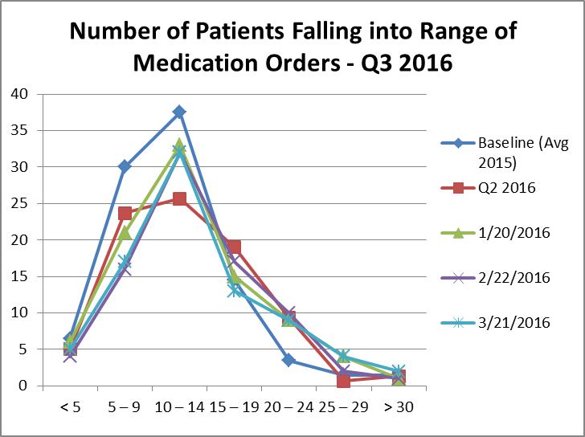

Nursing

Indicator: Mandate Occurrences

Definition: When no volunteers are found to cover a required staffing need, an employee is mandated to cover the staffing need according to policy. This creates difficulty for the employee who is required to unexpectedly stay at work up to 16 hours. It also creates a safety risk.

Objective: Through collaboration among direct care staff and management, solutions will be identified to improve the staffing process in order to reduce and eventually eliminate mandate occurrences. This process will foster safety in culture and actions by improving communication, improving staffing capacity, mitigating risk factors, supporting the engagement and empowerment of staff. It will also enhance fiscal accountability by promoting accountability and employing efficiency in operations.

Those responsible for monitoring: Monitoring will be performed by members of the Staffing Improvement Task Force which includes representation of Nurses and Mental Health Workers on all units, Staffing Office and Nursing Leadership.

Methods of monitoring: Monitoring would be performed by:
- Staffing Office Database Tracking System
- Human Resources Department Payroll System

Methods of reporting: Reporting would occur by one or all of the following methods:
- Staffing Improvement Task Force
- Nursing Leadership
- Riverview Nursing Staff Communication

Unit: Mandate shift occurrences

Baseline: September 2013: Nurse Mandates 14 shifts, Mental Health Worker Mandates 49 shifts

Monthly Targets: 10% reduction monthly x4 from baseline

Mandate Occurrences: When no volunteers are found to cover a required staffing need, an employee is mandated to cover the staffing need according to policy.
 | New Baseline  Sept 2013 | 4Q2015 |  |  | 1Q2016 |  |  | 2Q2016 |  |  | 3Q2016 |  |  | Goal
 | New Baseline  Sept 2013 | Apr 2015 | May 2015 | June 2015 | July 2015 | Aug 2015 | Sept 2015 | Oct 2015 | Nov 2015 | Dec 2015 | Jan 2016 | Feb 2016 | Mar 2016 | Goal
Nursing Mandates | 14 | 2 | 4 | 6 | 2 | 1 | 8 | 11 | 8 | 10 | 3 | 1 | 5 | 10% reduction monthly x4 from baseline)
Mental Health Worker (MHW) Mandates | 49 | 20 | 44 | 56 | 28 | 39 | 58 | 62 | 41 | 32 | 52 | 71 | 45 | 10% reduction monthly x4 from baseline)

Nursing mandates decreased from 29 last quarter to 9 this quarter.
MHW mandates increased from 135 last quarter to 168 this quarter.

Outpatient Services (OPS)

Responsible Party: Lisa Manwaring, Director

I. Measure Name: Admission Assessments

Measure Description: Within 5 business days of admission initial assessments from Psychiatry, Psychosocial, and Nursing will be complete and in the chart. All three will need to be present to count.

Measure Type: Performance Improvement

Results
 | Unit | Baseline | 1Q2016 | 2Q2016 | 3Q2016 | 4Q2016 | YTD
Target | Percent of assessments completed on time | FY 2015  0%  0/4 | 85% | 85% | 85% | 85% | 85%
Actual | Percent of assessments completed on time | FY 2015  0%  0/4 | 0%  0/3 | 0%  0/5 | 0%  0/4 |  | 0%  0/12

Data Analysis: We had one chart with two assessments completed this quarter.

Action Plan: To review data results with the OPS staff to ensure compliance.

Comments: To provide education and admission packets with assessment reminders to help facilitate compliance.

Peer Support

Responsible Party: Samantha St. Pierre, Peer Support Coordinator

Indicator: Inpatient Consumer Survey Return Rate

Definition: There is a low number of satisfaction surveys completed and returned once offered to patients due to a number of factors.

Objective: To increase the number of surveys offered to patients, as well as increase the return rate.

Those responsible for Monitoring: Peer Support Director and Peer Support Team Leader will be responsible for developing tracking tools to monitor survey due dates and surveys that are offered, refused, and completed. Peer Support Staff will be responsible for offering surveys to patients and tracking them until the responsibility can be assigned to one person.

Methods of Monitoring:
- Biweekly supervision check-ins
- Monthly tracking sheets/reports submitted for review

Methods of Reporting:
- Patient Satisfaction Survey Tracking Sheet
- Completed surveys entered into spreadsheet/database

Unit: All patient care/residential units

Baseline: Determined from previous year’s data.

Quarterly Targets: Quarterly targets vary based on unit baseline with the end target being 50%.

Survey Return Rate | Unit | Baseline | Target | 1Q2016 | 2Q2016 | 3Q2016 | 4Q2016 | YTD
The inpatient consumer survey is the primary tool for collecting data on how patients feel about the services they are provided at the hospital. | LK | 15% | 50% | 44%  7/16 | 23%  3/13 | 64%  7/11 |  | 43%  17/40
 | LS | 5% | 50% | 0%  0/21 | 54%  7/13 | 13%  2/16 |  | 18%  9/50
 | UK | 45% | 50% | 18%  3/17 | 25%  4/16 | 19%  5/26 |  | 20%  12/59
 | US | 30% | 50% | 88%  7/8 | 100%  7/7 | 0%  0/5 |  | 70%  14/20
 | Overall |  |  |  |  |  |  | 31%  52/169

Comments: Percentages are calculated based on the number of people eligible to receive a survey vs. the number of people who completed the surveys.

Inpatient Consumer Survey Results:

# | Indicators | 1Q  2016 | 2Q  2016 | 3Q  2016 | 4Q  2016 | YTD  Average
1 | I am better able to deal with crisis. | 69% | 82% | 53% |  | 68%
2 | My symptoms are not bothering me as much. | 79% | 77% | 64% |  | 73%
3 | The medications I am taking help me control symptoms that used to bother me. | 75% | 70% | 42% |  | 62%
4 | I do better in social situations. | 71% | 64% | 56% |  | 64%
5 | I deal more effectively with daily problems. | 73% | 83% | 64% |  | 73%
6 | I was treated with dignity and respect. | 71% | 65% | 56% |  | 64%
7 | Staff here believed that I could grow, change and recover. | 69% | 62% | 56% |  | 62%
8 | I felt comfortable asking questions about my treatment and medications. | 68% | 68% | 72% |  | 69%
9 | I was encouraged to use self-help/support groups. | 72% | 75% | 58% |  | 68%
10 | I was given information about how to manage my medication side effects. | 68% | 53% | 64% |  | 62%
11 | My other medical conditions were treated. | 65% | 69% | 64% |  | 66%
12 | I felt this hospital stay was necessary. | 65% | 48% | 58% |  | 57%

# | Indicators | 1Q  2016 | 2Q 2016 | 3Q  2016 | 4Q  2016 | YTD  Average
13 | I felt free to complain without fear of retaliation. | 69% | 60% | 44% |  | 58%
14 | I felt safe to refuse medication or treatment during my hospital stay. | 62% | 46% | 47% |  | 52%
15 | My complaints and grievances were addressed. | 63% | 55% | 47% |  | 55%
16 | I participated in planning my discharge. | 75% | 43% | 72% |  | 63%
17 | Both I and my doctor or therapists from the community were actively involved in my hospital treatment plan. | 63% | 30% | 53% |  | 49%
18 | I had an opportunity to talk with my doctor or therapist from the community prior to discharge. | 63% | 32% | 56% |  | 50%
19 | The surroundings and atmosphere at the hospital helped me get better. | 68% | 63% | 50% |  | 60%
20 | I felt I had enough privacy in the hospital. | 64% | 61% | 58% |  | 61%
21 | I felt safe while I was in the hospital. | 62% | 62% | 61% |  | 62%
22 | The hospital environment was clean and comfortable. | 66% | 63% | 56% |  | 62%
23 | Staff were sensitive to my cultural background. | 61% | 52% | 44% |  | 52%
24 | My family and/or friends were able to visit me. | 69% | 64% | 58% |  | 64%
25 | I had a choice of treatment options. | 64% | 56% | 44% |  | 55%
26 | My contact with my doctor was helpful. | 66% | 58% | 58% |  | 61%
27 | My contact with nurses and therapists was helpful. | 66% | 64% | 67% |  | 66%
28 | If I had a choice of hospitals, I would still choose this one. | 55% | 45% | 53% |  | 51%
29 | Did anyone tell you about your rights? | 71% | 51% | 50% |  | 57%
30 | Are you told ahead of time of changes in your privileges, appointments, or daily routine? | 63% | 54% | 44% |  | 54%
31 | Do you know someone who can help you get what you want or stand up for your rights? | 74% | 77% | 50% |  | 67%
32 | My pain was managed. | 62% | 75% | 50% |  | 62%
 | Overall Score | 67% | 63% | 55% |  | 61%

Pharmacy Services

Responsible Party: Michael Migliore, Director of Pharmacy

I. Measure Name: Controlled Substance Loss Data

Measure Description: Daily and monthly comparison of Pyxis vs CII Safe Transaction Report.

Type of Measure: Quality Assurance

 | Results
 | Unit | Baseline  FY 2015 | 1Q2016 | 2Q2016 | 3Q2016 | 4Q2016 | YTD
Target | Pharmacy | 0.19% | 0% | 0% | 0% | 0% | 0%
Actual | Pharmacy | 0.19% | 0% | 0% | 0% |  | 0%

Data Analysis: All of the controlled substances have been accounted for, resulting in a 0% loss of controlled substances for the third quarter.

Action Plan: Remain vigilant and continue to educate staff on proper automated dispensing cabinet procedures to avoid the creation of discrepancies.

Comments: The action plan is providing the desired results.

II. Measure Name: Invalid Orders

Measure Description: Incomplete/Invalid Orders.

Type of Measure: Performance Improvement

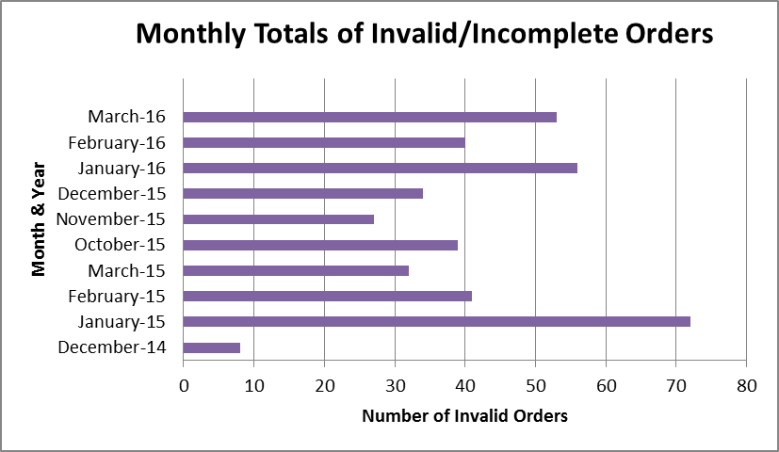
*Data not available for April-September 2015

Background: With a zero tolerance policy for invalid orders, every prescribed order must contain the drug name, strength, administration route, dosing frequency, provider signature, order time and date, accurate allergy and adverse drug reaction information, and indication.
The process for receiving an invalid order by the staff pharmacist requires documentation, copying and returning the invalid order to the prescriber for remediation as well as contacting and informing the unit of the invalided order.

Data Analysis: For the third quarter the number of invalid orders has increased averaging 49 invalid orders per month up from last quarter average of 33. Statistically one number higher than the baseline of 48 indicates additional room for improvement. Missing indications was the primary reason for incomplete orders followed by allergies and adverse drug reaction information on the order forms.

Action Plan: Rapid contact, resolution and awareness to the prescriber are an ongoing process to decrease the number of incomplete orders and provide excellent patient care. With the implementation of the CoCentrix CPOE (computerized physician order entry) system, due to arrive in June of this year, prescribers will be unable to process orders without filling in all the required fields. CPOE will eliminate incomplete orders.
III. Measure Name: Veriform Medication Room Audits

Measure Description: Comprehensive Unit Compliance Audits

Type of Measure: Quality Assurance

 | Results
 | Unit | Baseline  FY 2015 | 1Q2016 | 2Q2016 | 3Q2016 | 4Q2016 | YTD
Target | All | 100% | 100% | 100% | 100% | 100% | 100%
Actual | All | 100% | 100% | 100% | 100% |  | 100%

Data Analysis: The medication room audits have been concluded for quarter three without completion deficiencies.

Audit Compliance Findings: The Pharmacy Medication Room Audits for all the units have been completed for the third quarter.

Action Plan: No deficiencies were noted with pharmacy’s completion of the medication room audits. Pharmacy staff will continue to operate to maintain 100% completion and will continue reporting any noted deficiencies to nursing staff.

Comments: Medication room audits must be approved by the Nurse Unit Manager in a timely fashion. There are instances when the approvals have exceeded their required time limit and pharmacy has been diligent in their efforts to rectifying these occurrences by resending the requests and delivering hard copies to the responsible individuals.

IV. Measure Name: Fiscal Accountability

Measure Description: Monthly Tracking of Dispensed Discharge Prescriptions

Type of Measure: Quality Assurance

 | Results
 | Unit | Baseline  FY 2015 | 4Q  2015 | 1Q 2016 | 2Q 2016 | 3Q 2016 | YTD
Actual | All | $15764 for 861 Rx’s | $5266 for 261 Rx’s | $5281 for 368 Rx’s | $3719 for 312 Rx’s | $7679 for 461 Rx’s | $21,945  for 1402 Rx’s

Data Analysis: Riverview Psychiatric Center has an Extended Hospital Pharmacy license, meaning it can dispense to both in and outpatients. The majority of the outpatient prescriptions are for a 7-day supply of discharge medications. Special approval is required from administration when a great than 7 day supply is needed. The discharge prescriptions serve to cover the patient’s needs until they are able to obtain medications in the community.

Action Plan: Advance discharge planning would permit patients to obtain prescription coverage prior to discharge resulting in decreased pharmacy expenditures and a reduction in the volume of outpatient prescriptions provided by the pharmacy.

Comments: Calculating from the baseline figure of $15,764 for 861 Rx’s equals $18.30 per Rx, and the YTD figure of $21945.86 for 1402 Rx’s equals $15.65 per Rx. Subtracting YTD from baseline results in a $2.65 decrease per Rx to date. Additionally, in keeping drug costs down, monitoring and purchasing pharmaceuticals that are on preferred GPO pricing lists will provide a decrease in expenditures.

Psychology
Responsible Party: Arthur DiRocco, Ph.D., Director of Psychology
I. Measure Name: Outpatient Readiness Scale (ORS)
Measure Description: The ORS will be completed for those patients who reside in the community and are receiving services through OPS. Target is 90%of outpatients will have ORS completed and updated every 6 months.

Type of Measure: Performance Improvement

Results
 | Unit | Baseline | 1Q2016 | 2Q2016 | 3Q2016 | 4Q2016 | YTD
Target | Percent of OPS recipients evaluated with ORS | 1Q2016  4% | 90% | 90% | 90% | 90% | 90%
Actual | Percent of OPS recipients evaluated with ORS | 1Q2016  4% | 4%  2/47 | 11%  5/47 | 15%  7/47 |  | 10%  14/141

Data Analysis: This is a new initiative and will require training and follow-up with the OPS treatment team. Preliminary efforts have helped produce modest results in the first month. Baseline was measured from September 2015 to December 2015. The start of this initiative was mid-February 2016.

Action Plan: Psychology staff who work with the OPS treatment team will prompt the team to complete the ORS on each OPS recipient.

Comments: Plans are in place to assess patients on a more frequent basis as staff become more familiar with the assessment instrument. Our expectation is to double the number evaluated by the close of the next quarter.
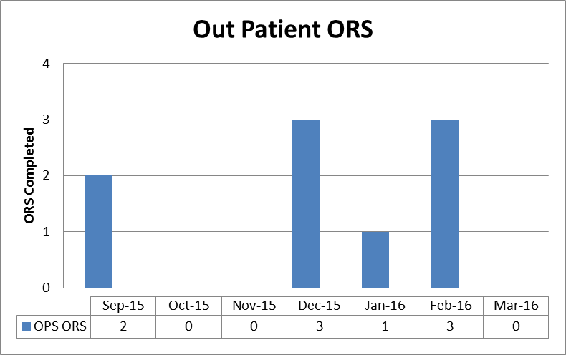
II. Measure Name: Treatment Plan Improvement Initiative

Measure Description: Patient treatment plans identifying psychological interventions will contain one or more of the following criteria: clear operational definitions, baseline data (e.g., excess or deficiency), and desired, measurable outcomes. Target is within 4 months 90% of all treatment plans developed with psychologist input will contain key features of proposed model intervention plans.

Type of Measure: Performance improvement

Results
 | Unit | Baseline | 1Q2016 | 2Q2016 | 3Q2016 | 4Q2016 | YTD
Target | Percent of treatment plans which meet new standard | 2Q2016  20% | 90% | 90% | 90% | 90% | 90%
Actual | Percent of treatment plans which meet new standard | 2Q2016  20% |  | 20%  2/10 | 25%  3/12 |  | 23%  5/22

Data Analysis: This is a new initiative and will require training and formative feedback to achieve desired level of thoroughness and conformity with desired standards. Baseline was measured from September 2015 to February 2016. The start of this initiative was February 15, 2016.

Action Plan: Psychology staff will work collaboratively in both an intra- and inter-disciplinary manner to achieve clear and practical behavior plans.

Comments: Individual treatment plans (10 to 12) were accessed at random from on-line unit entries and examined for elements consistent with this initiative. Future efforts will be made to ensure that patients with identified psychological treatment needs will have a corresponding treatment plan.

Rehabilitation Services
(Occupational Therapy, Therapeutic Recreation, Vocational Services,
Chaplaincy, Patient Education)

Responsible Party: Janet Barrett, CTRS, Director of Rehabilitation Services

I. Measure Name: Occupational Therapy Service Orders

Measure Description: Improving health outcomes/patient care. In order to receive effective treatment, all patients receiving Occupational Therapy Services have a doctor’s order and referral sheet completed before services are initiated.

Methodology: Each quarter Rehabilitation Services Director will audit the Occupational Therapy Referral Log and review the list of all patients receiving services to ensure a doctor’s order for the service has been written and a referral to OT was completed before the patient began receiving services.

The numerator will be the number of OT Service referrals that include the required MD order, the denominator will be the total number of OT Service referrals received.

Goal: To achieve and maintain an overall goal of 100% for 4 consecutive Quarters

Type of Measure: Performance Improvement

Results
 | Unit | Baseline | 1Q2016 | 2Q2016 | 3Q2016 | 4Q2016 | YTD
Target | Each patient receiving OT services has an MD order | FY 2015  97% | 100% | 100% | 100% | 100% | 100%
Actual | Each patient receiving OT services has an MD order | FY 2015  97% | 100%  25/25 | 100%  29/29 | 100%  25/25 |  | 100%  79/79

Data Analysis: In review of Occupational Therapy Services Log all patients referred for services from January 1, to March 31, 2016 had both the referral sheet completed as well at the doctor’s order attached to it.

Action Plan: Review the results of the audit with Occupational Therapy staff.

II. Measure Name: Vocational Services Documentation

Measure Description: Improving health outcomes/patient care. In order to receive effective treatment, all patients engaged in the Vocational Rehabilitation Program will have updated treatment plans and weekly documentation on the progress towards addressing the intervention outlines in the treatment plan.

Methodology: Each quarter Rehabilitation Services Director will audit the charts of the patients involved in the Vocational Rehabilitation Program to review treatment plans and progress notes to ensure they are being completed in a timely manner and updated on a regular basis.

The numerator will be the number of patient charts with the required documentation and the denominator will be the total number of patients in the Vocational Rehabilitation Program.

Goal: To achieve and maintain an overall goal of 100% for 4 consecutive Quarters

Type of Measure: Performance Improvement

Results
 | Unit | Baseline | 1Q2016 | 2Q2016 | 3Q2016 | 4Q2016 | YTD
Target | Each patient working in the Voc. Rehab. Program has the required documentation | 60% | 100% | 100% | 100% | 100% | 100%
Actual |  | 60% | 50%  6/12 | 91%  29/32 | 97%  29/30 |  | 76%  25/33

Data Analysis: Charts were audited using the Rehab. Services –Vocational Services tool. There was only 1 chart in which a weekly note was not done on time.

Action Plan: Continue with the monthly audits to assist with attaining the goal of 100% so that the Vocational documentation can reach the goal of 4 consecutive quarters of 100%.

Safety & Security

Responsible Party: Philip Tricarico, Safety Officer

I. Measure Name: Grounds Safety & Security Incidents

Measure Description: Safety/Security incidents occurring on the grounds at Riverview, Grounds being defined as “outside the building footprint of the facility; being the secured yards, parking lots, pathways surrounding the footprint, unsecured exterior doors, and lawns.” Incidents being defined as “Acts of thefts, vandalism, injuries, mischief, contraband found, and safety/security breaches.” These incidents shall also include “near misses, being of which if they had gone unnoticed, could have resulted in injury, an accident, or unwanted event”.

Type of Measure: Quality Assurance

Results
 | Unit | Baseline | 1Q2016 | 2Q2016 | 3Q2016 | 4Q2016 | Total
Target | # of Incidents | *Baseline of 10 | 2 | 4 | 2 | 2 | 9
Actual | # of Incidents | *Baseline of 10 | 4 | 2 | 1 |  | 7

3Q2016: The Q3 Target was (2). Our actual number was (1). We exceeded our goal! We have not had any issues this quarter with state owned pickup trucks and the contraband they frequently contained. We have been working with Capitol Police, Fleet Management and the Department of Conservation (agency the trucks are assigned to). There has been significant improvement in how often we are finding contraband items in these trucks. We will continue to work with all parties as we seek to resolve this issue. Although we had no issues this quarter a new system was implemented, by maintenance, for checking cars in and out. We will monitor and remain vigilant as we all get used to the new system. We are pleased that in all of the events, our Security staff or clinical staff had discovered/processed the event before there was a negative impact to the patients. The reporting, which follows below, continues to provide a very clear picture of Safety and Security events, how they are handled, and that the use of surveillance equipment plays an integral part in combating safety and security threats to people and property. Our aggressive rounds by Securitas continue to prove its worth with regard to Security’s presence and patrol techniques. The stability and longevity of our Security staff along with its cohesiveness with the Clinical component of the hospital has proven to be most effective in our management of practices.
Safety & Security Incidents:

Event | Date | Time | Location | Disposition | Comments
1. Safety Concern  (Staff member vehicle with contraband in the bed) | 2/8/16 | 1116 | Staff Parking Lot | Staff member moved truck to another lot, off grounds. | Staff member with multiple contraband and dangerous items in the bed of their truck. Items included long steel cable, rope, hack saw & blades and large pipe wrenches.

