Bureau of Alcoholic Beverages
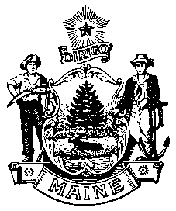
Division of Liquor Licensing and Enforcement
8 State House Station
Augusta, Me 04333-0008
Telephone Inquiries: (207) 287-4482 or (207) 287-4492
Fax Inquiries: (207) 287-3434
Email Inquiries: MaineLiquor@Maine.gov

NOTICE

To avoid any delay in the processing of your application and issuance of your liquor license, please make sure to:

- You have completed the application in full.

- Application is signed by the owner(s), Corporate Officer(s)

- The license fee is correct and you have made your check payable to
Treasurer, State of Maine.

- Applied for and received Retailers Certificate
Maine Revenue Service (207) 624-9693 Maine.gov/revenue

- Applied for and received a Federal I.D. Number
Internal Revenue Service (800) 829-4933 www.irs.gov

- Applied for and received the Federal Basic Permit Number
Federal Reselling Number (800) 937-8864 www.ttb.gov

- All Corporations, Limited Liability Company, Limited Liability Partnership, must complete and submit the Corporate Information Required for Business Entities Who Are Licensees form completely.

If not a publicly traded corporation, stock ownership must add up to 100%.

