State of Maine
Bureau of Alcoholic Beverages
Division of Liquor Licensing and Enforcement

Corporate Information Required for Business Entities Who Are Licensees
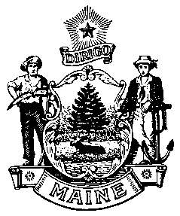
For Office Use Only:

License #: _______________

SOS Checked: ____________

100% Yes ☐ No ☐

Questions 1 to 4 must match information on file with the Maine Secretary of State’s office. If you have questions regarding this information, please call the Secretary of State’s office at (207) 624-7752.
Please clearly complete this form in its entirety.

- Exact legal name: ____________________________________________________________________

- Doing Business As, if any: ____________________________________________________________

- Date of filing with Secretary of State: ________________ State in which you are formed: __________

- If not a Maine business entity, date on which you were authorized to transact business in the State of Maine: _______________________________

- List the name and addresses for previous 5 years, birth dates, titles of officers, directors and list the percentage ownership: (attached additional sheets as needed)

NAME | ADDRESS (5 YEARS) | Date of Birth | TITLE | Ownership %
(Ownership must equal 100% for Corporations, LLC’s etc.)

- If Co-Op # of members: ___________________ (list primary officers in the above boxes)

- Is any principal person involved with the entity a law enforcement official?

Yes No If Yes, Name: _________________________ Agency: ______________________

- Has any principal person involved in the entity ever been convicted of any violation of the law, other than minor traffic violations, in the United States?

Yes No

- If Yes to Question 8, please complete the following: (attached additional sheets as needed)

Name: ____________________________________________

Date of Conviction: __________________

Offense: ____________________________________________________________________________

Location of Conviction: _______________________________________________________________

Disposition: ________________________________________________________________________

________________________________________________________________________

Signature:

_______________________________________ _________________________________
Signature of Duly Authorized Person Date

_______________________________________
Print Name of Duly Authorized Person

Submit Completed Forms To:

Bureau of Alcoholic Beverages
Division of Liquor Licensing and Enforcement
8 State House Station, Augusta, Me 04333-0008 (Regular address)
10 Water Street, Hallowell, ME 04347 (Overnight address)
Telephone Inquiries: (207) 624-7220 Fax: (207) 287-3434
Email Inquiries: MaineLiquor@Maine.gov

