
May 1, 2012

Robert W. Moosmann
Maine Department of Transportation, Bureau of Maintenance & Operations
16 State House Station
Augusta, Maine 04333-0016

RE: Variance permits for CMR 01-026, Chapters 22 and 29
Dear Mr. Moosmann:
This letter will serve as your 2012 variance permits covering Section 2 (C) of Chapter 22 and Section 6 of Chapter 29 for weed control along state maintained roads and other transportation facilities. Please bear in mind that these variance permits require agency personnel and contractors to adhere to the measures outlined in Section X of the Chapter 22 permit application and Section IX of the Chapter 29 permit application.
I will alert the Board at its May 11, 2012 meeting that the variance permits have been issued. If you have any questions concerning this matter, please feel free to contact me at 287-2731.
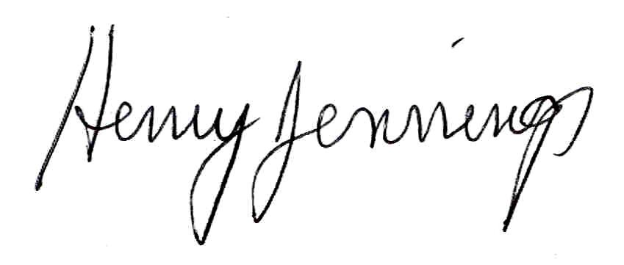
Sincerely,
Henry Jennings
Director
Maine Board of Pesticides Control

