
April 30, 2012July 30, 2026

Ronald Lemin
RCL Services LLC
291 Lincoln Street
Bangor, ME 04401

RE: Variance Permit for CMR 01-026, Chapter 29
Dear Mr. Lemin:
By way of this letter, your request for a variance from the 25-foot setback requirement contained in Chapter 29, Section 6 is hereby granted for the treatment of a Giant Hogweed infestation in the vicinity of Ohio Street in Bangor for the period of April 30 to May 15, 2012.
On November 18, 2011, the Board authorized the staff to issue permits for broadcast pesticide applications within 25 feet of water for control of plants that pose a dermal toxicity hazard.
We will alert the Board at its May 11, 2012 meeting that the variance permit has been issued. If you have any questions concerning this matter, please feel free to contact me at 287-2731.
Sincerely,
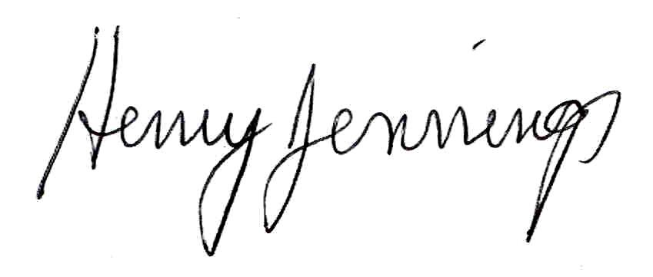
Henry Jennings
Director
Maine Board of Pesticides Control

