
May 2, 2012

Donald J. Dubois
Dubois Contracting
295 St. John Road
Fort Kent, ME 04743

RE: Variance Permit for CMR 01-026, Chapters 29 for Vegetation Control on the Fort Kent Levee
Dear Mr. Dubois:
At their June 3, 2011 meeting, the Maine Board of Pesticides Control (BPC) approved your application for variance permit to conduct a broadcast application of herbicides along portions of the Ft. Kent levee. Your recent application indicates that the spraying was not done in 2011 due to lack of funding and you have requested a repeat variance for 2012
This letter will serve as your variance permit for 2012. Please bear in mind that your permit is based upon your company adhering to the precautions listed in Section IX of your April 20, 2012 application.
If you have any questions concerning this matter, please feel free to contact me at 287-2731.
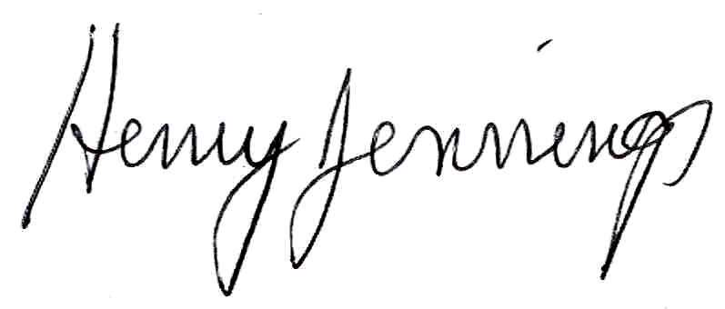
Sincerely,

Henry Jennings
Director
Maine Board of Pesticides Control

